Table of Contents

MODBUS SLAVE IDs 2

COILS AND REGISTERS… 2

Generic 2

1. Transfer case controller 3

2. Air suspension controller 3

# MODBUS SLAVE IDs

1 – Transfer case controller

# COILS AND REGISTERS…

## Generic

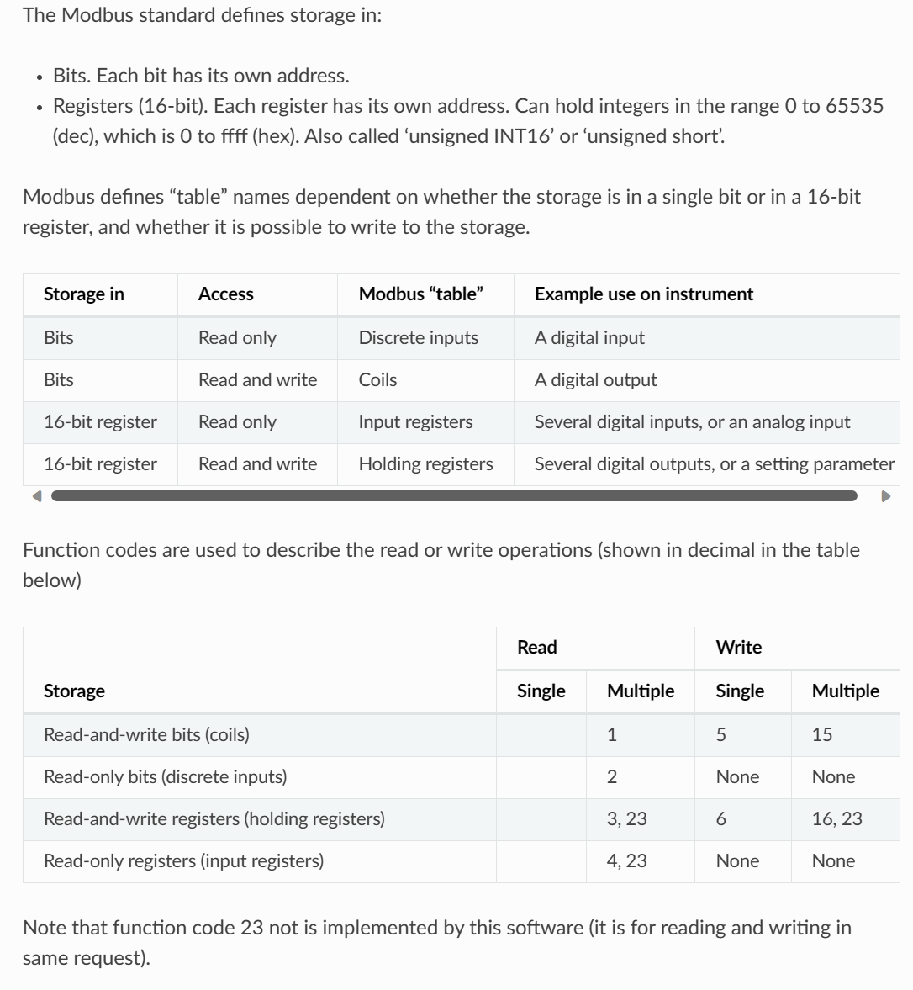

## Transfer case controller

Coils:

Discrete inputs:

Input registers:

Holding registers:

## Air suspension controller

Coils:

Discrete inputs:

Input registers:

Holding registers: