BRIDES User Guide

August 2022 / version 1.2.2

Cindy Bouchard, Université de Montréal
Etienne Lord, Université de Montréal

Table of contents
0. Changelog 3
1. Pre-requisites 3
1.1 R package and R version 3
1.2 C++ version 4
1.3 Objectives 4
2. Quickstart 6
2.1 Installation of the R version 6
2.2 Installation of the C++ version 7
2.3 Input files 7
2.3.1 Input under the R version 8
2.3.2 Input under the C++ version 8
2.4 Output files 8
2.4.1 R output file 9
2.4.2 C++ output file 9
3. Program parameters 10
3.2 Command-line and options for the standalone C++ version 13
4 Sample Network files (t0.txt, t1.txt,t2.txt,t3.txt) 14

BRIDES is a computer program that finds the number of Breakthroughs, Roadblocks, Impasses, Detours, Equals and Shortcuts (BRIDES) characterizing the evolution of an original network X into an augmented network Y (new nodes and edges have been added to X in order to create Y). It is distributed either as an R source file making use of the igraph and SDDE packages (this R version is suitable for networks with less than 1000 nodes) or as a standalone C++ program suitable for large evolving networks. The BRIDES program and its source code are freely available at: https://github.com/etiennelord/BRIDES under the GPL3 license. Our program, and the corresponding algorithms, were designed and developed at Université de Montréal (Monteal, Canada) and Université du Québec à Montréal (Montreal, Canada).

0. Changelog

NEW FEATURES
* Created the R package version that is available on github in the release section
* Added BRIDES evaluation of network scenarios (runmode): "exhaustive", "genetics" and "stepwise". Those scenarios evaluate successive addition of nodes from augmented network Y, from the network X, in order to MAXIMIZE the BRIDES score using a scoring function.
* Added the wt parameter to the BRIDES function to set a scoring strategy for the BRIDES statistics.
* Added the min_additionnal and max_additionnal nodes to the BRIDES function.
* Added the path_information parameter to the BRIDES function to save the traversed path information.
* Added the mutationChance parameter to the BRIDES function to control the genetics algorithm scenario.
* Added the legend_position parameter to the plot_network function.
* Removed the SDDE dependency for the R version

CHANGES
* Added Cindy Bouchard (PhD student, UdeM) to the author list.
* Changed the default behavior so that weighted edges are considered.
* Added a save network function.
* Fixed some path that were not displayed correctly in the traces in the R version.
* Various fixed to the output of the BRIDES functions.
* Fixed some error in the directed network evaluation.
* Added various warnings in the R code.

1. Pre-requisites

1.1 R package and R version
This version requires the R version 3.2 or higher. It has been tested on the MacOSX, Windows and Linux platforms. It also requires the installation of the two following R packages (including their dependencies): igraph (https://cran.r-project.org/web/packages/igraph) and fastmap (https://cran.r-project.org/web/packages/fastmap). Since September 2020, a new package version is available from github. This version is compatible with RStudio and should install using the R Studio package manager.

The package version is available in the release section on github.com/etiennelord/BRIDES

1.2 C++ version
The C++ version is distributed as a C++ source code with different MakeFile for different operating systems. The compilation of the source code has been tested on the MacOSX 10.10, Windows and Linux platforms using the gcc compiler suite. Our program uses the OpenMP directives for parallel computing when available.

1.3 Objectives
Both the R, R package and C++ functions can be used to estimate the number of different pathways, including Breakthroughs, Roadblocks, Impasses, Detours, Equals and Shortcuts (BRIDES), characterizing the evolution of an original network X into an augmented network Y (new nodes and edges have been added to X in order to create Y). Note that all nodes of X should be also present in Y, but some edges of X may be absent in Y. These pathways, found in the network Y, must contain at least one node that was absent in the original network X.
We can define the six following types of pathways, related to the existence of added nodes in Y, which can be used to characterize complex relationships in evolving networks (see Figure 1 below and Table 1):
Breakthrough: pathway that is impossible in network X but possible in network Y (e.g. path between nodes 2 and 12, passing by added node 15 in Figure 1B);
Roadblock: pathway that is possible in network X but impossible in network Y (e.g. a simple path between nodes 4 and 7 that passes by an added node in Y is impossible, see Figure 1B);
Impasse: pathway that is impossible in both networks, X and Y (e.g. there is no path between nodes 9 and 11 in Figures 1A and 1B);
Detour: pathway that is shorter in network X than in network Y (e.g. path between nodes 1 and 3 in Figures 1A and 1B);
Equal: pathway that has the same length in networks X and Y (e.g. path between nodes 1 and 6, assuming that all edge lengths in X and Y are equal, Figures 1A and 1B);
Shortcut: pathway that is longer in network X than in network Y (e.g. path between nodes 2 and 8 in Figures 1A and 1B).

In addition, the R package version add different search modes to evaluate different search strategies. Using those strategies, different weights can be attributed to the different types of paths, effectively allowing to search for different scenarios of the maximum BRIDES score. For search modes are available:’default’ (BRIDES statistics only), ’exhaustive’ scenario-based search the maximum BRIDES score using some weight scoring scheme, ’genetics’ scenario-based genetics algorithm search for the best BRIDES score, ’stepwise’ scenario-based incremental search adding the best one node, than the second best to maximize the BRIDES score using the weight scoring scheme (see section 3.1.9).

Figure 1. Examples of the BRIDES (Breakthrough, Roadblock, Impasse, Detour, Equal and Shortcut) paths in evolving networks. Panel (A) presents an original network X with 12 nodes. Panel (B) presents an augmented network Y with 15 nodes (including 12 original and 3 added nodes, which are colored in grey).

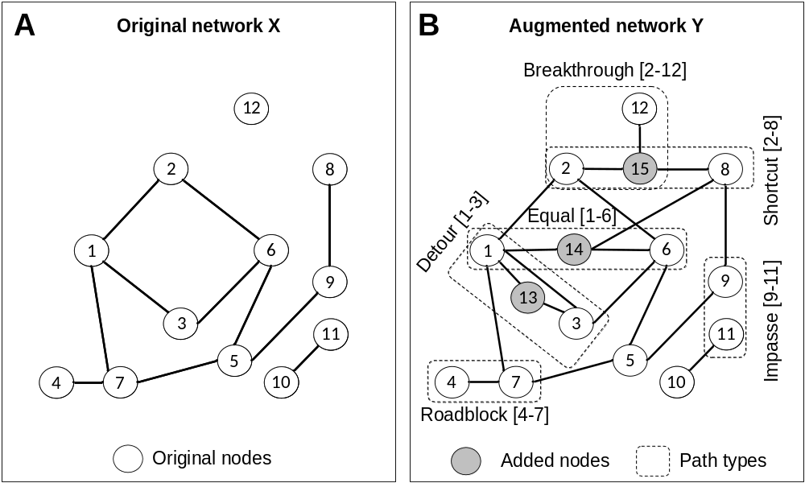
These networks correspond to the files sampleX.txt (A) and sampleY.txt (B) which can be found in the sample directory. Note, those networks are available as networkX and networkY in the BRIDES packages.
Table 1. Possible BRIDES outcomes depending on the length of simple path.
Simple path between i to j in X | Simple path between i to j in Y | BRIDES statistic
Impossible | Possible | Breakthrough
Possible | Impossible | Roadblock
Impossible | Impossible | Impasse
Shorter distance | Longer distance | Detour
Equal distance | Equal distance | Equal
Longer distance | Shorter distance | Shortcut

2. Quickstart

2.1 Installation of the R version

Option 1. Using a package manager
Download the release packaged version at https://github.com/etiennelord/BRIDES/releases
In the R terminal execute the following commands to install the BRIDES package.
install.packages("BRIDES_1.2.1.tar.gz", repos = NULL, type = "source")

or use the Tools → Install packages in R Studio, selecting the Install from : Package Archive File option (see below).
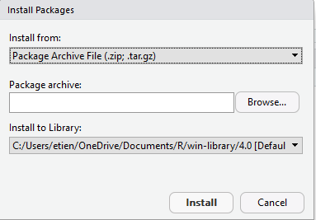
Note: you might neec to manually install the package igraph when using this method.
Option 2. Use from source code.
Download or clone the git distribution found at: https://github.com/etiennelord/BRIDES.
git clone https://github.com/etiennelord/BRIDES.git

In the R terminal, in the R_src directory of the BRIDES repository, execute the following commands to install both packages:
install.packages("igraph")
install.packages("fastmap")

Then, execute the following command from the directory containing the BRIDES.R archive (R_src):
source("BRIDES_2022.R")

2.2 Installation of the C++ version
Download the C++ source file (main.cpp) and the corresponding Makefile from Github. Then using the gcc compiler (version 4.5 or higher), compile the source code using the command make. Different Makefile(s) are provided.
make –f Makefile.Linux

//or

g++ -O3 main.cpp –o brides -fopenmp

Note, that under MacOSX, you will need to install the gcc compiler with an OpenMP support, using Homebrew (http://brew.sh/). For installation details, see the documentation available at: http://openmp.org/wp/openmp-compilers/ for more information.
brew install gcc --without-multilib

Otherwise, you can use the Makefile without OpenMP (Makefile.MacOSX_wo_Openmp).
This will either generate the brides.exe (under Windows) or brides (under Mac OSX and Linux) executables.
Note: the C++ version don’t include the search for the best additional nodes using scenarios.

2.3 Input files
For both R and C++ versions, the edge-list network representation is required in the program input. Additional annotation files containing nodes identification can also be supplied. The program requires as input either an original network X and an augmented network Y, or a network X and an annotation file identifying each the “color” or attribute of each node.
An input network file should be given as an edge-list in a tab-separated (\t or tab) format:
Source  node id | Destination  node id | Edge  weight

*Note that that each node can either be identified using a character string or a number. Single nodes are allowed in the edge-list. Rows beginning with the characters # or ! are ignored.
An input annotation file must be in the following, tab-separated, format:
Node id | color or attributes | …

Example of a network file:
#src dest distance
x1 x2 1
x1 x3 2
x12

Example of an annotation file:
#ID Attributes
x1 2
x2 1
x3 1
x12 3

2.3.1 Input under the R version
The BRIDES program in R uses the igraph network manipulation functions and objects. For example, to load edge-list encoded networks, one can use the load_network function as follows (using the t0.txt and t1.txt sample files from the examples directory, see section 3.1):
source("BRIDES.R")
networkX<-load_network("sample/t0.txt")
networkY<-load_network("sample/t1.txt")
results<-BRIDES(networkX,networkY)
print(results)

2.3.2 Input under the C++ version
Specify on the command line both desired networks (see section 3.2) as follows:
brides.exe -X=sample/t0.txt -Y=sample/t1.txt

2.4 Output files
For the R version, an output file can be specified using the "outfile" parameter (see section 3.1). For the C++ version, and output file can be specified using the "-outfile=file" parameter (see section 3.2). Note that the detailed path information is only available in this "outfile".

2.4.1 R output file
For the R version, the output file is a tab-separated list (tsv):
Source node  (src) | Destination node  (dest) | Original path length (dist_x) | Augmented path length  (dist_y) | BRIDES | Path  Visited  (path) | Path of visited taxa  (taxa)

#src dest Dist_X Dist_Y BRIDES path taxa
x2 x1 1 1 Roadblock
x4 x1 2 4 Detour x4,x3,y6,x2,x1 0,0,1,0,0
x6 x1 Inf Inf Impasse
x5 x1 3 5 Detour x5,x4,x3,y6,x2,x1 0,0,0,1,0,0
x3 x1 3 3 Equal x3,y6,x2,x1 0,1,0,0
x4 x2 1 3 Detour x4,x3,y6,x2 0,0,1,0
...

2.4.2 C++ output file
For the C++ version, the output file results follow the following format:
(Run parameters)
...
============================ PARTIAL RESULTS ==================================
src dest Dist_X Dist_Y BRIDES CPU time (ms) path taxa
x2 x1 1 1 R 0
x4 x1 2 4 D 0 x4,x3,y6,x2,x1 0,0,1,0,0
x5 x1 3 5 D 0 x5,x4,x3,y6,x2,x1 0,0,0,1,0,0
x3 x1 3 3 E 0 x3,y6,x2,x1 0,1,0,0
x6 x1 Inf Inf I 0
x4 x2 1 3 D 0 x4,x3,y6,x2 0,0,1,0
...
An output file section contains statistics for individual nodes, either the original node (NK) or the added nodes (K). The column inside refers to the number of times that the related node was part of the other path(s). For example, node x2 was part of 5 other simple paths, while node y6 was part of 8 other simple paths in the augmented network. The last column, attribute, refers to the node information (if any).

Node | B | R | I | D | E | S | Inside | Atribute

============================== STATISTICS ====================================
NK B R I D E S Inside Attribute
x1 0 1 1 2 1 0 0 0
x2 0 1 1 2 1 0 5 0
x4 0 1 1 3 0 0 3 0
x5 0 1 1 3 0 0 0 0
x3 0 0 1 2 2 0 4 0
x6 0 0 5 0 0 0 0 0

K Inside Attribute
y6 8 1
================================ RESULTS ======================================
B R I D E S Total Time (s)
0 2 5 6 2 0 15 0

3. Program parameters
3.1 R function parameters
BRIDES(X=networkX, Y=networkY)

Parameters | Default value | Description
X | NA | Original network X  (an igraph network object)
Y | NA | Augmented network Y  (an igraph network object)
A | "default" | Attribute which can be specified for an added node (K)  "tax" attribute: e.g. V(Y)$tax
src | "default" | Name or vertex number (source)
dest | "default" | Name or vertex number (destination)
random | 0 | If specified, will sample XX random pathways, default 100
maxdistance | 100 | Maximum distance to an added node, default 100
maxnode | 100 | Maximum number of added nodes (K) to consider, default 100
maxcores | 1 | Maximum number of threads to use
min_additional | 1 | Specify for the scenarios the minimum number of additional nodes to consider
max_additional | 1 | Specify for the scenarios the maximum number of additional nodes to consider
max_iters | 100 | Specify the number of iterations to search for the ’genetics’ runmode
mutationChance | 0.10 | Specify mutation chance for ’genetics’ runmode, default=0.1
outfile | None | If specified, will print the characteristics of each path into outfile
runmode | default | Runmode:  ’default’ (BRIDES statistics only)  ’exhaustive’ scenario-based search the maximum BRIDES score using the weight scoring scheme (wt parameter)  ’genetics’ scenario-based genetics algorithm search for the best BRIDES score  ’stepwise’ scenario-based incremental search adding the best one node, than the second best to  maximize the BRIDES score using the wt scoring scheme  Note : for those scenarios, a min_additional and max_additional node must be provided  Note²: for the ’genetics’ runmode, max_iters should be large enough.
size | 1000 | Group size
verbose | TRUE | Verbose to the screen some information
weighted | TRUE | Specify if we consider the edge’s lengths
wt | B: 3  R: -1  I: -2  D: 1  E: 1  S: 2 | wt Scoring sheme [B R I D E S] for the runmodes ’exhaustive’,’genetics’,’incremental’
first | 1 | First group computed
last | 1 | Last group computed

3.1.1 Example of a BRIDES network analysis in R
source("BRIDES.R")
networkX<-load_network("sample/t0.txt")
networkY<-load_network("sample/t1.txt")
results<-BRIDES(networkX,networkY)
print(results)
B R I D E S (utime stime)
0.00 2.00 5.00 6.00 2.00 0.00 0.07 0.95

3.1.2 Searching for a specific path between the source and destination nodes
Using the R version of BRIDES, the user can specify the source and destination nodes. For example, using the networks from the files t0.txt and t1.txt one can examine the augmented path from node x1 to node x3:

BRIDES(networkX,networkY,src="x1",dest="x3")
...
$from
[1] "x1"
$to
[1] "x3"
$path_type
[1] "Equal"
$path_type0
[1] 5
$original_path_length
[1] 3
$augmented_path_length
[1] 3
$path
[1] "x1" "x2" "y6" "x3"
$path_visited_taxa
[1] 1 1 2 1

The results are returned as a list containing:
Identification | Description
from | Source node
to | Destination node
path_type | BRIDES statistics  (Breakthrough, Roadblock, Impasse, Detour, Equal or Shortcut)
path_type0 | BRIDES statistics as a number  (1=B, 2=R, 3=I, 4=D, 5=E, 6=S)
original_path_length | The path length in original network X
augmented_path_length | The path length containing an added node in augmented network Y
path | The visited path
path_visited_taxa | The attributes (V(g)$tax) associated with each visited nodes

3.1.3 Sampling 100 random paths in a Erdős–Rényi random network
The user can specify the number of paths to investigate in a network. For example, he/she can examine at most 100 paths each time:
#Random network with 20 original nodes and 5 added nodes
g=random_network(20,5,model="erdos")
BRIDES(g$g1,g$g2,random=100)
* Note: the random_network function is part of the SDDE package.
3.1.4 Limit the distance to added nodes in network Y using the maxdistance parameter
The user can limit the distance to added nodes (this distance equals 2 in the example below):
BRIDES(g$g1,g$g2, maxdistance=2)

3.1.5 Running BRIDES on groups 1 to 4 with a group size of 10 pathways
If the workload needs to be distributed on a cluster, the group size (size, referring to a number of path evaluated), the starting group (first) and the ending group (last) can be specified. For example, one can use a total of 10 paths and iterate from group 1 to 4 (40 paths evaluated).
BRIDES(g$g1,g$g2, size=10, first=1, last=4)

3.1.6 Default analysis with an attribute file and directed network
source("BRIDES_2020.R")
# Specify an attributes files and that the network is directed
dX<-load_network("sample/U0.txt","sample/U0.attr.txt",directed=T)
# Specify which nodes are the added nodes (K).
results<-BRIDES(dX,A="2")

3.1.7 Output path details into file
BRIDES(dX,A="2", outfile="results.txt")
3.1.8 Weighted network analysis
# For BRIDES 2020 package version
data(dX)
data(dY)
plot_network(dX,dY,legend_position="topleft") #Plot network
BRIDES(dX,dY, outfile="directed2.txt")

3.1.9 Search scenarios
# For BRIDES 2020 package version
data(networkX)
data(networkY)
set.seed(1)
#Exhaustive search for the scenario favoring:Breakthough
# [B=1 R=0 I=0 D=0 E=0 S=0]
BRIDES(networkX, networkY,runmode='exhaustive',max_additional=2,
wt=c(1,0,0,0,0,0))
#Genetic search algorithm (20 iterations)

results<-BRIDES(networkX, networkY,runmode='genetics',max_additional=2,
wt=c(1,0,0,0,0,0),max_iters=20)

# Stepwise search
BRIDES(networkX, networkY,runmode='stepwise',max_additional=2,
wt=c(1,0,0,0,0,0))

3.2 Command-line and options for the standalone C++ version

Base command-line

brides.exe –X=networkX.txt –Y=networkY.txt

Command-line options

Parameters:
-X=file [filename for original network X]
-Y=file [filename for augmented network Y]
-A=file [filename for node attributes]
-usedist [use edge distances found in network files]
-directed [specifies that the networks are directed]
-K=B,C [attributes to consider as added nodes, e.g. B,C]
-NK=A [attributes to consider as original nodes, e.g. A]
-random=XX [sample XX random pathways]
-first=1 [first group of paths to process]
-last=n [last group of paths to process]
-size=1000 [group size, default: 1000]
-maxdistance=100 [maximum distance to an added node (K), default : 100]
-maxnodes=100 [maximum number of added nodes to examine, default: 100]
-maxpathnumber=100 [maximum shortest-path returned by Dijkstra or Yen: 100]
-maxthread=XX [maximum number of OpenMP threads to use, default unlimited]
-outfile=file [output path information into file: taxa, distance, etc.]
-seed=999 [set the random seed generator to a specific seed]
-strategy=1 [set the K nodes ordering strategy: (1) maxdist,(2) sum.]
-algo=1 [1-BRIDES, 2-BRIDES_Y, 3-BRIDES_YC, 4-BRIDES_EC, 5-DFS]

3.2.1 Default analysis
brides.exe –X=sample/sample_X.txt –Y=sample/sample_Y.txt
3.2.2 Randomly sample 10 paths with a specified seed
brides.exe –X=sample/t0.txt –Y=sample/t1.txt –random=10 –seed=1
3.2.3 Execute with algorithm: BRIDES_Y (2)
brides.exe –X=sample/t0.txt –Y=sample/t1.txt –algo=2
3.2.4 Output path details into a file
brides.exe –X=sample/t0.txt –Y=sample/t1.txt –outfile=results.txt
3.2.5 Use an attribute file and directed network
Here, the network U0.txt is treated as a directed network and the added nodes (with attribute corresponding to 2) are selected from its associated attribute file (U0.attr.txt).
brides.exe –X=sample/U0.txt –A=sample/U0.attr.txt -K=2 -directed

4 Sample Network files (t0.txt, t1.txt,t2.txt,t3.txt)

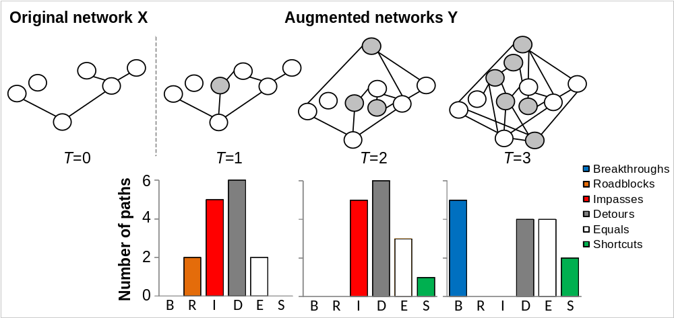
##This analysis can be carried out using the following commands:
brides.exe -X=sample/t0.txt -Y=sample/t1.txt -outfile=result_t1.txt
brides.exe -X=sample/t0.txt -Y=sample/t2.txt -outfile=result_t2.txt
brides.exe -X=sample/t0.txt -Y=sample/t3.txt -outfile=result_t3.txt
* See the next page for an example of output file.
Commented Results file: Result_t1.txt
=============================== PARAMETERS ====================================
-=[Multicores support]=-
Maximum threads : 8
Number of cores : 8

-=[Input files]=-
Networks :undirected <- This indicate that the networks are undirected
Network X : t0.txt <- Network X
Network Y : t1.txt <- Network Y
Nodes in network X: 6
Nodes in network Y: 7
Total added nodes (K) : 1 <- One added node (K)
Total number of paths : 15 <- 15 pathways to investigate

-=[Run parameters]=-
Running mode : normal <- Either normal or random path
Edge distance : unweighted <- Either weighted or unweighted
Group size : 1000 <- Group size
Number of groups : 1
First group : 1
Last group : 1
Maxdistance : 100
Maxnode : 100
Maxtime (s) : 100
Maxpathnumber : 100

-=[Miscellaneous]=-
Seed : clock time<- Either clock time or a specific seed number
Added nodes ordering : strategy 1 <- Added node (K) ordering strategy
Algorithm : BRIDES (1) <- Heuristic used
Output file : t0.txt.output.txt <- Output to t0.txt.output.txt file

============================ PARTIAL RESULTS ==================================
Node1 Node2 Dist_X Dist_Y Type CPU time (ms) Path Taxa
x2 x1 1 1 R 0
x4 x1 2 4 D 0 x4,x3,y6,x2,x1 0,0,1,0,0
x5 x1 3 5 D 0 x5,x4,x3,y6,x2,x1 \
0,0,0,1,0,0
x3 x1 3 3 E 0 x3,y6,x2,x1 0,1,0,0
x6 x1 Inf Inf I 0
x4 x2 1 3 D 0 x4,x3,y6,x2 0,0,1,0
x5 x2 2 4 D 0 x5,x4,x3,y6,x2 0,0,0,1,0
x3 x2 2 2 E 0 x3,y6,x2 0,1,0
x6 x2 Inf Inf I 0
x5 x4 1 1 R 0
x3 x4 1 3 D 0 x3,y6,x2,x4 0,1,0,0
x6 x4 Inf Inf I 0
x3 x5 2 4 D 0 x3,y6,x2,x4,x5 0,1,0,0,0
x6 x5 Inf Inf I 0
x6 x3 Inf Inf I 0

================================= INFO =======================================
(B) Breakthrough : pathway impossible in network X but possible in network Y
(R) Roadblock : pathway possible in network X but impossible in network Y
(I) Impasse : pathway impossible in both networks, X and Y
(D) Detour : pathway shorter in network X than in network Y
(E) Equal : pathway of same length in networks X and Y
(S) Shortcut : pathway longer in network X than in network Y
============================== STATISTICS ====================================

NK B R I D E S Inside Attribute
x1 0 1 1 2 1 0 0 0
x2 0 1 1 2 1 0 5 0
x4 0 1 1 3 0 0 3 0
x5 0 1 1 3 0 0 0 0
x3 0 0 1 2 2 0 4 0
x6 0 0 5 0 0 0 0 0

K Inside Attribute
y6 8 1
*Inside: number of times a node belongs to the other paths; K: K nodes; NK: non-K nodes
================================ RESULTS ======================================
B R I D E S Total Time (s)
0 2 5 6 2 0 15 0

http://openmp.org/wp/

