Freedom and Income:
Exploring the Relationship Between Political Freedom and Economic Prosperity
Etienne Lwamba
May 2026

1. Introduction
This report examines the relationship between two key global indicators in 2020: the Freedom House Freedom Index (freedix_fh) and Income per Capita in PPP terms (mincpcap_cppp). The Freedom House index rates countries on a scale from 1 (most free) to 7 (least free), capturing civil liberties and political rights. Income per capita, measured in purchasing power parity (PPP) in thousands of dollars, reflects the average economic output per person. By mapping and correlating these indicators, we aim to explore whether countries with greater political freedom also tend to enjoy higher economic prosperity.

2. Data Overview

2.1 Freedom Index (freedix_fh)
The Freedom House dataset contains 193 countries with annual scores from 1972 to 2022. Each country is identified by a three-letter ISO code (geo) and country name. In 2020, all 193 countries have valid scores. The index ranges from 1.0 to 7.0, with a mean of 3.49 and median of 3.0, indicating a roughly symmetric distribution with a slight skew toward freer countries. No duplicate entries were found, confirming one row per country.

2.2 Income per Capita (mincpcap_cppp)
The income per capita dataset also contains 193 countries, with data spanning from 1800 to projected values in 2100. Values are expressed in PPP-adjusted thousands of dollars. In 2020, the mean income per capita is approximately $26,680 (in PPP $1000s), but the distribution is heavily right-skewed: the median is $14,560 while the maximum reaches $513,540 (likely a small, wealthy state). No duplicate entries were found.

3. World Maps (2020)

3.1 Freedom Index Map
The map below displays the Freedom House Freedom Index for 2020. Green shading indicates freer countries (scores near 1), while red shading indicates less free countries (scores near 7). Western Europe, North America, and Oceania are predominantly free, while much of Central Asia, the Middle East, and parts of Africa and East Asia show lower levels of freedom.
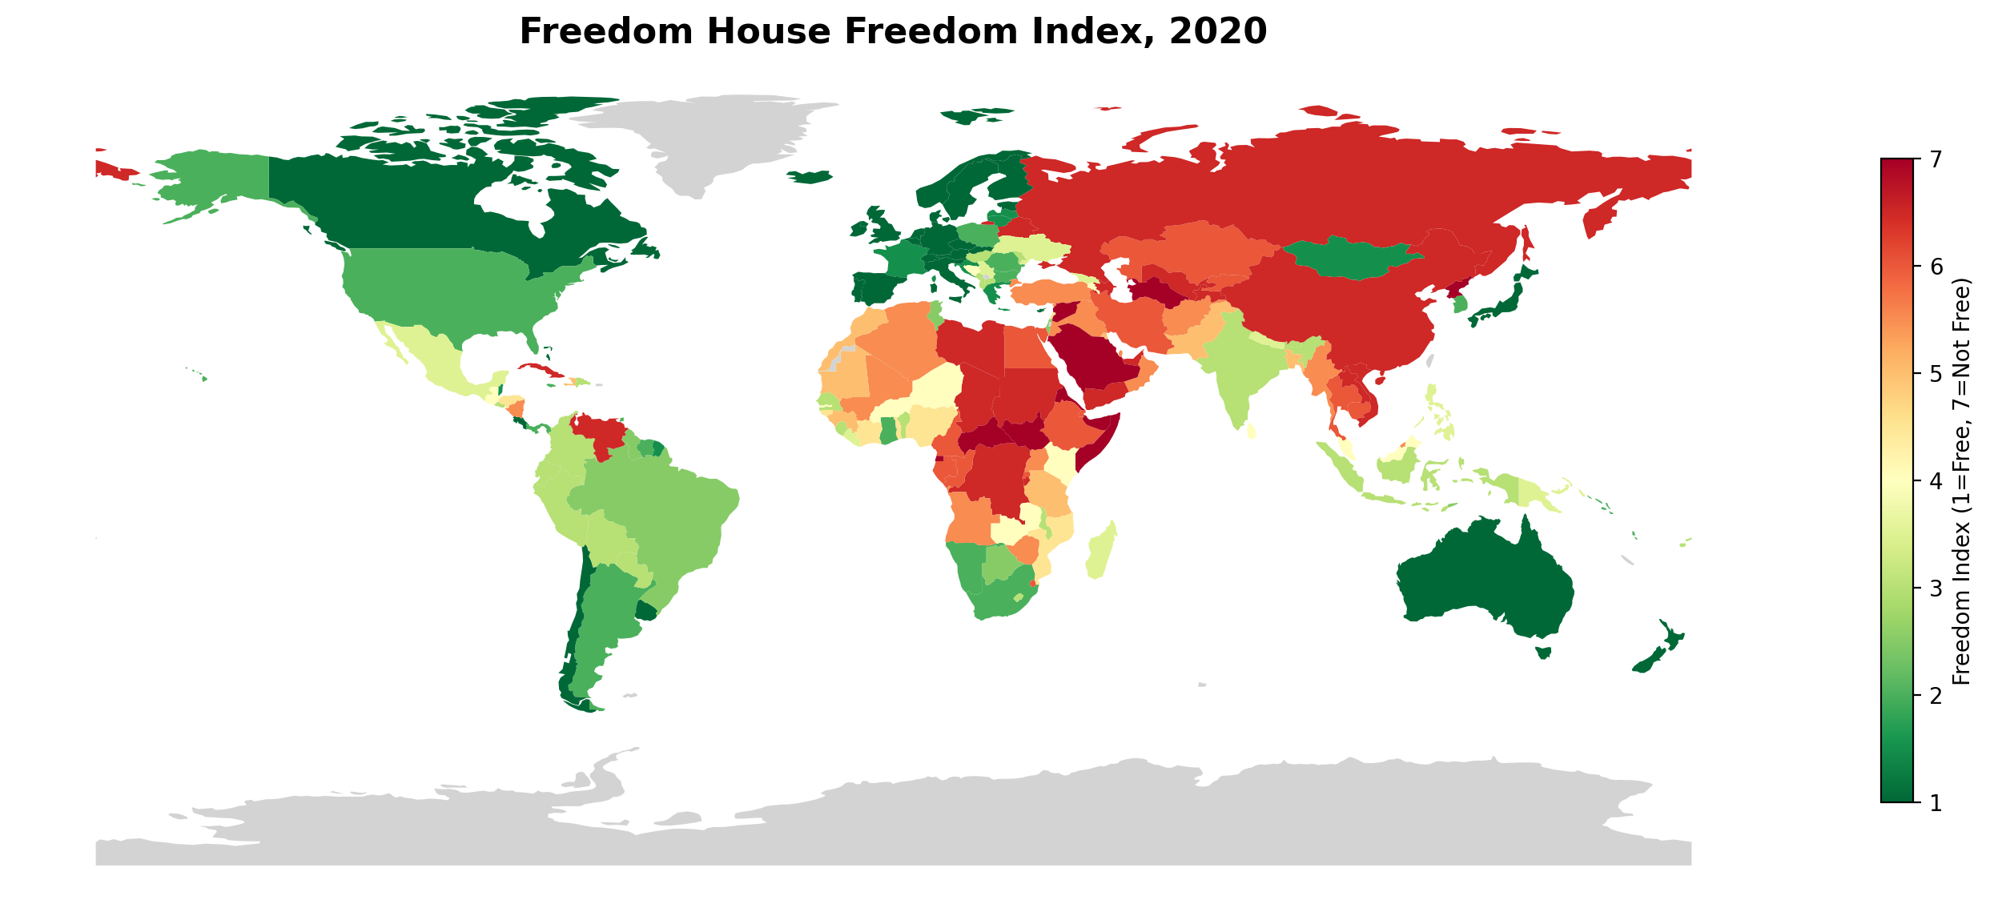
Figure 1: Freedom House Freedom Index, 2020

3.2 Income per Capita Map
The income per capita map uses a blue gradient, with darker shading indicating higher income levels. High-income countries cluster in North America, Western Europe, East Asia (Japan, South Korea), and Oceania. Sub-Saharan Africa and parts of South Asia show the lowest income per capita values. The geographic patterns show notable overlap with the freedom index map, with many free countries also being wealthier.
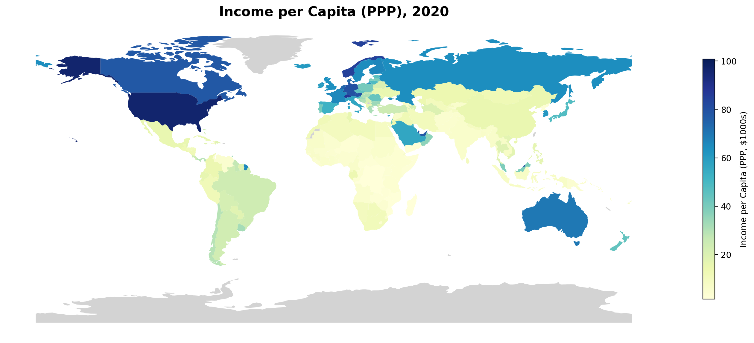
Figure 2: Income per Capita (PPP, $1000s), 2020

4. Scatterplot: Freedom vs. Income
To directly examine the relationship, the scatterplot below plots each country's Freedom Index score (x-axis) against its income per capita (y-axis). A total of 192 countries are included in the merged dataset. A linear trend line and Pearson correlation coefficient are displayed.
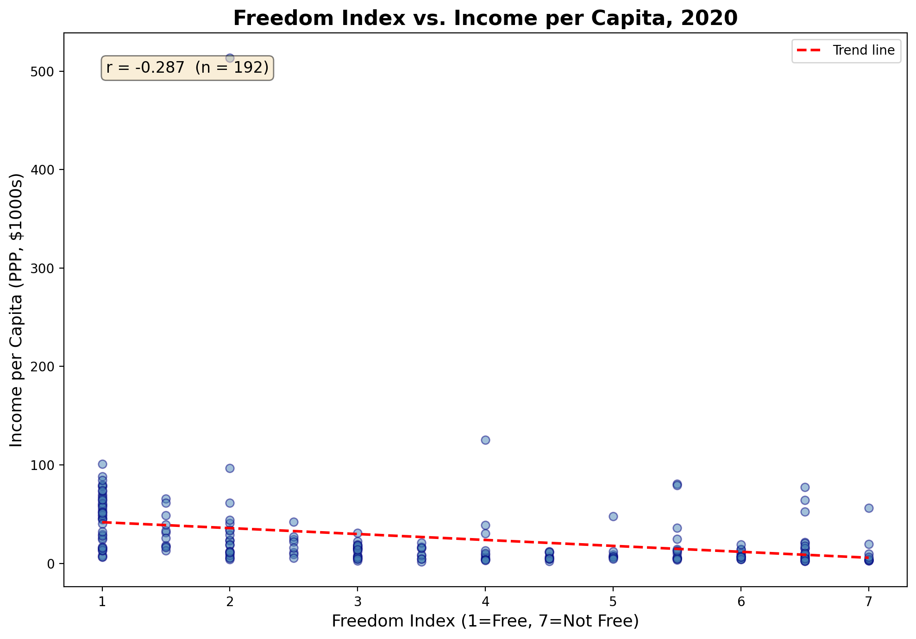
Figure 3: Freedom Index vs. Income per Capita, 2020 (r = -0.287, n = 192)

5. Interpretation
The Pearson correlation between the Freedom Index and Income per Capita is r = –0.287, indicating a weak-to-moderate negative relationship. Since higher Freedom Index values represent less freedom, this negative correlation means that countries with greater political freedom tend to have somewhat higher incomes per capita. However, the relationship is far from deterministic.
Several important observations emerge from the scatterplot. First, the freest countries (scores near 1) span a wide range of incomes, from relatively poor democracies to very wealthy ones. Second, a handful of wealthy but unfree countries (such as Gulf oil states) appear as outliers in the upper-right portion of the plot. Third, the least free countries (scores of 6–7) are predominantly low-income, but there are exceptions.
It is important to note that correlation does not imply causation. The observed relationship could be driven by many confounding factors, including historical colonial legacies, geographic endowments, institutional quality, and education levels. Some scholars argue that economic development leads to democratisation, while others contend that political freedom creates conditions favourable to growth. This cross-sectional snapshot cannot distinguish between these causal pathways.
In summary, the data suggest a modest tendency for freer countries to be wealthier, but the relationship is complex and shaped by numerous factors beyond what these two indicators alone can capture.

6. Reflection
On the results: I am not so surprised, to be honest. I kind of knew what the result would look like and, indeed, there is a strong correlation between income levels and freedom indicators. Does it mean that more freedom increases salary or that salary is a proxy for other indicators leading to more freedom? I think more analysis will be needed for it, but it seems like AI can be a good resource for that.
On the tools: I didn't manage to make the cursor app work, and it got my computer to crash, so I kind of gave up on it. But will try it again in my own time. For now, the combination of Claude and ChatGPT did the magic.

