Generic Encrypting Machine (GEM)

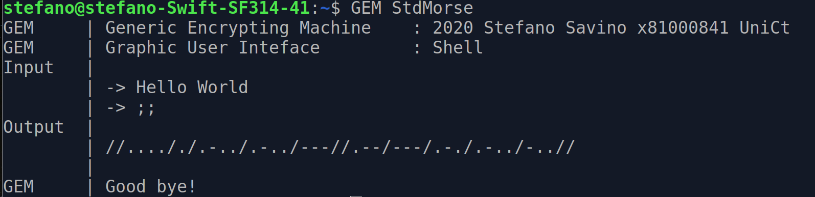

GEM is a software made in May 2020 by Stefano Savino X81000841 as project for “Ingegneria del Software” 9CFU at Università degli Studi di Catania during year 2019/2020.

Index
0 Preface 4
1 Functional Requirements 6
1.1 Overview 6
1.2 Requirements 6
1.2.1 Legend 6
1.2.2 Correctness State 6
1.2.3 Text 6
1.2.4 Encrypters 7
1.2.5 Validators 7
1.2.6 GEM (Generic Encrypting Machine) 8
1.2.7 GEMc (Generic Encrypting Machine configurer) 8
1.2.8 Args (Arguments) 8
1.2.9 GUI (Graphic User Interface) 8
1.2.10 Language 9
2 Design 10
2.1 Overwiew 10
2.1.1 Packages 10
2.1.2 Conventions 10
2.2 Correctness State 10
2.2.1 StdCorrect 10
2.3 Utilities 11
2.3.1 Words 11
2.3.2 Lines 11
2.3.3 Char 11
2.3.4 DirHandler 12
2.3.5 FileLoader and FileSaver 12
2.3.6 IO 12
2.4 Encrypters 13
2.4.1 Encrypter 13
2.4.2 StdSyntax 13
2.4.3 StdDivider 13
2.4.4 StdFixed 13
2.4.5 StdVariable 13
2.4.6 StdCesare 13
2.4.7 StdMorse 13
2.4.8 EncrypterHandler 14
2.5 Validators 14
2.5.1 Validator 14
2.5.2 StdValidator 14
2.5.3 StdAlphabetic 14
2.5.4 StdAlphaNumeric 14
2.5.5 StdAlphaNumericPoint 14
2.6 Args 14
2.6.1 Args 14
2.6.2 StdArgs 15
2.6.3 GEMArgs 15
2.6.4 GEMcArgs 15
2.7 GEM 15
2.7.1 StdGEM 15
2.7.2 GEM 15
2.7.3 GEMc 15
2.8 GUI 15
2.8.1 GUI 15
2.8.2 Shell 16
2.9 Languages 16
2.9.1 Language 16
2.9.2 Concrete Implementations 16
2.9.3 Languages 16
2.10 Tests 16
3 UML 17
3.1 UML : Encrypter and Validator 17
3.2 UML : Languages 19
3.3 UML : Lines and Words 20
3.4 UML : Main Diagram 21
3.5 Sequence UML : Encrypting/Translating execution 22
3.6 Sequence UML : Configuration Modality execution 23
4 Design Patterns 26
4.1 Overview 26
4.2 Singleton 26
4.3 State 26
4.4 Factory Method 27
4.5 Adapter 27
5 Code 28
5.1 Code : EcripterHandler 28
5.2 Code : Languages 29
5.3 Code : Encrypter Hierarchy 31
5.3.1 Code : StdCorrect 31
5.3.2 Code : Encrypter 32
5.3.3 Code : StdSyntax 33
5.3.4 Code : StdDivider 33
5.3.5 Code : StdFixed 34
5.3.6 Code : StdVariable 35
6 Usage 37
6.1 GEMc 37
6.2 GEM 37
6.3 Example 1 38
6.4 Example 2 39
6.5 Example 3 40
6.6 Example 4 40
6.7 Example 5 42
7 Summary 45

0 Preface
The choice of making a Generic Encrypting Machine is not casual.
I have been dealing with encrypting since many years now :
- As a twelve years experienced Scout I have had to work with many simple communication systems such as Morse Language (in this case we should talk about translation rather than encryption), Caesar’s Chipher and many others
- My Scientific Lyceum Final Exam’s Thesis has been about a C based emulator of Nazi’s encrypting machine Enigma I realized after a light 4 Months C language course I did in my school
As a result I have a little knowledge in the field of encryption.
I do not aim to become a programmer or a project manager. I would rather be a researcher in the field of algorithms and computing but also in this case knowledge about Software Engineering has its role.
Encryption/Translation may be seen in two ways :
- Algorithms that produce encrypted text.
  - There are different algorithms for different encryption/translation systems but many of them have pieces in common. This is the key point GEM is based on. Language Java is appropriated for this.
- Functions of the form where is the function defined in that is the set of all possible strings and with values in that is the set of all the possible encrypted strings.
  - In this way, encryption/translation system such as Morse could be easily defined as

This means that writing it in a pure functional language such as Haskell would have as a result :
g :: String - > String
g x = map f x

f :: Char -> String
f ‘a’ = “.-”
f ‘n’ = “-.”
[…]
f x = “Unknow_Char”

In this way code results more synthetic without all those switch, if, else, ecc… The correctness of the definition of the encrypting/translating function results would be easier to prove avoiding a certain number of bugs.
I had previously written an Haskell Functional version of Morse Translator and Caesar’s Cipher but in this paper I am going to talk about the Java based software GEM.
What I would like the reader to appreciate is its modular structure that makes it easy to maintain and expand.
This paper is organized as Software Engineering teacher Emiliano Tramontana suggested but in order to better understand the whole thing I would suggest an approach similar to the one adopted by Andrew Stuart Tanenbaum in Modern Operating Systems :
- Section 0 : Preface
- Section 1 : Functional Requirements
- Section 6 : Usage
- Section 2 : Design
- Section 4 : Design Patterns
- Section 3 : UML
- Section 5 : Code
- Section 7 : Summary
Thanks for reading
Stefano Savino

1 Functional Requirements

1.1 Overview
The aim of GEM is to realize a software able to join many encrypting/translating systems. It has to be easy expanding, easy maintaining and most of all easy understanding.
The only concrete systems implemented in this first version of GEM are :
- Caesar Cipher
- Morse Language
- Leon Battista Alberti’s Disk (Rotor) not implement yet
- Enigma Machine not implement yet

1.2 Requirements

1.2.1 Legend
- Classes
- Attributes
- Operations

1.2.2 Correctness State
- Correctness State informs if errors have happened
- Correctness State may only be switched from True to False
- Correctness State may be checked

1.2.3 Text
- The aim of the program is to encrypt Text
- Text is made of Lines
  - Lines are made of ordered Words separated by line feed
    - Words are made of ordered Strings separated by spaces
      - Strings are made of chars
        - Chars may be :
          - Alphabetic
            - Upper Case
            - Lower Case
          - Numeric (Digit)
          - Symbol
          - A combination of previous ones

1.2.4 Encrypters
- The program should emulate different Encrypters
- Encrypters have Correctness State
- Different Ecrypters refer to different encrypting systems
- Encrypters encrypt Lines
- Encrypters may have a syntax Validator
- Encrypters may partition encripting process :
  - Encrypters may encrypt a single Line into a single Line (Lines to Lines)
    - Encrypters may encrypt a single Word into a single Word (Words to Words)
      - Encrypters may encrypt a char into a single char (Char to Char)
      - Encrypters may encrypt a single char into a variable length string (Char to String)
- Encrypters may need to be configured
  - Encrypters may be configured and configurations saved
  - Encrypters may load configurations
- Implementations of Ecripters are identified ; the identifier is called Modality

1.2.5 Validators
- Validators check if lines are grammatically valid
- Validators may partition validation process :
  - Validators may validate one line per time
    - Validators may validate one word per time
      - Validators may validate one char per time
        - A Validator could check if chars are Alphabetic
        - A Validator could check if chars are Alphabetic or Numeric
        - A Validator could check if chars are Alphabetic, Numeric or Symbols

1.2.6 GEM (Generic Encrypting Machine)
- Software may be run in encrypting modality : GEM
- GEM loads execution arguments
- GEM checks if execution arguments are correct
- GEM gets information from execution arguments
- GEM loads an Encrypter (maybe configured)
- GEM gets the input for the Encrypter
- GEM shows the output of the Encrypter
- GEM may show Errors, Warnings and Messages

1.2.7 GEMc (Generic Encrypting Machine configurer)
- Software may be run in configuration modality : GEMc
- GEMc loads execution arguments
- GEMc checks if execution arguments are correct
- GEMc gets information from execution arguments
- GEMc sets the Encypter configuration
- GEMc may show Errors, Warnings and Messages

1.2.8 Args (Arguments)
- Arguments have Correctness State
- Arguments analyzes and holds the hidden information behind execution arguments
- To different execution arguments correspond different Arguments, to different Arguments correspond different executions of the software
- Arguments may refer to Language settings
- Arguments may refer to an Encrypter
- Arguments may refer to an Encrypter configuration
- Arguments may refer to IO Modality for input and output
- Arguments may refer to an input/output file
- Arguments may show Errors, Warnings and Messages

1.2.9 GUI (Graphic User Interface)
- GUI actually shows user Errors, Warnings and Messages
- GUI actually shows user output
- GUI actually gets input from user
- GUI actually shows user initialization, closure and rebooting of the program

1.2.10 Language
- The software may be run in different Languages
- A Language obtains all the strings referring to an Errors, Warnings and Messages
- Language may be set at the beginning or during execution
- Default Language is English

2 Design

2.1 Overwiew

2.1.1 Packages
Classes included in the project are organized in the following way
- Package GEM
  - Package args (Arguments) that contains all the classes aimed to deal with Arguments (UML color blue)
  - Package corr (Correctness State) that contains the basic Correctness State implementation (UML color white)
  - Package encr (Encrypters) that contains all the Encrypters (UML color red)
  - Package gem (GEM) that contains the GEM (UML color white)
  - Package gui (Graphic User Interface) that contains all the classes handling the GUI (UML color dark green)
  - Package lan (Languages) that contains all the Language utilities (UML color purple)
  - Package tests (Tests) that contains all the tests classes
  - Package utils (Utilities) that contains all the useful classes (UML color yellow)
  - Package val (Validators) that contains all the Validators (UML color orange)

2.1.2 Conventions
Classes in this software have explicit names. Some of them have prefix Std. This is given by the fact that the software is thought to be easily expanded. A new implementation of an Encrypter just be an expansion of an already defined class Std for example abstract class StdFixed (see StdFixed).

2.2 Correctness State

2.2.1 StdCorrect
As seen in requirements some of classes localized have a Correctness State. Correctness State could be seen only as an attribute but the best choice has turned to be the definition of abstract class StdCorrect that include :
- attribute correct that represents the Correctness State and is not visible outside of StdCorrect
- method setError() that sets correct to False and has a protected visibility
- method isCorrect() that returns correct value
Many of the classes in GEM project are extensions of StdCorrect.

2.3 Utilities

2.3.1 Words

As seen in requirements Text can be seen as Lines that are made of Words that are made of Strings.
Class Words is just an alias or in better words an Adapter of ArrayList<String>. If String a is at index j and String b is at index j+1 this means that in the text a and b are separated by a space.
Class Words offers :
- method size (taken from ArrayList<String>)
- method get (taken from ArrayList<String>)
- method add (taken from ArrayList<String>)
- method iterator (taken from ArrayList<String>)
- method toString that returns a semantically corresponding String
- method toWords that returns an instance of Words semantically corresponding to a given String

2.3.2 Lines
As seen in requirements Text can be seen as Lines that are made of Words that are made of Strings.
Class Lines is just an alias or in better words an Adapter of ArrayList<Words>. If Words a is at index j and Words b is at index j+1 this means that in the text a and b are separated by a line feed.
Class Lines offers :
- method size (taken from ArrayList<Words>)
- method get (taken from ArrayList<Words>)
- method add (taken from ArrayList<Words>)
- method iterator (taken from ArrayList<Words>)
- method toString that returns the corresponding String
- method toWords that returns an instance of Words corresponding to a given String

2.3.3 Char
As seen in requirements some considerations may need to be made dealing with chars.
Many methods are thus needed. They are all static and grouped in class Char. Because it would be just a waste of paper they are not listed here.

2.3.4 DirHandler
As seen in requirements, Encrypters may be configured (and then configurations saved) and the software may also be installed in the machine. This means the software may need to deal with directories inside the OS.
The adopted scheme is the following :
- home , User’s home directory
  - GEM directory that holds everything concerning the software
    - GEM directory that holds the executable files
      - Packages
    - GEMData directory that holds saved data
      - Encrypter directory that holds data referring to encrypters’ configurations
        - StdCesare directory that holds configuration files referring to the implentation of the Encrypter Caesar Cipher
        - […]
Class DirHandler offers :
- method getMain that returns home’s path
- method getData that returns GEMData’s path
- method getEncrypter that returns Encrypter’s paths
- method getEncrypter that returns an implementation of Encrypter’s directory path
- method getConfFile that returns a configuration file paths

2.3.5 FileLoader and FileSaver
As seen in requirements input and output may be taken/setted into a file and configurations may be saved. FileLoader and FileSaver are just adapters that make possible to read/write Lines into files and also check file existence.

2.3.6 IO
As seen in requirements input and output may be taken/setted into a file. This leads to the creation of class IO that contains
- enum Mod :
  - IO
  - file
- useful methods to deal with IO (isIOModIO, isIOModFile, ecc…)

2.4 Encrypters

2.4.1 Encrypter
An extension of StdCorrect and also one of the most important entities in the software is Encrypter. Different Ecrypters refer to different encrypting systems. At the same time different Encrypters may have similar approaches to encryption. This is why Encrypter is just an abstract class. Encrypter includes :
- abstract method encrypt that returs Lines encrypted
- static method setConfig that has to be implemented by subclasses that need configurations
- static method getConfig that has to be implemented by subclasses that need configurations

2.4.2 StdSyntax
As seen in requirements some Encrypters may have some syntax restrictions in their input files. This is why Abstract Class StdSyntax extends Encrypter adding a Validator.

2.4.3 StdDivider
As seen in requirements some StdSyntax may have the property that the ecrypting process may be partitioned (this could be used in future to speedup the software). Abstract Class StdDivider extends StdSyntax and does the partitioning down to the String level.

2.4.4 StdFixed
As seen in requirements some StdDivider may encrypt one char into another char. Abstract Class StdFixed extends StdDivider and implements this property.

2.4.5 StdVariable
As seen in requirements some StdDivider may encrypt one char into a variable/fixed length string. Abstract Class StdVariable extends StdDivider and implements this property.

2.4.6 StdCesare
StdCesare is an extention of StdFixed that implements the Caesar Cipher.
- It implements encryption char to char
- It instantiates an StdAlphaNumericPoint validator
- It needs configuration so it implements setConfig and getConfig

2.4.7 StdMorse
StdMorse is an extension of StdVariable that implements the Morse translation.
- It implements encryption char to String
- It instantiates an StdAlphaNumericPoint validator
- It does not need configuration so it does not implement setConfig and getConfig

2.4.8 EncrypterHandler
Users while running the software may desire to use an implementation of Encrypter. EncrypterHandler implements design patter FactoryMethod for class Encrypter. More about later in this paper.

2.5 Validators

2.5.1 Validator
As seen in requirements Encrypters may have a Validator. Validator is very wide concept. In the versions made up to this version of the software it can be seen just as a collection of methods that could even be static. Despite of this it may occur that in further versions of the software a Validator may need it’s own data and state. Because of this Validator has been implemented as an interface that offers only :
- abstract method isValid that checks if a Lines is valid

2.5.2 StdValidator
As seen in requirements also Validators may partition validation process (this could be used further to speed up the process) . This feature is implemented in abstract class StdValidator.

2.5.3 StdAlphabetic
StdAlphabetic extends StdValidator for grammars that accept only alphabetic chars.

2.5.4 StdAlphaNumeric
StdAlphaNumeric extends StdValidator for grammars that accept only alphabetic and numeric chars.

2.5.5 StdAlphaNumericPoint
StdAlphaNumericPoint extends StdValidator for grammars that accept only alphabetic, numeric and symbolic chars.

2.6 Args

2.6.1 Args
As seen in requirements executions of the software are different because of some parameters : Arguments.
These ones are understood and set by class Args that is an extension of StdCorrect (it has Correctness State).
Class Args offers utilities to deal with arguments that may be seen by subclasses :
- String current that contains the current execution argument analyzed
- method hasNext
- method goBack

2.6.2 StdArgs
Abstract Class StdArgs is an extension of Args that contains useful methods and attributes for both further extensions GEMArgs and GEMcArgs. These ones refer to Language, configuration and Encrypter.

2.6.3 GEMArgs
Class GEMArgs is an extension of StdArgs that implements Args for the execution of the software in encrypting/translating modality.

2.6.4 GEMcArgs
Class GEMcArgs is an extension of StdArgs that implements Args for the execution of the software in configuration modality.

2.7 GEM

2.7.1 StdGEM
As seen in requirements the software could be run in two different modalities : encrypt/translate and configuration. Both modalities have many pieces in common that are gathered in abstract class StdGem.

2.7.2 GEM
GEM extends StdGEM for encrypt/translate modality.

2.7.3 GEMc
GEMc extends StdGEM for configuration modality.

2.8 GUI

2.8.1 GUI
As seen in requirements the software has to be ready for further extensions. One of main features is that it has to be predisposed for Graphic User Interface. The interface has been seen in the following way :
- An error channel
- A warning channel
- A message channel
- An input/output channel
to deal with.
The interface should also be able to :
- Initialize itself
- Reboot
- Close
Interface GUI contains all the methods required. Further subclasses could act as adapters with GUIs.

2.8.2 Shell
In this first version of the software the only concrete implementation of GUI is Shell that implements GUI with shell utilities.

2.9 Languages

2.9.1 Language
As seen in requirements the software has to be ready for further extensions. This also regards languages. Interface Language contains all the methods that have to be overwritten by implementations to return correct error, message or warning. To make this easier three enums have been created : Error, Warning, Msg.

2.9.2 Concrete Implementations
In this first version of the software the only concrete implementations of Language are English, Italiano and Français.

2.9.3 Languages
The current language the software is running could be seen as a state. In order to manage this class Languages has been realized implementing design patterns Singleton and State. More about in Design Patterns’ section.

2.10 Tests
Many Test classes have been built during software development. These ones are all gathered in package tests.

3 UML
The full UML Diagram of the software is too big to fit in this paper (it would need an A2 paper to have an acceptable quality) for this reason the full version is attached as GEMx.y.html. Only some extracts are shown here.

3.1 UML : Encrypter and Validator
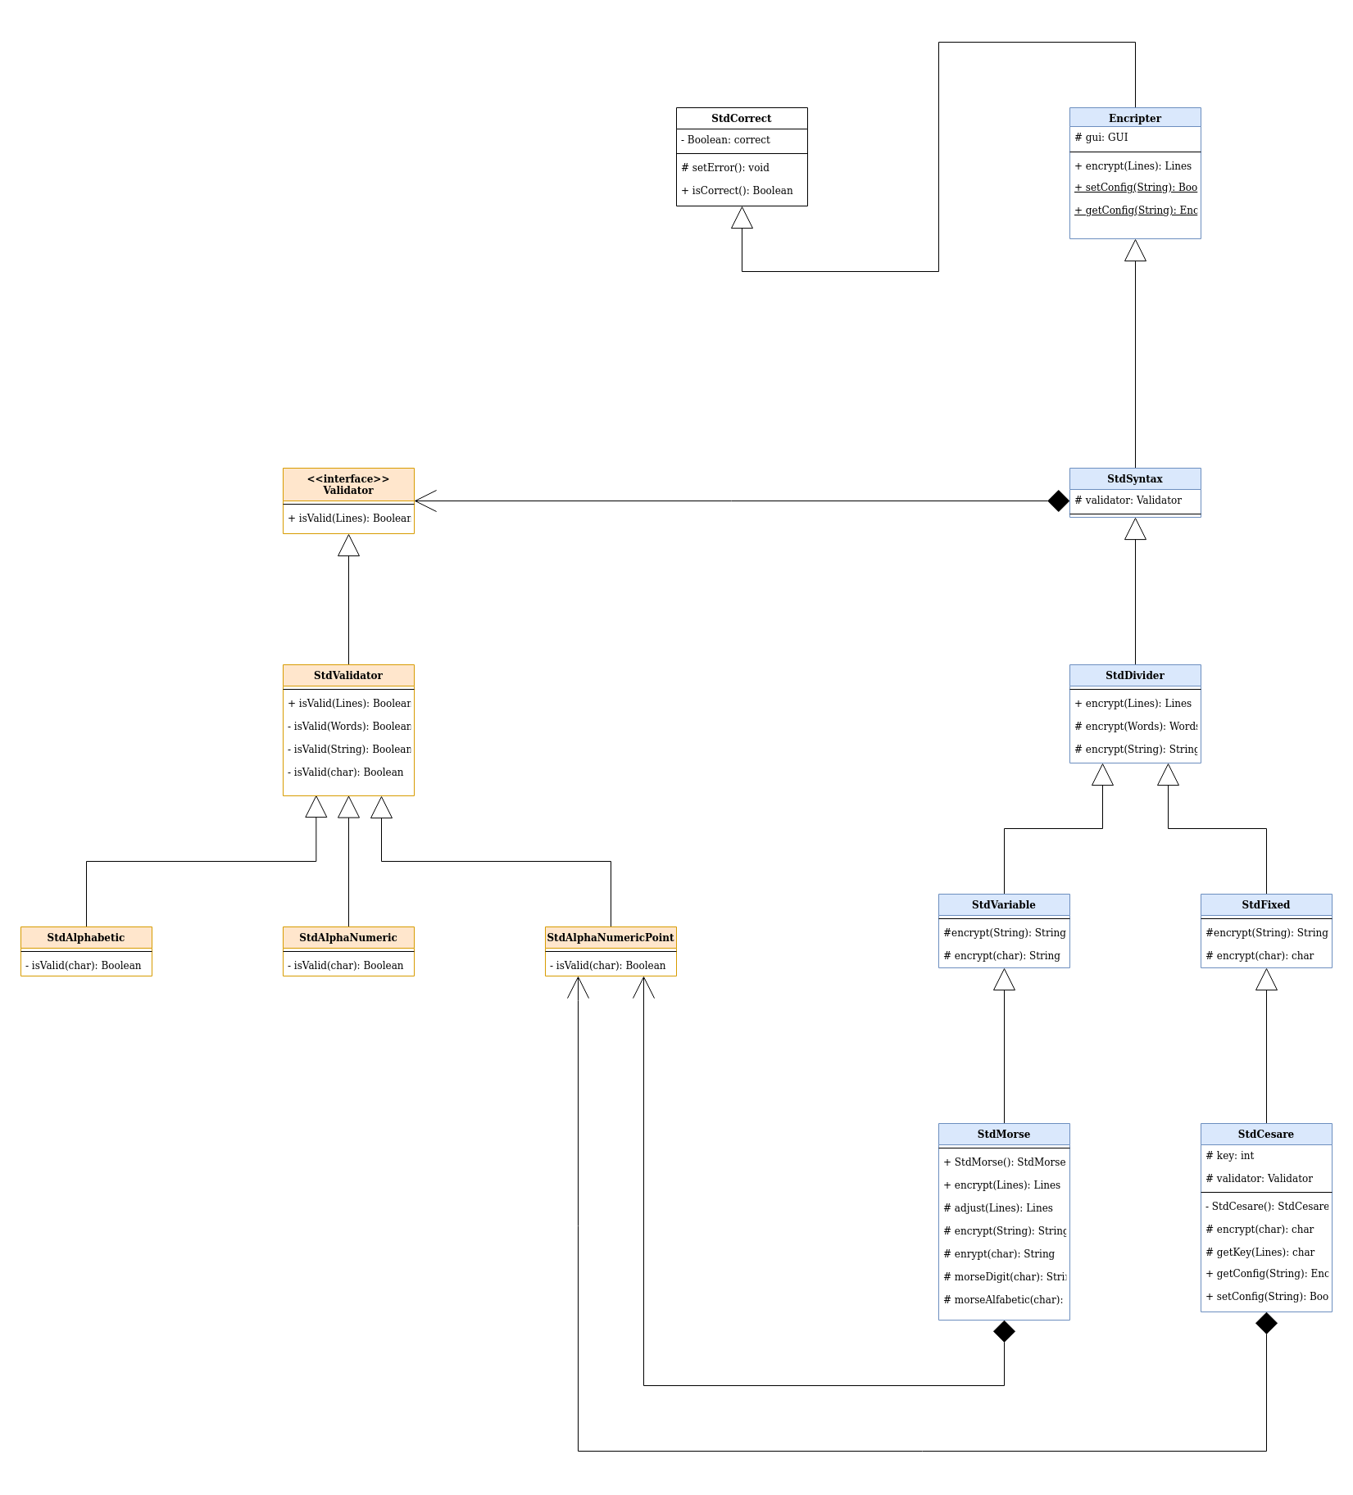
In this first paragraph we are going to analyze the structure of Encrypters (blue) and Validators (orange) :
- As stated before Encrypter has the Correctness State so it is an extension of class StdCorrect. It defines abstract method encrypt(Lines):Lines and static methods getConfig and setConfig that have to be overwritten by those extensions that are configurable.
- Abstract Class StdSyntax extends Encrypter adding the syntax Validator.
- Abstract Class StdDivider extends StdSyntax partitioning the encrypting/translating process down to Strings leaving abstract method encrypt(String):String
- Abstract Class StdFixed extends StdDivider for those encrypting/translating systems that encrypt/translate a char into a char leaving abstract method encrypt(char):char
- Abstract Class StdVariable extends StdDivider for those encrypting/translating systems that encrypt/translate a char into a variable length String leaving abstract method encrypt(char):String
- Validator is an interface that gives method isValid(Lines):Boolean for Lines
- Abstract Class StdValidator implements Validator partitioning work leaving abstract method isValid(char):Boolean
Classes :
- StdAlphabetic
- StdAlphaNumeric
- StdAlphaNumericDigit
are concrete implementations of Validator because they implement isValid(char):Boolean.
Classes :
- StdMorse
- StdCesare
are concrete implementations of Encrypter because :
- StdMorse implements StdVariable encrypt(char):String
- StdCesare implements StdFixed encrypt(char):char

3.2 UML : Languages
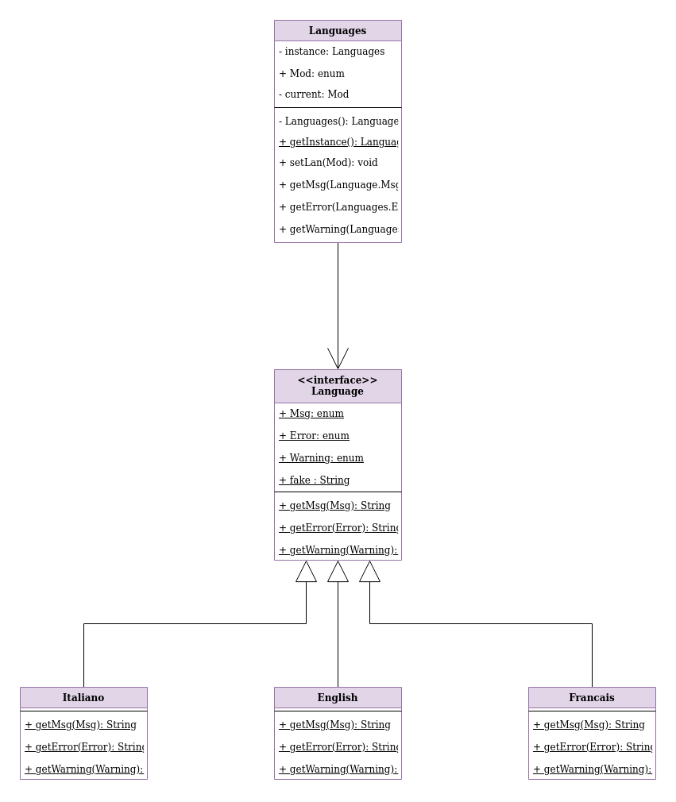
In this paragraph we are going to analyze the part of the program that deals with languages (purple). As said before it is all contained in package lan.
- Interface Language defines all the methods required by a language that supports the system :
  - getMsg
  - getError
  - getWarning
in order to make the code easy understanding errors, warnings and messages are not identified by a number code but by enum Error, enum Warning and enum Msg.
- Italiano, English and Français are concrete implementations of Language.
- As demonstrated in the section regarding Design Patterns it has been needed to create class Languages that implements Design Patterns Singleton and State. Class Languages contains :
  - Languages instance that is the only instance of the class and method getInstance to access to it
  - enum Mod that contains all the possible choices : en, it, fr.
  - Mod current that is the contains the state (the language the software is currently running) that could be changed anywhen with method setLan

3.3 UML : Lines and Words
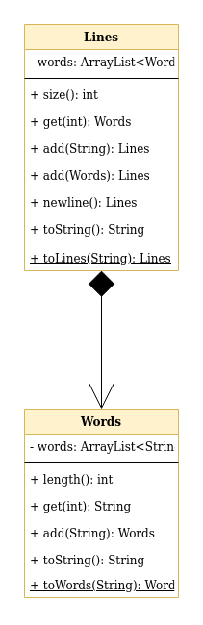
As seen in previous sections Text could be seen as Lines made of Words made of Strings. This way to see Text is directly taken from functional language Haskell. In language java this could be seen as ArrayList<ArrayList<String>> but that would not be easy understanding. Two adapters have been defined : Words and Lines. They are bound by composition : Lines are made of Words.

3.4 UML : Main Diagram
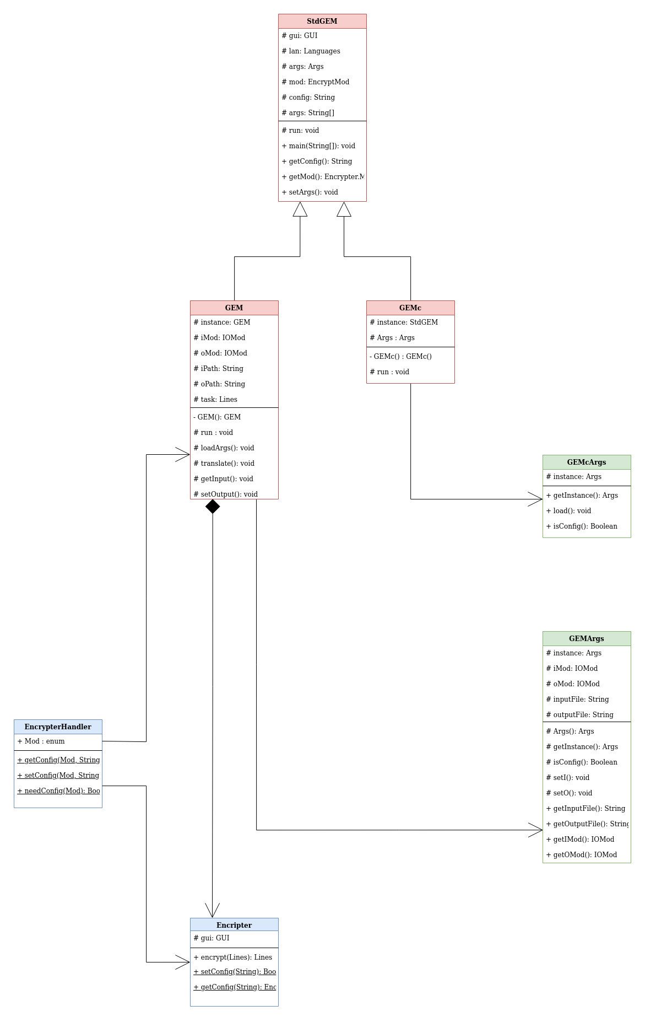
The last extract shown in this paper shows the main section of the software. As shown, classes GEM and GEMc (red) are in relationship with classes GEMArgs and GEMcArgs (green). In fact they give to the second ones the execution arguments to analyze. After that, if arguments are correct, they query EncrypterHandler. GEM recieves from EncrypterHandler the right Encrypter (configured if necessary). GEMc calls the right Encripter’s configuration method thanks to EncrypterHandler. For better understanding this scheme let’s go to next paragraphs.

3.5 Sequence UML : Encrypting/Translating execution
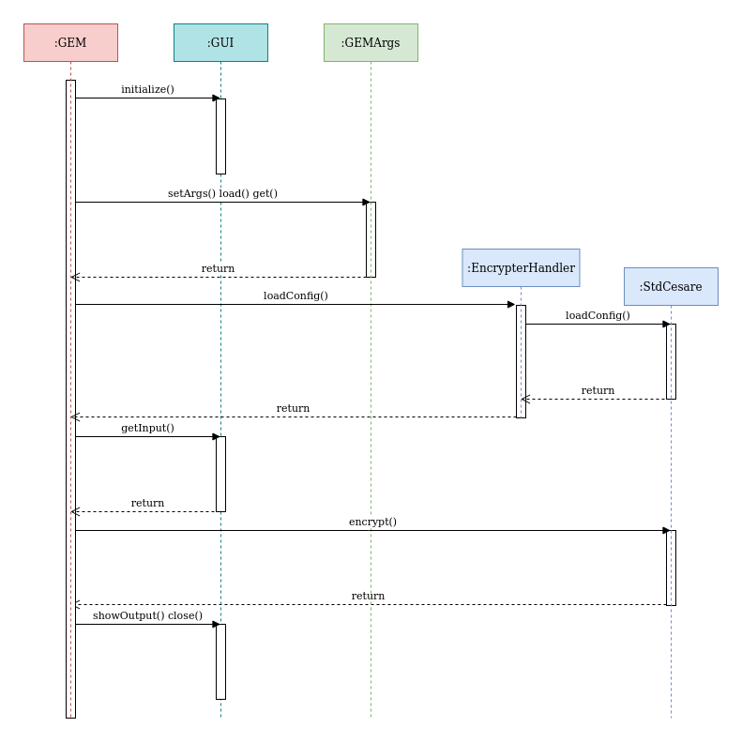
This scheme briefly explains the execution of the software in Encrypting/Translating modality. In this example the software is executed in the following way : “GEM StdCesare myConfig”. (see Usage)
Software then runs :
- The program begins from class GEM that asks class GUI to initialize
- After GUI’s initialization GEM gives execution arguments to GEMArgs and asks GEMArgs to load (undestand) them
- GEM checks GEMArgs Correctness State that is positive because the given arguments are correct so it asks GEMArgs to obtain all parameters needed.
- GEM then obtains the StdCesare with myConfig configuration thanks to EncrypterHandler
- As input modality is IO GEM asks GUI for input
- Once input obtained GEM asks StdMorse to encrypt it
- Once obtained the encrypted lines from StdCesare, GEM checks if issues have occurred checking StdCesare Correctness State that we suppose positive
- GEM can now ask GUI to show the output an then to close
- The execution is now terminated

3.6 Sequence UML : Configuration Modality execution
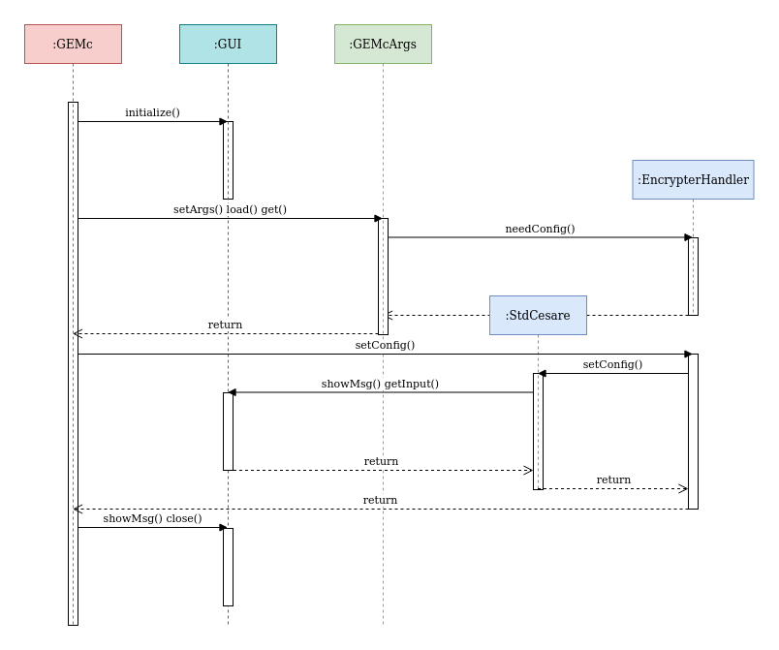
This scheme briefly explains the execution of the software in configuration modality. In this example the software is executed in the following way : “GEMc StdCesare myConfig”. (see Usage)
Software then runs :
- The program begins from class GEMc that asks class GUI to initialize
- After GUI’s initialization GEMc gives execution arguments to GEMcArgs and asks GEMcArgs to load (undestand) them
- GEMcArgs reads execution parameters and sees that user is trying to configure StdCesare so it asks EncrypterHandler if StdCesare is configurable (needs a configuration)
- GEMc checks GEMcArgs Correctness State that is positive because the given arguments are correct so it asks GEMcArgs to obtain all parameters needed.
- GEMc calls EncrypterHandler.setConfig and EncrypterHandler calls StdCesare.setConfig
- StdCesare creates and saves the new configuration. In order to do this it may ask GUI to show messages, errors, warnings or to obtain input and does all the stuff making use of all utilities in package utils
- GEMc asks GUI to show the outcome of the task and then to close
- The execution is now terminated

4 Design Patterns

4.1 Overview
During development some design patters have been adopted in order to make the code easier to maintain.
These ones are :
- Singleton
- State
- Factory Method
- Adapter

4.2 Singleton
Design Pattern Singleton has been adopted several times in this software :
- In class GUI the Graphic User Interface in fact has to be unique. Many instances of it could cause strange issues to user’s experience.
- In class Languages because the language settings (current language) should be unique for the whole software.
- In class GEM and GEMc because they have states that have to be unique. In these two classes method getInstance() has not been implemented because the only instance should only be accessed running the class itself.
- In class GEMArgs and GEMcArgs because they contain the execution arguments and the corresponding Correctness State that have to be unique during whole execution.

4.3 State
Design Pattern State has been adopted once in this software :
- In class Languages. As seen before there are many implementations of Language (English, Italiano, Français) but only one of them has to be used according to the current language that may be changed by users. Class Languages contains the current language state and returns the right Error, Warning, Msg according to it.
  - Context’s role is played by class Languages that acts in different ways according to the current language state
  - State’s role is played by interface Language
  - ConcreteState’s role is played by English, Italiano and Français

4.4 Factory Method
Design Pattern Factory Method has been adopted once in this software :
- In class EncrypterHandler. Encrypter’s implementations are someway the main part of the software but as stated before user may desire to use one instead of another. During encrypt/translate execution an instance of Encrypter is needed. The rigth one is given by EncrypterHandler. EncrypterHandler does not only give the right implementation of Encrypter but also can call the right configuration method and tell if an implementation of Encrypter needs to be configured.
  - The role of Product is played by Encrypter
  - The role of Concrete Product is played by StdCesare and StdMorse
  - The role of Creator and Concrete Creator is played by EncrypterHandler

4.5 Adapter
Design Pattern Adapter is used twice in the software :
- In class Words where it hides an ArrayList<String>
  - The role of Target and Adapter is played by Words
  - The role of Adaptee is played by ArrayList<String>
- In class Lines where it hides an ArrayList<Words>
  - The role of Target and Adapter is played by Words
  - The role of Adaptee is played by ArrayList<String>

5 Code

5.1 Code : EcripterHandler

Class EncrypterHandler
public class EncrypterHandler {
/**
* Enum Mod : all the possible Encrypters + fake value
*/
public static enum Mod{
none,
StdCesare,
StdMorse
}
/**
* Method getEncrypter that returns the right encrypter according to the arguments
* @return instance of Encrypter
*/
public static Encrypter loadConfig(Mod mod, String config){
switch (mod){
case StdCesare :
return StdCesare.getConfig(config);
case StdMorse :
return new StdMorse();
default:
return null;
}
}
/**
* Method set that calls the appropriate instance of EncrypterHandler.setConfig and returns outcome
* @return outcome
*/
public static Boolean setConfig(Mod mod, String config){
switch(mod){
case StdCesare:
return StdCesare.setConfig(config);
default:
return false;
}
}
/**
* Method need config that returns if a modality needs configuration
* @param mod
* @return
*/
public static Boolean needConfig(Mod mod){
switch (mod){
case StdCesare:
return true;
default :
return false;
}
}
}

As seen before class EncrypterHandler implements Design Pattern Factory Method.
EncrypterHandler defines enum Mod that identifies each concrete implementation of Encrypter plus a fake value: none.

EncrypterHandler also defines methods :

- loadConfig that return the concrete implementation of Encrypter
- setConfig that calls the appropriate configuration method of Encrypter
- needConfig that checks if an Encrypter needs to be configured

5.2 Code : Languages
Class Languages
/**
* Class Languages that implements desing pattern singleton and design pattern state with classes Language
*/
public class Languages {
/**
* Languages instance only instance of Languages
*/
private static Languages instance = new Languages();
/**
* Method getInstance that returns the only instance of Languages
* @return
*/
public static Languages getInstance(){
return instance;
}
/**
* Enum Mod that represents the languages that can be used
*/
public static enum Mod {
en,
it,
fr
}
/**
* Language current that is an instance of the current language
*/
private Mod current = Mod.en;
/**
* Method setLan that sets the state current
* @param l language mod desired
*/
public void setLan(Languages.Mod l){
current = l;
GUI.getInstance().showMsg(instance.getMsg(Language.Msg.switchLan) + l.name());
}
/**
* Method getError that return the error string in the correct language
* @param e code of error desired
* @return error string
*/
public String getError(Language.Error e){
switch(current){
case en: return English.getError(e);
case it: return Italiano.getError(e);
case fr: return Francais.getError(e);
default : return Language.fake;
}
}
/**
* Method getWarning that return the warning string in the correct language
* @param w code of warning desired
* @return warning string
*/
public String getWarning(Language.Warning w){
switch(current){
case en: return English.getWarning(w);
case it: return Italiano.getWarning(w);
case fr: return Francais.getWarning(w);
default : return Language.fake;
}
}
/**
* Method getMsg that return the msg string in the correct language
* @param m code of msg desired
* @return msg string
*/
public String getMsg(Language.Msg m){
switch(current){
case en: return English.getMsg(m);
case it: return Italiano.getMsg(m);
case fr: return Francais.getMsg(m);
default : return Language.fake;
}
}
}

As seen before, class Languages implements :
- Design Pattern State where the state is represented by the current language (Mod current)
- Design Pattern Singleton because the current language has to be unique during whole execution.

5.3 Code : Encrypter Hierarchy
In this paragraph we are going to shortly show the hierarchical structure given by the concept of Encrypter :
- StdCorrect
  - Encrypter
    - StdSyntax
      - StdDivider
        - StdFixed
          - StdCesare
        - StdVariable
          - StdMorse
In order to make it better understanding we will not see concrete implementations of Encrypter.

5.3.1 Code : StdCorrect
Abstract Class StdCorrect
/**
* Abstract Class StdCorrect that implements a class where :
* - initial status is correct
* - status can be changed only to incorrect
* - correctess is an information that can be obtained from outside
*/
public abstract class StdCorrect {
/**
* Boolean error, check if Args is valid
*/
private Boolean correct = true;
/**
* Method is correct that returns if Arguments are correct
* @return
*/
public Boolean isCorrect(){
return correct;
}
/**
* Method setError that sets correct to false
*/
protected void setError(){
correct = false;
}
}

At the top of this hierarchical system is StdCorrect that easily implements Correctness State. StdCorrect is set in package corr.

5.3.2 Code : Encrypter

Abstract Class Encrypter
/**
* Abstract class Encrypter that contains all the methods needed to encrypt
*/
public abstract class Encrypter extends StdCorrect {
/**
* GUI gui reference to GUI to make the code shorter
*/
protected GUI gui = GUI.getInstance();
/**
* Method encrypt that returns Lines encrypted
* @param ls Lines that has to be encrypted
* @return Lines ls encrypted
*/
public abstract Lines encrypt(Lines ls);
/**
* Method setConfig that creates a new configuration (config) using the GUI
* @param config
* @return
*/
public static Boolean setConfig(String config){return false;}
/**
* Method getConfig that returns an Encrypter configured
* @param config
* @return
*/
public static Encrypter getConfig(String config){return null;}
}

Encrypter extends StdCorrect defining abstract method encrypt and methods setConfig and getConfig that should be overwritten by further implementations that need configurations. Encrypter also defines a reference to GUI just in order to make further code shorter and better understanding.

Concrete extensions of Encrypter must implement method encrypt(Lines):Lines.

Encrypter and its extensions are set in package encr.

5.3.3 Code : StdSyntax

Abstract Class StdSyntax
/**
* Class StdSyntax that adds to Encrypter a validator
*/
public abstract class StdSyntax extends Encrypter {
/**
* Validator validator that validates the input
*/
protected Validator validator = new StdAlfaNumericPoint();
}

StdSyntax extends Encrypter adding a syntax Validator further used.

5.3.4 Code : StdDivider

Abstract Class StdDivider
/**
* Class StdDivider that partitions the encrypt task
*/
public abstract class StdDivider extends StdSyntax {
/**
* Method encrypt that returns Lines encrypted
*/
public Lines encrypt(Lines ls){
Lines r = new Lines();
if(!validator.isValid(ls))
setError();
else
for(Words ws : ls)
r.add(encrypt(ws));
return r;
}
/**
* Method encrypt that returns Words ws encrypted
* @param ws Words that has to be encypted
* @return words ws encrypted
*/
protected Words encrypt(Words ws){
Words r = new Words();
for(String cs: ws)
r.add(encrypt(cs));
return r;
}
/**
* Method encrypt that returns String cs encrypted
* @param cs String that has to be encrypted
* @return String cs encrypted
*/
protected abstract String encrypt(String cs);
}

Abstract Class StdDivider extends StdSyntax. In this first version it just partitions the encrypting/translating process but does all the stuff sequentially. In further versions this feature could be used to implement parallelization.

StdDivider has implemented Encrypter’s method encrypt(Lines):Lines but further concrete extensions of StdDivider must implement method encrypt(String):String.

5.3.5 Code : StdFixed

Abstract Class StdFixed
/**
* Class StdFixed that implemets a char parsed encryption that does not encrypt spaces ad newlines
*/
public abstract class StdFixed extends StdDivider {
/**
* Method encrypt that returns String cs encrypted
* @param cs String that has to be encrypted
* @return String cs encrypted
*/
protected String encrypt(String cs){
String r = "";
for(char c : cs.toCharArray()) r += encrypt(c);
return r;
}
/**
* Method encrypt that returns char c encrypted
* @param c char that has to be encrypted
* @return char c encrypted
*/
protected abstract char encrypt(char c);
}

Abstract Class StdFixed extends StdDivider.

StdFixed has implemented StdDivider’s method encrypt(String):String but further concrete extensions of StdFixed must implement method encrypt(char):char.

5.3.6 Code : StdVariable

Abstract Class StdVariable
/**
* Class StdVariable that implements Encrypter for systems where char -> String
*/
public abstract class StdVariable extends StdDivider {
/**
* Method encrypt that returns String cs encrypted
* @param cs String that has to be encrypted
* @return String cs encrypted
*/
protected String encrypt(String cs){
String r = "";
for(char c : cs.toCharArray()) r+= encrypt(c);
return r;
}
/**
* Method encrypt that returns char c encrypted
* @param c char that has to be encrypted
* @return char c encrypted
*/
protected abstract String encrypt(char c);
}

Abstract Class StdVariable extends StdDivider.

StdVariable has implemented StdDivider’s method encrypt(String):String but further concrete extensions of StdVariable must implement method encrypt(char):String.

6 Usage
As said in requirements and also many other times the software may be run in two different ways.

6.1 GEMc
Let’s see configuration modality.
After installation the following BNF shows how to run it :
GEMc (<language>) <configurable_encrypter> (<configuration_name>)
where
<language> ::= en | it | fr is the language used. Default language is en.
<configurable_encrypter> ::= StdCesare is an Encrypter that can be configured.
<configuration_name> is any possible string that would be the name of the configuration. Default “config”.
for example running
GEMc fr StdCesare myConfig
allows to use the software in french setting the configuration myConfig for encrypter StdCesare.

6.2 GEM
Let’s see encryption modality.
After installation the following BNF shows how to run it :
GEM (<language>) <configurable_encrypter> <configuration_name> (<input_mode> (<output_mode>) )
or
GEM (<language>) <not_configurable_encrypter> (<input_mode> (<output_mode>) )
where
<language> ::= en | it | fr is the language used. Default language is en.
<configurable_encrypter> ::= StdCesare is an encrypter that can be configured.
<not_configurable_encrypter> ::= StdMorse is an encrypter that cannot be configured.
<configuration_name> is any possible string but configuration has to be defined before. (see 6.1)
<input_mode> is “IO” for interactive use or the path of the source file. Default “IO”.
<output_mode> is “IO” for interactive use or the path of the destination file. Default “IO”.

6.3 Example 1
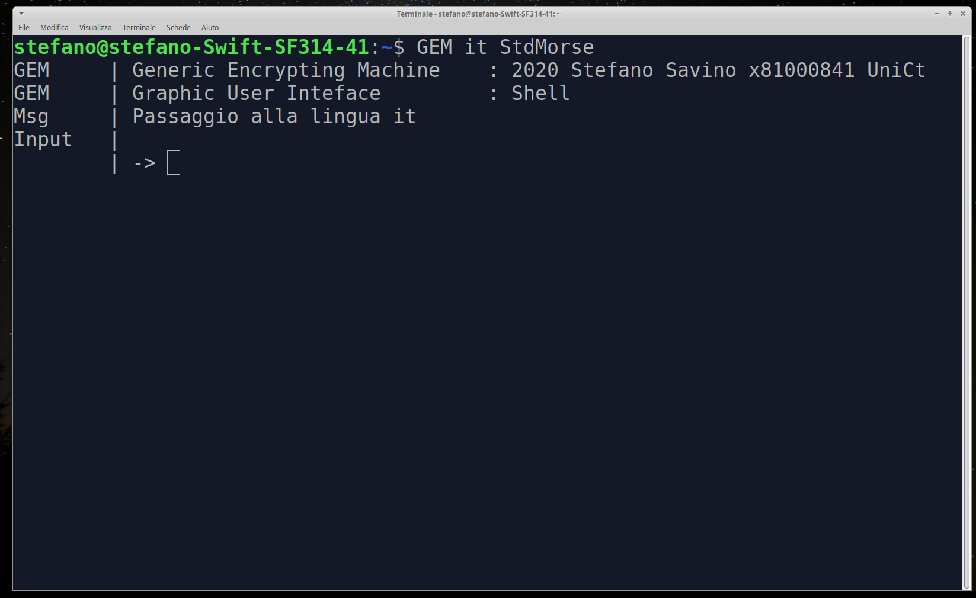
We invoke the program with “GEM it StdMorse” . We expect then the program to run in Italian the Encrypter StdMorse (Morse) with interactive input and output.
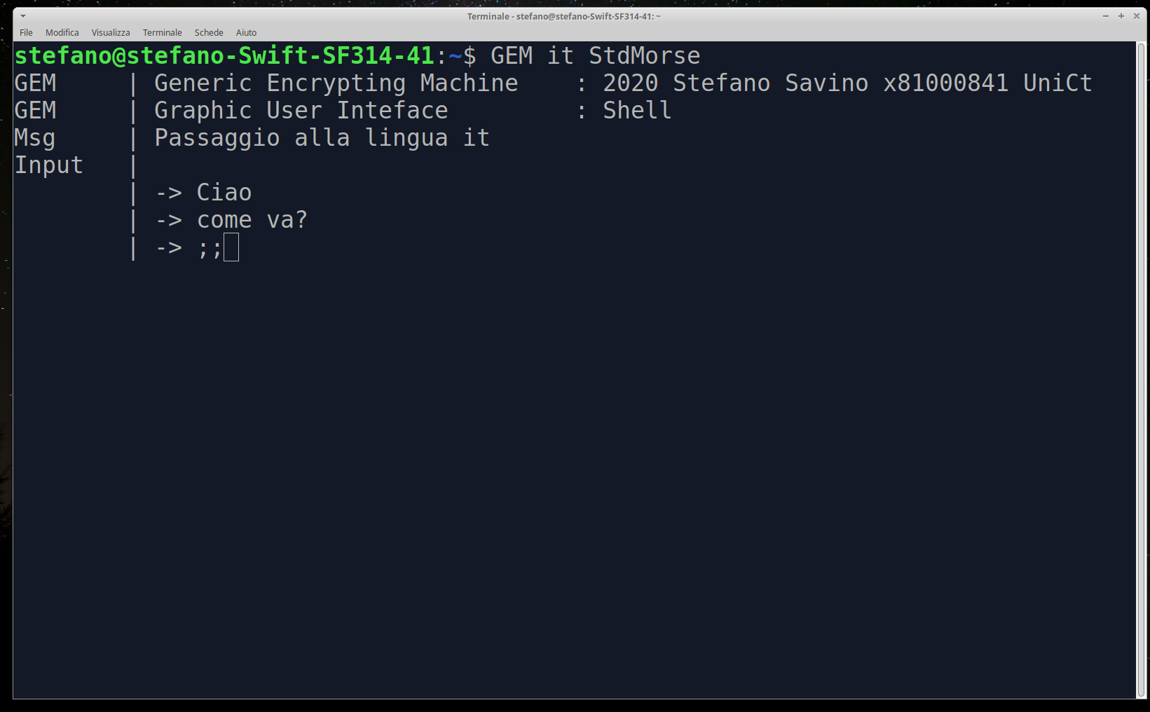
We type the text we want to be encrypted/translated. At the end in a single line we put the delimiter : “;;” . The message is ready to be encrypted.
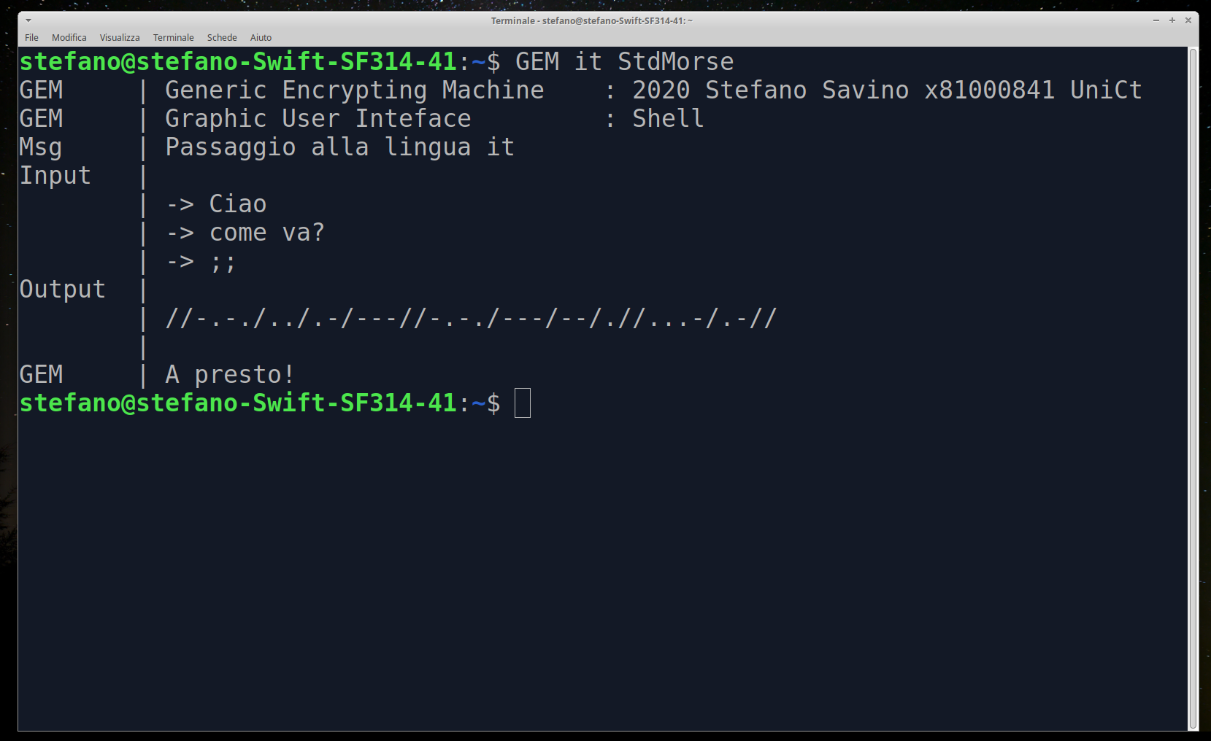
The output is shown and the program exits.

6.4 Example 2
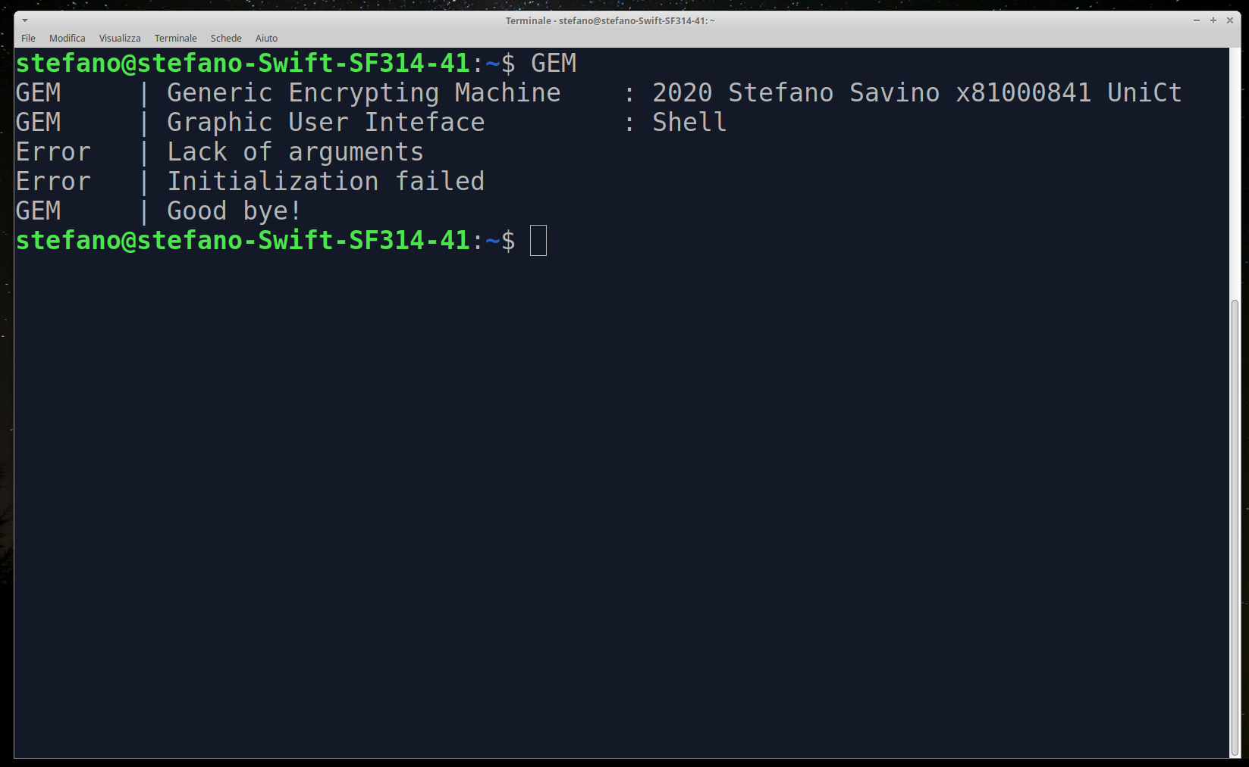
We call the program with lack of arguments. The program shows the error and exits.

6.5 Example 3
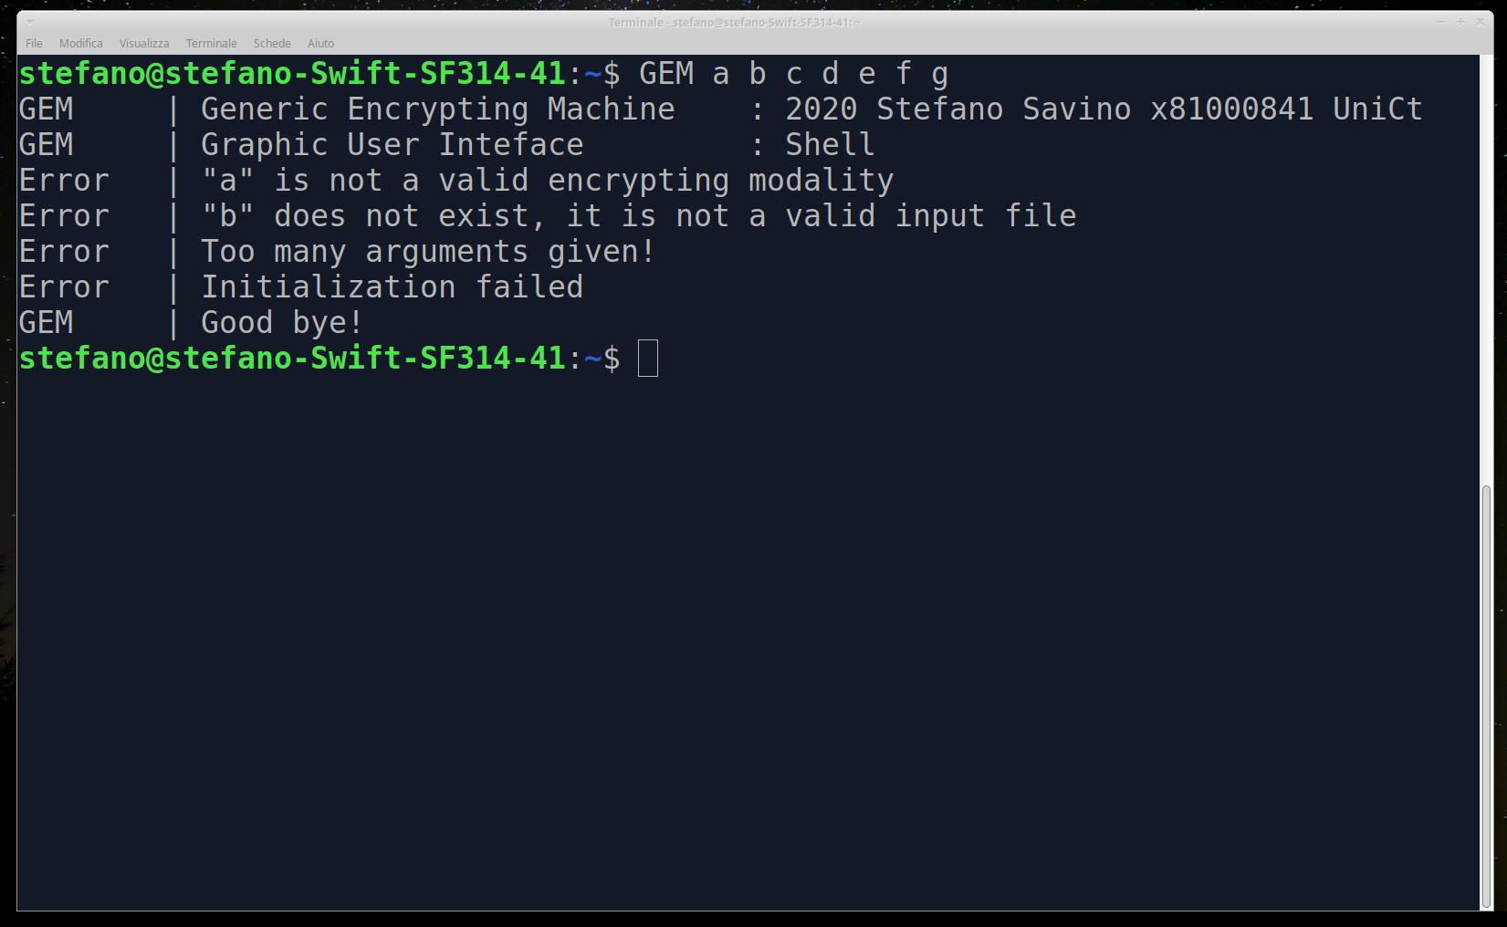
We call the program with casual arguments. The program shows all the errors found and exits.

6.6 Example 4
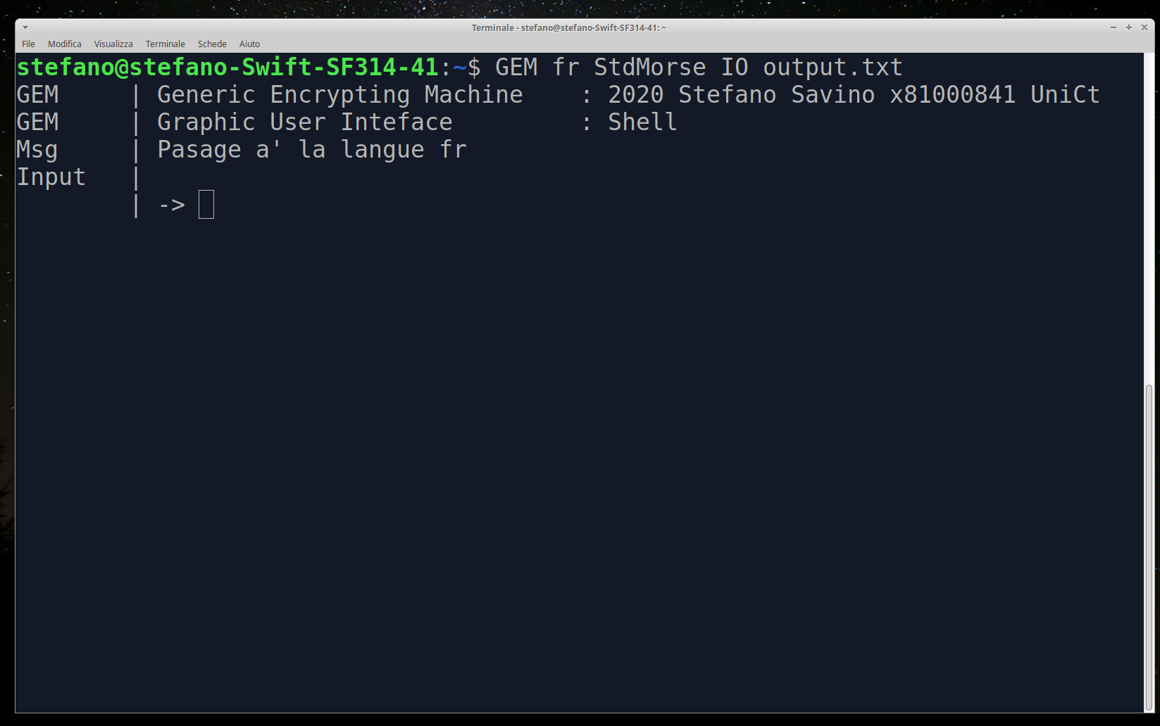
We call the program in french, asking for Encrypter StdMorse, interactive input and output in file output.txt.
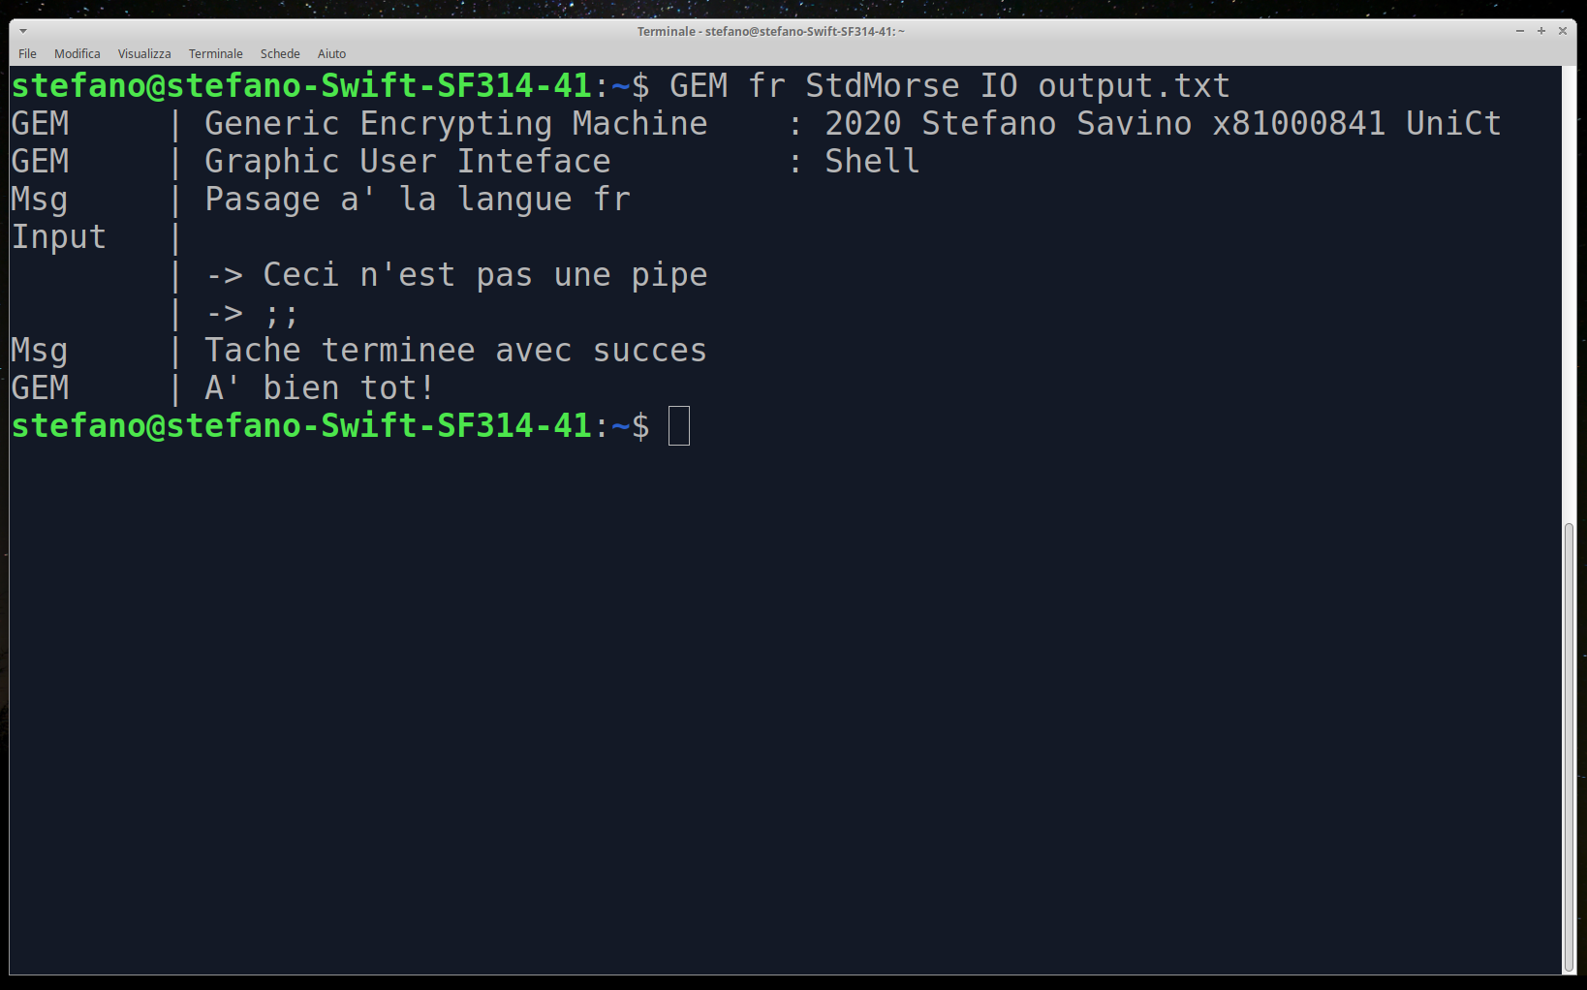
We give the program the string that has to be translated. The program tells us the process has terminated successfully.
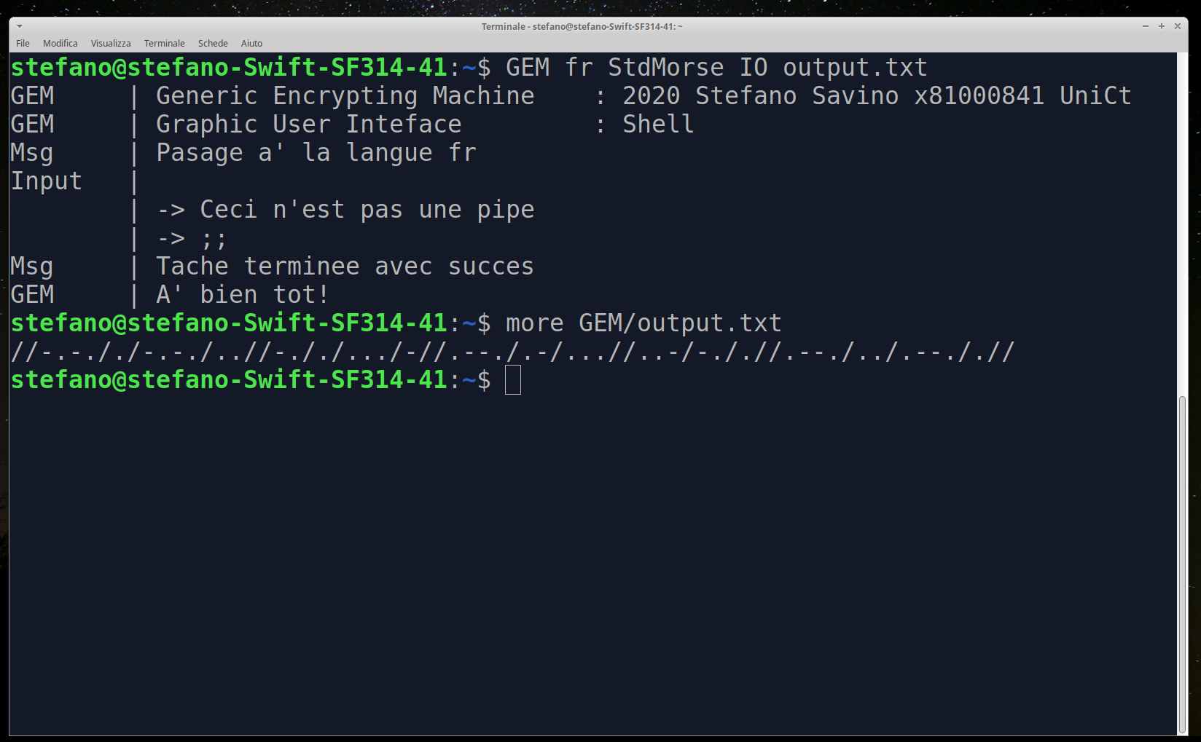
We have a look to the destination file and we find the encrypted message.

6.7 Example 5
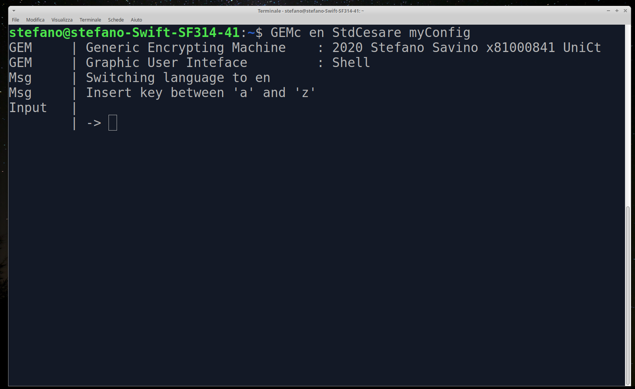
We create a new configuration of StdCesare called myConfig running GEMc in English.
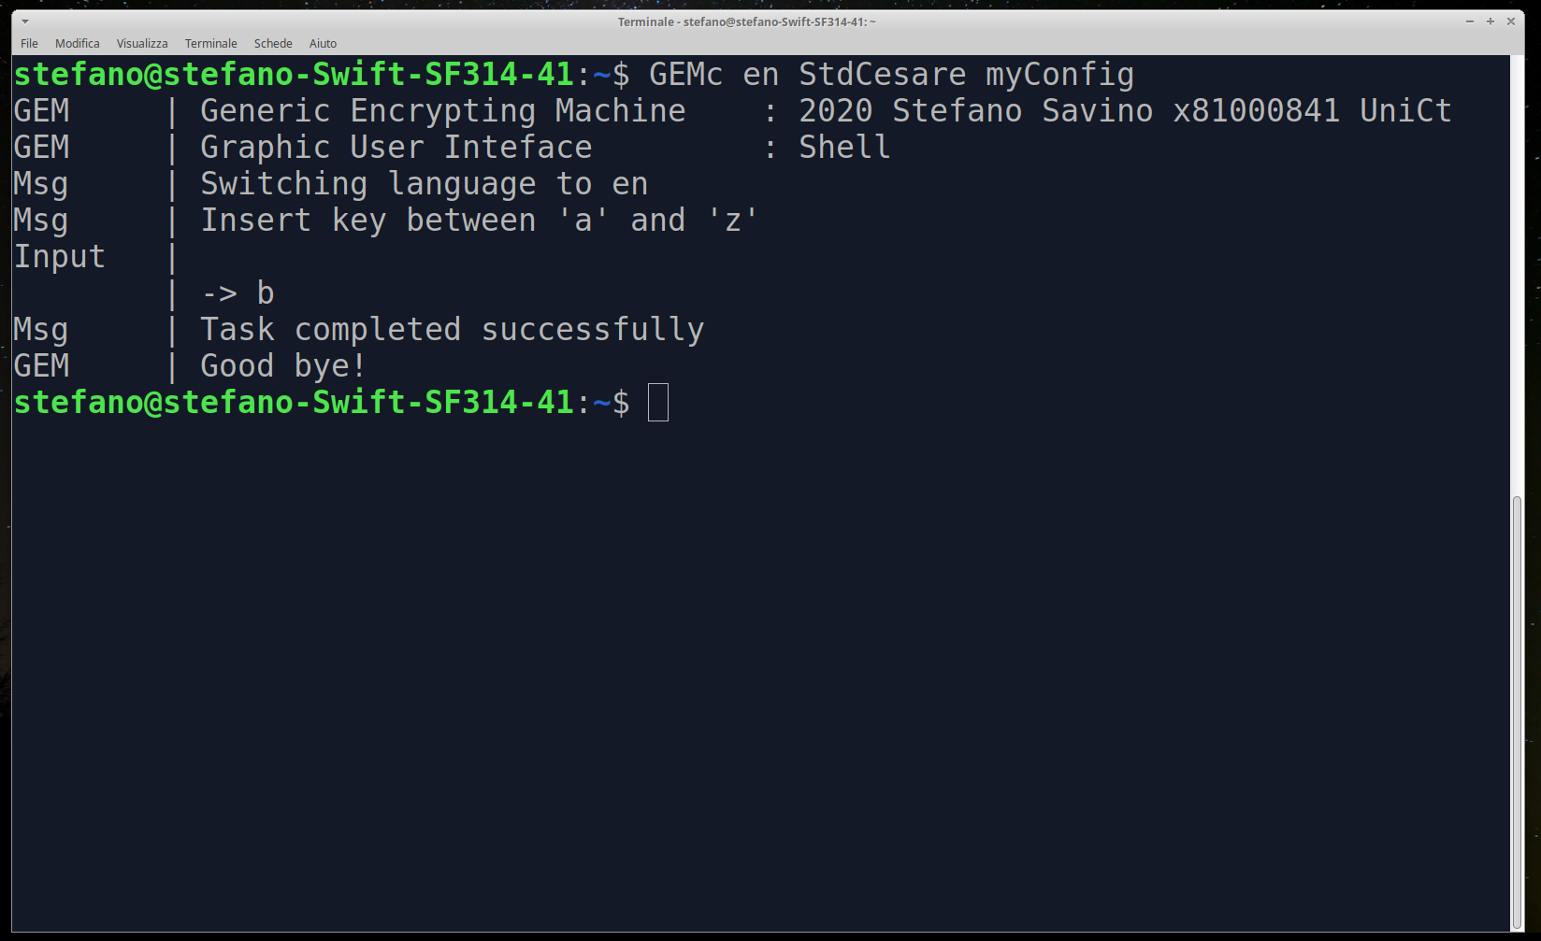
We follow instructions and make a valid configuration.
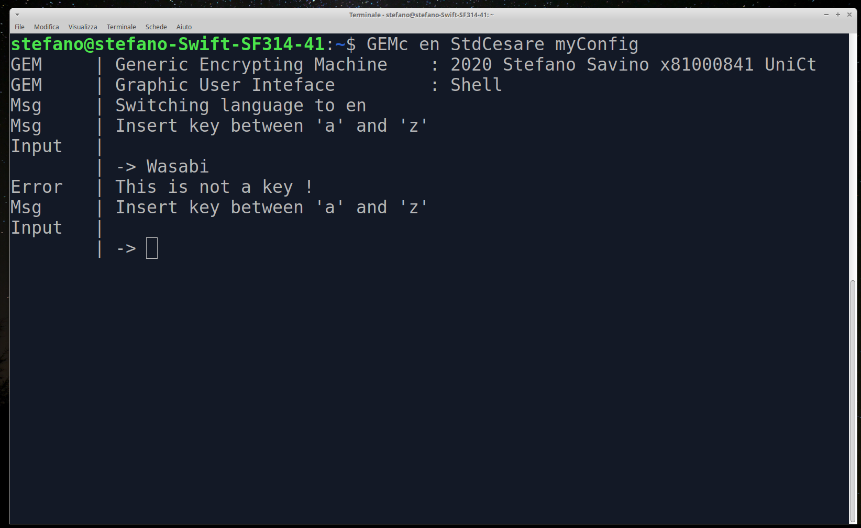
The program takes care if errors are made by users.
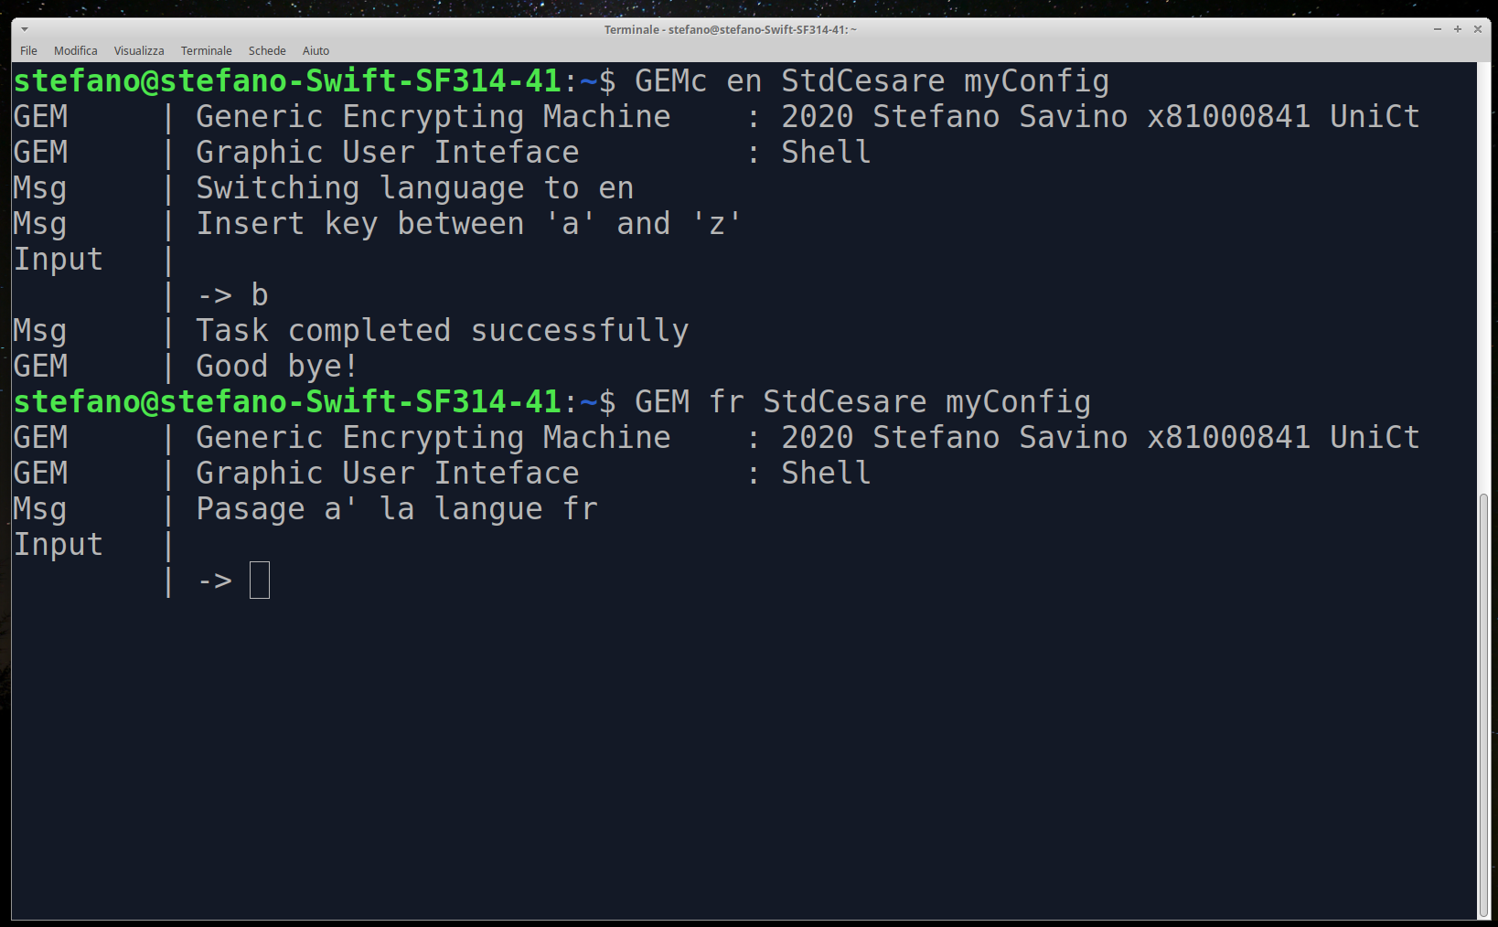

We call the Encrypter StdCesare loading the configuration just made, myConfig, running GEM in French with both input and output interactive.
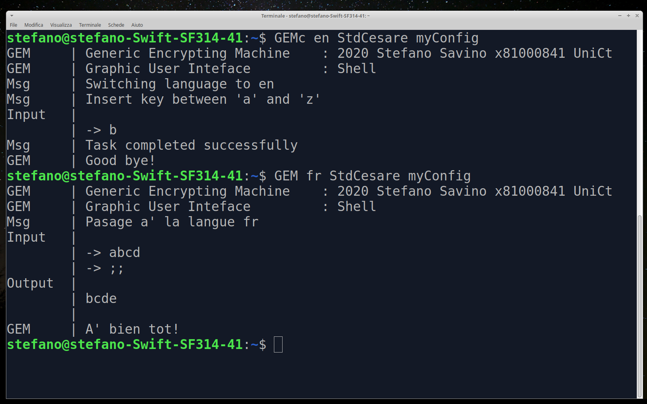
We set the text to be encrypted and the software does all the work.

7 Summary
This first version of GEM is not able to do lots of stuff but it is ready to expand very easily and also to improve its behavior thanks to its modularity. StdCesare is the sixth class among its hieranchy, this could seem exaggerated for the little work it does but further implementations would be easy to think and realize making use of already made methods just expanding the right class.
Thanks for reading
Stefano Savino

