**Chapter I**

**INTRODUCTION**

**Project Context**

The City Government office deals with numerous documents and handles various transactions daily. However, there are instances of misplacement of some of the documents, which makes the process of locating documents more time-consuming. To solve this issue, the Document Tracking System (DTS) is useful in this situation. Its main goal is to ensure that everyone, regardless of their office, has easy access to accurate information regarding the document’s location. This system effectively monitors the movement of documents and minimizes the chances of errors.

In the age of technology innovation, organizations must leverage such systems to optimize their operations and enhance efficiency. Recognizing this necessity, the researchers have created a user-friendly system specifically designed to help employees quickly locate and track important documents. By seamlessly integrating with the existing workflow, this system aims to empower employees and contribute to the attainment of the organization's overarching goals. Furthermore, it offers the adaptability of online monitoring, allowing employees to follow the progress of documents even when they are outside the workplace. This feature enhances the overall effectiveness of document monitoring, ensuring seamless access regardless of physical location.

**Purpose and Description**

The purpose of the Document Tracking System (DTS) is to offer an efficient and centralized solution for tracking the flow of documents from TCGC to the City Hall of Tangub. By providing a systematic approach to tracking documents, it seeks to alleviate the difficulties related to document location, and misplacement. The organization can improve document monitoring, increase productivity, and streamline procedures by deploying this system. The ultimate goal is to ensure easy access, precise tracking, and timely document monitoring so that authorized users may find and use information efficiently.

The Document Tracking System (DTS) is a software solution designed to monitor the movement of documents throughout their lifecycle. It serves as a centralized platform where you can access and track all your important documents. Simply register a document, specify its route, and designate responsible offices at each stage. Authorized users may input a document to be processed and select its route name. The system provides an automated tracking number for each document to facilitate easy access and tracking of documents. By implementing this system, even if the delivery is manual, this document tracking system can reduce the risk of misplacement and experience enhanced efficiency in document monitoring.

**Objectives of the Study**

The researcher aims to develop a system that provides an efficient and centralized solution for tracking the flow of documents from TCGC to the City Hall of Tangub. It specifically aims to achieve the following objectives:

* To develop a system for receiving, processing, and sending documents that includes date and time information.
* To develop a mechanism that enables real-time tracking of document status throughout its lifecycle. Users should be able to monitor the progress of a document, including the time of input, receive, process, and forward or distribution stages.
* To enhance the overall efficiency and productivity of document processes of TCGC to Tangub City Hall.

**Scope and Limitations**

The scope of this study focuses on implementing a Document Tracking System (DTS) specifically for the documents from TCGC moving to the City Hall of Tangub. It aims to address the challenges of document misplacement and time-consuming in locating the documents. It is designed to help employees quickly locate and track important documents, thereby improving document monitoring and increasing productivity.

The system provides a centralized platform for tracking documents, specifically focusing on the flow of documents from TCGC to the City Hall of Tangub. The system administrator has to register documents, specify their routes, and designate responsible offices at each stage. Users have to register through the system administrator to have an account and be authorized. TCGC document processors/liaisons have to log in using their account and may input documents to be processed and select their route name. The system provides an automated tracking number for each document to facilitate easy access and tracking of documents. Tangub City Hall employees/ staff have to log in using their accounts to update the status of documents.

The study's scope is limited to the specific context of the City Government office and its document tracking requirements. The findings and solutions may not be directly applicable to other organizations with different structures and processes. It may not address all possible scenarios or complexities related to document tracking. It is important to consider that unique situations or unforeseen challenges may arise during the implementation and usage of the system, requiring further modifications or adjustments.

The study focuses primarily on the efficiency and productivity aspects of document tracking. It does not extensively cover other aspects such as a database or repository that allows authorized users to upload, organize, and retrieve documents, document security, compliance, advanced analytics, and integration of SMS notification, which could be potential areas for future expansion or research.

**Significance of the Study**

The study of the Document Tracking System (DTS) is important for a variety of people and organizations, including TCGC management and liaison, Tangub City Hall Employees/staff, and future researchers. Here's a breakdown of how each group benefits from the study:

* TCGC management and liaison: Through the DTS tracking and monitoring of documents become easier, faster, and more convenient. The document processor will spend less time tracking documents’ locations and can monitor the progress of all documents in a single location. The DTS will enhance the overall efficiency and productivity of TCGC in processing documents.
* Tangub City Hall Employees/staff: The DTS provides a centralized platform for tracking documents. The Employees of Tangub City Hall as part of the document processing can provide updates of documents’ status in real-time and lessen the misplacement of documents.
* Future Researchers: The study on DTS can serve as a valuable foundation for future researchers interested in document management and related areas. It will provide them with insights into the development and implementation of a successful DTS. Future researchers can build upon the study's findings, expand the scope of research, and explore additional possibilities for improving document tracking systems.

**Chapter 2**

**REVIEW OF RELATED LITERATURE**

This chapter presents different relevant literature and studies that provide some information for a better understanding of the research study.

**Related Literature**

Numerous studies have highlighted the benefits of implementing a Document Tracking System in various organizations. These solutions increase efficiency and productivity, according to Smith and Johnson (2018), by automating manual document tracking procedures and lowering the possibility of misplacing documents. According to their study's findings, firms that adopted document tracking systems had faster document retrieval times and fewer mistakes than those that relied solely on manual tracking techniques. The study stressed the value of a central system that allows for smooth access to document data and real-time tracking.

In a case study conducted by Lee et al. (2019) in a government organization, the researchers addressed the challenge of time-consuming document location processes. Employees had to manually seek via physical file systems or rely on informal communication channels to find certain documents before a Document Tracking System was put into place, they discovered. This caused delays and made it difficult to make quick decisions. However, the researchers noticed a considerable decrease in document search time after putting the method into place. Employees were able to identify and find documents quickly because of the system's search capabilities and well-organized document repository. The study showed how the solution helped organizations overcome the difficulty of time-consuming document location, increase productivity, and improve overall performance.

Chen et al.'s (2020) study looked at the effects of document tracking systems on organizational productivity, client satisfaction, compliance, and risk management. Their research showed that deploying a document tracking system led to higher productivity by reducing the time required for document tracing and streamlining document handling procedures. Moreover, the study also emphasized the system's beneficial impact on customer satisfaction by facilitating quicker response times and precise tracking. These results highlight the value of document tracking systems for improving a range of organizational performance metrics, such as productivity, client satisfaction, compliance, and risk.

**Related Studies**

**Document Tracking System**

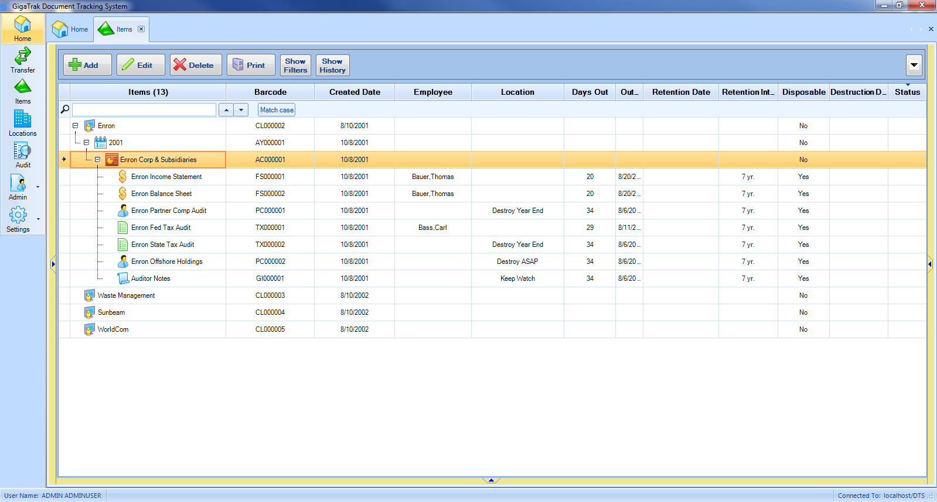

**Figure 1**

The Software Development Process activities served as the foundation for the development of (Lingaya, 2019). This system simplifies the management of documents in state universities or colleges by giving a way to watch, record, and track the location of in-process documents to support an academic organization. The study focused on the development and validation of a document tracking model for use by Philippine Higher Education Institutions. The declaration of the expected validation outcomes, and the utility and effectiveness of the system.

**Electronic Documents Management System**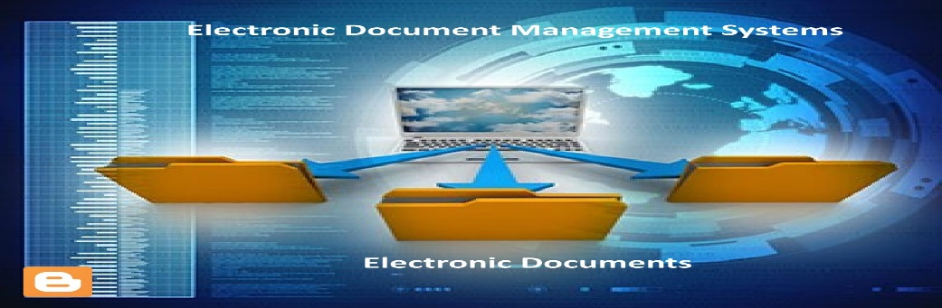

**Figure 2**

Moving from a traditional paperwork system to help educational institutions reduce costs, automating processes increased document security and minimized errors. (Arkan and Ibrahim, 2022). The developed EDMS provides users in the institution with a simple and efficient mechanism to access, manage, and share their documents using new techniques and modifying some features in security and management. The system enables users to manipulate, share, and synchronize, and considers the support of heterogeneous client devices.

**Deployment of Automated Electronic Document Management System**

`

**Figure 3**

The paper analyzes the efficiency of the use of an automated electronic document management system that will boost the infrastructure's overall dependability in municipal administration. (S V Koptyakova et al 2019).

**Accreditation Document Tracking System**



**Figure 4**

Documents tracking it takes a lot of time for staff to track documents, which involves recording and tracking their movement. The issues with document control have always been dislocation and timeline neglect. The simplest approach to implement a useful tool in the workplace is through a web-based system. The “(ADTS)” was created to effectively track the flow of documents from one department to the next and their timelines throughout the accreditation process. The major goal of this project is to create a system that can track a document's whereabouts and its submission status at every stage. **(**Salleh et al., 2020).

**Electronic Documents Location Tracking System**

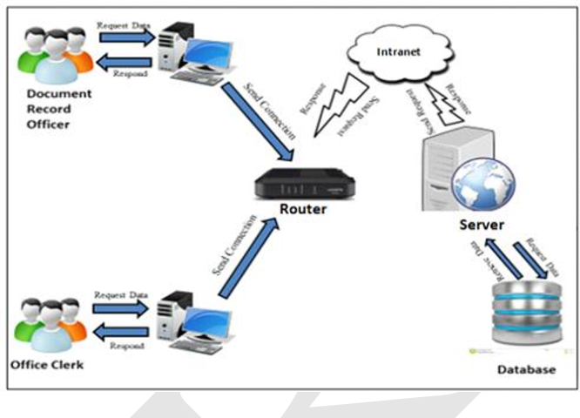

**Figure 5**

Some of the numerous documents that a particular organization manages to submit and pass through various offices include letters for communication, memoranda, vouchers, and travel orders. Employees must monitor and track the location and status of these documents, which is laborious and takes time and effort. In response to these issues, an “Electronic Documents Location Tracking System”, (Tecson, 2020). a browser-based application was created, tested, and implemented to run in a Local Area Network (LAN). This system is crucial for facilitating the monitoring and tracking of documents' location and status as they are submitted to various offices and delivered to the relevant offices.

**Synthesis**

The above literature and studies have a significant relationship in the sense that we are both discussing document issues. Every document in organizations is important; they must have a great system that tracks the movements of those documents. Manually monitoring the documents is now completely useless. A computerized system must have the advantage of handling the document and eliminating human error. Every organization requires a system that allows them to track and easily obtain the documents they require. The objective of this study was to develop a document tracking system that could store different types of documents, exchange documents across different offices quickly and smoothly, track important documents, and monitor their movements. The said system can execute more effectively than a manual approach to tracking and handling the documents. By having effective systems, they can build better organizations and achieve corporate goals. Additionally, it helps to improve the organization and solve document issues.

**Chapter 3**

# DESIGN AND METHODOLOGY

This chapter discusses the ways and different methods and procedures used by the researchers in doing this TCGC Document Tracking System. It describes the flow of the system that corresponds to the process and discusses the software and hardware specifications of the system.

**Methodology**

Documents tracking system is an online document tracking system. The researcher came up with this system to respond to the problem of the TCGC about how to track their documents.

This system will be created by using a System Development Life Cycle (SDLC). The SDLC methodology that has been chosen is the Waterfall methodology followed by a qualitative research methodology for the study. The benefit of using the waterfall model is that the waterfall relies on teams following a sequence of steps and never moving forward until the previous phase has been completed. Its primary goal has always been to assist internal teams in moving through project phases more effectively.



*Figure 1. SDLC Waterfall Model*

The waterfall model divides the development process into several different stages, each of which is finished before the start of the next. These phases include requirements gathering, design, implementation, testing, deployment, and maintenance.

An organization's generation, review, approval, and distribution of documents are managed by a document tracking system, which is a piece of software. It can be used to monitor how a document is doing as it moves through the workflow, from initial creation through final approval and distribution.

In the context of a City government payroll tracking system, the waterfall model might be used as follows:

Requirements gathering: This phase involves gathering and documenting the requirements for the city government payroll tracking system. This might include defining the types of documents that need to be tracked, the processes for creating and reviewing documents, and the security and access controls that need to be in place. Design: In this phase, the design of the city government payroll tracking system is developed based on the requirements gathered in the previous phase. This might include designing the user interface, the database schema, and the overall system architecture. Implementation: In this phase, the actual code for the city government payroll tracking system is developed based on the design created in the previous phase. Testing: Once the code has been written, it needs to be tested to ensure that it meets the requirements and functions correctly. This might involve both unit testing (testing individual components of the system) and integration testing (testing how the system functions as a whole). Deployment: Once the system has been tested and found to be functional, it can be deployed to the intended users. Maintenance: Even after the system is deployed, it will likely need ongoing maintenance to fix bugs, add new features, and ensure that it continues to function correctly over time.

**Development Phase**

The researchers of this study will use CSS (Cascading Style Sheet), HTML (Hypertext Mark-Up Language), JavaScript, and PHP (Hypertext Preprocessor) is a computer language for creating dynamic content that interacts with databases (tutorialspoint.com). JavaScript is a lightweight and widely used component of websites, allowing client-side scripts to interact with users and create dynamic pages (tutorialspoint.com). The structure of the system's web page is described in HTML. CSS is a language for describing the appearance of HTML documents and how HTML elements should be displayed on a computer.

The developers will also use MySQL, a freely available open-source Relational Database Management System (RDBMS) that uses Structured Query Language (SQL). Researchers used MySQL because it is a popular language for adding, accessing, and managing content in a database. It is most notable for its quick processing, proven reliability, ease of use, and applicability in the development of the Document Tracking System. It provides the administrator or user with flexibility and ease of use. Researchers also used SQLyog, a graphical tool to manage MySQL databases. Hence, providing fast and easy-to-use MySQL database instructions and commands.

**Hardware and Software Requirements**

The researchers of the study recommended that tablets, laptops, cellphones, or any device that has a web browser and can connect to the internet for the user to access the system and has at least 2GB of RAM. For this reason, it is recommended that the device should be connected to a stable internet connection for accessing and storing the data. This is another core requirement for a DTS. This is about the classification and structuring of records in the system. For instance, a DTS has to be able to track changes to every document. Why? Document management is closely associated with workflow optimization. Therefore, without a way to track the historical records of files, the workflow will probably suffer too.

**Search ability**

The ability to search through the search tab to find specific document information faster.

**Context Diagram for Document Tracking System**



**Narrative Flow**

The diagram above shows how the three entities: the admin, staff, and liaison interact with the system. As shown above, the admin serves as the central authority in the system. The said entity is primarily responsible for managing user accounts for both liaisons and staff members. Additionally, the stated entity can manage routes and office information, which is crucial for users to locate documents within the system. Furthermore, the liaison inputs document information into the system. Moreover, the system provides them with tracking details, enabling them to monitor the whereabouts of these documents. Lastly, the staff will be able to receive the document and update the status of the document. In this way, the liaison will be able to be informed that the document is currently in a certain staff office.

**Diagram 0 DFD for Document Tracking System**



**Narrative Flow**

As shown above, the admin will first input office information (1.0) into the database named office (D2). After that, the said entity will input and manage the user’s accounts (2.0) each of those users is associated with a certain existing office. And the user information will be stored in the user's database (D1). The said entity will also manage the route list (3.0) which will be later used for the users the track the document location. Hence, those routes are often associated with each office. Then the liaison will send the document to a certain office and input information about the document in the system (4.0). After the staff receives the documents, they will update the said document location in the system (5.0). This will enable the system to know the whereabouts of the documents. Lastly, through process number 5.0 the liaison and the staff will now be able to track the location of a certain document (6.0) as a certain staff will update the document location as it reaches their office making a way for easier tracking of the document's whereabouts.

**Diagram 1.0 DFD for Add Office**



**Narrative Flow**

In diagram 1.0, the admin will input the office name to the system which will be saved to the database named offices. Then the system will display the list of offices to the addition. Thus, those lists are those offices stored in the database named offices.

**Diagram 2.0 DFD for Manage User Account**



**Narrative Flow**

As shown in the DFD 2.0, the admin will add new users to the system by inputting their user details into the system. Thus that information will be stored in the user's database. If any changes occur the admin will be able to alter information of the user in the system which includes account deletion. Upon updating the user's information, it will be also updated in the user's database. Furthermore, the user account will then be distributed to the staff and the liaison.

**Diagram 3.0 DFD for Set up Document Route**

**Narrative Flow**

In this diagram, the admin will input the route details to the system. First, the admin will input the route name (3.1). Then, the admin will specify the route sequence (3.2) for the said route to have an ID that is created in sequence for easier tracking. Then the said route will be bound to a certain office (3.3) which is stored in the database named offices. After all the essential information is inputted the route will now be saved to the route database and will be displayed for the admin to see the list of the route.

**Diagram 4.0 DFD for Add Document Details**



**Narrative Flow**

In diagram 4.0, the entity (liaison) will add a document description (4.1) and then select the document route (4.2) to have tracking on where the document will be headed. Then, the liaison also has access to the list of documents in the system including their location and their tracking number (4.3) so that they will no longer have trouble finding the document's whereabouts. The document will now be forwarded to certain staff (4.4). The liaison also has the authority to delete documents registered in the system.

**Diagram 5.0 DFD for Update Document Status**



**Narrative Flow**

As shown in the diagram above, the staff first received the document (5.1). After receiving a certain document, the staff will then process the document and inform the system that the document is in their office (5.2). If another office requests to acquire a certain document that is located at the stated staff location, the said staff will forward the document to their office (5.3).

**Diagram 6.0 DFD for View Document Tracking Information**



**Narrative Flow**

In diagram 6.0, the entities (staff) and (liaison) are both can view the document tracking information all they have to do is copy the document tracking number and paste it into the tracking icon

**Use Case Diagram** **for Document Tracking System**

**Table 1**

**Add Office**

|  |  |
| --- | --- |
| Use case name | Add Office |
| Actor | Administrator |
| Description | The actor uses the use case to add the office name. |
| Normal Flow | 1. The use case begins when the actor views the office lists. 2. The actor can add, edit, and delete the names of the offices. 3. All changes made by the Administrator are automatically saved by the system. 4. Use case instance terminates. |
| Precondition | The system displays the list of offices and the data of offices must be available. |
| Post Condition | The newly added office will be included in the list of offices. |
| Assumption | The actor is on the system. |

**Table 2**

**Manage Users Account**

|  |  |
| --- | --- |
| Use case name | Manage Users Account |
| Actor | Administrator |
| Description | The actor uses the use case to create a user's account. |
| Normal Flow | 1. The use cases begin when the actor views the user's list, adds new users, and fill-out users' information 2. The admin inputs his/her personal information. 3. The actor clicks the “role” Is it staff or liaison 4. The system saves the information of the users. 5. Use case instance terminates. |
| Precondition | The data of the users must be available. |
| Post Condition | The newly added user will be included in the list of users. |
| Assumption | The actor is on the system. |

**Table 3**

**Set-up Document Route**

|  |  |
| --- | --- |
| Use case name | Set-up Document Route |
| Actor | Administrator |
| Description | The actor uses the use case to set up the document route. |
| Normal Flow | 1. The use case begins when the actor views the route list and sets up the routes. 2. The actor input route name type order number and select office. 3. The system saves the done sets of routes. 4. Use case instance terminates. |
| Precondition | The system displays the list of routes and the data of routes must be available. |
| Post Condition | The newly added routes will be included in the list of routes. |
| Assumption | The actor is on the system. |

**Table 4**

**Add Documents Details**

|  |  |
| --- | --- |
| Use case name | Add Documents Details |
| Actor | Liaison |
| Description | The actor uses the use case to add the document's name. |
| Normal Flow | 1. The use case begins when the actor views the documents list. 2. The actor clicks the green + plus symbol icon and adds document information. 3. The actor clicks the document route and chooses the route name 4. The actor clicks the “save” button and clicks the “arrow right” button to forward documents. 5. The actor must copy the tracking number click the home button and paste it to the “Track Document” to view the documents’ location. 6. Use case instance terminates. |
| Precondition | The system displays the list of documents that must be available. |
| Post Condition | The system saves all the documents. |
| Assumption | The actor is on the system. |

**Table 5**

**Update Document Tracking Status**

|  |  |
| --- | --- |
| Use case name | Update document tracking status |
| Actor | Staff, |
| Description | The use case is used in the actor to receive, process, and forward documents. |
| Normal Flow | 1. The use case begins when the actor views all of the list documents. 2. The actor clicks the “option” button to receive, process and forward documents 3. The actor must copy the tracking number click the home button and paste it to the “Track Document” to view the documents’ location. 4. Use case instance terminates. |
| Precondition | The system displays the list of document locations including date, and real-time. |
| Post Condition | The system saves all the document locations. |
| Assumption | The actor is on the system. |

**Table 6**

**View Document Tracking information**

|  |  |
| --- | --- |
| Use case name | View document tracking info. |
| Actor | Liaison/Staff |
| Description | The use case is used in the actor to view the display document status. |
| Normal Flow | 1. The use case begins when the actor views the list of documents. 2. The actor must copy the tracking number click the “home” button and paste it to the “Track Document” to view the documents’ location including the date and time of receiving, processing, and forwarding. 3. Use case instance terminates. |
| Precondition | The system displays the date and time of received, processed, and forwarded documents. |
| Post Condition | The system saves all the documents. |
| Assumption | The actor is on the system. |

**Chapter 4**

**COST ANALYSIS**

This chapter shows the cost and benefits of our study and the total development cost of our system.

**COST ANALYSIS**

**Steps Elapse Time Cost**

Feasibility Study 30 Days P 6,000.00

System Analysis 20 Days P 7,950.00

System Design 29 Days P 10,500.00

Implementation/Prototyping 21 Days P 9,900.00

**Grand Total 100 Days P 34,350.00**

**Detailed Expenses:**

**Feasibility Study (30 days)**

Project Leader - P 2,000.00

Project Analyst - P 1,000.00

Fare - P 1,000.00

Researches - P 1,000.00

Snack/Meal - P 1,000.00

**Total: - P 6,000.00**

**System Analysis (20 days)**

System Analyst - P 5,000.00

Fare - P 400.00

Snack/Meal - P 600.00

Researches - P 600.00

1 RIM Bond Paper (Short) - P 250.00

5 Sliding Folder - P 100.00

Print -P 1,000.00

**Total: - P 7,950.00**

**System Design (29 days)**

Project Designer - P 5,500.00

Fare - P 1,200.00

Router - P 2,000.00

Snack/Meal - P 1,500.00

Extension Wire - P 300.00

**Total: - P 10,500.00**

**System Implementation (16 days)**

Project Leader - P 3,000.00

System Analyst - P 3,000.00

System Designer - P 3,000.00

Fare - P 500.00

Snack/Meal - P 400.00

**Total: - P 9,900.00**

**Chapter 5**

**RESULTS AND DISCUSSION, CONCLUSIONS AND RECOMMENDATION**

This chapter presents the results and discussion of the Document Tracking at Tangub City System, the conclusion, and the recommendations offered.

**Results and Discussion**

The goal of this project, Document Tracking System, is to ensure easy access, precise tracking, and timely document monitoring so that authorized users may find and use information efficiently. To track the documents, the staff and liaison will organize the documents and process them with the help of the system, the liaison will forward the documents and the staff will receive, process, and forward them to the next where it's going.

**Conclusion**

According to the study, Tangub City Hall may benefit greatly from using the document tracking system because the system allows administrators and staff to exchange documents with other offices in the city hall.

The administrators and staff who will use this method may be sure to make easy transactions by exchanging documents. Additionally, by working on many documents all day, the system helps track the document easily.

Our project's main goal is to develop a website that would track the location of documents and update the document's whereabouts.

* User must have an internet connection
* It can be used on a computer, laptop, or Android/IOS phone
* Update the system for some bugs

**Recommendations**

The following recommendations were offered based on the conclusion and findings of the study.

The developers would like to recommend the following:

1. City Hall/ City Offices. By doing all transactions online, the created system may be improved. Administrator and staff can communicate with other offices on their transaction.
2. Administrators and Staff. Future administrators and staff should utilize the built system so they will know the transactions as it serves as a guide to send and locate documents.
3. Researchers and future researchers. The system will serve as a reference or guide for them to conduct their related research to the study.