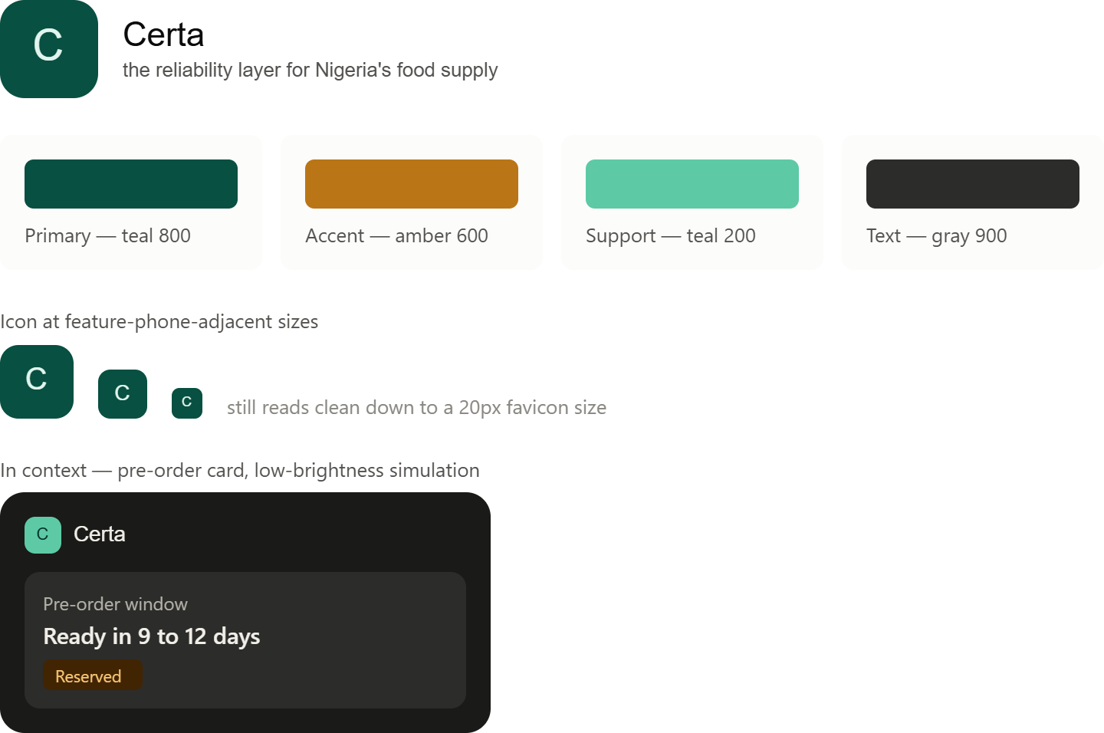

A few things worth calling out from the stress test:

The wordmark holds up at low brightness and small size — the deep teal + light mark combination doesn't wash out even in the dimmed simulation, and the icon is still legibly a "C" at 20px, which matters more for this product than it would for a typical consumer app.

The amber accent is doing real work — it's used sparingly (the "Reserved" status pill), so it doesn't compete with the primary teal, but it gives the interface a warm, human touch that pure teal-and-gray would read as too clinical or fintech-cold for a farmer/trader audience.

The pre-order card is the actual test case you asked about — showing a reservation status ("Ready in 9 to 12 days · Reserved") in this palette is where trust either lands or doesn't, since that's the exact moment a consumer is deciding whether to believe the platform's promise.

1. Logo
Wordmark: "Certa" — sentence case, medium weight, never all caps, never stylized beyond the standard typeface. Icon: A single letterform "C" on a solid teal field, no gradient, no drop shadow, no outline treatment.

Size | Usage
64px+ | Full lockup — icon plus wordmark, used on splash/onboarding screens
32–48px | Icon alone with wordmark alongside — app headers, nav bars
20px | Icon alone — favicons, notification badges, compact UI

Do: Keep a minimum clear space around the icon equal to a quarter of its own width, on every side. Don't: Never place the icon on a busy photo background, a gradient, or any color outside the approved palette below. Never stretch or skew the lockup to fit a space — resize the container instead.

2. Color Palette
Role | Hex | Usage
Primary — Teal 800 | #085041 | Logo fill, primary buttons, headers, key brand moments
Support — Teal 200 | #5DCAA5 | Secondary UI accents, active states, icon backgrounds on dark surfaces
Accent — Amber 600 | #BA7517 | Status highlights only (e.g. "Reserved," "Pending") — used sparingly
Text/Surface — Gray 900 | #2C2C2A | Primary text, dark-mode card surfaces
Muted text — Gray 400 | #888780 | Secondary/supporting text, labels
Light surface | #E1F5EE | Backgrounds behind teal elements, light-mode cards

Do: Use Teal 800 as the dominant color in any screen showing a trust-critical action — booking confirmation, pre-order reservation, payment status. Do: Reserve Amber 600 for status and state changes only — it should never be the majority color of a screen. Don't: Never introduce a color outside this table without a documented reason tied back to the reliability positioning. No red for anything except genuine errors — red reads as alarm, which works against the "trust" goal everywhere else. Don't: Never use pure black (#000000) or pure white (#FFFFFF) for text or surfaces — use the gray/light-surface values above, which hold up better across screen quality and lighting conditions.

3. Typography
- Typeface: A geometric sans-serif optimized for legibility at small sizes (system default is acceptable — the priority is rendering reliably on lower-end devices, not a custom font that may fail to load on a weak connection).
- Weights: Two only — regular (400) for body copy, medium (500) for headings and emphasis. Never bold beyond 500; heavier weights reduce legibility on compressed or low-resolution screens.
- Case: Sentence case everywhere — headings, buttons, labels, status pills. Never Title Case, never all caps.
- Minimum size: 11px anywhere. Status labels and metadata should sit at 12–13px minimum for real-world legibility, not the visual minimum.

Do: Test every text element at reduced screen brightness before calling it final — this is a genuine condition many users will actually be in, not an edge case. Don't: Never rely on color alone to convey meaning in text (e.g., don't make an error message readable only because it's red) — pair color with a label or icon so the message still lands for anyone with reduced visibility conditions or a poor-quality screen.

4. Status and State Colors
Reservation, booking, and matching flows all move through visible states. Keep these consistent everywhere they appear:

State | Background | Text
Reserved / Pending | Amber 50 tint #FAEEDA | Amber 600 #BA7517
Confirmed | Teal 50 tint #E1F5EE | Teal 800 #085041
Fulfilled / Delivered | Teal 200 #5DCAA5 | Teal 900 #04342C
Cancelled / Error | Neutral gray, never red-filled | Gray 900 #2C2C2A with a small icon indicator

Do: Use the same state-color pairing everywhere a status appears — buyer matching, warehouse booking, and pre-order should all read the same visual language for "confirmed" or "pending," so a user only has to learn it once. Don't: Never invent a one-off color for a new state without checking this table first — if a new state doesn't fit, flag it to Brand Design rather than approximating.

5. Iconography
- Use simple, single-weight outline icons — no filled icons, no illustrated/detailed icon sets.
- Icons inherit the surrounding text color by default; only use Teal or Amber fills when the icon itself is the primary visual element (e.g., a standalone status icon).
- Icons should always be paired with a text label in this product — never icon-only navigation, given the accessibility and literacy range of the target users.

Do: Keep icon meaning consistent across the whole product — the same icon should never mean two different things in different screens. Don't: Never use an icon as a substitute for a text label to save space — space savings aren't worth the comprehension risk for this user base.

6. Low-Bandwidth and Low-Brightness Principle
This is the identity's core constraint, and it overrides visual preference when the two conflict:

- Every screen and every brand asset must remain legible when device brightness is reduced and on a compressed or slow-loading image.
- Avoid relying on subtle color differences to distinguish elements — contrast should be clear enough to read on an older or lower-quality screen.
- Keep image and icon file sizes small; never let a decorative asset slow down a screen a farmer or trader is trying to load on a weak connection.

Do: When in doubt, test the darkest, most compressed version of an asset before approving it. Don't: Never add a decorative visual element that doesn't serve legibility, trust-signaling, or navigation — this product doesn't have room for pure decoration.

7. Voice, Applied Visually
The identity should always read as calm and certain, not exciting or urgent — even in a call-to-action. This shows up visually as:

Do: Flat, confident color blocks and clear status labels. Don't: No countdown-timer urgency styling, no flashing or pulsing elements, no "hurry" framing in color or motion — that undercuts the reliability positioning even if it might drive short-term engagement.

Quick Reference Summary
- Teal 800 (#085041) leads. Amber 600 (#BA7517) accents sparingly. Gray 900 (#2C2C2A) for text.
- Sentence case, two font weights, 11px absolute minimum.
- Status colors are fixed and consistent across every journey.
- Every asset gets checked at reduced brightness and small size before it's called done.
- If a decision doesn't reinforce reliability and trust, it doesn't belong in the product.

The rule that governs the whole doc, called out explicitly at the end: if a design choice doesn't reinforce reliability and trust, it doesn't belong — that's why there's a hard "no" on urgency styling (countdown timers, flashing states) even though that's a common growth-hacking pattern elsewhere, and why the low-bandwidth/low-brightness principle is framed as overriding visual preference rather than sitting alongside it. This is written so Frontend and UI/UX can build directly from it without a separate brand conversation — it's the same tokens from the mockups, just formalized with the do/don't rules spelled out.

