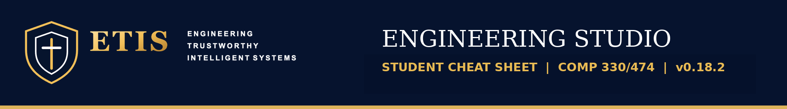

STUDENT CHEAT SHEET
  - What to click, what to say, and what to do next.

The normal path
- Push a draft to your verified team GitHub repository.
- Review Room → choose phase → Start Board Review (teal button).
- Answer naturally. Ask questions, disagree, or ask for an example.
- Need proof? Evidence Room → inspect a file or finding → return to your review.
- Change and verify your work in GitHub → push → Start another Board Review.

Which button?
Start Board Review | Let the Review Board choose an important question for this phase.
Other review options → Focused Review | Ask about a particular estimate, risk, document, design decision, or PR.
Other review options → Review Findings | Discuss one to three existing concerns.
Continue this review / Go to your reply | Return to your active conversation.
Start another Board Review | Begin a separate review directly. It does not finish earlier Open reviews.
Browse all reviews / Review History | Resume an Open review or read a Finished one.

What can I say to the reviewer?
- “I’m not sure. What should I check first?”
- “Can you explain that with a simple example?”
- “I think you missed this file. Can we inspect it?”
- “Before I answer that, can we discuss our estimates?”

Two rooms, one workflow
An Open review: Continue this review is the main action. Other reviews remain available.
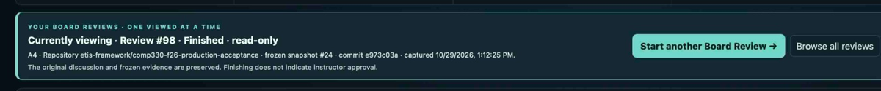
A Finished review: Start another Board Review begins a new review with one click.

Talk, inspect, and come back
- Review Room is the discussion. Evidence Room is the saved source notebook. Switching rooms does not finish a review.
- Standard is the normal conversation layout. Expanded gives your conversation more room.
- Inspect cited source opens the file attached to a concern. Find supporting evidence looks for relevant or equivalent files in the same saved snapshot.
- A review’s original snapshot never absorbs later GitHub commits. Check the commit when comparing old and new work.

When something seems wrong
The Board missed a file | Check the file is committed and pushed; inspect the saved snapshot; give its path and explain what it proves.
I changed the repo, but old review is unchanged | Expected. It is frozen. Start another Board Review for the newer available revision.
I cannot reply to a review | Finished reviews are read-only. Open an existing Open review or start another.
A button or response failed | Check review history and the current conversation before retrying; do not repeatedly click.
I do not know how to begin | Use the teal Start Board Review. You do not need a polished question or finished work.
My GitHub repository is already Verified | Do not repeat team setup. Confirm your own GitHub identity is linked in My Team.

Keep these three distinctions clear
- A REVIEW finding is a challengeable interpretation; a frozen FACT is repository evidence at a checkpoint.
- Finishing a review does not mean the instructor approved your work. Studio is developmental coaching.
- A new review is a new conversation, not necessarily a new repository snapshot.
