ETIS

Installation & Administration Guide
  - Greenfield installation, production configuration, deployment, validation, administration, upgrade, and decommissioning
Audience | Deployment administrators, course owners, engineering maintainers, institutional IT and security staff
Purpose | Enable a new administrator to install ETIS Engineering Studio safely from source through accepted Azure production operation, without relying on undocumented tribal knowledge.
Reference implementation | COMP 330/474 Software Engineering • Fall 2026
Canonical service | https://simulator.etisframework.org
Version | Production Baseline — August 2026 • August 23, 2026

CORE PRINCIPLE
AI may challenge, critique, synthesize, and ask for evidence. Engineers decide, defend, and own the consequences. Deterministic authorization, lifecycle state, and frozen repository evidence remain authoritative.

Contents
Executive Overview What this guide installs, who owns which boundary, and the canonical deployment path
1 Deployment model and installation sequence
2 Prerequisites and accounts
3 Clone, local installation, and verification
4 Microsoft Entra human authentication
5 GitHub OAuth identity linking
6 GitHub App repository evidence access
7 GitHub production environment, variables, and secrets
8 Azure infrastructure and resource topology
9 DNS, TLS, callbacks, and external alignment
10 First production deployment
11 Post-deployment acceptance
12 Routine administration and semester posture
13 Upgrade and rollback
14 Troubleshooting
15 Decommissioning
Appendix A Greenfield installation checklist
Appendix B Variables and secrets reference
Appendix C Acceptance and recovery commands

Executive Overview
ETIS Engineering Studio is a browser-based engineering apprenticeship environment. The production reference implementation uses Microsoft Entra for human authentication, database-backed course authorization, GitHub OAuth for engineering identity, a GitHub App for read-only repository evidence, Azure Container Apps for the web runtime, PostgreSQL Flexible Server for durable state, Key Vault and managed identity for secrets, Application Insights/Log Analytics for observability, ACR for immutable images, and OpenAI for bounded advisory review conversations.
THE INSTALLATION PRINCIPLE
Do not collapse independent trust boundaries. Entra authenticates the person. ETIS roster/staff records authorize course access. GitHub OAuth identifies the engineer’s GitHub account. The GitHub App authorizes exact repository evidence access. Azure/Key Vault protect runtime infrastructure and secrets.

1. Prepare required administrative accounts and DNS authority.
2. Clone the repository and prove the source locally.
3. Register/configure Microsoft Entra authentication.
4. Configure GitHub OAuth identity linking.
5. Configure the ETIS Engineering Studio GitHub App for selected-repository read access.
6. Create the protected GitHub production environment and configure required variables/secrets.
7. Run the repository’s controlled Deploy Azure workflow; the workflow provisions/updates Azure from Bicep, builds an immutable image, runs migrations, deploys the application, and verifies readiness.
8. Bind DNS/TLS and verify callbacks.
9. Run the Azure Operations CLI acceptance report and complete human identity/GitHub onboarding acceptance.
10. Only after acceptance, activate the semester for normal student use.
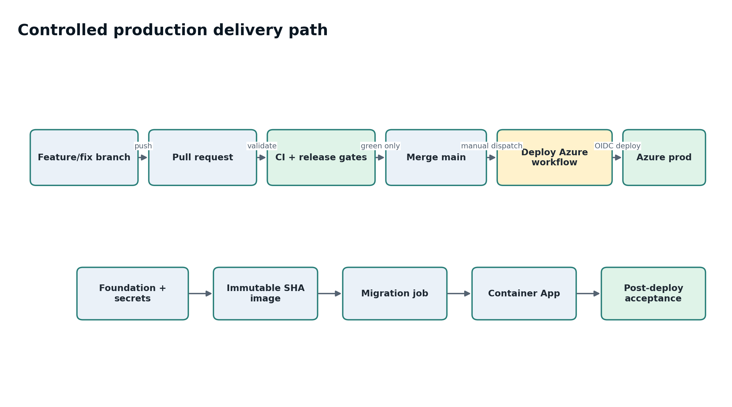
Figure 1. Canonical production delivery path. Deployment remains branch → PR → CI → merge → protected Deploy Azure workflow → post-deployment acceptance.

1. Deployment model and installation sequence

1.1 What is automated and what is not
Area | Administrator responsibility | Repository/workflow responsibility
External identity | Create/configure Entra application and GitHub integrations; protect credentials. | Validate required configuration and fail closed if production values are missing or unsafe.
Azure infrastructure | Provide subscription authority and protected deployment credentials. | Bicep defines networking, ACR, Key Vault, managed identity, Container Apps environment/app/job, PostgreSQL, monitoring, alerts.
Database schema | Protect PostgreSQL credentials and recovery posture. | Alembic migrations are explicit release artifacts and run before app deployment.
DNS/TLS | Control public DNS and ensure canonical origin/callback alignment. | Application requires HTTPS production origin and exposes health/readiness endpoints.
Semester/course data | Create term/sections, import roster, assign staff/teams, activate/archive. | Server enforces lifecycle-valid authorization and preserves historical records.

SOURCE OF TRUTH
Repository infrastructure and the protected GitHub workflow are authoritative for normal production deployment. Avoid one-off portal changes that are not represented in Bicep; they can create drift and may be overwritten by a later deployment.

2. Prerequisites and accounts
Area | Required before installation
Source control | GitHub repository access, ability to create PRs, manage repository environments/secrets, and manually run the protected production workflow.
Local workstation | Git, Python 3, a Python virtual environment, browser, curl, and Azure CLI for production operations. Node is not required for the bundled UI.
Azure | Subscription with authority to deploy Container Apps, PostgreSQL Flexible Server, ACR, Key Vault, managed identity, networking/private DNS, Log Analytics, Application Insights, Monitor alerts/action groups.
Microsoft Entra | Ability to create/configure the production app registration and client secret in the intended tenant.
GitHub integrations | Ability to create/configure the GitHub OAuth App and GitHub App.
OpenAI | API project/key with the configured reviewer model available.
DNS | Control of the intended public DNS name. Reference implementation: simulator.etisframework.org.
Operations | An email destination for Azure operational alerts and an owner for budget/incident response.

3. Clone, local installation, and verification

3.1 Clone and create the Python environment
git clone https://github.com/etis-framework/etis-engineering-studio.git
cd etis-engineering-studio
cp .env.example .env
python3 -m venv .venv
source .venv/bin/activate
pip install -r apps/api/requirements.txt
LOCAL ENVIRONMENT FILE
Use .env only for local development. Keep it excluded from Git and Docker build contexts. Never paste production secrets into .env.example, documentation, screenshots, test fixtures, or source control.

3.2 Run the test suite before local startup
pytest -q
Expected result: the repository test suite passes. Do not proceed to a production deployment from a source tree with failing release/security tests.

3.3 Start the local application
uvicorn apps.api.app.main:app --reload --port 8000
Open http://localhost:8000. Development behavior may use local/demo paths when external providers are not configured. Production validation is intentionally stricter and rejects development login, SQLite, weak session secrets, missing provider configuration, and non-HTTPS production origins.

3.4 Optional local PostgreSQL path
docker compose up --build
Use the containerized PostgreSQL path when validating database-specific behavior locally. PostgreSQL concurrency and migration proofs also run in controlled CI/release gates.

4. Microsoft Entra human authentication
Create or use a production Microsoft Entra application registration for ETIS Engineering Studio. Human authentication is separate from course authorization; a valid Microsoft identity does not grant course access unless ETIS has a current roster/staff assignment.
Setting | Production rule
Tenant | Use the explicit intended production tenant UUID; do not use a generic multi-tenant organizations authority for the accepted deployment.
Redirect URI | https://simulator.etisframework.org/auth/entra/callback
Protocol | OAuth 2.0 / OpenID Connect authorization code
Scopes | openid profile email
Client ID | Store as protected production environment configuration.
Client secret | Store only as a protected production secret; rotate if exposed.
MFA | Do not create a second ETIS-specific MFA scheme. Normal Loyola users satisfy their normal institutional MFA, then return to Studio.

AUTHENTICATION IS NOT AUTHORIZATION
A user who can complete Entra sign-in but is not in an active course/section/staff assignment should still be denied course operation. Treat “can sign in” and “can enter the course” as separate acceptance checks.

5. GitHub OAuth identity linking
The GitHub OAuth App links a Studio user to a GitHub login and immutable numeric GitHub account ID. It is an identity boundary only; repository evidence access is handled separately by the GitHub App.
Setting | Rule
Callback | https://simulator.etisframework.org/auth/github/callback
Scope | No repository scope is required for identity linking; ETIS intentionally avoids using OAuth repository tokens.
Account selection | Request explicit account selection so a student with multiple GitHub sessions can choose the intended engineering identity.
Persistence | Retain the GitHub login and immutable account ID; do not retain the OAuth access token for repository reading.

6. GitHub App repository evidence access
The ETIS Engineering Studio GitHub App is the repository trust boundary. It must support both personal and organization-owned repositories while remaining read-only and narrowly scoped.
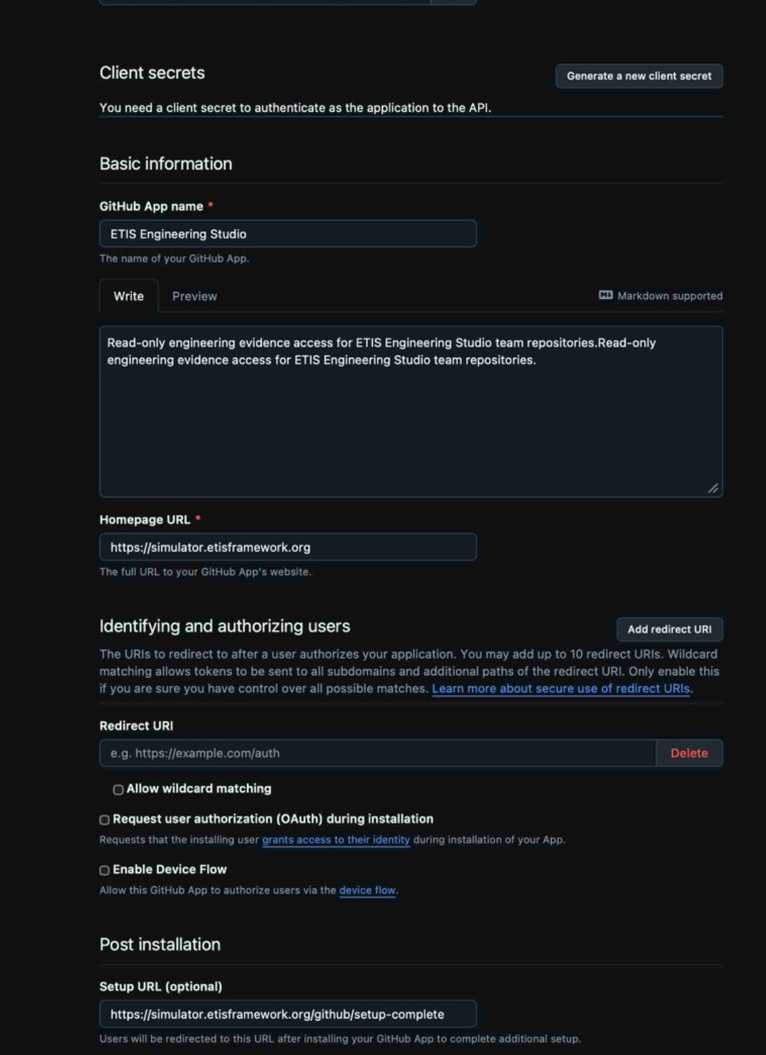
Figure 2. GitHub App general configuration. The production Setup URL returns the browser to ETIS after installation/update, and Redirect on update is enabled.
GitHub App setting | Accepted configuration
Name | ETIS Engineering Studio
Visibility/installability | Public, so personal GitHub accounts can install it; this does not make repositories public.
Homepage | https://simulator.etisframework.org
Setup URL | https://simulator.etisframework.org/github/setup-complete
Redirect on update | Enabled
Webhooks | Disabled in the current implementation; there is no webhook receiver.
Organization permissions | None required
Repository selection | Only select repositories. ETIS rejects repository_selection=all.

6.1 Repository permissions
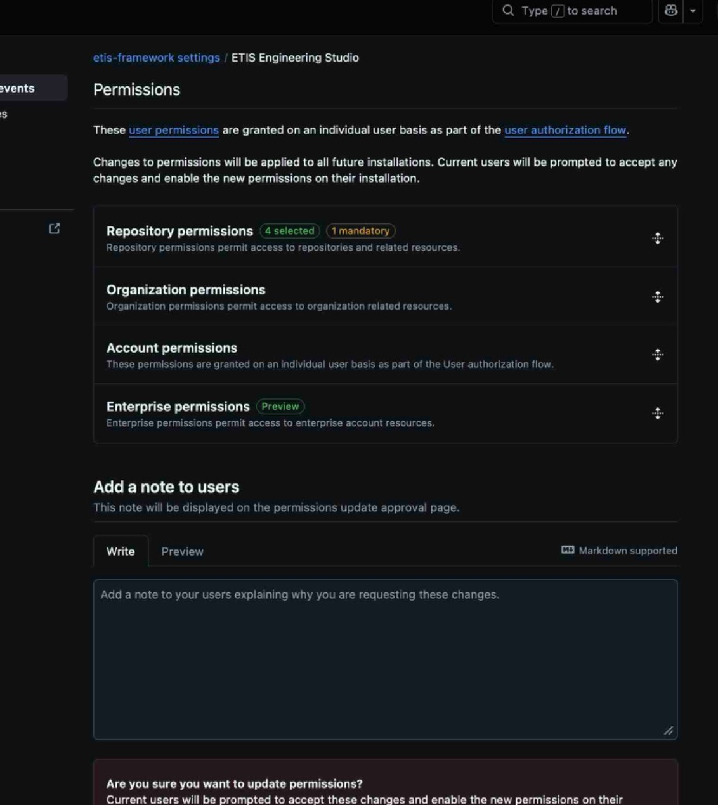
Figure 3. GitHub App permissions surface. Keep repository access read-only and limited to the permissions required for evidence acquisition.
Permission | Access
Metadata | Read
Contents | Read
Issues | Read
Pull requests | Read
Actions | Read

SELECTED REPOSITORIES ONLY
Every installation used by ETIS must choose “Only select repositories.” An installation that grants All repositories fails closed. Installation tokens are requested for the exact nominated repository only.

6.2 Private key handling
- Generate the GitHub App private key using GitHub’s App administration surface.
- Store the private key only in the protected production secret path used by the deployment workflow.
- Never commit the .pem key, paste it into documentation, or retain copies in shared course folders.
- Rotate/revoke the key immediately if exposure is suspected.

7. GitHub production environment, variables, and secrets
The repository uses a protected GitHub environment named production. The deployment workflow acquires Azure authority through OIDC only after source/release validation. Normal production deployment should be performed from main through the manual Deploy Azure workflow.
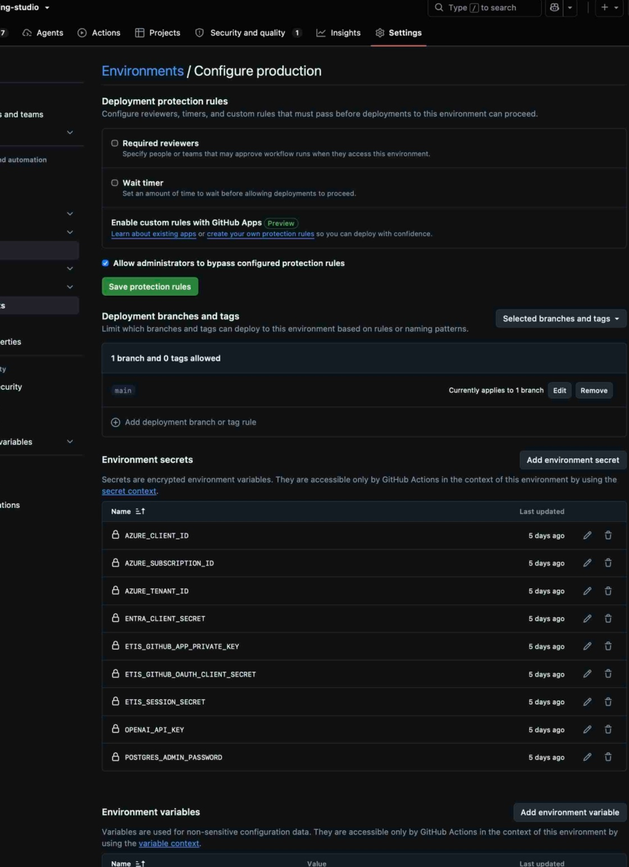
Figure 4. GitHub production environment (upper portion): deployment protection and branch restrictions plus the protected secret-name inventory. Secret values are not displayed.
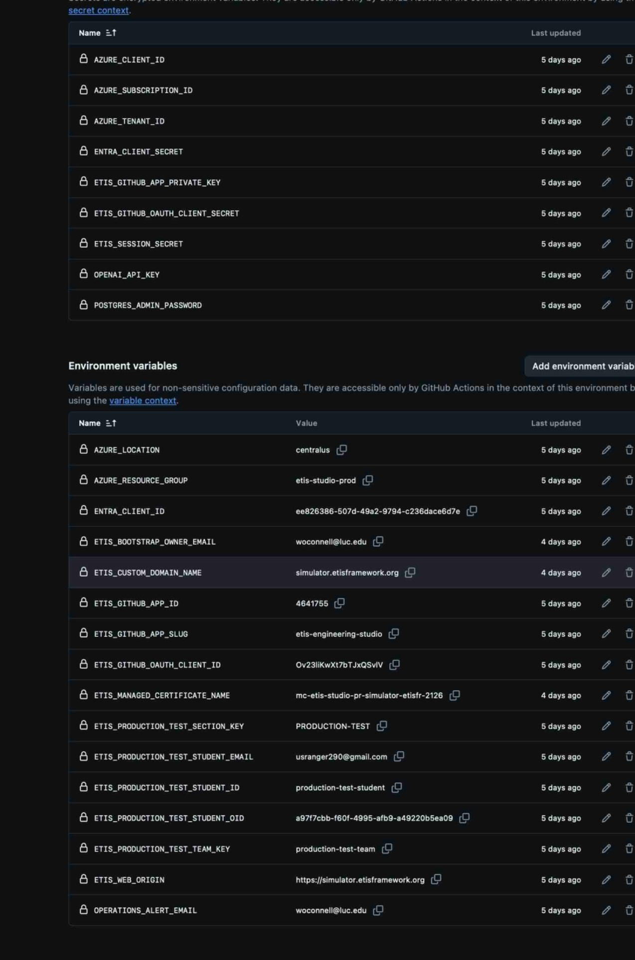
Figure 5. GitHub production environment (lower portion): continuation of secret names and the non-secret production variable inventory.
PRODUCTION ENVIRONMENT BOUNDARY
Restrict deployment branches/tags to the intended release source (accepted baseline: main). Treat changes to environment protection, secrets, or variables as production configuration changes requiring review.

7.1 Protected secrets
Secret name | Purpose
AZURE_CLIENT_ID | OIDC deployment application/client identity
AZURE_TENANT_ID | Azure/Entra tenant identifier used by deployment
AZURE_SUBSCRIPTION_ID | Target Azure subscription
POSTGRES_ADMIN_PASSWORD | PostgreSQL administrative bootstrap/secret provisioning
ETIS_SESSION_SECRET | Application session signing/entropy secret
ENTRA_CLIENT_SECRET | Entra application secret
ETIS_GITHUB_APP_PRIVATE_KEY | GitHub App private key
ETIS_GITHUB_OAUTH_CLIENT_SECRET | GitHub OAuth App client secret
OPENAI_API_KEY | OpenAI API project key

7.2 Non-secret production variables
Variable name | Purpose / expected relationship
AZURE_RESOURCE_GROUP | Production resource group; reference implementation etis-studio-prod
AZURE_LOCATION | Azure region
ETIS_WEB_ORIGIN | Canonical HTTPS public origin
ETIS_BOOTSTRAP_OWNER_EMAIL | Initial Course Owner bootstrap identity
ETIS_CUSTOM_DOMAIN_NAME | Public custom domain
ETIS_MANAGED_CERTIFICATE_NAME | Managed certificate resource name
ENTRA_CLIENT_ID | Entra application client ID
ETIS_GITHUB_APP_ID | GitHub App numeric ID
ETIS_GITHUB_APP_SLUG | GitHub App slug
ETIS_GITHUB_OAUTH_CLIENT_ID | GitHub OAuth identity-linking client ID
OPERATIONS_ALERT_EMAIL | Operational alert destination
ETIS_PRODUCTION_TEST_* | Exact production acceptance test-student identity/section/team values; never use these as a broad external-domain allow list.

8. Azure infrastructure and resource topology
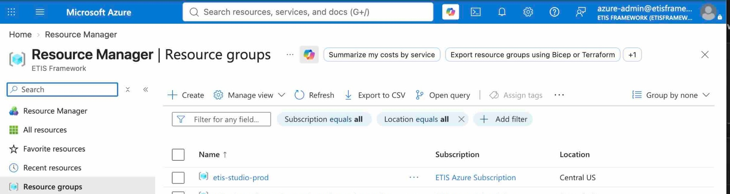
Figure 6. Azure resource-group view. The reference deployment keeps ETIS production resources under the dedicated etis-studio-prod resource group, plus platform-managed supporting groups where Azure requires them.
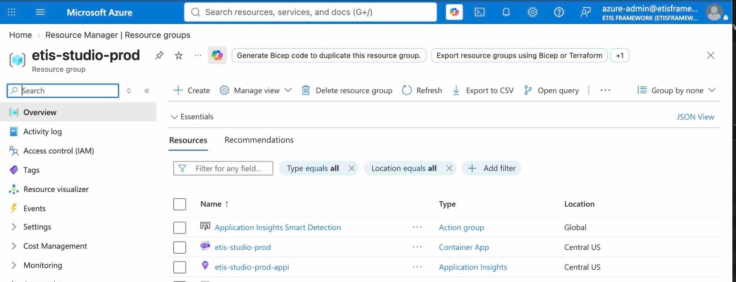
Figure 7. Production resource-group inventory. Key resources include Container Apps, Application Insights, Container Apps Environment, Key Vault, Log Analytics, migration job, alerts/action groups, PostgreSQL, ACR, managed identity, private networking, and supporting resources.
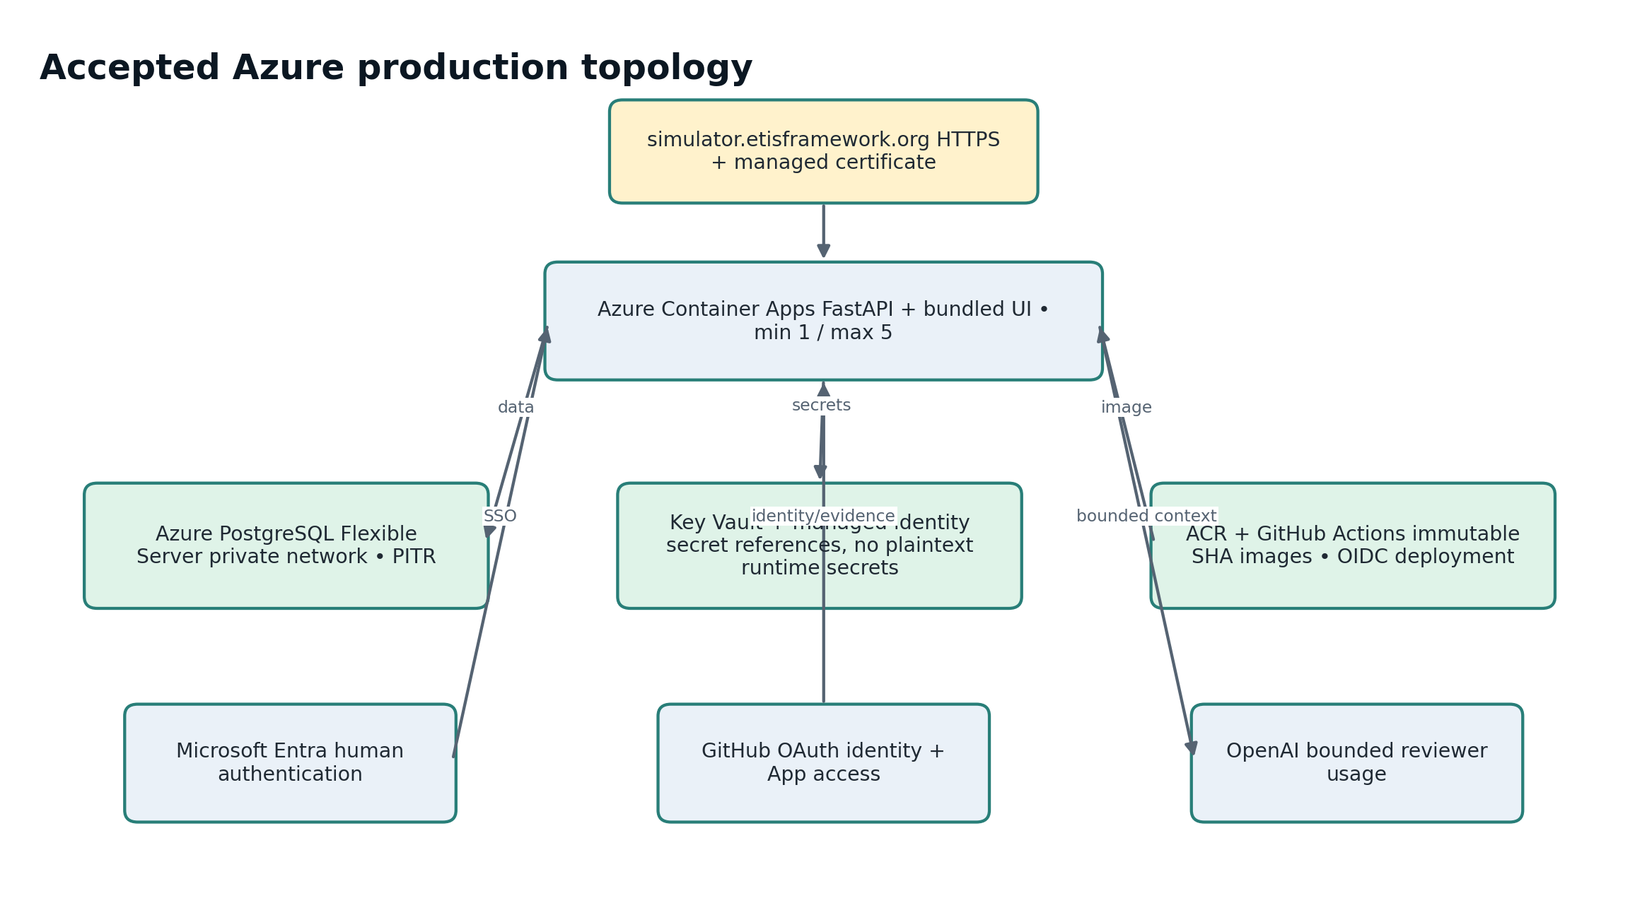
Figure 8. Accepted production topology. External providers remain separate trust boundaries around the managed Azure runtime.

8.1 Container Apps runtime
- Public HTTPS application endpoint through Azure Container Apps.
- Single revision mode in the accepted production baseline.
- Application container uses a user-assigned managed identity for ACR pull and Key Vault secret access.
- Runtime configuration references Key Vault secrets; do not place literal secrets in normal environment variables.
- Liveness/readiness probes are configured; /ready must fail closed on database connectivity or migration mismatch.
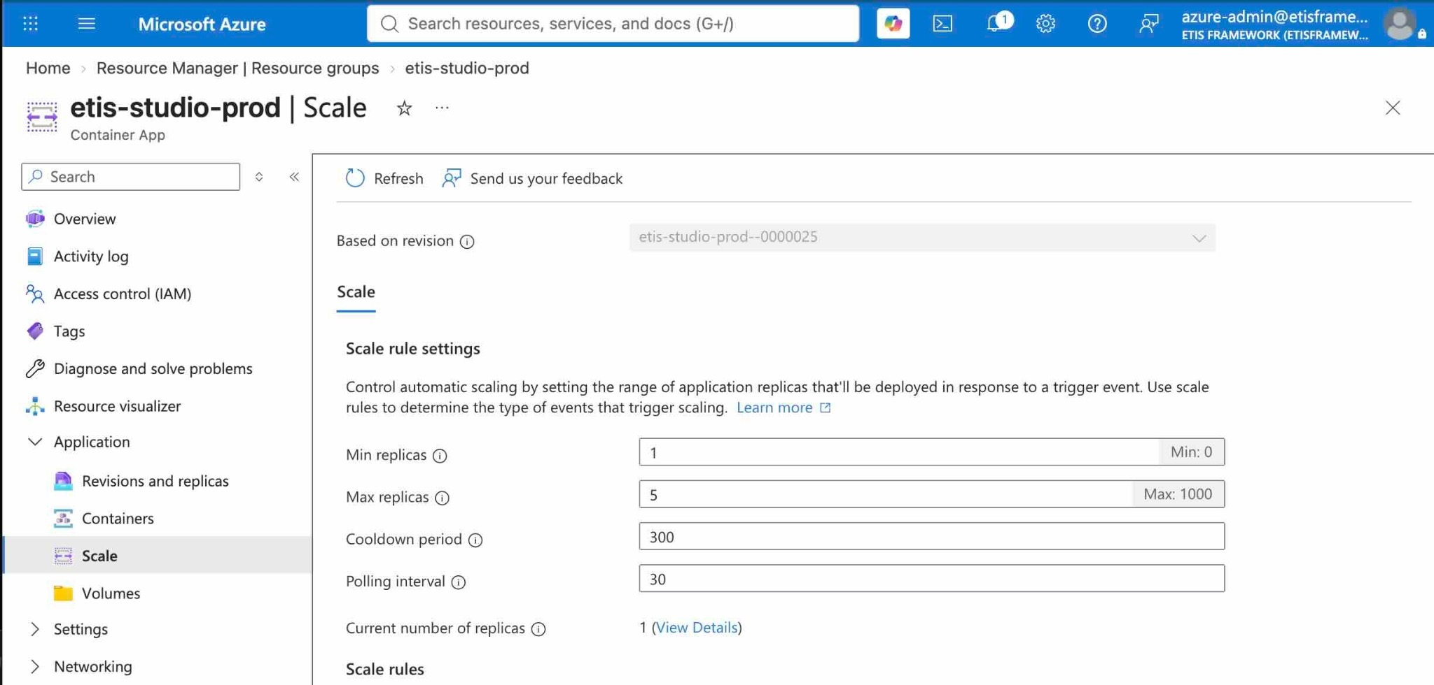
Figure 9. Semester production scaling baseline: minimum 1 replica, maximum 5 replicas. Keeping one replica warm avoids scale-to-zero cold starts during normal course operation.
IAC IS AUTHORITATIVE
The accepted source baseline now sets minReplicas=1 and maxReplicas=5 in the application Bicep. Do not preserve an old note that Bicep defaults to 0; that was corrected before this publication.

8.2 PostgreSQL Flexible Server
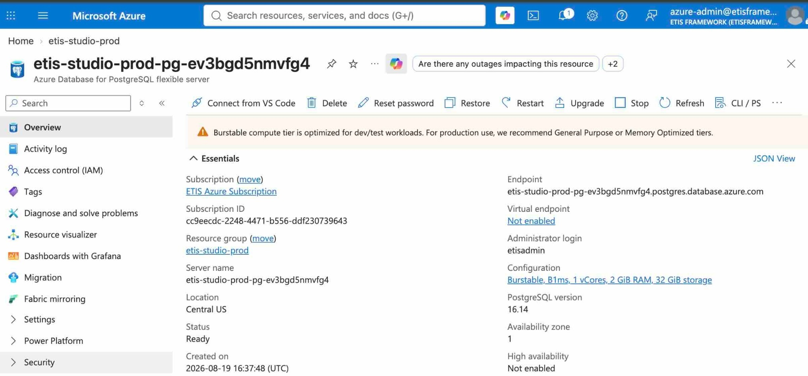
Figure 10. PostgreSQL Flexible Server overview. Production uses PostgreSQL as the durable system of record; schema lifecycle is controlled by Alembic.
- Production baseline uses PostgreSQL 16 with private/VNet-integrated connectivity.
- Backup retention/PITR must be enabled and validated before broad student use.
- The reference environment uses a cost-conscious small-course compute posture; capacity should be reviewed if course load or institutional use grows.
- Application readiness checks require database connectivity and migration_current=true.

8.3 Key Vault and managed identity
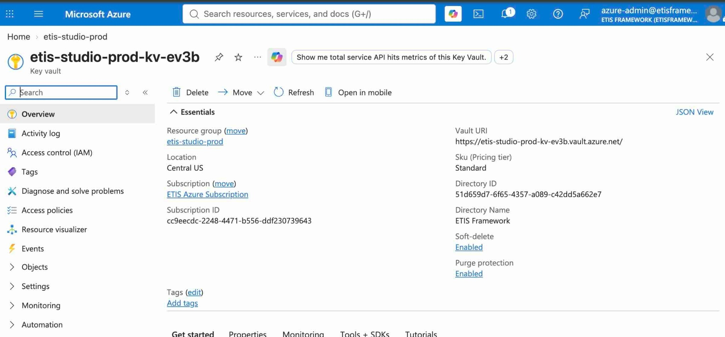
Figure 11. Key Vault overview. Document the vault and access model, never secret values.
- Use Azure Key Vault with RBAC authorization.
- Grant the runtime managed identity Key Vault Secrets User at the production vault scope; do not grant application runtime broad vault administration.
- ACR administrative credentials remain disabled; use managed-identity AcrPull.
- Secret names may be documented; secret values must not be.

9. DNS, TLS, callbacks, and external alignment
Item | Production value / requirement
Canonical origin | https://simulator.etisframework.org
DNS | CNAME/custom-domain configuration must point the public host at the Container App target used by the deployment.
TLS | Managed certificate, HTTPS only, expected HSTS/security headers.
Entra callback | https://simulator.etisframework.org/auth/entra/callback
GitHub OAuth callback | https://simulator.etisframework.org/auth/github/callback
GitHub App Setup URL | https://simulator.etisframework.org/github/setup-complete
PostgreSQL | Private network/DNS path only; no public database exposure in the accepted design.

CALLBACKS MUST MATCH EXACTLY
Authentication failures after a technically successful Azure deployment are often alignment failures among ETIS_WEB_ORIGIN, DNS/TLS, Entra callback, GitHub OAuth callback, and GitHub App Setup URL. Verify them as one set.

10. First production deployment

10.1 Pre-deployment source gate
1. Create a feature/fix branch from current main.
2. Run focused tests and the full pytest suite.
3. Open a PR and require green CI/release gates.
4. Merge to main only after review and green CI.
5. Do not attempt to bypass protected-main or the production environment.

10.2 Run the protected Deploy Azure workflow
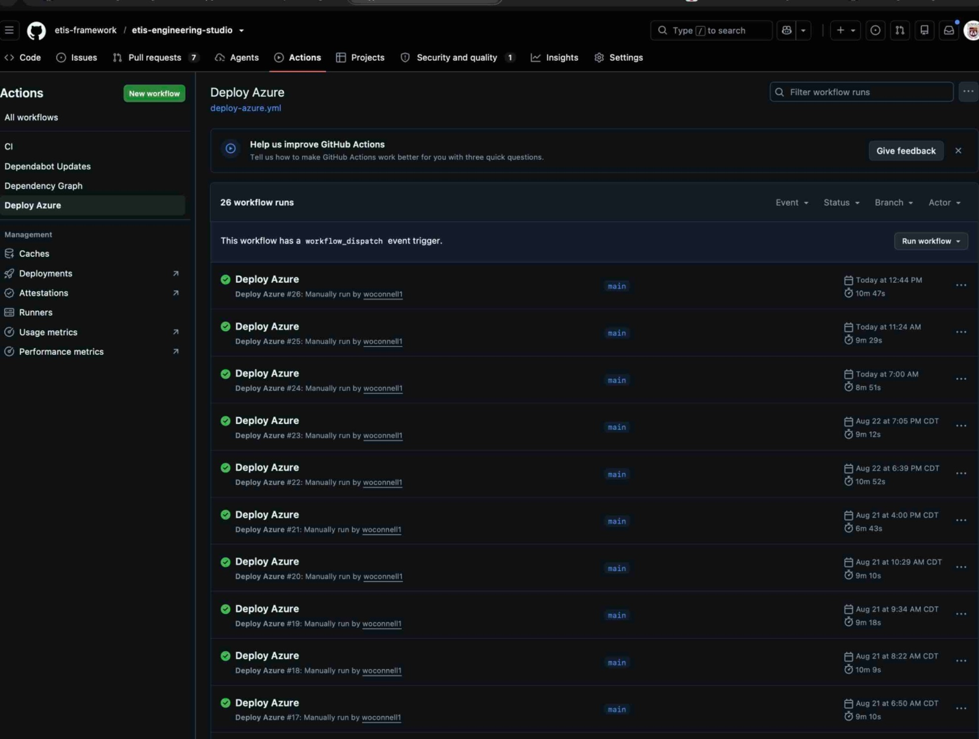
Figure 12. Deploy Azure workflow history. Production deployment is manually dispatched after merge to main.
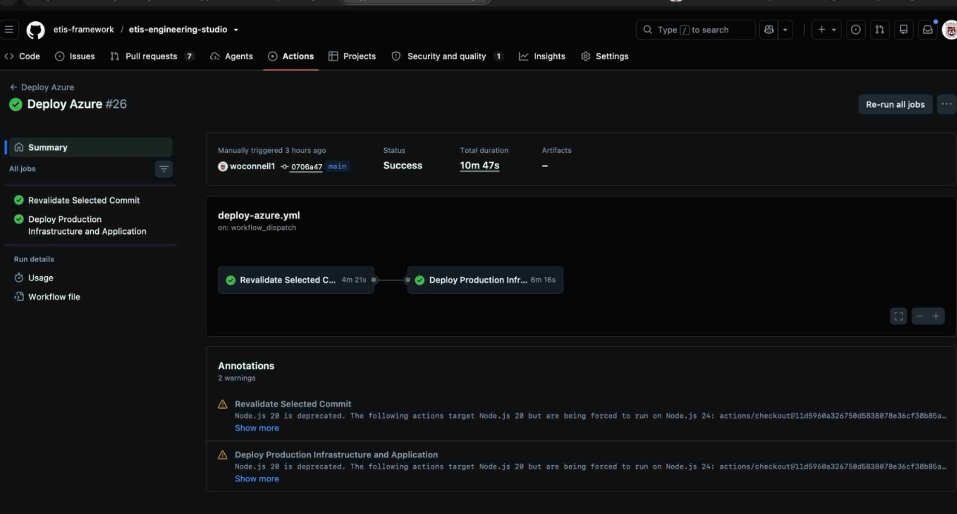
Figure 13. Successful deployment summary. The workflow first revalidates the selected commit, then deploys production infrastructure and the application.
The workflow’s controlled order is: release validation → Azure login (OIDC) → foundation → Key Vault secrets → immutable image → migration job → application → operational controls → readiness verification.
DO NOT BYPASS THE WORKFLOW
A green source build is not production authorization. Use the protected production environment and manual Deploy Azure workflow so the deployed image is tied to the validated Git SHA and production configuration.

11. Post-deployment acceptance
After every production deployment, use the repository’s Azure Operations CLI for repeatable acceptance rather than relying on portal screenshots or one-off raw Azure commands.
./scripts/azure/etis-azure doctor
./scripts/azure/etis-azure status
./scripts/azure/etis-azure acceptance
A healthy acceptance report should show required checks PASS for production status, application health, replica capacity, external smoke test, runtime drift, and budget controls. Cost telemetry is informational and may WARN if Azure Cost Management is throttled; it must not silently become a production-health gate.
Acceptance area | What must be true
Health | /health returns 200 and production status is healthy.
Readiness | /ready returns 200, database_connected=true, migration_current=true, and application can serve normal traffic.
Replica posture | Runtime matches min 1 / max 5 baseline with a ready running replica.
Authentication | Loyola user returns from normal institutional sign-in/MFA without a second ETIS password/MFA enrollment.
GitHub identity | Link/relink returns to Studio and remains bound to the initiating session.
Repository onboarding | Personal and organization repositories reach verified state through Step 1 authorization plus Step 2 exact verification.
Secrets | Runtime uses managed identity/Key Vault references; no plaintext secret drift.
Observability | Application Insights/Log Analytics connected; alerts/action group active.
Recovery | PITR window exists and restore procedure has been validated before broad use.
Cost controls | $100 monthly budget and 50/80/100% actual-cost alerts are configured.

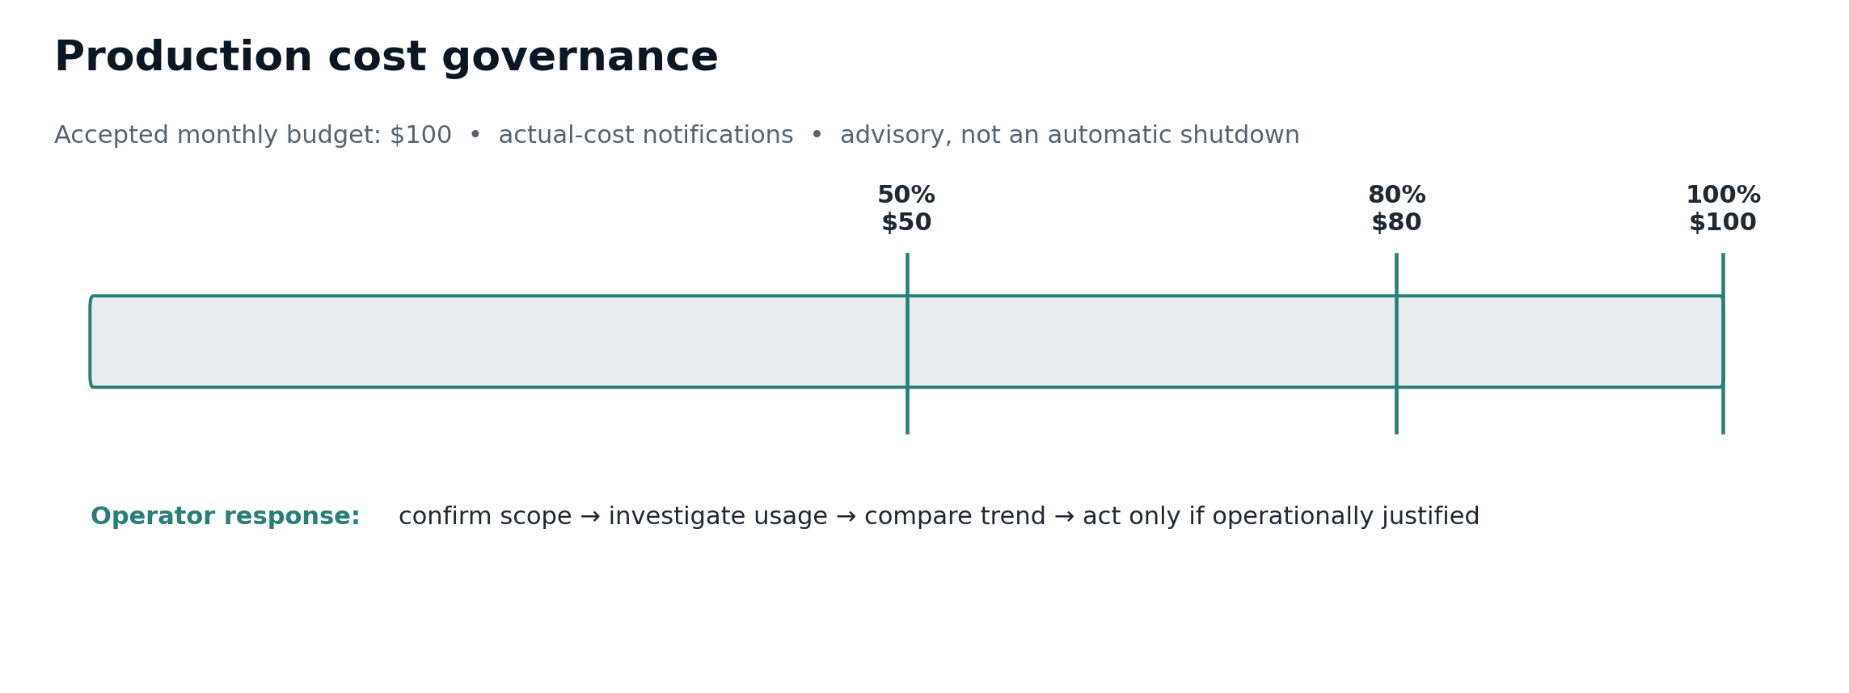
Figure 14. Accepted cost-control posture. Budget alerts notify operators; they do not automatically stop or scale down production.

12. Routine administration and semester posture
- Use Studio Semester Setup for course term, sections, roster, teams, review calendar, staff, activation, and archive.
- Treat setup → active → archived as authoritative lifecycle. Setup is administrative preparation; Active is normal student operation; Archived is historical/read-only and cannot grant current student/team/review authority.
- Keep one warm Container App replica during normal semester operation.
- Use ./scripts/azure/etis-azure status for quick checks and acceptance after deployments.
- Use repository reset only for deliberate re-onboarding; never force-bind arbitrary Team.repo_full_name state in the database.
- Review budget/cost signals as stewardship telemetry, not grades or automated shutdown triggers.

13. Upgrade and rollback

13.1 Normal upgrade
1. Branch from current main.
2. Implement the smallest controlled change.
3. Run targeted tests, full pytest, compilation/checks, one-Alembic-head validation where applicable, and diff review.
4. Push/open PR and require green CI.
5. Merge to main.
6. Run Deploy Azure for the merged commit.
7. Run etis-azure acceptance.
8. Record material acceptance findings; avoid speculative changes to a healthy release.

13.2 Application rollback
Container Apps runs Single revision mode. Rollback is a controlled redeployment of a known-good immutable ACR image tagged by Git commit SHA, not a traffic switch to an indefinitely retained active revision. Do not rebuild an old commit merely to recreate an image if the immutable known-good image already exists.

13.3 Database changes
Schema changes go through Alembic. Never edit the production schema ad hoc. A rollback decision involving an incompatible migration requires explicit recovery planning; application rollback alone does not automatically reverse database schema changes.

14. Troubleshooting
Symptom | First checks | Likely boundary / action
Can sign in, cannot enter Studio | Confirm active roster/section or staff assignment. | Authentication succeeded; course authorization is missing/stale.
Entra callback error | Compare ETIS_WEB_ORIGIN and exact Entra redirect URI. | Identity configuration/callback alignment.
GitHub identity wrong | Use relink/account selection; check immutable GitHub ID collision. | OAuth identity boundary; do not change repository binding as a shortcut.
Repository verification fails | Confirm App is installed for exact repo and Only select repositories; confirm owner/admin authorization. | GitHub App trust boundary.
GitHub App install returns but Step 2 pending | Return to My Team and explicitly verify repository access. | Expected two-step trust flow.
/health OK, /ready not ready | Check PostgreSQL connectivity and Alembic revision/head. | Database or migration readiness.
First request slow | Check minReplicas via etis-azure config/drift/replicas. | Scale-to-zero drift or replica issue.
Deployment green but wrong live behavior | Run etis-azure drift and smoke; verify latest revision/traffic and source baseline. | Runtime drift or external-path issue.
Cost command WARN 429 | Wait; do not hammer Cost Management. | Advisory telemetry throttling, not app health.
Secret/provider failure | Confirm secret name/reference, managed identity access, and environment configuration; never print secret values. | Key Vault/provider configuration.

15. Decommissioning
ARCHIVE IS NOT DELETION
Normal semester archive preserves engineering records and ends normal student operation. Infrastructure deletion is a separate governance action after retention requirements are satisfied.

1. Archive the term through the authoritative lifecycle and verify student operational access ends.
2. Confirm retention requirements for frozen evidence, review turns, findings/dispositions, memberships, and AI usage records.
3. Take/validate the required final database backup/PITR checkpoint and record the restore window.
4. Export required operational/audit evidence.
5. Disable general access/callbacks before destructive infrastructure actions.
6. Revoke/delete GitHub App installations and rotate/revoke private key if retiring the application.
7. Remove/rotate GitHub OAuth and Entra secrets; remove callbacks if the service will no longer be hosted.
8. Delete runtime, database, registry, vault, monitoring, networking, and supporting Azure resources only after retention authorization.
9. Remove DNS/certificate after intentional service shutdown.
10. Close budgets/alerts and record decommission date and retained records.

Appendix A. Greenfield installation checklist
☐ Administrative accounts/DNS authority ready
☐ Repository cloned; local pytest green
☐ Entra app/callback/client secret configured
☐ GitHub OAuth identity App/callback configured
☐ GitHub App public; Setup URL/Redirect on update configured
☐ GitHub App selected-repository read permissions verified
☐ Production GitHub environment restricted to main
☐ All required secrets and variables configured
☐ Azure deployment workflow completes successfully
☐ DNS/TLS/callback set aligned
☐ etis-azure acceptance PASS
☐ Normal Loyola MFA path verified
☐ Personal and organization GitHub onboarding verified
☐ minReplicas 1 / maxReplicas 5 confirmed
☐ Monitoring/alerts/PITR/budget verified
☐ Semester data prepared before activation

Appendix B. Required variables and secrets reference
Use Section 7 as the normative classification. Names may be present in documentation; secret values may not. When moving ETIS to another institution, keep the variable names stable unless intentionally changing the deployment contract, and replace institution-specific values such as domain, tenant, bootstrap owner, production-test identity, section/team keys, and alert recipient.

Appendix C. Acceptance and recovery command reference
./scripts/azure/etis-azure help
./scripts/azure/etis-azure doctor
./scripts/azure/etis-azure status
./scripts/azure/etis-azure config
./scripts/azure/etis-azure health
./scripts/azure/etis-azure replicas
./scripts/azure/etis-azure revisions
./scripts/azure/etis-azure logs
./scripts/azure/etis-azure smoke
./scripts/azure/etis-azure drift
./scripts/azure/etis-azure budget
./scripts/azure/etis-azure cost
./scripts/azure/etis-azure acceptance
MUTATING SCALE OVERRIDE
./scripts/azure/etis-azure scale <min> <max> changes live Azure runtime configuration and requires deliberate confirmation. Bicep remains authoritative. Use this only as a guarded operational override, not as a replacement for source-controlled infrastructure changes.

