ETIS

Architecture & Detailed Design
  - Product architecture, trust boundaries, course model, evidence pipeline, review orchestration, security, lifecycle, and Azure production design
Audience | Engineering maintainers, security reviewers, architects, course-platform owners, advanced operators
Purpose | Explain why Studio is built the way it is and define the invariants future changes must preserve.
Reference implementation | COMP 330/474 Software Engineering • Fall 2026
Canonical service | https://simulator.etisframework.org
Version | Production Baseline — August 2026 • August 23, 2026

CORE PRINCIPLE
AI may challenge, critique, synthesize, and ask for evidence. Engineers decide, defend, and own the consequences. Deterministic authorization, lifecycle state, and frozen repository evidence remain authoritative.

Contents
Executive Overview Architectural intent, responsibility boundaries, and key invariants
1 Product intent and explicit non-goals
2 Logical architecture
3 Identity and authorization model
4 Course, term, section, team, and membership model
5 GitHub identity and repository onboarding
6 Evidence acquisition, FACT/REVIEW, and frozen snapshots
7 Review orchestration and AI boundary
8 Student decision and learning-history model
9 Instructor/teaching-staff design
10 Persistence and schema lifecycle
11 Concurrency, idempotency, and fail-closed invariants
12 Azure production topology
13 Delivery, observability, recovery, and cost control
14 Security and privacy boundaries
15 Failure modes and defensive behavior
16 Extension points and change discipline
Appendix A Key invariants
Appendix B Source map
Appendix C Architecture decision test cases

Executive Overview
ETIS Engineering Studio is a decision-and-defense environment for engineering apprenticeship. Its core learning surface is the Engineering Review Room: students confront repository-derived evidence, uncertainty, tradeoffs, consequences, and professional responsibility. The architecture intentionally separates deterministic responsibilities from AI assistance. Authentication, course authorization, lifecycle state, repository trust, frozen evidence, and persistence are deterministic system responsibilities; AI is a bounded adviser.
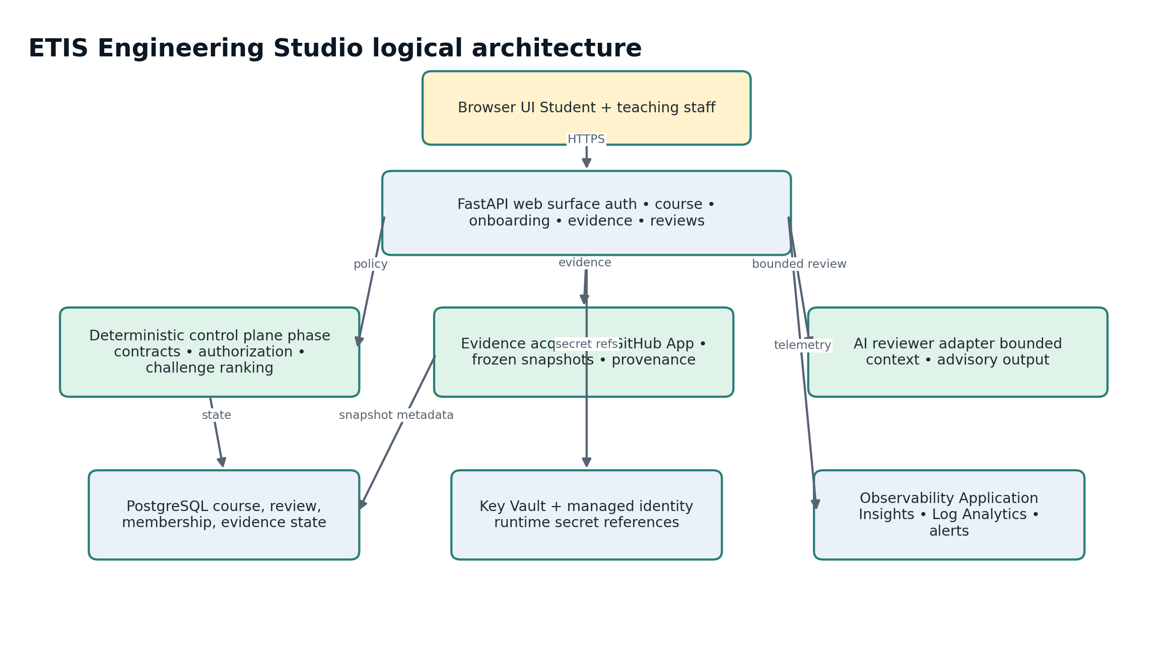
Figure 1. Logical architecture. Deterministic policy and frozen evidence remain authoritative; AI is advisory.
ARCHITECTURAL RULE
The system may help a student reason, but it must never silently become the responsible engineer. Course requirements, authorization, snapshot evidence, and lifecycle state are deterministic system responsibilities.

1. Product intent and explicit non-goals

1.1 Intended outcomes
- Practice professional engineering judgment rather than answer retrieval.
- Force explicit evidence boundaries, uncertainty, tradeoffs, ownership, and consequences.
- Expose students to multiple professional lenses without treating AI reviewers as authorities.
- Preserve an inspectable engineering record of frozen evidence and persisted review turns.
- Allow disagreement and correction when REVIEW interpretations are wrong without mutating FACT evidence.

1.2 Explicit non-goals
- No autonomous final grading.
- No hidden assignment-scope expansion beyond instructor/course contracts.
- No fabrication of missing repository evidence.
- No student PATs for repository access.
- No generic application-global instructor role that bypasses term/section authority.
- No destructive archive semantics.
- No AI-generated mutation of the repository as a substitute for student engineering work.

2. Logical architecture
Component | Responsibility
Web surface | FastAPI serves bundled UI and API routes for authentication, course administration, onboarding, evidence, instructor views, and review sessions.
Course model | Machine-readable A1-A6 phase contracts define deterministic requirements, release context, and challenge anchors for the COMP 330/474 implementation.
Challenge control plane | Ranks evidence gaps, phase defenses, professional lenses, and engineering moves without delegating policy to the LLM.
Evidence services | GitHub App access, repository intelligence, frozen snapshot creation, evidence packages, strengths/findings, provenance.
AI services | Bounded reviewer adapter, semantic repository interpretation/coaching, cost/latency telemetry.
Persistence | SQLAlchemy models on PostgreSQL production / SQLite local; Alembic controls schema.
Operations | Azure health/readiness, monitoring, alerts, PITR, immutable ACR images, budget controls, operations CLI.

3. Identity and authorization model
The design deliberately separates human authentication, course authorization, GitHub identity, GitHub repository authority, and the active Studio session. Conflating any pair would make it possible for the wrong external identity or stale course role to mutate current state.
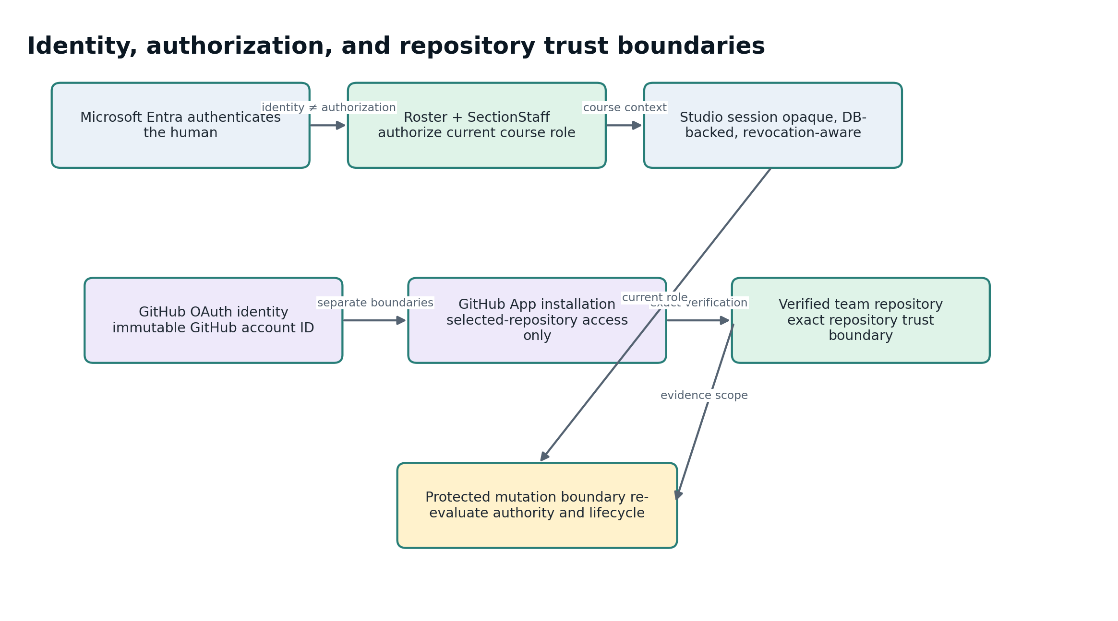
Figure 2. Identity, authorization, and repository trust are separate boundaries that converge only at protected action/evidence boundaries.
Boundary | Design
Microsoft Entra | Authenticates the human. Production uses an explicit tenant and verified tenant-scoped object ID.
Roster / SectionStaff | Authorizes current course access and role. Lifecycle-valid database state is authoritative.
GitHub OAuth identity | Maps Studio user to immutable GitHub account ID + current login. OAuth state is bound to the initiating revocation-aware Studio session.
GitHub App installation | Authorizes read-only repository evidence access. Selected repositories only; exact repository token scope.
Studio session | Opaque, database-backed, revocation-aware, approximately 12-hour session in the accepted design. Current authorization is re-evaluated during parsing/mutation boundaries.

3.1 Staff roles
Role | Authority boundary
Course Owner | Term-scoped elevated administration; prepare/activate/archive terms, grant elevated staff authority, bounded repository reset, historical read.
Instructor | Assigned-section administration and historical read where permitted; bounded repository reset.
TA | Bounded active-semester review/read; no roster/lifecycle/elevated-role mutation; no archived authority.
Reviewer | Bounded active-semester review/read; no course administration; no archived authority.
Student | Current active section/team access and own permitted review activity.

4. Course, term, section, team, and membership model
Durable scope follows Course Template → Term → Section → Team → Student. Parallel sections share the COMP 330 lifecycle model but can differ in dates, release overrides, roster, teams, and staff.
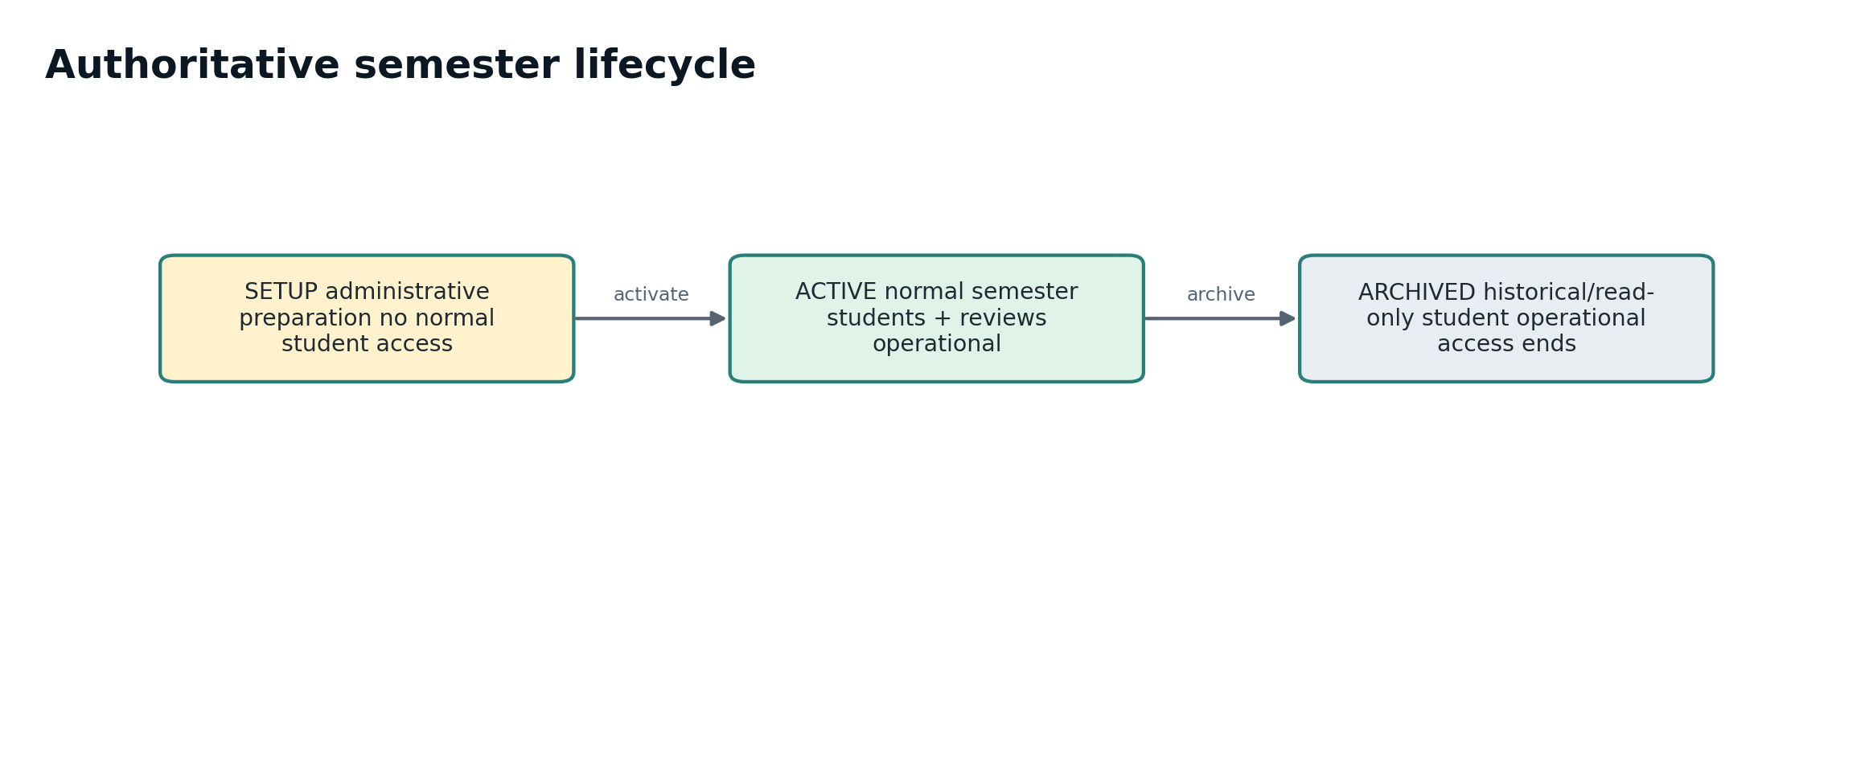
Figure 3. Semester lifecycle is forward-only: setup → active → archived. Archive preserves history but ends normal student operation.
- Setup is administrative preparation.
- Active is current teaching state; authorization resolves from current enrollment, team membership, section staff, release state, and lifecycle.
- Archived is read-only history; student operational access ends; active reviews become archived_incomplete; historical evidence and conversations remain.
- Moving/dropping a student preserves earlier review history and membership events.

5. GitHub identity and repository onboarding
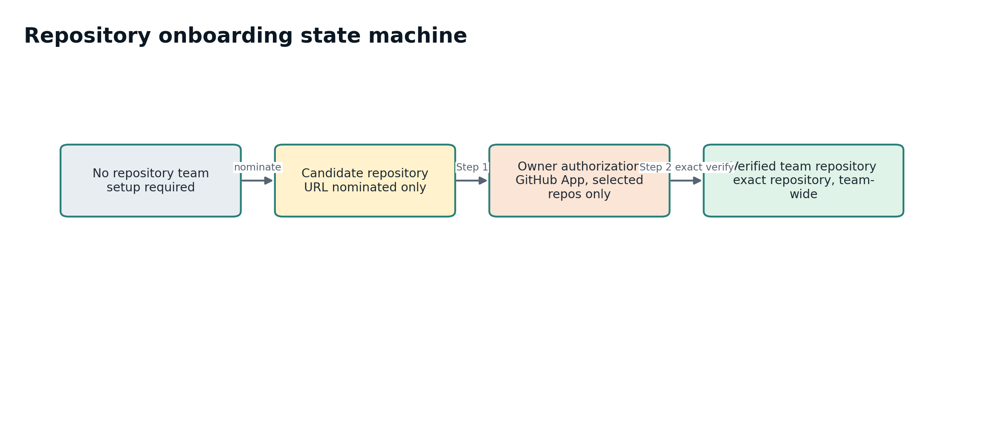
Figure 4. Team repository onboarding is a controlled state machine. A pasted URL is a nomination, not trusted evidence.

5.1 Candidate versus verified repository
A typed URL is only a candidate. Candidate nomination cannot populate authoritative verified repository metadata and cannot be used as trusted evidence until exact GitHub verification succeeds.

5.2 Owner authority and installation/token invariants
- Repository ownership is resolved from namespace owner identity using immutable GitHub account ID where applicable.
- Personal repository: only the actual owner may authorize ETIS. Non-owning teammates wait; verification success becomes team-wide.
- Organization repository: GitHub’s native owner/admin request/approval workflow determines who can grant access.
- The App is public so personal accounts can install it, but every installation must use selected repositories only.
- repository_selection=all fails closed.
- ETIS requests a short-lived installation token containing only the nominated repository and verifies the returned repository list exactly.
- PATs and long-lived OAuth repository credentials are not supported.
- Changing an individual GitHub identity does not silently replace a team’s verified repository.

6. Evidence acquisition, FACT/REVIEW, and frozen snapshots
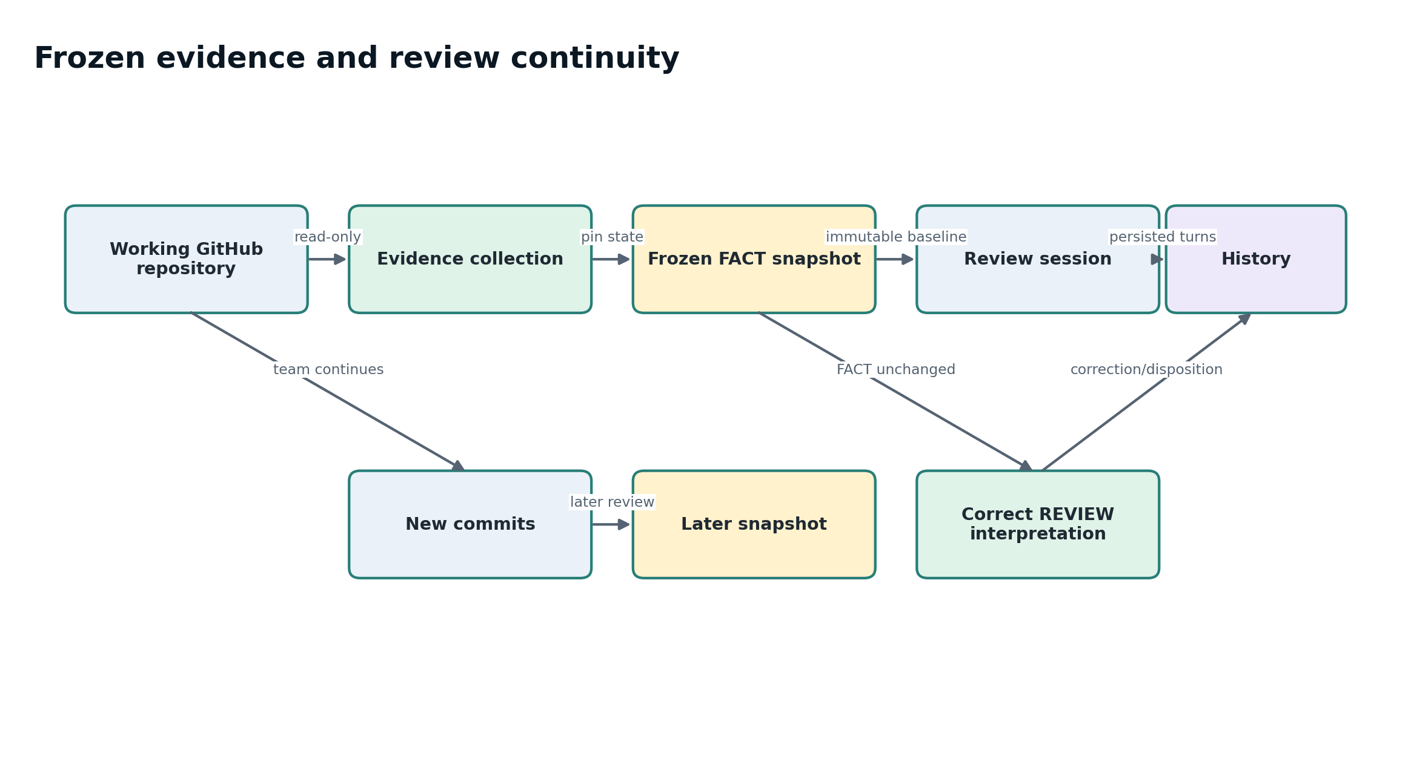
Figure 5. Evidence checkpoint lifecycle. New repository commits never mutate the FACT snapshot already bound to an active or completed review.
Concept | Meaning
FACT | Immutable repository-derived baseline: paths, commit SHA/provenance, bounded artifact excerpts/metadata, workflow signals.
REVIEW | Interpretation of FACT evidence: findings, strengths, gaps, concerns. REVIEW may be corrected without changing FACT.
Snapshot | Pinned evidence package used by a review. Repository refresh never mutates evidence underneath an active review.
Correction/disposition | Validated correction or staff disposition prevents a later review on the same snapshot from rediscovering the same false interpretation while preserving original FACT.
Commit history | GitHub remains authoritative for raw commit history. ETIS may use commit/workflow history as evidence signals but does not replace GitHub as the source-control history browser.

6.1 Evidence acquisition scope
The collector reads bounded repository information authorized by the GitHub App: repository metadata, default-branch ref/tree/blobs, issues, pull requests/reviews, Actions runs, tags, commits, branches, and later-phase release signals. The evidence layer converts those observations into phase-aware FACT and REVIEW structures before review.

7. Review orchestration and AI boundary
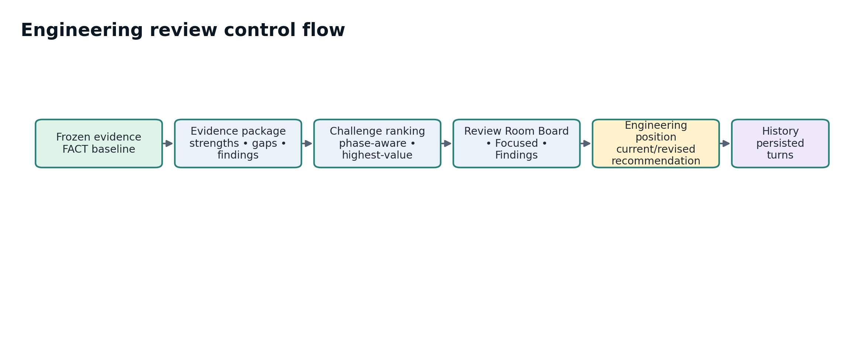
Figure 6. Review orchestration from frozen evidence through persisted learning history. AI operates inside the review step, not as the authority for evidence or course policy.

7.1 Review types
Type | Purpose
Board Review | Normal developmental phase-gate review. The board ranks/selects the highest-value current challenge.
Focused Review | Student-selected artifact, decision, PR, architecture choice, risk, AI use, or work-in-progress concern.
Review Findings | Understand, challenge, resolve, accept/defer, or provide contrary evidence for one or a small related set of existing findings.

7.2 Reviewer lenses
Professional lenses include Chief Architect, Security Engineer, Verification Lead, Operations Lead, Human Impact Reviewer, and Red Team. They challenge from different risk perspectives; legitimate disagreement is preserved rather than flattened into one synthetic “correct” answer.

7.3 Bounded AI economics and context
- OpenAI receives compact, relevant evidence packages rather than entire repositories.
- Usage telemetry tracks model, input/cached-input/output tokens, latency, and estimated cost without duplicating complete prompts/responses into telemetry records.
- AI may fail or be unavailable; deterministic authorization and evidence policy still fail closed rather than inventing evidence.

8. Student decision and learning-history model
- Current recommendation is optional and revisable; it tells the reviewer where the engineer is leaning.
- A student may remain “not ready to choose yet” while evidence or reasoning is incomplete.
- The recommendation posture changes the next engineering move/coaching challenge.
- Formal recommendation/discussion actions occur only when the student is prepared to defend a consequential position; not every review requires a final commitment.
- Review History preserves individual persisted turns against the frozen evidence used at that moment.
- Unsent drafts remain private.
DEVELOPMENTAL VS. FORMAL EVIDENCE
Studio dialogue is developmental. It may influence what the team changes, but it does not silently become formal phase-gate evidence. Formal review uses the instructor-designated repository evidence boundary/tag.

9. Instructor/teaching-staff design
- Instructor Command Center aggregates authorized active sections and makes section context explicit.
- Section selection persists across meaningful instructor views; browser Back/Forward restores meaningful context.
- Team Detail shows stable team identifier/context, membership, repository state, evidence signals, and active student reviews.
- Gold/amber means needs attention; green means no current attention signal. Attention is a coaching signal, not an automated grade.
- Teaching staff may inspect persisted review turns when authorized; generic read access never grants student mutation authority.
- Repository reset is bounded recovery: it clears the current verified binding while preserving frozen evidence/review history.
- TA/Reviewer roles remain intentionally read-oriented and cannot mutate elevated course administration or archived state.

10. Persistence and schema lifecycle
PostgreSQL is the production system of record. Local development may use SQLite. Alembic migrations are explicit release artifacts; production startup does not silently create or mutate schema.
- Production readiness compares current Alembic revision with application head.
- One Alembic head is required before release/deploy.
- Migrations execute in a Container Apps Job before application deployment.
- Duplicate immutable GitHub account IDs fail closed rather than merging identities.
- Archive retains historical evidence, review turns, findings/dispositions, membership events, and AI usage records according to lifecycle/retention policy.

11. Concurrency, idempotency, and fail-closed invariants
Invariant | Defensive behavior
Repository promotion race | After external GitHub verification, re-read/lock authoritative candidate state; if candidate changed, fail instead of promoting stale repository.
Team mutation authority | Re-evaluate membership/staff authority at the mutation boundary, not only request entry.
Session revocation | Archived/lost course authority revokes course-bound session access during parsing/authorization.
OAuth callback | Signed state alone is not authentication; callback requires the same initiating Studio session/user.
Side-effecting GET | Repository authorization navigation does not silently persist trust-state mutation; persisted transitions occur through explicit mutation behavior.
Malformed repository URL | Reject credentials, ports, query/fragment, extra path segments, invalid names, and non-HTTPS GitHub URLs.
All-repository GitHub installation | Fail closed; do not accept overly broad scope.
Schema/readiness mismatch | /ready is not ready; deployment acceptance fails rather than serving normal traffic.

12. Azure production topology
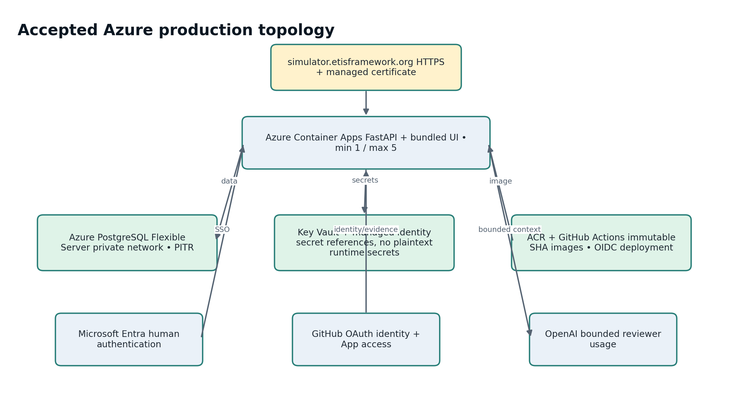
Figure 7. Azure production topology and external trust boundaries.
Control | Accepted design
Container Apps | Public HTTPS FastAPI/bundled UI, Single revision mode, min 1/max 5 semester baseline.
PostgreSQL Flexible Server | PostgreSQL 16, private network, PITR/backup retention enabled and restore-tested.
Key Vault | Production secrets referenced at runtime; managed identity receives narrow RBAC.
ACR | Immutable application images tagged by Git commit SHA; managed identity pull.
Application Insights + Log Analytics | Workspace-based observability and operational telemetry.
Azure Monitor | Alerts for restarts, HTTP 5xx, PostgreSQL health/storage with operations action group.
Budget | $100 monthly reference budget with 50/80/100% actual-cost notifications.

13. Delivery, observability, recovery, and cost control
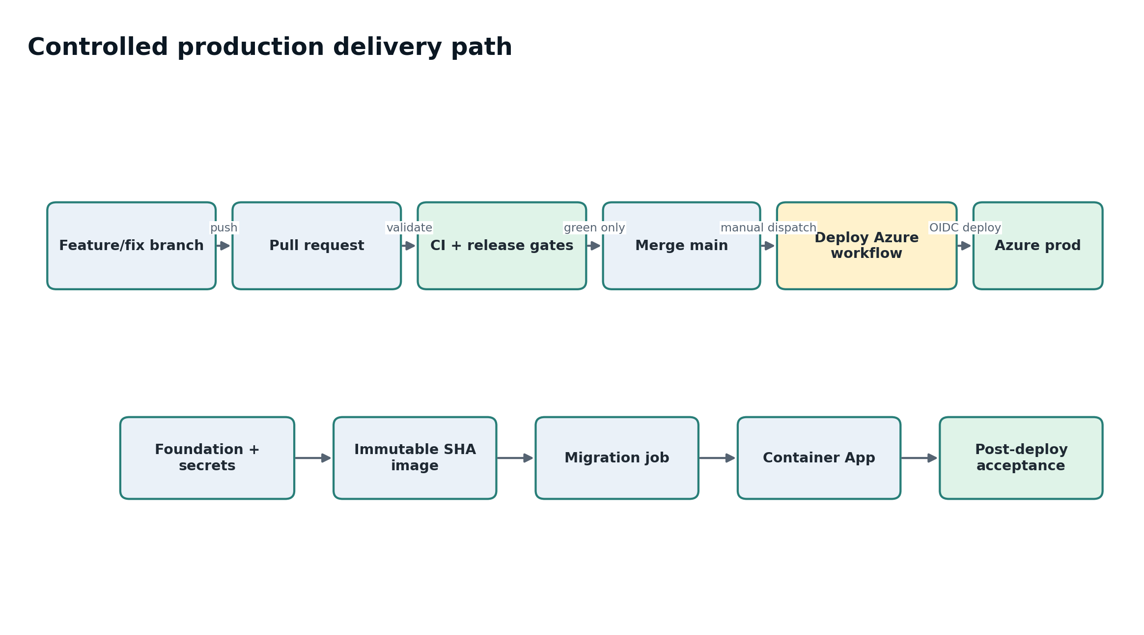
Figure 8. Production delivery is repository-controlled and revalidated before Azure authority is acquired.
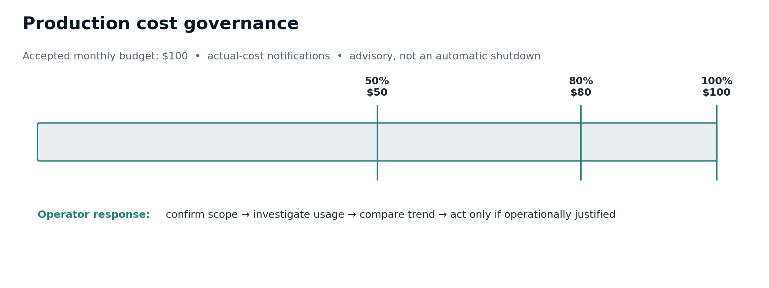
Figure 9. Cost governance is advisory operational control: thresholds notify operators but do not become an availability or grading mechanism.
Operational control | Architectural purpose
/health | Liveness/service state. Should not claim full readiness when critical dependencies are unavailable.
/ready | Fail closed on database connectivity or migration mismatch.
PITR | Recover durable PostgreSQL state to a known point in time; validate restored schema/data before use.
Rollback | Redeploy a prior immutable SHA-tagged image; Single revision mode avoids relying on a pile of simultaneously active revisions.
Drift | Compare live runtime with source/accepted baseline rather than assuming portal state matches IaC intent.
Budget/Cost | Stewardship telemetry. Cost APIs may lag/throttle; this is not a production-health gate.

14. Security and privacy boundaries
- No student Studio passwords; Entra is the human identity provider.
- No PATs; GitHub App short-lived exact-repository tokens only.
- No long-lived GitHub OAuth access-token retention for repository reading.
- No plaintext runtime secrets in Container App configuration.
- No complete prompts/responses in AI usage telemetry; telemetry is bounded metadata.
- Normal logs must not contain cookies, authorization codes, tokens, API keys, complete prompt bodies, complete model responses, or unnecessary student PII.
- Archive preserves historical engineering record; retention/deletion is a separate governance decision.
- Unsent student drafts remain private; staff conversation drill-down exposes persisted turns only.

15. Failure modes and defensive behavior
Failure | Expected behavior
GitHub App installed for all repositories | Verification fails with explicit selected-repository requirement.
Wrong GitHub account | Identity can be relinked; immutable account-ID conflict fails closed.
Organization approval pending | Student sees owner/admin authorization requirement rather than generic “instructor approval.”
Candidate changes mid-verification | Promotion returns conflict; authoritative team connection is not corrupted.
Archived term | Student operational access ends; stale staff authority cannot mutate unrelated semesters.
Database unavailable / schema behind | /ready is not ready; deployment acceptance fails.
AI unavailable | Do not fabricate evidence or silently claim semantic coaching occurred.
Browser GitHub authorization tab | Setup URL returns to ETIS; exact repository verification remains Step 2.
Cost API throttled | Report advisory WARN; do not mark application unhealthy or repeatedly hammer API.

16. Extension points and change discipline
- Deeper A3-A6 conversational depth and specialized engineering stress scenarios.
- Advanced instructor analytics, annotations, replay/archive UI, and research exports.
- Push notifications and finer-grained cost/rate controls.
- Explicit accessibility/performance instrumentation as separate controlled workstreams.
- Institution-neutral course templates beyond the COMP 330/474 six-gate implementation.
CHANGE DISCIPLINE
Do not reopen accepted trust boundaries for speculative polish. Future changes should be driven by an observed defect, course need, security requirement, or intentionally scheduled enhancement and must preserve Appendix A invariants.

Appendix A. Key invariants
☐ Authentication and course authorization remain separate.
☐ Archived semesters never grant current mutation authority.
☐ A candidate repository is never trusted evidence.
☐ Only the repository owner/authorized organization can grant GitHub App access.
☐ All-repositories GitHub App scope is rejected.
☐ Exact-repository installation token scope is verified.
☐ Frozen FACT evidence is immutable.
☐ Correctable REVIEW interpretation is not FACT evidence.
☐ Read authority does not imply student mutation authority.
☐ Unsent drafts remain private.
☐ Schema changes go through Alembic.
☐ Production secrets remain in Key Vault / protected deployment secrets.
☐ Health/readiness fail closed on critical dependencies.
☐ Cost telemetry does not silently become an availability or grading gate.
☐ Formal phase-gate evidence boundary remains distinct from developmental Studio dialogue.

Appendix B. Source map
Source | Primary design authority
docs/ARCHITECTURE.md | Product/logical architecture
docs/SECURITY_AND_PRIVACY.md | Privacy, logging, GitHub/AI boundaries
docs/architecture/IDENTITY_COURSE_ADMINISTRATION.md | Identity, roles, lifecycle, onboarding
docs/architecture/REPOSITORY_INTELLIGENCE_AND_REVIEW_ORCHESTRATION.md | Evidence/repository/review orchestration
docs/architecture/ENGINEERING_EVIDENCE_AND_REVIEW_CONTINUITY.md | Evidence workspace and review continuity
apps/api/app/services/auth.py | Session, Entra, OAuth state and identity binding
apps/api/app/services/github_app.py | GitHub owner resolution and exact-repository tokens
apps/api/app/routers/onboarding.py | Repository onboarding state transitions
apps/api/app/routers/reviews.py | Review mutations and authority
infra/azure/*.bicep | Production IaC layers
.github/workflows/deploy-azure.yml | Release validation/deployment order
scripts/azure/ | Operator-facing production inspection, drift, smoke, acceptance, and guarded scale override

Appendix C. Architecture decision test cases
Scenario | Required architectural result
Student signs in with valid Loyola account but is not rostered | Authenticate human; deny course operation.
Student pastes a GitHub URL | Store candidate only; do not trust evidence.
App installation has All repositories | Fail exact verification.
Team changes candidate while verification is in flight | Do not promote stale candidate.
Repository receives new commits during active review | Active review remains bound to frozen snapshot.
Reviewer interpretation is proven wrong | Correct/disposition REVIEW without mutating FACT snapshot.
TA can read a review | TA still cannot perform student review mutation or elevated course administration.
Term archived while review active | End normal student access; preserve review as archived_incomplete.
Database migration behind application head | /ready fails; deployment acceptance blocks normal service.
OpenAI unavailable | Preserve deterministic controls; do not fabricate a reviewer result.
Cost API returns 429 | Report advisory WARN; production health remains determined by required checks.

