ETIS

Instructor & Course Owner Handbook
  - Complete teaching-staff reference for oversight, coaching, evidence interpretation, course administration, student support, and responsible use of ETIS
Audience | Course Owners, instructors, TAs, reviewers, and authorized teaching staff
Purpose | Enable a first-time teaching-staff member to use ETIS confidently, preserve role boundaries, coach from evidence, resolve routine student issues, and know when administrative or operational escalation is required.
Reference implementation | COMP 330/474 Software Engineering • Fall 2026
Version | Semester Start 2026 • August 23, 2026

CORE PRINCIPLE
Teaching staff use ETIS to observe engineering reasoning, evidence, and risk without turning activity counts, AI output, or attention signals into grades. Students remain responsible engineers; staff remain responsible educators and course authorities.

Contents
Use Word’s Navigation pane to jump directly among numbered headings. The section list below follows the same structure.
1. Executive Overview
2. Teaching-staff roles and authority boundaries
3. First sign-in, navigation, and section context
4. Instructor Command Center
5. Teams and Team Detail
6. Students: roster and team membership
7. Reviews: viewing student engineering conversations
8. Engineering Evidence: FACT, REVIEW, snapshots, and longitudinal change
9. Findings, disputes, and staff dispositions
10. Repository recovery and reset
11. AI Usage & Cost
12. Settings & Access
13. Using ETIS as a coaching instrument, not a grader
14. Daily and weekly instructor operating rhythm
15. Supporting common student situations
16. Teaching-staff troubleshooting
17. Appendix A - Role authority matrix
18. Appendix B - Instructor use cases
19. Appendix C - First-week checklist
20. Appendix D - Terminology

Executive Overview
ETIS Engineering Studio gives teaching staff a view into the engineering evidence, reasoning, unresolved risk, and review activity that sit behind student project work. The instructor experience is intentionally different from the student experience: staff observe, coach, administer authorized course state, and validate selected findings; they do not impersonate student review actions or convert telemetry into grades.

What this guide enables
- Orient quickly to section health and teams that need attention.
- Move from a class-level signal to Team Detail, Engineering Evidence, and persisted review conversations.
- Interpret coverage, findings, active reviews, and AI telemetry without over-reading them.
- Manage roster/team membership only when your role permits it and preserve historical context.
- Reset repository onboarding only as a bounded recovery action.
- Understand Course Owner, Instructor, TA, and Reviewer boundaries.
- Support students with repository, review, evidence, and history questions.
- Escalate platform/auth/database incidents to the operational runbook rather than trying to solve infrastructure from the course UI.

Normal teaching-staff path
Choose section | Scan Command Center | Inspect team | Read evidence | Review persisted reasoning | Coach / administer | Recheck

DESIGN BOUNDARY
ETIS will not autonomously assign a final grade, rank students by activity, invent repository evidence, expose private unsent student drafts, or give students a hidden “correct” engineering decision.

ABOUT THE SCREENSHOTS
Screenshots use the production acceptance environment. Real sections will contain more students, teams, repositories, reviews, and evidence. Use the screenshots to recognize controls and information hierarchy, not as expected numerical values.

2. Teaching-staff roles and authority boundaries
Authentication and authorization are separate. Signing in proves identity; database-backed course/term/section state determines what a staff member may read or change. Role authority is intentionally scoped so a broad read role cannot silently become an administrative or student-action role.
Role | Typical authority | Explicit boundary
Course Owner | Term lifecycle, elevated staff assignment, semester setup, section administration, bounded repository reset, historical read. | Not a global application superuser; archived assignment does not create unrelated current authority.
Instructor | Assigned-section administration, roster/team operations, bounded repository reset, evidence/review oversight, historical read where permitted. | Authority is section/term scoped.
TA | Active-semester bounded read/review visibility and coaching support. | No roster mutation, term lifecycle control, elevated staff assignment, repository reset, or archived authority.
Reviewer | Active-semester bounded read/review visibility. | No course administration and no archived authority.
Student | Own active course/team context and own review actions. | Cannot use staff read authority or replace verified repository directly.

READ IS NOT ACT
Seeing a persisted student review does not grant permission to answer as the student, change the student’s recommendation, or continue the student’s review. If a staff screen exposes student mutation actions, treat that as a defect.

3. First sign-in, navigation, and section context
1. Open the production Studio and sign in with Loyola Microsoft identity.
2. Confirm your role in the upper-right identity area and open Command Center.
3. Use the SECTION selector to choose All sections for broad read-oriented orientation or one section when making section-scoped decisions.
4. Use browser Back/Forward for meaningful navigation; the server still rechecks authorization at protected actions.
5. Use Help & guidance whenever a teaching-staff surface is unfamiliar.
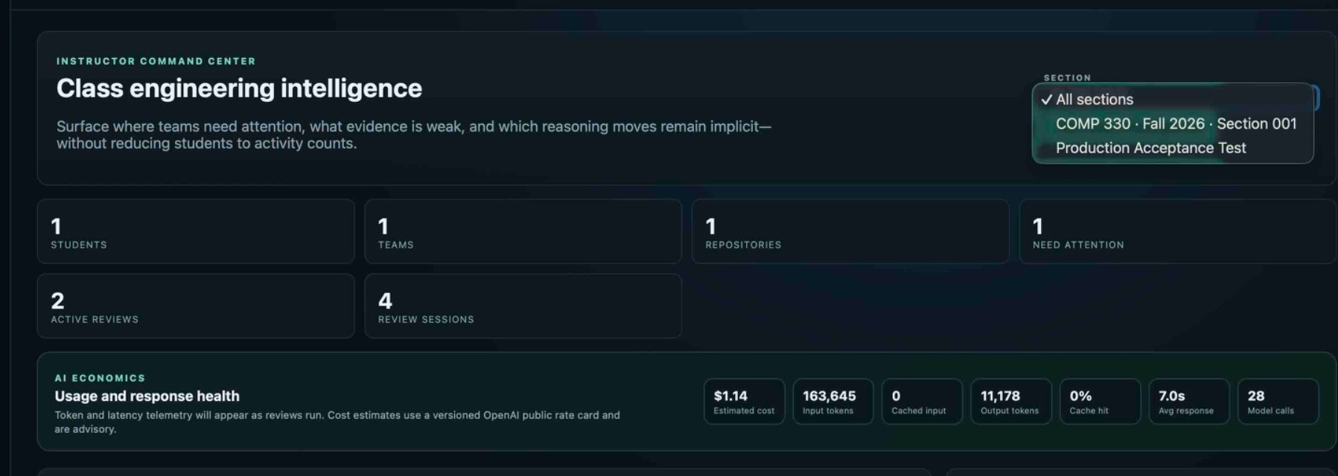
Figure 1. The section selector makes teaching context explicit. Use a specific section before administrative decisions.
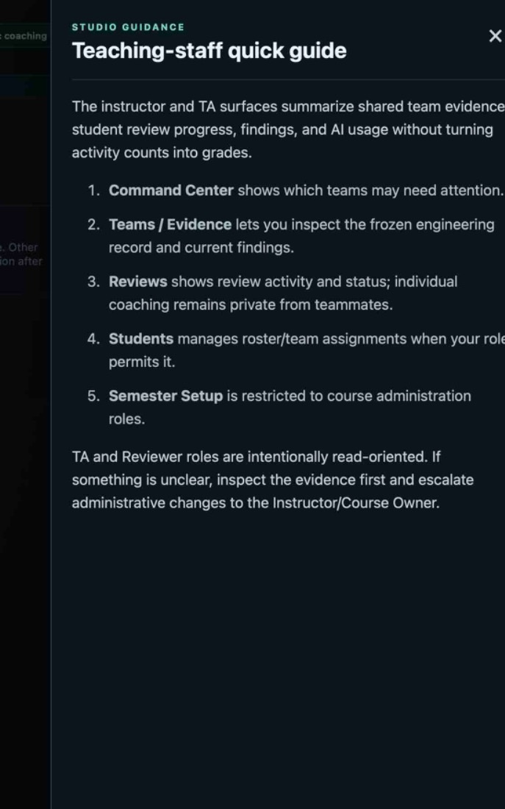
Figure 2. Teaching-staff quick guide: Command Center for attention, Teams/Evidence for shared engineering state, Reviews for persisted conversations, Students for roster/team changes, and Semester Setup for administrative roles.
SECTION CONTEXT
“All sections” is useful for orientation and aggregated read views. Before changing roster, team, schedule, staff, or other section-scoped state, confirm the intended section explicitly.

4. Instructor Command Center
The Command Center is a triage surface, not a gradebook. Its job is to answer: Where should I look next? It combines section/team counts, active reviews, AI economics, attention signals, and Team Detail context.
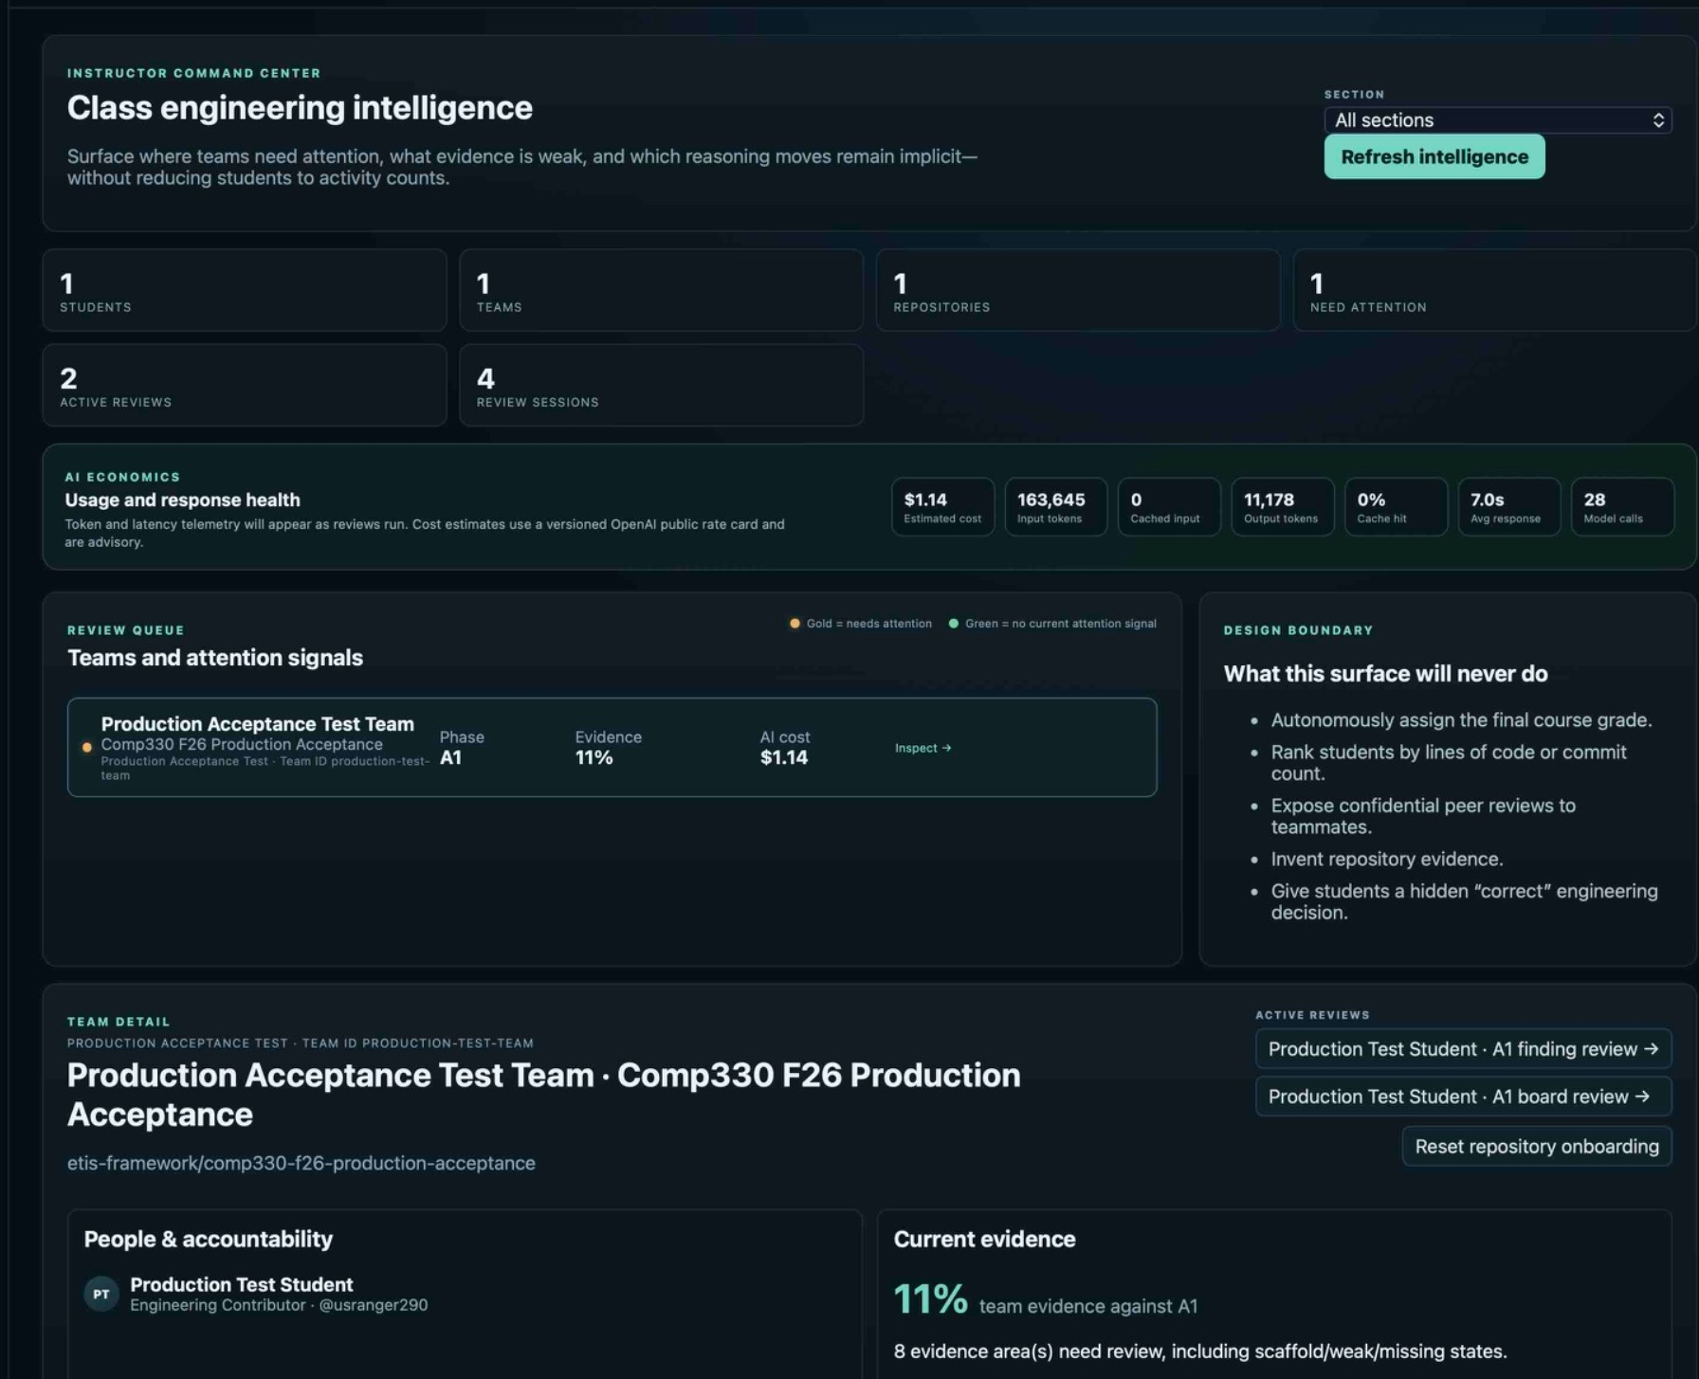
Figure 3. Instructor Command Center. The gold attention signal means “inspect,” not “student failed.” The same surface exposes Team Detail and active reviews.
Signal | Interpretation | Next move
Need attention | One or more evidence/reasoning conditions cross an attention threshold. | Inspect the team; do not infer a grade.
Evidence coverage | How much current-phase evidence is present/equivalent in the frozen/latest snapshot context. | Open Engineering Evidence; distinguish scaffold, missing, equivalent, and project-specific work.
Active reviews | Students currently have live Studio sessions. | Useful context; an active review is not itself a problem.
AI cost / latency | Operational telemetry for model use. | Investigate abnormal patterns as stewardship, not student evaluation.
Gold / green team dot | Gold = needs attention; green = no current attention signal. | Use as triage only.

INSTRUCTOR QUESTION TO ASK
Do not ask “How much activity did this team generate?” Ask “What engineering evidence or reasoning needs my attention, and what coaching or course action is actually warranted?”

5. Teams and Team Detail
Teams is the operational inventory of repository connection, shared evidence state, review participation, and cost. Team Detail is the bridge from class-level triage into the people, repository, evidence, and active-review context for one team.
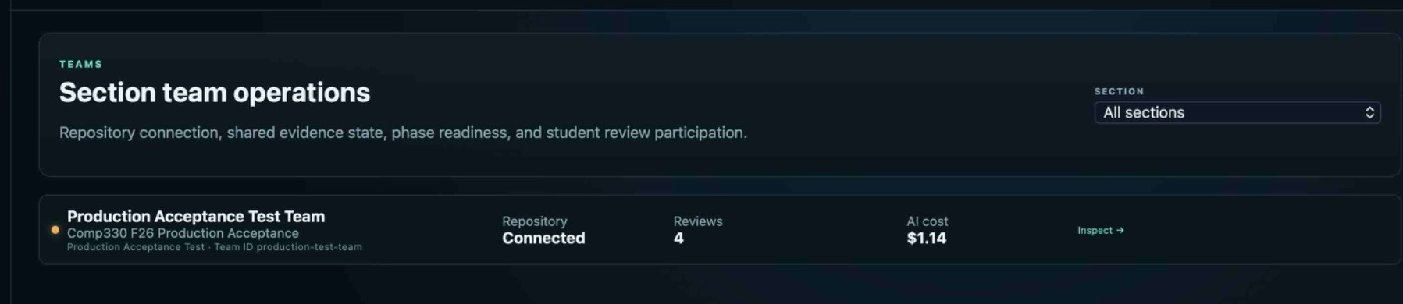
Figure 4. Teams page. Repository state, review count, AI cost, and the Inspect path are visible without exposing student-private drafts.
- Use the human-readable team name and stable team/section context together; names can change, stable identifiers preserve continuity.
- People & accountability should list all current members, not just students who linked GitHub.
- If multiple students have active reviews, Team Detail should surface each active review separately rather than one ambiguous “open review” action.
- Current evidence is a summary. Use Engineering Evidence for detailed FACT/REVIEW inspection.
- Use Reset repository onboarding only when a verified repository truly needs replacement or re-onboarding.

6. Students: roster and team membership
The Students surface is for bounded roster and team membership operations. Changes preserve historical membership/review context instead of rewriting the past.
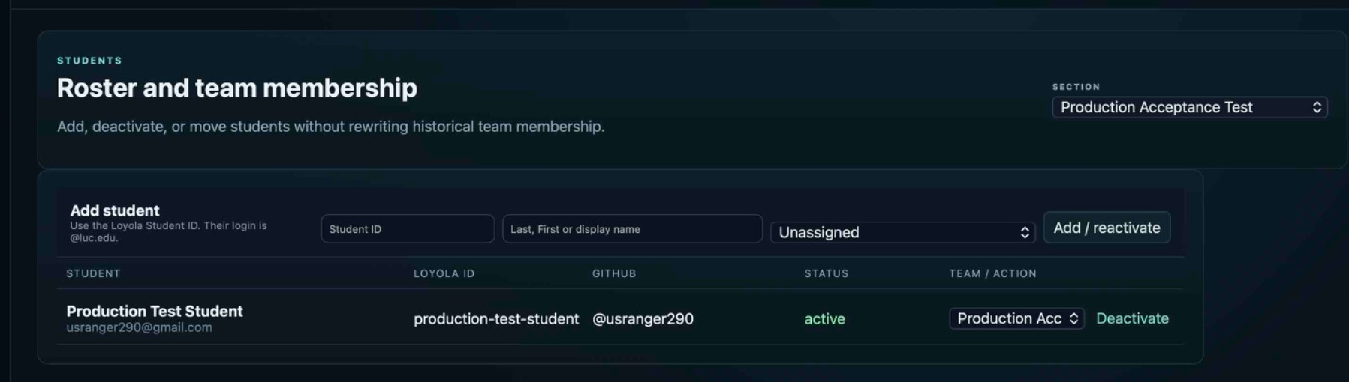
Figure 5. Students page. Authorized staff can add/reactivate, deactivate, or move students while preserving membership history.
Action | When to use it | What to preserve
Add / reactivate | A student is newly enrolled or returns after deactivation. | Use the institutional Student ID and intended team assignment.
Move team | A current student changes teams. | Preserve prior membership and review history; future authority follows current membership.
Deactivate | A student drops/leaves the section. | End current course authorization without deleting historical engineering records.
Correct wrong team | Roster is correct but team assignment is wrong. | Change the current membership; do not delete/recreate historical reviews.

ROSTER IMPORT VS. INDIVIDUAL CHANGES
Semester Setup handles section roster import. Students is the clearer surface for individual add/reactivate/deactivate/move operations during the semester. Do not use database edits to shortcut the lifecycle.

7. Reviews: viewing student engineering conversations
Reviews lists recent sessions by team/student/phase/type/status and allows authorized teaching staff to open a read-only persisted conversation. This is where you inspect how reasoning developed, not just whether a student clicked through the UI.
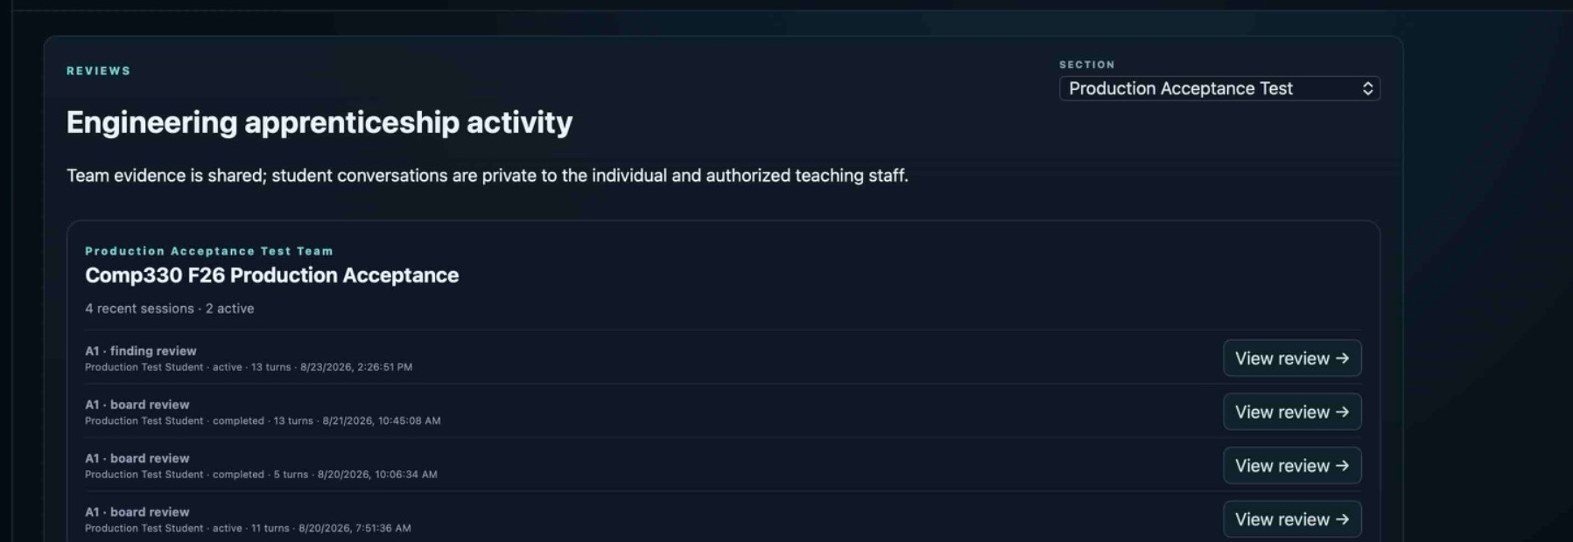
Figure 6. Reviews list. Each session retains phase, review type, student, status, turn count, and time context.
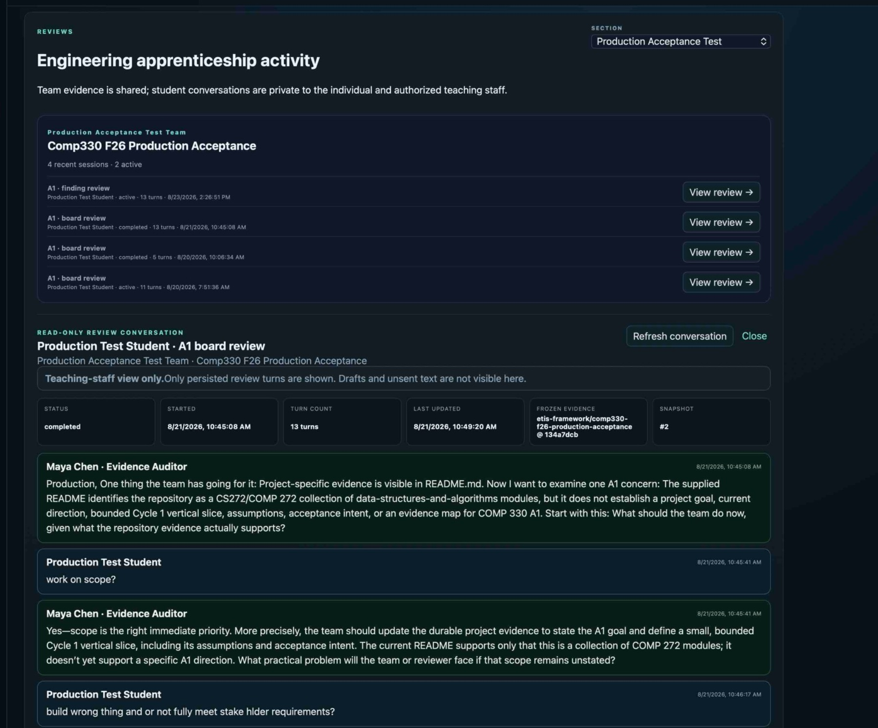
Figure 7. Read-only teaching-staff review drill-down. Persisted turns and frozen evidence provenance are visible; drafts and unsent text are not.
- Use Refresh conversation if a live session is active and you need the latest persisted turns.
- Read the frozen-evidence identifier/snapshot with the conversation; do not interpret a historical review against the team’s current repository state.
- Look for evidence references, uncertainty, consequences, ownership, and whether the student can explain why a decision is defensible.
- A polished answer is not automatically stronger than an evidence-grounded disagreement or honest “I do not know yet.”
PRIVACY BOUNDARY
Only persisted review turns are visible to authorized teaching staff. Unsent drafts remain private. Do not describe the review drill-down as live keystroke monitoring.

8. Engineering Evidence: FACT, REVIEW, snapshots, and longitudinal change
Engineering Evidence is the staff-facing view of frozen team evidence and change over time. It distinguishes immutable repository-derived observations (FACT) from review interpretations (REVIEW). REVIEW can be challenged/corrected without rewriting the snapshot FACT baseline.
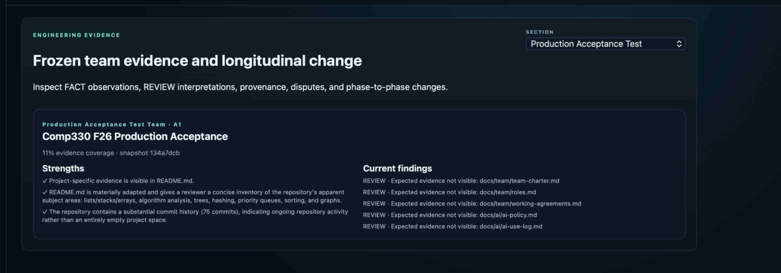
Figure 8. Instructor Engineering Evidence view. Strengths and current findings are tied to a named snapshot and current phase.
Concept | Instructor meaning
FACT | Frozen repository-derived provenance: commit/tree/artifact/workflow state. Do not rewrite it during a review.
REVIEW | Interpretation of FACT evidence: concern, strength, gap, or finding. May be challenged/corrected/dispositioned.
Snapshot | Pinned evidence state used by a review. A later repository refresh does not mutate the historical review.
Coverage | Evidence present/equivalent for the phase; starter scaffold is not completed team work.
Longitudinal change | Compare later snapshots/phase context to see what changed without overwriting earlier evidence.

0% OR LOW COVERAGE
Low coverage can mean scaffold-only, missing, weak, or project-specific evidence not yet recognized. Inspect the underlying evidence before coaching or evaluating the team.

9. Findings, disputes, and staff dispositions
A finding is a REVIEW interpretation, not immutable repository truth. Students can discuss, challenge, provide contrary evidence, accept/defer, or work toward resolution. Staff finding validation/disposition is a separate authority from generic review read access.
1. Open the relevant Engineering Evidence or review context.
2. Read the FACT provenance first.
3. Read the finding as an interpretation of that FACT baseline.
4. Consider the student’s contrary evidence or correction.
5. Use explicit staff validation/disposition only when your role permits it.
6. Preserve the frozen snapshot; correct the interpretation, not the historical evidence.

10. Repository recovery and reset
Students cannot directly replace a verified team repository. A Course Owner/Instructor reset is the bounded recovery path when the team’s verified repository must legitimately change.
Repository replacement recovery
Confirm replacement is necessary | Open Team Detail | Reset repository onboarding | Historical evidence remains | Team nominates again | Owner/admin authorizes | Exact repo reverified

WHEN TO RESET
Reset only when the verified team repository must be deliberately replaced or re-onboarded. Do not reset merely because GitHub App approval is pending, a student linked the wrong personal GitHub identity, or the team has weak evidence.

- Reset clears the current trusted repository binding/onboarding state.
- Historical frozen evidence and reviews remain preserved.
- The team returns to the normal nomination → owner/admin authorization → exact verification flow.
- Do not force-bind arbitrary repository state directly in the database.

11. AI Usage & Cost
AI Usage & Cost is operational intelligence: token volume, caching, model latency, estimated cost, and call counts. It supports stewardship and capacity/cost investigation. It is not student performance telemetry.
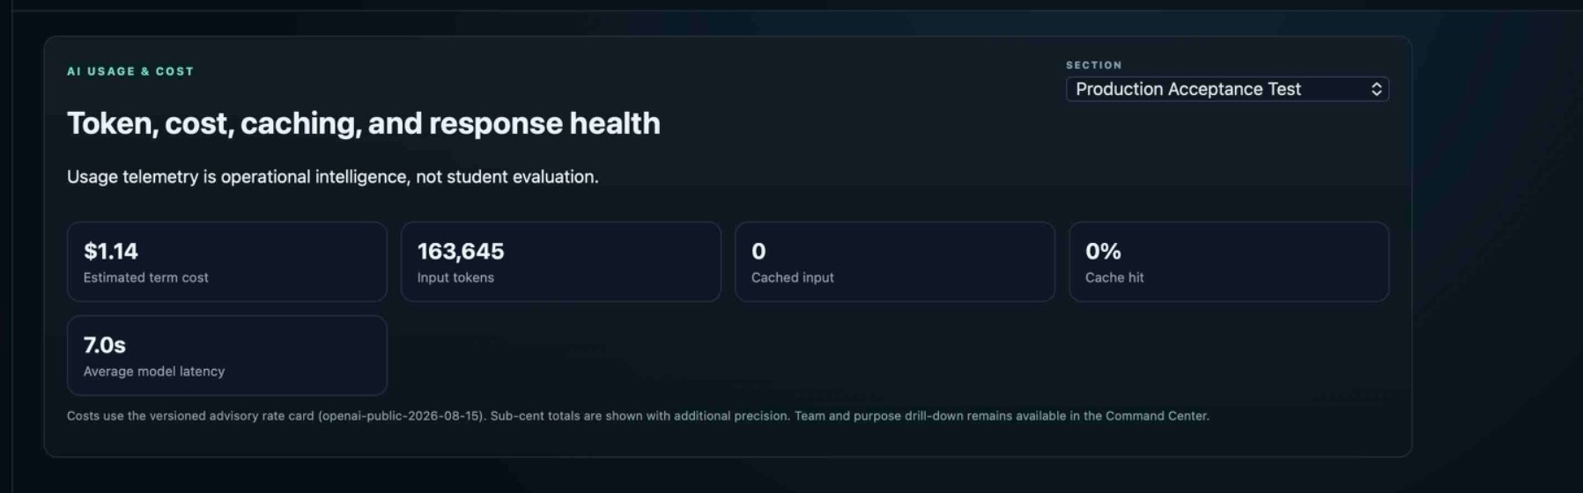
Figure 9. AI Usage & Cost. The section selector scopes telemetry; the surface explicitly states that usage telemetry is operational intelligence, not student evaluation.
Signal | Reason to investigate | Do not conclude
Estimated cost | Unexpected term/team spending or budget trajectory. | “High cost = poor student.”
Input/output tokens | Very large context/response patterns. | “More tokens = more learning.”
Cache hit | Operational efficiency/cost behavior. | Any academic meaning.
Model latency | User experience degradation or provider issues. | Student effort or quality.
Model calls | Unexpected automation or usage spike. | Engagement score.

12. Settings & Access
Settings & Access summarizes the identity and integration boundaries staff should understand: Loyola Microsoft SSO authenticates the human; GitHub identity linking identifies the engineer; GitHub App repository authorization grants bounded repository evidence access; ETIS maintains no local production passwords.
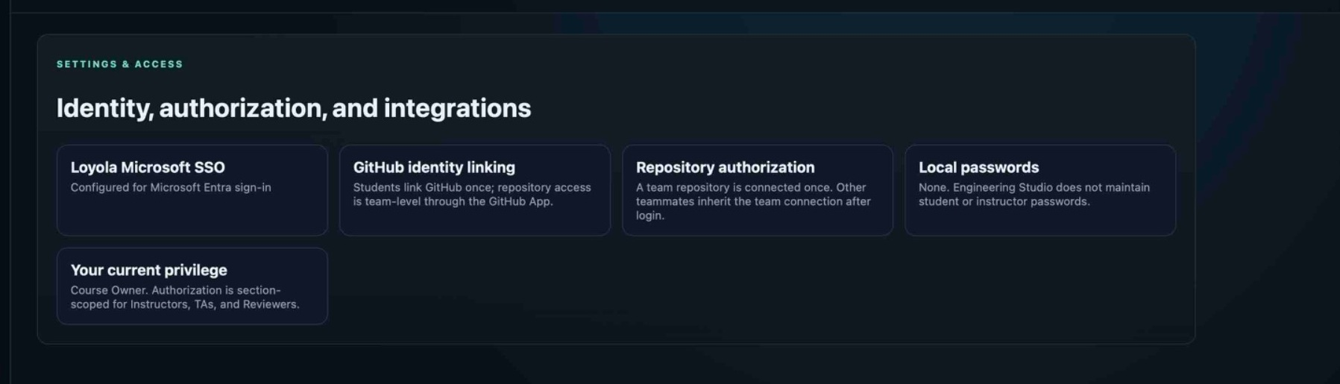
Figure 10. Settings & Access. The current privilege card helps staff confirm their authority posture without exposing secrets.
IDENTITY IS NOT AUTHORITY
A successful Microsoft sign-in does not itself grant instructor authority. A linked GitHub identity does not grant repository administration. Repository App access does not grant course authority. Keep these boundaries separate when troubleshooting.

13. Using ETIS as a coaching instrument, not a grader
Better teaching question | Avoid
What evidence supports the student’s recommendation? | How many review turns did they generate?
What uncertainty did they identify and how would they reduce it? | Did they agree with the reviewer?
What consequence or residual risk did they own? | Did the AI mark it green?
Can they challenge a bad finding with evidence? | Did they accept every finding?
What changed between snapshots and why? | Did evidence coverage reach a magic percentage?

ACADEMIC AUTHORITY
ETIS supports instructor judgment; it does not replace it. Sakai/course policy remains authoritative for deadlines, submissions, grading, and academic decisions.

14. Daily and weekly instructor operating rhythm
Lightweight operating rhythm
Before class: status/known issues | Scan Command Center | Inspect gold teams | Open evidence/reviews | Coach or administer only as needed | Recheck after team changes

Cadence | Recommended use
Before a class/project work session | Scan Command Center and any known operational notices. Confirm students are not blocked by roster/repository issues.
Weekly | Review teams needing attention, unresolved findings, evidence movement, and abnormal cost/latency.
Before a phase transition | Confirm release/calendar state, repository readiness, evidence context, and course instructions in Sakai.
After a student support incident | Confirm the underlying state changed as intended; preserve historical records.
After production deployment | Operations owner runs production acceptance; instructor need not manually inspect Azure if acceptance is green.

15. Supporting common student situations
Student report | Instructor response
“I can sign in but cannot enter.” | Check active roster/section enrollment. Authentication is not course authorization.
“I am on the wrong team.” | Correct current membership through Students; preserve prior membership/review history.
“GitHub says approval is required.” | Determine repository ownership. Organization owner/admin may need to approve; do not call it instructor approval unless you have GitHub organization authority.
“We linked the wrong GitHub account.” | Student uses Change linked GitHub account. Do not reset verified repo solely for a personal identity relink.
“Our verified repo is actually wrong.” | Use bounded repository reset, then have team repeat normal onboarding.
“The finding is wrong.” | Have the student challenge it with evidence; use Review Findings. Staff can validate/disposition when appropriate.
“Evidence says 0%.” | Inspect whether repository is scaffold-only, genuinely missing evidence, or uses project-specific equivalents.
“Studio is slow/down.” | Move to the production operations runbook; capture time, section/team, route/screen, and request/browser evidence if available.

16. Teaching-staff troubleshooting
Symptom | First check | Next action
Wrong/missing section | SECTION selector + staff assignment | Confirm SectionStaff/course role for active term.
Cannot mutate roster/team | Current role | TA/Reviewer are read-oriented; Instructor/Course Owner required.
Archived term appears writable | Term state | Treat as blocker; archived is historical/read-only.
Review conversation missing student draft | Expected privacy behavior | Only persisted turns are intentionally visible.
Review seems tied to old evidence | Snapshot identifier/date | Historical review remains pinned; inspect newer snapshot/review separately.
Team attention signal surprising | Team Detail + Engineering Evidence | Inspect underlying evidence/reasoning; do not infer grade.
Repository reset unavailable | Role/section context | Confirm Instructor/Course Owner authority and active term.
AI cost spike | AI Usage & Cost + operations telemetry | Investigate usage pattern/provider cost; do not treat as academic signal.
Health OK but user cannot access | Roster/authorization/auth path | Differentiate service health from identity/course authorization.

17. Appendix A - Role authority matrix
Capability | Course Owner | Instructor | TA | Reviewer
Read active section/team/evidence | Yes | Assigned | Bounded | Bounded
Read persisted reviews | Yes | Assigned | Bounded | Bounded
Roster/team mutation | Yes | Assigned | No | No
Repository reset | Yes | Assigned | No | No
Term lifecycle | Yes | No unless Course Owner | No | No
Assign elevated staff | Yes | No | No | No
Archived historical read | Yes | Assigned where permitted | No | No
Act as student in review | No | No | No | No

18. Appendix B - Instructor use cases

Use case: a team is gold on Command Center
1. Inspect Team Detail.
2. Open Engineering Evidence and identify the actual weak/missing/scaffold state.
3. Open relevant persisted review if reasoning context matters.
4. Decide whether coaching, course clarification, or no intervention is appropriate.
5. Recheck after the team makes evidence changes/new reviews.

Use case: student moved teams mid-semester
1. Change current team membership through Students.
2. Verify new current access.
3. Do not delete old review history or membership events.
4. Use historical context carefully: old reviews remain associated with the earlier team/evidence state.

Use case: repository must be replaced
1. Confirm the verified repository is truly wrong.
2. Use Reset repository onboarding.
3. Confirm old snapshots/reviews remain.
4. Have team nominate the new repository.
5. Owner/admin authorizes selected-repository access.
6. Team completes exact verification.

Use case: student challenges a finding
1. Read the frozen FACT evidence.
2. Read the finding as REVIEW interpretation.
3. Evaluate the student’s contrary evidence.
4. If correction is valid, use the authorized disposition/correction path rather than rewriting FACT.

19. Appendix C - First-week checklist
- Confirm the term is Active and correct sections exist.
- Confirm your role and section selector behavior.
- Confirm roster and team assignments.
- Confirm each team has the intended repository onboarding path.
- Confirm students can sign in with Loyola identity and normal Loyola MFA.
- Confirm at least one instructor can inspect Teams, Reviews, Engineering Evidence, and Students.
- Explain to students that Studio is developmental and evidence-grounded, not grading AI.
- Explain GitHub owner/admin authorization vs instructor authority.
- Know where the production operations runbook lives before class.

20. Appendix D - Terminology
Term | Meaning
Attention signal | Triage indicator that a team may warrant inspection; not a grade.
FACT | Frozen repository-derived evidence/provenance.
REVIEW | Interpretation of FACT evidence; challengeable/correctable.
Snapshot | Pinned evidence state used by a review.
Persisted turn | Student/reviewer message actually submitted and stored; visible to authorized staff.
Unsent draft | Private student text not submitted/persisted; not visible to staff.
Repository reset | Bounded instructor/course-owner recovery action returning team to normal onboarding.
Section | Course offering context within a term; shared context for roster, teams, release schedule, and staff.
Archived | Historical/read-only term state; normal student operational access ends.

