ETIS

Student User Guide
  - Complete student reference: sign-in, team/repository setup, evidence, frozen checkpoints, reviews, engineering decisions, history, and troubleshooting
Audience | Students in COMP 330/474 and other approved ETIS course sections
Purpose | Explain the complete student experience from first sign-in through repeated evidence-based engineering reviews and historical learning records.
Reference implementation | COMP 330/474 Software Engineering • Fall 2026
Version | Semester Start 2026 • August 23, 2026

CORE PRINCIPLE
The Studio can challenge, coach, explain, and ask for evidence. You remain the responsible engineer. You may disagree with the reviewer, admit uncertainty, and change your position when the evidence changes.

Contents
Use Word’s Navigation pane to jump directly among the numbered headings. The section list below follows the same structure.
1. Executive Overview
2. How ETIS fits with Sakai, GitHub, and your engineering work
3. First sign-in and navigation
4. My Team, GitHub identity, and repository trust
5. Repository setup: normal, personal, and organization cases
6. Evidence, commit history, and frozen checkpoints
7. Engineering Evidence workspace
8. Choosing the right review type
9. Starting Board, Focused, and Review Findings sessions
10. Working in the Engineering Review Room
11. Recommendations, decisions, and completing a review
12. Findings, challenges, corrections, and follow-up
13. Review History and revisiting older work
14. What happens after new commits and later checkpoints
15. Help, privacy, team-shared vs. individual state
16. Student troubleshooting
17. Appendix A - Student use cases
18. Appendix B - Strong engineering response checklist
19. Appendix C - Snapshot, commit, and history FAQ
20. Appendix D - Terminology

Executive Overview
ETIS Engineering Studio is an engineering apprenticeship environment. It uses your team’s real repository evidence to create senior-review-style conversations. The goal is not to satisfy an AI reviewer. The goal is to practice making decisions that are evidence-based, explicit about uncertainty and consequences, and defensible to other engineers.

What you should be able to do
- Sign in using Loyola Microsoft identity and confirm the correct course/team context.
- Link the GitHub identity you actually use for engineering work.
- Establish one verified team repository through the controlled GitHub App process.
- Understand what the Studio can and cannot see in the current phase.
- Use Board Review, Focused Review, or Review Findings for the right purpose.
- Ask questions, challenge the reviewer, state uncertainty, and own your engineering position.
- Understand how frozen evidence checkpoints relate to commits and later repository changes.
- Revisit old reviews without rewriting the evidence or reasoning that existed at that time.

Normal student path
Sign in | Confirm team | Link GitHub | Verify repository | Inspect evidence | Start review | Reason & decide | Revisit history

WHAT THIS IS NOT
The Studio is not the course submission system, not an automated grader, not a replacement for GitHub, and not an AI oracle. Sakai remains authoritative for official course requirements and deadlines. GitHub remains the source of your team’s working repository history.

ABOUT THE SCREENSHOTS
Screenshots in this guide use a production acceptance test account and example team/repository states. Your name, team, project, repository, session numbers, evidence counts, and findings will differ. Use the screenshots to recognize controls and workflow states - not as values your screen must exactly match.

2. How ETIS fits with Sakai, GitHub, and your engineering work
System | What it is for | What it is not
Sakai | Official course announcements, deadlines, assignment instructions, and course control. | Not the engineering review room.
GitHub | Your actual working repository, commits, branches, pull requests, issues, Actions, tags, and team engineering activity. | Not automatically trusted by ETIS until the team repository is verified.
ETIS Engineering Studio | Developmental engineering judgment practice using frozen repository evidence and bounded senior-review coaching. | Not the formal grading authority and not a replacement for the responsible engineer.
ETIS Preflight | Readiness check near a formal phase-gate review. | Not the Studio and not the formal review itself.
ETIS Engineering Review Center | Instructor-facing formal phase-gate review against designated evidence boundaries. | Not a continuation of a student Studio conversation by default.

WHY THE BOUNDARIES MATTER
A Studio conversation is developmental. It can influence what your team chooses to change, but the conversation itself does not silently become formal phase-gate evidence. Formal review is grounded in the designated repository evidence boundary.

3. First sign-in and navigation

3.1 Sign in with Loyola
1. Open https://simulator.etisframework.org.
2. Choose Sign in with Loyola.
3. Complete normal Loyola Microsoft sign-in and Loyola MFA if your account requires it.
4. ETIS checks course/section authorization after identity verification; authentication alone does not create course access.
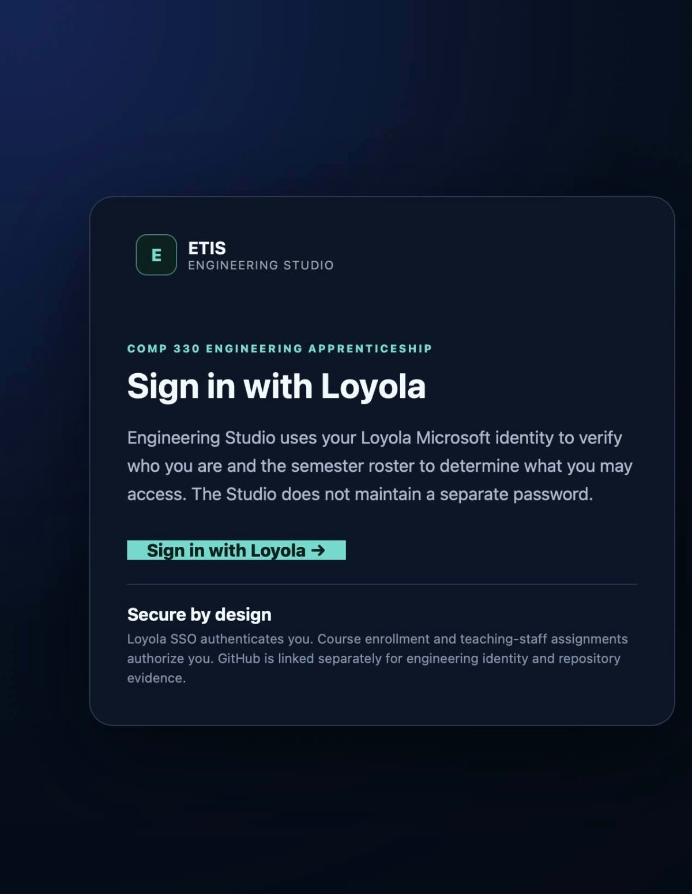
Figure 1. Loyola sign-in gate. ETIS does not maintain a separate student password.

3.2 Main student navigation
Area | Use it for
Engineering Studio | Choose/start a review, see phase context, work in the Review Room, and continue an active session.
Engineering Evidence | See strengths, current-phase evidence, professional lenses, findings, coverage, and paths into review.
Review History | Revisit prior sessions and see how your engineering judgment changed over time.
My Team | Confirm team membership, GitHub identity, project details, and verified repository state.
Help & guidance | Open Studio guidance for how to engage reviewers and own the judgment.

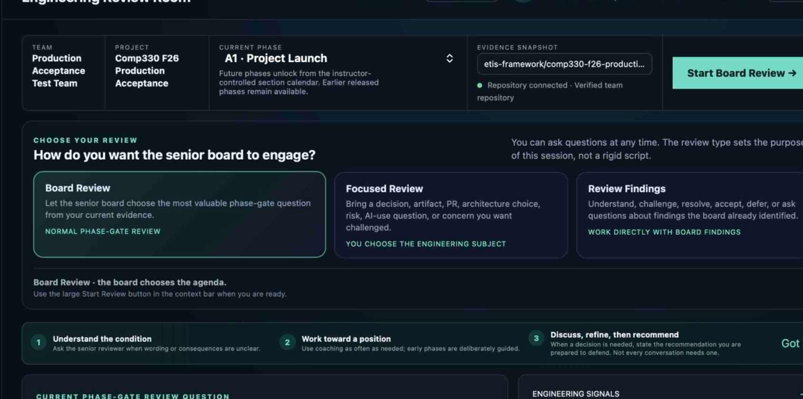
Figure 2. The Studio context bar shows team, project, current phase, evidence snapshot context, and the review-start action.
BROWSER BACK/FORWARD
Meaningful Studio navigation preserves relevant section/team/review context. Do not rely on an old tab to prove access; the server reevaluates current authorization for protected actions.

4. My Team, GitHub identity, and repository trust
My Team separates four conditions that students often confuse: Loyola identity, course/team assignment, GitHub identity, and verified repository access. All four can be healthy independently or fail independently.
Condition | Meaning
Loyola identity verified | ETIS knows who you are through Microsoft Entra.
COMP 330 team assigned | The course roster/team model authorizes your student context.
GitHub identity linked | ETIS knows which GitHub account represents you as an engineer. The OAuth access token is not retained for repository reading.
Verified team repository | The exact team repository has been verified through the GitHub App and becomes team-wide trusted evidence.

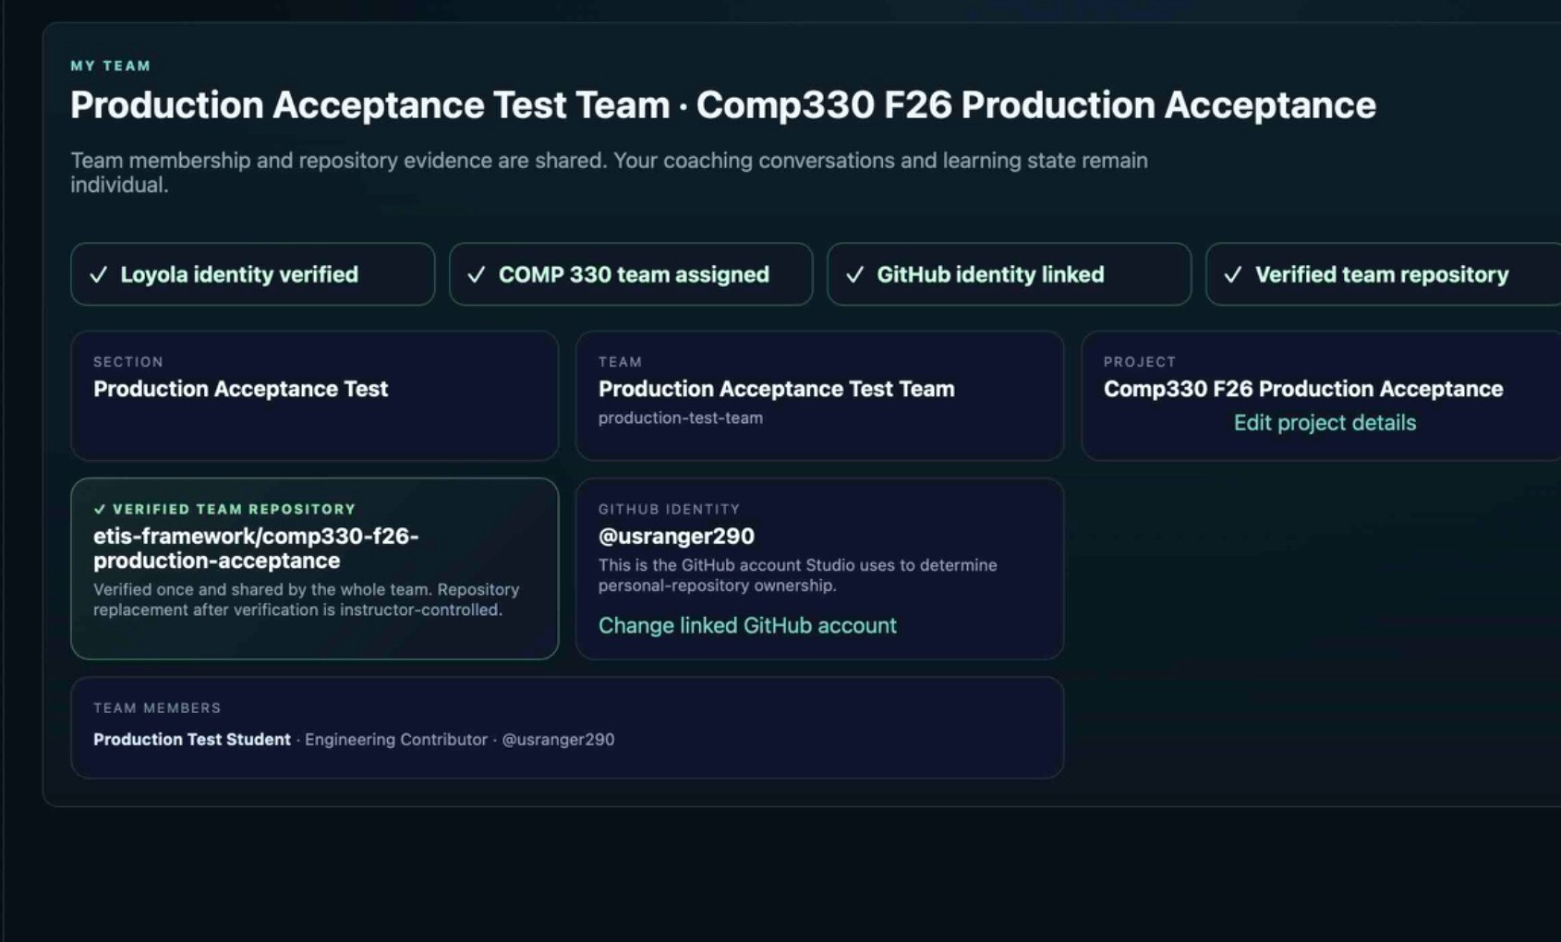
Figure 3. Healthy My Team state: identity, team, GitHub link, and verified team repository are all established.

4.1 Changing your linked GitHub account
Use Change linked GitHub account when you linked the wrong GitHub identity or need ETIS to associate you with the account you actually use. Changing your personal GitHub identity does not silently replace the team’s verified repository.
TEAM-SHARED VS. INDIVIDUAL
Repository binding, team membership, and repository evidence are team-shared. Your coaching conversations, recommendation development, and learning history are individual. One teammate verifying the repository does not merge everyone’s review conversations.

5. Repository setup: normal, personal, and organization cases
Controlled repository trust flow
Nominate URL | Owner/admin authorizes App | Return to ETIS | Verify exact repository | Team-wide verified state

5.1 Nominate the working repository
1. In My Team, paste the HTTPS URL for the team’s actual working GitHub repository. The .git suffix is optional.
2. Check the owner and repository name carefully. A pasted URL is only a candidate; ETIS will not use it as trusted review evidence yet.
3. Choose Nominate team repository.
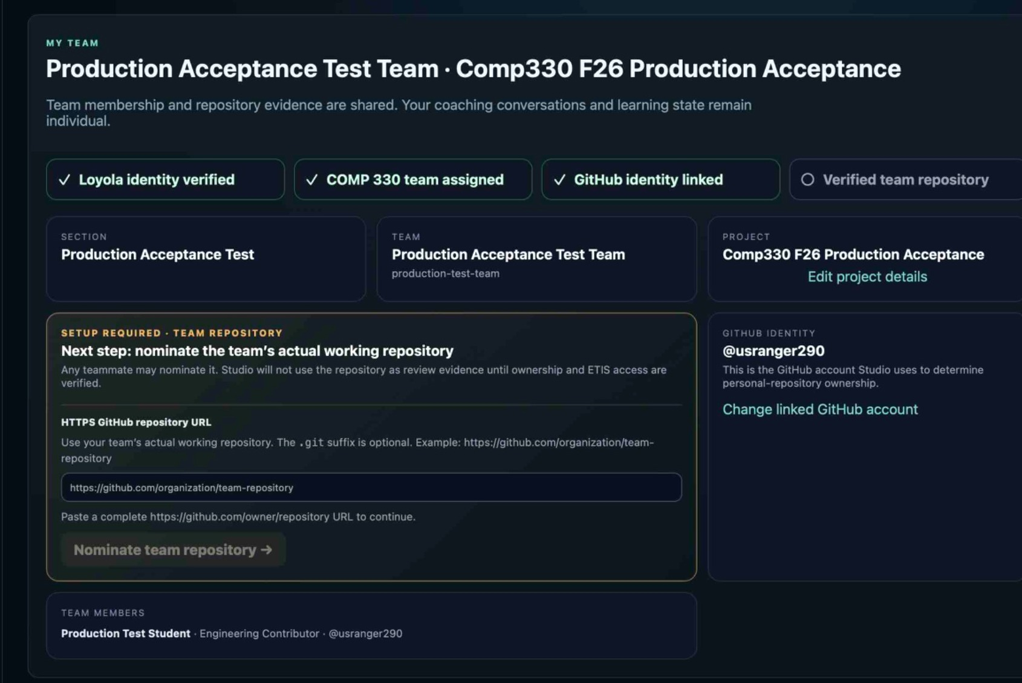
Figure 4. Nominate the team’s actual working repository. The URL is a candidate until exact access is verified.

5.2 Step 1 - repository owner/organization authorization
GitHub, not ETIS, decides whether your account can install the App directly or whether an organization owner/admin must approve the request.
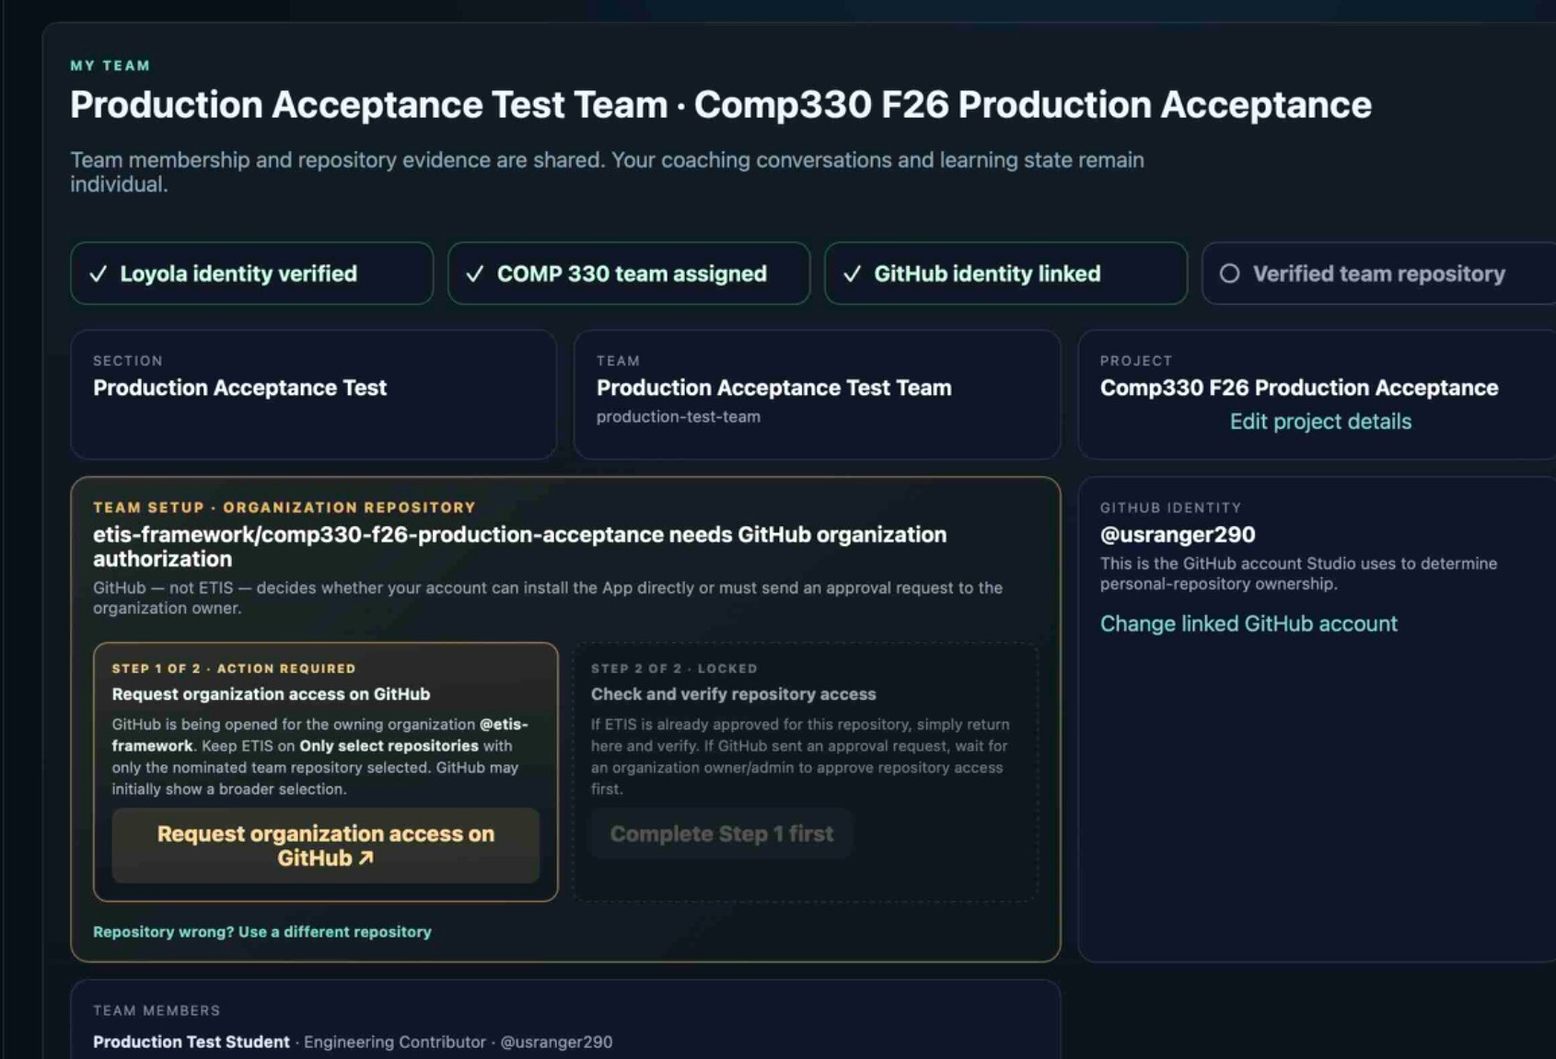
Figure 5. Organization repository onboarding before Step 1. Step 2 remains locked until GitHub authorization is opened/completed.
Repository ownership | Who must act | Student behavior
Personal repository | The actual personal-repository owner. | A non-owning teammate should wait for the owner rather than attempting to take over repository authorization.
Organization repository | GitHub organization owner/admin if GitHub requires approval. | Follow the GitHub request/approval flow. Do not describe this automatically as instructor approval unless the instructor actually has organization authority.

5.3 On GitHub: Only select repositories
- Select Only select repositories.
- Select the nominated team repository and no unrelated repositories.
- Do not choose All repositories. ETIS intentionally fails closed on all-repository installation scope.
- Do not use personal access tokens (PATs) for ETIS repository evidence access.
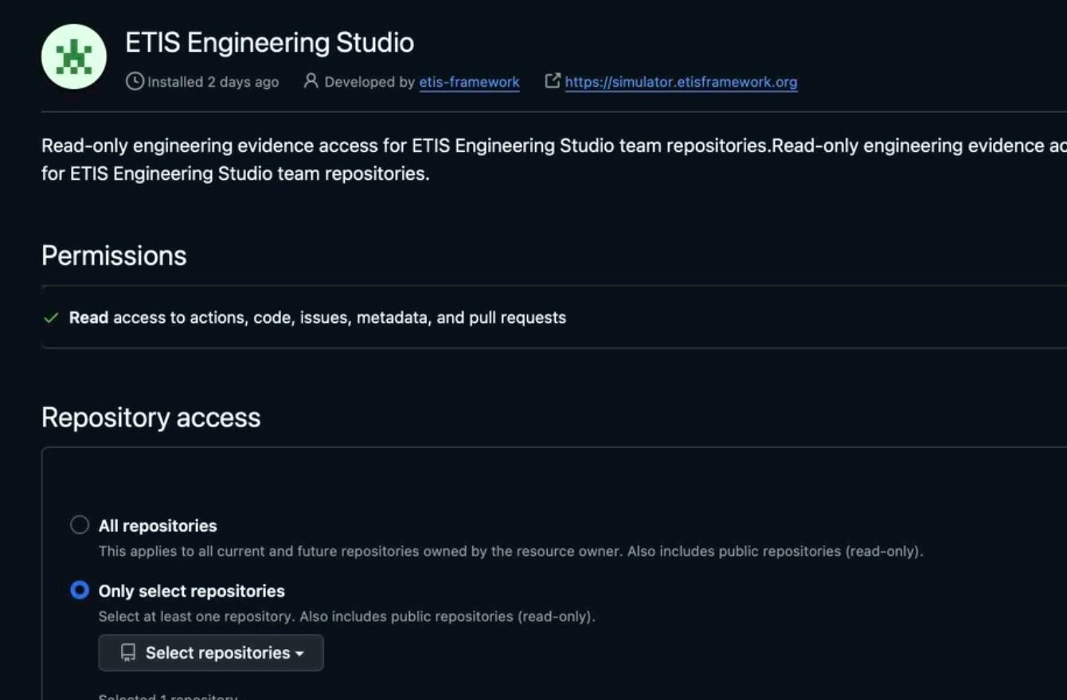
Figure 6. GitHub App repository-access screen. Choose Only select repositories, then choose only the repository nominated in My Team. The example intentionally crops out a repository name because your team repository will differ.
STOP AND CHECK BEFORE SAVING
The important security decision on this GitHub page is scope: Only select repositories must be selected. The repository chooser should contain the same repository you nominated in My Team - not another class project, personal repository, or all repositories.

5.4 Step 2 - verify the exact repository
After GitHub authorization or organization approval, return to My Team and use Check & verify repository access. Authorization alone is not enough. ETIS requests short-lived access scoped to the nominated repository and verifies the exact repository before promoting it to trusted team evidence.
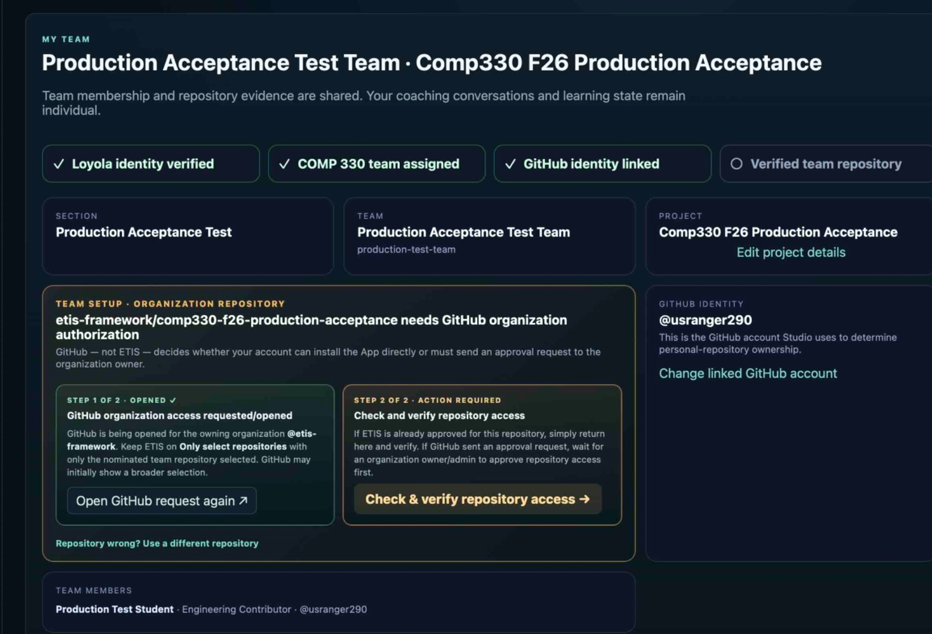
Figure 7. Step 1 is complete, but the repository is not trusted until Step 2 verifies exact access.

Figure 8. Verified team repository. Once verified, the repository connection is shared by the team.
IF THE REPOSITORY IS WRONG
Before verification, use the “Repository wrong? Use a different repository” path. After verification, students cannot directly replace the trusted repository; an Instructor/Course Owner reset is required so the normal trust process can begin again.

6. Evidence, commit history, and frozen checkpoints

6.1 The central idea: a review uses a frozen checkpoint
Your GitHub repository keeps changing as the team works. A useful review cannot move underneath you. When you start a review, the Studio freezes the repository evidence state used by that session. The UI calls this a frozen evidence snapshot. You can think of it as the review checkpoint.
Checkpoint lifecycle
Working GitHub repository | Start review | Freeze evidence snapshot | Review uses that snapshot | Team keeps working | Later review freezes a newer snapshot

Question | Answer
Do I press a separate “checkpoint” button? | No. In the current student experience, beginning a review freezes the current evidence snapshot automatically.
Does a later commit change an active/completed review? | No. The old review remains tied to its original frozen evidence.
Can the team keep committing while I review? | Yes. New GitHub work does not rewrite the evidence already frozen for that session.
How do later changes become reviewable? | Start a later review so the Studio can analyze/freeze a newer repository state.
Where is exact Git commit history? | GitHub remains the authoritative commit-history browser. ETIS can analyze commit/workflow history as engineering evidence, but the current student UI is not a full replacement for GitHub’s commit browser.

COMMIT HISTORY VS. REVIEW HISTORY
Commit history answers “what changed in the repository?” in GitHub. Review History answers “what did I reason about, against which frozen evidence, and how did my position develop?” in ETIS. They are related but not the same record.

6.2 Snapshot identifiers and evidence context
Engineering Evidence displays the current evidence context and a short snapshot identifier. The Review Room also shows that the evidence is Frozen. Treat these identifiers as provenance: they help distinguish the repository state used by one review from a later review after the team has changed the repository.
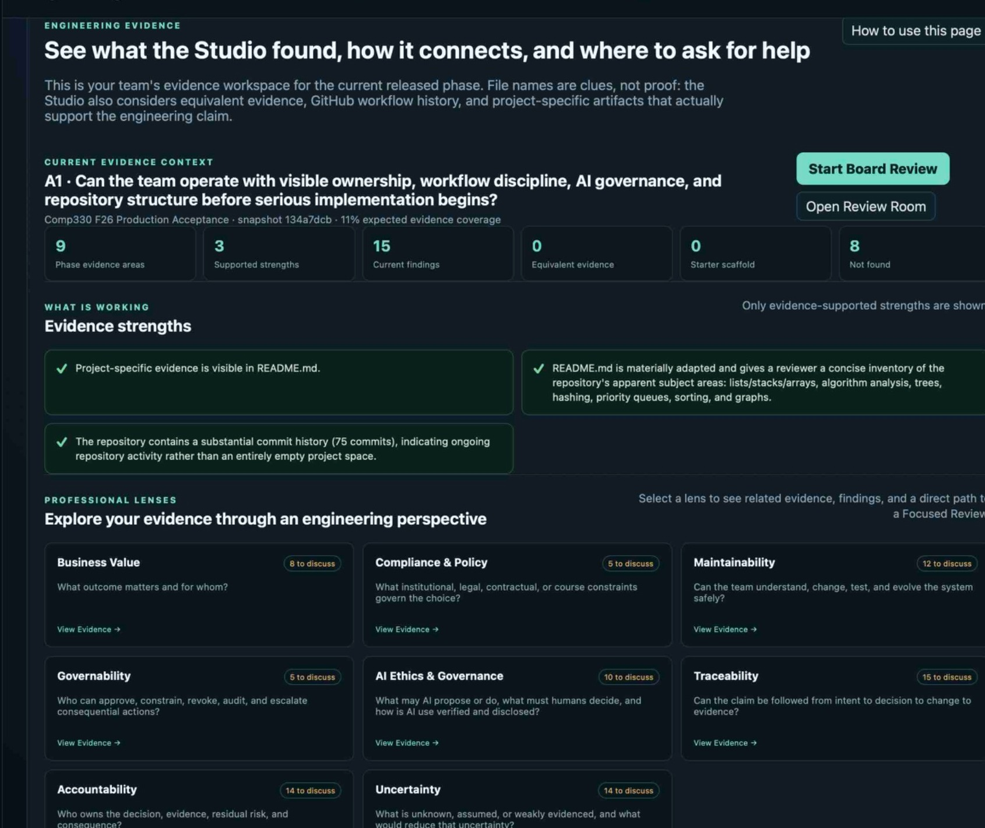
Figure 9. Engineering Evidence shows the current phase, snapshot identifier, strengths, findings, and evidence lenses.

7. Engineering Evidence workspace
Engineering Evidence is where you inspect what the Studio found before or during a review. It is phase-aware: it emphasizes the current released phase and distinguishes actual team evidence from unchanged starter scaffold.
Element | How to read it
Phase evidence areas | Evidence categories expected or relevant for the current phase.
Supported strengths | Evidence-backed things the team is already doing defensibly.
Current findings | REVIEW interpretations/questions worth examining. They are not immutable facts.
Equivalent evidence | Project-specific artifacts that satisfy the engineering purpose even if they use a different form/name.
Starter scaffold | Unchanged starter-kit material. Useful structure, but not evidence that your team actually performed the work.
Not found | Expected/equivalent evidence was not visible in the frozen snapshot.
Professional lenses | Ways to inspect evidence through business value, policy, maintainability, governance, AI ethics, traceability, accountability, uncertainty, and other engineering concerns.

7.1 Reading common evidence labels
Label | Student interpretation
FACT | Repository-derived evidence frozen into the current review context.
REVIEW | A Studio interpretation or finding derived from FACT evidence; it may be challenged or corrected.
CURRENT PHASE | Relevant to the phase currently released by the instructor.
TEAM ADAPTED | Starter/template material has been materially adapted into team-specific evidence.
SCAFFOLD / BASELINE | Provided starter structure; useful context but not proof that your team completed the work.
OPEN / WEAK | A finding or evidence area still needs engineering attention; it is not an automatic grade.


Figure 10. Evidence strengths and professional lenses help you start with what is working, then choose where deeper reasoning is useful.
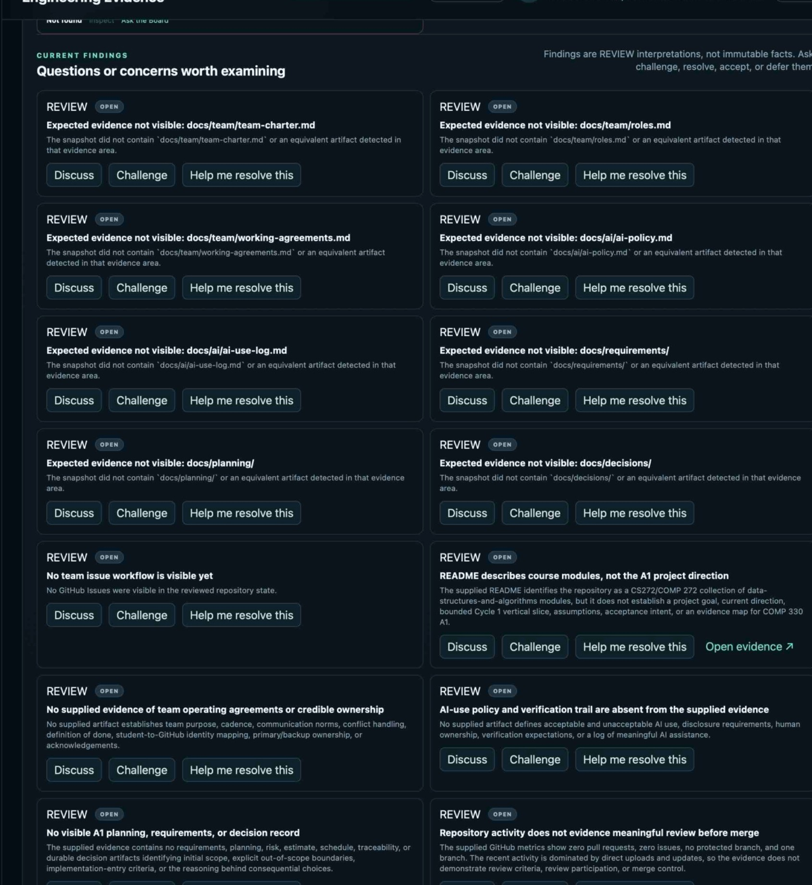
Figure 11. Findings are REVIEW interpretations. Use Discuss, Challenge, or Help me resolve this instead of treating them as unquestionable facts.
0% OR LOW COVERAGE
Low coverage does not necessarily mean GitHub is disconnected or the repository is empty. Starter-kit scaffold is intentionally not counted as completed team evidence, and project-specific equivalent evidence may need to be recognized or discussed.

START VS. OPEN REVIEW ROOM
If no review is active, the Evidence workspace can offer a Start Board Review path. If you already have an active review, use Open Review Room to return to that conversation instead of starting a duplicate session just to see the same frozen evidence.

8. Choosing the right review type
Review | Use it when | Who sets the agenda
Board Review | You want the normal phase-gate developmental review using the most valuable challenge in the current evidence. | The senior board chooses the highest-value current challenge.
Focused Review | You want candid coaching on a specific artifact, decision, pull request, architecture choice, risk, AI-use question, or work-in-progress concern. | You name the engineering subject.
Review Findings | You want to understand, challenge, resolve, accept/defer, or provide contrary evidence for existing findings. | You select one to three related findings so the session remains coherent.

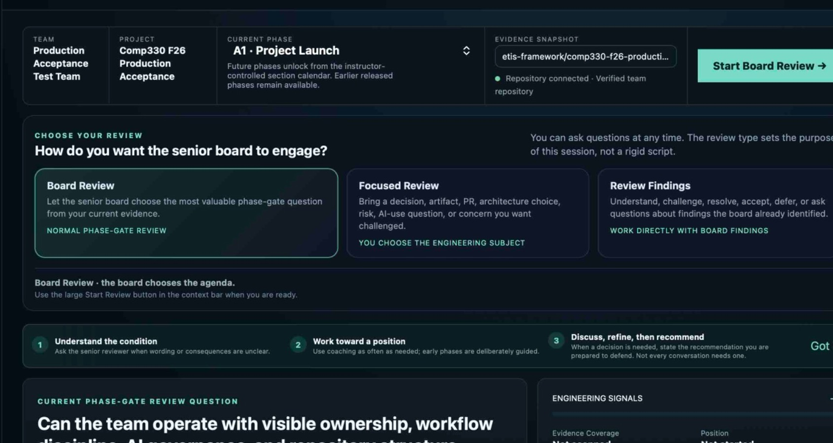
Figure 12. The three review types. Choose the purpose before starting; the type stays locked for that session.

9. Starting Board, Focused, and Review Findings sessions

9.1 Board Review
1. Choose Board Review.
2. Read the current phase-gate review question and engineering signals.
3. Choose Start Board Review.
4. The Studio freezes the current evidence snapshot and the board selects a high-value challenge.

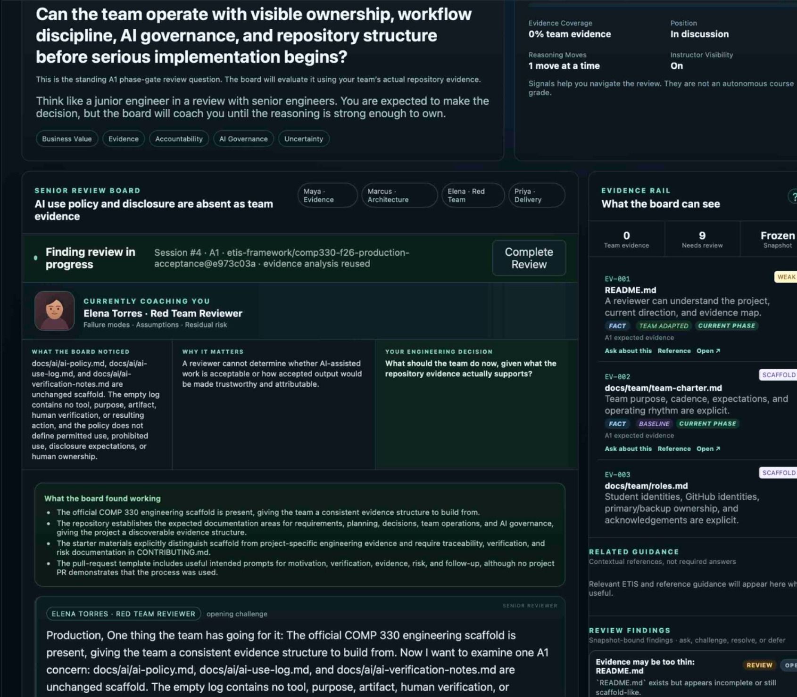
Figure 13. Before the review starts, the evidence rail explains that beginning the review freezes the current evidence snapshot.

9.2 Focused Review
1. Choose Focused Review.
2. In “What should the board focus on?”, name the actual engineering subject - for example authentication architecture, a PR, a database choice, a risk register, or an AI verification concern.
3. Start the review. Bring the relevant decision/evidence into the conversation instead of asking for generic approval.
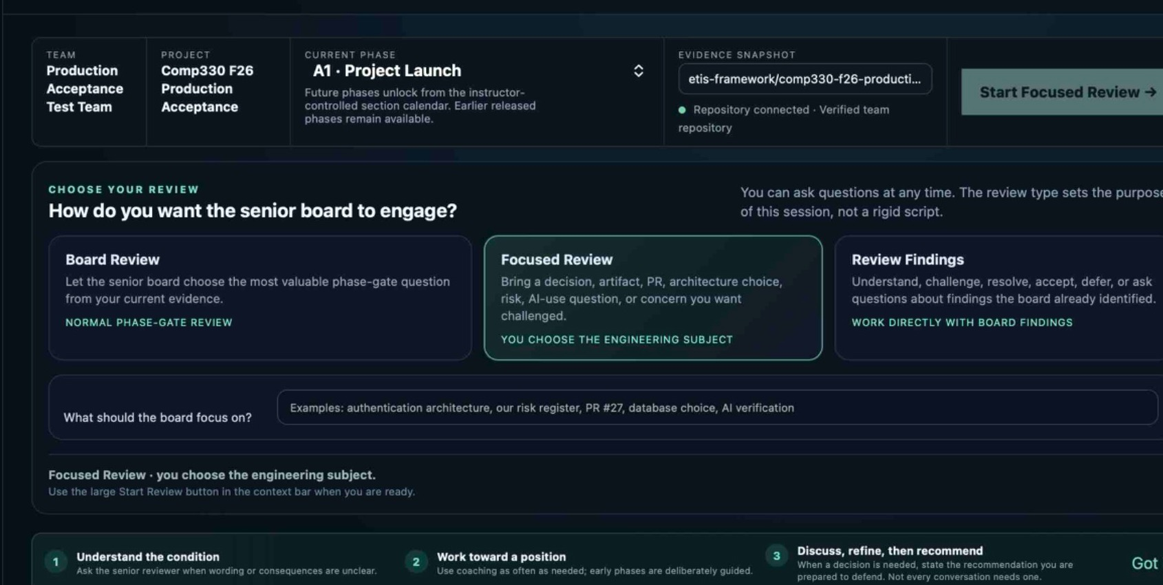
Figure 14. Focused Review lets you choose the engineering subject while keeping the same phase/evidence context.

9.3 Review Findings
1. Choose Review Findings.
2. Select up to three related findings.
3. Start the finding review.
4. Ask what the finding means, challenge it, provide contrary evidence, accept/defer it, or work toward resolution.
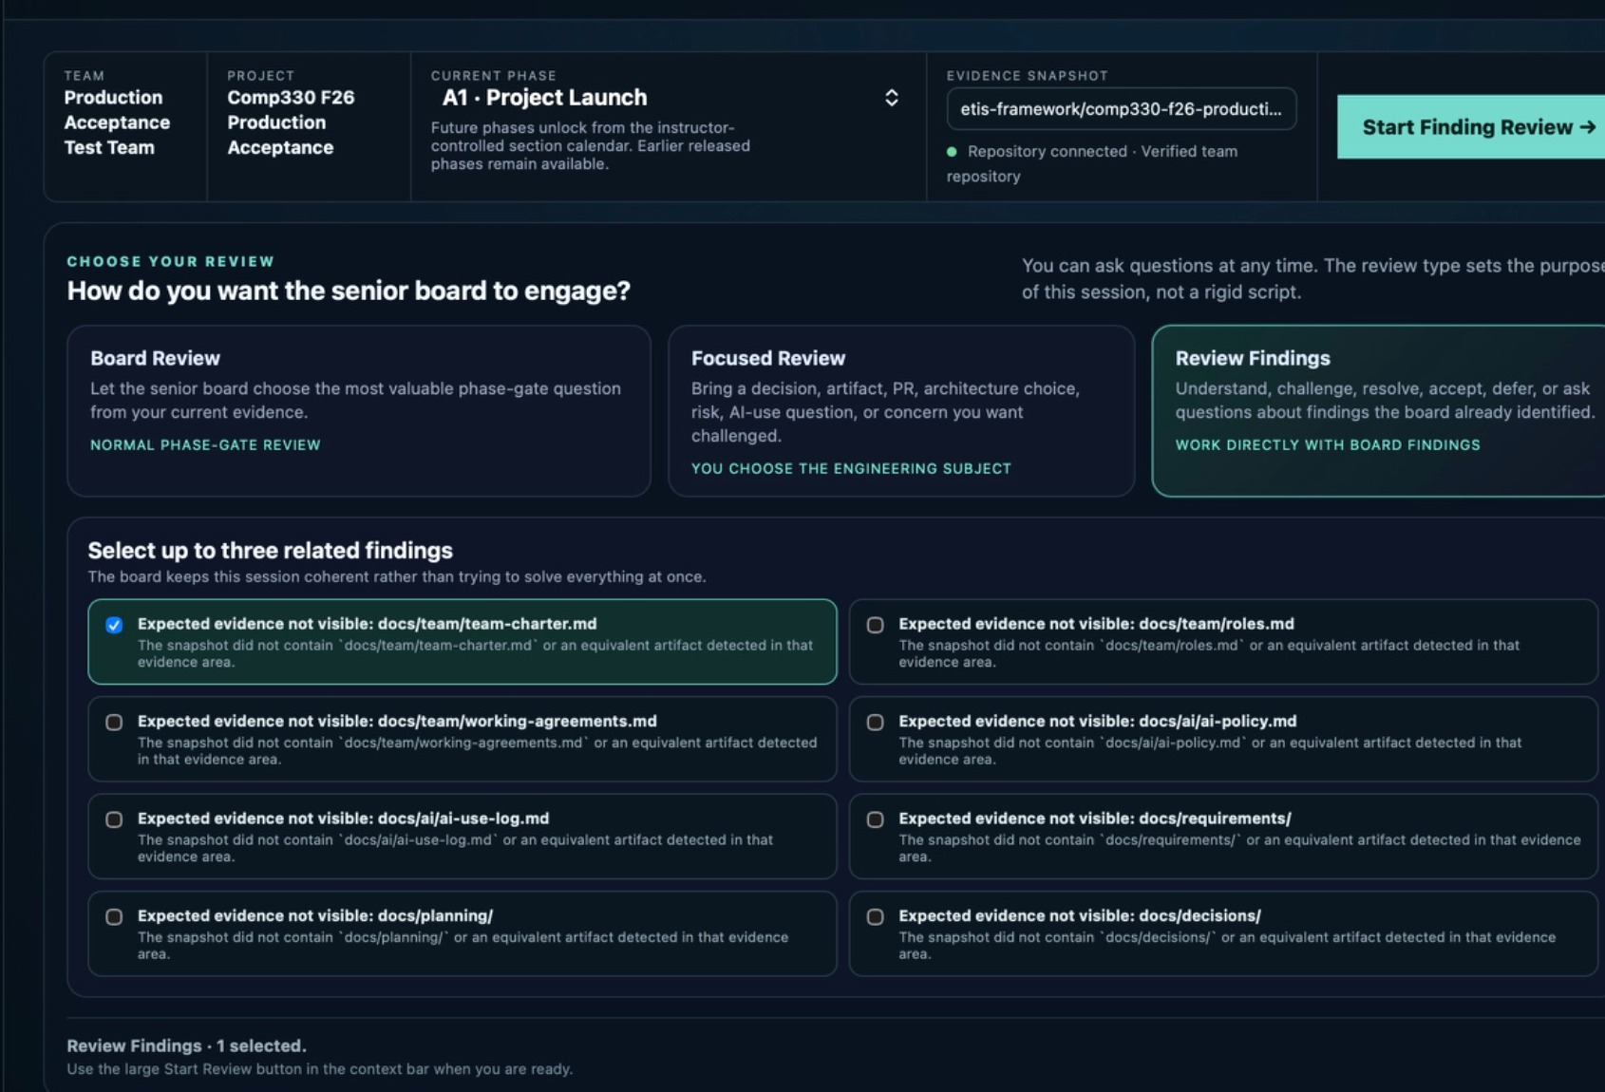
Figure 15. Review Findings limits the session to a small related set so the conversation stays coherent.

10. Working in the Engineering Review Room
The Review Room is designed as an apprenticeship conversation, not a quiz. The reviewer may be demanding, but you can ask questions, disagree, or say that you do not know yet. Productive struggle can turn into more direct teaching when you use the coaching controls.
Area | What it does
Senior Review Board | Shows the challenge and the active professional reviewer/lens.
What the board noticed | Summarizes the evidence/problem the reviewer is reacting to.
Why it matters | Connects the evidence to engineering consequences.
Your engineering decision | Frames what you, as the engineer, must decide or investigate.
Evidence rail | Shows frozen evidence, related guidance, and review findings that remain bound to the snapshot.
Talk to reviewer | Normal conversational response. Ask, answer, disagree, or think aloud.
Give me a nudge | Requests a reframe/scaffold when stuck. The system should teach without silently deciding for you.
Build my recommendation | Shifts coaching toward a defensible decision when the discussion is mature enough.
Current recommendation | Optional, revisable indication of where you are leaning right now.

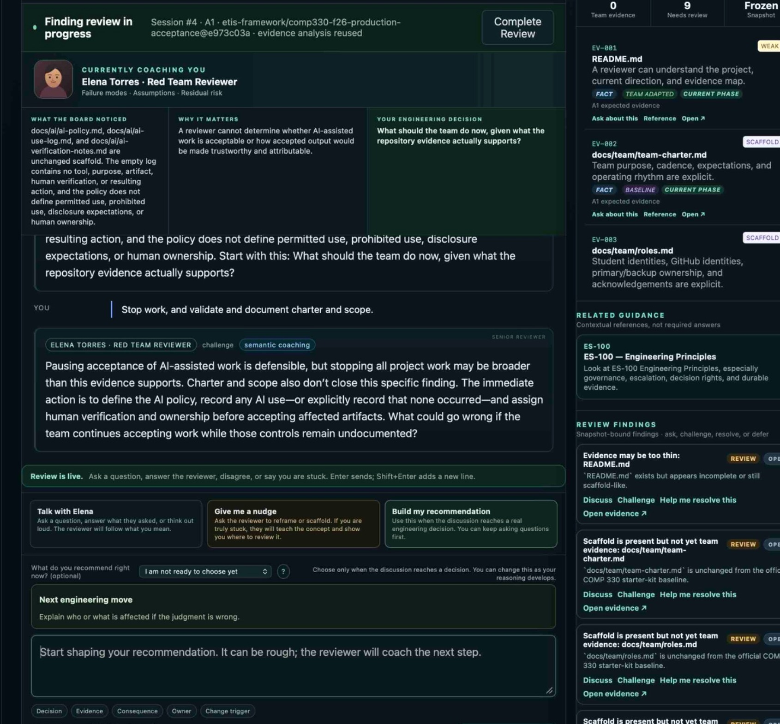
Figure 16. Active review: reviewer challenge, evidence rail, coaching modes, current recommendation, next engineering move, and response area.

10.1 How to talk to the reviewer
- Answer naturally. Grammar, spelling, and accent are not the engineering objective.
- Ask what a term, risk, or consequence means when you do not understand it.
- Say “I don’t know yet” when that is true, then identify what evidence would reduce the uncertainty.
- Challenge the reviewer when it missed evidence or drew the wrong interpretation.
- Name tradeoffs, consequences, constraints, ownership, and the evidence/event that would cause you to change your position.
- Do not optimize for agreement. A well-supported disagreement can show stronger judgment than passive acceptance.
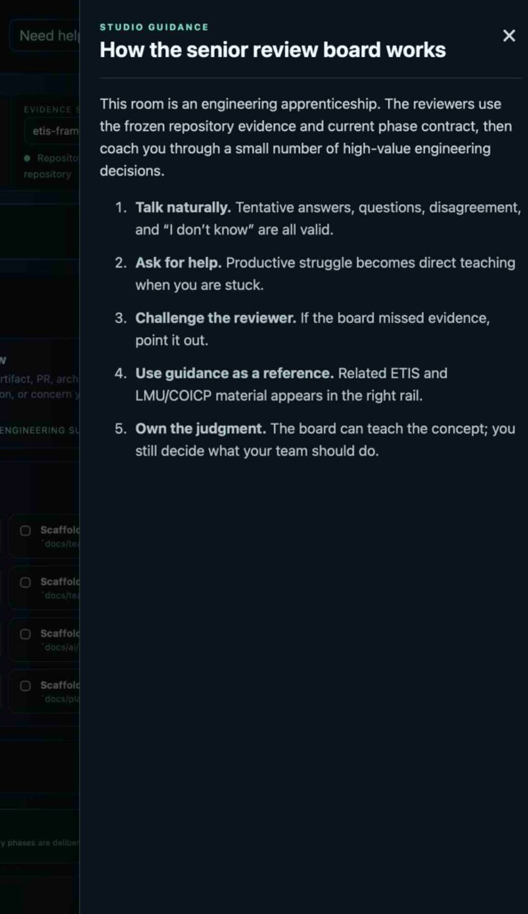
Figure 17. “Need help?” explains the apprenticeship model: talk naturally, ask for help, challenge the reviewer, use guidance as reference, and own the judgment.

11. Recommendations, decisions, and completing a review

11.1 Current recommendation is optional and revisable
Posture | What it communicates
I am not ready to choose yet | There is not enough reasoning/evidence yet for a responsible position.
Continue | Proceed on the current path.
Continue with conditions | Proceed only within explicit conditions/boundaries.
Hold / defer | Pause the relevant decision/work until uncertainty or evidence is reduced.
Reject this path | Recommend a different direction.
Request evidence / escalate | The decision cannot responsibly be made at the current evidence or authority level.

Your current recommendation changes how the reviewer challenges you. It is not automatically your final commitment. You may change it as the discussion develops.
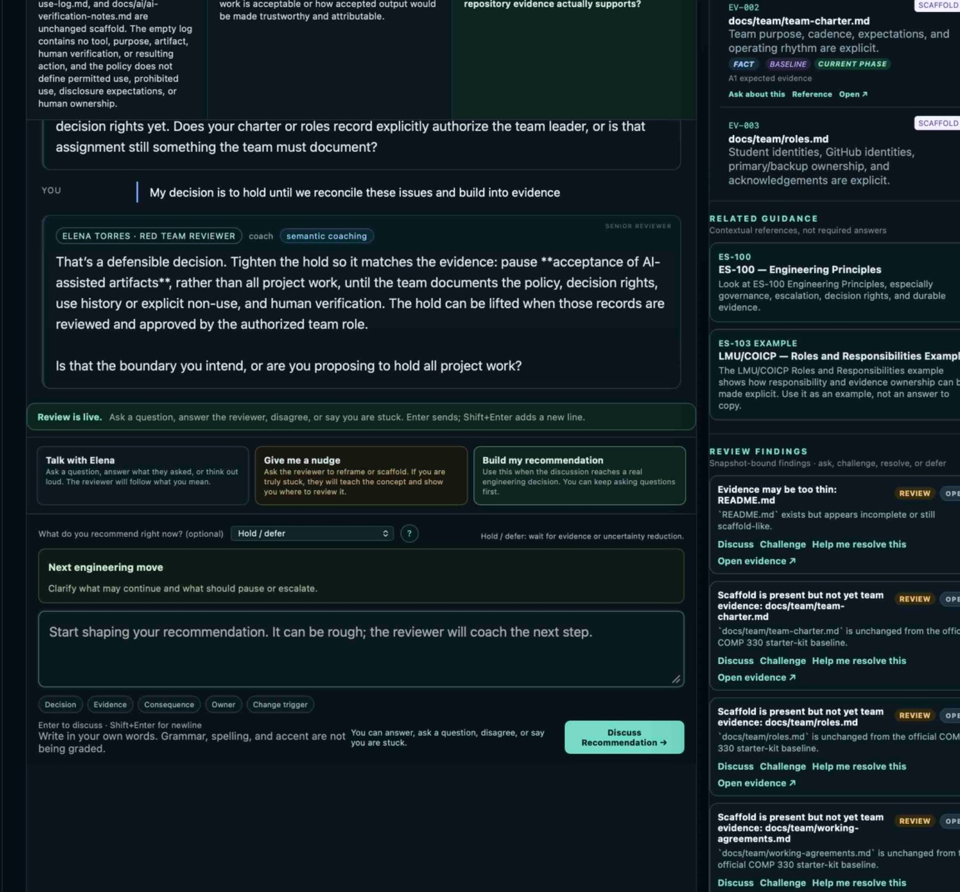
Figure 18. Example of a developing position: “Hold / defer.” The reviewer narrows the boundary so the student can make a more defensible decision.

11.2 Discuss Recommendation - the formal recommendation action
When the conversation reaches a consequential engineering decision, use Discuss Recommendation to shape and state the position you are prepared to defend. Earlier ETIS/course materials may refer to this concept as State My Recommendation. Not every review must end in a formal recommendation, and the system should not force a decision before the engineering meaning is ready.

11.3 Complete Review
Complete Review closes the current developmental session and preserves its persisted turns and frozen evidence context. Completion is not a grade. If the repository changes later and you need a clean new context, start a new review rather than trying to rewrite the old one.

12. Findings, challenges, corrections, and follow-up
Action | Use it when | What good use looks like
Discuss | You want to understand the finding and its consequence. | Ask what evidence caused it, what risk it implies, and what would close it.
Challenge | You believe the interpretation is wrong or incomplete. | Point to contrary evidence or explain the engineering rationale; do not simply say “AI is wrong.”
Help me resolve this | The finding is reasonable but you need a path forward. | Use coaching to identify the next evidence/work, owner, and closure condition.
Accept / defer | You agree or intentionally postpone it. | State why, the consequence you are accepting, and the condition/date/evidence for revisit.
Correction / staff disposition | The finding was a false REVIEW interpretation and is validated as such. | The correction prevents rediscovery on the same snapshot without mutating the underlying FACT evidence.

FACT VS. REVIEW
FACT is frozen repository-derived evidence. REVIEW is an interpretation of FACT. A review finding can be challenged or corrected; the frozen evidence itself is not rewritten to make the conversation look cleaner.

13. Review History and revisiting older work
Review History is your cumulative learning record. It lists sessions by phase/session number, date/time, completion state, and position-development state. Your conversations are individual, but each session remains tied to the frozen team evidence used at that moment.
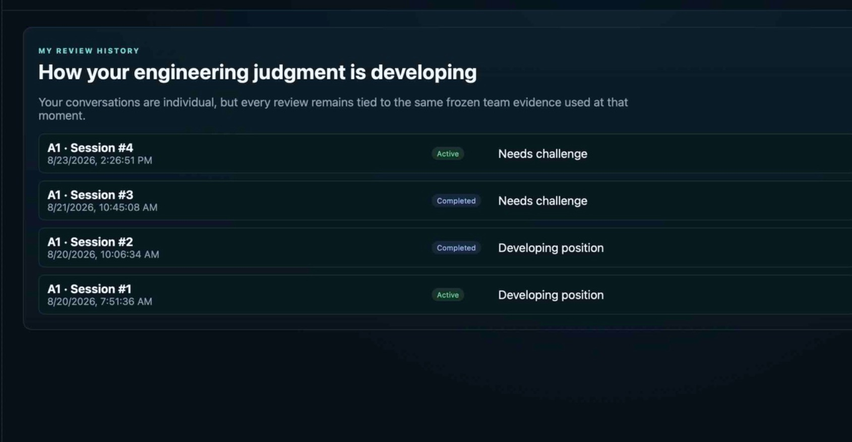
Figure 19. Review History preserves multiple sessions over time. Active and completed sessions can coexist.
1. Open Review History.
2. Choose the session you want to revisit.
3. If the session is active, return to it when you want to continue that same frozen-context conversation.
4. If the session is completed, treat it as read-only history against its original frozen evidence snapshot. Use it to remember what you knew, what you recommended, and what evidence existed then.
5. If the team has materially changed the repository and you want those changes reviewed, start a new review for the newer evidence state rather than trying to rewrite the old historical session.
Your goal | Use this path
Continue the same conversation | Open the active session from Engineering Studio or Review History. It remains tied to the same frozen snapshot.
See what you previously reasoned | Open the older session in Review History and compare its reasoning/position with what you know now.
Get feedback on new commits | Start a new review so the Studio freezes and analyzes a newer evidence snapshot.
See the exact code/commit diff | Use GitHub commit, branch, pull-request, or tag history; ETIS Review History is the engineering-conversation record, not a replacement Git browser.

WHY OLD REVIEWS STAY OLD
Historical integrity is intentional. A strong engineering record shows what was known and decided at the time, not a retroactively cleaned-up version after later commits solved the problem.

14. What happens after new commits and later checkpoints
Situation | What to do
Team pushes commits while my review is active | Continue the current review against its frozen snapshot. The new commits do not silently change the evidence under the conversation.
We fixed issues after the review | Commit/push the changes in GitHub. When you need the Studio to evaluate the newer state, start a later review so a new evidence snapshot is frozen.
I want to compare “before” and “after” | Use GitHub to inspect exact commit/PR history, then compare the older Review History session/snapshot with the newer review and its evidence context.
I need to prove a formal phase-gate boundary | Follow the course’s required designated Git tag/formal evidence procedure. Studio developmental review is not itself the formal evidence boundary.
A finding was wrong on the old snapshot | Challenge/correct the REVIEW interpretation. Do not mutate FACT evidence or pretend later commits were present earlier.

15. Help, privacy, team-shared vs. individual state

15.1 Help & guidance
Use Need help? / Help & guidance when you are unsure how to engage the board. Related ETIS and course/reference guidance may also appear in the right rail. Guidance is contextual reference, not a required answer to copy.

15.2 What instructors can see
- Teaching staff can inspect persisted review turns when authorized.
- Unsent drafts remain private.
- Instructor visibility is for coaching/oversight; generic read authority does not let staff impersonate your student review actions.
- AI usage telemetry is bounded operational metadata; it is not a transcript dump and is not an automated grade.

15.3 Shared and individual data
Team-shared | Individual
Verified repository binding | Your review conversations
Frozen team evidence snapshots | Your developing recommendation/position
Team membership and project context | Your personal review history/learning state
Repository-derived strengths/findings | Your GitHub identity link

16. Student troubleshooting
Problem | What to check/do
I can sign in but cannot enter the course | Authentication is not course authorization. Confirm you are on the active roster/section and contact the instructor if the assignment is wrong.
Wrong GitHub account is linked | My Team -> Change linked GitHub account -> choose the intended engineering account.
Repository says owner authorization required | The personal owner or GitHub organization owner/admin must authorize the App. Non-owners should wait.
GitHub App shows repository selection | Choose Only select repositories and only the nominated repository. Never choose All repositories.
Step 1 is complete but repository is not verified | Return to My Team and choose Check & verify repository access.
Verification fails | Confirm the App installation includes the exact nominated repository and uses selected-repository scope. Do not keep nominating random URLs.
Verified repository must change | Ask the instructor/course owner to Reset repository onboarding. Students cannot directly replace a verified binding.
Evidence is 0%/thin | Check whether the repo mostly contains starter scaffold. Look for team-created project-specific evidence and equivalent artifacts.
Finding seems wrong | Use Challenge and point to evidence. For an existing finding, use Review Findings.
I am stuck in the conversation | Ask a question or use Give me a nudge. You are allowed to say what you do not know yet.
Review is using old evidence | That may be correct: an active/completed session is frozen. Start a new review for newer repository evidence.
Page is repeatedly slow | Wait/retry once; if persistent, capture browser Network timings/request IDs if available and report the slow request to the instructor.
Logout/sign-in seems odd | Log out, close stale tabs if needed, and sign in again. Your persisted GitHub/team/review records are not erased by logout.

17. Appendix A - Student use cases

Normal A1 Board Review
When: Repository is verified and the team wants phase-aware developmental review.
Recommended path: Inspect Engineering Evidence -> choose Board Review -> start review -> reason/ask/challenge -> state recommendation only when warranted -> Complete Review -> commit follow-up changes in GitHub.

Specific architecture concern
When: You are deciding whether to use a database, auth pattern, deployment design, API boundary, etc.
Recommended path: Choose Focused Review, name the decision/artifact, bring the relevant evidence, and ask the board to stress the tradeoff rather than asking “is this good?”

Reviewer missed evidence
When: The finding says an artifact is missing, but the repo contains equivalent evidence.
Recommended path: Use Challenge; reference the path/PR/decision record and explain why it serves the engineering purpose. Seek correction if the interpretation is demonstrably false.

Team changed the repository after a completed review
When: The old review still shows missing/weak evidence.
Recommended path: Leave the old review intact. Use GitHub to verify the new commits, then start a new review so a new snapshot captures the improved state.

Organization repository approval pending
When: Student cannot complete Step 1 immediately.
Recommended path: Use GitHub’s organization request flow. Wait for an owner/admin with GitHub authority; then return and complete Step 2 verification.

Not ready to decide
When: The reviewer asks for a recommendation but key evidence is missing.
Recommended path: Keep “I am not ready to choose yet” or Request evidence/escalate. State exactly what evidence/authority is needed and who owns obtaining it.

Responsible hold
When: Risk is high enough that work/acceptance should pause.
Recommended path: Choose Hold/defer, narrow what is actually paused, name the condition for lifting the hold, and avoid broader stoppage than the evidence supports.

A teammate already verified the repository
When: You open My Team and the repository is already marked Verified team repository.
Recommended path: Do not nominate or authorize another repository. Verify that it is the correct team repository, then continue to Engineering Evidence/Studio. Repository trust is team-shared.

You return after a break and see an Active session
When: Review History or Engineering Studio shows an existing active review.
Recommended path: Resume it if you want the same frozen-context conversation. Start a new review only when you intentionally want a new review purpose or newer evidence snapshot.

You need evidence from a different file or artifact
When: A finding references one path, but the engineering purpose is satisfied elsewhere.
Recommended path: Use Open/Inspect/Ask the Board/Challenge as available, point to the equivalent artifact, and explain why it satisfies the engineering purpose rather than merely having a similar filename.

18. Appendix B - Strong engineering response checklist
- What do I recommend right now - or why am I not ready to recommend?
- What repository evidence supports that position?
- What important uncertainty/evidence boundary remains?
- What consequence or residual risk am I accepting?
- What condition, constraint, or guardrail limits the decision?
- Who owns the follow-up?
- What evidence/event would cause me to change, lift, reject, or close the decision?
- If the reviewer disagrees, can I explain the tradeoff instead of simply repeating my preference?

19. Appendix C - Snapshot, commit, and history FAQ
Question | Answer
Is a snapshot the same as a Git commit? | A snapshot is ETIS’s frozen evidence package for a review. It is anchored in a repository state and provenance such as commit/ref information, but it can also contain bounded metadata from issues, PRs, Actions, tags, branches, and other repository signals. GitHub remains authoritative for the raw commit history.
When is the checkpoint created? | When a review begins. The UI explicitly says beginning a review freezes the current evidence snapshot.
Can I refresh an active review to the newest commits? | Not by rewriting the existing snapshot. Finish/leave the historical session intact and start a later review for a new snapshot.
Why does Review History show an older problem after we fixed it? | Because it is a truthful historical record of the evidence and reasoning at that time.
How do I inspect old code exactly? | Use GitHub commit/branch/tag history. Use ETIS Review History to inspect the old engineering conversation and snapshot context.
Does the Studio’s checkpoint replace the formal phase-gate tag? | No. The Studio checkpoint is developmental review evidence. Follow the course’s designated Git-tag/formal evidence process for formal review.

20. Appendix D - Terminology
Term | Student meaning
FACT | Immutable repository-derived evidence frozen for a review.
REVIEW | Interpretation of FACT evidence; may be challenged/corrected.
Candidate repository | Nominated URL that is not yet trusted.
Verified team repository | Exact repository verified through the GitHub App and shared by the team.
Evidence snapshot / checkpoint | Frozen evidence package used by a particular review.
Current recommendation | Optional and revisable decision posture.
Discuss Recommendation | Current UI action used when a consequential position is ready to defend; earlier materials may call this State My Recommendation.
Review History | Your persisted sessions tied to the frozen evidence that existed at the time.
Equivalent evidence | Project-specific artifact that serves the required engineering purpose even if its form/name differs.
Starter scaffold | Provided structure/examples that do not by themselves prove the team performed the engineering work.

