ETIS

Team GitHub & Repository Setup Quickstart
  - Verify the correct team repository once, with the minimum GitHub access required
Audience | Student teams, repository owners, and organization members
Purpose | Complete the normal nomination -> GitHub authorization -> exact verification path safely and understand what to do when the path differs.
COMP 330/474 Software Engineering • Fall 2026 • Semester Start 2026 • August 23, 2026
EXECUTIVE OVERVIEW
One teammate nominates the real working repository. The personal owner or authorized organization grants selected-repository access. A student returns to ETIS and verifies that exact repository. Once verified, the repository binding is shared by the whole team.

1. Sign in & link GitHub | 2. Nominate repo | 3. Owner/admin authorizes | 4. Verify exact repo | 5. Team is ready

DO NOT SKIP STEP 2
A pasted URL is only a candidate. GitHub authorization is only Step 1. The repository becomes trusted team evidence only after ETIS completes Step 2: Check & verify repository access.

Step | Do this | Do not do this
1 | Sign in with Loyola. In My Team, confirm the GitHub account is the one you actually use. | Do not assume Loyola and GitHub identities are the same account.
2 | Paste the complete HTTPS URL of the team’s actual working repository and choose Nominate team repository. | .git is optional. Do not treat the pasted URL as trusted evidence yet.
3 | On GitHub choose Only select repositories and choose only the nominated team repository. | Never choose All repositories. Never use a PAT for ETIS.
4 | Return to My Team and choose Check & verify repository access. | Do not stop after GitHub authorization; Step 2 is required.
5 | Confirm Verified team repository. Other teammates inherit the binding. | Do not have every teammate nominate a different URL.

The setup flow on screen
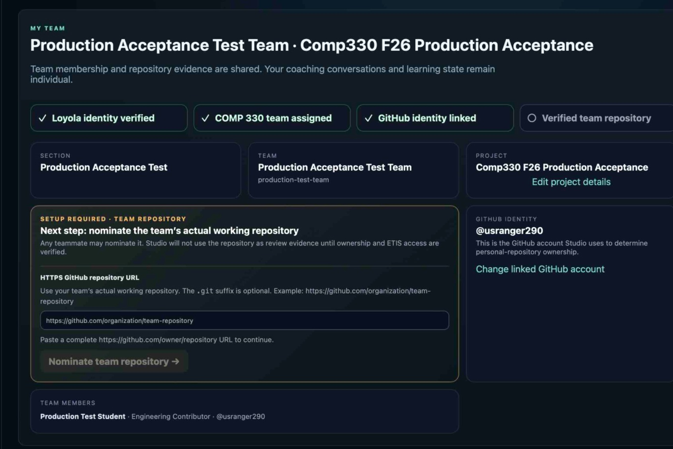  1. Nominate the team’s actual working repository. | 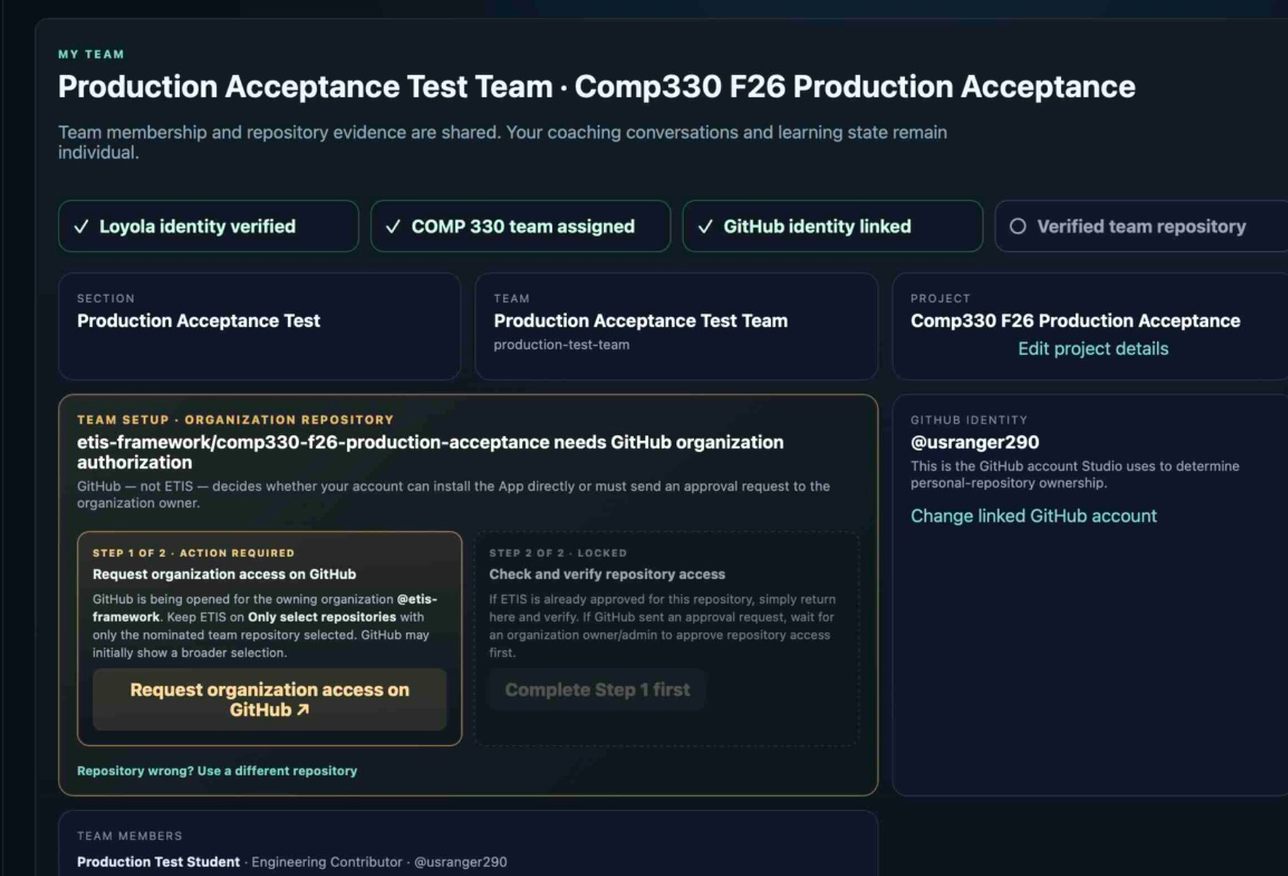  2. If GitHub organization authorization is required, complete/request Step 1.
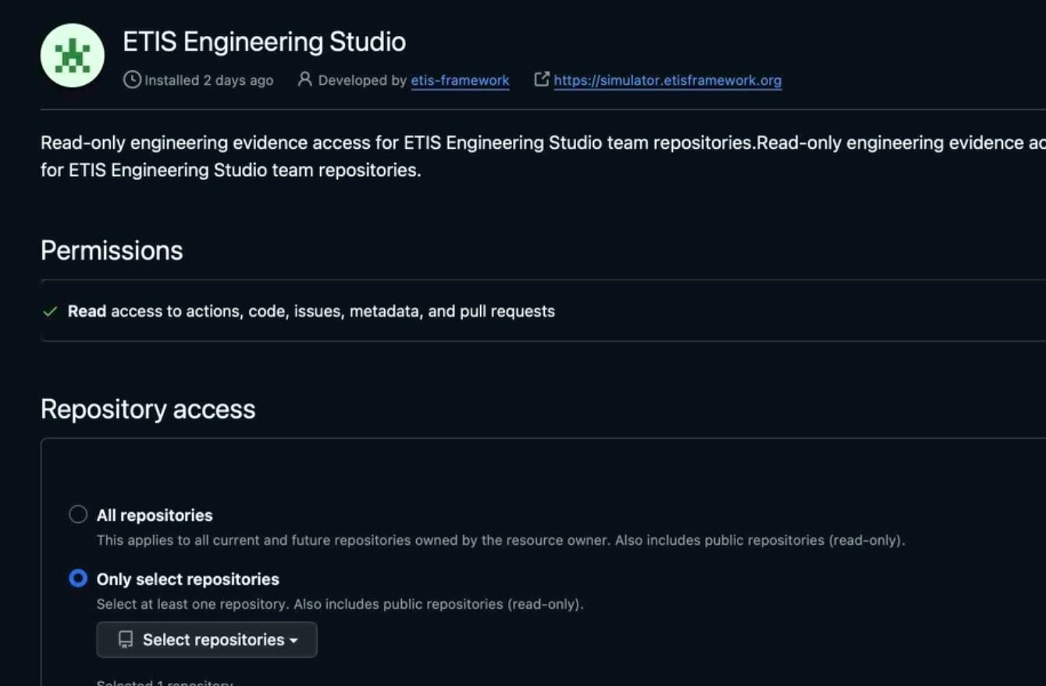  3. On GitHub select Only select repositories, then choose only the nominated team repository. | 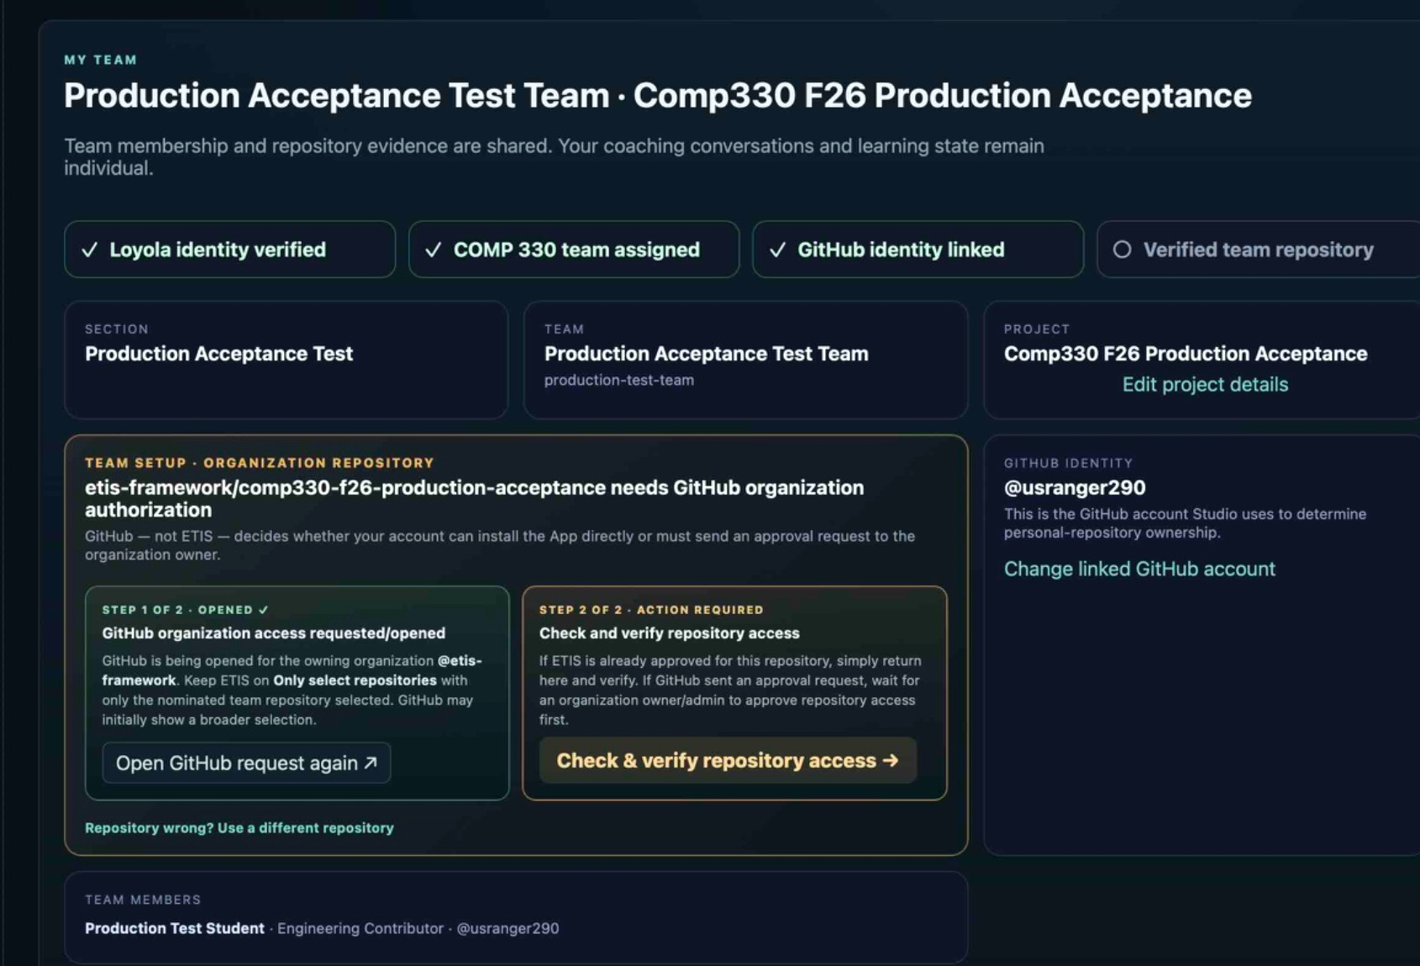  4. Back in ETIS, complete Step 2: Check & verify repository access.

GITHUB SCOPE CHECK
The GitHub example intentionally does not show a repository name. Your selected repository must be the same one nominated in My Team. If you see an unrelated class/personal repository, stop and correct the selection before saving.

Personal vs. organization repositories
Repository type | Who authorizes | What students should do
Personal | The actual personal-repository owner. | If you are not the owner, wait for the owner. After verification, the team shares the binding.
Organization-owned | GitHub organization owner/admin if GitHub requires approval. | Follow GitHub’s request/approval path. This is not automatically instructor approval unless the instructor actually has GitHub organization authority.

Fast troubleshooting
You see | Do this
Wrong GitHub account | My Team -> Change linked GitHub account. Then select the account you actually use for the team.
Step 1 locked | Complete/request owner or organization authorization first.
Step 1 complete, Step 2 pending | Click Check & verify repository access.
Verification fails | Confirm the GitHub App includes the exact nominated repository and uses selected-repository scope.
Wrong repo before verification | Use Repository wrong? Use a different repository.
Wrong repo after verification | Ask the Instructor/Course Owner to reset repository onboarding; then repeat the normal trust flow.
All repositories selected | Change the installation to Only select repositories. ETIS is designed to reject broad scope.
A teammate already verified it | Do nothing to the repository binding. Confirm it is correct, then continue to Engineering Evidence/Studio.

READY CHECK
Loyola identity ✓ Team assigned ✓ GitHub identity linked ✓ Verified team repository ✓

SECURITY RULE
ETIS repository access is read-only and selected-repository scoped. Never give ETIS a personal access token and never authorize All repositories.

