ETIS

Azure Operations CLI User Guide
  - Complete operator reference for production inspection, validation, troubleshooting, and guarded runtime scaling
Audience | ETIS production operators, course owners, maintainers, and administrators
Purpose | Use the supported command-line interface safely, interpret every result, and know what to do when production differs from the accepted baseline.
Production service | https://simulator.etisframework.org
Reference implementation | COMP 330/474 Software Engineering • Fall 2026
Version | Semester Start 2026 • August 23, 2026

OPERATING PRINCIPLE
Production changes must be deliberate, reversible where possible, observable, and validated. The repository and protected deployment workflow remain authoritative; local tools do not replace controlled deployment.

Contents
Section | Purpose
Executive Overview | Operating philosophy, accepted baseline, and command selection

Section | Purpose
1-3 | Safety model, prerequisites, output semantics

Section | Purpose
4 | Complete command reference with all options and examples

Section | Purpose
5-7 | Normal operating workflows, troubleshooting, and escalation

Section | Purpose
Appendices | Command matrix, expected baseline, exit behavior, and examples

Executive Overview
The ETIS Azure Operations CLI is the supported operator interface for inspecting ETIS Engineering Studio production. It converts raw Azure state into explicit PASS, WARN, FAIL, and INFO results and keeps routine operations read-only. It is deliberately not a deployment tool.
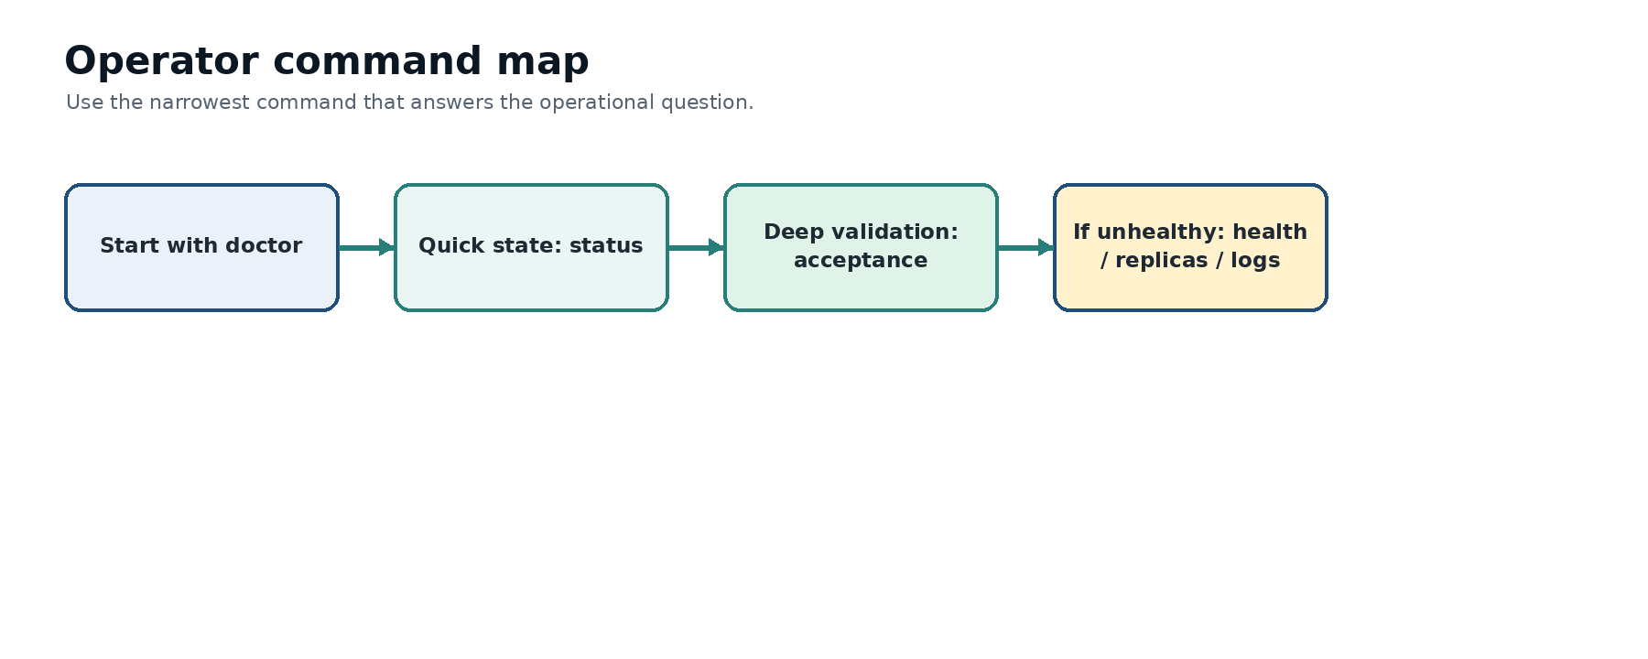
Figure 1. Operator command map. Start with readiness, move to concise state, then run full acceptance when the question is “is this deployment production-ready?”
ACCEPTED PRODUCTION BASELINE
Production application/resource group: etis-studio-prod; canonical URL: https://simulator.etisframework.org; revision mode: Single; target port: 8000; external ingress enabled; min/max replicas: 1 / 5; normal semester posture keeps one replica warm.

Question | Preferred command
Can this workstation safely operate ETIS? | doctor
Is production generally healthy right now? | status
What is the live non-secret configuration? | config
Are public health/readiness endpoints healthy? | health
Are replicas ready/restarting? | replicas
Which revision has traffic? | revisions
What happened recently? | logs
What is month-to-date spend? | cost
Are budget controls configured? | budget
Does the externally visible app behave correctly? | smoke
Does runtime match the accepted/source baseline? | drift
Did the deployment pass all required production checks? | acceptance
Do I need a temporary runtime scaling override? | scale - guarded mutation

1. Operating model and safety boundaries
- Read-only commands are the normal path.
- `scale` is the only current command that mutates live Azure runtime configuration.
- Production deployment remains branch → PR → CI → merge → protected GitHub Deploy Azure workflow.
- Secrets, tokens, Key Vault secret values, and database credentials are intentionally not printed.
- Cost telemetry is advisory and may lag or be throttled without making Studio unhealthy.
- A drift finding is a reason to investigate, not permission to “fix” Azure blindly.

2. Prerequisites and first use
1. Open a terminal in the `etis-engineering-studio` repository.
2. Activate the Python environment used by the repository if applicable.
3. Confirm Azure CLI authentication and subscription context.
4. Run the local readiness check before any production investigation.
./scripts/azure/etis-azure doctor

FIRST-TIME OPERATOR
If `doctor` does not show the intended subscription, resource group, and production Container App, stop before using `scale` or making any portal changes.

3. Reading output
State | Meaning | Operator response
PASS | The checked invariant matches the accepted/healthy condition. | Continue. A collection of PASS results supports, but does not replace, the final acceptance report.
WARN | The command completed but found an advisory or degraded condition. | Read the note. Determine whether it is expected, transient, or a precursor to failure.
FAIL | A required invariant or operation failed. | Do not declare production accepted. Investigate the indicated boundary before mutation.
INFO | Context or telemetry without pass/fail authority. | Use it to understand the environment; do not treat it as an acceptance gate.

4. Complete command reference

4.1 `help`
Purpose. Display the command catalog and command-specific option pointers.

Examples
./scripts/azure/etis-azure help
./scripts/azure/etis-azure -h
./scripts/azure/etis-azure --help

What you are looking for
Help must render without Azure authentication. `scale` must be classified as mutating. Deployment must remain explicitly outside this CLI.

If it does not match
If help requests Azure login, local argument parsing has regressed. Fix the CLI/tests before relying on it.

4.2 `doctor`
Purpose. Check workstation tools, repository context, Azure authentication/subscription, Container App access, and source replica baseline.

Examples
./scripts/azure/etis-azure doctor

What you are looking for
Azure CLI/Git/curl available; repo recognized; Azure authentication PASS; production Container App accessible; Bicep baseline 1/5. A dirty working tree may WARN.

If it does not match
Correct missing prerequisites or Azure context. If Bicep differs, inspect the source change before any runtime action.

4.3 `status`
Purpose. Show a concise production snapshot.

Examples
./scripts/azure/etis-azure status

What you are looking for
PRODUCTION; app/resource group etis-studio-prod; provisioning Succeeded; Single revision mode; 100% traffic to expected revision; min/max 1/5; at least one running replica; STATUS: PASS.

If it does not match
Use `config`, `revisions`, `replicas`, and `drift` to isolate the mismatch. Wrong subscription/app context is a stop condition.

4.4 `config`
Purpose. Display important non-secret runtime configuration and source baseline.

Examples
./scripts/azure/etis-azure config

What you are looking for
External ingress Yes; target port 8000; Single revision mode; runtime 1/5; Bicep 1/5; secret values intentionally absent.

If it does not match
Treat ingress/port/revision-mode differences as material drift. Determine whether a temporary scale override exists before changing anything.

4.5 `health`
Purpose. Check public `/health`, `/ready`, migration-current state, root reachability, and latency.

Examples
./scripts/azure/etis-azure health

What you are looking for
`/health` 200 status=ok environment=production; `/ready` 200 status=ready migration_current=True; root reachable; HEALTH: PASS.

If it does not match
If `/health` fails, inspect replicas/ingress/logs. If `/ready` fails, prioritize DB connectivity/migration state. `migration_current=False` blocks acceptance.

4.6 `replicas`
Purpose. Inspect configured capacity, replica readiness, restart count, revision ownership, and running state.

Examples
./scripts/azure/etis-azure replicas

What you are looking for
Configured 1/5; one or more ready/running replicas; restart counts stable/low; current revision expected; REPLICAS: PASS.

If it does not match
Zero ready replicas or repeated restarts: run `logs`, `health`, and check the Container App alert/revision. Avoid scaling as a substitute for fixing startup failure.

4.7 `revisions`
Purpose. Inspect revision history and traffic allocation.

Examples
./scripts/azure/etis-azure revisions

What you are looking for
Current/latest revision identifiable; active; 100% traffic under Single mode; replica count expected.

If it does not match
Unexpected traffic or revision: compare deployment workflow/run SHA and `status`. Resolve deployment state before acceptance.

4.8 `logs`
Purpose. Show structured recent console activity while suppressing routine probes by default.

Examples
./scripts/azure/etis-azure logs
./scripts/azure/etis-azure logs --tail 100
./scripts/azure/etis-azure logs --all
./scripts/azure/etis-azure logs --raw
./scripts/azure/etis-azure logs --follow
./scripts/azure/etis-azure logs -f

What you are looking for
Default view emphasizes real requests/errors and summarizes health/readiness probes. `--all` includes probes; `--raw` removes formatting; `--follow/-f` streams live logs; `--tail N` changes history depth.

If it does not match
HTTP/application error counts should drive investigation. Raw/follow are escalation tools; stop streaming with Ctrl-C.

4.9 `cost`
Purpose. Show month-to-date Azure cost telemetry.

Examples
./scripts/azure/etis-azure cost

What you are looking for
Cost telemetry returns when available. If Azure Cost Management throttles (429), COST: WARN is advisory and exit remains non-blocking.

If it does not match
Do not hammer the API after 429. Wait and retry later. Use budget alerts as the durable stewardship control.

4.10 `budget`
Purpose. Verify the production budget and thresholds without printing recipient email addresses.

Examples
./scripts/azure/etis-azure budget

What you are looking for
$100 monthly budget; 50/80/100% actual-cost alerts enabled; at least one recipient; BUDGET: PASS.

If it does not match
If missing or changed, restore the intended budget configuration or document the approved new baseline. Budget issues do not mean the app is technically down.

4.11 `smoke`
Purpose. Run non-destructive external production checks including authentication/bootstrap invariants.

Examples
./scripts/azure/etis-azure smoke

What you are looking for
Health/readiness 200; production environment; migrations current; root reachable; Loyola login marker present; native fail-closed shell marker present; Entra route redirects to Microsoft; SMOKE TEST: PASS.

If it does not match
A smoke failure is externally observable. Treat auth/bootstrap failures as release-blocking even when `/health` is green.

4.12 `drift`
Purpose. Compare runtime state with source-of-truth and accepted production invariants.

Examples
./scripts/azure/etis-azure drift

What you are looking for
App/resource group, Bicep 1/5, runtime 1/5, Single revision mode, external ingress, port 8000, 100% traffic, fail-closed shell all PASS.

If it does not match
Do not auto-correct. Determine whether runtime or source is wrong. A temporary live override should be documented and eventually reconciled through source/deployment.

4.13 `acceptance`
Purpose. Orchestrate the required post-deployment checks and issue the production decision.

Examples
./scripts/azure/etis-azure acceptance

What you are looking for
Required: status, health, replicas, smoke, drift, budget PASS. Cost is informational. Final line: PRODUCTION ACCEPTANCE: PASS.

If it does not match
Any required FAIL blocks acceptance. Investigate the failing subcommand. Advisory cost WARN must not be misrepresented as production failure.

4.14 `scale`
Purpose. Apply a guarded live runtime min/max replica override.

Examples
./scripts/azure/etis-azure scale --help
./scripts/azure/etis-azure scale 1 5
./scripts/azure/etis-azure scale 0 5

What you are looking for
Invalid ranges are rejected before Azure authentication. Maximum above 10 is rejected. A no-op exits without mutation. A real change shows target/current/requested values, warns about Bicep authority, and requires typing `PROD`.

If it does not match
Use only for deliberate temporary runtime control. `0 5` re-enables scale-to-zero/cold-start risk. Permanent changes belong in Bicep and the protected deployment path.

5. Normal operator workflows

5.1 Start-of-day / before class
./scripts/azure/etis-azure status
./scripts/azure/etis-azure health

- If both pass and there was no deployment/change, no deeper action is normally required.
- If status or health warns/fails, move to replicas and logs before changing anything.

5.2 After every production deployment
./scripts/azure/etis-azure acceptance

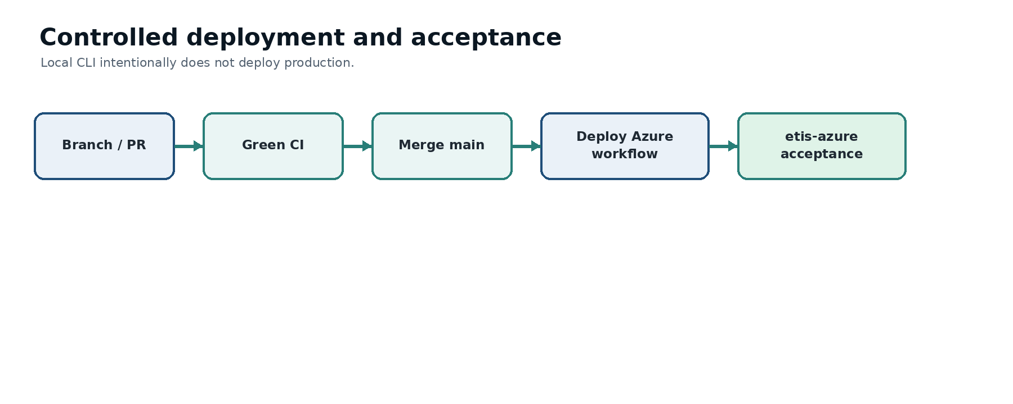
Figure 2. Deployment remains controlled in GitHub; the CLI validates the deployed result.

5.3 Investigating a student report
1. Confirm whether the issue is one student/team or platform-wide.
2. Run `status` and `health`.
3. If platform health is good, use Studio/instructor workflows to inspect identity, roster, GitHub authorization, repository verification, or the specific review.
4. Use `logs` only after you know the approximate time/action being investigated.

5.4 Handling drift
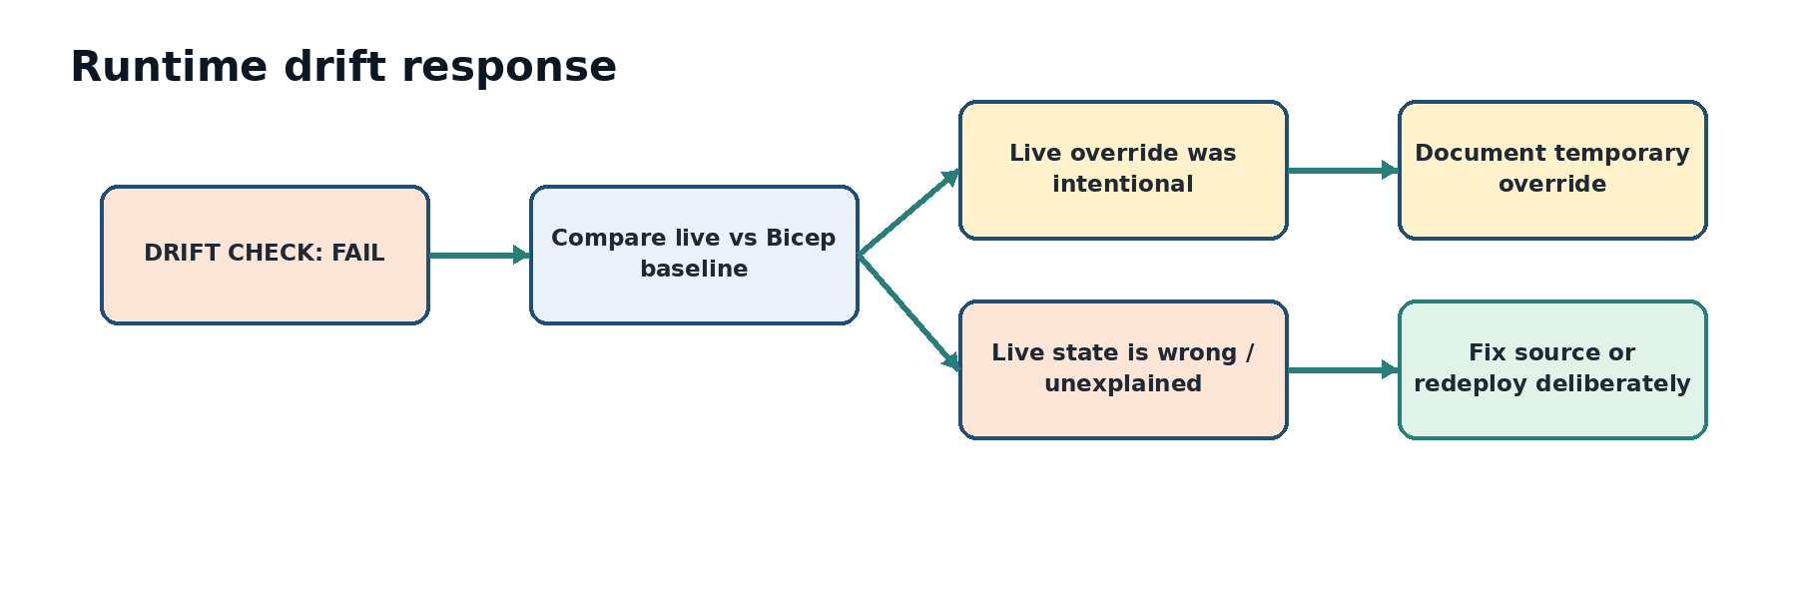
Figure 3. Drift is an investigation signal. Decide which side is authoritative before reconciling.

6. Troubleshooting patterns
Symptom | Run next | Likely boundary
Site unavailable | status → health → replicas → logs | Container App/ingress/runtime
/health 200 but /ready fails | health → logs → config | Database, migration, startup dependency
Login loop/blank shell | smoke → logs | Entra callback/session/bootstrap
Repository verification fails | smoke/status then instructor/student onboarding checks | GitHub App authorization or wrong repo
Repeated restarts | replicas → logs | Application startup/resource/dependency
Unexpected 0 replicas | status → config → drift | Scaling/runtime drift
Wrong revision | status → revisions → GitHub workflow run | Deployment selection/traffic
High cost alert | budget → cost | Stewardship/capacity; not automatically health
Cost command 429 | No immediate retry | Azure Cost Management throttling

7. Escalation and stop conditions
- Wrong Azure subscription/resource group/application context.
- `migration_current=False` or schema head mismatch.
- Production environment reports development settings or non-production identity behavior.
- Smoke test shows authenticated application shell can flash before authentication state is established.
- GitHub App is scoped to All repositories.
- A proposed recovery requires editing production data/schema directly or exposing secrets.
- A runtime override is being considered as a substitute for understanding an application failure.

Appendix A. Quick command matrix
Command | Read-only? | Typical use
help | Yes | Display the command catalog and command-specific option pointers.
doctor | Yes | Check workstation tools, repository context, Azure authentication/subscription, Container App access, and source replica baseline.
status | Yes | Show a concise production snapshot.
config | Yes | Display important non-secret runtime configuration and source baseline.
health | Yes | Check public `/health`, `/ready`, migration-current state, root reachability, and latency.
replicas | Yes | Inspect configured capacity, replica readiness, restart count, revision ownership, and running state.
revisions | Yes | Inspect revision history and traffic allocation.
logs | Yes | Show structured recent console activity while suppressing routine probes by default.
cost | Yes | Show month-to-date Azure cost telemetry.
budget | Yes | Verify the production budget and thresholds without printing recipient email addresses.
smoke | Yes | Run non-destructive external production checks including authentication/bootstrap invariants.
drift | Yes | Compare runtime state with source-of-truth and accepted production invariants.
acceptance | Yes | Orchestrate the required post-deployment checks and issue the production decision.
scale | No | Apply a guarded live runtime min/max replica override.

Appendix B. Accepted baseline
Invariant | Accepted value
Application/resource group | etis-studio-prod
Public origin | https://simulator.etisframework.org
Revision mode | Single
Ingress | External HTTPS
Target port | 8000
Min/max replicas | 1 / 5
Budget | $100 monthly; actual-cost alerts at 50%, 80%, 100%
Database | PostgreSQL Flexible Server; migration_current must be true
Deployment | Protected GitHub Deploy Azure workflow after merge to main

Appendix C. Representative healthy output
Exact latency, revision names, replica IDs, costs, and timestamps vary. The examples below show the shape and decision signals an operator should expect rather than values to copy literally.

status
ETIS Engineering Studio
Production Status
Environment .................... PRODUCTION
Application .................... etis-studio-prod
Resource Group ................. etis-studio-prod
Provisioning State ............. PASS Succeeded
Revision Mode .................. PASS Single
Traffic ........................ PASS 100%
Min / Max Replicas ............. PASS 1 / 5
Running Replicas ............... PASS 1
STATUS: PASS

health
ETIS Engineering Studio
Application Health
/health ........................ PASS HTTP 200
status=ok, environment=production
/ready ......................... PASS HTTP 200
status=ready, migration_current=True
Root Page ...................... PASS HTTP 200
HEALTH: PASS

replicas
Configured Capacity ............ PASS 1 / 5
Running Replicas ............... PASS 1
Replica Revision Ready Restarts State
<replica-id> <latest-revision> Yes 0 Running
REPLICAS: PASS

budget
Budget Name ..................... etis-studio-prod-monthly
Monthly Budget ................. PASS $100
50% Actual Cost Alert .......... PASS enabled
80% Actual Cost Alert .......... PASS enabled
100% Actual Cost Alert ......... PASS enabled
BUDGET: PASS

drift
Bicep Min Replicas ............... PASS 1
Runtime Min Replicas ............ PASS 1
Bicep Max Replicas .............. PASS 5
Runtime Max Replicas ............ PASS 5
Revision Mode ................... PASS Single
External Ingress ................ PASS
Target Port ..................... PASS 8000
Latest Revision Traffic ......... PASS 100%
Fail-Closed Shell ............... PASS
DRIFT CHECK: PASS

acceptance
Required Production Checks
Production Status ............. PASS
Application Health ............ PASS
Replica Capacity .............. PASS
External Smoke Test ........... PASS
Runtime Drift ................. PASS
Budget Controls ............... PASS
Informational Checks
Cost Telemetry ................ PASS
PRODUCTION ACCEPTANCE: PASS

scale 1 5 (no-op)
Environment .................... PRODUCTION
Current Min / Max ............... 1 / 5
Requested Min / Max ............. 1 / 5
Change Required ................. PASS runtime already matches requested values
Result: No Azure change was made.
SCALE OVERRIDE: PASS

Appendix D. Exit behavior and automation
Situation | Expected behavior
Successful required check | Exit 0; final PASS.
Advisory condition designed not to block operation | Exit 0 with WARN when appropriate; caller must read status text.
Required failure or invalid operation | Non-zero exit; FAIL/error detail.
Invalid `scale` arguments | Rejected locally before Azure mutation/authentication where possible.
Cost Management throttling | COST: WARN; non-blocking because cost is informational.
Unknown command/option | Usage/error with non-zero exit.
Automation should test both process exit status and the documented final decision label when the distinction between required and advisory checks matters.

Appendix E. Temporary runtime override record
When `scale` is used for a real production change, record the override so a later operator does not mistake deliberate temporary state for unexplained drift.
Field | Record
Date/time and operator
Reason / incident or change reference
Previous min/max
Requested min/max
Expected duration
Bicep/source changed? | No, unless separately approved and merged
Validation performed | status / health / drift / acceptance as appropriate
Reconciliation plan | When and how runtime will return to the authoritative baseline

