ETIS

Semester Administration & Course Operations Guide
  - End-to-end semester lifecycle: term creation, sections, roster, teams, review calendar, teaching staff, activation, in-semester changes, archive, and handoff
Audience | Course Owners and instructors responsible for course setup/administration
Purpose | Provide a repeatable, first-time-friendly operating procedure for preparing, running, changing, and closing an ETIS semester without losing historical engineering records.
Reference implementation | COMP 330/474 Software Engineering • Fall 2026
Version | Semester Start 2026 • August 23, 2026

CORE PRINCIPLE
Teaching staff use ETIS to observe engineering reasoning, evidence, and risk without turning activity counts, AI output, or attention signals into grades. Students remain responsible engineers; staff remain responsible educators and course authorities.

Contents
Use Word’s Navigation pane to jump directly among numbered headings. The section list below follows the same structure.
1. Executive Overview
2. Administrative model and source-of-truth boundaries
3. Before you create a semester
4. Create the course term and sections
5. Import and maintain the section roster
6. Create teams and assign students
7. Configure review calendar and release control
8. Add teaching staff and verify authority
9. Activate the term and perform go-live checks
10. Operate the semester week to week
11. Adds, drops, reactivations, and team moves
12. Repository onboarding and instructor recovery
13. Phase/release changes during the semester
14. Archive the term
15. Post-archive records, retention, and handoff
16. Semester administration troubleshooting
17. Appendix A - Semester start checklist
18. Appendix B - Mid-semester change playbooks
19. Appendix C - End-of-semester checklist
20. Appendix D - Administrative invariants

Executive Overview
The semester lifecycle is a controlled administrative sequence. Setup is for preparation, Active is the normal teaching state, and Archived is historical/read-only. ETIS preserves membership, evidence, reviews, findings, and usage history across lifecycle transitions; administration changes current authority and future behavior without rewriting the past.

What this guide enables
- Create a term once and add one or more sections with independent rosters/teams/schedules.
- Import a roster from Sakai gradebook CSV using Student ID and Name while ignoring grade columns.
- Create teams, assign students, and preserve membership history when teams change.
- Configure A1-A6 availability, due/accept-until dates, and release controls by section.
- Assign teaching staff with the minimum role required.
- Activate only after identity, roster, team, repository, and schedule readiness checks.
- Handle adds/drops/team moves without deleting historical engineering records.
- Archive cleanly so student operational access ends while the semester record remains preserved.

Normal teaching-staff path
Create term | Add sections | Import roster | Create teams | Set calendar | Assign staff | Activate | Operate | Archive

DESIGN BOUNDARY
Normal semester archive is not deletion. Do not treat end-of-semester lifecycle state as permission to delete frozen evidence, review turns, findings/dispositions, membership history, or usage records.

2. Administrative model and source-of-truth boundaries
Durable administrative scope
Course Template | Term | Section | Team | Student

Boundary | Authoritative source / rule
Official course deadlines and instructions | Sakai remains authoritative.
Semester lifecycle | CourseTerm status: Setup → Active → Archived.
Current course authorization | Active roster, team membership, SectionStaff, term/section state.
Repository trust | Verified team repository through GitHub App exact-repository flow.
Historical evidence/reviews | Frozen snapshots and persisted records; never rewritten to match later course state.
Schema/runtime | Application release + Alembic + production infrastructure; not managed from Semester Setup.

FORWARD-ONLY LIFECYCLE
Setup prepares. Active teaches. Archived preserves history and ends student operational access. Treat archive as a governance boundary, not a temporary hide/show toggle.

3. Before you create a semester
- Confirm course template/phase contracts are the intended version for the semester.
- Confirm the production service has passed post-deployment acceptance.
- Confirm Course Owner authority and the intended institutional email identity.
- Prepare section identifiers, display names, meeting schedule, roster CSV(s), team plan, A1-A6 dates, and teaching-staff list.
- Know the intended GitHub organization/repository ownership model and who can authorize the ETIS GitHub App.
- Confirm Sakai communication/deadline pages are ready or know which dates remain provisional.
SEPARATE COURSE SETUP FROM INFRASTRUCTURE
Semester Setup configures course/term/section state. It does not provision Azure, change production secrets, or deploy application code. Use the installation/operations documentation for platform changes.

4. Create the course term and sections
Create each semester once, then add one or more sections. Sections inherit the lifecycle template but keep independent rosters, teams, review availability, and date overrides.
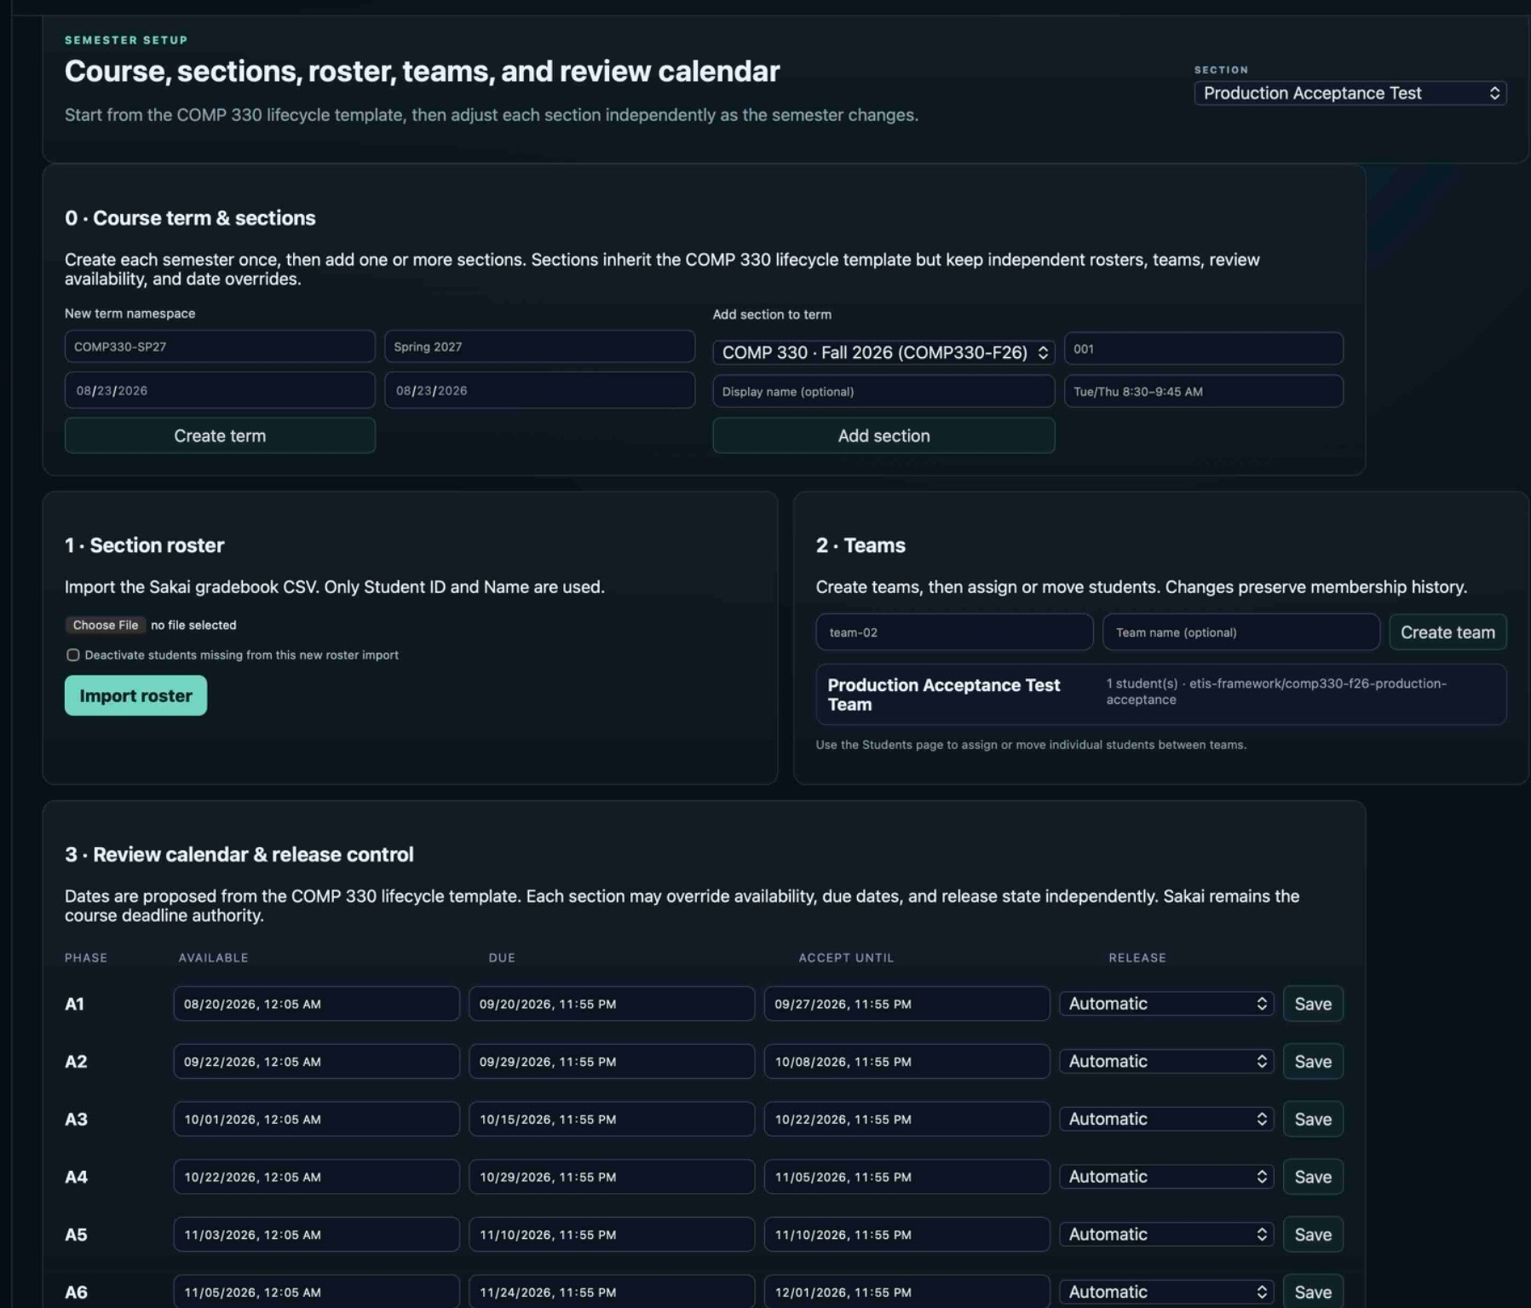
Figure 1. Semester Setup top. The page groups term/section creation, roster import, team creation, and the A1-A6 review calendar into one controlled setup workspace.
1. Open Semester Setup as Course Owner.
2. Create the new term namespace/display label and semester date context.
3. Add each section to the term with the intended section key/display name and meeting context.
4. Select each section explicitly before importing roster or configuring section-specific state.
5. Do not reuse an old Active/Archived term to represent a new semester.
Field / concept | Administrative guidance
Term namespace | Stable semester key; choose a consistent course-term naming convention.
Section key | Stable identifier for the offering within the term.
Display name | Human-readable label for instructor/student navigation.
Meeting context | Helpful orientation; does not replace Sakai calendar/deadline authority.
Multiple sections | Share course template but maintain independent roster/team/release state.

5. Import and maintain the section roster
Semester Setup accepts the Sakai gradebook CSV for roster import. ETIS uses Student ID and Name; grade columns are intentionally ignored. Imports should be repeatable and idempotent with respect to the intended current roster.
1. Select the intended section.
2. Choose the current Sakai gradebook CSV.
3. Review whether “Deactivate students missing from this new roster import” matches your intent.
4. Import the roster.
5. Verify student count and spot-check names/IDs.
6. Use Students for individual mid-semester add/reactivate/deactivate actions when that is clearer than a full re-import.
DEACTIVATE MISSING STUDENTS CAREFULLY
Use the deactivation option only when the CSV represents the authoritative complete current roster for that section. Do not deactivate students accidentally because you imported a partial file.

6. Create teams and assign students
Create teams, then assign or move students. Team changes preserve membership history so older reviews/evidence remain interpretable in their original context.
1. Create each team with a stable team key and optional human-readable name.
2. Use Students to assign current students to teams.
3. Verify each team’s membership before asking students to onboard repositories.
4. If a student moves later, change current membership; do not delete/recreate historical records.
Situation | Correct action
New team | Create team, then assign students.
Student initially unassigned | Assign through Students.
Student moves teams | Change current assignment; history is preserved.
Team renamed for display | Change human-readable project/team details if supported; preserve stable ID.
Team dissolved | Reassign current students; preserve earlier membership/reviews.

7. Configure review calendar and release control
Each section can override phase availability, due date, accept-until window, and release state. The screenshot shows A1-A6 with Automatic release behavior. Sakai remains the official deadline authority, so course communication and ETIS scheduling must agree intentionally.
Field | Meaning / use
Available | Earliest time the phase becomes available in the Studio.
Due | Course-plan due time for the phase context; keep aligned with Sakai.
Accept until | Late/acceptance window used by the section’s release contract.
Release | Controls phase release behavior; Automatic is the current reference example.
Save | Persist the section-specific override for that phase.

DATE CHANGES
If a deadline changes, update Sakai first or in the same controlled change window, then update the ETIS section schedule. Avoid creating two authoritative-looking dates.

8. Add teaching staff and verify authority
Teaching staff are added by institutional email with an explicit role. Authentication and authorization remain separate: adding a staff assignment grants course authority only according to the role and active lifecycle state.
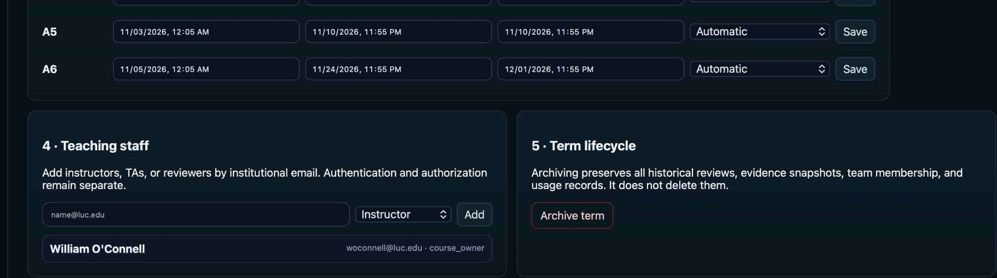
Figure 2. Semester Setup bottom. Teaching-staff assignment and term lifecycle actions are intentionally adjacent because both are elevated administrative responsibilities.
Role | Use it for | Do not use it for
Course Owner | Term lifecycle and elevated administration. | Routine broad assignment when Instructor is sufficient.
Instructor | Assigned-section administration and oversight. | Global authority outside assigned course/section.
TA | Bounded active-semester review/read support. | Roster, lifecycle, repository reset, archived access.
Reviewer | Bounded active-semester review/read role. | Course administration.

1. Add staff using the correct institutional email.
2. Choose the minimum role needed.
3. Have the staff member sign in and verify section context.
4. Confirm administrative controls are absent for TA/Reviewer accounts.

9. Activate the term and perform go-live checks
Activation changes the term from administrative preparation to normal semester operation. Do not activate simply because setup data exists; activate after a deliberate readiness check.
Activation gate
Setup complete | Roster verified | Teams verified | Staff verified | Calendar/release verified | Repository onboarding ready | Activate term

- Confirm students can authenticate with Loyola identity and the section roster authorizes them.
- Confirm team assignments are correct.
- Confirm staff roles and section selector behavior.
- Confirm the intended repository onboarding instructions are published.
- Confirm A1 availability/release timing is correct.
- Confirm Sakai “Start Here”/course instructions point to the production Studio URL.
- Confirm production acceptance is green and there is no known platform incident.
ACTIVATION EFFECT
Active is the normal state in which student/team/review authorization becomes operational. If activation produces unexpected access, stop and correct roster/staff/lifecycle state rather than adding broad exceptions.

10. Operate the semester week to week
Weekly administration loop
Check section context | Scan Command Center | Handle roster/team changes | Monitor repository readiness | Adjust release dates if needed | Coach from evidence/reviews | Watch operational notices

Area | Weekly question
Roster | Are current students active and correctly assigned?
Teams | Did any membership/project structure change?
Repository | Are teams verified; does any legitimate reset need instructor action?
Release calendar | Are upcoming phase dates still aligned with Sakai?
Reviews/evidence | Are there patterns requiring course clarification or coaching?
AI/cost | Any abnormal operational pattern?
Operations | Any deployment, health, or incident requiring the operations runbook?

11. Adds, drops, reactivations, and team moves
Change | Procedure | Historical effect
Add student | Students → Add / reactivate with institutional Student ID and name → assign team. | No effect on prior records because none exist for the new enrollment.
Reactivate student | Use Add / reactivate for existing identity/enrollment record when appropriate. | Preserves prior context instead of creating a duplicate person.
Drop/deactivate | Deactivate current enrollment. | Ends current course access; prior reviews/evidence/membership remain.
Move team | Change current team assignment. | Earlier team membership/reviews remain historically attributable.
Correct data error | Fix current administrative state using supported UI path. | Do not delete historical review/evidence to make the past look like the correction always existed.

HISTORY IS A FEATURE
Membership events and review history let instructors understand what was true at the time. Do not “clean up” history by deleting records after a legitimate move/drop.

12. Repository onboarding and instructor recovery
Repository onboarding is student/team-driven through nomination, owner/admin authorization, and exact verification. Instructor administration should intervene only when authority or recovery genuinely requires it.
Situation | Instructor action
Organization approval pending | Identify the GitHub organization owner/admin path; wait for approval. Do not reset.
Wrong student GitHub identity | Student relinks their GitHub account. Do not reset verified repository solely for this.
Candidate URL wrong before verification | Student uses the “different repository” path.
Verified repository truly wrong | Instructor/Course Owner resets repository onboarding.
All-repositories GitHub App scope | Do not accept; selected repositories only is required.
Verification fails after approval | Confirm exact repository is selected in App installation, then retry verification.

13. Phase/release changes during the semester
1. Confirm the pedagogical/course decision first.
2. Update Sakai/course communication so students have one authoritative deadline message.
3. Select the intended ETIS section.
4. Change the relevant phase availability/due/accept-until/release control.
5. Save and verify the value.
6. If the phase was already released, consider what students may already have seen/done before making a disruptive change.
7. Document significant exceptions for later course review.
DO NOT USE RELEASE CONTROLS AS PUNISHMENT
Release controls are course administration. They should reflect the course plan or an explicit exception, not be changed reactively based on individual student performance.

14. Archive the term
Archiving is the authoritative end-of-semester operational transition. It ends normal student operational access and makes the term historical/read-only while preserving the engineering record.
Archive lifecycle
Active term | Confirm course completion | Resolve/record known admin issues | Archive term | Student operational access ends | Active reviews → archived_incomplete | Historical read/retention continues

- Confirm the intended semester is selected before archive.
- Confirm all official course submissions/grades are handled in their authoritative systems.
- Record any reviews that are expected to become archived_incomplete.
- Archive through the supported lifecycle action.
- Verify student operational access ends.
- Verify historical evidence/reviews remain readable to authorized historical staff roles.
- Do not delete the database or infrastructure as part of normal archive.
ARCHIVE IS NOT DELETE
Frozen evidence, review turns, findings/corrections/dispositions, membership events, and AI usage records remain historical records. Retention/deletion is governed separately.

15. Post-archive records, retention, and handoff
- Confirm the archive date and semester identifier in administrative records.
- Preserve required evidence/review history according to institutional/course policy.
- Do not assume TA/Reviewer active-semester authority continues into archive.
- Use the Backup/Recovery/DR runbook for platform-level retention/recovery checks.
- If the application will be decommissioned rather than merely the semester archived, follow the Installation & Administration decommission procedure.

16. Semester administration troubleshooting
Problem | Likely boundary | Response
Student authenticates but cannot enter | Roster/term/section authorization | Verify Active term and active enrollment.
Student in wrong team | Current membership | Move current assignment; preserve history.
Roster import would deactivate unexpected students | Import file/options | Stop. Confirm complete CSV and deactivation checkbox intent.
TA cannot add student | Role boundary | Expected. Use Instructor/Course Owner.
Instructor cannot archive | Course Owner authority | Archive is elevated lifecycle authority.
Old section appears in selector | Historical/authorized context | Confirm term status; do not mutate archived state.
Phase not available when expected | Release/calendar | Check selected section and availability/release configuration against Sakai.
Verified repo must change | Repository trust | Use bounded reset, not database edit.
Archived term writable | Lifecycle enforcement | Treat as production blocker and escalate.
Student access persists after archive | Authorization/session revocation | Treat as production blocker and escalate to operations/security.

17. Appendix A - Semester start checklist
- Term created once with correct semester identity.
- All sections added and selected correctly.
- Roster imported and verified.
- Teams created and students assigned.
- Teaching staff assigned with least privilege.
- A1-A6 calendar/release controls reviewed against Sakai.
- Students receive repository onboarding instructions.
- Course Owner/Instructor can use Command Center, Teams, Students, Reviews, Engineering Evidence, Semester Setup.
- TA/Reviewer accounts lack elevated administration.
- Production acceptance green; canonical URL works.
- Term activated only after readiness review.

18. Appendix B - Mid-semester change playbooks

Playbook: late add
1. Add/reactivate student through Students.
2. Assign intended team.
3. Confirm student signs in and inherits current section/team state.
4. Explain repository/team history already in progress.
5. Do not fabricate backdated membership.

Playbook: student drops
1. Deactivate current enrollment.
2. Confirm current operational access ends.
3. Preserve prior review/membership/evidence history.
4. Adjust current team membership/work planning as needed.

Playbook: team move
1. Move current student to new team.
2. Confirm future authorization follows new membership.
3. Do not rewrite old team reviews/evidence.
4. Tell instructors reviewing history to interpret older sessions in original team context.

Playbook: schedule extension
1. Make the course decision.
2. Update Sakai authoritative deadline communication.
3. Update the intended ETIS section/phase dates.
4. Verify save and student-visible availability.
5. Document material exception if appropriate.

19. Appendix C - End-of-semester checklist
- Confirm final course deadlines/submissions are complete in Sakai/Review Center as applicable.
- Review unresolved administrative issues and repository bindings.
- Record any active Studio reviews that will archive incomplete.
- Archive the correct term.
- Verify student operational access ends.
- Verify historical records remain.
- Confirm authorized staff historical access posture.
- Hand off backup/recovery/retention checks to the operations/DR procedures.
- Do not delete infrastructure unless the application itself is being intentionally decommissioned.

20. Appendix D - Administrative invariants
- CourseTerm.status is authoritative for Setup / Active / Archived.
- Archived terms cannot grant current student/team/review mutation authority.
- Authentication does not equal course authorization.
- Staff authority is term/section scoped and role bounded.
- Roster/team changes preserve historical membership and review context.
- A verified repository is changed only through bounded reset + normal re-verification.
- A pasted repository URL is never trusted evidence.
- Frozen FACT evidence is immutable.
- Unsent student drafts remain private.
- Sakai remains authoritative for official course deadlines/instructions.
- Archive preserves records; retention/deletion is a separate governance decision.

