ETIS

Backup, Recovery & Disaster Recovery Runbook
  - Controlled recovery of application, database, configuration, identity dependencies, and durable engineering records
Audience | ETIS production operators, maintainers, course owners, and designated recovery personnel
Purpose | Provide a safe, testable recovery path that preserves data integrity, provenance, authorization boundaries, and the ability to prove the recovered system is trustworthy.
Production service | https://simulator.etisframework.org
Reference implementation | COMP 330/474 Software Engineering • Fall 2026
Version | Semester Start 2026 • August 23, 2026

OPERATING PRINCIPLE
Production changes must be deliberate, reversible where possible, observable, and validated. The repository and protected deployment workflow remain authoritative; local tools do not replace controlled deployment.

Contents
Section | Purpose
Executive Overview | Recovery philosophy and decision model

Section | Purpose
1-3 | Recovery assets, responsibilities, and pre-incident preparation

Section | Purpose
4-8 | Application rollback, PostgreSQL PITR, schema/data validation, secrets/config recovery

Section | Purpose
9-11 | External dependency/DNS recovery, disaster scenarios, return to service

Section | Purpose
12 | DR exercise procedure

Section | Purpose
Appendices | Recovery checklists, validation queries/concepts, evidence record

Executive Overview
ETIS recovery is not “get the web page back.” A recovered system must preserve the semester lifecycle, memberships, frozen evidence, review sessions/turns, findings/dispositions, AI usage records, and the trust boundaries that make those records meaningful. Recovery therefore treats application images, database state, configuration source, secrets, and external identity/repository dependencies as separate layers.
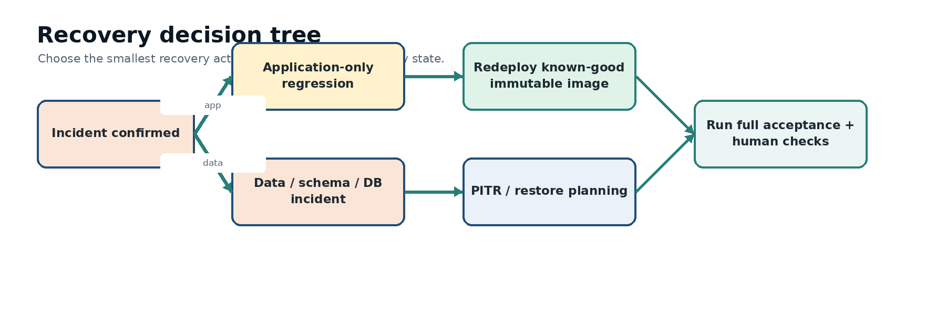
Figure 1. Recovery decision model. Use application rollback for application-only regression; use PITR/restore planning when data or schema integrity is involved.
RECOVERY PRINCIPLE
Prefer the smallest recovery action that restores a known-good, auditable state. Never overwrite or delete the only known copy of production data while investigating.

1. Recovery layers and authoritative records
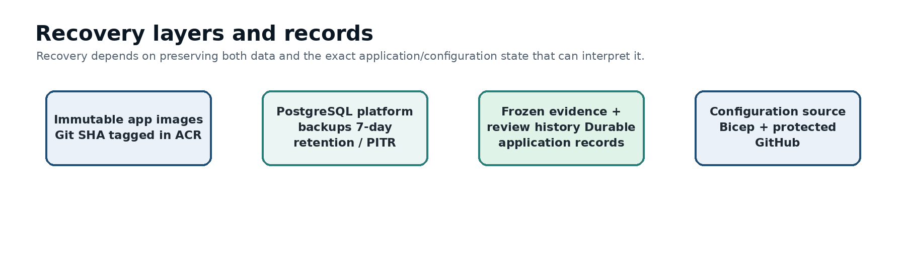
Figure 2. ETIS recovery depends on multiple preserved layers: immutable application images, PostgreSQL backups/PITR, durable engineering records, and authoritative configuration source.
Layer | Authority / recovery asset | Important constraint
Application | Immutable ACR images tagged by Git commit SHA | Do not rebuild an old commit just to recreate an already-retained rollback image.
Database | Azure PostgreSQL Flexible Server platform backup/PITR | Restore to a temporary server first when proving recovery; validate schema and data before cutover.
Schema | Alembic migration history/head | Do not manually edit schema to force compatibility.
Infrastructure | Bicep under `infra/azure/` plus protected deployment workflow | Portal state is not the long-term source of truth.
Secrets | Key Vault + protected GitHub environment secret provisioning | Never copy secret values into docs/tickets; rotate if exposure is suspected.
Identity/repository | Entra app/callbacks; GitHub OAuth/App configuration | Authentication and GitHub repository authority remain separate boundaries.
Engineering records | PostgreSQL durable records + frozen evidence provenance | Archive preserves history; recovery must not silently rewrite old evidence/reviews.

2. Recovery objectives and stop conditions
- Primary objective: restore trustworthy course operation without corrupting or rewriting historical engineering records.
- Recovery time is secondary to integrity when the incident involves database/schema uncertainty.
- If the current database may be corrupted, stop normal writes before experimentation.
- If secrets may be exposed, rotate/revoke them as part of recovery; do not merely restore the application.
- If a migration is incompatible with an application rollback, plan database recovery explicitly instead of assuming code rollback is sufficient.

3. Pre-incident readiness
1. Keep known-good Git-SHA application images in ACR.
2. Keep PostgreSQL backup retention/PITR enabled; accepted baseline is 7 days.
3. Maintain the protected `production` GitHub environment and authoritative Bicep.
4. Run post-deployment acceptance after every production change.
5. Periodically perform a restore drill to a temporary private PostgreSQL server and delete it after validation.
6. Ensure operators know where alerting, budget, Key Vault, and database restore controls are located.
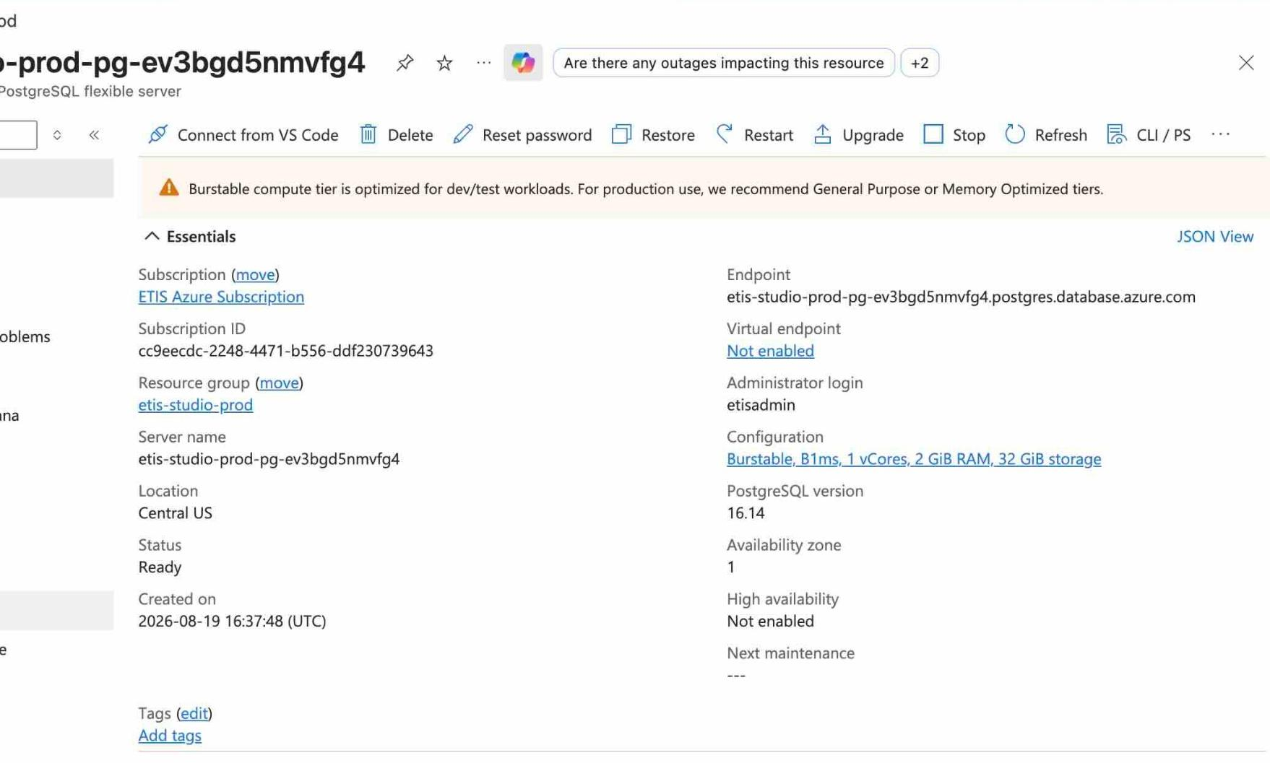
Figure 3. PostgreSQL Flexible Server overview. The production database is the durable system of record; Azure exposes a Restore action for point-in-time recovery.

4. Recovery decision procedure
1. Classify the incident as application-only, database/data/schema, secret/configuration, external identity/GitHub, or infrastructure/network.
2. Freeze or limit writes if data integrity is uncertain.
3. Capture current revision, database/server state, migration status, incident time window, and the last known-good time.
4. Choose the smallest recovery path below.
5. Perform recovery in a way that preserves the original evidence until the new state is validated.
6. Run technical validation, then full ETIS acceptance, then a human user-path spot-check.

5. Application rollback
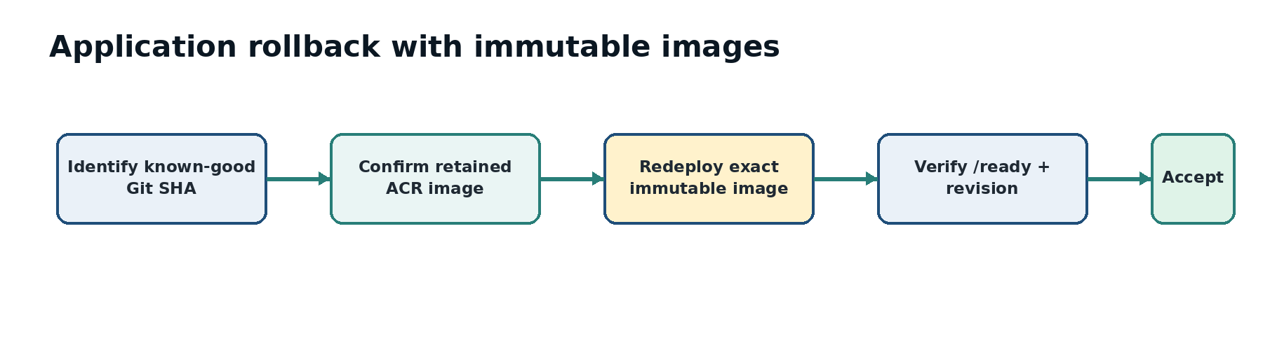
Figure 4. Application rollback redeploys a retained known-good immutable image. It is not a manual traffic switch to an indefinitely retained revision.
1. Identify the last known-good merged Git SHA and corresponding successful Deploy Azure run.
2. Confirm the immutable ACR image for that SHA still exists.
3. Confirm the target image is compatible with the current database schema. If not, stop and use a coordinated database recovery plan.
4. Redeploy the known-good image through the controlled production deployment mechanism or approved recovery path; preserve the SHA provenance.
5. Verify latest revision and `/ready`.
6. Run `etis-azure acceptance` and affected-path spot checks.
DO NOT REBUILD HISTORY
If the exact immutable image exists, use it. Rebuilding an old commit later can introduce changed base images/dependencies and is not the same artifact.

6. PostgreSQL point-in-time recovery (PITR)
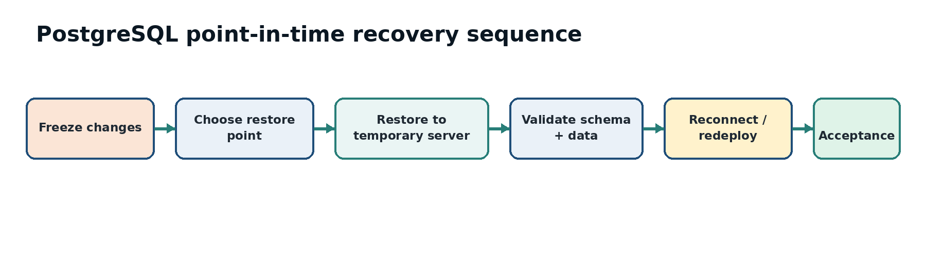
Figure 5. PITR sequence: freeze changes, select a restore point, restore to a temporary server, validate, reconnect/redeploy, and accept.

6.1 Select the restore point
1. Establish the incident window and last known-good time using application logs, deployment history, and operator reports.
2. Choose a restore timestamp before the damaging event while minimizing legitimate data loss.
3. Record the timestamp and rationale before starting the restore.

6.2 Restore to a temporary server
1. Use Azure PostgreSQL Flexible Server Restore to create a temporary private server at the selected point in time.
2. Keep the original production server intact while validating the restore.
3. Ensure restored networking/DNS/private access allows only the intended validation path.
4. Do not redirect production traffic to the restored server until validation is complete.

6.3 Validate restored database
Validation | What must be true
Connectivity | Authorized validation client/application can connect through the intended private path.
Alembic | Database revision is understood and compatible with the application image selected for recovery.
Core tables | Course term, sections, enrollments, teams, memberships, evidence snapshots, reviews/turns, findings/dispositions, and AI usage records exist as expected.
Incident boundary | Damaging change is absent; expected pre-incident records are present.
Referential integrity | No obvious orphaning or partial recovery in critical authorization/evidence relationships.
Sample user path | A representative authorized user/team can be resolved against the restored data in a controlled validation environment.

7. Schema/migration incident
1. If `/ready` reports migration_current=False, first determine whether the migration job failed or the database is at an unexpected revision.
2. Never run ad-hoc DDL to “match” the app.
3. If the migration itself caused data/schema damage, choose a restore point before the migration and pair it with a compatible application image.
4. If a forward fix is safer than rollback, implement it as a reviewed migration on a branch, test it, then deploy through the controlled workflow.
5. Record the pre/post Alembic revisions and acceptance evidence.

8. Secret or Key Vault recovery
1. Determine whether the secret is missing/misconfigured or actually exposed.
2. For exposure: revoke/rotate at the provider first (GitHub App key, OAuth secret, Entra secret, OpenAI key, DB admin credential, session secret as appropriate).
3. Update only the protected provisioning secret path; do not paste values into tickets, chat, screenshots, or documentation.
4. Redeploy/restart only as required for the application to consume the rotated secret.
5. Run `smoke` and `acceptance`; for identity/GitHub secrets, perform a human sign-in/repository verification spot-check.

9. DNS, TLS, Entra callback, or GitHub callback recovery
Symptom | Check | Recovery principle
Custom domain fails | DNS record, Container App custom-domain binding, managed certificate | Restore intended DNS/binding; do not switch users to an undocumented origin.
TLS/certificate error | Managed certificate state and domain validation | Repair certificate/binding; keep HTTPS-only posture.
Entra callback error | ENTRA redirect URI and ETIS_WEB_ORIGIN alignment | Use the canonical https://simulator.etisframework.org/auth/entra/callback.
GitHub OAuth callback error | OAuth App callback and web origin | Restore exact production callback; do not broaden redirect patterns.
GitHub App return flow broken | Setup URL and Redirect on update | Restore /github/setup-complete return path; exact repository verification remains Step 2.

10. Disaster scenarios
Scenario | Primary recovery path | What must be preserved
Bad application deployment | Known-good immutable image redeploy | Current DB unless incompatibility exists; deployment SHA provenance.
Database corruption/erroneous destructive change | PITR to validated temporary server, then controlled cutover | Original server until validation; restore timestamp/rationale.
Failed/incompatible migration | Application/schema compatibility decision; PITR or reviewed forward migration | Alembic revisions, affected data, deployment history.
Secret compromise | Provider revocation/rotation + protected secret update + redeploy/validation | Incident timeline; never preserve compromised secret in docs.
Container App/runtime misconfiguration | Reconcile with Bicep/source and controlled deployment | Source-of-truth; avoid unmanaged portal-only drift.
GitHub App over-scoped | Reduce to selected repositories; revalidate repository trust | Exact authorized repo boundary; do not retain All repositories.
Semester accidentally archived/authority issue | Treat as data/authorization incident; do not edit DB directly | Lifecycle history and membership events; require authorized controlled correction.

11. Return-to-service acceptance
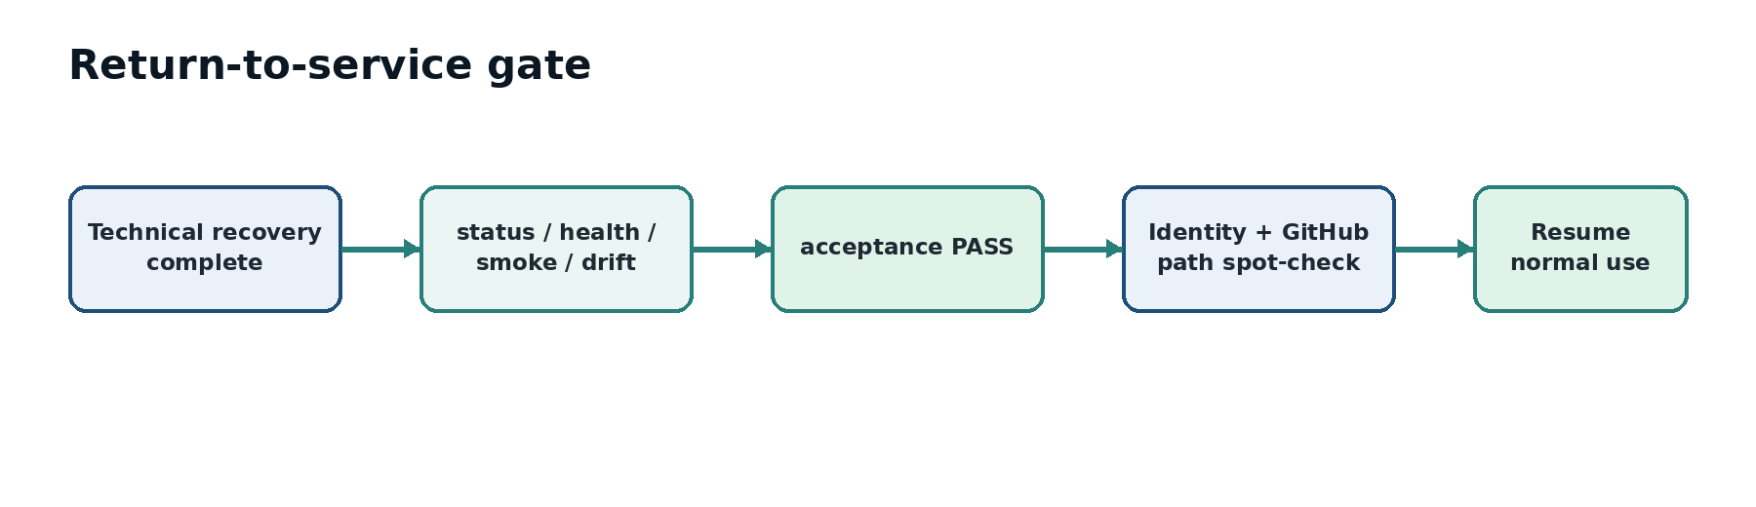
Figure 6. A recovered system returns to service only after technical acceptance and a representative human path check.
./scripts/azure/etis-azure status
./scripts/azure/etis-azure health
./scripts/azure/etis-azure smoke
./scripts/azure/etis-azure drift
./scripts/azure/etis-azure acceptance

1. Confirm final acceptance is PASS.
2. Confirm restored/redeployed revision and expected min/max replicas.
3. Validate the affected identity/GitHub/review path with a representative authorized account.
4. Confirm archived terms remain read-only and active-term authorization is correct.
5. Confirm no temporary recovery server, widened permission, debug setting, or exposed secret remains.
6. Document the recovery outcome and any accepted data-loss window.

12. Disaster recovery exercise procedure
1. Schedule the drill outside critical class windows.
2. Record current production revision, database server, Alembic head, and a representative data sample/count.
3. Choose a recent point in time and restore to a temporary private PostgreSQL server.
4. Validate connectivity, Alembic revision, core tables, representative records, and authorization/evidence relationships.
5. Do not switch production traffic during a proof-only drill.
6. Delete the temporary recovery server after evidence is captured and the drill is accepted.
7. Record drill date, operator, restore point, duration, validation results, and lessons/actions.
DRILL SUCCESS CRITERION
A DR drill is not successful merely because Azure created a server. Success means the restored database is connectable through the intended private path, its schema is understood, representative ETIS records are intact, and the recovery process is documented/repeatable.

Appendix A. Emergency recovery checklist
- [ ] Incident time window and current revision captured
- [ ] Write activity limited if data integrity is uncertain
- [ ] Recovery path classified
- [ ] Original database/artifact preserved until validation
- [ ] Restore point or known-good SHA recorded
- [ ] Schema/application compatibility checked
- [ ] Restored/redeployed state validated
- [ ] Full ETIS acceptance PASS
- [ ] Human affected-path check PASS
- [ ] Temporary resources/overrides removed
- [ ] Recovery record completed

Appendix B. Recovery evidence record
Field | Record
Incident ID/date
Operator
Failure boundary
Current/bad revision
Known-good revision/image
Database restore point
Original DB preserved?
Alembic revision before/after
Expected/accepted data-loss window
Acceptance result
Human path validated
Temporary resources deleted
Follow-up actions

Appendix C. Records that must survive normal archive/recovery
- Course terms/sections and lifecycle state.
- Enrollments and team membership/history.
- Frozen evidence snapshots and provenance.
- Review sessions and persisted turns.
- Findings, corrections, dispositions, disputes, and recommendations.
- Membership events and repository trust state/history as implemented.
- AI usage records required for operational/audit history.

Appendix D. Repository recovery tooling
The repository includes a PostgreSQL backup/restore verification helper used for controlled recovery proof. Run it only in the documented/test context and review the script before pointing it at any environment:
./scripts/verify_postgres_backup_restore.sh
The existence of the script does not authorize an ad-hoc production restore. Production recovery still requires an explicit restore point, preservation of the original database until validation, schema/data verification, and final production acceptance.

