ETIS

Team GitHub & Repository Setup Quickstart
  - Verify the correct team repository once, with the minimum GitHub access required
v0.18.1 candidate manual edition. Local UI validation only; production remains accepted v0.18.0 until protected deployment and human acceptance.
Audience | Student teams, repository owners, and organization members
Purpose | Complete the normal nomination -> GitHub authorization -> exact verification path safely and understand what to do when the path differs.
COMP 330/474 Software Engineering • Fall 2026 • v0.18.1 candidate • October 8, 2026
EXECUTIVE OVERVIEW
One teammate nominates the real working repository. The personal owner or authorized organization grants selected-repository access. A student returns to ETIS and verifies that exact repository. Once verified, the repository binding is shared by the whole team.

1. Sign in & link GitHub | 2. Nominate repo | 3. Owner/admin authorizes | 4. Verify exact repo | 5. Team is ready

DO NOT SKIP STEP 2
A pasted URL is only a candidate. GitHub authorization is only Step 1. The repository becomes trusted team evidence only after ETIS completes Step 2: Check & verify repository access.

Step | Do this | Do not do this
1 | Sign in with Loyola. In My Team, confirm the GitHub account is the one you actually use. | Do not assume Loyola and GitHub identities are the same account.
2 | Paste the complete HTTPS URL of the team’s actual working repository and choose Nominate team repository. | .git is optional. Do not treat the pasted URL as trusted evidence yet.
3 | On GitHub choose Only select repositories and choose only the nominated team repository. | Never choose All repositories. Never use a PAT for ETIS.
4 | Return to My Team and choose Check & verify repository access. | Do not stop after GitHub authorization; Step 2 is required.
5 | Confirm Verified team repository. Other teammates inherit the binding. | Do not have every teammate nominate a different URL.

The setup flow on screen
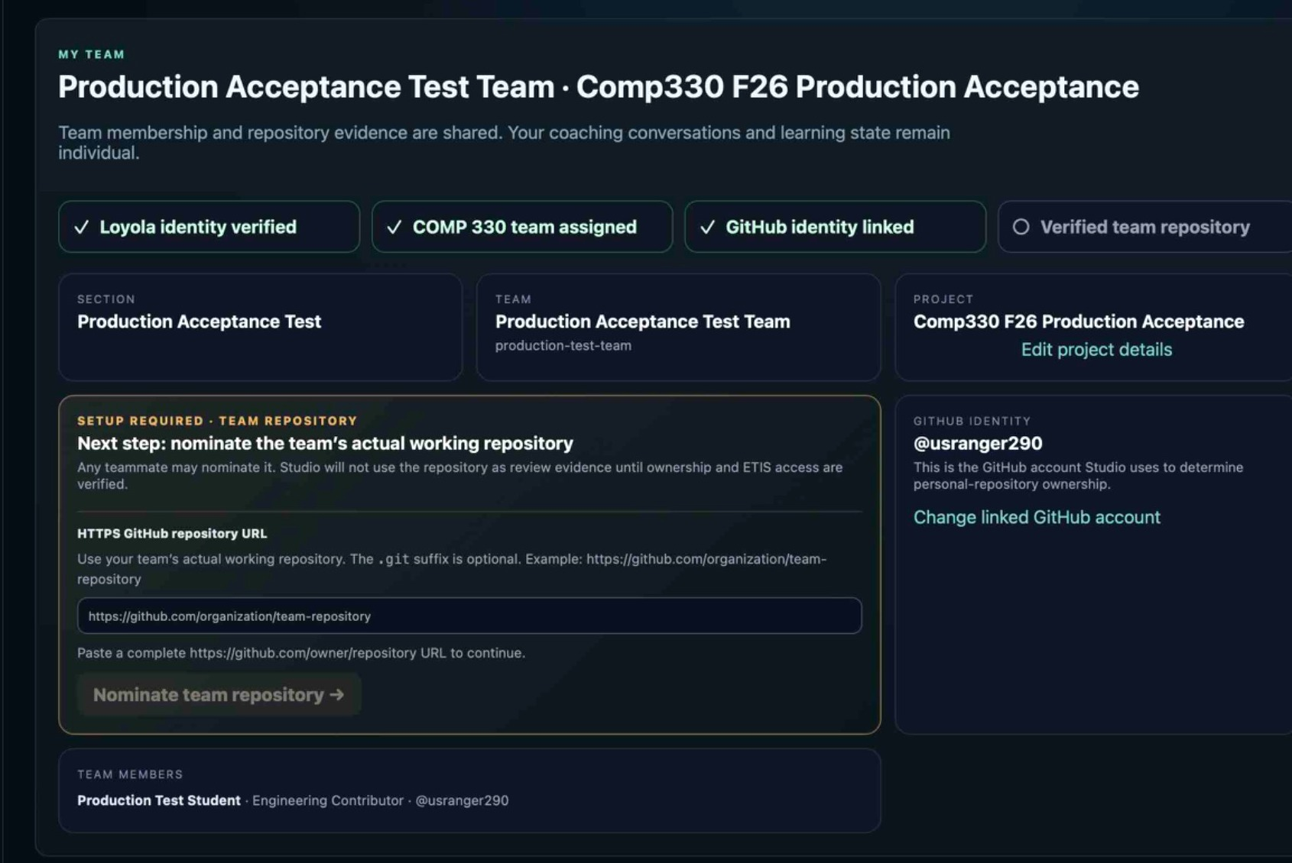  1. Nominate the team’s actual working repository. | 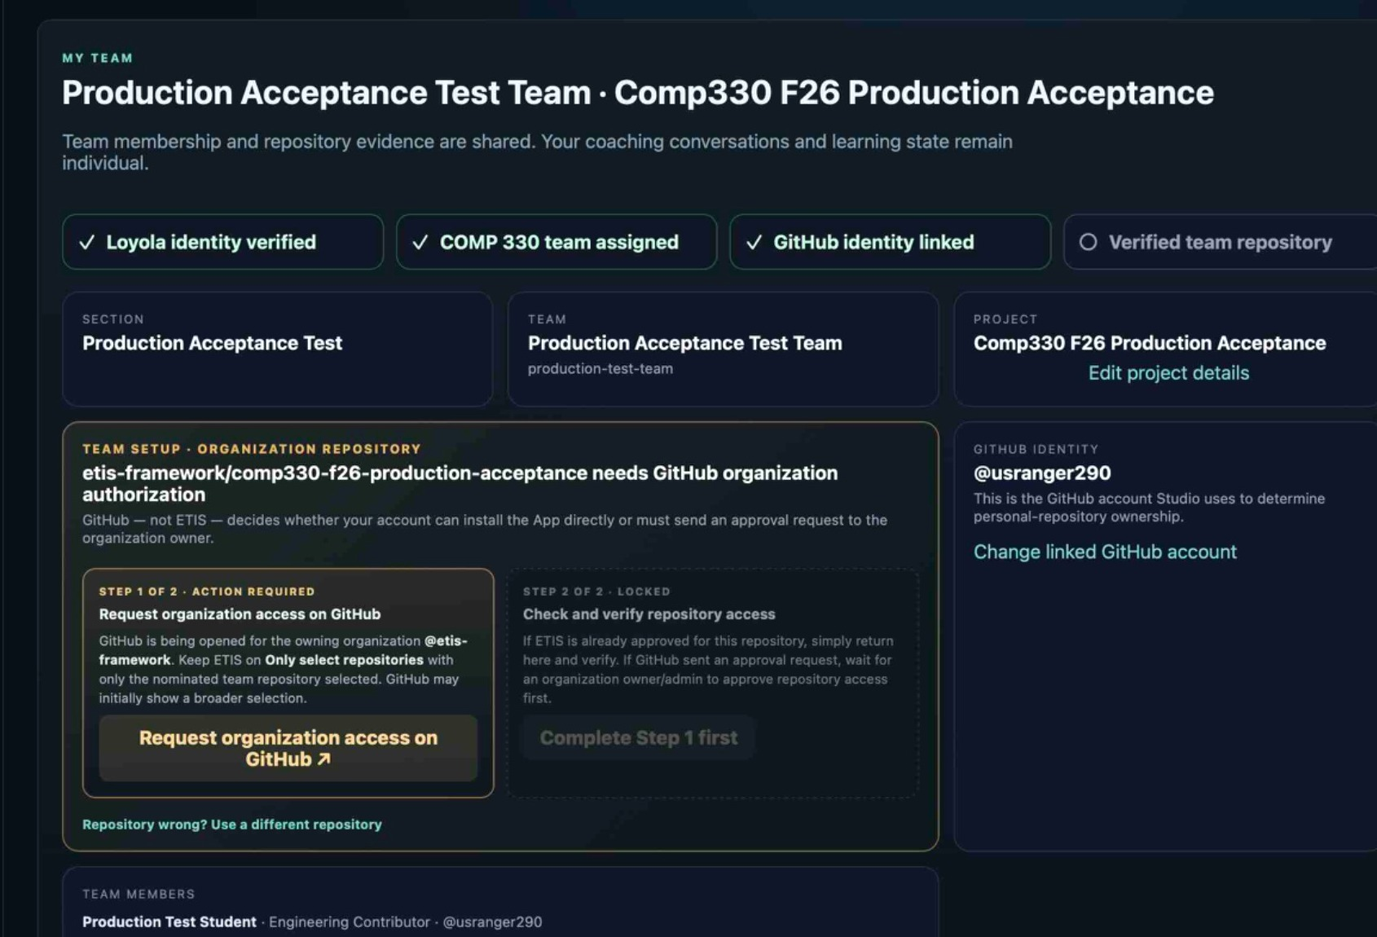  2. If GitHub organization authorization is required, complete/request Step 1.
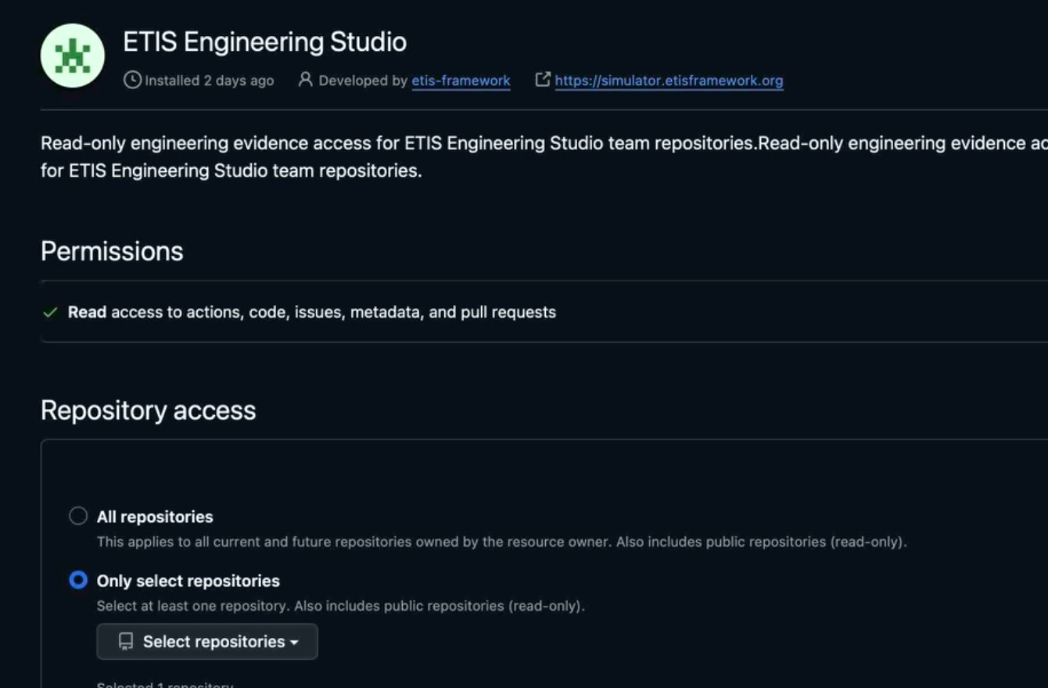  3. On GitHub select Only select repositories, then choose only the nominated team repository. | 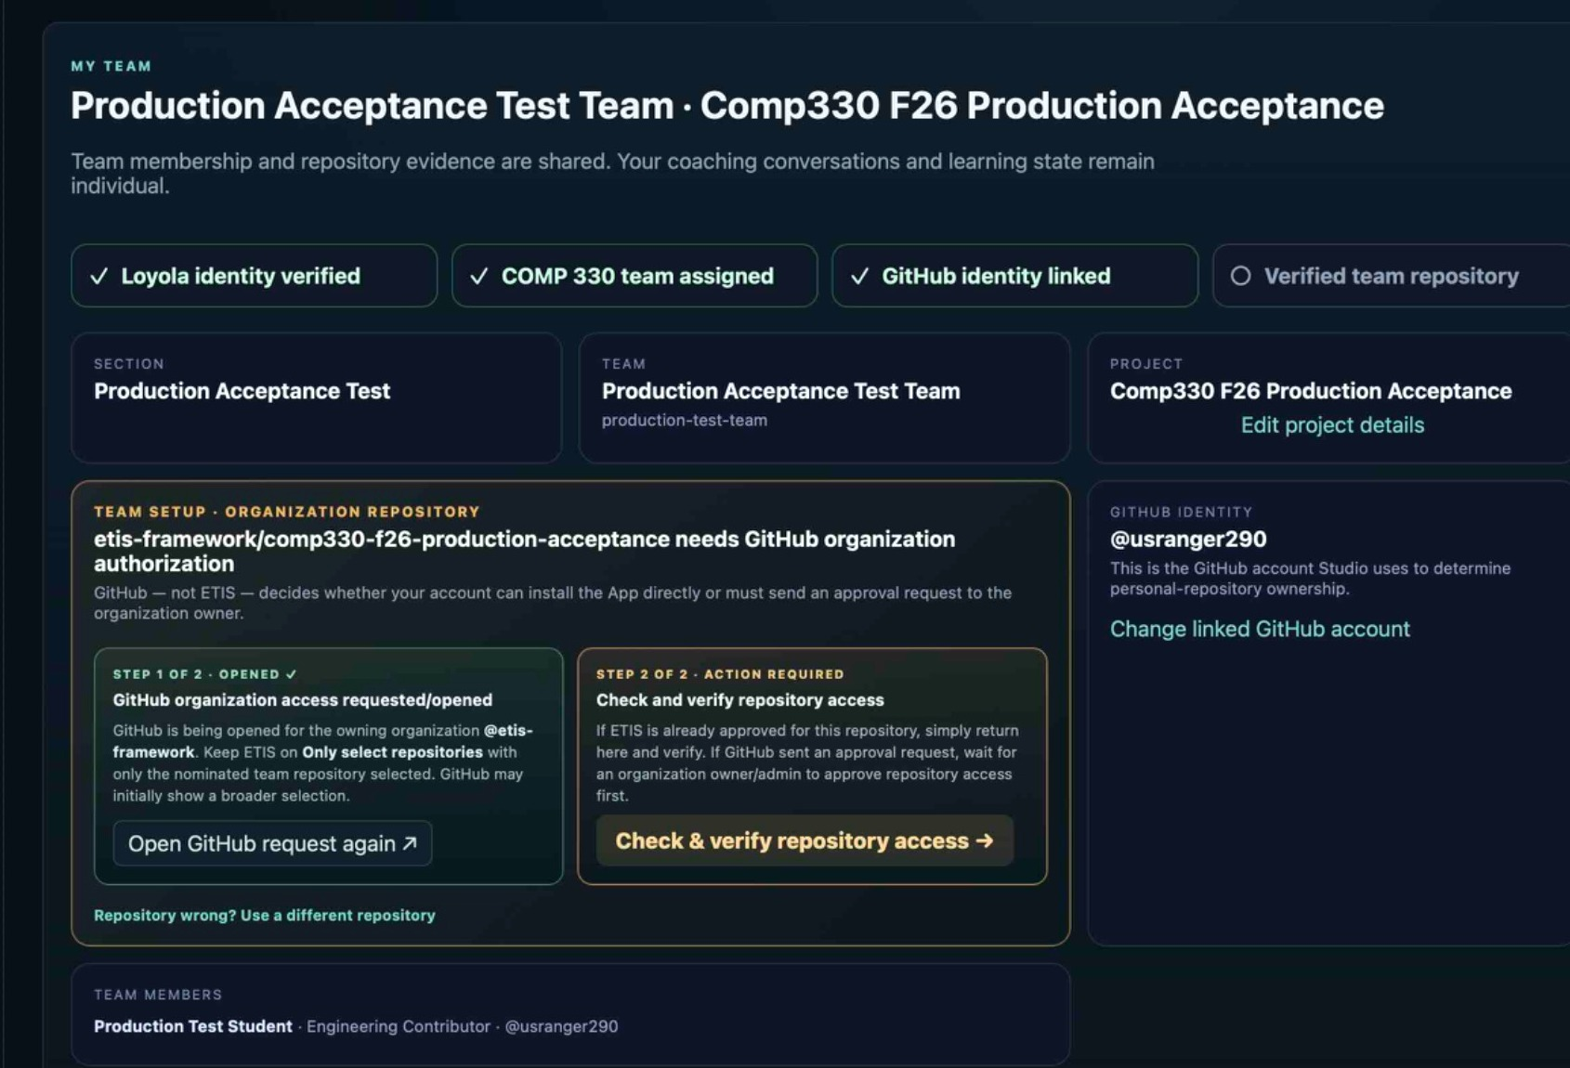  4. Back in ETIS, complete Step 2: Check & verify repository access.

GITHUB SCOPE CHECK
The GitHub example intentionally does not show a repository name. Your selected repository must be the same one nominated in My Team. If you see an unrelated class/personal repository, stop and correct the selection before saving.

Personal vs. organization repositories
Repository type | Who authorizes | What students should do
Personal | The actual personal-repository owner. | If you are not the owner, wait for the owner. After verification, the team shares the binding.
Organization-owned | GitHub organization owner/admin if GitHub requires approval. | Follow GitHub’s request/approval path. This is not automatically instructor approval unless the instructor actually has GitHub organization authority.

After verification
The Review Room is the conversation home. Engineering Evidence is the saved source notebook. Same-snapshot and newer-saved-snapshot notices explain their relationship; browsing newer saved evidence never changes an active review’s frozen baseline.
Use the v0.18.0 Student User Guide (05) and Quick Reference (07) for current review actions. Screenshots show historical setup examples; exact names, counts and provider UI may differ. No additional GitHub permissions are required by this release.

Fast troubleshooting
You see | Do this
Wrong GitHub account | My Team -> Change linked GitHub account. Then select the account you actually use for the team.
Step 1 locked | Complete/request owner or organization authorization first.
Step 1 complete, Step 2 pending | Click Check & verify repository access.
Verification fails | Confirm the GitHub App includes the exact nominated repository and uses selected-repository scope.
Wrong repo before verification | Use Repository wrong? Use a different repository.
Wrong repo after verification | Ask the Instructor/Course Owner to reset repository onboarding; then repeat the normal trust flow.
All repositories selected | Change the installation to Only select repositories. ETIS is designed to reject broad scope.
A teammate already verified it | Do nothing to the repository binding. Confirm it is correct, then continue to Engineering Evidence/Studio.

READY CHECK
Loyola identity ✓ Team assigned ✓ GitHub identity linked ✓ Verified team repository ✓

SECURITY RULE
ETIS repository access is read-only and selected-repository scoped. Never give ETIS a personal access token and never authorize All repositories.

After connecting: move between rooms and reviews

Verification is two distinct conditions
Your personal GitHub identity link and your instructor-verified team repository are different checks; both must be ready before your first real review.

First review to updated work
Open Engineering Review Room, select the phase, and choose Start Board Review. Visit Engineering Evidence Room when you need evidence. After updating and pushing your repository, use Start another Board Review. The older review stays accessible under Review History.

Snapshot check
The saved Evidence Room snapshot may differ from the frozen snapshot of an earlier Board Review; compare commit/snapshot labels. This is not a live GitHub HEAD view.

