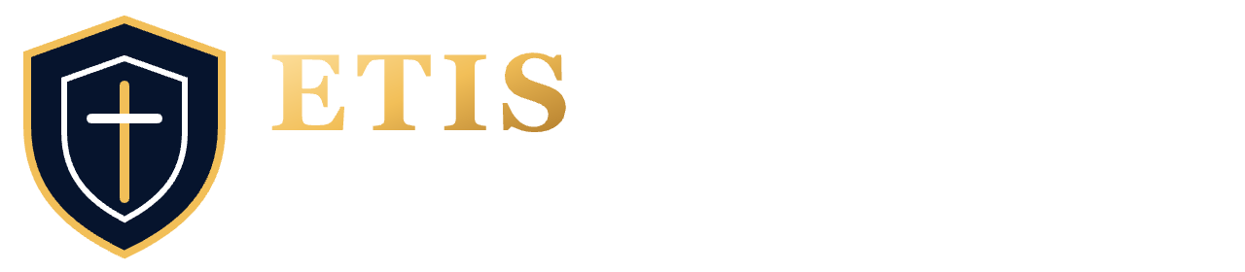 | ENGINEERING STUDIO  START HERE | COMP 330 | v0.18.1
Use Studio while your work is still in progress. It challenges your engineering thinking; it does not grade or approve your work.
TWO ROOMS • ONE WORKFLOW
ENGINEERING REVIEW ROOM · DISCUSS  Talk with the Review Board. Explain decisions, ask questions, challenge feedback. | ENGINEERING EVIDENCE ROOM · INSPECT  Examine saved repository evidence, findings, and supporting sources.
Move between rooms at any time. Switching rooms does not finish or replace your review.
YOUR FIRST FIVE MOVES
1 | CHECK YOUR SETUP Sign in, open My Team, link your own GitHub identity, and confirm the team repository is verified.
2 | PUSH WORK IN PROGRESS Studio cannot see files only on your computer. Commit and push your draft to your team GitHub repository before reviewing it.
3 | START THE RIGHT REVIEW Check the phase. Start Board Review for a phase question. For draft feedback, choose Other review options → Focused Review, enter your concern, and start.
4 | DISCUSS & INSPECT Explain your thinking in Review Room; switch to Evidence Room to inspect sources. Return to the same conversation without finishing the review.
5 | IMPROVE & REVIEW AGAIN Make and verify changes with your team, then commit and push. Choose Start another Board Review (or a new Focused Review). Earlier reviews remain in history.
FOCUSED REVIEW EXAMPLE "Are our draft Cycle 1 estimates reasonable? What assumptions, dependencies, or testing work have we missed?"
REVIEW STATUS — THREE THINGS TO REMEMBER
CURRENTLY VIEWING  One selected review on screen; others may also be open. | OPEN  You can resume discussion using its original frozen evidence. | FINISHED  Read-only; still in Review History. Not instructor approval.
SNAPSHOT RULE Each review uses fixed repository evidence. Later commits do not update earlier reviews. Evidence Room may show a newer saved snapshot; check the commit when revisiting old work. No new commit may mean reused evidence.
NEED HELP? Use Help for buttons and navigation (no AI call). For engineering feedback, talk with the Review Board. If an action fails, check Review History before retrying.
OPEN STUDIO simulator.etisframework.org MORE DETAIL Student Cheat Sheet • Student User Guide

