Homework 1

Powerpoints 1 and 2

1. Identify the variables listed below as either quantitative (discrete or continuous) or categorical (nominal or ordinal):

a. Age :

quantitative (continuous)

b. Gender:   
categorical (nominal)

c. Heart Rate:

quantitative (continuous)

d. Number of pets:

quantitative (discrete)

e. Salary:

quantitative (continuous)

f. Eye color:

categorical (nominal)

g. Metal Rankings (Bronze, Silver, Gold)

categorical (ordinal)

1. For the following, identify the sample and population of interest.

a. A researcher is interested in the career paths of college seniors. A survey is conducted in which questionnaires are sent out to all college seniors living in Greensburg PA.

Sample: college senior living in Greensburg  
population of interest: College seniors

b. A researcher is interested in the health benefits of a new medication for lung cancer patients. They recruit 100 individuals currently receiving treatment at a local hospital and randomly assign them into treatment groups.

Sample: 100 people receiving treatment at local hospital  
population of interest: lung cancer patients

c. A business is looking into advertisements which would target adults in the tri-state area. They decide to send out email surveys to those living within a 5 mile radius asking for opinions as to which format is their preferred method of obtaining information.

Sample: adults in 5 mile radius

Population of interest: adults in tri-state area

d. Studies have suggested that the prevalence of childhood asthma is higher in cities than in rural areas. A research decided to randomly sample 50 elementary students from a rural school and 50 elementary students from an inner city school and compare the rates of athesma.

Sample: 50 elementary students from both settings.

Population of interest: childhood asthma in cities and rural areas

1. **100 individuals were polled as to what their favorite color was. Information was summarized in the following frequency table**

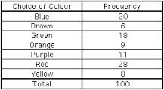

**a. How many people answered Purple was their favorite color? 11**

**b. What percent of people answered Red was their favorite color? 28%**

**c. What is the frequency of someone answering green is their favorite color? 18**

1. **Given the following histograms, describe the shape of the distributions.**

**a.** 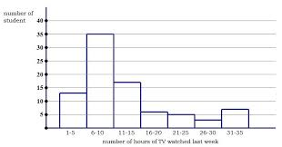  
  
**skewed to the right**

**b. 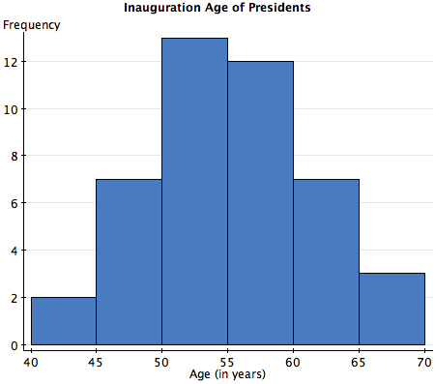 bell curve**

**c.** 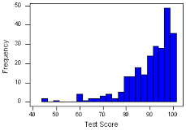  
  
skewed to the left

1. Measures of center:

Calculate the Mean, Median, and Modes of the following sets of numbers.

* + Test Scores: 80, 91, 93, 78, 95  
    #s in order : 78, 80, 91,93,95  
    Mean : 87.4  
    Median : 91  
    Mode: None
  + Test Scores: 80, 91, 93, 78, 95, 100  
    #s in order : 78, 80, 91,93,95,100  
    Mean: 89.5  
    Median: 92  
    Mode: None
  + Infants weight on different scales: 7.01, 7.02, 7.01, 7.03, 7.02  
    #s in order: 7.01, 7.01, 7.02, 7.02, 7.03  
    Mean: 7.018 (or 7.02)  
    Median: 7.02  
    Mode: 7.01, 7.02

What does it mean if the mean is not the same as the median?

It means that there are different measures of center for both methods. This could mean that some of the values used to calculate the mean were skewed which resulted in the mean being not as close or the exact number as the median. Median is the overall best method used to find the midpoint if there are skewed points but overall Mean is the preferred method.

1. Measures of Spread:

For the data listed in question (5), determine the min value ($x_{lowest}$), max value ($x_{highest}$), Range of data, Quartiles, Variance, and Standard Deviation.  
  
min value:   
  
Set 1: 78

Set 2: 78

Set 3: 7.01  
  
  
max value:  
  
Set 1: 95  
Set 2: 100  
Set 3: 7.03  
Range of data:  
  
Set 1: 17  
Set 2: 22  
Set 3: .02  
  
  
Quartiles:

Set 1:   
  
Q1 : 79  
Q2 : 91  
Q3 : 94

set 2:

Q1: 79.5

Q2:92  
Q3: 96.25  
  
set 3:  
Q1: 7.01  
Q2: 7.02  
Q3: 7.02  
  
  
  
Variance:  
  
Set 1: 61.3  
Set 2: 75.5

Set 3: 0.00837

Standard Deviation: