**AMPED-AF by Steel Supplements**

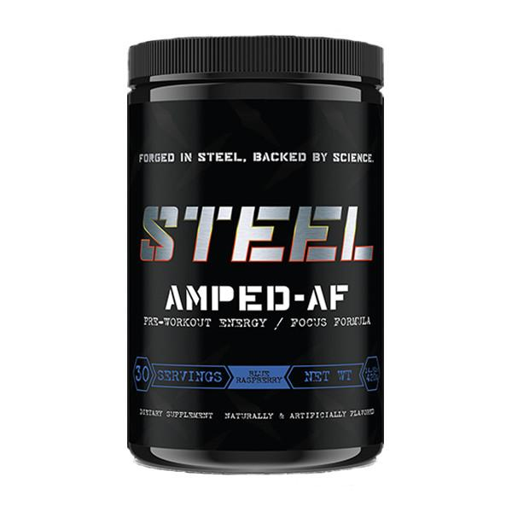

**The Product’s Claims**

“Designed to amplify energy, focus, alertness, strength, stamina and pumps while giving the athlete essential nutrients to optimize anaerobic and aerobic capacity.” GMP Certified.

**The Science**

With proper dosage amounts of beta alanine, l-citrulline, and betaine anhydrous, a consumer can expect delayed onset of fatigue, small improvements in power output and energy levels, as well as increased blood flow to muscles.

AMPED-AF’s **Energy and Focus Blend**: Caffeine anhydrous, One3 and Orchilean may improve focus and might increase self-perceived energy levels. Theanine may help with mental regeneration while yohimbine HCl improves reaction time, and huperzine helps optimize muscle fiber recruitment.

**The Concerns**

Note that the vitamin B supplementation in this product is unnecessary for individuals with a proper diet. One3 comes from a type of geranium and may therefore contain MHA which was banned by the World Anti-Doping Agency in 2010. Orchilean (orchid extract) is said to be three times stronger than DMAA which may lead to restlessness. The amounts of the ingredients in the Energy and Focus Blend present in this product are unknown.