**Ecommerce Exam 1 Notes:**

Analog, Digital and Internet Communications

Internet Access: through telephone cable TV, DSL (?), fiber optics, satellite, Bluetooth

Twister copper pair: outer jacket, aluminum shielding, twisted pair (consists of two insulated copper wires each twisted around each other – one carries the electrical signal the other is grounded and shields against interference)

Coaxial cable: outer jacket, insulating layer, copper conducting wire, aluminum conducting shell (shields against electrical and radio frequency interference) – still used by cable firms.

Amplitude Modulation: Frequency Modulation:

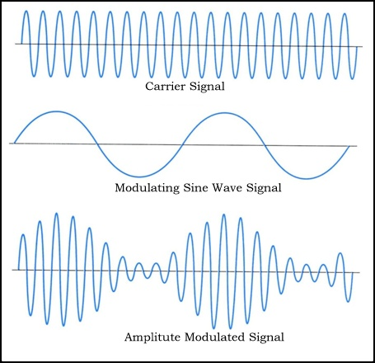

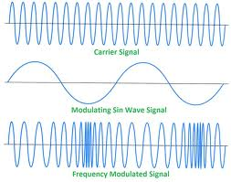

α

α

Fiber-optic cable: pvc jacket, Kevlar strength member, buffer tube, individual optical fiber (glass threads as thin as a human hair which carry info as pulses of light), laser-generated beam of light. 1 terabit per second, but extremely expensive.

* Multi-mode fiber – 10 mbps to 1- gbps, up to 600 m, >125 micrometer diameter
* 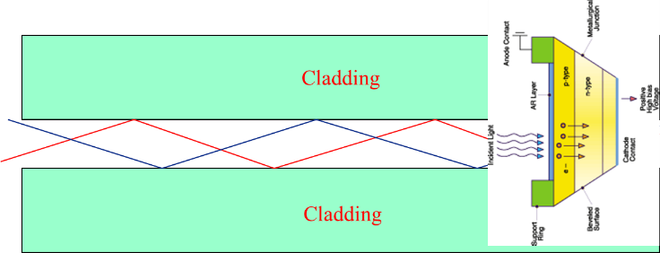
* graded-index fiber – refractive index decreases with radial distance from the center of the fiber optic core, 50 micrometer core
* 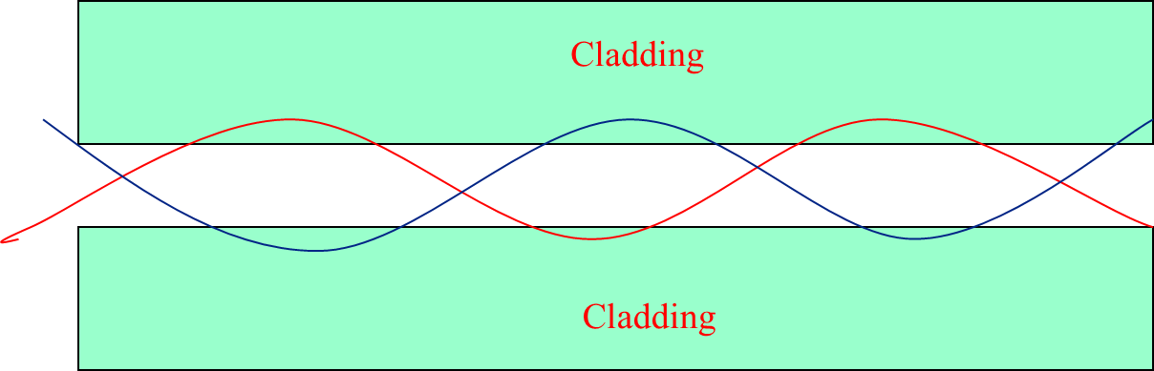
* single-mode fiber – 8 to 10 micrometer diameter, typical speed of 10-40 gbps, wavelength division multiplexing (WDM), over 240 km and 69 tbps (432 channels), no cross talk and hard to wire tap.
* 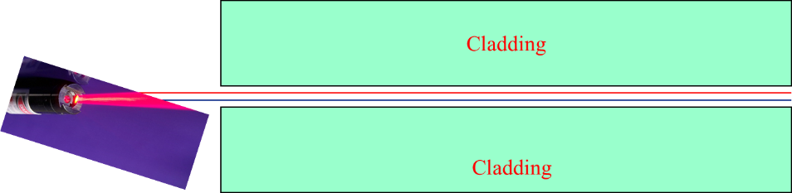

Analog modems: 110 bps to 56 kbps

ISDN : Integrated Services Digital Network

* Employs digital telephone
* Two 64 kbps channels

Cable TV:

* Bidirectional
* Unidirectional systems:

DSL : Digital Subscriber Line:

* Speed limited by distance:
* Variations: ADSL (asymmetric), SDSL (symmetric), HDSL (high-speed); VDSL (very high speed)

Fiber Optics:

* Fantastic bandwidth
  1. 10-400 gbps
  2. More with WDM (?)
* “last mile problem”
* Internet backbone is all fiber optic: speeds from 34 Mbps to 2 gbps
* FTTx – Fiber To The x:
  1. FTTN: node (neighborhood)
  2. FTTC: curb
  3. FTTB: building
  4. FTTH: home
  5. FTTP: premises – holy grail of telephone, cable, ISP providers. Everything connected to provider via one set-top box.

Satellites:

* Iridium: telecomm carries voice and data.
* Teledisc: “Internet in the sky” cost 9B dollars, data comm network that could also carry voice.
* Ellipso: 17 satellites cover 90% of the world.

Wireless Applications:

* Interaction between handheld devices and between devices/appliances (such as parking meters, drink machines, ticket sellers, household devices, cars, factory devices)
* Bluetooth: 10-20 m wireless connection. Drawbacks: channel designed for raw data, no support for TCP/IP, hard to manage devices from moving from one piconet (?) to another

History of the Internet

Darpa: a minicomputer and 56 kbps leased line, starting with a remote login. October 29th 1969 first successful login between UCLA and Stanfod. November 21, 1969 first successful packet. First four connections: UCLA, UCSD, Univ of Utah, and Stanford

* ARPAnet: set of physical comm links and protocols that internconnect computers.
* 1969
* Interconnect gov, industry and university researching working on classified projects via the 56 kbps leased lines.
* All data converted to packets (contain a source and destination address).
* Must provide end-to-end reliabilities protocols:
  1. IP: internet protocol – routing
  2. UDP: User Datagram Protocol – unreliable messages
  3. TCP: Transmission Control Protocol – reliable host-to-host communications
  4. HTTP: HyperText Transmission Protocol (and more)

NSFnet: funded by National Science Foundation in the 1980s. Interconnected major computing facilities with T1 (1.5 mbps) and later T3/DS-3 (45 mbps) lines

* Connect military, contractor and academic researches.
* Share supercomputers
* Use of e-mail

Killer apps: e-mail in the 70s and 80s, the web, and streaming multimedia

There was no commercial internet use prior to 1991. Companies began adding commercial links so that they could transmit private information. Transition from NSFnet to Internet completed on April 30th, 1995.

WWW (world wide web) was developed by Tim Berneres-Lee at CERN in 1989-1990 to allow scientists to visualize and share data. Attempt to make internet user friendly.

First browser (Netscape) in 1995 US

TLD: top level domain.

Billion dollar industry : network addressing (network solutions 🡪 VeriSign)

Domains are now managed by ICANN – Internet Corp for assigned names and Numbers

How to be a Zillionaire

Cycle of Web Commerce:

* Web 1.0: provide corporate information anytime, anywhere; purchase physical products (electronic catalogs, ordering, payments), access to services (telemedicine, auctions, e-payments).
* Web 2.0: multimedia, social networking, wikis, blogs, folksonomies.
* Web 3.0 semantic web, machine to machine interaction and understanding, artificial intelligence.
  1. Semantic web is collaborative movement led by the World Wide Web Consortium (W3C). The standard promotes common data formats on the WWW.

Online Advertising and Data Privacy

Privacy: the ability to hide data from unauthorized viewers or alternatively to reveal information selectively to authorized viewers (persons or programs).

Publishers send code that forces client to visit an advertiser, advertisers use content networks to send ads.

Cookies come from ad server domain, not publisher domain. All cookies are returned to the ad server in the ad server domain – so the user can be tracked across multiple publishers and multiple advertisers.

Ad server builds a profile of the user to pick what ads are displayed. When the user makes a purchase, the click becomes a purchase once the purchase ends and the ad server gets paid.

How to ad tracking/cookies:

* Turn off computer
* Disable all cookies
* Disable third party cookies
* Use ad-blocking software
* Depend on “do not track” browsing

Privacy is lost when user voluntarily gives it away or a vendor illegally shares info without permission

Starting and Growing an eCommerce Company

Requirements for success:

* Clever idea,
* Dedicated employees,
* Realistic market
* Understand of the capital markets
* Long hours, hard work, frustration,
* Accepting the chance of failure.

Corporation: creating a new entity with a virtual life of its own. Name, mission, owners, tax ID number. Liability protection limited to assets of the corporation. Operate as independent entity with regular meetings. Runs like a business. Two types: C and S (normal and small)

* C Corp (normal) – any number of shareholders. Double taxation (company pays taxes on profits, individuals pay taxes on salaries & capital gains taxes on distributions), salaries = duties performed, retirement, medical dental, 401k. File 1120
* S Corp (small) – simplified corporate structure. All profits/losses flow to shareholders. Limited to 100 shareholders. No medical. Limitations on retirement plans. Files 1120s. Salaries distributed normally. S Corp no taxes.
* LLC (Limited Liability Company)
  1. Not a corp.
  2. Similar to SP and partnership
  3. Does not pay taxes itself.

Terms of Equity Financing:

* Common vs preferred stock.
* Dividends and interest
* Conversion method/price/timing
* Redemption
* Voting
* Anti-dilution
* Pre-emptive rights
* Protective covenants

Proprietary Rights of the Company:

* Protection of intellectual property.
* Nondisclosure and inventions agreements.
* Patent, copyright, trade secrets.

Business Plans:

* Elevator speech: what problem? Why can you solve it? What the market? 30 seconds.
* Short business plan: whats the market? Whats the problem? Why is your tech a solution? Marketing plan. Management plan. Return on investment. Venture funding plan, timing, exit strategy.
* Visual aid.
* Formal business plan
  1. Executive summary
  2. Mission
  3. Market opportunity
  4. Target opportunity
  5. Market need
  6. Value proposition
  7. Size of the target market
  8. Company history
  9. Management team
  10. Strategy
  11. Competition
  12. Investment opportunity
  13. Financial milestones
  14. Financial projections
  15. Exit strategy

Sweet Spot of eCommerce

* Five approaches to innovation:
  1. Extend the reach of an existing business
  2. Same product, different delivery
  3. 24/7 availability
  4. Brand new product or service
  5. Something that leverage the Internet
* Innovation drives success: save money, make money, fulfill, enable
* Weaver’s Rule: The Sweet Spot:
  1. Cost of information acquisition is low
  2. Cost of storage is low
  3. Cost of duplication is low
  4. Cost of distribution is low
  5. Cost of payment processing is low
* Innovation needs infrastructure
* eCommerce is different because the infrastructure is already present.

Bluetooth has data transmission speeds up to 24 mbps

First packet to successfully transit ARPAnet did so in 1969

Web 1.0 is:

* utilizes HTML as its markup language
* any document can link to any other document
* is predominantly a read-only architecture
* transmits form data using HTTP

The internet protocol most often used for end-to-end packet error detection is TCP

DirecPC transmits digital data over an analog channel

ISDN regular: 64 kbps; Bonded: 128 kbps; with multiplexors: 512 kbps

In which year was ALOHAnet developed? 1970

When was Ethernet first described in a PhD dissertation? March 22nd 1973

In what year was the Melissa macro virus released? 1999

USB - univeral serial bus

NCP-- netwrok control program