Once you have your Management Studio connected to your database engine:

(When installing your SQL Server Express, make sure to select “Mixed Mode Authentication”)

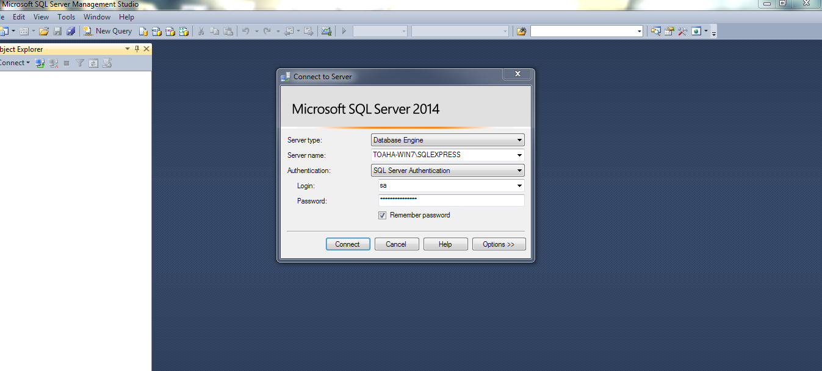1. Open the script file:

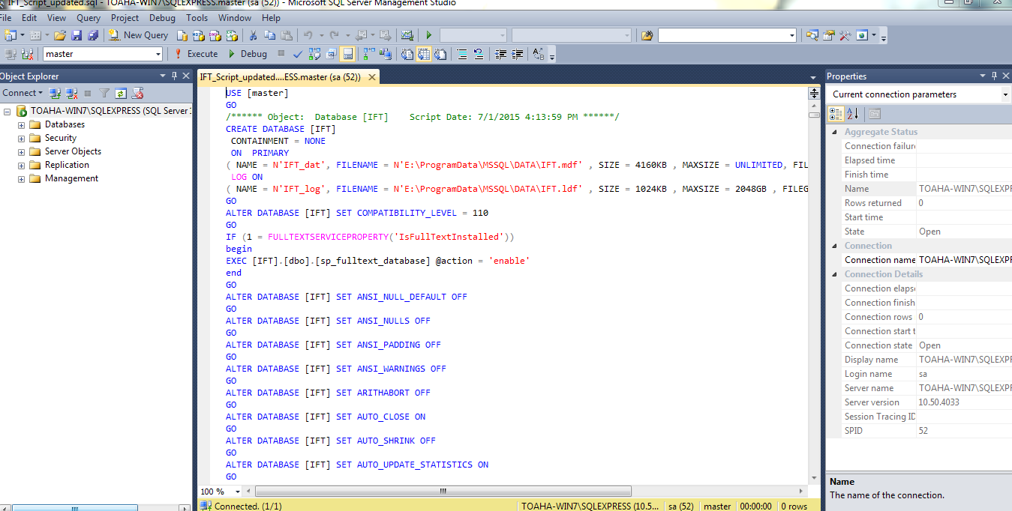

3. Update the path to your local MS SQL server:



4. Then execute:

