Handwritten Number Parity Classification
Computer Vision Course Assignment

1. Introduction
The goal of this project is to build a computer vision system that classifies handwritten numbers as either even or odd. A self-collected dataset was created by manually drawing the digits 0–9 in multiple handwriting styles. The original images were automatically segmented into individual digit images and organized into two classes: even and odd.

2. Dataset
The dataset contains approximately 200 handwritten digit images. Digits 0, 2, 4, 6, and 8 belong to the even class, while digits 1, 3, 5, 7, and 9 belong to the odd class. The dataset is balanced, with approximately 100 images in each class.
The images were collected manually and then automatically cropped from larger image sheets. Each individual digit was centered on a white background and resized to 64 × 64 pixels.

3. Preprocessing and Data Augmentation
All images were converted to grayscale and resized to 64 × 64 pixels. The pixel values were normalized before model training. The dataset was divided into training, validation, and test sets using a 70/15/15 split.
Data augmentation was applied only to the training data. The augmentation operations included small rotations, translations, and zoom transformations. These transformations increased the diversity of the training data while preserving the original class labels.

4. Models

4.1 Baseline Model
Logistic Regression was selected as the baseline model. Each 64 × 64 grayscale image was flattened into a one-dimensional feature vector. The model was trained to distinguish between even and odd handwritten numbers.

4.2 Improved CNN Model
The improved model was a Convolutional Neural Network (CNN). The architecture consisted of three convolutional layers followed by max-pooling layers, a fully connected dense layer, dropout regularization, and a sigmoid output layer for binary classification. Early stopping was used to reduce overfitting.

5. Results
Model | Accuracy | Precision | Recall | F1-score
Logistic Regression | 0.867 | 0.867 | 0.867 | 0.867
CNN | 0.967 | 0.938 | 1.000 | 0.968

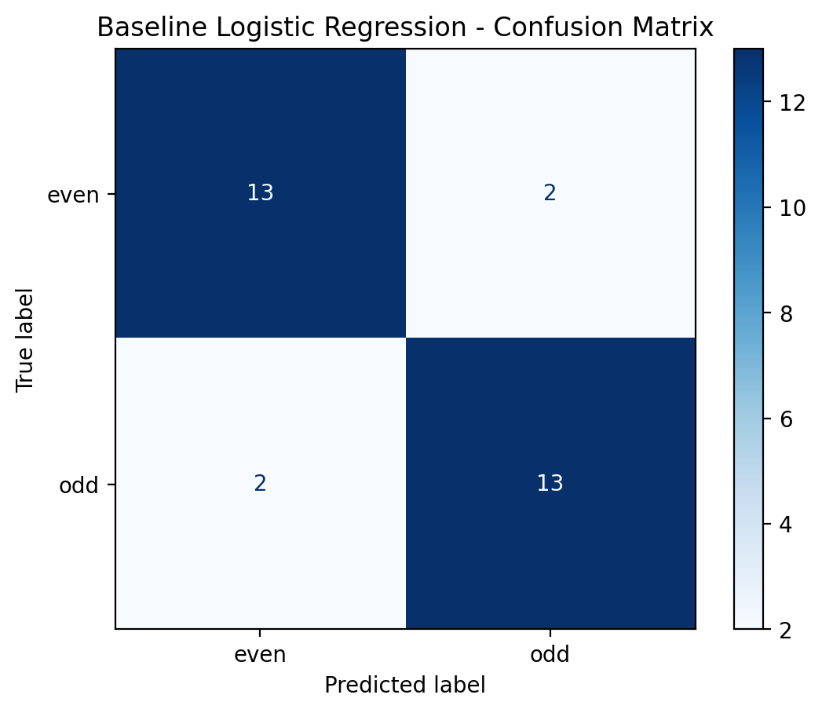
Figure 1. Baseline model confusion matrix.
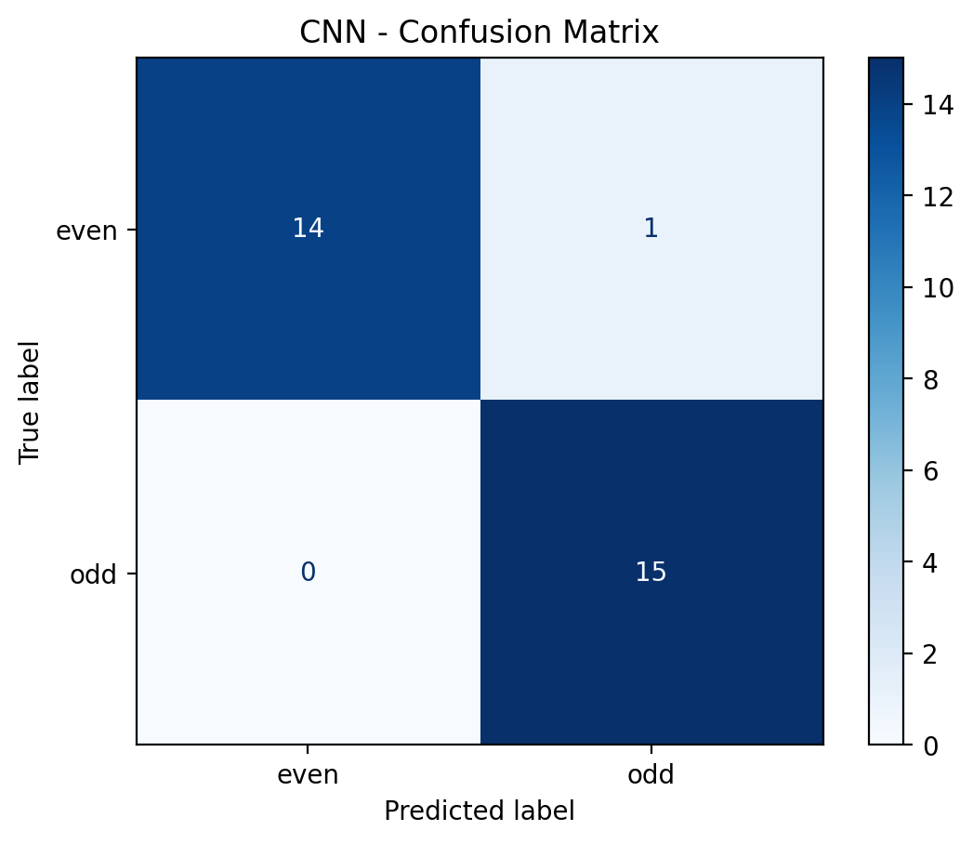
Figure 2. CNN confusion matrix.
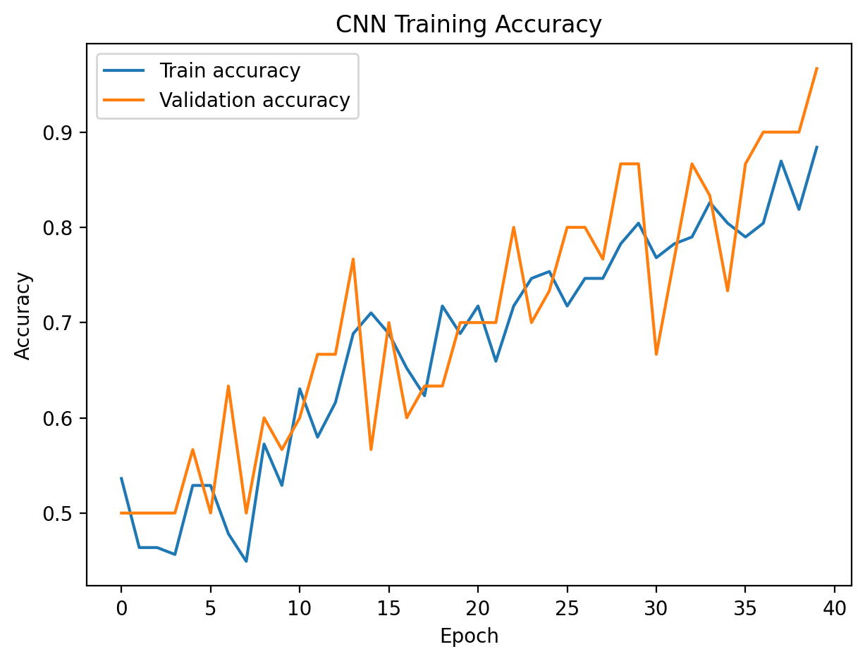
Figure 3. CNN training and validation accuracy.

6. Discussion
The CNN achieved a higher test accuracy than the baseline Logistic Regression model.
The results should be interpreted with consideration of the relatively small dataset size. Because the dataset contains handwritten digits with different shapes and writing styles, some examples may be difficult to classify. Data augmentation helps improve generalization by exposing the CNN to slightly modified versions of the training samples.
A limitation of the project is that the dataset contains only a small number of handwriting styles. Future work could include collecting samples from additional people, increasing the dataset size, and testing deeper neural network architectures.

7. Conclusion
This project demonstrated a complete computer vision workflow using a self-collected handwritten digit dataset. Two classification approaches were evaluated: Logistic Regression and a Convolutional Neural Network. The baseline model achieved an accuracy of 0.867, while the CNN achieved an accuracy of 0.967. The experiment demonstrated the effects of preprocessing, data augmentation, and model architecture on handwritten number parity classification.

