ASTANA IT UNIVERSITY

Handwritten Number Parity Classification
  - Assignment 2 Report
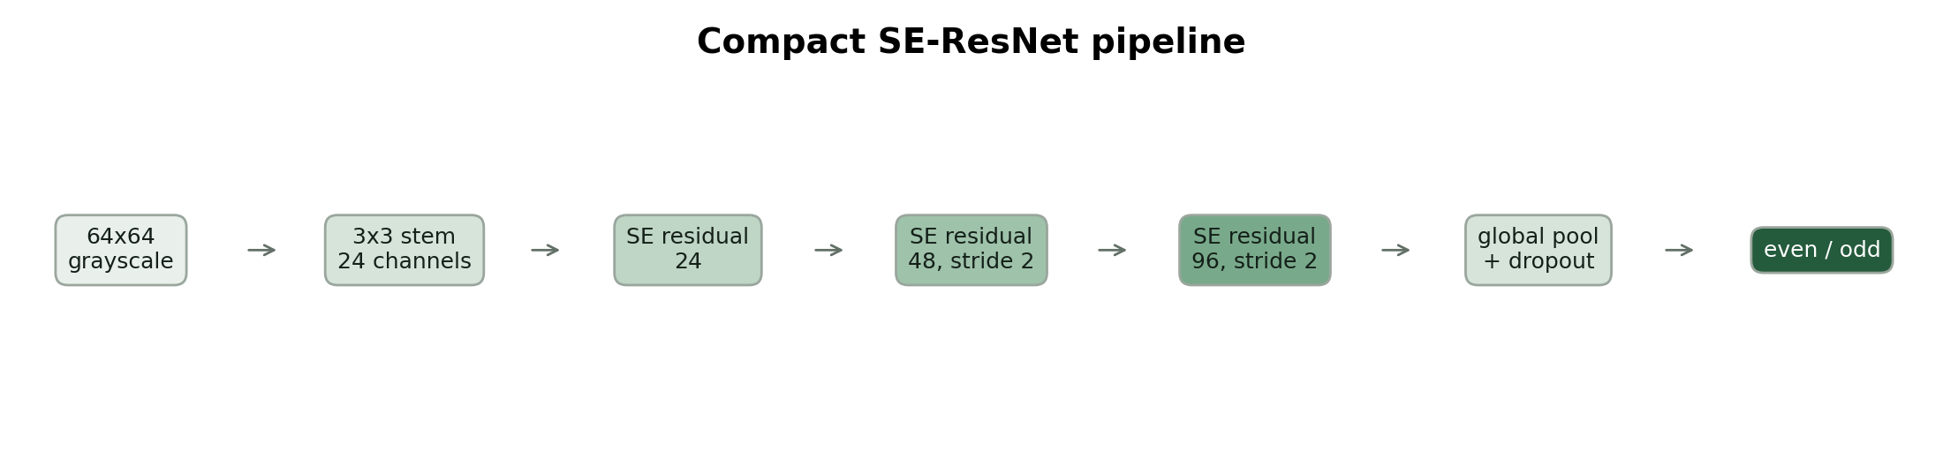
Modern residual attention pipeline for even versus odd classification
Computer Vision
Prepared 3 November 2026
Asia Almaty
Main result The compact SE-ResNet with domain-safe augmentation improves the Assignment 1 Logistic Regression baseline from 0.867 to 0.900 accuracy and from 0.867 to 0.903 F1. The earlier CNN remains strongest at 0.967 accuracy, showing that a modern architecture does not automatically win on a 198-image dataset.

1 Problem and dataset update
The task is binary image classification: a single handwritten digit is assigned to the even class (0, 2, 4, 6, 8) or odd class (1, 3, 5, 7, 9). Assignment 2 retains the original topic, data, and fixed split so the new method can be compared directly with Assignment 1. The delivered archive contained images, trained weights, figures, a metrics CSV, and a report, but no source code; the training and application pipeline was therefore reconstructed around those retained artifacts.

1.1 Dataset composition
Split | Even | Odd | Total | Use
Train | 69 | 69 | 138 | Model fitting
Validation | 15 | 15 | 30 | Early stopping and selection
Test | 15 | 15 | 30 | Final metrics only
Total | 99 | 99 | 198 | Balanced self-collected set

All images are 64 x 64 grayscale crops on white paper. The test set remains untouched. Training-only augmentation applies small rotations, translations, scaling, mild blur, brightness/contrast variation, and rare small erasures. These operations approximate camera tilt, stroke thickness, focus, and illumination while preserving parity.

1.2 Data governance
The supplied report describes the images as manually drawn and automatically segmented. No faces, names, or identity labels are required. New contributors should give consent before their handwriting is added. Online augmentations are generated from training images, are not counted as newly collected samples, and are never mixed into validation or test data.

1.3 Evaluation question
The experiment asks whether a compact residual attention network improves the linear baseline and whether domain-safe augmentation improves that network. Accuracy, precision, recall, F1, confusion matrices, training curves, and per-image latency are reported. Because n=30 for testing, each error changes accuracy by 3.33 percentage points; results are therefore descriptive rather than population-level estimates.

2 Modern method integration
The added method is a compact Squeeze-and-Excitation Residual Network (SE-ResNet). Residual blocks learn a correction to an identity path, which makes deeper feature learning easier to optimize [1]. Squeeze-and-Excitation blocks summarize each channel globally and learn channel weights that recalibrate feature responses [2]. The original SENet work won the ILSVRC 2017 classification competition; this project uses the same channel-attention principle in a small network sized for 64 x 64 grayscale images.
Figure 1. Implemented compact SE-ResNet architecture

2.1 Architecture
Stage | Output | Role
Input | 1 x 64 x 64 | Normalized grayscale image
Stem | 24 x 64 x 64 | Local stroke features
SE residual stage 1 | 24 x 64 x 64 | Residual refinement and channel attention
SE residual stage 2 | 48 x 32 x 32 | Downsample and widen
SE residual stage 3 | 96 x 16 x 16 | Higher-level digit structure
Global pool and dropout | 96 | Compact regularized representation
Linear classifier | 2 | Even and odd logits

2.2 Why it fits this topic
Parity cannot be inferred from a single generic stroke: the model must distinguish digit shapes such as 1 versus 7 and 2 versus 3. Residual processing supports multi-level shape features, while channel attention can emphasize feature maps that respond to discriminative curves, intersections, and endpoints. The network is intentionally compact to limit latency and overfitting.

3 Experimental protocol

3.1 Compared systems
- Logistic Regression baseline: supplied Assignment 1 model using flattened normalized 64 x 64 pixels.
- Legacy CNN: supplied Assignment 1 result and Keras weight artifact; its published metrics are retained for comparison.
- SE-ResNet plain: reconstructed modern architecture trained without stochastic image augmentation.
- SE-ResNet augmented: identical architecture and optimizer with only training-time domain augmentation enabled.

3.2 Training configuration
Setting | Value
Random seed | 42
Optimizer | AdamW
Initial learning rate | 0.001
Schedule | Cosine annealing
Loss | Cross-entropy with 0.05 label smoothing
Batch size | 32
Epoch cap | 50
Model selection | Highest validation F1
Early stopping patience | 15 epochs
Hardware used for measured run | CPU

The ablation changes only the augmentation flag. This isolation is important: otherwise a score difference could be caused by architecture, optimization, or data handling rather than augmentation. Model selection uses validation F1; the test split is evaluated only after loading the best validation checkpoint.
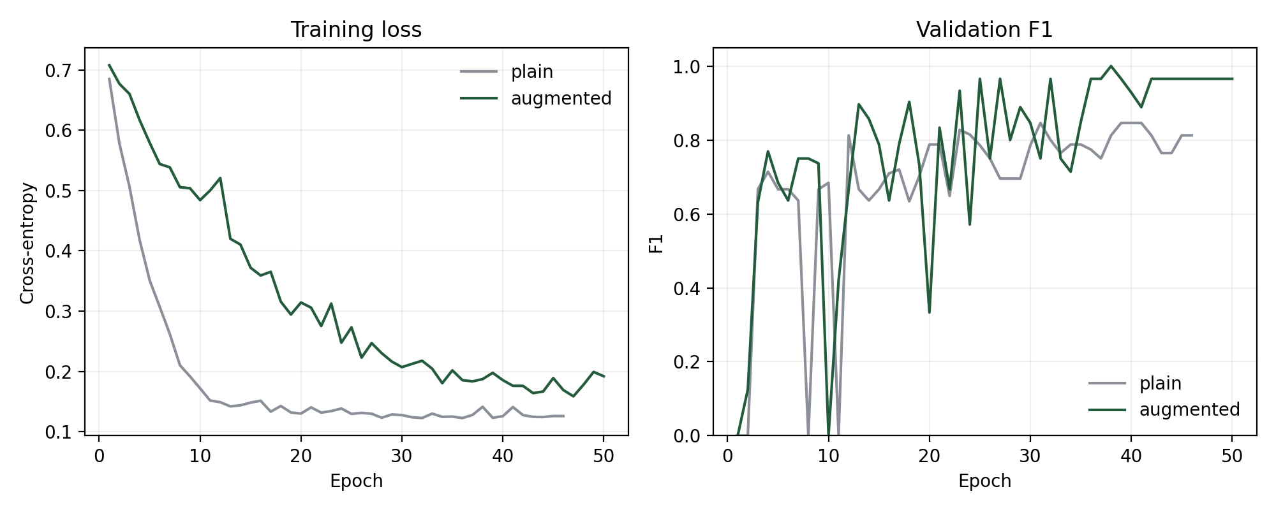
Figure 2. Training loss and validation F1 for the augmentation ablation
Validation F1 is noisy because the validation set contains only 30 images. The augmented model learns more slowly, as expected, because each epoch includes perturbed inputs, but reaches a stronger validation checkpoint.

4 Results and ablation
Model | Accuracy | Precision | Recall | F1 | Latency ms
Logistic Regression | 0.867 | 0.867 | 0.867 | 0.867 | 0.043
Legacy CNN | 0.967 | 0.938 | 1.000 | 0.968 | Not recorded
SE-ResNet plain | 0.833 | 1.000 | 0.667 | 0.800 | 5.145
SE-ResNet augmented | 0.900 | 0.875 | 0.933 | 0.903 | 4.370

The SE-ResNet with augmentation improves on Logistic Regression by 3.3 percentage points in accuracy and 3.6 points in F1. It also improves over the unaugmented SE-ResNet by 6.7 points accuracy and 10.3 points F1. The latency benchmark uses one image, ten warm-up passes, and 100 timed CPU passes; timing depends on hardware and software environment.
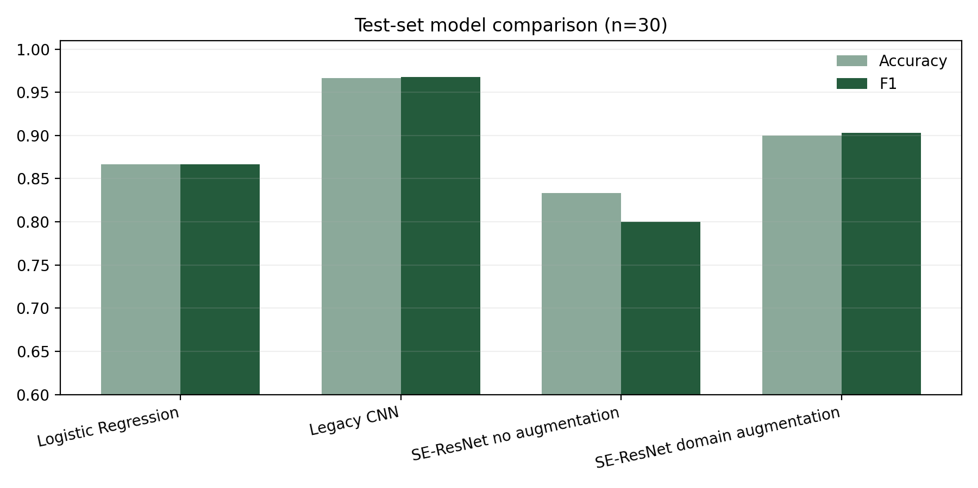
Figure 3. Accuracy and F1 on the unchanged 30-image test set
The legacy CNN remains best. This is plausible because the data are small and visually simple, and a deeper attention model has more capacity than the dataset can reliably support. The result is not evidence that SE blocks are generally inferior; it shows that architecture choice must match data scale. The modern model still satisfies the Assignment 2 objective by integrating and evaluating a contemporary attention component, improving the original linear baseline, supporting explainability, and enabling a deployable PyTorch application.

4.1 Ablation conclusion
Domain-safe augmentation is the only tested factor that produces a clear gain within the new architecture. Aggressive generic transforms such as inversion or solarization were excluded because they would create an acquisition domain unlike black ink on white paper. This design choice keeps generated samples plausible and reduces label-preserving but distribution-breaking artifacts.

5 Explainability and application
Grad-CAM uses the gradient of the predicted class with respect to the last convolutional feature maps to form a class-discriminative localization map [3]. The heatmap does not prove causal reasoning, but it helps identify whether the model focuses on digit strokes, edges, or irrelevant background regions.
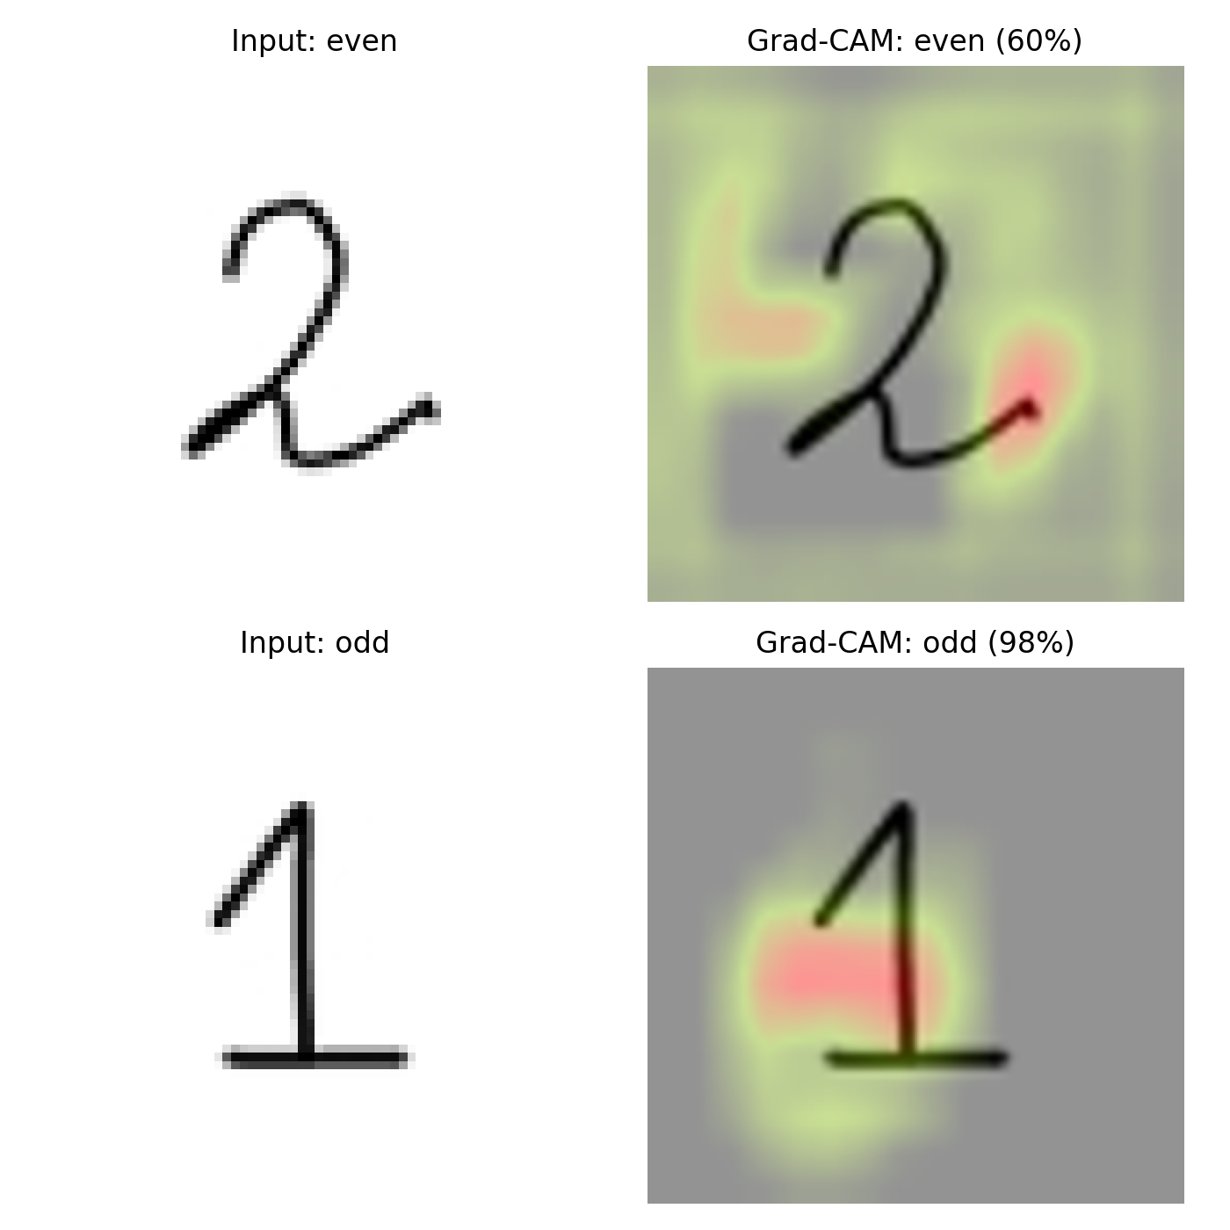
Figure 4. Grad-CAM examples from the augmented SE-ResNet
For the digit 2, the model assigns moderate confidence and focuses on the terminal stroke and nearby structure. For the digit 1, it assigns high confidence and emphasizes the vertical and base strokes. Background activation remains visible, which is a useful warning that explanations should be reviewed across many examples rather than treated as proof for one prediction.

5.1 Interactive demo
The FastAPI web application supports file upload and mobile camera capture through the browser. It returns the even/odd label, confidence, class probabilities, live inference latency, and a Grad-CAM overlay. The interface includes a limitation notice and does not store uploads. The implementation loads the augmented checkpoint once at server startup to keep interaction responsive.
Requirement | Implementation
Upload or camera | HTML file input with image capture hint
Prediction | SE-ResNet softmax label and confidence
Visual explanation | Grad-CAM overlay from final residual stage
Latency | Measured for each request
Environment | FastAPI, PyTorch, desktop or mobile browser

6 Ethics limitations and failure modes

6.1 Ethics and consent
Handwriting can become identifying when combined with names, signatures, or personal documents. This dataset should remain limited to isolated practice digits without identity metadata. Contributors should understand the course purpose and consent to collection. The application must not be used to infer intelligence, disability, identity, or authorship. If synthetic images are exported or shown outside training, they should be labeled as generated or augmented.

6.2 Bias and generalization
The dataset includes roughly 99 examples per class but only a limited number of writers and acquisition conditions. Class balance does not guarantee style balance. Performance may drop for children, left-handed writers, unfamiliar numeral conventions, thick markers, lined paper, shadows, multiple digits, partial crops, or camera angles not represented in training.

6.3 Technical limitations
Limitation | Effect | Mitigation
Small test set | One error changes accuracy by 3.33 points | Collect a writer-disjoint test set
Writer overlap may exist | Scores may reflect familiar styles | Split by contributor, not only image
Binary target | A wrong digit can still have correct parity | Add a 10-class digit head and parity rule
Grad-CAM is coarse | Heat can spread beyond strokes | Inspect multiple layers and use occlusion tests
CPU latency is environment-specific | Cannot predict all devices | Benchmark target laptop and phone
Legacy CNN source absent | Training cannot be exactly replayed | Retain artifact and rebuild source pipeline

6.4 Recommended next experiment
The most informative improvement is not a larger model. Collect at least 20 writers, keep every writer in only one split, and predict all ten digits before mapping the prediction to parity. This tests whether the network learns digit identity rather than dataset-specific stroke patterns. Confidence calibration and rejection of low-quality or multi-digit inputs should be added before broader use.

7 Reproducibility and conclusion

7.1 Run instructions
- Create a Python 3.10 to 3.12 virtual environment and install requirements.txt.
- Run python train.py --mode both to reproduce the plain and augmented checkpoints.
- Run python evaluate_baseline.py to verify the retained Logistic Regression baseline.
- Run python make_artifacts.py to regenerate tables, curves, confusion matrix, and Grad-CAM examples.
- Run uvicorn app:app --reload and open http://127.0.0.1:8000 for the demo.
The repository includes the fixed split, both new checkpoints, per-epoch histories, test predictions, metric JSON files, comparison CSV, figures, application code, original Assignment 1 artifacts, and a timed demo script. Seed 42 and deterministic-algorithm warnings are enabled. Exact reproducibility across PyTorch versions and hardware is not guaranteed, so the final environment should be archived with pip freeze.

7.2 Conclusion
Assignment 2 upgrades the handwritten parity project with residual learning, Squeeze-and-Excitation channel attention, domain-safe augmentation, Grad-CAM, latency measurement, an ablation, and an interactive camera-ready web demo. The augmented SE-ResNet improves the Logistic Regression baseline to 0.900 accuracy and 0.903 F1, while the legacy CNN remains best at 0.967 accuracy. The central lesson is that modern components add useful robustness and explainability, but data scale and evaluation design matter more than architectural novelty alone.

References
[1] K. He, X. Zhang, S. Ren, and J. Sun. Deep Residual Learning for Image Recognition. CVPR, 2016. doi:10.1109/CVPR.2016.90.
[2] J. Hu, L. Shen, S. Albanie, G. Sun, and E. Wu. Squeeze-and-Excitation Networks. CVPR, 2018. doi:10.1109/CVPR.2018.00745.
[3] R. R. Selvaraju et al. Grad-CAM: Visual Explanations from Deep Networks via Gradient-Based Localization. ICCV, 2017. doi:10.1109/ICCV.2017.74.

