SITE INSPECTION FORM

Project Information
Project Name | : | {ProjectName}
Implementing Agency | : | {ImplementingAgency}
Project Location | : | {Location}
Contractor | : | {Contractor}
Contract Amount | : | {ContractAmount}
Revised Contract Amount | : | {RevisedContractAmount}
Notice to Proceed | : | {NTP}
Original Contract Duration (days) | : | {Duration}
Time Extension (days) | : | {TimeExtension}
Target Completion |  | {TargetCompletion}
Original Target Completion | : | {OriginalTargetCompletion}
Revised Target Completion | : | {RevisedTargetCompletion}
Accomplishment as of | : | {AsOfDate}
% Accomplishment To Date | : | {PercentToDate}
% Accomplishment Previous | : | {PercentPrevious}
% Accomplishment Planned | : | {PercentPlanned}

Ongoing Activities
{Activities}

Issues & Concerns
{Issue}

Action Taken
{ActionTaken}

Remarks
{Remarks}

Other Project Details
{OtherProjectDetails}

Project Photos
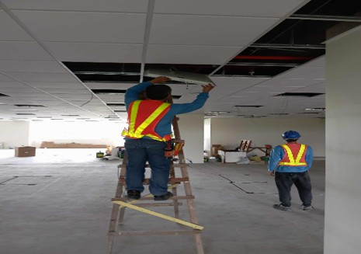 | 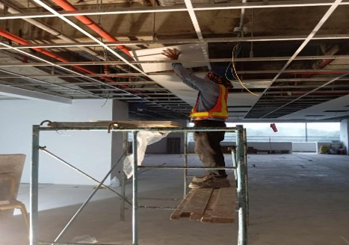 | 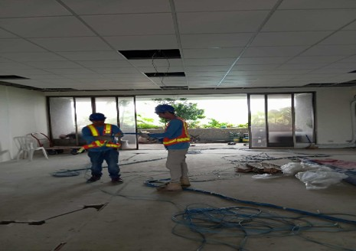

Signatures
Inspector: | Signature/Date:
Contractor Representative: | Signature/Date:

