Figure 1
PRISMA 2020 Flow Diagram of the Study Selection Process
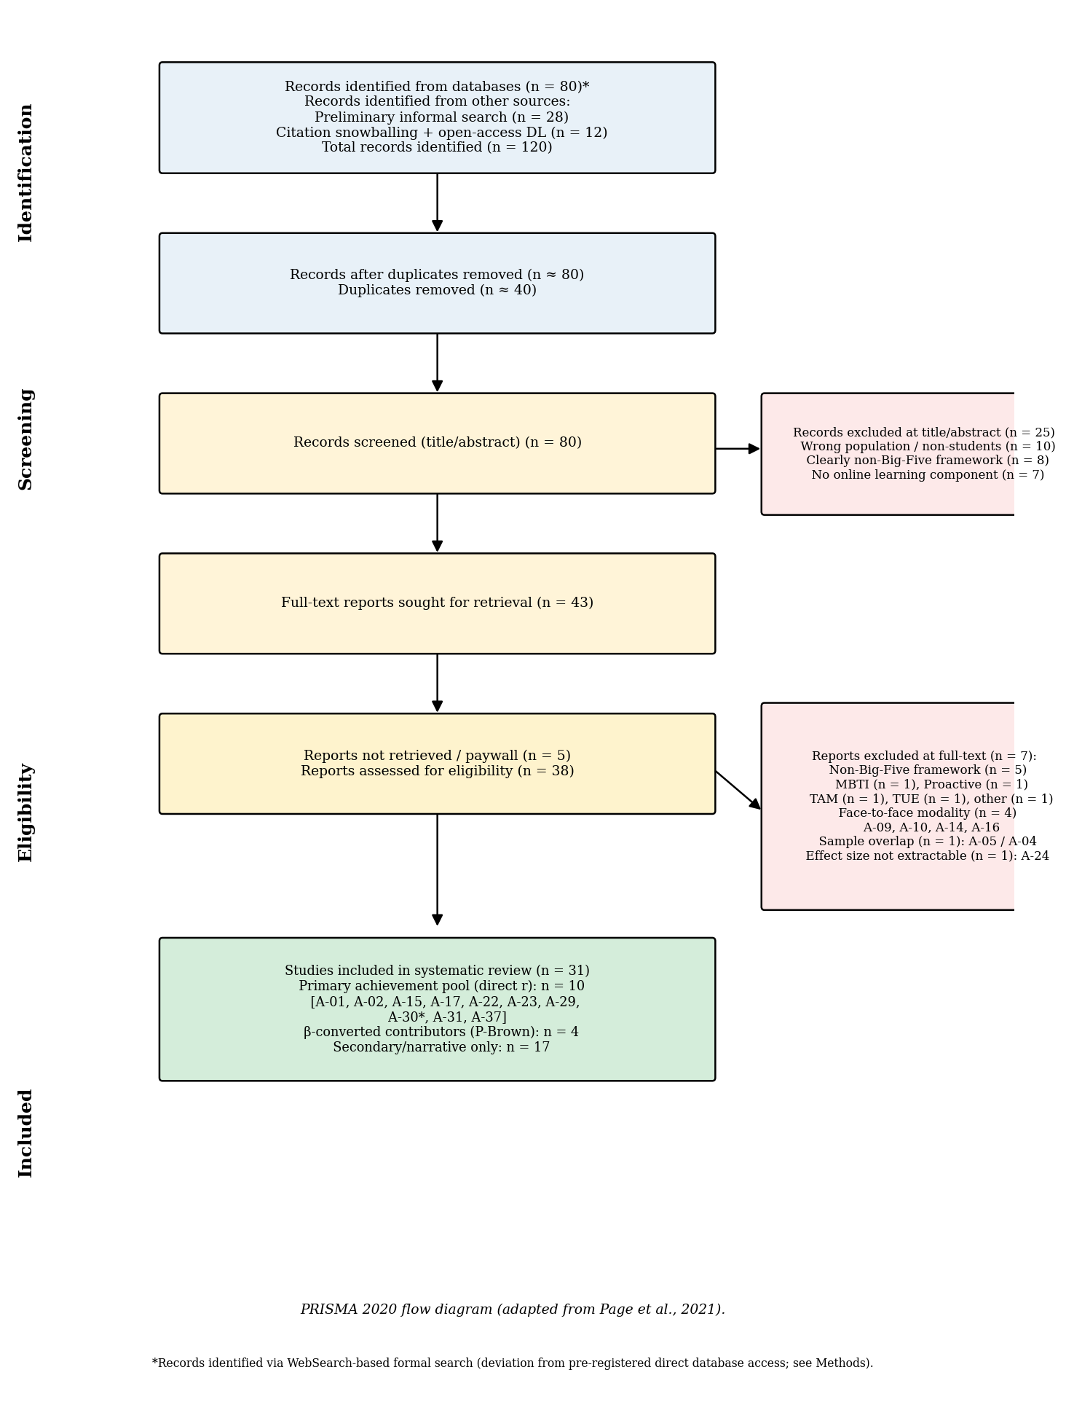
Note. Flow diagram adapted from the PRISMA 2020 statement (Page et al., 2021). Records were identified through WebSearch-based formal search (n = 80 from eight structured queries), preliminary informal search yielding a previously curated corpus (n = 28), and citation snowballing combined with open-access repository downloads (n = 12), for a total of 120 records. After deduplication (n = 40 removed), 80 records underwent title and abstract screening, with 25 excluded primarily for wrong population, non-Big-Five personality frameworks, or no online learning component. Of 43 full-text reports sought, 5 were not retrievable (paywall), and 38 were assessed for eligibility. Eleven reports were excluded at the full-text stage with explicit reasons: non-Big-Five framework (n = 5; MBTI, Proactive Personality, TAM, TUE, and other non-FFM operationalization), face-to-face modality (n = 4; A-09 Bhattacharjee & Ramkumar, 2025; A-10 Boonyapison et al., 2025; A-14 Eilam et al., 2009; A-16 Hidalgo-Fuentes et al., 2024), sample overlap with an already-included study (n = 1; A-05 Audet et al., 2023 overlapped with A-04 Audet et al., 2021), and effect size not extractable (n = 1; A-24 Tlili et al., 2023, lag sequential analysis). The remaining studies, supplemented by four newly identified primary studies (A-29 Bahçekapılı & Karaman, 2020; A-30 Kaspar et al., 2023; A-31 Rivers, 2021; A-37 Zheng & Zheng, 2023), yielded 31 primary studies catalogued in this review (Table 1). Of these, 25 were retained for qualitative synthesis, and 10 contributed direct Pearson correlations or β-converted effect sizes to the primary quantitative achievement pool (with two studies — A-28 Yu, 2021 and A-30 Kaspar et al., 2023 — providing β-converted effect sizes via Peterson and Brown's, 2005, approximation). The remaining 15 retained studies contributed only to secondary-outcome narrative synthesis.

Figure 2
Forest Plot: Conscientiousness and Academic Achievement in Online Learning Environments
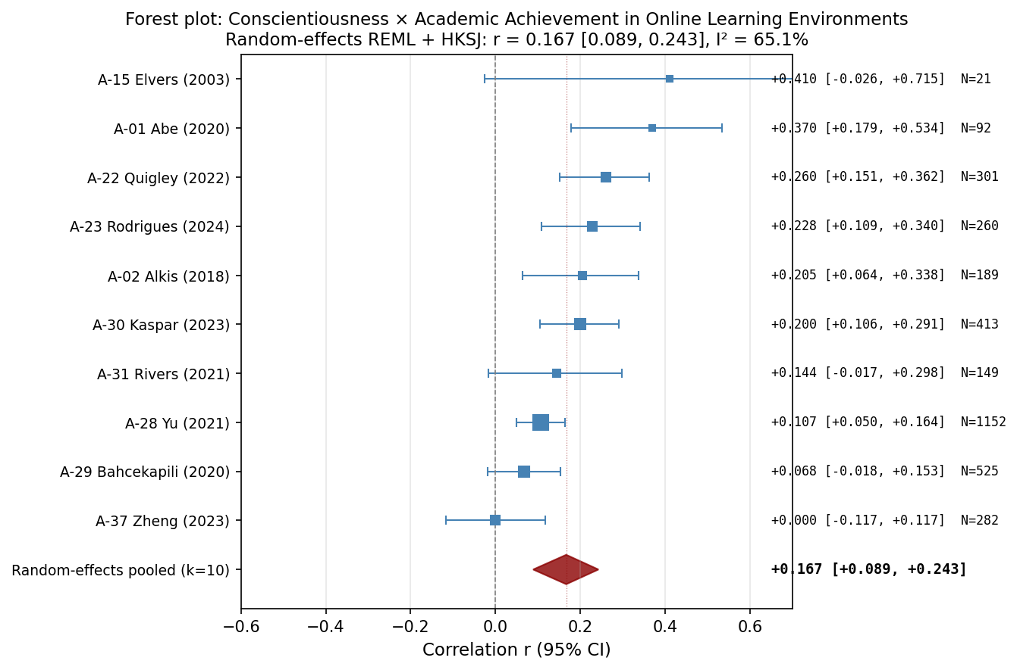
Note. Forest plot of study-level Pearson correlations between Conscientiousness and academic achievement in online learning environments. Each square represents a study; square size is proportional to the inverse-variance weight. Horizontal bars show 95% confidence intervals. The red diamond represents the random-effects REML pooled estimate with HKSJ 95% confidence interval. Studies are sorted by effect size (descending). See Table 2 for pooled statistics.

Figure 3
Forest Plot: Agreeableness and Academic Achievement in Online Learning Environments
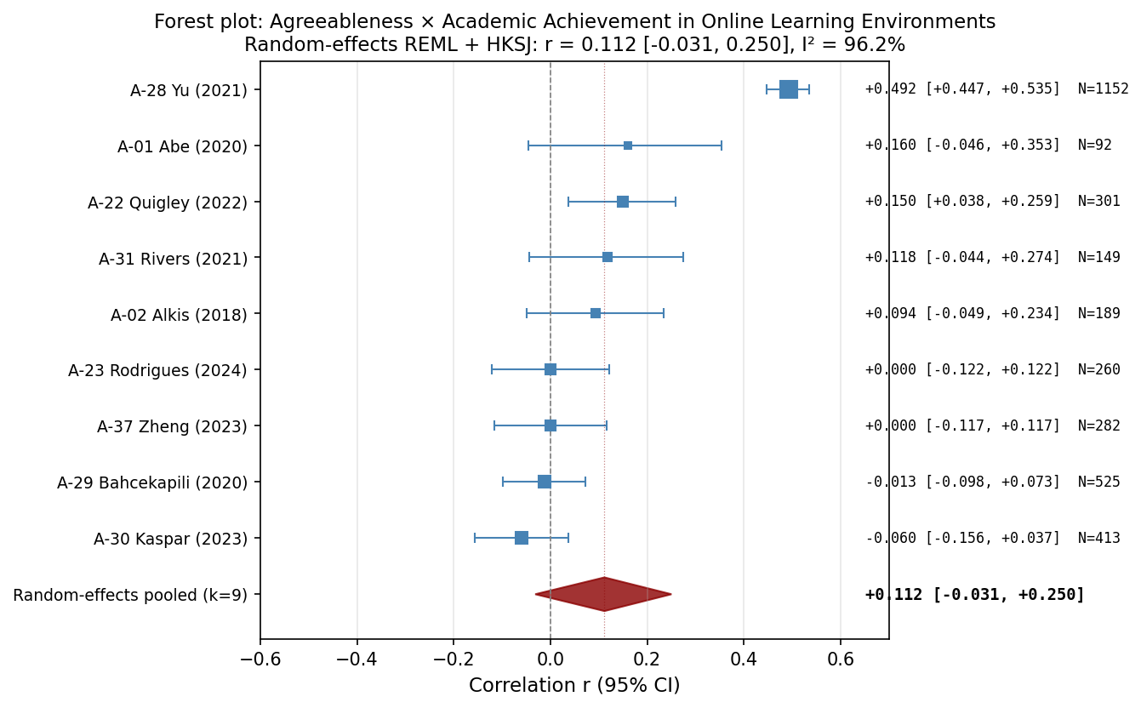
Note. Forest plot of study-level Pearson correlations between Agreeableness and academic achievement in online learning environments. Each square represents a study; square size is proportional to the inverse-variance weight. Horizontal bars show 95% confidence intervals. The red diamond represents the random-effects REML pooled estimate with HKSJ 95% confidence interval. Studies are sorted by effect size (descending). See Table 2 for pooled statistics.

Figure 4
Forest Plot: Openness and Academic Achievement in Online Learning Environments
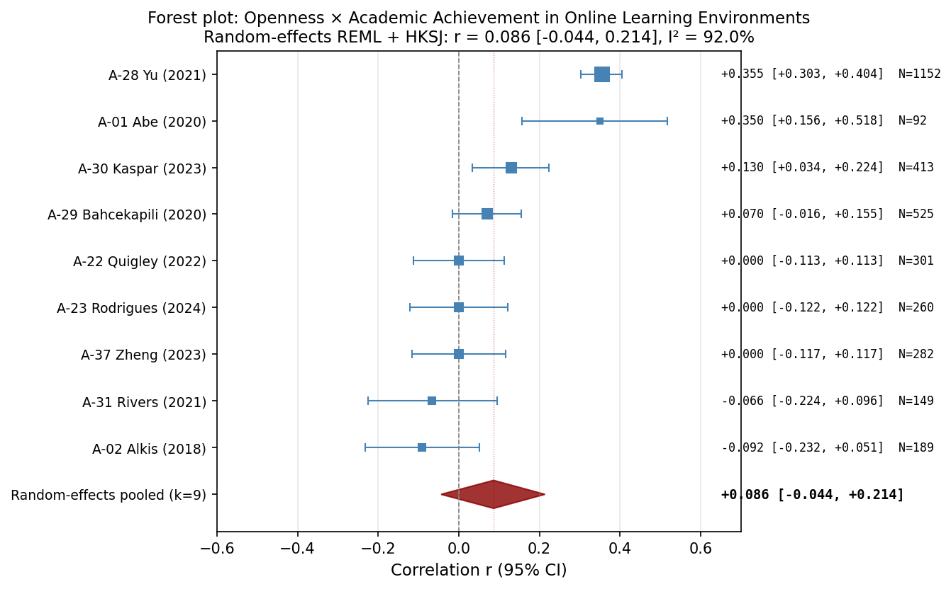
Note. Forest plot of study-level Pearson correlations between Openness and academic achievement in online learning environments. Each square represents a study; square size is proportional to the inverse-variance weight. Horizontal bars show 95% confidence intervals. The red diamond represents the random-effects REML pooled estimate with HKSJ 95% confidence interval. Studies are sorted by effect size (descending). See Table 2 for pooled statistics.

Figure 5
Forest Plot: Neuroticism and Academic Achievement in Online Learning Environments
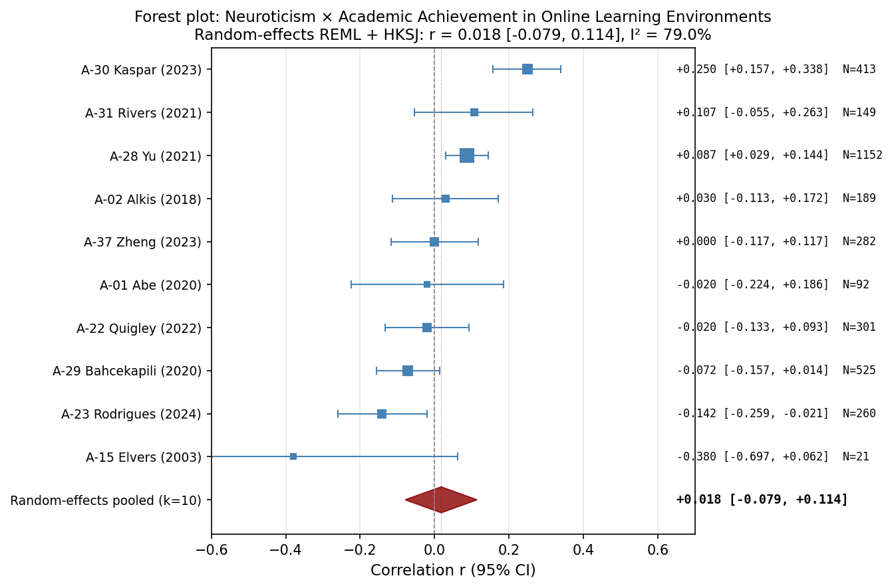
Note. Forest plot of study-level Pearson correlations between Neuroticism and academic achievement in online learning environments. Each square represents a study; square size is proportional to the inverse-variance weight. Horizontal bars show 95% confidence intervals. The red diamond represents the random-effects REML pooled estimate with HKSJ 95% confidence interval. Studies are sorted by effect size (descending). See Table 2 for pooled statistics.

Figure 6
Forest Plot: Extraversion and Academic Achievement in Online Learning Environments
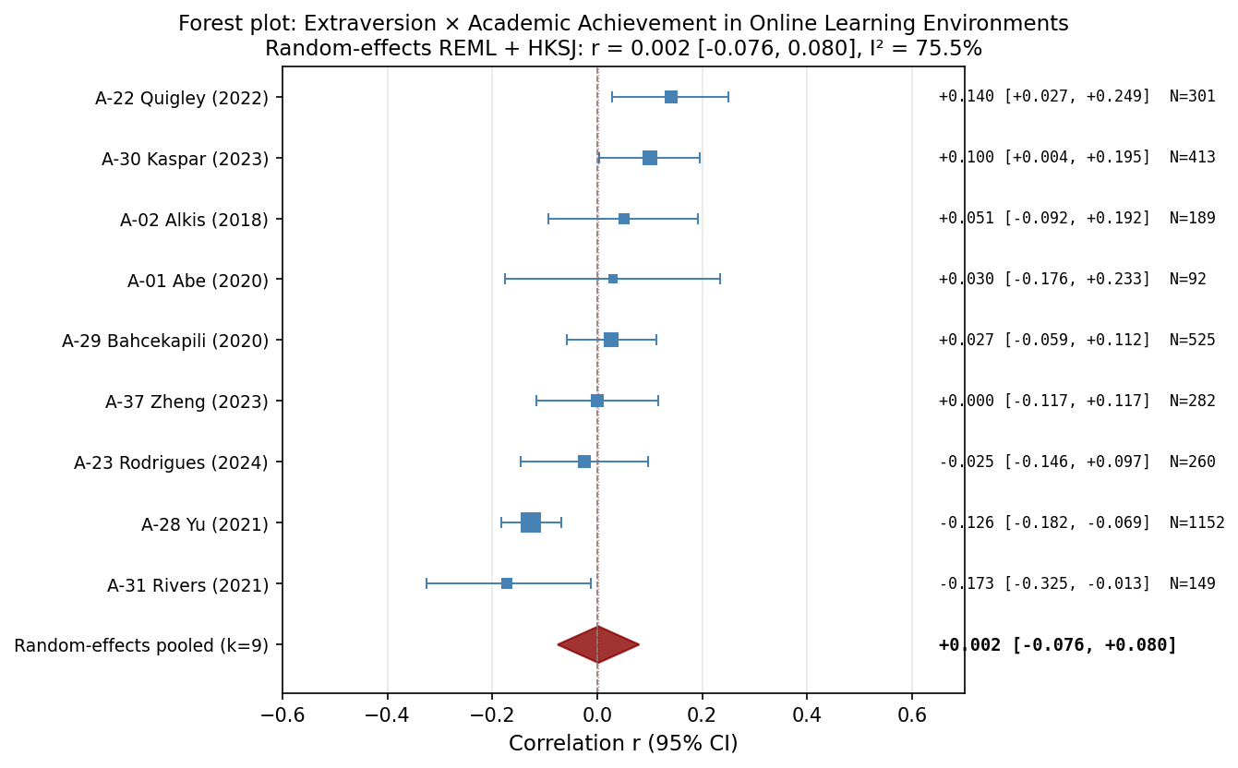
Note. Forest plot of study-level Pearson correlations between Extraversion and academic achievement in online learning environments. Each square represents a study; square size is proportional to the inverse-variance weight. Horizontal bars show 95% confidence intervals. The red diamond represents the random-effects REML pooled estimate with HKSJ 95% confidence interval. Studies are sorted by effect size (descending). See Table 2 for pooled statistics.

Figure 7
Funnel Plot: Conscientiousness and Academic Achievement in Online Learning Environments
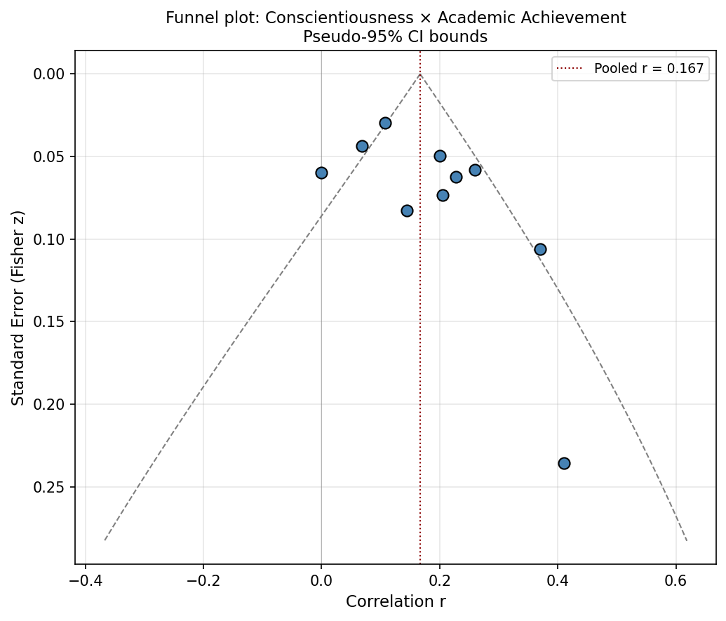
Note. Funnel plot of Pearson correlations between Conscientiousness and academic achievement in online learning environments. Points represent individual studies. The vertical dashed red line indicates the random-effects pooled correlation. Diagonal dashed lines represent pseudo-95% confidence bounds under the assumption of no heterogeneity. Asymmetric dispersion may suggest small-study effects or publication bias. Egger's test results: intercept = 2.14, p = .094. See Table 4 for full publication-bias assessment.

Figure 8
Funnel Plot: Agreeableness and Academic Achievement in Online Learning Environments
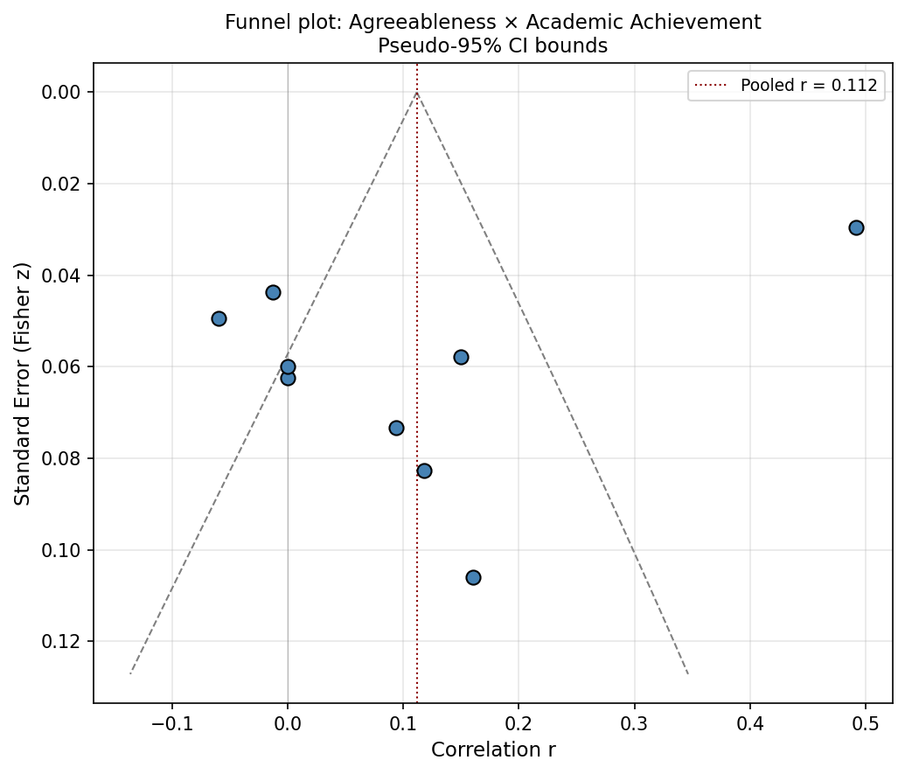
Note. Funnel plot of Pearson correlations between Agreeableness and academic achievement in online learning environments. Points represent individual studies. The vertical dashed red line indicates the random-effects pooled correlation. Diagonal dashed lines represent pseudo-95% confidence bounds under the assumption of no heterogeneity. Asymmetric dispersion may suggest small-study effects or publication bias. Egger's test results: intercept = −8.53, p = .072. See Table 4 for full publication-bias assessment.

Figure 9
Funnel Plot: Openness and Academic Achievement in Online Learning Environments
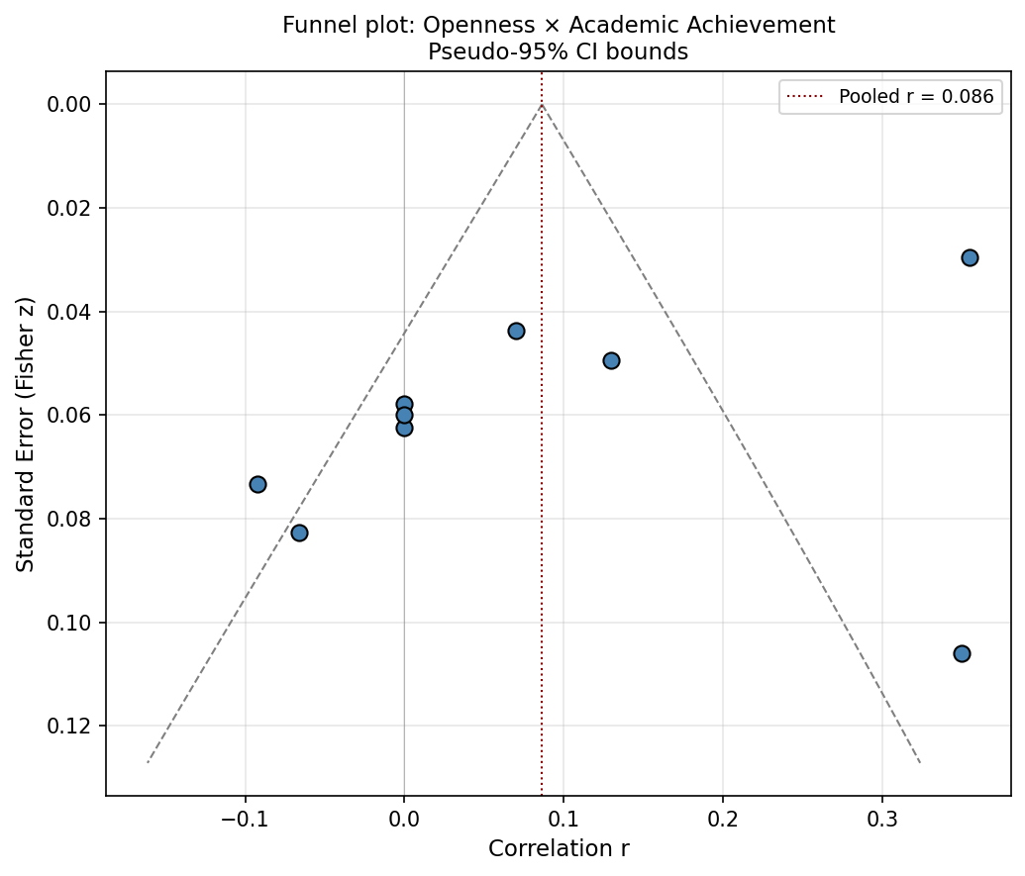
Note. Funnel plot of Pearson correlations between Openness and academic achievement in online learning environments. Points represent individual studies. The vertical dashed red line indicates the random-effects pooled correlation. Diagonal dashed lines represent pseudo-95% confidence bounds under the assumption of no heterogeneity. Asymmetric dispersion may suggest small-study effects or publication bias. Egger's test results: intercept = −6.41, p = .045. See Table 4 for full publication-bias assessment.

Figure 10
Funnel Plot: Neuroticism and Academic Achievement in Online Learning Environments
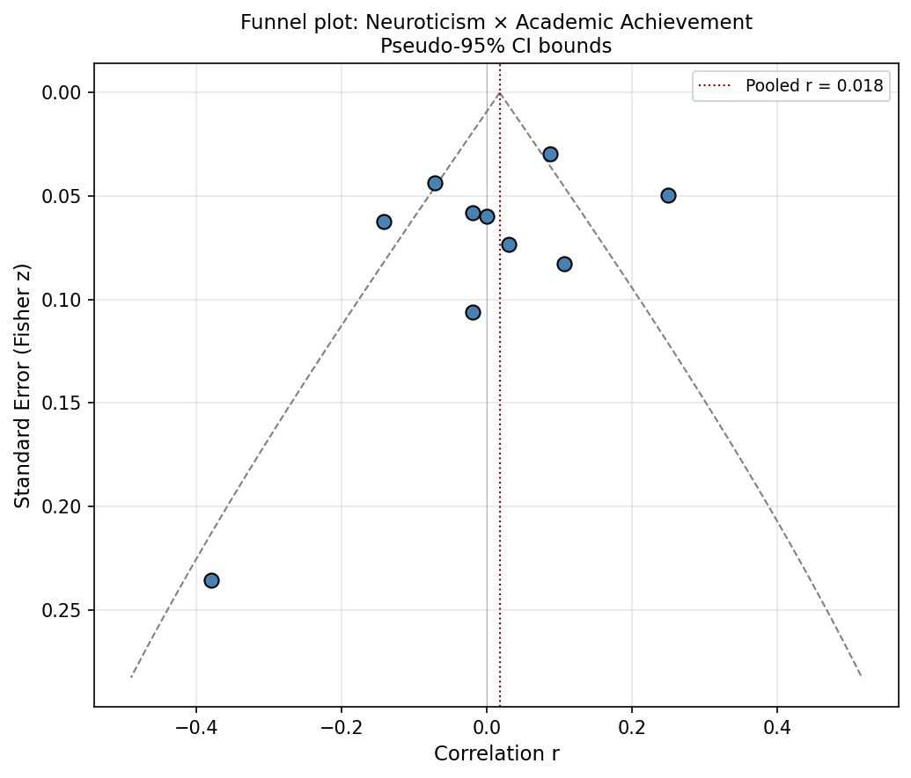
Note. Funnel plot of Pearson correlations between Neuroticism and academic achievement in online learning environments. Points represent individual studies. The vertical dashed red line indicates the random-effects pooled correlation. Diagonal dashed lines represent pseudo-95% confidence bounds under the assumption of no heterogeneity. Asymmetric dispersion may suggest small-study effects or publication bias. Egger's test results: intercept = −1.79, p = .304. See Table 4 for full publication-bias assessment.

Figure 11
Funnel Plot: Extraversion and Academic Achievement in Online Learning Environments
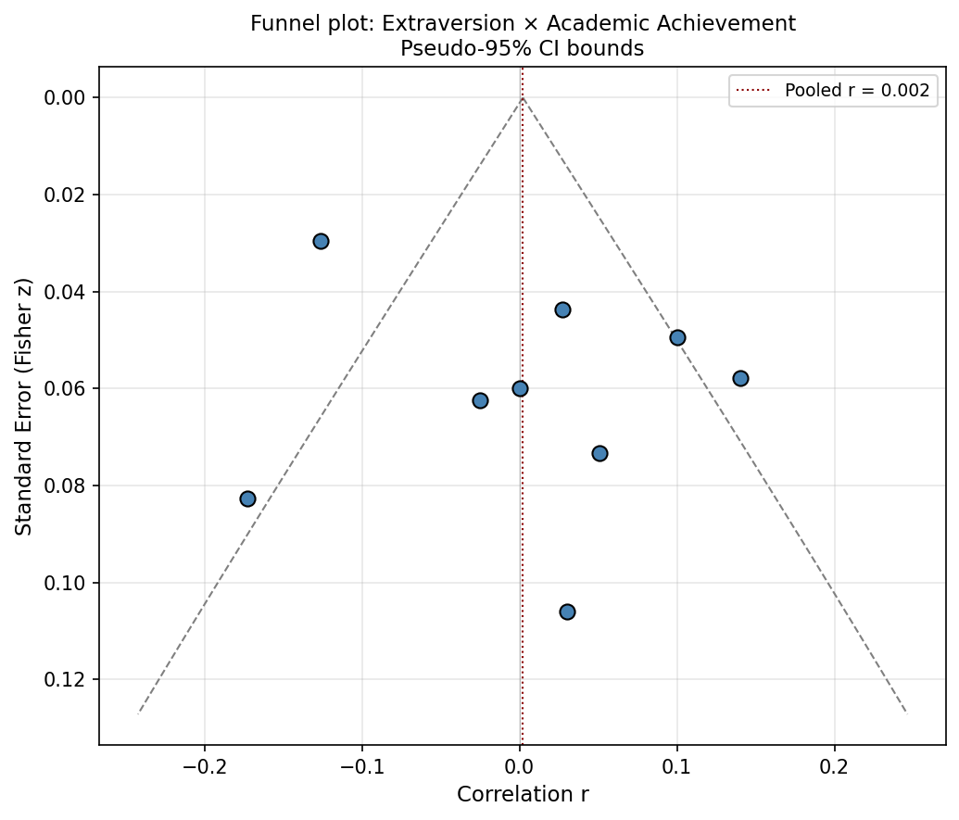
Note. Funnel plot of Pearson correlations between Extraversion and academic achievement in online learning environments. Points represent individual studies. The vertical dashed red line indicates the random-effects pooled correlation. Diagonal dashed lines represent pseudo-95% confidence bounds under the assumption of no heterogeneity. Asymmetric dispersion may suggest small-study effects or publication bias. Egger's test results: intercept = 2.29, p = .255. See Table 4 for full publication-bias assessment.

