Figure 1
PRISMA-ScR Flow Diagram of the Study Selection Process
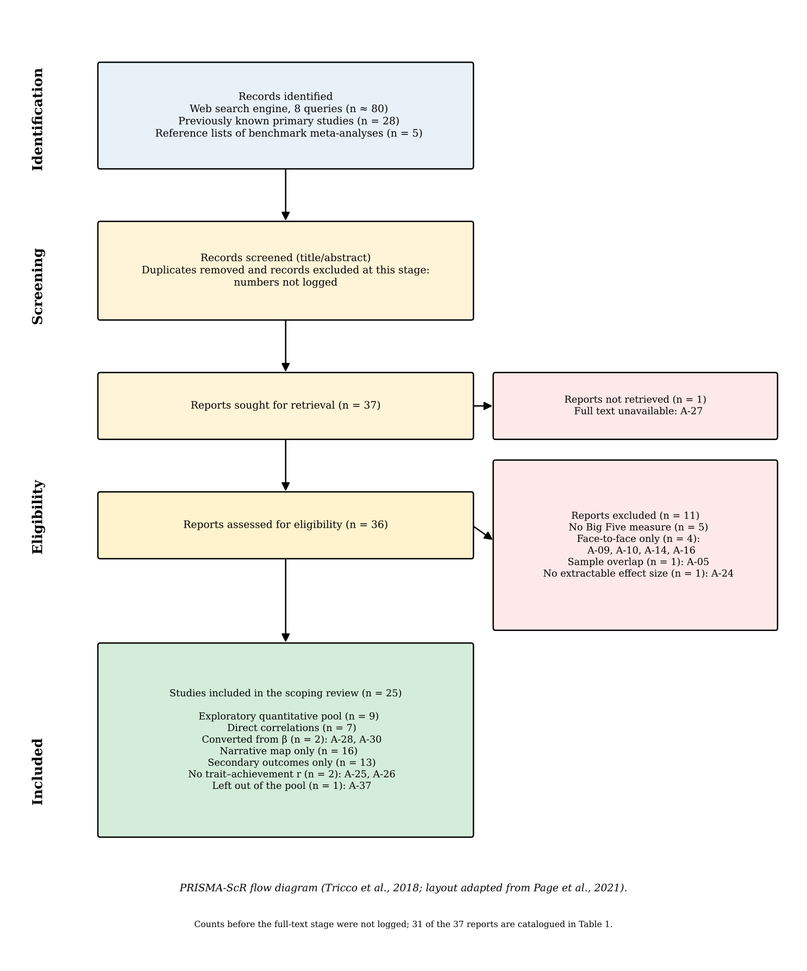
Note. Flow diagram following PRISMA-ScR (Tricco et al., 2018), with the layout of Page et al. (2021). Records were identified from eight web-search-engine queries (about 80 hits), 28 primary studies already known from preliminary searching, and the reference lists of five benchmark meta-analyses. The numbers of duplicates and of records excluded at title and abstract screening were not logged. From the full-text stage onward the counts are exact: of 37 reports sought, one could not be retrieved (A-27) and 36 were assessed; 11 were excluded (no Big Five measure, 5; face-to-face only, 4: A-09, A-10, A-14, A-16; sample overlap, 1: A-05; no extractable effect size, 1: A-24), leaving 25 studies. Of these, 9 contributed correlations to the quantitative pool (7 direct, 2 converted from β) and 16 entered the narrative map only, including A-37, which was left out of the pool. Table 1 catalogues 31 of the 37 reports.

Figure 2
Forest Plot: Conscientiousness and Academic Achievement in Online Learning Environments
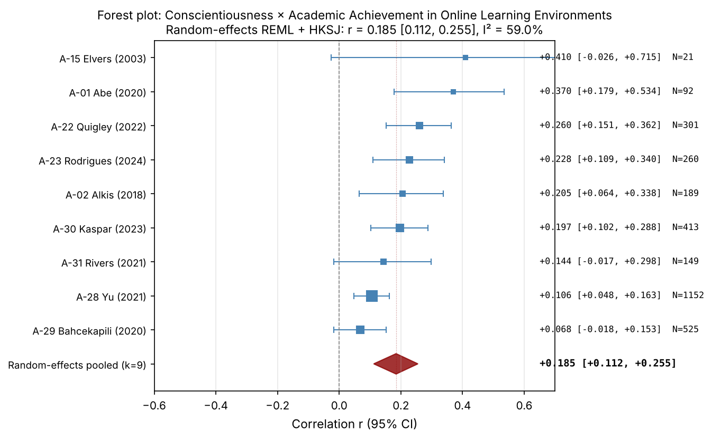
Note. Forest plot of study-level Pearson correlations between Conscientiousness and academic achievement in online learning environments. Each square represents a study; square size is proportional to the inverse-variance weight. Horizontal bars show 95% confidence intervals. The red diamond represents the random-effects REML pooled estimate with HKSJ 95% confidence interval. Studies are sorted by effect size (descending). See Table 2 for pooled statistics.

Figure 3
Forest Plot: Agreeableness and Academic Achievement in Online Learning Environments
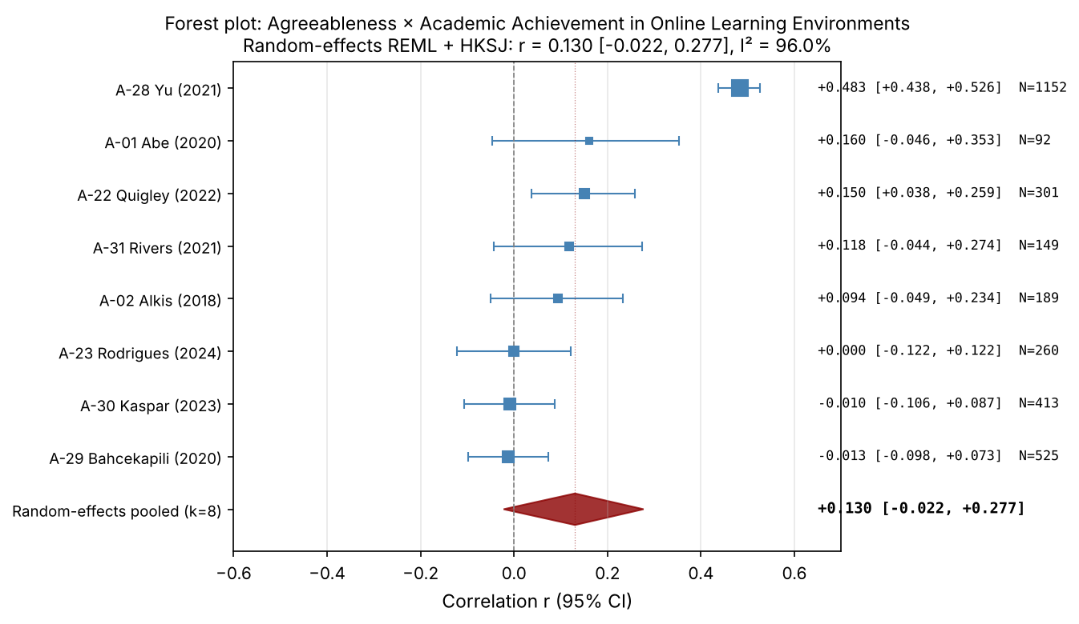
Note. Forest plot of study-level Pearson correlations between Agreeableness and academic achievement in online learning environments. Each square represents a study; square size is proportional to the inverse-variance weight. Horizontal bars show 95% confidence intervals. The red diamond represents the random-effects REML pooled estimate with HKSJ 95% confidence interval. Studies are sorted by effect size (descending). See Table 2 for pooled statistics.

Figure 4
Forest Plot: Openness and Academic Achievement in Online Learning Environments
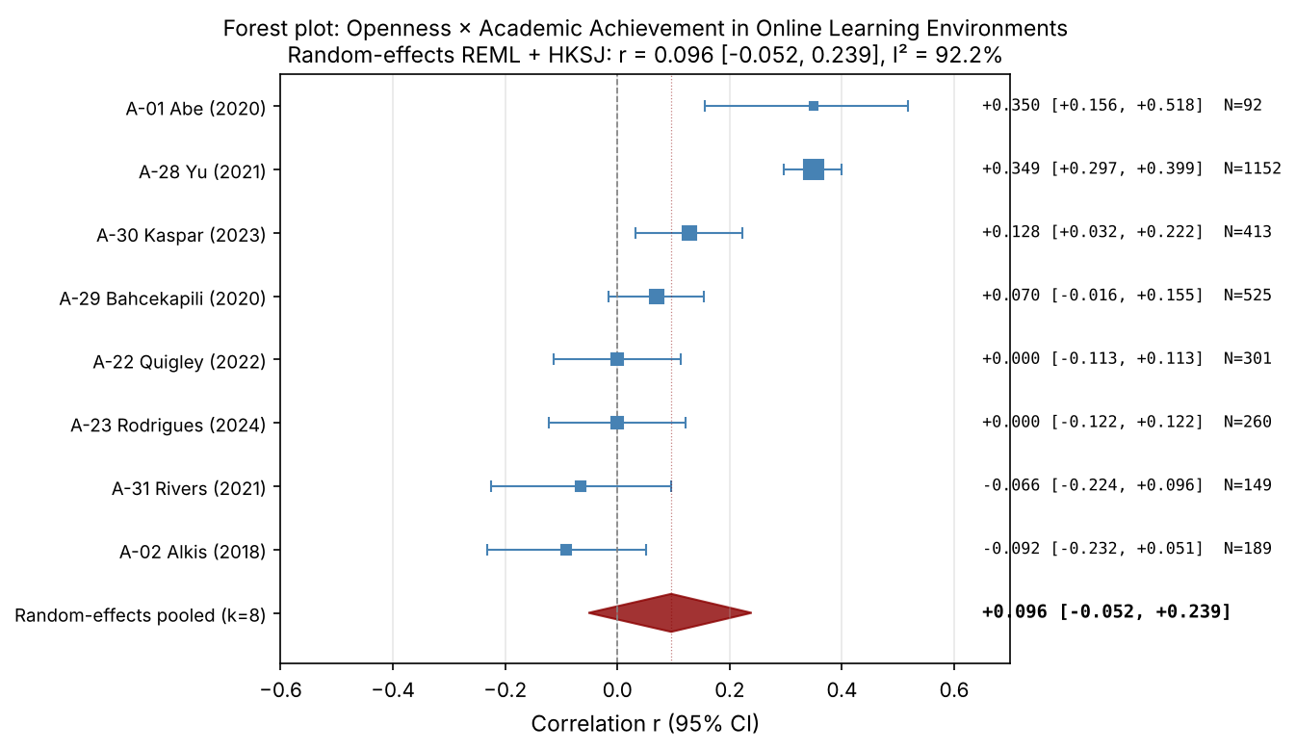
Note. Forest plot of study-level Pearson correlations between Openness and academic achievement in online learning environments. Each square represents a study; square size is proportional to the inverse-variance weight. Horizontal bars show 95% confidence intervals. The red diamond represents the random-effects REML pooled estimate with HKSJ 95% confidence interval. Studies are sorted by effect size (descending). See Table 2 for pooled statistics.

Figure 5
Forest Plot: Neuroticism and Academic Achievement in Online Learning Environments
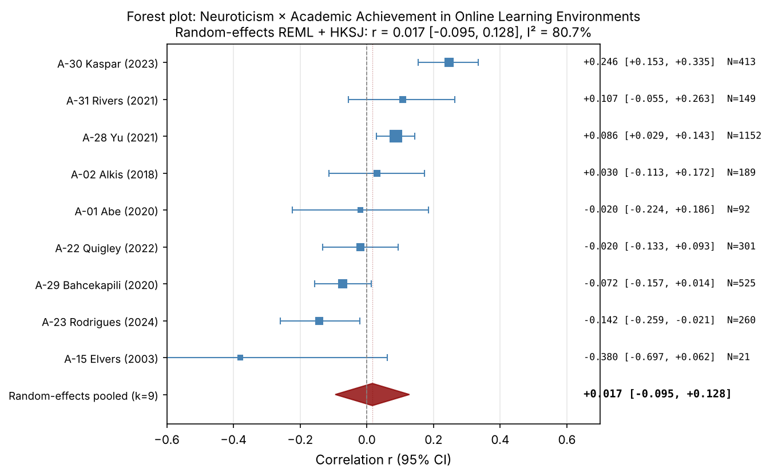
Note. Forest plot of study-level Pearson correlations between Neuroticism and academic achievement in online learning environments. Each square represents a study; square size is proportional to the inverse-variance weight. Horizontal bars show 95% confidence intervals. The red diamond represents the random-effects REML pooled estimate with HKSJ 95% confidence interval. Studies are sorted by effect size (descending). See Table 2 for pooled statistics.

Figure 6
Forest Plot: Extraversion and Academic Achievement in Online Learning Environments
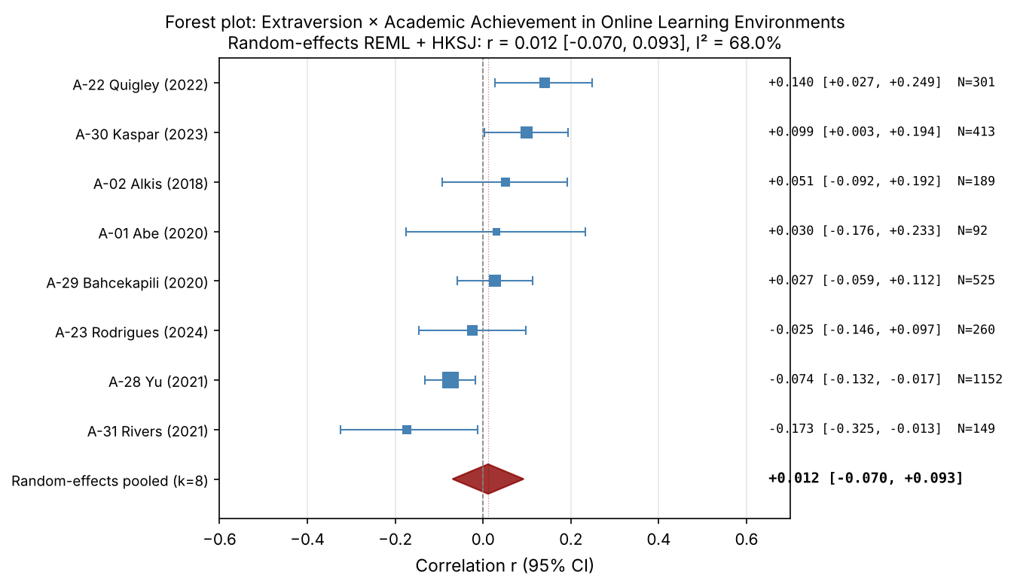
Note. Forest plot of study-level Pearson correlations between Extraversion and academic achievement in online learning environments. Each square represents a study; square size is proportional to the inverse-variance weight. Horizontal bars show 95% confidence intervals. The red diamond represents the random-effects REML pooled estimate with HKSJ 95% confidence interval. Studies are sorted by effect size (descending). See Table 2 for pooled statistics.

Figure 7
Funnel Plot: Conscientiousness and Academic Achievement in Online Learning Environments
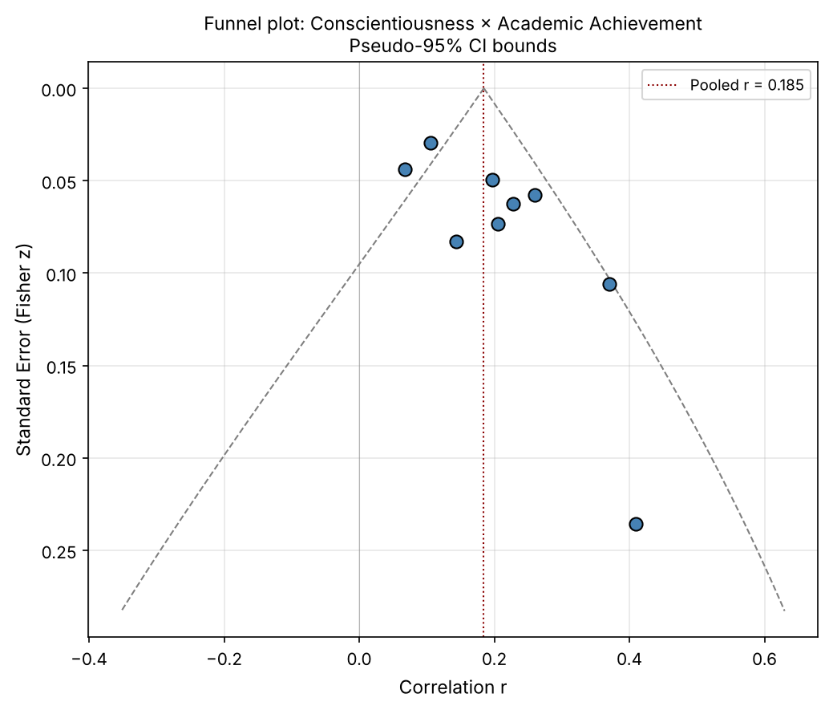
Note. Funnel plot of Pearson correlations between Conscientiousness and academic achievement in online learning environments. Points represent individual studies. The vertical dashed red line indicates the random-effects pooled correlation. Diagonal dashed lines represent pseudo-95% confidence bounds under the assumption of no heterogeneity. Asymmetric dispersion may suggest small-study effects or publication bias. Egger's test: intercept = 2.46, p = .026. See Table 4 for the other diagnostics.

Figure 8
Funnel Plot: Agreeableness and Academic Achievement in Online Learning Environments
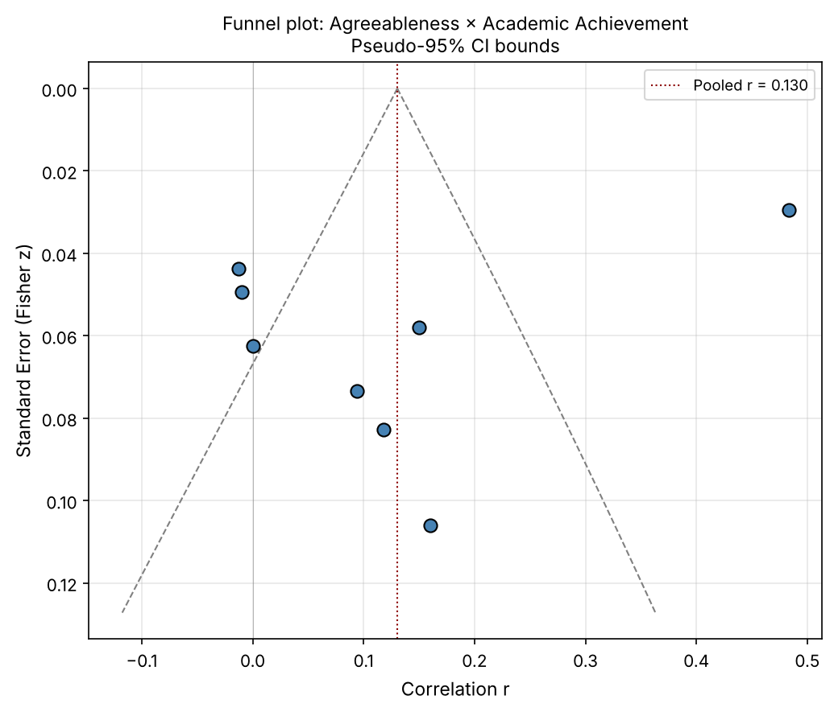
Note. Funnel plot of Pearson correlations between Agreeableness and academic achievement in online learning environments. Points represent individual studies. The vertical dashed red line indicates the random-effects pooled correlation. Diagonal dashed lines represent pseudo-95% confidence bounds under the assumption of no heterogeneity. Asymmetric dispersion may suggest small-study effects or publication bias. Egger's test: intercept = −7.93, p = .101. See Table 4 for the other diagnostics.

Figure 9
Funnel Plot: Openness and Academic Achievement in Online Learning Environments
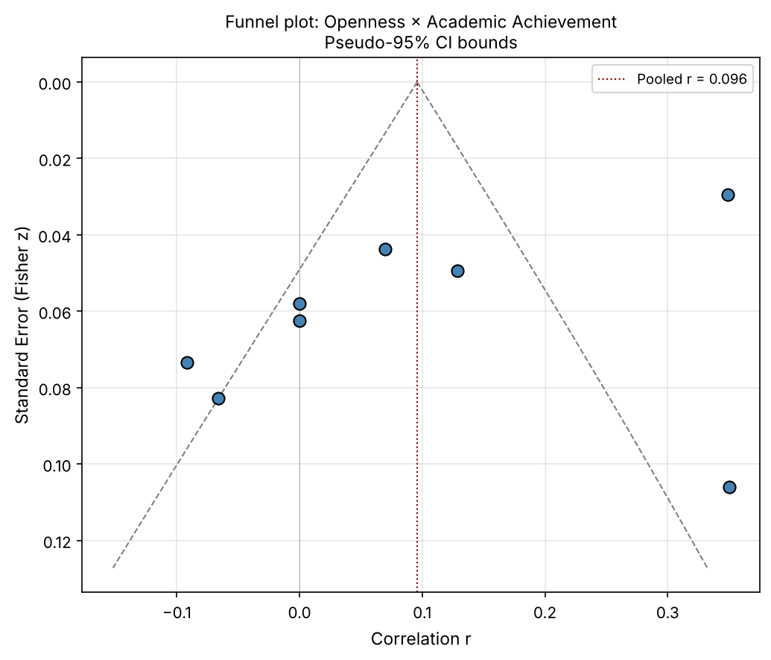
Note. Funnel plot of Pearson correlations between Openness and academic achievement in online learning environments. Points represent individual studies. The vertical dashed red line indicates the random-effects pooled correlation. Diagonal dashed lines represent pseudo-95% confidence bounds under the assumption of no heterogeneity. Asymmetric dispersion may suggest small-study effects or publication bias. Egger's test: intercept = −6.01, p = .075. See Table 4 for the other diagnostics.

Figure 10
Funnel Plot: Neuroticism and Academic Achievement in Online Learning Environments
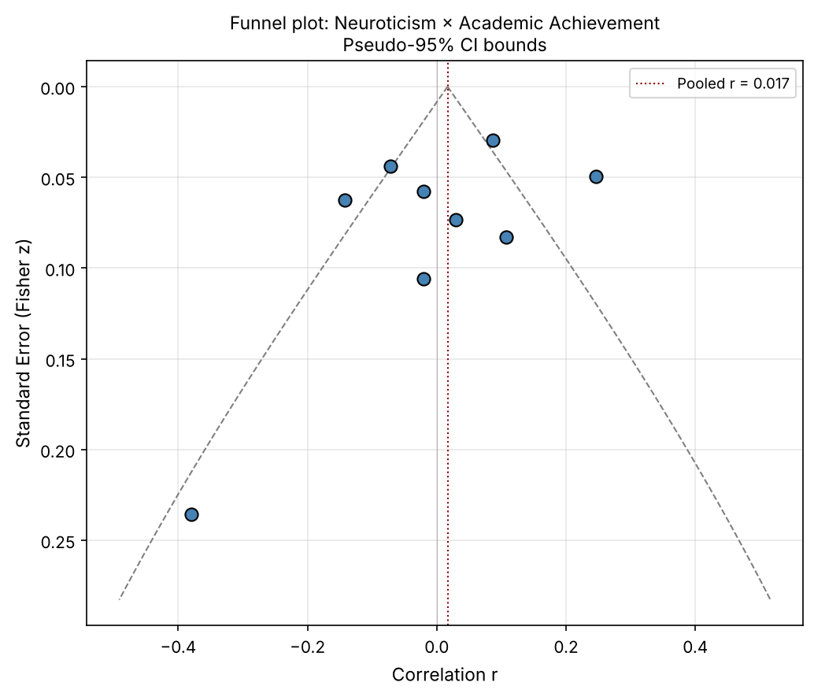
Note. Funnel plot of Pearson correlations between Neuroticism and academic achievement in online learning environments. Points represent individual studies. The vertical dashed red line indicates the random-effects pooled correlation. Diagonal dashed lines represent pseudo-95% confidence bounds under the assumption of no heterogeneity. Asymmetric dispersion may suggest small-study effects or publication bias. Egger's test: intercept = −1.74, p = .350. See Table 4 for the other diagnostics.

Figure 11
Funnel Plot: Extraversion and Academic Achievement in Online Learning Environments
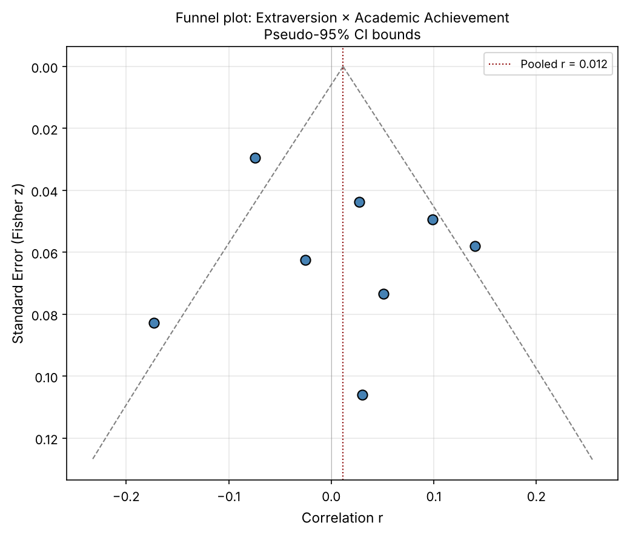
Note. Funnel plot of Pearson correlations between Extraversion and academic achievement in online learning environments. Points represent individual studies. The vertical dashed red line indicates the random-effects pooled correlation. Diagonal dashed lines represent pseudo-95% confidence bounds under the assumption of no heterogeneity. Asymmetric dispersion may suggest small-study effects or publication bias. Egger's test: intercept = 1.31, p = .485. See Table 4 for the other diagnostics.

