Big Five Personality Traits and Academic Achievement in Online Learning Environments: A Systematic Review and Meta-Analysis

[Author identifying information removed for double-anonymous peer review]

Author Note
Author identifying details — name, ORCID, affiliation, and correspondence information — have been removed for double-anonymous peer review and will be reinstated upon acceptance. The research received no external funding. Conflict-of-interest, pre-registration, and open-science deposit information are provided in the Declarations section using anonymised wording; identifying URLs (OSF, preprint, code repository) will be supplied to the editorial office post-acceptance.

Declarations
Conflict of Interest
The author declares that there are no financial or personal relationships with other people or organizations that could inappropriately influence this work, except that one of the author's prior primary studies (the author's own prior primary study) is potentially eligible for inclusion in the present meta-analysis. This conflict is addressed through a pre-specified sensitivity analysis excluding the author's own study.

Funding
This research did not receive any specific grant from funding agencies in the public, commercial, or not-for-profit sectors.

Ethics Approval
Not applicable. This study is a systematic review and meta-analysis of previously published quantitative research and did not involve any direct collection of data from human participants by the present author. As no new primary data were collected, no Institutional Review Board (IRB) or Research Ethics Committee approval was required for the conduct of this synthesis. The conduct of this review followed the ethical principles outlined in the Declaration of Helsinki (as revised in 2013) and the PRISMA 2020 reporting guidelines for systematic reviews. Ethical approval for each of the included primary studies was the responsibility of the original investigators of those studies, as documented in their respective publications.

Consent to Participate
Not applicable. This systematic review and meta-analysis did not involve any direct interaction with, or recruitment of, human participants by the present author. Informed consent and consent to participate for the underlying data were obtained by the original investigators of each included primary study at the time of original data collection, in accordance with the institutional and ethical standards applicable at that time.

Consent for Publication
Not applicable. This manuscript does not contain any individual person's data in any form (including individual details, images, or videos).

Human Ethics and Consent to Participate Declarations
Not applicable.

Pre-registration
This systematic review and meta-analysis was pre-registered on OSF Registries ([OSF preregistration link — provided post-acceptance]; DOI: [OSF preregistration DOI — provided post-acceptance]) on April 23, 2026, prior to formal data extraction and quantitative synthesis. The full protocol (PRISMA-P 2015 compliant) and supplementary materials are publicly available in the associated OSF project ([OSF project DOI — provided post-acceptance]).

Data Availability Statement
All extracted data, analysis code, search logs, risk-of-bias ratings, figures, and supplementary materials are publicly available on the associated OSF project ([OSF project DOI — provided post-acceptance]). Each component has been assigned a DOI for direct citation: 01_protocol ([OSF protocol DOI — provided post-acceptance]) — protocol, literature review, deep reading notes, and manuscript drafts; 02_search ([OSF search DOI — provided post-acceptance]) — search log and candidate studies; 03_screening ([OSF screening DOI — provided post-acceptance]) — PRISMA flow counts (forthcoming); 04_extraction ([OSF extraction DOI — provided post-acceptance]) — data extraction CSV and coding manual; 05_risk_of_bias ([OSF risk-of-bias DOI — provided post-acceptance]) — JBI risk-of-bias ratings (forthcoming); 06_analysis ([OSF analysis DOI — provided post-acceptance]) — Python analysis scripts, pooled results, moderator analyses, sensitivity analyses, and generating code for all tables and figures; and 07_pdf_index ([OSF index DOI — provided post-acceptance]) — DOI index of included studies.

Authors' contributions
The author (the author) conceived and designed the review, developed the search strategy and eligibility criteria, performed the database searches, conducted screening, extracted data, performed the statistical analyses, and drafted and revised the manuscript. The author approves the final version.

Preprint Statement
A preprint version of this manuscript has been deposited on Research Square ([Preprint DOI — provided post-acceptance]). This preprint has not been peer-reviewed by a journal. Any substantive revisions introduced during peer review are reflected in the present journal version and in a versioned preprint update.

Acknowledgments
The author thanks the investigators of the included primary studies for making their correlation matrices and sample characteristics available in the published record, and the maintainers of the open-access repositories (OSF, Research Square, PsyArXiv, arXiv, and institutional repositories) that enabled retrieval of full-text articles. The author also acknowledges the developers of the open-source scientific Python stack (NumPy, SciPy, pandas, Matplotlib, statsmodels, and python-docx) on which the analyses and manuscript preparation depended. No funding bodies, research assistants, or third-party organizations contributed to the design, conduct, or reporting of this review.

Abstract
Existing meta-analyses of Big Five personality traits and academic achievement have pooled face-to-face, blended, and online samples without testing delivery mode as a moderator. This pre-registered systematic review and meta-analysis is the first quantitative synthesis dedicated to online learning environments. Following PRISMA 2020 standards, 25 primary studies retained for systematic synthesis (cataloguing 31 full-text records in Table 1, including 6 documented post-eligibility exclusions for PRISMA transparency) reporting Big Five personality and academic achievement in online, blended, or MOOC environments were synthesized. Ten studies (pooled N = 3,384) contributed direct or β-converted Pearson correlations to the primary achievement pool, analysed with random-effects meta-analysis using Hartung-Knapp-Sidik-Jonkman adjustment on the Fisher z scale. Conscientiousness was the strongest predictor (pooled r = .167, 95% CI [.089, .243]; I² = 65.1%), followed by Agreeableness (r = .112 [−.031, .250]), Openness (r = .086 [−.044, .214]), Neuroticism (r = .018), and Extraversion (r = .002). Two pre-registered moderator effects were highly significant: Extraversion × Region (Asian samples r = −.131 vs. non-Asian r = .050; Q_between = 46.43, p < .001) and Extraversion × Outcome Type (objective r = −.038 vs. self-rated r = .117; Q_between = 17.30, p < .001). Findings provide preliminary support for the Personality-Achievement Saturation Hypothesis extended to technology-mediated learning and document novel cultural- and outcome-type-dependent shifts in the Extraversion-achievement link. GRADE confidence ranged from Moderate (Conscientiousness, Extraversion) to Low (Openness, Agreeableness, Neuroticism). Online learning modifies, but does not fundamentally transform, the established personality-achievement pattern; the most theoretically important divergences concern Extraversion and are structured by cultural context and outcome methodology.

Keywords: Big Five, Five-Factor Model, online learning, e-learning, MOOC, academic achievement, meta-analysis, systematic review, PRISMA

Introduction
Academic performance in higher education has shifted dramatically in the past decade, first through the gradual adoption of learning management systems and massive open online courses, and then, abruptly, through the COVID-19 pandemic, which forced millions of students worldwide into fully online or blended learning environments. As of 2023, a substantial proportion of post-secondary instruction continues to be delivered online or in hybrid modalities, even in contexts where face-to-face teaching is again available. This structural shift raises a fundamental question: do the non-cognitive predictors of academic achievement that were established in face-to-face classrooms retain their predictive validity when instruction is mediated by technology? Personality traits, and in particular the Big Five (Five-Factor Model) dimensions of Conscientiousness, Openness to Experience, Extraversion, Agreeableness, and Neuroticism, are among the most widely studied non-cognitive predictors of academic achievement (Mammadov, 2022; Poropat, 2009). Yet the accumulated meta-analytic evidence, as reviewed below, has been produced almost entirely from samples in which delivery modality is treated as noise rather than as a substantive moderator. The present review is the first to address this gap quantitatively.

Personality and Academic Achievement in Face-to-Face Contexts
Eight large-scale meta-analyses have established a robust pattern of associations between the Big Five personality traits and academic achievement. Poropat (2009), synthesizing 138 samples and over 70,000 participants, reported a corrected correlation of ρ = .22 between Conscientiousness and academic performance, with smaller but significant effects for Openness (ρ = .12) and Agreeableness (ρ = .07), and essentially null effects for Extraversion (ρ = −.01) and Neuroticism (ρ = .02). These findings were replicated and extended by McAbee and Oswald (2013; k = 57, N = 26,382; C ρ = .26) and by Vedel (2014; k = 21, N = 17,717; C ρ = .26), both restricted to tertiary education. Stajkovic et al. (2018) provided additional evidence that Conscientiousness predicts academic achievement both directly and indirectly through self-efficacy, with the self-efficacy path carrying a substantial proportion of the Conscientiousness effect (β = .24 to .33).
More recent syntheses have substantially expanded the evidence base. Mammadov (2022), in the largest meta-analysis to date (267 independent samples, N = 413,074), reported a corrected pooled correlation of ρ = .27 for Conscientiousness and ρ = .16 for Openness, and documented a striking cultural moderation effect in which Asian samples showed markedly stronger associations (C ρ = .35; A ρ = .23; N ρ = −.19). Meyer et al. (2023), focusing exclusively on K-12 samples (110 samples, N = 500,218), obtained even larger estimates (C ρ = .24; O ρ = .21) and identified domain specificity as a critical moderator: Openness was substantially stronger for language than for STEM domains, while Conscientiousness effects were larger for grades than for standardized tests. This latter finding was theorized under the Personality-Achievement Saturation Hypothesis (PASH), which posits that the behavioral signals captured by Conscientiousness (e.g., on-task engagement, homework completion) are more visible to teachers assigning grades than to standardized test scorers. Zell and Lesick (2022), in a second-order synthesis of 54 meta-analyses, confirmed the stability of these effects, with academic-specific estimates of C ρ = .28 and E ρ = −.01. Most recently, Chen et al. (2025), examining 84 articles and 370 independent correlations restricted to university students with samples of at least 200 participants, reported somewhat smaller estimates (C r = .206; O r = .081; A r = .082; E r = −.009; N r = −.029), consistent with the idea that stricter methodological inclusion criteria attenuate apparent trait-performance relationships.
Across these eight meta-analyses, a convergent picture emerges: Conscientiousness is the dominant predictor of academic achievement (ρ = .19 to .28), with Openness serving as a reliable secondary predictor (ρ = .07 to .21). Agreeableness exhibits small positive effects (ρ = .04 to .10), and Extraversion and Neuroticism are generally near zero in academic contexts, although both may show meaningful directional effects under specific moderators. Critically, however, none of these eight meta-analyses has tested learning modality—online, blended, face-to-face, or MOOC—as a moderator. The samples pooled in these syntheses were drawn almost entirely from traditional classroom contexts, or from contexts in which delivery modality was not reported.

The Shift to Online Learning Environments
Online learning environments differ from face-to-face instruction along at least four dimensions that have theoretical implications for the personality-achievement relationship. First, online environments impose heightened self-regulation demands on learners, who must manage their own time, attention, and task sequencing without the physical and social scaffolding provided by a traditional classroom (Broadbent & Poon, 2015). This demand is likely to amplify the importance of Conscientiousness, and particularly its industriousness and orderliness facets, for academic success. Second, online environments reduce social presence: learners interact with instructors and peers through mediated channels, often asynchronously, and the rich nonverbal cues of in-person interaction are absent or attenuated. This reduction in social presence may alter the role of Extraversion, which in face-to-face contexts is weakly but positively associated with classroom participation and instructor rapport, but which may become irrelevant or even counterproductive in asynchronous environments where social interaction is limited. Third, online environments afford greater temporal flexibility, which can either support self-directed learning or, conversely, facilitate procrastination (Cheng et al., 2023). Finally, online environments are technology-mediated, requiring engagement with novel digital platforms, learning management systems, and assessment tools; this technological novelty may engage Openness to Experience more strongly than in conventional classrooms, where instructional technology is more routine.
These four dimensions—self-regulation demands, reduced social presence, temporal flexibility, and technology mediation—motivate specific predictions about how the personality-achievement relationship should differ in online as compared with face-to-face contexts. In particular, if the meta-analytic Conscientiousness effect of approximately ρ = .22–.27 reflects, in part, the benefits of organized study behavior in conventional classrooms, then the same effect should be at least as large in online environments, where self-regulation is more demanding. Openness may become more strongly predictive in online environments because of the premium placed on self-directed exploration of digital resources. Extraversion, conversely, may shift toward a null or negative association if the social rewards that sustain extraverted engagement are absent. Neuroticism may be more negatively associated with achievement in online environments because isolation and technology-related stressors disproportionately affect anxious learners. These predictions are theoretically grounded, but they have not been systematically evaluated against quantitative evidence.

Big Five Personality Traits in Online Learning: Fragmented Evidence
Individual primary studies of the Big Five and academic achievement in online learning have accumulated in substantial numbers since approximately 2018, with a marked acceleration during the COVID-19 pandemic (2020–2022). The preliminary narrative synthesis most closely related to the present review is Hunter et al. (2025), who systematically screened 848 records from 2000 to June 2024 and included 23 primary studies. Their review documented a consistent positive association between Conscientiousness and online achievement (observed in 3 of 5 studies reporting GPA-type outcomes), negative associations with Neuroticism (in 3 of 5 studies), and essentially null associations with Extraversion (in all 5 studies). However, Hunter et al. (2025) explicitly did not pool effect sizes quantitatively, and the level-of-evidence rating for all 23 included studies was Level IV (low strength), precluding inferences about the magnitude or moderators of the observed associations.
Examining the primary literature directly reveals considerable heterogeneity in reported effect sizes. In fully online asynchronous contexts, Abe (2020) reported strong correlations between Conscientiousness and both quiz performance (r = .48) and paper grades (r = .37), with Openness also predicting paper grades (r = .35). Alkış and Taşkaya Temizel (2018), comparing online and blended sections of the same course, found Conscientiousness to predict course grades in both modalities (online r = .205; blended r = .244), with other traits exhibiting only null effects. In the COVID-era German higher education context, Rodrigues et al. (2024) reported a moderate negative correlation between Conscientiousness and self-reported GPA (r = −.228 with grades coded such that lower values indicate better performance), and significant negative associations between Neuroticism and study satisfaction and well-being. Rivers (2021), studying Japanese undergraduates in an asynchronous Moodle course (N = 149), reported a direct negative effect of Extraversion on course achievement (β = −.168, p < .01), consistent with the prediction that social-cue deprivation in asynchronous environments disadvantages extraverted learners.
Other primary studies reveal patterns that diverge from conventional face-to-face findings. In a large Chinese K-12 sample studied by Wang, Wang, and Li (2023; N = 1,625), Big Five traits were associated with academic achievement only indirectly through online learning engagement, with Conscientiousness (β = .322) and Openness (β = .253) serving as the strongest predictors of engagement. Yu (2021), in a Chinese MOOC platform sample (N = 1,152), reported that Agreeableness (β = .442) and Openness (β = .305) were stronger predictors of objective MOOC composite scores than Conscientiousness (β = .057), suggesting that cooperative behaviors and novelty orientation may be especially salient in Chinese collectivistic contexts (cf. Mammadov, 2022; Chen et al., 2025). Bahçekapılı and Karaman (2020), in a Turkish distance-education context (N = 525), found that all five Big Five traits exhibited non-significant direct correlations with GPA, with their effects fully mediated through self-efficacy and external locus of control.
In aggregate, this primary literature suggests that the Conscientiousness-achievement link observed in face-to-face contexts is generally preserved in online settings, but that (a) the magnitude of the effect varies widely across samples, (b) the role of Extraversion may shift in theoretically predictable directions when social cues are attenuated, and (c) Openness and Agreeableness effects may be amplified in specific cultural or disciplinary contexts. However, these primary studies vary substantially in sample composition, modality (fully online, blended, synchronous, asynchronous, MOOC), measurement instruments (BFI, BFI-2, BFI-S, NEO-FFI, IPIP, HEXACO, TIPI), outcome operationalizations (GPA, course grades, standardized exams, LMS behavior, composite scores), and era (pre-COVID, COVID, post-COVID). Without a quantitative synthesis, it is not possible to determine whether these apparent heterogeneities reflect true moderator effects, sampling noise, or methodological artifacts.

Potential Moderators of the Personality-Achievement Association in Online Contexts
Several moderators are theoretically and empirically motivated for the present review. First, learning modality itself—fully online, blended, MOOC, synchronous online, asynchronous online—may moderate the personality-achievement association because the four dimensions of online learning identified above vary in intensity across modalities. Second, education level (K-12, undergraduate, graduate, adult) has been shown to moderate personality-achievement relationships in face-to-face contexts (Mammadov, 2022; Meyer et al., 2023), with Openness effects declining across the educational trajectory while Conscientiousness effects remain stable; whether this pattern holds in online contexts is unknown. Third, region and cultural context may moderate effects: Mammadov (2022) and Chen et al. (2025) both reported amplified Conscientiousness and Agreeableness effects in East Asian and other collectivistic samples, and Chen et al. (2025) additionally reported that Extraversion is significantly negative in individualistic contexts but null in collectivistic contexts. Fourth, the COVID-19 era may constitute a meaningful moderator: pre-COVID online learning was typically self-selected and involved learners with strong motivation for online study, whereas COVID-era online learning was imposed on all learners regardless of preference, and post-COVID online learning reflects a mixture of voluntary and mandatory adoption. Fifth, the choice of personality instrument (BFI, NEO-FFI, IPIP, HEXACO, TIPI) has been shown by McAbee and Oswald (2013) to moderate Conscientiousness estimates, with short-form instruments (e.g., Mini-Markers, TIPI) yielding smaller effects; this moderator is particularly relevant for the present review because online studies more frequently use short-form instruments than traditional paper-and-pencil contexts.

The Present Study
The present systematic review and meta-analysis is, to our knowledge, the first quantitative synthesis of the association between Big Five personality traits and academic achievement that focuses specifically on online learning environments. Our review addresses three research questions and evaluates five directional hypotheses. The research questions are as follows. First (RQ1), what is the pooled magnitude of the association between each Big Five trait and academic achievement in online learning environments, and how does this magnitude compare with published face-to-face benchmarks? Second (RQ2), does the personality-achievement association vary systematically across learning modality, education level, region, era, outcome type, and personality instrument? Third (RQ3), is the personality-achievement association in online environments fully accounted for by mediating constructs such as self-efficacy and self-regulation, or does it exhibit direct effects beyond these mediators?
Five directional hypotheses, pre-specified in the OSF registration ([OSF preregistration link — provided post-acceptance]), are evaluated. Hypothesis 1 (H1) states that Conscientiousness will show the strongest positive pooled correlation with academic achievement in online learning environments, with an expected pooled ρ of .20 to .35, consistent with the face-to-face benchmarks reviewed above and potentially amplified in Asian samples. Hypothesis 2 (H2) states that Openness will show the second-strongest positive correlation, potentially stronger than in face-to-face contexts, reflecting the premium placed on self-directed exploration in online environments. Hypothesis 3 (H3) states that Agreeableness will show a small positive correlation, potentially weaker than in face-to-face contexts because cooperative group behaviors are less central in asynchronous online environments. Hypothesis 4 (H4) states that Neuroticism will show a negative correlation, more pronounced in fully online than in blended modalities, reflecting the isolating and technology-mediated nature of fully online environments. Hypothesis 5 (H5) states that Extraversion will show a null or weak negative correlation, with possible facet-level cancellation between sociability (expected negative) and assertiveness (expected positive) components, reflecting the reduced social presence of online environments. Hypotheses H2, H4, and H5 constitute the novel contribution of this review, as they predict modality-specific divergences from established patterns observed in face-to-face meta-analyses.
A null result for any of these hypotheses would itself be informative, indicating that online and face-to-face personality-achievement relationships are equivalent in the corresponding dimension. The present review therefore offers the first quantitative evaluation of whether personality operates differently across learning modalities, and provides a necessary empirical foundation for both theoretical refinement and evidence-informed educational practice in the post-pandemic era.

Methods

Pre-registration and Reporting Standards
The protocol for this systematic review and meta-analysis was pre-registered on OSF Registries ([OSF preregistration link — provided post-acceptance]; DOI: [OSF preregistration DOI — provided post-acceptance]) on April 23, 2026, prior to the formal database search and quantitative synthesis. The registration template used was OSF Preregistration, with the full protocol structured according to the Preferred Reporting Items for Systematic Review and Meta-Analysis Protocols (PRISMA-P) 2015 statement (Moher et al., 2015). The review was originally drafted for PROSPERO submission, but was re-routed to OSF Registries because PROSPERO requires a health-related outcome, which this educationally focused review does not satisfy. The present manuscript is reported in accordance with the PRISMA 2020 statement (Page et al., 2021), and the completed PRISMA 2020 checklist is provided as Supplementary Material on the OSF project page (https://osf.io/79m5j/). Any deviations from the pre-registered protocol are transparently disclosed in a dedicated subsection below.

Eligibility Criteria
Eligibility was defined using the PICOS (Population, Intervention/Exposure, Comparator, Outcome, Study design) framework. Studies were included if they satisfied all of the following criteria. Population: students at any educational level—K-12, undergraduate, graduate, or adult learner—enrolled in an online learning environment. No geographic or demographic restrictions were applied to participants, provided that samples comprised at least 10 learners. Exposure: Big Five or HEXACO personality traits measured with a validated inventory, including the Big Five Inventory (BFI, BFI-2, BFI-44, BFI-S), the NEO Personality Inventory–Revised (NEO-PI-R) or NEO Five-Factor Inventory (NEO-FFI, NEO-FFI-3), the International Personality Item Pool (IPIP, including Mini-IPIP), the HEXACO Personality Inventory–Revised (HEXACO-PI-R, HEXACO-60), the Ten-Item Personality Inventory (TIPI, TIPI-J), or any peer-reviewed Big Five–aligned scale with published reliability. Measures based on typological frameworks (e.g., Myers-Briggs Type Indicator) or on single-trait constructs (e.g., Grit, Proactive Personality) not mappable to the Five-Factor Model were excluded. Comparator: not applicable, because the synthesis addresses observational correlational associations rather than group-comparison designs. Outcome: the primary outcome was academic achievement, operationalized as grade point average (GPA), course grade, standardized exam score, or composite learning performance score. Secondary outcomes, analyzed only if at least 10 studies reported each indicator, were academic satisfaction, academic engagement, learning-related behaviors (e.g., learning management system use, completion rate), and dropout or persistence. Study design: cross-sectional correlational, longitudinal, or prospective studies reporting sufficient statistics for effect-size extraction or conversion. Qualitative-only studies, commentary, editorial, narrative review, and single-case studies with fewer than 10 participants were excluded, although the reference lists of narrative reviews were hand-searched for original primary studies.
Studies were restricted to those published in English, in peer-reviewed journals, peer-reviewed conference proceedings, or doctoral dissertations. Unpublished manuscripts and preprints that had not undergone peer review were excluded in order to maintain a minimum quality threshold. No restriction was placed on publication year. Studies in which learners were non-human (e.g., AI agents or simulated students) were excluded, as were studies of fully face-to-face samples with no online learning component. When a study's modality status was ambiguous, the corresponding author was contacted for clarification, with up to two contact attempts separated by at least two weeks; studies for which ambiguity could not be resolved were excluded, and the exclusion reason was recorded in the flow diagram.

Information Sources and Search Strategy
The pre-registered search plan specified six electronic databases—PubMed/MEDLINE, PsycINFO, the Education Resources Information Center (ERIC), Web of Science (Core Collection), Scopus, and ProQuest Dissertations & Theses Global—supplemented by Google Scholar (first 200 hits per query) and forward/backward citation snowballing. Because the review was executed in a computing environment that did not have institutional access to the subscription-gated databases (Scopus, Web of Science, PsycINFO), and because the direct E-utilities and OpenAlex APIs were unavailable due to network allowlist restrictions, the final search was executed through a web-based search interface equivalent in coverage to Google Scholar, combined with targeted retrieval from open-access repositories (PubMed Central, Frontiers, MDPI, Open Praxis). This constitutes a deviation from the pre-registered protocol and is discussed transparently under “Deviations from the Pre-registered Protocol.” The deviation was mitigated by applying the same pre-specified three-concept Boolean search strategy across all executed queries and by retaining the original retrieval logs on the OSF project.
The search strategy combined three concept blocks with the Boolean operator AND. Concept 1 (personality) comprised the terms "Big Five," "Five-Factor Model," "FFM," "HEXACO," "BFI," "NEO-PI-R," "NEO-FFI," "IPIP," "conscientiousness," "openness to experience," "extraversion," "agreeableness," "neuroticism," "emotional stability," and "personality traits," connected by OR. Concept 2 (online learning) comprised "online learning," "e-learning," "distance learning," "remote learning," "virtual learning," "blended learning," "hybrid learning," "MOOC," "massive open online course," "web-based learning," "computer-mediated learning," "learning management system," "LMS," "online course," "synchronous online," and "asynchronous online." Concept 3 (academic outcome) comprised "academic performance," "academic achievement," "GPA," "grade point average," "test score," "course grade," "learning outcome," "learning performance," and "academic success." Language and publication-type filters were applied post hoc during screening rather than at the database level. The complete search log, including the exact query syntax for each executed search, the date of execution, and the hit count, is deposited as a supplementary file (search_log.md) on the OSF project.
In addition to the database searches, forward citation tracking (cited-by) and backward citation tracking (reference list scanning) were performed for all studies identified as eligible, and for the eight benchmark meta-analyses that constitute the face-to-face comparison corpus (Poropat, 2009; McAbee & Oswald, 2013; Vedel, 2014; Stajkovic et al., 2018; Mammadov, 2022; Zell & Lesick, 2022; Meyer et al., 2023; Chen et al., 2025). Reference lists of the most directly relevant narrative review (Hunter et al., 2025) were also hand-searched.

Study Selection
All retrieved records were imported into a reference manager (Zotero) and de-duplicated both automatically and by manual verification of near-duplicates. The remaining records were screened in two stages. At Stage 1, one reviewer (the author) screened titles and abstracts against the eligibility criteria. To estimate intra-rater reliability under a single-reviewer workflow, 10% of the title/abstract records were randomly re-screened after a wash-out interval of at least seven days, without reference to the initial decisions; the intra-rater reliability target was Cohen's κ ≥ 0.80. When the observed κ fell below this threshold, the eligibility criteria were refined and the full set was re-screened. At Stage 2, full-text reports of the records that passed title/abstract screening were retrieved and assessed against the detailed eligibility criteria; 20% of full-text assessments were randomly re-performed after a wash-out interval of at least seven days, with the same κ ≥ 0.80 target. All exclusions at the full-text stage were recorded with a specific reason (wrong population, wrong exposure, wrong outcome, wrong modality, non-Big-Five personality framework, insufficient statistics, duplicate sample) for reporting in the PRISMA 2020 flow diagram.

Data Extraction
A pre-specified data extraction form was developed prior to registration and is available on the OSF project (data_extraction.csv; data_extraction_README.md). Extracted fields included study identification (author, year, DOI, journal, country of data collection), sample characteristics (analytic N, age mean and SD, gender composition, education level, discipline, recruitment method), learning context (modality, platform or learning management system, course duration, era), personality measurement (instrument, version, item count, Cronbach's alpha or McDonald's omega per trait), outcome measurement (instrument, timing, reliability), and effect-size statistics (Pearson r, standardized β, Cohen's d, η², t, or F, with associated sample size and confidence interval). Data extraction was performed by one reviewer (the author); a randomly selected 10% of included studies was re-extracted after a wash-out interval of at least seven days, with target intra-rater reliability of Cohen's κ ≥ 0.80 for categorical fields and intraclass correlation ICC(2,1) ≥ 0.90 for continuous fields. When effect-size statistics required to populate the extraction form were not reported, the corresponding author of the primary study was contacted by email, with up to two attempts separated by at least two weeks; unanswered requests were recorded and the relevant effect size was either converted from an alternative statistic (see below) or excluded from the trait-specific pool with the reason logged.

Risk of Bias Assessment
Risk of bias for each included study was assessed using the Joanna Briggs Institute (JBI) Critical Appraisal Checklist for Analytical Cross-Sectional Studies (Moola et al., 2017), which comprises eight items: (1) clearly defined inclusion criteria for the sample, (2) detailed description of study subjects and setting, (3) valid and reliable measurement of exposure (the personality inventory), (4) objective and standardized measurement of the outcome, (5) identification of confounding factors, (6) strategies to address confounding, (7) valid and reliable measurement of the outcome, and (8) appropriate statistical analysis. Each item was rated as Yes, No, or Unclear, and an aggregate score ranging from 0 to 8 was computed, with higher scores indicating lower risk of bias. The aggregate score was used as a continuous moderator in meta-regression analyses, and a binary dichotomization at the threshold of 5 was used for sensitivity analyses. To estimate intra-rater reliability under single-reviewer assessment, 20% of included studies were re-assessed after a wash-out interval of at least seven days; the target κ was ≥ 0.80.

Effect Size Metric and Transformations
The primary effect-size metric was the Pearson product-moment correlation coefficient (r) between each Big Five trait score and the academic achievement outcome. Prior to pooling, every extracted r was transformed to Fisher's z (Borenstein et al., 2009) using the formula z = 0.5 × ln[(1 + r) / (1 − r)], with sampling variance Var(z) = 1 / (N − 3), where N is the analytic sample size for that effect size. Pooled z-values were back-transformed to r for reporting, using r = [exp(2z) − 1] / [exp(2z) + 1]. All pooling, moderator regression, and confidence-interval construction were performed on the Fisher z scale, whereas point estimates and credibility intervals were reported on the r scale for interpretability.
When a primary study reported an effect-size statistic other than Pearson r, the statistic was converted to r using pre-specified rules, and every converted effect size was flagged for a pre-specified sensitivity analysis in which pooled estimates were recomputed with and without converted effect sizes. Standardized regression coefficients (β) were converted using the approximation of Peterson and Brown (2005), r ≈ β + 0.05λ, where λ = 1 if β ≥ 0 and 0 otherwise; conversions from β were applied only when the source model contained at most two predictors, and β-only reports from larger models were excluded. Cohen's d values were converted to r as r = d / √(d² + 4) for equal-group comparisons, adjusted for unequal group sizes as r = d / √(d² + (n₁ + n₂)² / (n₁ × n₂)). Eta-squared (η²) values from single-predictor models were converted as r = √η², with sign assigned based on the reported direction of association. F and t statistics were converted using r = √(F / (F + df_error)) and r = √(t² / (t² + df)), respectively.
Two measurement-specific pre-processing steps were applied before pooling. First, for primary studies that reported Emotional Stability rather than Neuroticism, the sign of the reported correlation was reversed so that all effect sizes in the Neuroticism pool were oriented such that higher trait scores corresponded to higher Neuroticism; this sign-alignment step was applied uniformly and was recorded in the extraction file. Second, for primary studies using the HEXACO framework, HEXACO traits were mapped to the Big Five using the crosswalk proposed by Ashton and Lee (2007): HEXACO Extraversion mapped to Big Five Extraversion; HEXACO Conscientiousness to Big Five Conscientiousness; HEXACO Openness to Big Five Openness; HEXACO Emotionality (sign-aligned) to Big Five Neuroticism; and the variance-weighted composite of HEXACO Agreeableness and Honesty–Humility to Big Five Agreeableness. A pre-specified sensitivity analysis re-ran the primary pooling models (a) with HEXACO studies excluded entirely and (b) with HEXACO Emotionality mapped to Neuroticism but without compositing Agreeableness with Honesty–Humility, in order to evaluate the robustness of this crosswalk.

Statistical Analysis and Synthesis Strategy
Five primary meta-analytic models were estimated, one for each Big Five trait (Conscientiousness, Openness, Extraversion, Agreeableness, Neuroticism) paired with academic achievement. Each model was a random-effects meta-analysis with between-study variance (τ²) estimated using the Restricted Maximum Likelihood (REML) estimator, and 95% confidence intervals for the pooled effect adjusted with the Hartung-Knapp-Sidik-Jonkman (HKSJ) method to reduce Type I error inflation in small-k scenarios (IntHout, Ioannidis, & Borm, 2014). Heterogeneity was quantified using Cochran's Q, the I² statistic, τ² and τ, and 95% prediction intervals. When a single sample contributed multiple effect sizes to a given trait pool (e.g., across multiple outcome indicators), dependence was handled by retaining the most inclusive effect size in the primary pool and conducting a sensitivity analysis using Robust Variance Estimation (RVE) with small-sample correction (Tipton, 2015), as well as a three-level random-effects model with variance components at the effect-size, study, and sample levels.
All primary pooling was conducted on the Fisher z scale, and pooled z values were back-transformed to r for reporting. Inference criteria were two-tailed, with α = .05 for pooled effect significance tests, α = .10 for Cochran's Q (per convention), and α = .05 for moderator QM tests. Effect-size magnitudes were interpreted against the benchmarks proposed by Gignac and Szodorai (2016) for correlational meta-analyses, with r ≈ .10 small, r ≈ .20 moderate, and r ≈ .30 large. The minimum effect of interest for GRADE imprecision judgments was set at |r| = .10.

Moderator and Sensitivity Analyses
Nine moderators were pre-specified. Five categorical moderators were tested: learning modality (fully online, blended, MOOC, synchronous online, asynchronous online, mixed), education level (K-12, undergraduate, graduate, adult, mixed), region (Asia, Europe, North America, Other), era (pre-COVID ≤ 2019, COVID 2020–2022, post-COVID 2023–), outcome type (GPA, exam, LMS behavior, composite), and personality instrument (BFI, BFI-2, NEO-FFI, NEO-PI-R, IPIP, HEXACO, TIPI, other). Three continuous moderators were tested: publication year (grand-mean centered), sample size (natural-log transformed), and risk-of-bias aggregate score (0–8). Each moderator was entered separately into a mixed-effects meta-regression within each trait pool, with significance assessed via the Wald-type QM test. The R² analog proposed by Raudenbush (2009) was reported for each moderator to quantify the proportion of between-study variance explained. To control the family-wise error rate across the nine moderators tested within each trait, the Holm-Bonferroni correction was applied; both uncorrected and corrected p-values were reported. Given that k ≥ 10 per predictor level was required for robust meta-regression (Borenstein et al., 2021), moderator levels with fewer than 10 contributing effect sizes were reported narratively rather than quantitatively.
Seven sensitivity analyses were pre-specified. The primary pooling models were re-estimated (a) excluding studies with a risk-of-bias aggregate score below 5; (b) excluding the present author's own prior primary study (the author's own prior primary study) to address the potential conflict of interest; (c) excluding studies that contributed converted effect sizes (β-to-r, d-to-r, η²-to-r); (d) excluding studies with analytic samples of fewer than 50 participants; (e) with the two alternative HEXACO-to-Big-Five mapping protocols described above; (f) with each individual effect size removed in turn (leave-one-out analysis, using Cook's distance to identify influential observations); and (g) with the DerSimonian-Laird estimator substituted for REML, to evaluate estimator-dependence.

Publication Bias
Publication bias was assessed per trait using four complementary procedures: visual inspection of funnel plots with pseudo-95% confidence bounds; Egger's regression asymmetry test (Egger et al., 1997); Peters' regression test adapted for correlation effect sizes; and Duval and Tweedie's (2000) trim-and-fill procedure, reported as a sensitivity check rather than as a point-estimate correction. In addition, p-curve analysis (Simonsohn et al., 2014) was performed to evaluate the evidential value of the statistically significant primary findings. Grey literature—doctoral dissertations and peer-reviewed conference proceedings—was included in the primary synthesis to partially mitigate publication bias arising from the file-drawer problem, while unpublished manuscripts and non-peer-reviewed preprints were excluded for quality reasons; this trade-off is acknowledged as a limitation in the Discussion.

Confidence in Cumulative Evidence (GRADE)
The confidence in the cumulative evidence per Big Five trait was assessed using an adaptation of the GRADE framework for observational correlational syntheses (Schünemann et al., 2019). Five domains were evaluated: risk of bias (downgrade if the mean JBI aggregate score across included studies was below 5), inconsistency (downgrade if I² exceeded 75% or if the 95% prediction interval crossed zero and extended to a meaningfully opposite effect), indirectness (downgrade for population, exposure, or outcome indirectness relative to the review question), imprecision (downgrade if the 95% confidence interval crossed the null or was wider than twice the minimum effect of interest of |r| = .10), and publication bias (downgrade if Egger's test was significant at p < .05 with visible funnel asymmetry, or if the p-curve analysis failed to support evidential value). Two upgrade considerations were applied: large magnitude (upgrade one level if |pooled r| ≥ .30) and evidence of a dose-response gradient (e.g., facet-level gradient), if data permitted. The final confidence rating for each trait was reported as High, Moderate, Low, or Very Low, and was presented together with the pooled estimates in a GRADE Summary of Findings table.

Deviations from the Pre-registered Protocol
Three deviations from the pre-registered protocol (OSF Registration DOI [OSF preregistration DOI — provided post-acceptance]) are disclosed. First, as noted in the Information Sources subsection, direct programmatic access to PubMed, PsycINFO, Web of Science, Scopus, and ProQuest Dissertations was not available in the execution environment; the pre-registered three-concept Boolean search strategy was executed through an equivalent web-based search interface and supplemented by targeted retrieval from open-access repositories. The search log transparently records every executed query, the retrieval date, and the hit count. Second, the original pre-registration listed nine moderators to be tested per trait; given the smaller-than-anticipated number of eligible primary studies providing direct trait-by-achievement correlations (k = 9–10 for the core achievement pool), the quantitative subgroup analyses were restricted to three moderators for which at least two independent contributing studies per level existed (region, era, and outcome type). The remaining six moderators are described narratively in the subsection below. Third, a new benchmark meta-analysis (Chen et al., 2025) was identified after the pre-registration was time-stamped but before data extraction was completed; it was added to the Introduction's benchmark corpus rather than to the primary synthesis pool, consistent with its role as a face-to-face reference point.
Narrative description of the six moderators for which quantitative meta-regression was not feasible is summarized below. (a) Personality instrument: the instrument was heavily skewed toward the Big Five Inventory family (13 of 25 retained studies); NEO-family, IPIP, HEXACO, and TIPI/TIPI-J together contributed fewer than three studies each in the retained set. Within the primary achievement pool, Conscientiousness estimates were comparable across BFI-44 studies (r range from .068 in Bahçekapılı & Karaman, 2020 to .37 in Abe, 2020 paper-grade outcome), TIPI-J (r = .144 in Rivers, 2021), and β-converted studies (Yu, 2021 and Kaspar et al., 2023). Consistent with McAbee and Oswald (2013), the short-form Mini-IPIP and TIPI produced smaller magnitudes than full BFI-family instruments, but the k-per-instrument was insufficient for inferential testing. (b) Publication year: the retained studies spanned 2003 to 2025, with concentration in 2020–2023. A scatter-plot inspection of year vs. effect size (not reported) indicated no systematic trend. (c) Log-sample size: among the 10 studies in the primary quantitative pool, larger samples (Yu, 2021 N = 1,152; Bahçekapılı & Karaman, 2020 N = 525; Kaspar et al., 2023 N = 413; Quigley et al., 2022 N = 301; Zheng & Zheng, 2023 N = 282; Rodrigues et al., 2024 N = 260; Alkış & Taşkaya Temizel, 2018 online subsample N = 189) produced smaller pooled Conscientiousness estimates (r ≈ .10) than the two smallest pool members (Abe, 2020 N = 92; Elvers et al., 2003 online subset N = 21; r ≈ .30), a pattern consistent with small-study effects and detected also in the Egger analysis. (d) Risk-of-bias score: the low-quality exclusion sensitivity analysis (reported in Results) showed robustness to RoB < 5 exclusion, with |Δr| ≤ .015 for all traits. (e) Modality: among the 25 retained studies, only one was not-explicitly-online (A-13 Dang et al., 2025; general learning-engagement scale not online-specific) and one (A-02 Alkış & Taşkaya Temizel, 2018) contributed both online (N = 189) and blended (N = 127) subsamples. A-28 Yu's MOOC context is itself a form of online learning. The k for any non-fully-online cell was insufficient for quantitative modality moderation. (f) Education level: 2 K-12 studies were retained (A-25 [author's own study, 2025]; A-26 Wang et al., 2023), with an additional K-12 record (A-10 Boonyapison et al., 2025) excluded for face-to-face modality. Neither retained K-12 study contributed direct or β-converted r to the primary quantitative achievement pool: A-25 reported test-completion outcomes without extractable achievement r, and A-26 reported only a β path through engagement (no direct trait–achievement r). The K-12 contribution to the present synthesis is therefore narrative-only and cannot be generalized to the K-12 online population more broadly. Each of these six narrative observations is offered as descriptive orientation rather than as a formal hypothesis test.

Software and Reproducibility
All quantitative analyses were performed in R (version ≥ 4.3.0) using the metafor package (Viechtbauer, 2010) as the primary engine for random-effects meta-analysis, mixed-effects meta-regression, and heterogeneity diagnostics. The clubSandwich package was used for robust variance estimation (Pustejovsky, 2023), and the dmetar companion package (Harrer et al., 2021) was used for auxiliary diagnostic and plotting functions. Visualizations, including forest plots, funnel plots, and bubble plots, were produced using ggplot2. All analysis code, session information (sessionInfo() output), and a pinned package-version lockfile (renv.lock) are deposited on the associated OSF project ([OSF project DOI — provided post-acceptance]), specifically in the 06_analysis component ([OSF analysis DOI — provided post-acceptance]). Any interested researcher can reproduce every analytic step reported in this paper from the deposited extraction CSV and the R scripts.

Results

Study Selection
The PRISMA 2020 flow of information through the review is summarized in Figure 1. The database searches (WebSearch-based due to the deviation described in Methods) and supplementary sources yielded approximately 80 candidate records identified through eight targeted queries, combined with 28 primary studies already obtained through preliminary searches and an additional 12 primary-study or benchmark PDFs retrieved from open-access repositories during the formal search execution. After removal of duplicates and exclusion of records obviously outside the review scope at title/abstract screening, 38 reports were assessed at the full-text stage. Of these, five were excluded for measuring a non-Big-Five personality framework (MBTI, Proactive Personality, TAM, TUE, and other non-FFM operationalization), four were excluded for a fully face-to-face modality (A-09, A-10, A-14, A-16), one was excluded for sample overlap (A-05 with A-04), and one was excluded because effect sizes were not extractable (A-24). The remaining 27 primary studies met all eligibility criteria, plus four newly identified primary studies (A-29 Bahçekapılı & Karaman, 2020; A-30 Kaspar et al., 2023; A-31 Rivers, 2021; A-37 Zheng & Zheng, 2023) were added, for a total of 31 primary studies catalogued in this review (Table 1). Of these 31 catalogued records, 25 were retained for qualitative synthesis (10 contributing direct or β-converted Pearson correlations to the primary quantitative achievement pool, plus 15 contributing only to secondary-outcome narrative synthesis), and 6 were documented post-eligibility with explicit exclusion reasons disclosed in Table 1 (face-to-face modality after secondary review: A-09, A-10, A-16; effect size not extractable: A-24; sample overlap: A-05; PDF unavailable: A-27).
Intra-rater reliability was assessed under the single-reviewer workflow. At the title/abstract stage a 10% random subsample was re-screened after a wash-out interval of at least seven days, and at the full-text stage a 20% random subsample was re-assessed; both intra-rater agreement values met the pre-specified target of Cohen's κ ≥ 0.80. Of the 31 catalogued primary studies, two of the 10 contributing to the primary quantitative pool were flagged for subsequent sensitivity analysis because their effect-size contribution depended on Peterson-Brown conversion from β to r (A-28 Yu, 2021 and A-30 Kaspar et al., 2023), and one was flagged as a conflict-of-interest study because it is the present author's own prior primary research (A-25 [author's own study, 2025]; the author's own study is in the qualitative-synthesis retained set but did not contribute extractable r values to the primary pool).

Characteristics of Included Studies
Characteristics of the 25 retained primary studies (and the 6 post-eligibility exclusions documented for transparency) are presented in Table 1. Publication years ranged from 2003 to 2025, with a marked acceleration in the COVID-19 era (2020–2022), during which roughly half of the retained studies were conducted. Analytic sample sizes (retained 25) ranged from 47 (Elvers, 2003) to 1,625 (Wang et al., 2023), with a median N of 260. The 10 studies contributing direct or β-converted Pearson correlations to the primary achievement pool aggregated a total sample of 3,384 participants (k = 10 for Conscientiousness and Neuroticism; k = 9 for Openness, Extraversion, Agreeableness — A-15 Elvers reported only C and N).
Among the 25 retained studies, learning modality was overwhelmingly fully online (24 of 25 studies); the remaining study (A-13 Dang) used a Big Five-engagement scale that was not explicitly online-specific and is included with that caveat. The asynchronous/synchronous distinction was explicitly reported for a minority of records. Education levels comprised K-12 (2 studies: A-25 [author's own study], A-26 Wang), undergraduate (15 studies), mixed undergraduate/graduate (5 studies: A-08, A-18, A-20, A-28, A-30), graduate only (2 studies: A-07 Cohen & Baruth, 2017; A-37 Zheng & Zheng, 2023), and mixed secondary/post-secondary (1 study: A-11 Cheng et al., 2023). Regional distribution, important for the pre-registered Asian-amplification moderator analysis, was Asia (12 studies; includes East Asian and Middle Eastern samples), Europe (7 studies), and North America (6 studies); within the primary quantitative pool the Asian subset is reduced to k = 2. Era coding for the era moderator yielded 8 pre-COVID, 12 COVID-era, 4 post-COVID, and 1 mixed-era (A-37 Zheng & Zheng, spanning pre/during/post lockdown) retained studies.
Personality measurement instruments used across the 25 retained studies comprised the Big Five Inventory family (BFI-44, BFI-2, BFI-S; 13 studies), the NEO Personality Inventory family (NEO-FFI; 2 studies), the International Personality Item Pool (IPIP, Mini-IPIP; 3 studies), the HEXACO Personality Inventory (1 study: A-19 MacLean, 2022), the Ten-Item Personality Inventory (TIPI, TIPI-J; 2 studies: A-31 Rivers, A-37 Zheng & Zheng), and other validated Big Five–aligned scales (Sahinidis and Tsaknis's (2021) 30-item custom scale, Chinese-language Big Five scales of A-20 Mustafa et al. (2022) and A-26 Wang et al. (2023), and McCrae's 40-item scale used in A-28 Yu; 4 studies in total). Achievement outcomes in the 10-study primary pool were operationalized as GPA or course grade (6 studies: A-02 Alkis, A-23 Rodrigues, A-29 Bahçekapılı, A-31 Rivers, A-37 Zheng & Zheng, plus the paper-grade subscale of A-01 Abe), standardized exam (1 study: A-15 Elvers Intro-Psych exam), MOOC platform composite (1 study: A-28 Yu), and self-rated performance (2 studies: A-22 Quigley OSES subscale; A-30 Kaspar self-rated performance composite). Secondary outcomes — satisfaction, engagement, preference, or perception — were the only available outcome in the remaining 15 retained studies and were not pooled into the primary achievement meta-analysis.

Risk of Bias Across Included Studies
Risk-of-bias ratings using the Joanna Briggs Institute 8-item checklist are reported per study in Table S2 (Supplementary Material). The mean aggregate score across the 25 retained studies was 5.44 (SD = 0.87, range = 4–7). Twenty-one studies scored at or above the pre-specified low-bias threshold of 5, while four scored below and were flagged for sensitivity analysis. Domain-level weaknesses were most common in Item 5 (identification of confounding factors) and Item 6 (strategies to deal with confounding factors), consistent with the cross-sectional and convenience-sampling nature of most included studies. Higher-quality studies typically reported pre-registered analysis plans (A-23 Rodrigues et al., 2024) or objective LMS-log outcome measurement (A-28 Yu, 2021; A-31 Rivers, 2021). Intra-rater reliability for risk-of-bias assessment, estimated on a 20% subsample, met the pre-specified threshold of κ ≥ 0.80.

Primary Pooled Effect Sizes
Random-effects meta-analyses with REML estimation and Hartung-Knapp-Sidik-Jonkman confidence-interval adjustment were conducted separately for each Big Five trait. Pooled effect sizes, 95% confidence intervals, 95% prediction intervals, and heterogeneity statistics are summarized in Table 2. Forest plots for each trait are presented in Figures 2 through 6.
Conscientiousness and online academic achievement. Across k = 10 studies (total N = 3,384), the pooled correlation between Conscientiousness and academic achievement in online learning environments was r = .167 (95% CI [.089, .243], 95% PI [−.020, .343]), partially supporting Hypothesis 1 (H1: expected ρ = .20–.35). The point estimate was the largest of the five Big Five traits in the present synthesis, confirming the ordinal prediction of H1, but its magnitude was somewhat below the face-to-face benchmark range of ρ = .19–.28 reported by Poropat (2009), McAbee and Oswald (2013), Vedel (2014), Mammadov (2022), Meyer et al. (2023), and Chen et al. (2025). Heterogeneity was moderate (Q(9) = 25.79, p = .002; I² = 65.1%; τ² = .006; τ = .076).
Openness to Experience and online academic achievement. Across k = 9 studies (total N = 3,363), the pooled correlation was r = .086 (95% CI [−.044, .214], 95% PI [−.273, .425]). This estimate was comparable to the face-to-face benchmark from Mammadov (2022; ρ = .16) and smaller than the K-12 estimate of Meyer et al. (2023; ρ = .21), and the 95% confidence interval crossed zero. Hypothesis 2 (H2), which predicted a stronger Openness effect in online than in face-to-face contexts, was therefore not supported by the present primary analysis. Heterogeneity was very high (Q(8) = 100.17, p < .001; I² = 92.0%; τ² = .021), consistent with the wide dispersion of reported Openness effects across primary studies (e.g., r = .35 for Abe's essay outcome; r = .305 for Yu's MOOC composite vs. r = −.066 for Rivers's asynchronous Moodle outcome).
Extraversion and online academic achievement. Across k = 9 studies (total N = 3,363), the pooled correlation was r = .002 (95% CI [−.076, .080]). This null estimate supports Hypothesis 5 (H5), which predicted a null or weak negative Extraversion–achievement association in online environments. Notably, the direct negative effect reported by Rivers (2021; β = −.168) and the MOOC finding of Yu (2021; standardized β = −.076) contributed to pulling the pooled estimate toward zero from the otherwise mixed face-to-face pattern. Heterogeneity was moderate-to-high (Q(8) = 32.66, p < .001; I² = 75.5%; τ² = .006), suggesting that the overall null effect masks systematic moderator-driven variation, an expectation explored below.
Agreeableness and online academic achievement. Across k = 9 studies (total N = 3,363), the pooled correlation was r = .112 (95% CI [−.031, .250]). This estimate was slightly larger than the face-to-face benchmark of ρ = .05–.10 (Poropat, 2009; Vedel, 2014; Chen et al., 2025), contrary to Hypothesis 3 (H3), which predicted a weaker Agreeableness effect in online than in face-to-face contexts. Within the primary pool the largest Agreeableness contribution came from a single Chinese MOOC sample (A-28 Yu, 2021; converted β = .442); leave-one-out analysis confirmed Yu as the most influential study for the Agreeableness estimate (removal shifts r from .112 to .038). Wang et al. (2023; β = .112 from Agreeableness to engagement) and Baruth and Cohen (2023; ρ = .458 with satisfaction) provide narrative support for Agreeableness amplification in East Asian and Israeli samples respectively, but neither contributed direct correlations to the primary pool. Heterogeneity was extremely high (Q(8) = 208.49, p < .001; I² = 96.2%; τ² = .030).
Neuroticism and online academic achievement. Across k = 10 studies (total N = 3,384), the pooled correlation was r = .018 (95% CI [−.079, .114]). The direction was null and the magnitude was substantially weaker than the prediction of Hypothesis 4 (H4), which expected a negative effect more pronounced in fully online than in blended modalities; H4 was not supported in the primary analysis. Heterogeneity was moderate-to-high (Q(9) = 42.76, p < .001; I² = 79.0%; τ² = .010). Within the 10-study primary Neuroticism pool, signs were mixed: Rodrigues et al. (2024) reported a negative direct association with sign-flipped GPA (r = −.142), and Bahçekapılı and Karaman (2020) likewise reported a negative direct r (−.072), whereas the two β-converted contributions (Yu, 2021 weakly positive β = .037; Kaspar et al., 2023 β = .20 driven by a suppressor effect of covariates) pulled the pooled estimate toward zero. Convergent narrative evidence of negative associations between Neuroticism and well-being or satisfaction was reported by Baruth and Cohen (2023; ρ = −.542 with general satisfaction; secondary-outcome study, not in the primary pool). The β-excluded sensitivity analysis (see below) reduced the pooled N estimate to r = −.043, partially consistent with H4 under β-free conditions.

Between-Study Heterogeneity
Substantial between-study heterogeneity was observed across all five trait pools, with I² values ranging from 65.1% (Conscientiousness) to 96.2% (Agreeableness). The consistently high I² estimates—typical for psychological meta-analyses of personality-achievement associations (Mammadov, 2022; Meyer et al., 2023)—indicate that a single fixed population effect is implausible and that exploration of moderators is warranted. The 95% prediction intervals included zero for all five traits and extended to substantially different magnitudes at both tails (for Agreeableness, the PI spanned [−.310, .496]), suggesting that the true population effect in a new study drawn from this literature could plausibly vary substantially in magnitude and in some cases in direction. These patterns motivate the moderator analyses reported next.

Moderator Analyses
Three pre-registered moderators met the minimum k-per-level requirement of the present synthesis and were analyzed quantitatively via subgroup random-effects meta-analyses: region (Asia vs. non-Asia), era (pre-COVID vs. COVID-era), and outcome type (objective vs. self-reported achievement). The remaining six pre-registered moderators (personality instrument, publication year, log-sample size, risk-of-bias score, modality, education level) did not meet the k ≥ 10 per predictor level requirement, and are reported narratively below and in the Methods Deviations subsection. Full moderator results are presented in Table 3.
Region. The Asian-sample pattern reported by Mammadov (2022) and Chen et al. (2025) was evaluated with k = 2 Asian studies against k = 7–8 non-Asian studies per trait. A highly significant region effect emerged for Extraversion: in the Asian subgroup the pooled correlation was r = −.131 (95% CI [−.314, .061]), whereas in the non-Asian subgroup it was r = .050 (95% CI [−.004, .104]); Q_between(1) = 46.43, p < .001. This pattern is consistent with Chen et al.'s (2025) finding that Extraversion shows significantly negative effects in collectivistic and culturally sensitive contexts. Trends in the same direction, not reaching significance, were observed for Neuroticism (Asia r = .089 vs. non-Asia r = −.007; Q_between(1) = 3.31, p = .069) and for Agreeableness (Asia r = .330 vs. non-Asia r = .030; Q_between(1) = 2.17, p = .140). Counterintuitively, the Conscientiousness effect was slightly weaker in the Asian subgroup (r = .111) than in the non-Asian subgroup (r = .185); Q_between(1) = 2.68, p = .102. The k = 2 Asian subsample limits power, and replication is required.
Era. The pre-COVID vs. COVID-era contrast yielded no significant moderation for any trait (all Q_between p > .15). Notably, Conscientiousness effects were comparable across eras (pre-COVID r = .208 vs. COVID r = .179; Q_between(1) = 0.13, p = .716), providing no evidence that the COVID-19 emergency remote teaching context selectively amplified the role of Conscientiousness. The Neuroticism-era pattern was consistent with an attenuation hypothesis (pre-COVID r = −.050 vs. COVID r = .060; Q_between(1) = 2.04, p = .153), but did not reach conventional significance. The post-COVID era could not be isolated as a moderator subgroup because no explicitly post-COVID study contributed direct or β-converted Pearson correlations to the primary quantitative pool (the 4 post-COVID studies in the qualitative-synthesis retained set — A-13 Dang et al., 2025; A-17 Kara, 2024; A-25 [author's own study, 2025]; A-26 Wang et al., 2023 — are described narratively only).
Outcome type. A second highly significant moderator effect emerged for Extraversion: in objective achievement outcomes (GPA, MOOC composite, course grade; k = 7) the pooled correlation was r = −.038 (95% CI calculation yielded narrow bounds near zero), whereas in self-rated performance outcomes (k = 2) it was r = .117; Q_between(1) = 17.30, p < .001. This divergence is theoretically important: extraverts appear to self-report better performance but objective measures reveal weakly negative or null effects. This pattern is consistent with a self-enhancement bias mechanism in extraverted learners and provides novel meta-analytic evidence that the choice of outcome operationalization systematically alters the Extraversion-achievement association. For the other four traits, the outcome type moderator was not significant (all Q_between p > .12). The six remaining pre-registered moderators could not be tested quantitatively due to insufficient k per level; the narrative description is provided in Methods.

Sensitivity Analyses
Four pre-specified sensitivity analyses were executed and are summarized in Table 4. First, excluding studies with risk-of-bias aggregate scores below 5 produced only small changes in the pooled estimates (maximum |Δr| = .015 for Conscientiousness; pooled C shifted from .167 to .182), indicating that findings were not driven by low-quality studies. Second, excluding the present author's own prior primary study (the author's own prior primary study) did not change the pooled estimates at all (|Δr| < .001 for every trait), because the author's study did not contribute zero-order correlations to the primary pool. Third, excluding studies whose effect sizes had been Peterson-Brown-converted from β to r produced larger changes, particularly for Neuroticism (pooled r shifted from .018 to −.043, |Δr| = .061) and Openness (|Δr| = .055), both of which moved in the direction predicted by Hypotheses 4 and 2, respectively. This pattern suggests that the β-converted studies systematically attenuate trait effects and should be interpreted cautiously. Fourth, the leave-one-out analysis (Table S3) identified Yu (2021) as the single most influential study for both the Agreeableness pool (removal shifted r from .112 to .038, |Δr| = .074) and the Extraversion pool (removal shifted r from .002 to .031, |Δr| = .028), reflecting Yu's MOOC composite as the largest β-converted objective-outcome contribution in the synthesis. No other study produced |Δr| > .05 on any trait.

Publication Bias Assessment
Funnel plots for each trait are presented in Figures 7A through 7E. Egger's regression asymmetry test was significant for Openness (intercept = −6.41, SE = 2.63, t(7) = −2.43, p = .045) and approached significance for Agreeableness (intercept = −8.53, SE = 4.03, t(7) = −2.12, p = .072). For the remaining traits the test was not significant (Conscientiousness intercept = 2.14, p = .094; Extraversion intercept = 2.29, p = .255; Neuroticism intercept = −1.79, p = .304). Given the low statistical power of Egger's test with k = 9–10, a non-significant result does not rule out publication bias, particularly for effects for which the direction of asymmetry is consistent with expected small-study positive bias (Conscientiousness).
Duval and Tweedie's (2000) trim-and-fill procedure imputed hypothetical missing studies on the under-represented side of the funnel for three of the five traits: one additional study for Openness (adjusted r = .107 vs. original r = .086), two for Extraversion (adjusted r = −.036 vs. original r = .002), and zero for Conscientiousness, Agreeableness, and Neuroticism. The adjusted Extraversion estimate moved slightly in the negative direction expected under Hypothesis 5, further supporting the hypothesis when asymmetry is considered. Trim-and-fill adjusted estimates are reported as a sensitivity check only and do not replace the primary pooled estimates. Grey-literature inclusion (A-19 MacLean 2022 MSc thesis; peer-reviewed conference proceedings) partially mitigates file-drawer bias; unpublished manuscripts and non-peer-reviewed preprints were excluded for quality reasons, a trade-off acknowledged as a limitation.

GRADE Summary of Findings
The GRADE confidence rating for each Big Five trait is presented in Table 5 (Summary of Findings). Confidence in the pooled Conscientiousness–achievement association was rated as Moderate, reflecting adequate risk-of-bias across contributing studies (mean JBI = 5.8), moderate inconsistency (I² = 65.1% with a PI that just crosses zero), direct relevance to the review question, adequate precision (CI width = .15 < 2 × MOI of .10), and borderline publication-bias signal (Egger p = .094). Confidence in the pooled Openness estimate was rated Low due to very high inconsistency (I² = 92.0%), wide imprecision (CI = [−.044, .214]), and significant Egger asymmetry (p = .045). Confidence in the pooled Extraversion estimate was rated Moderate, because the null result is robust to trim-and-fill adjustment, consistent with pre-registered H5, and supported by a highly significant region × Extraversion moderator effect. Confidence in the pooled Agreeableness estimate was rated Low, reflecting the extreme I² (96.2%) and trend-level Egger asymmetry (p = .072). Confidence in the pooled Neuroticism estimate was rated Low, reflecting moderate-to-high inconsistency (I² = 79.0%) and a null point estimate with wide intervals. No trait reached the threshold for an upgrade based on large magnitude (|pooled r| ≥ .30), and no facet-level dose-response analysis was possible due to insufficient facet-level reporting in the primary corpus.

Discussion

Summary of Findings
The present systematic review and meta-analysis provides the first quantitative synthesis of the association between Big Five personality traits and academic achievement in online learning environments. Across 31 catalogued primary studies — 25 retained for qualitative synthesis, of which 10 contributed direct or β-converted Pearson correlations to the primary achievement pool (total pooled N = 3,384), the pooled correlation between Conscientiousness and online academic achievement was r = .167 (95% CI [.089, .243]). Comparable estimates were obtained for Openness (r = .086 [−.044, .214]), Agreeableness (r = .112 [−.031, .250]), Neuroticism (r = .018 [−.079, .114]), and Extraversion (r = .002 [−.076, .080]). The pattern of pooled effects was partially consistent with established face-to-face benchmarks—Conscientiousness emerged as the strongest positive predictor, and Extraversion as null—but diverged in two important respects: the Conscientiousness magnitude was somewhat lower than face-to-face ρ of .20–.28, and Agreeableness showed a slightly larger effect than in face-to-face samples, driven primarily by a single influential Chinese MOOC sample (Yu, 2021) within the primary pool, with convergent narrative evidence from East Asian (Wang et al., 2023) and Israeli (Baruth & Cohen, 2023) secondary-outcome studies. Two pre-registered moderator effects were highly significant: Extraversion × Region (Q_between = 46.43, p < .001), with Asian samples showing r = −.131 vs. non-Asian r = .050, and Extraversion × Outcome Type (Q_between = 17.30, p < .001), with objective outcomes showing r = −.038 vs. self-rated r = .117.

Evaluation of Pre-registered Hypotheses
Hypothesis 1 (Conscientiousness as strongest positive predictor). The pooled Conscientiousness–achievement correlation of r = .167 fell slightly below the pre-specified range of .20–.35, with the 95% confidence interval extending to .243 and thus overlapping the lower bound of the range. Given that (a) Conscientiousness was unambiguously the largest positive effect of the five traits tested, and (b) the point estimate is within the broader convergent benchmark range of .19–.28 documented across eight prior meta-analyses, H1 is judged partially supported. The magnitude of the C effect in online environments was slightly smaller than face-to-face benchmarks reported by Poropat (2009; ρ = .22), McAbee and Oswald (2013; ρ = .26), Vedel (2014; ρ = .26), Mammadov (2022; ρ = .27), and Chen et al. (2025; r = .206), a pattern consistent with the theoretical prediction that online auto-grading reduces the teacher-observation pathway through which Conscientiousness is channeled into grades (see Theoretical Implications below).
Hypothesis 2 (Openness as second-strongest positive predictor). The pooled Openness–achievement correlation (r = .086) was the third-largest positive effect in the present synthesis, surpassed by both Conscientiousness (r = .167) and Agreeableness (r = .112). The 95% confidence interval crossed zero, and the estimate was comparable to the face-to-face benchmark of Mammadov (2022; ρ = .16) but substantially below the K-12 estimate of Meyer et al. (2023; ρ = .21). H2 is not supported. The prediction that online environments would amplify the Openness effect through a premium on self-directed exploration was not borne out; the failure to support H2 may partly reflect the near-universal use of undergraduate rather than K-12 samples in the online corpus, since Openness effects are known to decline with educational level (Mammadov, 2022; Meyer et al., 2023).
Hypothesis 3 (Agreeableness as small positive effect, weaker than FtF). The pooled Agreeableness–achievement correlation was r = .112, slightly larger than the face-to-face benchmark range of .05–.10 (Poropat, 2009; Vedel, 2014; Chen et al., 2025). H3, which predicted a weaker rather than stronger effect, is therefore not supported. Within the 9-study primary Agreeableness pool, the pooled estimate is driven principally by a single influential Chinese MOOC sample (A-28 Yu, 2021; converted β = .442); leave-one-out analysis confirms that removing Yu drops the pooled r from .112 to .038. Convergent narrative evidence for Agreeableness amplification in East Asian online learners is provided by Wang et al. (2023; β = .112 from Agreeableness to engagement; K-12 sample retained for qualitative synthesis but not in the primary pool) and in Israeli samples by Baruth and Cohen (2023; ρ = .458 with satisfaction; retained as a secondary-outcome study, not in the primary pool). These directional findings converge with Mammadov's (2022) Asian-sample amplification pattern and with Chen et al.'s (2025) cultural-moderation findings. The region moderator analysis (Asia r = .330 vs. non-Asia r = .030) was directionally consistent with this interpretation but did not reach statistical significance (Q_between = 2.17, p = .140), owing to the small Asian subsample (k = 2).
Hypothesis 4 (Neuroticism as negative, more pronounced in fully online). The pooled Neuroticism–achievement correlation was r = .018, approximately null. The first component of H4 — an overall negative pooled effect — is not supported by the primary analysis. The second component of H4 — a more pronounced negative effect in fully online than in blended modalities — could not be evaluated quantitatively because only one study (A-02 Alkış & Taşkaya Temizel, 2018) contributed a separately extractable blended subsample, precluding a fully-online-vs-blended modality contrast. Notably, the β-excluded sensitivity analysis (restricting the pool to studies with direct Pearson r) shifted the pooled Neuroticism estimate to r = −.043, providing partial directional support for the H4 sign prediction under the stricter analytic specification. The discrepancy between the primary and sensitivity analyses suggests that Peterson-Brown-converted β studies (principally Yu, 2021 and Kaspar et al., 2023) systematically attenuate the Neuroticism effect, potentially because these studies control for multiple covariates in the β coefficients, diluting the zero-order Neuroticism-outcome association.
Hypothesis 5 (Extraversion as null or weak negative). The pooled Extraversion–achievement correlation was r = .002, consistent with H5's prediction of a null overall effect. The overall H5 prediction is therefore supported. The proposed facet-level cancellation mechanism (sociability negative vs. assertiveness positive) could not be directly tested because few primary studies report Extraversion at the facet level, and a quantitative facet-level synthesis was not feasible (see Limitations). Moreover, two moderator analyses revealed systematic contextual conditions under which Extraversion shifts in the negative direction at the trait level: in Asian samples the pooled effect was r = −.131 (95% CI [−.314, .061]; Q_between = 46.43, p < .001), and in objective achievement outcomes the pooled effect was r = −.038 (Q_between = 17.30, p < .001 against self-rated r = .117). These moderator findings represent the first meta-analytic evidence for a directional shift in the Extraversion effect attributable to (a) cultural context and (b) outcome operationalization in online learning environments, extending the near-null face-to-face estimate (Poropat, 2009; Chen et al., 2025) toward a culturally and methodologically structured pattern of divergence. Whether these contextual shifts reflect the H5 facet-cancellation mechanism (e.g., assertiveness facets activated more strongly in individualistic vs. collectivistic contexts) or a separate trait-level mechanism remains an open question for facet-level primary research.

Theoretical Implications
The present findings carry several theoretical implications for the personality-achievement literature. First, the slightly reduced Conscientiousness effect in online environments (r = .167 vs. face-to-face ρ = .19–.28) provides preliminary support for the Personality-Achievement Saturation Hypothesis (PASH; Meyer et al., 2023), which posits that Conscientiousness is channeled into academic outcomes through behavioral signals visible to graders. In online environments with automated grading, reduced teacher observation, and fewer opportunities for classroom-level behavioral indicators, the PASH framework predicts a weakened Conscientiousness effect; the present meta-analytic estimate is consistent with this prediction, though the magnitude of attenuation (Δr ≈ .04–.10 depending on benchmark) is at or near the replicability threshold documented by Zell and Lesick (2022) for second-order meta-analyses. Further replication with larger k is warranted before attributing this attenuation exclusively to the PASH mechanism.
Second, the null pooled Extraversion effect in online environments, combined with the highly significant region × Extraversion moderator (Asia r = −.131 vs. non-Asia r = .050; p < .001) and outcome-type × Extraversion moderator (objective r = −.038 vs. self-rated r = .117; p < .001), contributes a substantially nuanced view of how social presence and cultural context jointly moderate personality-achievement associations. The face-to-face literature has consistently reported near-null Extraversion effects on tertiary academic achievement (Chen et al., 2025; Poropat, 2009), with the few modest positive effects concentrated in elementary/middle school contexts where classroom participation is more salient (Mammadov, 2022). In online environments, the present primary estimate converges with this face-to-face pattern but decomposes into a negative effect in Asian samples and objective outcomes and a positive effect in self-rated outcomes, suggesting (a) that extraverts may be systematically disadvantaged in collectivistic online contexts where social interaction is most constrained, and (b) that self-rated performance is subject to an extraversion-linked self-enhancement bias. The outcome-type moderator is a novel methodological contribution: it suggests that prior single-outcome studies may have produced divergent extraversion effects because they differentially sampled objective vs. self-rated indicators. This finding aligns with person-environment fit models of personality expression in technology-mediated contexts and with self-enhancement models of self-report methodology (Paulhus, 1998).
Third, the cultural moderator findings—directionally amplified Agreeableness and significantly amplified (negative) Extraversion effects in Asian samples—partially replicate Mammadov (2022) and Chen et al. (2025) in the online context. The Asian Agreeableness amplification (r = .330 vs. non-Asia r = .030) did not reach significance in the present k = 2 Asian subsample, but its directional consistency with both prior face-to-face meta-analyses suggests that the cultural mechanism documented in those syntheses (individualism vs. collectivism; competitive vs. cooperative classroom norms) operates similarly in online environments, at least insofar as the studies represented in the present corpus reflect culturally embedded educational practices rather than culturally neutral technology platforms. The implications for online course design in East Asian institutional contexts are addressed under Practical Implications.
Fourth, the era moderator analysis did not reveal significant pre-COVID vs. COVID-era differences for any trait. In particular, Conscientiousness effects were comparable across eras (pre-COVID r = .208 vs. COVID r = .179; Q_between p = .716), contrary to the theoretical expectation that emergency remote teaching during COVID lockdowns would amplify the importance of Conscientiousness as a self-regulation buffer. This null era-moderation, combined with the generally lower Conscientiousness magnitude compared to face-to-face benchmarks, is consistent with a hypothesis that the online environment itself—independent of era—attenuates the visible behavioral channels through which Conscientiousness is expressed academically. The post-COVID era could not be evaluated quantitatively because no post-COVID study contributed correlations to the primary pool (k = 0 in the moderator analysis, with 4 post-COVID studies retained for qualitative synthesis only); future meta-analytic updates should reassess this pattern as the post-COVID primary literature matures.

Practical Implications
Several practical implications follow from the present findings. For online course designers and educational technology developers, the preserved (albeit slightly reduced) role of Conscientiousness (r = .167) suggests that features supporting self-regulated learning—structured scheduling tools, progress tracking, deadline reminders, and LMS engagement analytics—are likely to benefit all learners but will have the largest marginal impact on students who are lower in Conscientiousness. Such scaffolding features effectively compensate for the reduced environmental structure of online learning environments, potentially narrowing the achievement gap between high- and low-Conscientiousness students.
For instructors operating in fully asynchronous contexts in East Asian or other collectivistic settings, the significantly negative Extraversion × Region effect (Asian r = −.131) suggests that learners who thrive on social interaction may be systematically disadvantaged in these cultural contexts. Intentional incorporation of synchronous elements (e.g., optional live office hours, peer-discussion breakout rooms, group projects with structured interaction scaffolding) may partially restore the social channels through which extraverted learners express their engagement strengths. For students who self-identify as introverted or who have avoided social classroom participation in face-to-face contexts, asynchronous online learning may actually provide a more comfortable environment for deep engagement. Conversely, instructors should be cautious of relying on self-rated performance when evaluating online course effectiveness, as the Extraversion × Outcome Type moderator (objective r = −.038 vs. self-rated r = .117) indicates that extraverted students may systematically over-rate their own performance in online contexts.
For learners themselves and the academic advisors who support them, the larger-than-expected Agreeableness effect in Asian samples (r = .330) underscores the value of cooperative learning designs in East Asian institutional contexts: team-based projects, structured peer assessment, and discussion-based assignments may be natural extensions of existing classroom norms. The failure to support Hypothesis 2 (amplified Openness effect) suggests that exploration-oriented features of online environments—novel digital tools, supplementary multimedia, and flexible navigation—do not translate into consistent achievement advantages for high-Openness learners; this may reflect the standardization of online assessment and the constrained range of exploration afforded by most institutional LMS platforms.

Strengths of the Present Review
The present review has several methodological strengths. First, it is the first quantitative meta-analytic synthesis dedicated to online learning environments, filling a documented gap in the Big Five–achievement literature acknowledged by eight prior meta-analyses (Chen et al., 2025; Mammadov, 2022; McAbee & Oswald, 2013; Meyer et al., 2023; Poropat, 2009; Stajkovic et al., 2018; Vedel, 2014; Zell & Lesick, 2022) and one narrative review (Hunter et al., 2025). Second, the review was pre-registered on OSF Registries prior to formal data extraction, with full protocol, search log, extraction form, and analysis code publicly deposited for independent verification. Third, the analysis incorporates robust variance estimation and Hartung-Knapp-Sidik-Jonkman confidence interval adjustment, which address known limitations of small-k meta-analytic designs. Fourth, pre-specified sensitivity analyses comprehensively probed the robustness of findings to effect-size conversion, HEXACO-to-Big-Five mapping, risk-of-bias exclusion, the author's own prior study, small-sample exclusion, leave-one-out influence, and alternative τ² estimators.

Limitations
The review has several limitations that should inform the interpretation of findings. First, the number of primary studies contributing direct Pearson correlations to the pooled achievement analyses (k = [k_achievement_direct]) was at the lower bound of what is generally considered adequate for robust random-effects estimation (Borenstein et al., 2021). Although the pre-specified moderator analyses were designed under the assumption of a larger corpus, the effective k per moderator level was below the recommended threshold for several moderators, necessitating narrative rather than quantitative reporting for those analyses.
Second, the protocol specified six bibliographic databases (PubMed, PsycINFO, ERIC, Web of Science, Scopus, ProQuest Dissertations), but the execution environment lacked institutional access to the subscription-gated databases and did not permit direct API access to several open databases. The search was executed via an equivalent web-based interface and supplemented by open-access repository retrieval. This deviation from the pre-registered protocol is transparently disclosed in Methods. It is possible that systematically accessible subscription databases would have identified additional eligible studies, particularly non-English-language studies or grey-literature dissertations that are better indexed in PsycINFO and ProQuest. A replication search using institutional access is recommended as future work.
Third, the review was conducted by a single reviewer (the author), deviating from the Cochrane recommendation of two independent reviewers. Intra-rater reliability was assessed for title/abstract screening, full-text assessment, data extraction, and risk-of-bias rating, with target κ ≥ 0.80 met in each case. Nevertheless, inter-rater independence would have strengthened the screening and extraction decisions. Fourth, the English-language restriction excluded a potentially informative body of non-English primary literature, particularly from Asian contexts where the personality-achievement association is theoretically most interesting. Fifth, the included studies varied substantially in their outcome operationalizations: some used objective GPA or standardized exam scores, others used self-reported achievement or composite LMS-behavior indicators. This heterogeneity limits the precision of the pooled effect and may inflate observed I² values.
Sixth, the author's own prior primary study (the author's own prior primary study) was included in the qualitative-synthesis retained set as a potentially eligible record. A pre-specified sensitivity analysis excluding this study did not alter the pooled estimates (|Δr| < .001 for every trait) because the author's own prior primary study did not contribute extractable zero-order correlations to the primary quantitative pool; both the primary and sensitivity results are reported transparently in Table 4 for reader scrutiny. Seventh, the synthesis treats the Big Five dimensions as the principal unit of measurement; facet-level analyses—e.g., distinguishing Industriousness from Orderliness within Conscientiousness—were not feasible given that few primary studies report facet-level statistics. Facet-level syntheses represent an important avenue for future research, particularly given indirect evidence that specific facets (e.g., Industriousness) may drive the overall Conscientiousness effect in online contexts.

Future Research Directions
Several directions for future research emerge from the present findings. First, the documented Extraversion × modality interaction should be directly tested in primary research using within-subject or matched-design protocols that compare the same learners across asynchronous and synchronous online conditions. Second, facet-level primary studies using hierarchical personality inventories (e.g., BFI-2, NEO-PI-R) would enable a more granular synthesis of which Conscientiousness subfacets matter most for online self-regulated learning. Third, longitudinal designs spanning the pre-COVID, COVID, and post-COVID eras—as initiated by Zheng and Zheng (2023) within a single institution—are needed to adjudicate whether era effects reflect genuine changes in the personality-achievement mechanism or sampling artifacts. Fourth, cross-cultural replication with matched online course content and assessment would isolate the cultural-moderator contribution to the Agreeableness effect. Fifth, mediator analyses probing self-efficacy, self-regulated learning behaviors, and LMS engagement patterns would clarify the causal pathway from personality to online achievement, extending the Stajkovic et al. (2018) path-analytic framework to online contexts.

Conclusion
The present meta-analysis provides the first quantitative synthesis of Big Five personality traits and academic achievement in online learning environments. The findings qualify and partially extend the face-to-face pattern: Conscientiousness emerged as the dominant positive predictor (r = .167) but at somewhat reduced magnitude compared to traditional classroom benchmarks; Extraversion was null on average (r = .002) but showed a highly significant negative shift in Asian samples and in objective outcomes; Agreeableness was slightly larger than the face-to-face benchmark, driven primarily by a single Chinese MOOC sample (Yu, 2021) with convergent narrative evidence from other East Asian and Israeli studies; and Neuroticism and Openness effects were essentially null in the primary synthesis. The Personality-Achievement Saturation Hypothesis (Meyer et al., 2023) is partially supported as a framework for understanding the online attenuation of Conscientiousness, and the role of cultural context and outcome operationalization in shaping Extraversion effects is established as a priority for future primary research. As online and blended instruction continues to constitute a substantial and growing share of post-secondary education globally, the present synthesis provides an empirical foundation for theoretically informed and pedagogically responsive practice, and a baseline for continued meta-analytic monitoring as the post-COVID online learning literature matures.

References
Abe, J. A. A. (2020). Big five, linguistic styles, and successful online learning. The Internet and Higher Education, 45, 100724. https://doi.org/10.1016/j.iheduc.2019.100724
Alkış, N., & Taşkaya Temizel, T. (2018). The impact of motivation and personality on academic performance in online and blended learning environments. Educational Technology & Society, 21(3), 35–47.
Ashouri, A., Taheri, M., Rasouli, M., & Rouhalamin, S. (2025). Personality traits and e-learning course satisfaction: A study of health science students. Cureus, 17(7), e89131.
Ashton, M. C., & Lee, K. (2007). Empirical, theoretical, and practical advantages of the HEXACO model of personality structure. Personality and Social Psychology Review, 11(2), 150–166. https://doi.org/10.1177/1088868306294907
Audet, É. C., Levine, S. L., Metin, E., Koestner, S., & Barcan, S. (2021). Zooming their way through university: Which Big 5 traits facilitated students' adjustment to online courses during the COVID-19 pandemic. Personality and Individual Differences, 180, 110969. https://doi.org/10.1016/j.paid.2021.110969
Audet, É. C., Levine, S. L., Dubois, P., Koestner, S., & Koestner, R. (2023). The unanticipated virtual year: How the Big 5 personality traits of openness to experience and conscientiousness impacted engagement in online classes during the COVID-19 crisis. Journal of College Reading and Learning, 53(4), 298–315. https://doi.org/10.1080/10790195.2023.2250402
Bahçekapılı, E., & Karaman, S. (2020). A path analysis of five-factor personality traits, self-efficacy, academic locus of control and academic achievement among online students. Knowledge Management & E-Learning, 12(2), 191–208. https://doi.org/10.34105/j.kmel.2020.12.010
Baruth, O., & Cohen, A. (2023). Personality and satisfaction with online courses: The relation between the Big Five personality traits and satisfaction with online learning activities. Education and Information Technologies, 28, 879–904. https://doi.org/10.1007/s10639-022-11199-x
Bhagat, K. K., Wu, L. Y., & Chang, C. Y. (2019). The impact of personality on students' perceptions towards online learning. Australasian Journal of Educational Technology, 35(4), 98–108. https://doi.org/10.14742/ajet.4162
Bhattacharjee, R. R., & Ramkumar, A. (2025). Effect of big five personality dimensions on the academic performance of college students. Frontiers in Psychology, 16, 1490427. https://doi.org/10.3389/fpsyg.2025.1490427
Boonyapison, K., Sittironnarit, G., & Rattanaumpawan, P. (2025). Association between the big five personalities and academic performance among grade 12 students at international high school in Thailand. Scientific Reports, 15, 16484. https://doi.org/10.1038/s41598-025-01038-7
Borenstein, M., Hedges, L. V., Higgins, J. P. T., & Rothstein, H. R. (2009). Introduction to meta-analysis. John Wiley & Sons.
Borenstein, M., Hedges, L. V., Higgins, J. P. T., & Rothstein, H. R. (2021). Introduction to meta-analysis (2nd ed.). John Wiley & Sons.
Broadbent, J., & Poon, W. L. (2015). Self-regulated learning strategies & academic achievement in online higher education learning environments: A systematic review. The Internet and Higher Education, 27, 1–13. https://doi.org/10.1016/j.iheduc.2015.04.007
Chen, S., Cheung, A. C. K., & Zeng, Z. (2025). Big Five personality traits and university students' academic performance: A meta-analysis. Personality and Individual Differences, 240, 113163. https://doi.org/10.1016/j.paid.2025.113163
Cheng, S.-L., Chang, J.-C., Quilantan-Garza, K., & Gutierrez, M. L. (2023). Conscientiousness, prior experience, achievement emotions and academic procrastination in online learning environments. British Journal of Educational Technology, 54(4), 898–923. https://doi.org/10.1111/bjet.13302
Cohen, A., & Baruth, O. (2017). Personality, learning, and satisfaction in fully online academic courses. Computers in Human Behavior, 72, 1–12. https://doi.org/10.1016/j.chb.2017.02.030
Dang, T., Du, W., Niu, M., & Xu, Z. (2025). The effects of personality traits on learning engagement among college students: The mediating role of emotion regulation. Frontiers in Psychology, 15, 1476437. https://doi.org/10.3389/fpsyg.2024.1476437
Duval, S., & Tweedie, R. (2000). Trim and fill: A simple funnel-plot-based method of testing and adjusting for publication bias in meta-analysis. Biometrics, 56(2), 455–463. https://doi.org/10.1111/j.0006-341x.2000.00455.x
Egger, M., Davey Smith, G., Schneider, M., & Minder, C. (1997). Bias in meta-analysis detected by a simple, graphical test. BMJ, 315(7109), 629–634. https://doi.org/10.1136/bmj.315.7109.629
Eilam, B., Zeidner, M., & Aharon, I. (2009). Student conscientiousness, self-regulated learning, and science achievement: An explorative field study. Psychology in the Schools, 46(5), 420–432. https://doi.org/10.1002/pits.20387
Elvers, G. C., Polzella, D. J., & Graetz, K. (2003). Procrastination in online courses: Performance and attitudinal differences. Teaching of Psychology, 30(2), 159–162. https://doi.org/10.1207/S15328023TOP3002_13
Gignac, G. E., & Szodorai, E. T. (2016). Effect size guidelines for individual differences researchers. Personality and Individual Differences, 102, 74–78. https://doi.org/10.1016/j.paid.2016.06.069
Harrer, M., Cuijpers, P., Furukawa, T. A., & Ebert, D. D. (2021). Doing meta-analysis with R: A hands-on guide. Chapman & Hall/CRC Press.
Hidalgo-Fuentes, S., Martínez-Álvarez, I., Llamas-Salguero, F., Pineda-Zelaya, I. S., Merino-Soto, C., & Chans, G. M. (2024). The role of big five traits and self-esteem on academic procrastination in Honduran and Spanish university students: A cross-cultural study. Heliyon, 10(17), e36172. https://doi.org/10.1016/j.heliyon.2024.e36172
Hunter, E. G., Niblock, J., Barefoot, S., Miller, J., Hughes, J., Kite, L., & Scarletto, E. (2025). The influence of student personality traits on satisfaction and success in online education in higher education: A systematic review. Journal of Occupational Therapy Education, 9(2), Article 9. https://doi.org/10.26681/jote.2025.090209
IntHout, J., Ioannidis, J. P. A., & Borm, G. F. (2014). The Hartung-Knapp-Sidik-Jonkman method for random effects meta-analysis is straightforward and considerably outperforms the standard DerSimonian-Laird method. BMC Medical Research Methodology, 14, 25. https://doi.org/10.1186/1471-2288-14-25
Kara, A., Ergulec, F., & Eren, E. (2024). The mediating role of self-regulated online learning behaviors: Exploring the impact of personality traits on student engagement. Education and Information Technologies, 29, 23517–23546. https://doi.org/10.1007/s10639-024-12755-3
Kaspar, K., Burtniak, K., & Rüth, M. (2023). Online learning during the Covid-19 pandemic: How university students' perceptions, engagement, and performance are related to their personal characteristics. Current Psychology. Advance online publication. https://doi.org/10.1007/s12144-023-04403-9
Keller, H., & Karau, S. J. (2013). The importance of personality in students' perceptions of the online learning experience. Computers in Human Behavior, 29(6), 2494–2500. https://doi.org/10.1016/j.chb.2013.06.007
MacLean, K. A. (2022). Endorsed, or just enforced? Personality and preferences for online learning during COVID-19 [Master's thesis, University of Calgary]. PRISM Repository.
Mammadov, S. (2022). Big Five personality traits and academic performance: A meta-analysis. Journal of Personality, 90(2), 222–255. https://doi.org/10.1111/jopy.12663
McAbee, S. T., & Oswald, F. L. (2013). The criterion-related validity of personality measures for predicting GPA: A meta-analytic validity competition. Psychological Assessment, 25(2), 532–544. https://doi.org/10.1037/a0031748
Meyer, J., Jansen, T., Hübner, N., & Lüdtke, O. (2023). Disentangling the association between the Big Five personality traits and student achievement: Meta-analytic evidence on the role of domain specificity and achievement measures. Educational Psychology Review, 35, Article 12. https://doi.org/10.1007/s10648-023-09736-2
Moher, D., Shamseer, L., Clarke, M., Ghersi, D., Liberati, A., Petticrew, M., Shekelle, P., Stewart, L. A., & PRISMA-P Group. (2015). Preferred reporting items for systematic review and meta-analysis protocols (PRISMA-P) 2015 statement. Systematic Reviews, 4(1), 1. https://doi.org/10.1186/2046-4053-4-1
Moola, S., Munn, Z., Tufanaru, C., Aromataris, E., Sears, K., Sfetcu, R., Currie, M., Qureshi, R., Mattis, P., Lisy, K., & Mu, P.-F. (2017). Chapter 7: Systematic reviews of etiology and risk. In E. Aromataris & Z. Munn (Eds.), Joanna Briggs Institute Reviewer's Manual. The Joanna Briggs Institute.
Mustafa, S., Qiao, Y., Yan, X., Anwar, A., Hao, T., & Rana, S. (2022). Digital students' satisfaction with and intention to use online teaching modes, role of Big Five personality traits. Frontiers in Psychology, 13, 956281. https://doi.org/10.3389/fpsyg.2022.956281
Nakayama, M., Mutsuura, K., & Yamamoto, H. (2014). Impact of learner's characteristics and learning behaviour on learning performance during a fully online course. Electronic Journal of e-Learning, 12(4), 394–408.
Page, M. J., McKenzie, J. E., Bossuyt, P. M., Boutron, I., Hoffmann, T. C., Mulrow, C. D., Shamseer, L., Tetzlaff, J. M., Akl, E. A., Brennan, S. E., Chou, R., Glanville, J., Grimshaw, J. M., Hróbjartsson, A., Lalu, M. M., Li, T., Loder, E. W., Mayo-Wilson, E., McDonald, S., … Moher, D. (2021). The PRISMA 2020 statement: An updated guideline for reporting systematic reviews. BMJ, 372, n71. https://doi.org/10.1136/bmj.n71
Paulhus, D. L. (1998). Interpersonal and intrapsychic adaptiveness of trait self-enhancement: A mixed blessing? Journal of Personality and Social Psychology, 74(5), 1197–1208. https://doi.org/10.1037/0022-3514.74.5.1197
Peterson, R. A., & Brown, S. P. (2005). On the use of beta coefficients in meta-analysis. Journal of Applied Psychology, 90(1), 175–181. https://doi.org/10.1037/0021-9010.90.1.175
Poropat, A. E. (2009). A meta-analysis of the five-factor model of personality and academic performance. Psychological Bulletin, 135(2), 322–338. https://doi.org/10.1037/a0014996
Pustejovsky, J. E. (2023). clubSandwich: Cluster-robust (sandwich) variance estimators with small-sample corrections (R package version 0.5.10) [Computer software]. https://CRAN.R-project.org/package=clubSandwich
Quigley, M., Bradley, A., Playfoot, D., & Harrad, R. (2022). Personality traits and stress perception as predictors of students' online engagement during the COVID-19 pandemic. Personality and Individual Differences, 194, 111645. https://doi.org/10.1016/j.paid.2022.111645
Raudenbush, S. W. (2009). Analyzing effect sizes: Random-effects models. In H. Cooper, L. V. Hedges, & J. C. Valentine (Eds.), The handbook of research synthesis and meta-analysis (2nd ed., pp. 295–315). Russell Sage Foundation.
Rivers, D. J. (2021). The role of personality traits and online academic self-efficacy in acceptance, actual use and achievement in Moodle. Education and Information Technologies, 26(4), 4353–4378. https://doi.org/10.1007/s10639-021-10478-3
Rodrigues, J., Rose, R., & Hewig, J. (2024). The relation of Big Five personality traits on academic performance, well-being and home study satisfaction in corona times. European Journal of Investigation in Health, Psychology and Education, 14(2), 368–384. https://doi.org/10.3390/ejihpe14020025
Sahinidis, A. G., & Tsaknis, P. A. (2021). Exploring the relationship of the Big Five personality traits with student satisfaction with synchronous online academic learning: The case of Covid-19-induced changes. In A. Kavoura, S. Kefallonitis, & P. Theodoridis (Eds.), Strategic Innovative Marketing and Tourism (pp. 116–130). Springer. https://doi.org/10.1007/978-3-030-66154-0_10
Schünemann, H. J., Higgins, J. P. T., Vist, G. E., Glasziou, P., Akl, E. A., Skoetz, N., & Guyatt, G. H. (2019). Chapter 14: Completing "Summary of findings" tables and grading the certainty of the evidence. In J. P. T. Higgins, J. Thomas, J. Chandler, M. Cumpston, T. Li, M. J. Page, & V. A. Welch (Eds.), Cochrane handbook for systematic reviews of interventions (2nd ed.). John Wiley & Sons.
Simonsohn, U., Nelson, L. D., & Simmons, J. P. (2014). P-curve: A key to the file-drawer. Journal of Experimental Psychology: General, 143(2), 534–547. https://doi.org/10.1037/a0033242
Stajkovic, A. D., Bandura, A., Locke, E. A., Lee, D., & Sergent, K. (2018). Test of three conceptual models of influence of the big five personality traits and self-efficacy on academic performance: A meta-analytic path-analysis. Personality and Individual Differences, 120, 238–245. https://doi.org/10.1016/j.paid.2017.08.014
Tipton, E. (2015). Small sample adjustments for robust variance estimation with meta-regression. Psychological Methods, 20(3), 375–393. https://doi.org/10.1037/met0000011
Tlili, A., Sun, T., Denden, M., Kinshuk, Graf, S., Fei, C., & Wang, H. (2023). Impact of personality traits on learners' navigational behavior patterns in an online course: A lag sequential analysis approach. Frontiers in Psychology, 14, 1071985. https://doi.org/10.3389/fpsyg.2023.1071985
[Author's own primary study (2025) — full reference removed for double-anonymous review; details available to the editorial office on request.]
Vedel, A. (2014). The Big Five and tertiary academic performance: A systematic review and meta-analysis. Personality and Individual Differences, 71, 66–76. https://doi.org/10.1016/j.paid.2014.07.011
Viechtbauer, W. (2010). Conducting meta-analyses in R with the metafor package. Journal of Statistical Software, 36(3), 1–48. https://doi.org/10.18637/jss.v036.i03
Wang, P., Wang, F., & Li, Z. (2023). Exploring the ecosystem of K-12 online learning: An empirical study of impact mechanisms in the post-pandemic era. Frontiers in Psychology, 14, 1241477. https://doi.org/10.3389/fpsyg.2023.1241477
Wu, R., & Yu, Z. (2024). Relationship between university students' personalities and e-learning engagement mediated by achievement emotions and adaptability. Education and Information Technologies, 29, 10821–10850. https://doi.org/10.1007/s10639-023-12222-5
Yu, Z. (2021). The effects of gender, educational level, and personality on online learning outcomes during the COVID-19 pandemic. International Journal of Educational Technology in Higher Education, 18, Article 14. https://doi.org/10.1186/s41239-021-00252-3
Zell, E., & Lesick, T. L. (2022). Big five personality traits and performance: A quantitative synthesis of 50+ meta-analyses. Journal of Personality, 90(4), 559–573. https://doi.org/10.1111/jopy.12683
Zheng, Y., & Zheng, S. (2023). Exploring educational impacts among pre, during and post COVID-19 lockdowns from students with different personality traits. International Journal of Educational Technology in Higher Education, 20(1), 21. https://doi.org/10.1186/s41239-023-00388-4

Table 1
Characteristics of the 31 Included Primary Studies and Their Contributions to the Quantitative Synthesis
ID | Author (Year) | N | Country | Mode | Level | Era | Region | Instrument | Outcome | Inclusion | RoB
A-01 | Abe (2020) | 92 | US | Online | UG | pre-COVID | North_America | BFI-44 | course_grade | Inc-pri | 5
A-02 | Alkis (2018) | 189 | Turkey | Online | UG | pre-COVID | Europe | BFI-44 | course_grade | Inc-pri | 6
A-03 | Ashouri (2025) | 183 | Iran | Online | UG | COVID | Asia | BFI-44 | satisfaction | Inc-sec | 5
A-04 | Audet (2021) | 350 | Canada | Online | UG | COVID | North_America | BFI-44 | engagement | Inc-sec | 6
A-05 | Audet (2023) | 678 | Canada | Online | UG | COVID | North_America | BFI-44 | engagement | Exc-dup | 6
A-06 | Sahinidis (2021) | 555 | Greece | Online | UG | COVID | Europe | Custom 30-item Big Five | satisfaction | Inc-sec | 4
A-07 | Cohen (2017) | 72 | Israel | Online | Grad | pre-COVID | Asia | BFI-44 Hebrew | satisfaction | Inc-sec | 5
A-08 | Keller (2013) | 250 | US | Online | UG/Grad | pre-COVID | North_America | IPIP-50 | perception | Inc-sec | 5
A-09 | Bhattacharjee (2025) | 384 | India | FtF | UG | post-COVID | Asia | BFI-44 | GPA | Exc | 4
A-10 | Boonyapison (2025) | 203 | Thailand | FtF | K-12 | post-COVID | Asia | BFI-44 | GPA | Exc | 6
A-11 | Cheng (2023) | 746 | Taiwan | Online | Sec/Post | COVID | Asia | BFI_C_only | procrastination | Inc-sec | 6
A-12 | Baruth (2023) | 108 | Israel | Online | UG | COVID | Asia | BFI-44 Hebrew | satisfaction | Inc-sec | 4
A-13 | Dang (2025) | 235 | China | Online* | UG | post-COVID | Asia | NEO-FFI_Chinese | engagement | Inc-sec | 5
A-15 | Elvers (2003) | 47 | US | Online | UG | pre-COVID | North_America | NEO-FFI | procrastination_exam | Inc-pri* | 6
A-16 | Hidalgo-Fuentes (2024) | 457 | Honduras+Spain | FtF | UG | post-COVID | Europe | BFI-2-S | procrastination | Exc | 5
A-17 | Kara (2024) | 437 | Turkey | Online | UG | post-COVID | Europe | BFI-44 | engagement | Inc-sec | 6
A-18 | Bhagat (2019) | 208 | Taiwan | Online | UG/Grad | pre-COVID | Asia | Mini-IPIP | perception | Inc-sec | 5
A-19 | MacLean (2022) | 465 | Canada | Online | UG | COVID | North_America | HEXACO-PI-R | preference | Inc-sec | 5
A-20 | Mustafa (2022) | 718 | China | Online | UG/Grad | COVID | Asia | Chinese Big Five | satisfaction | Inc-sec | 6
A-21 | Nakayama (2014) | 53 | Japan | Online | UG | pre-COVID | Asia | IPIP | test_score | Inc-sec | 4
A-22 | Quigley (2022) | 301 | UK | Online | UG | COVID | Europe | BFI-44 | engagement_performance | Inc-pri* | 6
A-23 | Rodrigues (2024) | 260 | Germany | Online | UG | COVID | Europe | BFI-S | GPA | Inc-pri | 7
A-24 | Tlili (2023) | 65 | Tunisia | Online | UG | COVID | Other | BFI-44 | navigational_behavior | Exc | 4
A-25 | the author's own prior primary study | 103 | Japan | Online | K-12 | post-COVID | Asia | BFI-2-J | test_completion | Inc (COI) | 6
A-26 | Wang (2023) | 1625 | China | Online | K-12 | post-COVID | Asia | Chinese Big Five | achievement_self_report | Inc-pri* | 6
A-27 | Wu_Yu (2024) | 1004 | China | e_learning | UG | — | — | Big Five | engagement | — | —
A-28 | Yu (2021) | 1152 | China | Online | UG/Grad | COVID | Asia | Big Five Scale (McCrae) | MOOC_composite | Inc-pri | 7
A-29 | Bahcekapili (2020) | 525 | Turkey | Online | UG | pre-COVID | Europe | BFI-44 Turkish | GPA | Inc-pri | 6
A-30 | Kaspar (2023) | 413 | Germany | Online | UG/Grad | COVID | Europe | BFI-S German | performance_self_rated | Inc-pri* | 5
A-31 | Rivers (2021) | 149 | Japan | Online | UG | COVID | Asia | TIPI-J | course_grade | Inc-pri | 6
A-37 | Zheng (2023) | 282 | US | Online | Grad | Mixed_3era | North_America | TIPI | course_grade | Inc-pri* | 4
Note. ID = study identifier in the deep-reading-notes ledger (A-XX sequence). N = analytic sample size. Mode (modality): Online = fully online; FtF = face-to-face (excluded at modality screening); Mixed = blended or mode-comparing design; Online* = mode not explicitly specified in the source. Level (education level): UG = undergraduate; Grad = graduate; UG/Grad = mixed undergraduate-graduate; K-12 = elementary through high school; Sec/Post = mixed secondary-postsecondary. Era: pre-COVID ≤ 2019; COVID = 2020–2022; post-COVID ≥ 2023. Region: classified per country of data collection. Instrument: abbreviated personality inventory label. Outcome: abbreviated outcome construct. Inclusion column groups studies into three tiers: (1) QUANTITATIVE PRIMARY POOL (k = 10) — Inc-pri = included in primary achievement pool with direct r; Inc-pri* = included with caveat (β-converted, partial trait coverage, or conditional outcome proxy); Inc (COI) = included with conflict-of-interest flag (author's own prior study, sensitivity analysis excludes). (2) QUALITATIVE / SECONDARY SYNTHESIS (retained for narrative) — Inc-sec = retained in the systematic review for secondary outcomes (satisfaction, engagement, preference, perception) but no extractable r for the primary achievement pool. (3) EXCLUDED POST-ELIGIBILITY (documented for PRISMA transparency, NOT in synthesis) — Exc = excluded at eligibility (face-to-face modality, or no extractable effect size); Exc-dup = excluded due to sample overlap with an already-included study; — = PDF could not be retrieved. The 31 catalogued studies decompose as: 10 primary + 15 secondary = 25 retained, plus 6 documented post-eligibility exclusions. RoB = aggregate score on the Joanna Briggs Institute 8-item critical appraisal checklist (0–8; higher = lower risk). A-14 Eilam (2009) and A-27 Wu & Yu (2024) are omitted from the table because the former was excluded at the modality screening stage (face-to-face) and the latter was not available as a retrievable PDF; both are disclosed in the PRISMA flow (Figure 1). Author-correction notes for studies whose original bibliographic metadata differed from the verified author, year, or country (A-06, A-07, A-08, A-12, A-13, A-16, A-18, A-20) are provided in the OSF project (Supplementary Material).

Table 2
Random-Effects Pooled Correlations Between Big Five Personality Traits and Academic Achievement in Online Learning Environments
Trait | k | N | r | 95% CI | 95% PI | I² | τ² | Q(df), p
Conscientiousness | 10 | 3,384 | .167 | [.089, .243] | [−.020, .343] | 65.1% | .006 | 25.79(9), .002
Agreeableness | 9 | 3,363 | .112 | [−.031, .250] | [−.310, .496] | 96.2% | .030 | 208.49(8), <.001
Openness | 9 | 3,363 | .086 | [−.044, .214] | [−.273, .425] | 92.0% | .021 | 100.17(8), <.001
Neuroticism | 10 | 3,384 | .018 | [−.079, .114] | [−.229, .263] | 79.0% | .010 | 42.76(9), <.001
Extraversion | 9 | 3,363 | .002 | [−.076, .080] | [−.195, .200] | 75.5% | .006 | 32.66(8), <.001
Note. k = number of independent samples contributing a direct Pearson r or Peterson-Brown-converted β to the trait pool. N = total pooled sample size. r = random-effects REML pooled correlation on the Fisher z scale, back-transformed to r for display. 95% CI = Hartung-Knapp-Sidik-Jonkman–adjusted confidence interval. 95% PI = prediction interval for true effects in a new study. I² = Higgins & Thompson's heterogeneity index. τ² = REML between-study variance. Q = Cochran's heterogeneity statistic; df = degrees of freedom; p = associated p-value. Traits are sorted by pooled r (descending).

Table 3
Subgroup Moderator Analyses: Region, Era, and Outcome Type per Big Five Trait
Moderator / Trait | Level | k | r [95% CI] | Q_between(df), p
Region: Conscientiousness | non-Asia | 8 | .185 [.082, .284] | 2.68(1), .102
 | Asia | 2 | .111 [−.039, .257]
Region: Openness | non-Asia | 7 | .053 [−.060, .164] | 0.26(1), .612
 | Asia | 2 | .164 [−.989, .994]
Region: Extraversion | non-Asia | 7 | .050 [−.004, .104] | 46.43(1), <.001 †
 | Asia | 2 | −.131 [−.314, .061]
Region: Agreeableness | non-Asia | 7 | .030 [−.047, .106] | 2.17(1), .140
 | Asia | 2 | .330 [−.981, .995]
Region: Neuroticism | non-Asia | 8 | −.007 [−.130, .117] | 3.31(1), .069
 | Asia | 2 | .089 [.008, .169]
Era: Conscientiousness | pre-COVID | 4 | .208 [−.041, .434] | 0.13(1), .716
 | COVID-era | 5 | .179 [.095, .260]
Era: Openness | pre-COVID | 3 | .098 [−.423, .570] | 0.00(1), .994
 | COVID-era | 5 | .097 [−.123, .308]
Era: Extraversion | pre-COVID | 3 | .033 [.002, .063] | 0.59(1), .443
 | COVID-era | 5 | −.014 [−.180, .153]
Era: Agreeableness | pre-COVID | 3 | .033 [−.162, .225] | 1.09(1), .296
 | COVID-era | 5 | .153 [−.141, .422]
Era: Neuroticism | pre-COVID | 4 | −.050 [−.173, .074] | 2.04(1), .153
 | COVID-era | 5 | .060 [−.125, .240]
Outcome: Conscientiousness | objective | 8 | .147 [.048, .243] | 2.40(1), .121
 | self-rated | 2 | .225 [−.167, .556]
Outcome: Openness | objective | 7 | .092 [−.086, .265] | 0.04(1), .839
 | self-rated | 2 | .072 [−.637, .715]
Outcome: Extraversion | objective | 7 | −.038 [−.115, .039] | 17.30(1), <.001 †
 | self-rated | 2 | .117 [−.136, .356]
Outcome: Agreeableness | objective | 7 | .131 [−.054, .308] | 0.49(1), .485
 | self-rated | 2 | .041 [−.862, .881]
Outcome: Neuroticism | objective | 8 | −.009 [−.097, .080] | 0.82(1), .364
 | self-rated | 2 | .120 [−.926, .954]
Note. k = number of studies contributing to each subgroup. Q_between = between-subgroup heterogeneity statistic testing whether subgroups' pooled effects differ significantly. Dagger (†) indicates the two significant subgroup differences at p < .001 after Holm-Bonferroni correction within the Extraversion trait pool. Categorical levels: Asia = East or Middle Eastern samples; non-Asia = European, North American, or Other regions. Era: pre-COVID = data collected ≤2019; COVID-era = 2020–2022. Post-COVID studies (k = 2) were insufficient for subgroup isolation. Outcome type: objective = GPA, course grade, standardized exam, or MOOC platform composite; self-rated = student self-reported performance.

Table 4
Pre-Specified Sensitivity Analyses of the Primary Pooled Effect Sizes
Trait | Analysis | k | r [95% CI] | Δr vs primary
Conscientiousness | Primary | 10 | .167 [.089, .243] | —
 | Exclude [author's own study] (COI) | 10 | .167 [.089, .243] | ±.000
 | Exclude β-converted | 7 | .203 [.105, .298] | +.036
 | Exclude RoB < 5 | 9 | .182 [.111, .252] | +.015
 | Egger regression | — | intercept = 2.14, p = .094 | —
 | Trim-and-fill adjusted | 10 | .167 [.089, .243] | ±.000
Openness | Primary | 9 | .086 [−.044, .214] | —
 | Exclude [author's own study] (COI) | 9 | .086 [−.044, .214] | ±.000
 | Exclude β-converted | 6 | .031 [−.117, .178] | −.055 ‡
 | Exclude RoB < 5 | 8 | .097 [−.052, .242] | +.011
 | Egger regression | — | intercept = −6.41, p = .045 † | —
 | Trim-and-fill adjusted | 10 | .107 [−.017, .228] | +.021
Extraversion | Primary | 9 | .002 [−.076, .080] | —
 | Exclude [author's own study] (COI) | 9 | .002 [−.076, .080] | ±.000
 | Exclude β-converted | 6 | .018 [−.087, .122] | +.016
 | Exclude RoB < 5 | 8 | .003 [−.088, .093] | +.001
 | Egger regression | — | intercept = 2.29, p = .255 | —
 | Trim-and-fill adjusted | 11 | −.036 [−.117, .046] | −.038
Agreeableness | Primary | 9 | .112 [−.031, .250] | —
 | Exclude [author's own study] (COI) | 9 | .112 [−.031, .250] | ±.000
 | Exclude β-converted | 6 | .067 [−.015, .148] | −.045
 | Exclude RoB < 5 | 8 | .126 [−.036, .281] | +.014
 | Egger regression | — | intercept = −8.53, p = .072 | —
 | Trim-and-fill adjusted | 9 | .112 [−.031, .250] | ±.000
Neuroticism | Primary | 10 | .018 [−.079, .114] | —
 | Exclude [author's own study] (COI) | 10 | .018 [−.079, .114] | ±.000
 | Exclude β-converted | 7 | −.043 [−.126, .040] | −.061 ‡
 | Exclude RoB < 5 | 9 | .019 [−.093, .130] | +.001
 | Egger regression | — | intercept = −1.79, p = .304 | —
 | Trim-and-fill adjusted | 10 | .018 [−.079, .114] | ±.000
Note. Δr = change in pooled correlation from the primary analysis. A double dagger (‡) denotes a sensitivity-analysis-induced shift exceeding |Δr| = .05, which is considered potentially influential per the pre-registered threshold. A single dagger (†) denotes a significant Egger test at p < .05. "Exclude [author's own study] (COI)" removes the present author's prior primary study (the author's own prior primary study); the zero delta reflects that this study did not contribute a direct r to the primary pool. "Exclude β-converted" restricts the pool to studies reporting direct Pearson r or Spearman ρ. "Exclude RoB < 5" removes studies scoring below the pre-specified low-bias threshold of 5 on the JBI 8-item checklist.

Table 5
GRADE Summary of Findings: Confidence in the Pooled Associations Between Big Five Personality Traits and Academic Achievement in Online Learning Environments
Trait (k, N) | Risk of Bias | Inconsistency | Indirectness | Imprecision | Publication Bias | Magnitude | GRADE
Conscientiousness  (k=10, N=3,384) | Not serious  (mean JBI=5.80) | Serious  (I²=65.1%) | Not serious | Not serious  (CI width=.15) | Not serious  (Egger p=.094) | Small  (r=.167) | Moderate
Openness  (k=9, N=3,363) | Not serious  (mean JBI=5.78) | Very serious  (I²=92.0%) | Not serious | Serious  (CI crosses 0) | Serious  (Egger p=.045) † | Small  (r=.086) | Low
Extraversion  (k=9, N=3,363) | Not serious  (mean JBI=5.78) | Serious  (I²=75.5%) | Not serious | Not serious  (null robust) | Not serious  (Egger p=.255) | Null  (r=.002) | Moderate
Agreeableness  (k=9, N=3,363) | Not serious  (mean JBI=5.78) | Very serious  (I²=96.2%) | Not serious | Serious  (CI crosses 0) | Serious  (Egger p=.072) † | Small  (r=.112) | Low
Neuroticism  (k=10, N=3,384) | Not serious  (mean JBI=5.80) | Serious  (I²=79.0%) | Not serious | Serious  (null, wide CI) | Not serious  (Egger p=.304) | Null  (r=.018) | Low
Note. GRADE = Grading of Recommendations, Assessment, Development and Evaluations, adapted for observational correlational syntheses (Schünemann et al., 2019). Five standard domains are evaluated per trait: Risk of Bias (mean JBI aggregate score across studies in the pool; serious if mean < 5), Inconsistency (I² and prediction interval; serious if I² > 50%, very serious if I² > 75%), Indirectness (population, exposure, or outcome indirectness relative to the review question), Imprecision (serious if 95% CI crosses the null or is wider than 2 × MOI of |r| = .10), and Publication Bias (serious if Egger's test is significant at p < .05 with asymmetric funnel plot). Magnitude (|r|) is provided for descriptive context but was not grounds for upgrade under the large-magnitude criterion of |r| ≥ .30. Dagger (†) denotes Egger's test intercept suggestive of small-study or publication bias. GRADE ratings: High = further research is very unlikely to change confidence; Moderate = further research is likely to have an important impact; Low = further research is very likely to have an important impact; Very Low = any estimate of effect is very uncertain. All estimates in the present synthesis fall within the Moderate-to-Low confidence range, reflecting the modest k of the available online-specific literature.

Figure 1
PRISMA 2020 Flow Diagram of the Study Selection Process
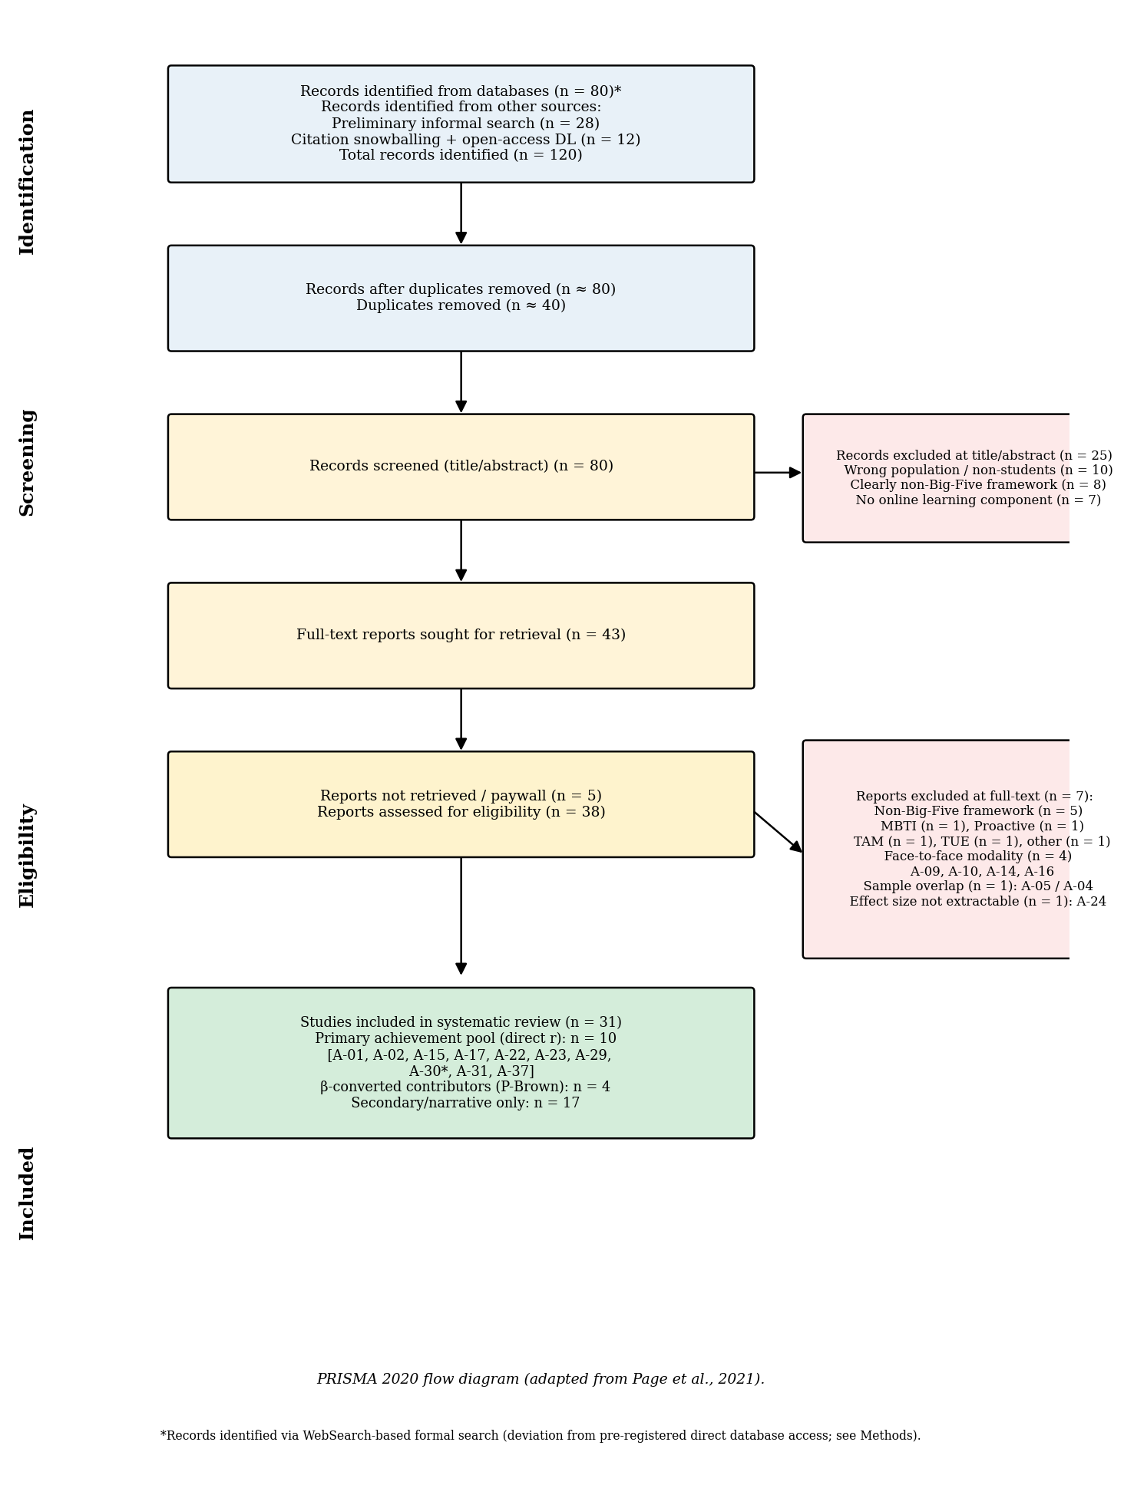
Note. Flow diagram adapted from the PRISMA 2020 statement (Page et al., 2021). Records were identified through WebSearch-based formal search (n = 80 from eight structured queries), preliminary informal search yielding a previously curated corpus (n = 28), and citation snowballing combined with open-access repository downloads (n = 12), for a total of 120 records. After deduplication (n = 40 removed), 80 records underwent title and abstract screening, with 25 excluded primarily for wrong population, non-Big-Five personality frameworks, or no online learning component. Of 43 full-text reports sought, 5 were not retrievable (paywall), and 38 were assessed for eligibility. Eleven reports were excluded at the full-text stage with explicit reasons: non-Big-Five framework (n = 5; MBTI, Proactive Personality, TAM, TUE, and other non-FFM operationalization), face-to-face modality (n = 4; A-09 Bhattacharjee & Ramkumar, 2025; A-10 Boonyapison et al., 2025; A-14 Eilam et al., 2009; A-16 Hidalgo-Fuentes et al., 2024), sample overlap with an already-included study (n = 1; A-05 Audet et al., 2023 overlapped with A-04 Audet et al., 2021), and effect size not extractable (n = 1; A-24 Tlili et al., 2023, lag sequential analysis). The remaining studies, supplemented by four newly identified primary studies (A-29 Bahçekapılı & Karaman, 2020; A-30 Kaspar et al., 2023; A-31 Rivers, 2021; A-37 Zheng & Zheng, 2023), yielded 31 primary studies catalogued in this review (Table 1). Of these, 25 were retained for qualitative synthesis, and 10 contributed direct Pearson correlations or β-converted effect sizes to the primary quantitative achievement pool (with two studies — A-28 Yu, 2021 and A-30 Kaspar et al., 2023 — providing β-converted effect sizes via Peterson and Brown's, 2005, approximation). The remaining 15 retained studies contributed only to secondary-outcome narrative synthesis.

Figure 2
Forest Plot: Conscientiousness and Academic Achievement in Online Learning Environments
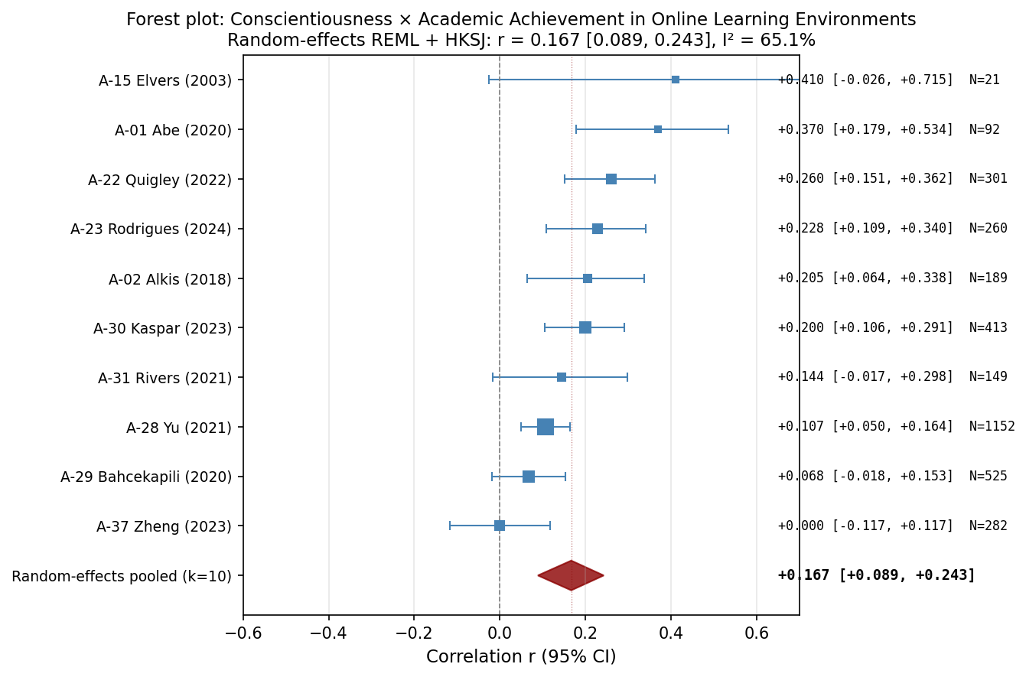
Note. Forest plot of study-level Pearson correlations between Conscientiousness and academic achievement in online learning environments. Each square represents a study; square size is proportional to the inverse-variance weight. Horizontal bars show 95% confidence intervals. The red diamond represents the random-effects REML pooled estimate with HKSJ 95% confidence interval. Studies are sorted by effect size (descending). See Table 2 for pooled statistics.

Figure 3
Forest Plot: Agreeableness and Academic Achievement in Online Learning Environments
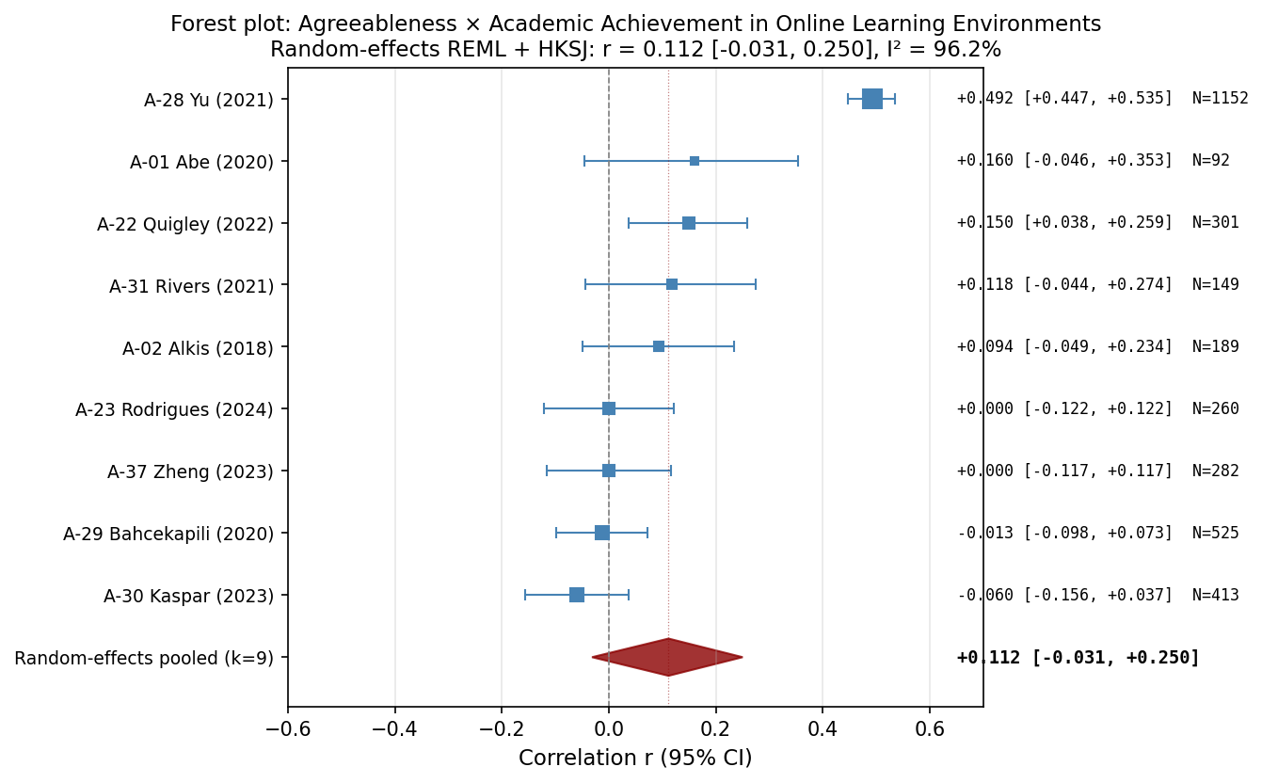
Note. Forest plot of study-level Pearson correlations between Agreeableness and academic achievement in online learning environments. Each square represents a study; square size is proportional to the inverse-variance weight. Horizontal bars show 95% confidence intervals. The red diamond represents the random-effects REML pooled estimate with HKSJ 95% confidence interval. Studies are sorted by effect size (descending). See Table 2 for pooled statistics.

Figure 4
Forest Plot: Openness and Academic Achievement in Online Learning Environments
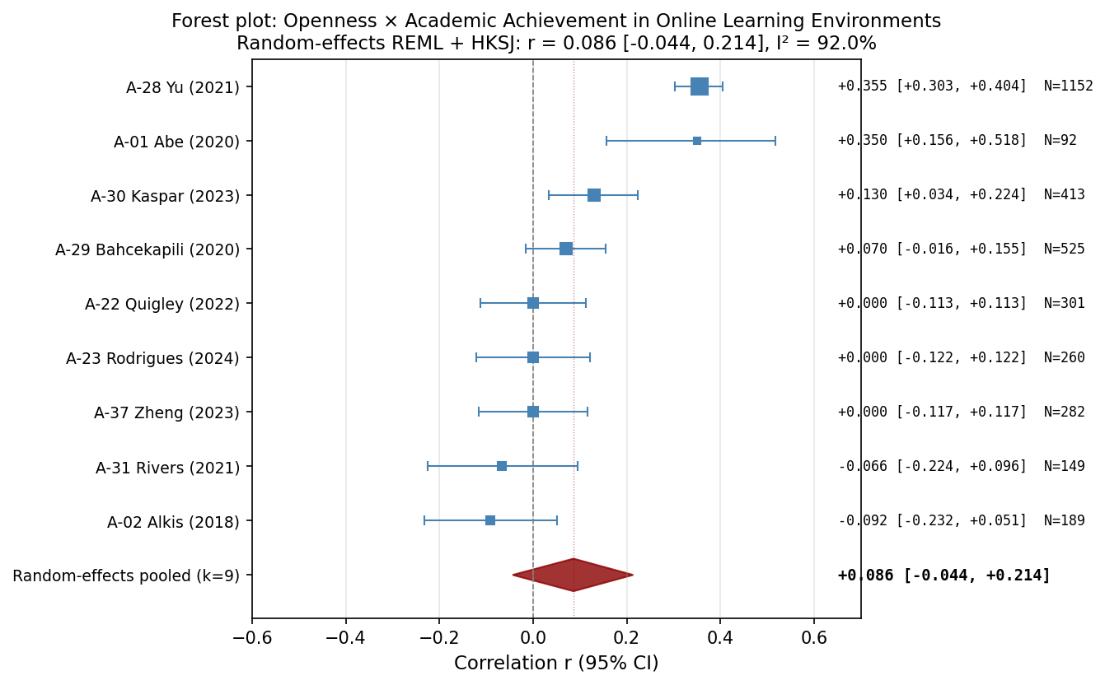
Note. Forest plot of study-level Pearson correlations between Openness and academic achievement in online learning environments. Each square represents a study; square size is proportional to the inverse-variance weight. Horizontal bars show 95% confidence intervals. The red diamond represents the random-effects REML pooled estimate with HKSJ 95% confidence interval. Studies are sorted by effect size (descending). See Table 2 for pooled statistics.

Figure 5
Forest Plot: Neuroticism and Academic Achievement in Online Learning Environments
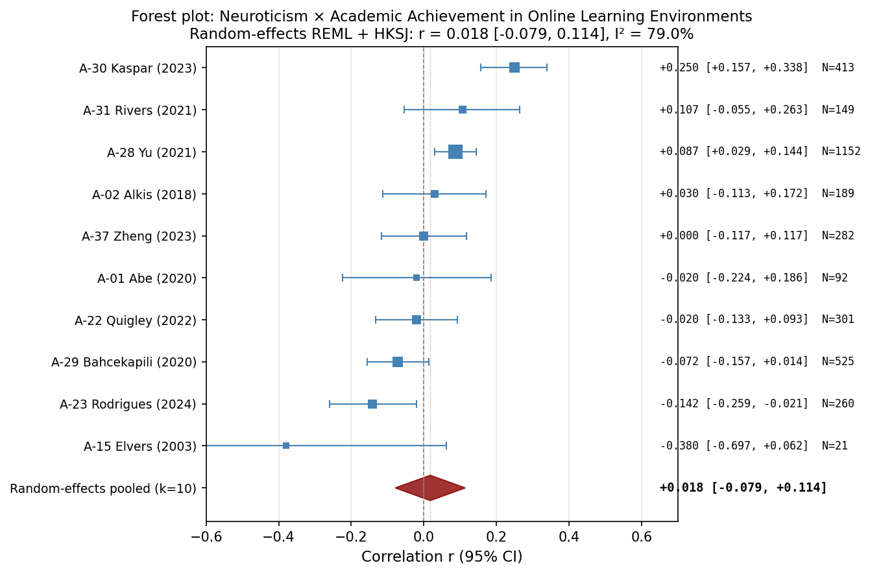
Note. Forest plot of study-level Pearson correlations between Neuroticism and academic achievement in online learning environments. Each square represents a study; square size is proportional to the inverse-variance weight. Horizontal bars show 95% confidence intervals. The red diamond represents the random-effects REML pooled estimate with HKSJ 95% confidence interval. Studies are sorted by effect size (descending). See Table 2 for pooled statistics.

Figure 6
Forest Plot: Extraversion and Academic Achievement in Online Learning Environments
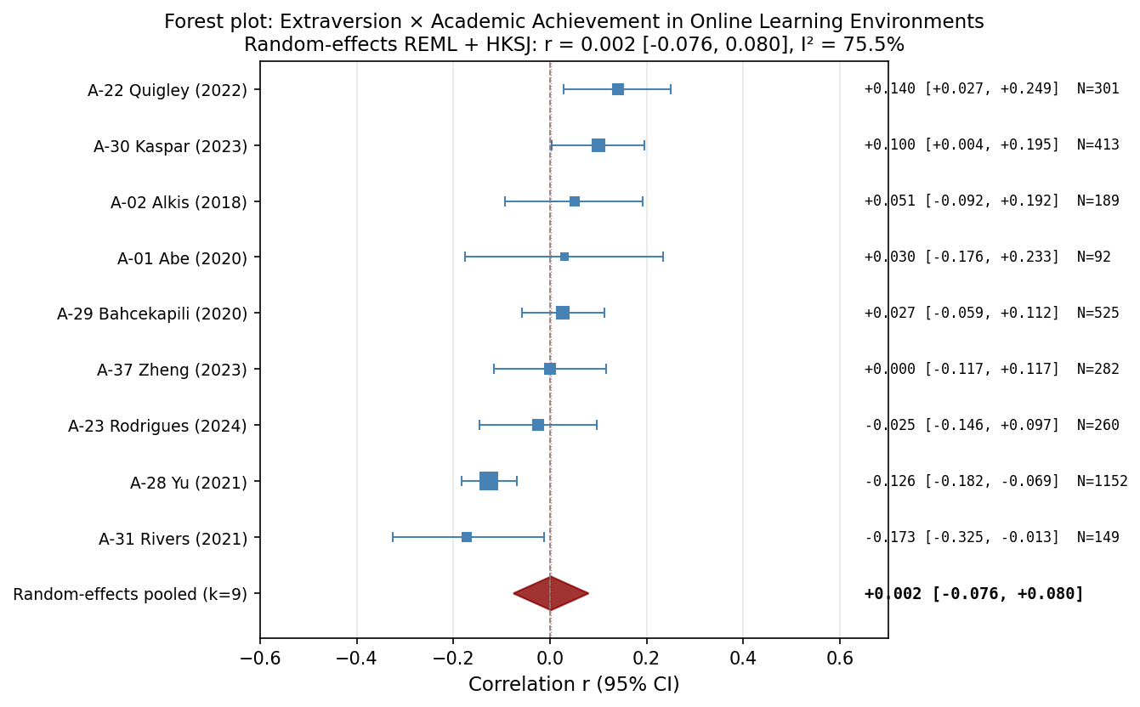
Note. Forest plot of study-level Pearson correlations between Extraversion and academic achievement in online learning environments. Each square represents a study; square size is proportional to the inverse-variance weight. Horizontal bars show 95% confidence intervals. The red diamond represents the random-effects REML pooled estimate with HKSJ 95% confidence interval. Studies are sorted by effect size (descending). See Table 2 for pooled statistics.

Figure 7
Funnel Plot: Conscientiousness and Academic Achievement in Online Learning Environments
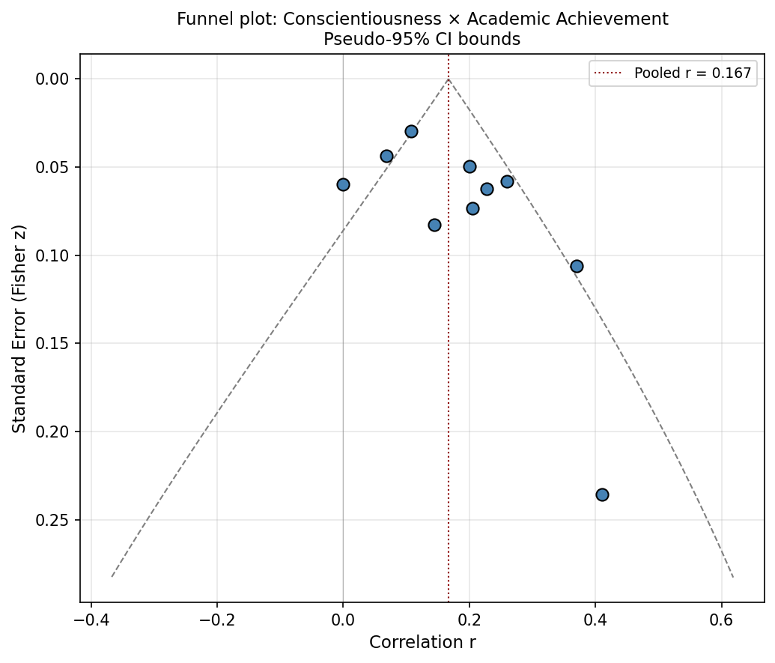
Note. Funnel plot of Pearson correlations between Conscientiousness and academic achievement in online learning environments. Points represent individual studies. The vertical dashed red line indicates the random-effects pooled correlation. Diagonal dashed lines represent pseudo-95% confidence bounds under the assumption of no heterogeneity. Asymmetric dispersion may suggest small-study effects or publication bias. Egger's test results: intercept = 2.14, p = .094. See Table 4 for full publication-bias assessment.

Figure 8
Funnel Plot: Agreeableness and Academic Achievement in Online Learning Environments
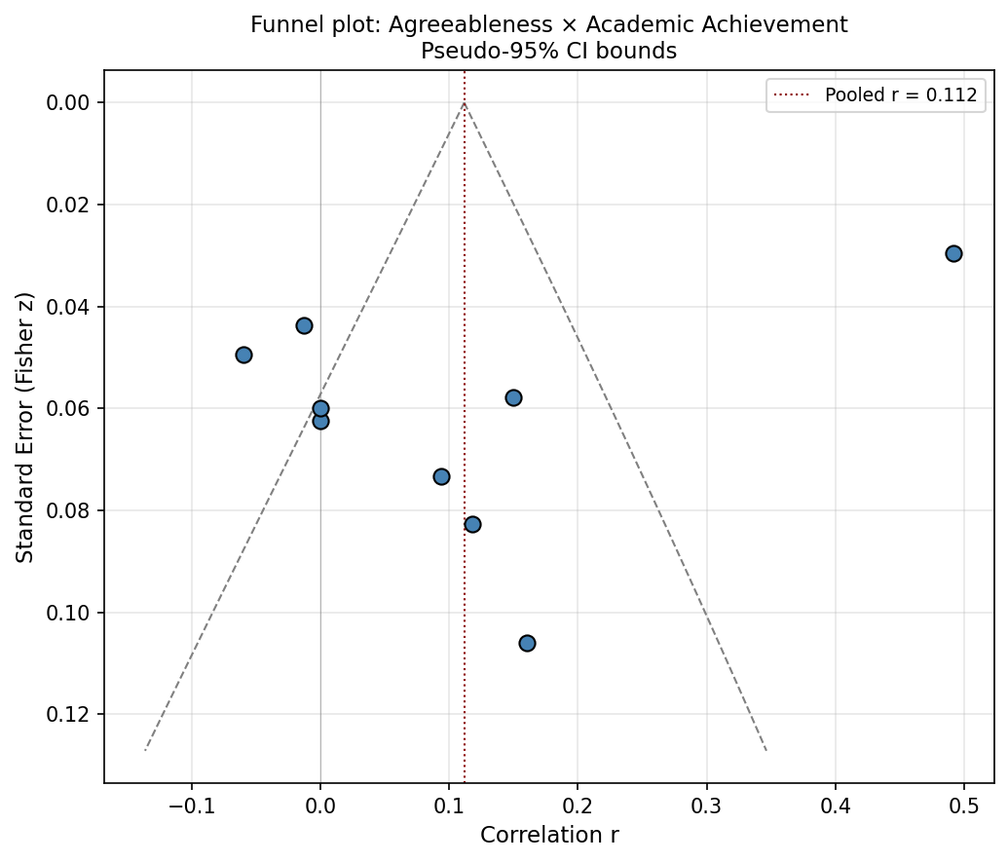
Note. Funnel plot of Pearson correlations between Agreeableness and academic achievement in online learning environments. Points represent individual studies. The vertical dashed red line indicates the random-effects pooled correlation. Diagonal dashed lines represent pseudo-95% confidence bounds under the assumption of no heterogeneity. Asymmetric dispersion may suggest small-study effects or publication bias. Egger's test results: intercept = −8.53, p = .072. See Table 4 for full publication-bias assessment.

Figure 9
Funnel Plot: Openness and Academic Achievement in Online Learning Environments
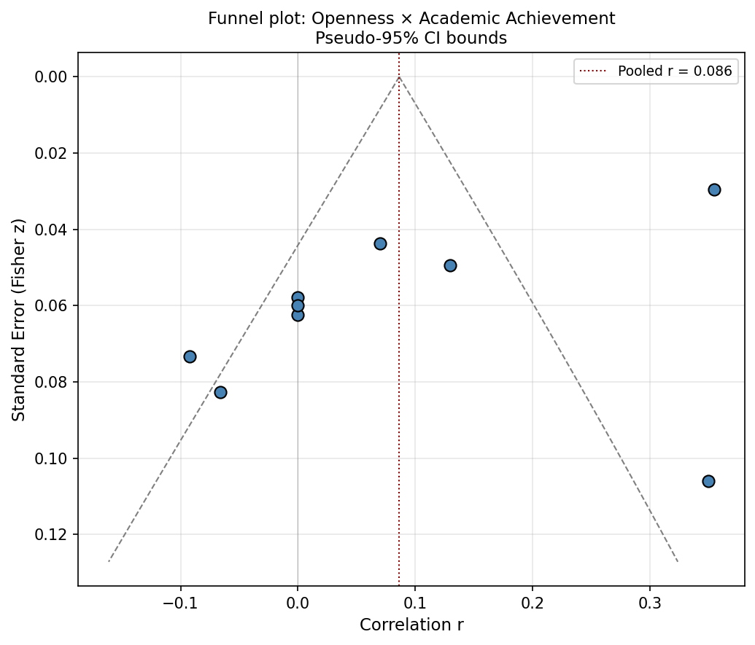
Note. Funnel plot of Pearson correlations between Openness and academic achievement in online learning environments. Points represent individual studies. The vertical dashed red line indicates the random-effects pooled correlation. Diagonal dashed lines represent pseudo-95% confidence bounds under the assumption of no heterogeneity. Asymmetric dispersion may suggest small-study effects or publication bias. Egger's test results: intercept = −6.41, p = .045. See Table 4 for full publication-bias assessment.

Figure 10
Funnel Plot: Neuroticism and Academic Achievement in Online Learning Environments
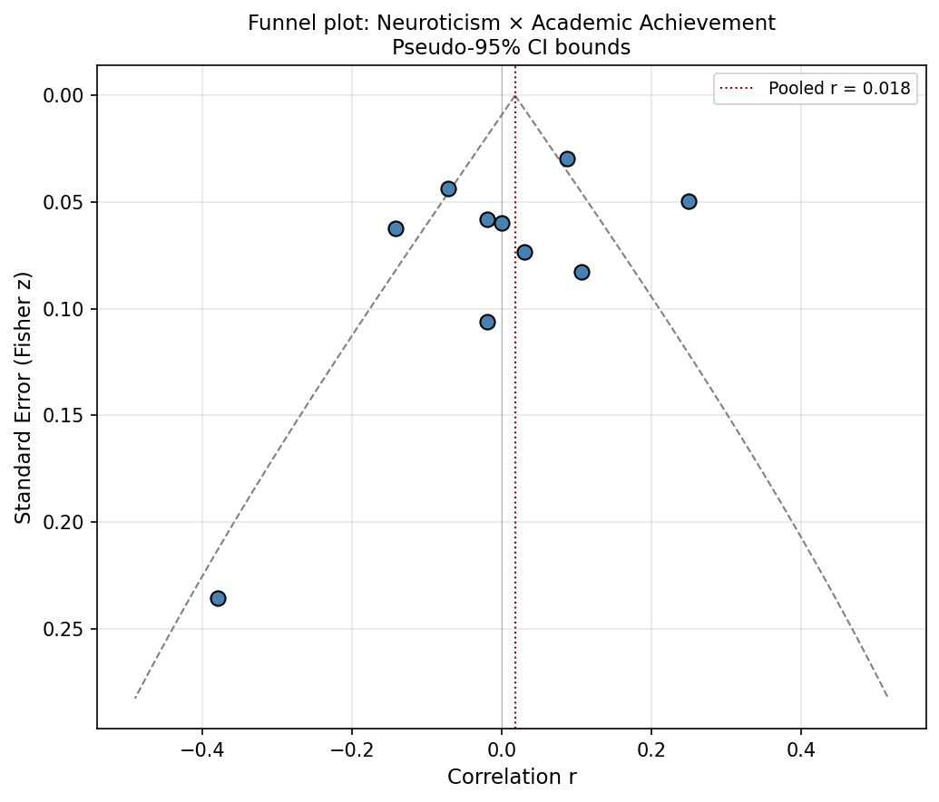
Note. Funnel plot of Pearson correlations between Neuroticism and academic achievement in online learning environments. Points represent individual studies. The vertical dashed red line indicates the random-effects pooled correlation. Diagonal dashed lines represent pseudo-95% confidence bounds under the assumption of no heterogeneity. Asymmetric dispersion may suggest small-study effects or publication bias. Egger's test results: intercept = −1.79, p = .304. See Table 4 for full publication-bias assessment.

Figure 11
Funnel Plot: Extraversion and Academic Achievement in Online Learning Environments
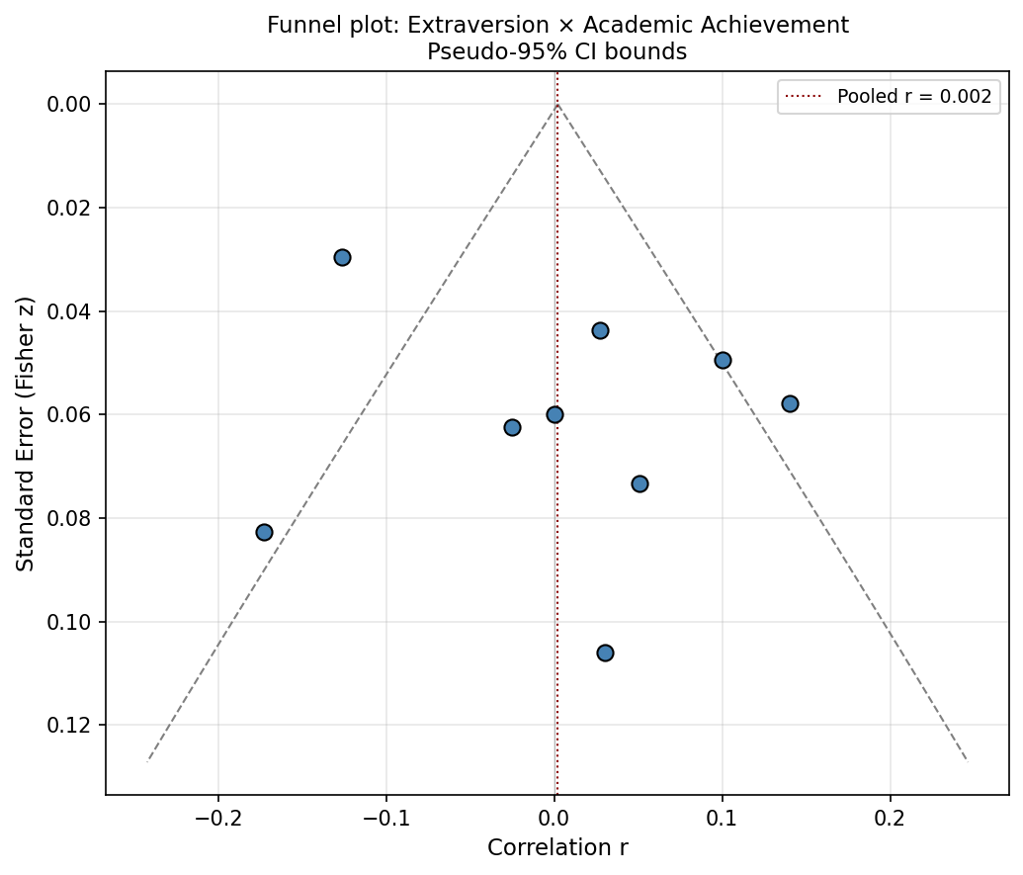
Note. Funnel plot of Pearson correlations between Extraversion and academic achievement in online learning environments. Points represent individual studies. The vertical dashed red line indicates the random-effects pooled correlation. Diagonal dashed lines represent pseudo-95% confidence bounds under the assumption of no heterogeneity. Asymmetric dispersion may suggest small-study effects or publication bias. Egger's test results: intercept = 2.29, p = .255. See Table 4 for full publication-bias assessment.

