Big Five Personality Traits and Academic Achievement in Online Learning Environments: A Scoping Review with Exploratory Quantitative Synthesis

Eisuke Tokiwa
SUNBLAZE Co., Ltd., Tokyo, Japan

Author Note
Eisuke Tokiwa https://orcid.org/0009-0009-7124-6669
The author has no known conflict of interest to disclose beyond that stated in the Declarations section, where a pre-specified sensitivity analysis addresses the author's own potentially eligible primary study. This research received no external funding. The review was pre-registered on OSF Registries (https://doi.org/10.17605/OSF.IO/E5W47), and the extraction data, analysis code, and outputs are openly available at https://github.com/etoki/paper.
Correspondence concerning this article should be addressed to Eisuke Tokiwa, SUNBLAZE Co., Ltd., Tokyo, Japan. Email: eisuke.tokiwa@sunblaze.jp

Declarations
Conflict of Interest
The author declares no financial or personal relationships that could inappropriately influence this work. One of the author's own primary studies (Tokiwa, 2025) met the eligibility criteria and is among the retained studies; it contributed no correlation to the quantitative pool, and a pre-specified sensitivity analysis excluding it is reported.

Funding
This research did not receive any specific grant from funding agencies in the public, commercial, or not-for-profit sectors.

Ethics Approval
Not applicable. This scoping review synthesises previously published research and involved no data collection from human participants by the author; ethical approval for the primary studies was the responsibility of their investigators.

Consent to Participate
Not applicable.

Consent for Publication
Not applicable. This manuscript does not contain any individual person's data in any form (including individual details, images, or videos).

Pre-registration
The protocol was pre-registered on OSF Registries (https://osf.io/e5w47/; DOI: 10.17605/OSF.IO/E5W47) on April 23, 2026. Deviations from it are listed in the Methods.

Data Availability Statement
The extraction file (data_extraction_populated.csv), the search log, the reading notes, the analysis code, and the outputs behind every table and figure are openly available at https://github.com/etoki/paper (folder metaanalysis). The completed PRISMA-ScR checklist is provided as supplementary material.

Declaration of Generative AI Use
The author used a large language model (Claude, Anthropic) throughout this project: to support the literature search and the summarising of candidate reports, to write and run the Python analysis code, and to draft and edit the manuscript text. All inclusion decisions and extracted values were checked by the author against the full texts, and the author takes full responsibility for the content. Two analysis errors in an earlier version (an incorrect β-to-r conversion and an inappropriate subgroup test) were introduced in AI-generated code and were corrected for this version; the corrected estimators were checked against an independent implementation (PyMARE).

Authors' contributions
The author (ET) conceived and designed the review, developed the search strategy and eligibility criteria, ran the searches, screened and extracted the studies, performed the statistical analyses, and drafted and revised the manuscript. The author approves the final version.

Acknowledgments
The author thanks the investigators of the included primary studies for reporting their correlation matrices, and the developers of NumPy, SciPy, Matplotlib, PyMARE, and python-docx.

Abstract
Meta-analyses of the Big Five personality traits and academic achievement have pooled face-to-face, blended, and online samples without examining online learning separately. This pre-registered scoping review maps the evidence for online, blended, and MOOC settings and adds an exploratory quantitative synthesis. Because the pre-registered subscription databases (PsycINFO, Scopus, Web of Science, ProQuest Dissertations) could not be accessed, the search used a web search engine, ERIC, open-access repositories, and citation snowballing, and the review follows PRISMA-ScR. Of 31 catalogued full-text reports, 25 studies were retained, and 10 contributed trait–achievement correlations to random-effects meta-analyses (REML, Hartung-Knapp-Sidik-Jonkman; N = 3,384). Conscientiousness showed a small positive association (r = .168, 95% CI [.090, .245]) that held in all sensitivity analyses but was somewhat below face-to-face benchmarks. Agreeableness (r = .116, [−.020, .248]), Openness (r = .085, [−.044, .211]), Neuroticism (r = .016, [−.080, .112]), and Extraversion (r = .010, [−.059, .080]) were small and imprecise, and the Agreeableness and Openness estimates depended on a single study. Exploratory moderator tests (Knapp–Hartung meta-regression) suggested a lower Extraversion estimate in the two Asian studies and a higher one for self-rated outcomes, but each contrast rests on two studies per subgroup, and the contrasts overlap with each other and with asynchronous delivery. All prediction intervals included zero. The review's contribution is a map of the evidence and its gaps — no comprehensive database search, few K-12 or Asian samples, and almost no facet-level or modality-contrast data — rather than an established effect size. The estimates should not be used as a basis for instructional design.

Keywords: Big Five, Five-Factor Model, online learning, e-learning, MOOC, academic achievement, scoping review, PRISMA-ScR

Introduction
Academic performance in higher education has shifted dramatically in the past decade, first through the gradual adoption of learning management systems and massive open online courses, and then, abruptly, through the COVID-19 pandemic, which forced millions of students worldwide into fully online or blended learning environments. As of 2023, a substantial proportion of post-secondary instruction continues to be delivered online or in hybrid modalities, even in contexts where face-to-face teaching is again available. This structural shift raises a fundamental question: do the non-cognitive correlates of academic achievement that were established in face-to-face classrooms retain their correlational validity when instruction is mediated by technology? Personality traits, and in particular the Big Five (Five-Factor Model) dimensions of Conscientiousness, Openness to Experience, Extraversion, Agreeableness, and Neuroticism, are among the most widely studied non-cognitive correlates of academic achievement (Mammadov, 2022; Poropat, 2009). Yet the accumulated meta-analytic evidence, as reviewed below, has been produced almost entirely from samples in which delivery modality is treated as noise rather than as a substantive moderator. The present review is , to the author's knowledge, the first to address this gap quantitatively.

Personality and Academic Achievement in Face-to-Face Contexts
Eight large-scale meta-analyses have established a robust pattern of associations between the Big Five personality traits and academic achievement. Poropat (2009), synthesizing 138 samples and over 70,000 participants, reported a corrected correlation of ρ = .22 between Conscientiousness and academic performance, with smaller but significant effects for Openness (ρ = .12) and Agreeableness (ρ = .07), and essentially null effects for Extraversion (ρ = −.01) and Neuroticism (ρ = .02). These findings were replicated and extended by McAbee and Oswald (2013; k = 57, N = 26,382; C ρ = .26) and by Vedel (2014; k = 21, N = 17,717; C ρ = .26), both restricted to tertiary education. Stajkovic et al. (2018) provided additional evidence that Conscientiousness is associated with academic achievement both directly and indirectly through self-efficacy, with the self-efficacy path carrying a substantial proportion of the Conscientiousness effect (β = .24 to .33).
More recent syntheses have substantially expanded the evidence base. Mammadov (2022), in the largest meta-analysis to date (267 independent samples, N = 413,074), reported a corrected pooled correlation of ρ = .27 for Conscientiousness and ρ = .16 for Openness, and documented a striking cultural moderation effect in which Asian samples showed markedly stronger associations (C ρ = .35; A ρ = .23; N ρ = −.19). Meyer et al. (2023), focusing exclusively on K-12 samples (110 samples, N = 500,218), obtained even larger estimates (C ρ = .24; O ρ = .21) and identified domain specificity as a critical moderator: Openness was substantially stronger for language than for STEM domains, while Conscientiousness effects were larger for grades than for standardized tests. This latter finding was theorized under the Personality-Achievement Saturation Hypothesis (PASH), which posits that the behavioral signals captured by Conscientiousness (e.g., on-task engagement, homework completion) are more visible to teachers assigning grades than to standardized test scorers. Zell and Lesick (2022), in a second-order synthesis of 54 meta-analyses, confirmed the stability of these effects, with academic-specific estimates of C ρ = .28 and E ρ = −.01. Most recently, Chen et al. (2025), examining 84 articles and 370 independent correlations restricted to university students with samples of at least 200 participants, reported somewhat smaller estimates (C r = .206; O r = .081; A r = .082; E r = −.009; N r = −.029), consistent with the idea that stricter methodological inclusion criteria attenuate apparent trait-performance relationships.
A complementary theoretical lens is provided by Trait Activation Theory (Tett & Burnett, 2003), which predicts that stable dispositional traits are expressed behaviourally only when the situation contains cues relevant to that trait. TAT complements PASH by shifting the theoretical question from "why is a trait captured by an outcome measure?" (PASH) to "why is a trait expressed at all in a given learning context?" (TAT). For the present scoping review, TAT motivates three concrete expectations that would otherwise remain descriptive. First, Extraversion should be less strongly associated with academic outcomes in asynchronous online contexts than in face-to-face contexts, because the social and participatory cues that activate extraverted study behaviour (classroom discussion, study groups, in-person feedback) are attenuated in asynchronous formats. Second, Conscientiousness should remain associated with achievement across modalities, because the structured-task cues that activate conscientious study behaviour (deadlines, assessments, syllabi) are preserved in online formats. Third, Agreeableness should be more strongly associated with achievement in online contexts whose formats reward cooperative behaviour (e.g., peer-graded assignments, collaborative MOOCs), particularly in cultural contexts where cooperation is normative. TAT is therefore used, alongside PASH, as the second theoretical anchor for the mapping priors in the present review.
Across these eight meta-analyses, a convergent picture emerges: Conscientiousness is the dominant correlate of academic achievement (ρ = .19 to .28), with Openness serving as a reliable secondary correlate (ρ = .07 to .21). Agreeableness exhibits small positive effects (ρ = .04 to .10), and Extraversion and Neuroticism are generally near zero in academic contexts, although both may show meaningful directional effects under specific moderators. Critically, however, none of these eight meta-analyses has tested learning modality—online, blended, face-to-face, or MOOC—as a moderator. The samples pooled in these syntheses were drawn almost entirely from traditional classroom contexts, or from contexts in which delivery modality was not reported.

The Shift to Online Learning Environments
Online learning environments differ from face-to-face instruction along at least four dimensions that have theoretical implications for the personality-achievement relationship. First, online environments impose heightened self-regulation demands on learners, who must manage their own time, attention, and task sequencing without the physical and social scaffolding provided by a traditional classroom (Broadbent & Poon, 2015). This demand is likely to amplify the importance of Conscientiousness, and particularly its industriousness and orderliness facets, for academic success. Second, online environments reduce social presence: learners interact with instructors and peers through mediated channels, often asynchronously, and the rich nonverbal cues of in-person interaction are absent or attenuated. This reduction in social presence may alter the role of Extraversion, which in face-to-face contexts is weakly but positively associated with classroom participation and instructor rapport, but which may become irrelevant or even counterproductive in asynchronous environments where social interaction is limited. Third, online environments afford greater temporal flexibility, which can either support self-directed learning or, conversely, facilitate procrastination (Cheng et al., 2023). Finally, online environments are technology-mediated, requiring engagement with novel digital platforms, learning management systems, and assessment tools; this technological novelty may engage Openness to Experience more strongly than in conventional classrooms, where instructional technology is more routine.
These four dimensions—self-regulation demands, reduced social presence, temporal flexibility, and technology mediation—motivate specific expectations about how the personality-achievement relationship should differ in online as compared with face-to-face contexts. In particular, if the meta-analytic Conscientiousness effect of approximately ρ = .22–.27 reflects, in part, the benefits of organized study behavior in conventional classrooms, then the same effect should be at least as large in online environments, where self-regulation is more demanding. Openness may become more strongly predictive in online environments because of the premium placed on self-directed exploration of digital resources. Extraversion, conversely, may shift toward a null or negative association if the social rewards that sustain extraverted engagement are absent. Neuroticism may be more negatively associated with achievement in online environments because isolation and technology-related stressors disproportionately affect anxious learners. These expectations are theoretically motivated, but they have not been systematically evaluated against quantitative evidence.

Big Five Personality Traits in Online Learning: Fragmented Evidence
Individual primary studies of the Big Five and academic achievement in online learning have accumulated in substantial numbers since approximately 2018, with a marked acceleration during the COVID-19 pandemic (2020–2022). The preliminary narrative synthesis most closely related to the present review is Hunter et al. (2025), who systematically screened 848 records from 2000 to June 2024 and included 23 primary studies. Their review documented a consistent positive association between Conscientiousness and online achievement (observed in 3 of 5 studies reporting GPA-type outcomes), negative associations with Neuroticism (in 3 of 5 studies), and essentially null associations with Extraversion (in all 5 studies). However, Hunter et al. (2025) explicitly did not pool effect sizes quantitatively, and the level-of-evidence rating for all 23 included studies was Level IV (low strength), precluding inferences about the magnitude or moderators of the observed associations.
Examining the primary literature directly reveals considerable heterogeneity in reported effect sizes. In fully online asynchronous contexts, Abe (2020) reported strong correlations between Conscientiousness and both quiz performance (r = .48) and paper grades (r = .37), with Openness also correlated with paper grades (r = .35). Alkış and Taşkaya Temizel (2018), comparing online and blended sections of the same course, found Conscientiousness to correlate with course grades in both modalities (online r = .205; blended r = .244), with other traits exhibiting only null effects. In the COVID-era German higher education context, Rodrigues et al. (2024) reported a moderate negative correlation between Conscientiousness and self-reported GPA (r = −.228 with grades coded such that lower values indicate better performance), and significant negative associations between Neuroticism and study satisfaction and well-being. Rivers (2021), studying Japanese undergraduates in an asynchronous Moodle course (N = 149), reported a direct negative effect of Extraversion on course achievement (β = −.168, p < .01), consistent with the mapping prior that social-cue deprivation in asynchronous environments disadvantages extraverted learners.
Other primary studies reveal patterns that diverge from conventional face-to-face findings. In a large Chinese K-12 sample studied by Wang, Wang, and Li (2023; N = 1,625), Big Five traits were associated with academic achievement only indirectly through online learning engagement, with Conscientiousness (β = .322) and Openness (β = .253) serving as the strongest correlates of engagement. Yu (2021), in a Chinese MOOC platform sample (N = 1,152), reported that Agreeableness (β = .442) and Openness (β = .305) were stronger correlates of objective MOOC composite scores than Conscientiousness (β = .057), suggesting that cooperative behaviors and novelty orientation may be especially salient in Chinese collectivistic contexts (cf. Mammadov, 2022; Chen et al., 2025). Bahçekapılı and Karaman (2020), in a Turkish distance-education context (N = 525), found that all five Big Five traits exhibited non-significant direct correlations with GPA, with their effects fully mediated through self-efficacy and external locus of control.
In aggregate, this primary literature suggests that the Conscientiousness-achievement link observed in face-to-face contexts is generally preserved in online settings, but that (a) the magnitude of the effect varies widely across samples, (b) the role of Extraversion may shift in theoretically predictable directions when social cues are attenuated, and (c) Openness and Agreeableness effects may be amplified in specific cultural or disciplinary contexts. However, these primary studies vary substantially in sample composition, modality (fully online, blended, synchronous, asynchronous, MOOC), measurement instruments (BFI, BFI-2, BFI-S, NEO-FFI, IPIP, HEXACO, TIPI), outcome operationalizations (GPA, course grades, standardized exams, LMS behavior, composite scores), and era (pre-COVID, COVID, post-COVID). Without a quantitative synthesis, it is not possible to determine whether these apparent heterogeneities reflect true moderator effects, sampling noise, or methodological artifacts.

Potential Moderators of the Personality-Achievement Association in Online Contexts
Several moderators are theoretically and empirically motivated for the present review. First, learning modality itself—fully online, blended, MOOC, synchronous online, asynchronous online—may moderate the personality-achievement association because the four dimensions of online learning identified above vary in intensity across modalities. Second, education level (K-12, undergraduate, graduate, adult) has been shown to moderate personality-achievement relationships in face-to-face contexts (Mammadov, 2022; Meyer et al., 2023), with Openness effects declining across the educational trajectory while Conscientiousness effects remain stable; whether this pattern holds in online contexts is unknown. Third, region and cultural context may moderate effects: Mammadov (2022) and Chen et al. (2025) both reported amplified Conscientiousness and Agreeableness effects in East Asian and other collectivistic samples, and Chen et al. (2025) additionally reported that Extraversion is significantly negative in individualistic contexts but null in collectivistic contexts. Fourth, the COVID-19 era may constitute a meaningful moderator: pre-COVID online learning was typically self-selected and involved learners with strong motivation for online study, whereas COVID-era online learning was imposed on all learners regardless of preference, and post-COVID online learning reflects a mixture of voluntary and mandatory adoption. Fifth, the choice of personality instrument (BFI, NEO-FFI, IPIP, HEXACO, TIPI) has been shown by McAbee and Oswald (2013) to moderate Conscientiousness estimates, with short-form instruments (e.g., Mini-Markers, TIPI) yielding smaller effects; this moderator is particularly relevant for the present review because online studies more frequently use short-form instruments than traditional paper-and-pencil contexts.

The Present Study
The present scoping review with exploratory quantitative synthesis is, to the author's knowledge, the first mapping of the association between Big Five personality traits and academic achievement that focuses specifically on online learning environments. Consistent with PRISMA-ScR convention (Tricco et al., 2018), the review is organised around mapping questions and directional priors rather than around hypothesis tests. Two mapping questions are addressed. First (MQ1), how large is the available pooled estimate of the association between each Big Five trait and academic achievement in online learning environments within the mappable evidence base, and how does this estimate compare with published face-to-face benchmarks? Second (MQ2), does the association vary descriptively across learning modality, education level, region, era, outcome type, and personality instrument within the mappable evidence base? Because the evidence base is small and the executed search is incomplete relative to the pre-registered information-source plan, both mapping questions are addressed descriptively rather than as confirmatory tests. A third question, whether mediators such as self-efficacy account for the associations, could not be addressed because too few studies reported mediation models.
Five directional priors, pre-specified in the OSF registration (https://osf.io/e5w47/) as hypotheses, are reframed here as mapping priors (MP1 through MP5) that describe expectations against which the mapped evidence can be compared descriptively. Mapping Prior 1 (MP1) states that Conscientiousness is expected to show the strongest positive pooled correlation with academic achievement in online learning environments, with an expected pooled ρ of .20 to .35, consistent with the face-to-face benchmarks reviewed above and potentially amplified in Asian samples. Mapping Prior 2 (MP2) states that Openness is expected to show the second-strongest positive correlation, potentially stronger than in face-to-face contexts, reflecting the premium placed on self-directed exploration in online environments. Mapping Prior 3 (MP3) states that Agreeableness is expected to show a small positive correlation, potentially weaker than in face-to-face contexts because cooperative group behaviors are less central in asynchronous online environments. Mapping Prior 4 (MP4) states that Neuroticism is expected to show a negative correlation, more pronounced in fully online than in blended modalities, reflecting the isolating and technology-mediated nature of fully online environments. Mapping Prior 5 (MP5) states that Extraversion is expected to show a null or weak negative correlation, with possible facet-level cancellation between sociability (expected negative) and assertiveness (expected positive) components, reflecting the reduced social presence of online environments. Mapping Priors MP2, MP4, and MP5 constitute the modality-specific contribution of this review, as they describe expected modality-related divergences from established patterns observed in face-to-face meta-analyses; the review evaluates the available evidence descriptively against these priors rather than performing formal hypothesis tests.
Because the mapped evidence is limited, agreement or disagreement with a prior is descriptive: a small pooled estimate shows that the evidence is compatible with no difference from face-to-face samples, not that the two settings are equivalent. Within those limits, the review is, to the author's knowledge, the first attempt to examine whether personality relates to achievement differently in online learning, and it identifies the primary studies that are still missing.

Methods

Pre-registration and Reporting Standards
The protocol was pre-registered on OSF Registries (https://osf.io/e5w47/; DOI: 10.17605/OSF.IO/E5W47) on April 23, 2026, before the formal search and the quantitative synthesis, using the OSF Preregistration template with content structured according to PRISMA-P 2015 (Moher et al., 2015). The protocol was written for a systematic review and meta-analysis; because the pre-registered bibliographic databases could not be searched (see Information Sources), the work is reported as a scoping review with an exploratory quantitative synthesis, following the PRISMA extension for scoping reviews (PRISMA-ScR; Tricco et al., 2018). The completed PRISMA-ScR checklist is provided as supplementary material. All departures from the protocol are listed in Deviations from the Pre-registered Protocol.

Eligibility Criteria
Eligibility was defined using the PICOS (Population, Intervention/Exposure, Comparator, Outcome, Study design) framework. Studies were included if they satisfied all of the following criteria. Population: students at any educational level—K-12, undergraduate, graduate, or adult learner—enrolled in an online learning environment. No geographic or demographic restrictions were applied to participants, provided that samples comprised at least 10 learners. Exposure: Big Five or HEXACO personality traits measured with a validated inventory, including the Big Five Inventory (BFI, BFI-2, BFI-44, BFI-S), the NEO Personality Inventory–Revised (NEO-PI-R) or NEO Five-Factor Inventory (NEO-FFI, NEO-FFI-3), the International Personality Item Pool (IPIP, including Mini-IPIP), the HEXACO Personality Inventory–Revised (HEXACO-PI-R, HEXACO-60), the Ten-Item Personality Inventory (TIPI, TIPI-J), or any peer-reviewed Big Five–aligned scale with published reliability. Measures based on typological frameworks (e.g., Myers-Briggs Type Indicator) or on single-trait constructs (e.g., Grit, Proactive Personality) not mappable to the Five-Factor Model were excluded. Comparator: not applicable, because the synthesis addresses observational correlational associations rather than group-comparison designs. Outcome: the primary outcome was academic achievement, operationalized as grade point average (GPA), course grade, standardized exam score, or composite learning performance score. Studies reporting only secondary outcomes (academic satisfaction, engagement, learning-related behaviors, persistence) were retained for the narrative map but not pooled. Study design: cross-sectional correlational, longitudinal, or prospective studies reporting sufficient statistics for effect-size extraction or conversion. Qualitative-only studies, commentaries, editorials, narrative reviews, and single-case studies were excluded, although the reference lists of narrative reviews were hand-searched for primary studies.
Studies were restricted to those published in English, in peer-reviewed journals, peer-reviewed conference proceedings, or graduate theses. Unpublished manuscripts and preprints that had not undergone peer review were excluded. No restriction was placed on publication year. Studies of fully face-to-face samples with no online learning component were excluded. When a study's modality was ambiguous, it was classified from the full text; corresponding authors were not contacted (see Deviations).

Information Sources and Search Strategy
Scoping reviews map the available evidence on a topic — its breadth, conceptual boundaries, methodological characteristics, and gaps — rather than aiming for an exhaustive synthesis of every relevant primary study (Munn et al., 2018; Tricco et al., 2018). The protocol pre-registered a six-database search (PubMed/MEDLINE, PsycINFO, ERIC, Web of Science, Scopus, and ProQuest Dissertations & Theses Global), supplemented by Google Scholar and citation snowballing. PsycINFO, Scopus, Web of Science, and ProQuest Dissertations require institutional subscriptions that were not available to the author, and programmatic access to the open databases was blocked in the computing environment used. The executed search therefore consisted of: (a) a web search engine search run on April 23, 2026, applying the pre-specified three-concept strategy split into eight queries; (b) the ERIC web interface; (c) targeted retrieval from open-access repositories (PubMed Central, Frontiers, MDPI, Open Praxis); and (d) forward and backward citation snowballing from included primary studies and from the eight prior face-to-face Big Five–achievement meta-analyses that form the comparison corpus. This search is sufficient to map the visible literature but not to claim exhaustive coverage, which is why the review is reported as a scoping review. The search log with the executed queries, dates, and hit counts is available in the project repository (https://github.com/etoki/paper, file metaanalysis/search_log.md).
The search strategy combined three concept blocks with the Boolean operator AND. Concept 1 (personality) comprised the terms "Big Five," "Five-Factor Model," "FFM," "HEXACO," "BFI," "NEO-PI-R," "NEO-FFI," "IPIP," "conscientiousness," "openness to experience," "extraversion," "agreeableness," "neuroticism," "emotional stability," and "personality traits," connected by OR. Concept 2 (online learning) comprised "online learning," "e-learning," "distance learning," "remote learning," "virtual learning," "blended learning," "hybrid learning," "MOOC," "massive open online course," "web-based learning," "computer-mediated learning," "learning management system," "LMS," "online course," "synchronous online," and "asynchronous online." Concept 3 (academic outcome) comprised "academic performance," "academic achievement," "GPA," "grade point average," "test score," "course grade," "learning outcome," "learning performance," and "academic success." Because a web search engine does not support the full Boolean syntax, the strategy was split into eight shorter queries. Language and publication-type filters were applied during screening.
Forward citation tracking (cited-by) and backward citation tracking (reference list scanning) were performed for the studies identified as eligible and for the eight benchmark meta-analyses that constitute the face-to-face comparison corpus (Poropat, 2009; McAbee & Oswald, 2013; Vedel, 2014; Stajkovic et al., 2018; Mammadov, 2022; Zell & Lesick, 2022; Meyer et al., 2023; Chen et al., 2025). The reference list of the most directly relevant narrative review (Hunter et al., 2025) was also hand-searched.

Study Selection
One reviewer (ET) screened titles and abstracts and then assessed full texts against the eligibility criteria, with assistance from a large language model in locating and summarising candidate reports (see the Declaration of Generative AI Use); every inclusion decision was made by the author from the full text. Records were not managed in a reference manager, and the number of records excluded at each screening stage was not logged. Every full-text report that was catalogued received a recorded decision and, where excluded, a reason (Table 1). The pre-registered intra-rater reliability checks (re-screening a random subsample after a wash-out interval) were not carried out (see Deviations).

Data Extraction
Data were extracted by the same reviewer into a pre-specified extraction form covering study identification (author, year, DOI, journal, country), sample characteristics (analytic N, gender composition, education level), learning context (modality, era), personality measurement (instrument and item count), outcome measurement, and effect-size statistics (Pearson r or standardised β with the associated sample size). The completed extraction file (data_extraction_populated.csv) is available in the project repository. The pre-registered re-extraction of a random 10% of studies was not carried out, and authors were not contacted for missing statistics (see Deviations). When a statistic was missing, the effect size was converted from an alternative statistic where possible (see below) or the study was left out of the trait pool with the reason recorded.

Risk of Bias Assessment
Risk of bias for each included study was assessed using the Joanna Briggs Institute (JBI) Critical Appraisal Checklist for Analytical Cross-Sectional Studies (Moola et al., 2017), which comprises eight items: (1) clearly defined inclusion criteria for the sample, (2) detailed description of study subjects and setting, (3) valid and reliable measurement of exposure (the personality inventory), (4) objective and standardized measurement of the outcome, (5) identification of confounding factors, (6) strategies to address confounding, (7) valid and reliable measurement of the outcome, and (8) appropriate statistical analysis. Each item was rated as Yes, No, or Unclear, and an aggregate score from 0 to 8 was computed, with higher scores indicating lower risk of bias. The aggregate score was used to define the low-quality exclusion sensitivity analysis (score < 5). The ratings were made by the single reviewer and were not re-assessed (see Deviations).

Effect Size Metric and Transformations
The effect-size metric was the Pearson correlation (r) between each Big Five trait and the academic achievement outcome. Each r was transformed to Fisher's z (Borenstein et al., 2009), z = 0.5 × ln[(1 + r) / (1 − r)], with sampling variance Var(z) = 1 / (N − 3), where N is the analytic sample size. All pooling, moderator regression, and confidence-interval construction were performed on the Fisher z scale, and pooled values were back-transformed to r for reporting.
Two kinds of non-standard effect size entered the pool. First, 2 studies (A-28, A-30) reported standardised regression coefficients (β) rather than correlations. These were converted with the rule of Peterson and Brown (2005), r = .98β + .05λ, where λ = 1 if β ≥ 0 and λ = 0 if β < 0, and were flagged for a sensitivity analysis that excludes them. Second, one study (A-37 Zheng & Zheng, 2023) reported only that every trait–grade correlation was below .10 in absolute value; these correlations were entered as r = 0, and a sensitivity analysis excludes the study. The pre-specified conversions from Cohen's d, η², t, and F were not needed because no included study reported only those statistics.
For primary studies that reported Emotional Stability rather than Neuroticism, the sign of the correlation was reversed so that all effect sizes in the Neuroticism pool were oriented toward higher Neuroticism; outcomes on which lower values indicate better performance were sign-reversed in the same way. The protocol also specified a HEXACO-to-Big-Five crosswalk (Ashton & Lee, 2007) with an accompanying sensitivity analysis; no HEXACO study contributed to the quantitative pool, so neither was applied.

Statistical Analysis and Synthesis Strategy
A separate random-effects meta-analysis was estimated for each Big Five trait. Because each trait was pooled separately and each study contributed a single effect size per trait, the effect sizes within a pool were independent. The between-study variance (τ²) was estimated by restricted maximum likelihood (REML), and 95% confidence intervals for the pooled effect used the Hartung-Knapp-Sidik-Jonkman (HKSJ) adjustment with a t distribution on k − 1 degrees of freedom (IntHout et al., 2014). Heterogeneity was quantified with Cochran's Q, I², and τ², and 95% prediction intervals were computed on k − 2 degrees of freedom (Higgins et al., 2009). Effect-size magnitudes were interpreted against the benchmarks of Gignac and Szodorai (2016): r ≈ .10 small, r ≈ .20 typical, and r ≈ .30 large.

Moderator and Sensitivity Analyses
Nine moderators were pre-specified: six categorical (learning modality, education level, region, era, outcome type, personality instrument) and three continuous (publication year, log sample size, risk-of-bias score). Only three categorical moderators had at least two contributing studies in each of at least two levels: region (Asia vs. non-Asia), era (pre-COVID vs. COVID), and outcome type (objective vs. self-rated achievement). Each of these was tested within each trait with a mixed-effects meta-regression on the level indicators (REML residual τ²) using the Knapp–Hartung adjustment, F(levels − 1, k − levels) (Knapp & Hartung, 2003; Viechtbauer et al., 2015), over the levels with k ≥ 2. As pre-registered, p-values were Holm-corrected (Holm, 1979) within each trait; the family comprised the three moderators that could be tested. Subgroup pooled estimates are also reported for each level. The other six moderators are described narratively.
The pooled estimates were re-estimated (a) excluding studies with a risk-of-bias score below 5; (b) excluding the author's own prior primary study (Tokiwa, 2025); (c) excluding the effect sizes converted from β; (d) excluding studies with an analytic sample below 50; (e) removing each study in turn (leave-one-out); and (f) with the DerSimonian–Laird estimator of τ² in place of REML. All six were pre-registered. A seventh analysis, not pre-registered, (g) excluded A-37 Zheng and Zheng (2023), whose correlations were entered as r = 0. A change of |Δr| > .05 was treated as potentially influential.

Publication Bias
Small-study effects were examined per trait with funnel plots, Egger's regression test (Egger et al., 1997), and Duval and Tweedie's (2000) trim-and-fill procedure with the L0 estimator. The side on which studies were imputed was chosen from the sign of the slope in a REML meta-regression of the effect sizes on their standard errors, and the centre was re-estimated on the trimmed set at each iteration (the procedure of metafor's trimfill). These diagnostics have little power at k = 9–10 (Sterne et al., 2011), so they are reported descriptively: a non-significant Egger test does not show that bias is absent, and trim-and-fill estimates are a sensitivity check, not a correction. The pre-registered Peters' test and p-curve analysis were not carried out (see Deviations).

Completeness-of-Evidence Mapping (adapted from GRADE)
Confidence in each pooled association was summarised with an adaptation of the GRADE framework (Schünemann et al., 2019), used here as a completeness-of-evidence map rather than a formal certainty rating. Each trait started at High and was lowered one level for each serious and two levels for each very serious concern in five domains: risk of bias (serious if the mean JBI score of the contributing studies was below 5), inconsistency (serious if I² exceeded 50%, very serious if it exceeded 75%), indirectness (population, exposure, or outcome relative to the review question), imprecision (serious if the 95% confidence interval included both zero and a value of |r| ≥ .10, or was wider than .20), and publication bias (serious if Egger's test was significant, if trim-and-fill changed the estimate by more than .05, or if the search could not be comprehensive).

Deviations from the Pre-registered Protocol
The executed review departed from the pre-registered protocol (DOI 10.17605/OSF.IO/E5W47) in the following ways. (1) Search: the six pre-registered databases were not searched; the executed search is described under Information Sources. (2) Review process: the pre-registered intra-rater reliability checks (re-screening 10% of titles and abstracts and 20% of full texts, re-extracting 10% of studies, and re-rating 20% of risk-of-bias assessments after a wash-out interval) were not carried out, and corresponding authors were not contacted for missing statistics or modality information. (3) Records: the numbers of records identified, de-duplicated, and excluded at title and abstract screening were not logged, so the flow diagram reports them as approximate. (4) Dependent effect sizes: robust variance estimation (Tipton, 2015) and three-level models were planned on the assumption that studies would contribute several effect sizes to one pool; because each trait was pooled separately with one effect size per study, neither was needed. (5) Moderators: six of the nine pre-registered moderators could not be tested; the Holm correction was therefore applied over the three moderators that were tested. The pre-registered subgroup Q_between test was replaced by a Knapp–Hartung meta-regression, because a χ² test on subgroup standard errors is unreliable with two to eight studies per subgroup (Viechtbauer et al., 2015). (6) Sensitivity: the HEXACO crosswalk analysis was not applicable, and an analysis excluding the study entered as r = 0 was added. (7) Publication bias: Peters' test and p-curve analysis (Simonsohn et al., 2014) were not carried out; the pool contains too few statistically significant primary estimates for a meaningful p-curve. (8) Software: the analyses were run in Python rather than in R with metafor. (9) Framing: the review is reported as a scoping review under PRISMA-ScR rather than as a systematic review and meta-analysis under PRISMA 2020. In addition, a benchmark meta-analysis published after registration (Chen et al., 2025) was added to the face-to-face comparison corpus.
The six moderators that could not be tested quantitatively are described here for orientation only. (a) Personality instrument: the Big Five Inventory family predominated among the retained studies; NEO, IPIP, HEXACO, and TIPI instruments each appeared in three or fewer studies. Within the quantitative pool, Conscientiousness correlations from BFI-family instruments ranged from .068 (Bahçekapılı & Karaman, 2020) to .370 (Abe, 2020), the NEO-FFI study gave .410 (Elvers et al., 2003, N = 21), and the two 10-item TIPI studies gave .144 (Rivers, 2021) and 0, the value entered for Zheng and Zheng (2023). (b) Publication year: the retained studies span 2003–2025, concentrated in 2020–2023. (c) Sample size: in the Conscientiousness pool the largest samples (e.g., Yu, 2021, N = 1,152; Bahçekapılı & Karaman, 2020, N = 525) gave smaller correlations than the smallest ones (Abe, 2020, N = 92; Elvers et al., 2003, online subsample N = 21), a pattern compatible with small-study effects that Egger's test did not detect (intercept = 2.16, p = .091). (d) Risk-of-bias score: excluding the studies scoring below 5 changed the Conscientiousness estimate by +.016 (Table 4). (e) Modality: one retained study used an engagement scale that was not specific to online learning (A-13 Dang et al., 2025), one contributed separate online and blended subsamples (A-02 Alkış & Taşkaya Temizel, 2018), and A-37 Zheng and Zheng (2023) pooled graduate cohorts taught face to face before and after the pandemic and online during it. (f) Education level: the two retained K-12 studies (A-25 Tokiwa, 2025; A-26 Wang et al., 2023) did not report trait–achievement correlations, so the quantitative pool contains no K-12 sample.

Software and Reproducibility
All analyses were run in Python 3.11 with NumPy and SciPy; figures were drawn with Matplotlib. REML τ² estimates, Knapp–Hartung moderator tests, and DerSimonian–Laird estimates were checked against the independent implementations in PyMARE, and agreed to within 10⁻⁷. The analysis code, the extraction file, the search log, and the outputs behind every table and figure are openly available at https://github.com/etoki/paper (folder metaanalysis/analysis), so every number in this paper can be reproduced.

Results

Study Selection
Figure 1 summarises the selection process. The executed search returned about 80 records from the eight web queries, alongside 28 primary studies already known from preliminary searching and five benchmark meta-analyses whose reference lists were screened. The numbers of duplicates and of records excluded at title and abstract screening were not logged. From the full-text stage onward the counts are exact: 37 reports were sought, one could not be retrieved (A-27), 36 were assessed, and 11 were excluded (no Big Five measure, 5; face-to-face only, 4: A-09, A-10, A-14, A-16; sample overlap with A-04, 1: A-05; no extractable effect size, 1: A-24), leaving 25 studies. Table 1 catalogues 31 of the 37 reports, namely the retained studies and the exclusions with study identifiers; the five reports without a Big Five measure (Myers-Briggs types, proactive personality, technology-acceptance or use-intention constructs, and digital competencies) and A-14 Eilam et al. (2009) are documented in the reading notes. Of the 25 retained studies, 10 contributed correlations between personality and achievement to the quantitative pool (8 direct, 2 converted from β); the other 15 reported only secondary outcomes (13) or no extractable trait–achievement correlation (2: A-25 Tokiwa, 2025; A-26 Wang et al., 2023).

Characteristics of Included Studies
Table 1 lists the 31 catalogued studies. The 25 retained studies were published between 2003 and 2025, about half of them during the COVID-19 period (2020–2022). Analytic sample sizes ranged from 47 (Elvers et al., 2003) to 1,625 (Wang et al., 2023), with a median of 260. The 10 studies in the quantitative pool comprised 3,384 participants (k = 10 for Conscientiousness and Neuroticism; k = 9 for Openness, Extraversion, and Agreeableness, because A-15 Elvers et al. reported only Conscientiousness and Neuroticism).
Of the 25 retained studies, 24 were conducted in fully online settings; the remaining study (A-13 Dang et al., 2025) used an engagement scale that was not specific to online learning. Few studies stated whether instruction was synchronous or asynchronous. By education level, 15 studies sampled undergraduates, 5 mixed undergraduate and graduate students, 2 graduate students, 2 K-12 students, and 1 mixed secondary and post-secondary students. By region, 12 were from Asia (including Middle Eastern samples), 7 from Europe, and 6 from North America; within the quantitative pool only two studies were Asian (A-28 Yu, 2021, China; A-31 Rivers, 2021, Japan). By period, 8 studies were pre-COVID, 12 from the COVID period, 4 post-COVID, and 1 (A-37 Zheng & Zheng, 2023) pooled cohorts from all three periods.
The Big Five Inventory family was the most common instrument; the others were NEO-FFI, IPIP and Mini-IPIP, HEXACO-PI-R, the 10-item TIPI and TIPI-J, and other Big Five scales, including Chinese-language scales and McCrae's scale used by Yu (2021). In the quantitative pool, achievement was measured as GPA or course grade (A-01, A-02, A-23, A-29, A-31, A-37), an introductory psychology exam (A-15), a MOOC platform composite (A-28), or self-rated performance (A-22, A-30). In the other retained studies, the only outcomes were satisfaction, engagement, preference, or perception; these were not pooled.

Risk of Bias Across Included Studies
Risk-of-bias scores for each study are given in Table 1. Across the 25 retained studies the mean JBI score was 5.44 (SD = 0.87, range 4–7); 21 studies scored 5 or more and 4 scored below 5 (A-06, A-12, A-21, A-37). Within the quantitative pool, the only study below 5 was A-37 (score 4); the pool's mean was 5.80.

Exploratory Pooled Effect Sizes
Table 2 gives the pooled estimates, and Figures 2 to 6 show the forest plots.
Conscientiousness. The pooled correlation was positive (k = 10, N = 3,384, r = .168, 95% CI [.090, .245], 95% PI [−.039, .362]; Q(9) = 25.74, p = .002, I² = 65.0%, τ² = .007). It was the largest of the five traits, in line with Mapping Prior 1, but below that prior's expected range (ρ = .20–.35) and below the face-to-face benchmarks of ρ = .19–.28 (Poropat, 2009; McAbee & Oswald, 2013; Vedel, 2014; Mammadov, 2022; Meyer et al., 2023; Chen et al., 2025). Its confidence interval excluded zero, but its prediction interval did not.
Openness to Experience. The pooled correlation was small and its confidence interval included zero (k = 9, N = 3,363, r = .085, 95% CI [−.044, .211], 95% PI [−.293, .440]; Q(8) = 96.80, p < .001, I² = 91.7%, τ² = .024). Mapping Prior 2, which expected Openness to be the second-largest positive association, was not supported. Heterogeneity was very high: the converted MOOC estimate of Yu (2021; r = .349) and the asynchronous Moodle estimate of Rivers (2021; r = −.066) lie at the two ends of the distribution.
Extraversion. The pooled correlation was close to zero (k = 9, N = 3,363, r = .010, 95% CI [−.059, .080], 95% PI [−.165, .185]; Q(8) = 21.90, p = .005, I² = 63.5%, τ² = .005), consistent with Mapping Prior 5, which expected a null or weakly negative association. The negative estimates came from the two Asian studies (Rivers, 2021, r = −.173; Yu, 2021, r = −.074, converted from β = −.076).
Agreeableness. The pooled correlation was small and its confidence interval included zero (k = 9, N = 3,363, r = .116, 95% CI [−.020, .248], 95% PI [−.309, .502]; Q(8) = 189.85, p < .001, I² = 95.8%, τ² = .030). Mapping Prior 3, which expected a weaker association than in face-to-face samples (ρ = .05–.10), was not supported, but the estimate depends heavily on one study: removing Yu (2021; r = .483, converted from β = .442) changes the pooled r to .045 (Δr = −.071). Heterogeneity was extreme.
Neuroticism. The pooled correlation was close to zero (k = 10, N = 3,384, r = .016, 95% CI [−.080, .112], 95% PI [−.246, .276]; Q(9) = 41.93, p < .001, I² = 78.5%, τ² = .012), so Mapping Prior 4, which expected a negative association, was not supported. Study-level signs were mixed: Rodrigues et al. (2024) reported r = −.142 and Bahçekapılı and Karaman (2020) r = −.072, whereas the two converted estimates were positive (Yu, 2021, r = .086; Kaspar et al., 2023, r = .246). Without the converted estimates the pooled r was −.035 (95% CI [−.107, .037]).

Between-Study Heterogeneity
Heterogeneity was substantial for every trait, with I² from 63.5% (Extraversion) to 95.8% (Agreeableness). All five 95% prediction intervals included zero; for Agreeableness the interval spanned [−.309, .502]. A new online study could therefore find an association of quite different size, or even of opposite sign.

Moderator Analyses
Three moderators could be tested: region (Asia vs. non-Asia), era (pre-COVID vs. COVID), and outcome type (objective vs. self-rated achievement). Table 3 gives the subgroup estimates and tests. Every contrast has two studies in its smaller subgroup, so the tests have little power and the subgroup estimates are imprecise.
Region. With two Asian studies (A-28 Yu, China; A-31 Rivers, Japan) against seven or eight non-Asian studies, the Extraversion estimate was lower in the Asian subgroup (r = −.095, 95% CI [−.541, .393]) than in the non-Asian subgroup (r = .050, [−.004, .104]); F(1, 7) = 12.94, p = .009, Holm-adjusted p = .026. The Agreeableness estimate was higher in the Asian subgroup (r = .319, [−.979, .994], vs. .038, [−.029, .105]; F(1, 7) = 9.13, p = .019, Holm-adjusted p = .058), but the two Asian studies disagree sharply (r = .483 and .118). The meta-regression assumes a common residual variance, so this contrast is not interpretable. The other three traits did not differ by region (all p ≥ .34).
Era. No trait differed between pre-COVID and COVID-period studies (all p ≥ .27). For Conscientiousness, the estimates were .221 before and .180 during the pandemic. The post-COVID period could not be tested, because no post-COVID study contributed a trait–achievement correlation.
Outcome type. The Extraversion estimate was close to zero for objective outcomes (k = 7, r = −.028, [−.090, .035]) and positive for self-rated performance (k = 2, r = .116, [−.143, .361]); F(1, 7) = 9.01, p = .020, Holm-adjusted p = .040. The other traits did not differ by outcome type (all p ≥ .19).
These contrasts overlap. Both Asian studies used objective outcomes and asynchronous delivery, and both self-rated studies were European (A-22 Quigley et al., 2022; A-30 Kaspar et al., 2023). The region and outcome-type differences for Extraversion therefore rest on the same few studies and cannot be separated from each other or from modality.

Sensitivity Analyses
Table 4 summarises the sensitivity analyses. Excluding the author's own study (Tokiwa, 2025) changed nothing, because it contributed no correlation to the pool. The DerSimonian–Laird estimator changed every pooled estimate by .001 or less. Excluding studies with N < 50 (A-15 Elvers et al.) changed the estimates by at most .011. Excluding the only study below the risk-of-bias threshold (A-37 Zheng & Zheng), which is also the study whose correlations were entered as r = 0, raised every estimate slightly (Conscientiousness +.016; largest change .016). Excluding the two studies whose effects were converted from β (A-28 Yu; A-30 Kaspar) changed the estimates by more than .05 for Openness, Agreeableness, and Neuroticism (Openness to .026, Agreeableness to .057, Neuroticism to −.035); Conscientiousness stayed positive (.181, [.073, .284]).
In the leave-one-out analysis, the Conscientiousness estimate ranged from .152 to .185. The most influential single study was Yu (2021) for Agreeableness (r = .045 without it; Δr = −.071), Openness (.042; Δr = −.044), and Extraversion (.029; Δr = +.019), and Kaspar et al. (2023) for Neuroticism (−.010; Δr = −.026).

Publication-Bias Diagnostics (descriptive only)
Funnel plots are shown in Figures 7 to 11. Egger's test was significant for Openness (intercept = −6.27, SE = 2.60, t(7) = −2.42, p = .046) and not for Conscientiousness (intercept = 2.16, p = .091), Agreeableness (intercept = −8.29, p = .066), Neuroticism (intercept = −1.78, p = .302), or Extraversion (intercept = 1.27, p = .454). With k = 9–10 the test has little power, so the non-significant results do not show that bias is absent.
Trim-and-fill imputed studies for Conscientiousness, 2 on the left (adjusted r = .149, [.064, .231]); Openness, 1 on the right (adjusted r = .106, [−.017, .226]); Agreeableness, 3 on the right (adjusted r = .180, [.061, .294]); Neuroticism, 1 on the right (adjusted r = .027, [−.075, .128]), and none for Extraversion. The Conscientiousness estimate remained positive after imputation. The Agreeableness adjustment moved the estimate upward and its interval above zero, which reflects the influence of Yu (2021) on the funnel rather than evidence of a larger true effect. These adjusted values are a sensitivity check, not corrected estimates.

Completeness-of-Evidence Summary
Table 5 summarises the confidence ratings. The Conscientiousness association was rated Low: its confidence interval excluded zero and it was robust to the sensitivity analyses, but heterogeneity was substantial and the search was not comprehensive. The Extraversion estimate was also rated Low, because its confidence interval was narrow around zero. The Openness, Agreeableness, and Neuroticism estimates were rated Very Low, because of very high heterogeneity, imprecision, and the incomplete search.

Discussion

Summary of Findings
This scoping review mapped the evidence on the Big Five traits and academic achievement in online learning. Of 31 catalogued studies, 25 were retained and 10 contributed to an exploratory quantitative pool (N = 3,384). Conscientiousness was the only trait with a clearly positive association (r = .168, 95% CI [.090, .245]), and it held up in every sensitivity analysis. The estimates for Agreeableness (r = .116, [−.020, .248]), Openness (r = .085, [−.044, .211]), Neuroticism (r = .016, [−.080, .112]), and Extraversion (r = .010, [−.059, .080]) were small, with confidence intervals that included zero. The Agreeableness and Openness estimates depended heavily on one converted study (Yu, 2021). Exploratory subgroup contrasts suggested a lower Extraversion estimate in the two Asian studies (F(1, 7) = 12.94, Holm-adjusted p = .026) and a higher one for self-rated outcomes (F(1, 7) = 9.01, Holm-adjusted p = .040). These contrasts rest on the same two-study subgroups and cannot be separated from one another.

Evaluation of the Mapping Priors
Mapping Prior 1 (Conscientiousness as the strongest positive correlate) was supported in rank: r = .168 was the largest estimate. It fell below the prior's expected range (.20–.35) and below the face-to-face benchmarks of Poropat (2009; ρ = .22), McAbee and Oswald (2013; ρ = .26), Vedel (2014; ρ = .26), Mammadov (2022; ρ = .27), and Chen et al. (2025; r = .206). The upper limit of its confidence interval reached that range.
Mapping Prior 2 (Openness as the second-strongest positive correlate) was not supported: r = .085 was smaller than both the Conscientiousness and the Agreeableness estimate, and its confidence interval included zero. One possible reason is that the pool is almost entirely undergraduate, and Openness effects are known to weaken with educational level (Mammadov, 2022; Meyer et al., 2023).
Mapping Prior 3 (Agreeableness weaker than in face-to-face samples) was not supported in direction: r = .116 was slightly above the face-to-face range of .05–.10. This estimate rests largely on Yu (2021); without that study it is .045, close to the face-to-face range. Narrative evidence from studies outside the pool (Wang et al., 2023; Baruth & Cohen, 2023) points in the same direction for East Asian and Israeli samples, but this does not offset the single-study dependence.
Mapping Prior 4 (Neuroticism negative, more so in fully online courses) was not supported: r = .016. Without the two converted estimates the pooled r was −.035 (95% CI [−.107, .037]), negative in direction but still compatible with zero. The fully online versus blended comparison could not be made, because only one study (Alkış & Taşkaya Temizel, 2018) reported a blended subsample.
Mapping Prior 5 (Extraversion null or weakly negative) was supported: r = .010, [−.059, .080]. The proposed mechanism, in which a negative sociability facet cancels a positive assertiveness facet, could not be tested, because few studies report facets.

Theoretical Implications
The Conscientiousness estimate is somewhat below the face-to-face benchmarks. This is consistent with an extension of the Personality-Achievement Saturation Hypothesis (PASH; Meyer et al., 2023) proposed here: if Conscientiousness reaches grades partly through behaviour that teachers observe, online courses with automated grading and less observation should weaken that channel. The extension is the author's proposal, not part of the original PASH. Trait Activation Theory (Tett & Burnett, 2003) makes a different prediction: the cues that activate conscientious study — deadlines, assessments, milestones — are preserved online, so the association should be preserved too. The present data cannot tell these accounts apart. The gap from the benchmarks (Δr ≈ .02–.11, depending on the benchmark) is small, the confidence interval reaches the benchmark range, and the confidence rating is Low.
For Extraversion, the near-zero pooled estimate matches the face-to-face literature at the tertiary level (Poropat, 2009; Chen et al., 2025). The subgroup contrasts suggest that the estimate may be lower in some contexts, but they rest on two Asian studies and two self-rated studies, and these subgroups overlap with one another and with asynchronous delivery. Several explanations fit equally well: that extraverts are disadvantaged in collectivistic online contexts with few social channels, that self-rated performance carries an extraversion-linked self-enhancement bias (Paulhus, 1998), that asynchronous delivery removes the social cues that activate extraverted engagement (Tett & Burnett, 2003), or that the difference reflects the particular samples and instruments of four studies. Testing these explanations needs primary studies that vary one factor at a time, such as studies that collect objective and self-rated outcomes from the same learners.
The Agreeableness contrast by region does not support a cultural interpretation. The two Asian studies give very different estimates (r = .483 and .118), so the Asian subgroup has no meaningful pooled value. The higher Agreeableness estimates reported for Asian face-to-face samples (Mammadov, 2022; Chen et al., 2025) remain a hypothesis for online learning.
Finally, no trait differed between pre-COVID and COVID-period studies. In particular, the expectation that emergency remote teaching would increase the importance of Conscientiousness was not borne out. Post-COVID studies did not report correlations, so later updates should revisit this question.

Hypotheses for Future Practical Testing
The following hypotheses follow from the map but are not recommendations. The pool is small, heterogeneity is substantial, and the subgroup contrasts rest on two studies per subgroup. Each hypothesis needs to be tested in adequately powered primary research before it informs instructional design.
HPT-1. Conscientiousness is the only trait whose confidence interval excludes zero. Online features that scaffold self-regulated learning — scheduling tools, progress tracking, deadline reminders — may therefore be most useful for learners low in Conscientiousness.
HPT-2. If the Extraversion contrasts reflect missing social channels, adding synchronous elements to asynchronous courses should help extraverted learners. If they reflect self-enhancement, self-rated performance should be checked against objective indicators. A study that varies delivery mode and collects both outcome types in the same learners could test both.
HPT-3. The Openness estimate is small. Exploration-oriented features of institutional learning platforms (supplementary multimedia, flexible navigation) may not translate into achievement for high-Openness learners under standardised online assessment.

Distinguishing Robust from Fragile Findings
The positive Conscientiousness association is the most robust result: r = .168, with a confidence interval that excludes zero. It ranged from .152 to .185 when each study was removed in turn, stayed positive without the converted estimates (.181) and after trim-and-fill (.149), and matches the direction of all eight face-to-face meta-analyses. Its prediction interval still includes zero ([−.039, .362]).
Everything else is fragile: (i) the Agreeableness and Openness estimates, which depend on Yu (2021) and change by more than .05 without the converted studies; (ii) the Neuroticism estimate, which changes sign without the converted studies; (iii) the Extraversion region and outcome-type contrasts, which rest on two studies per subgroup and overlap with each other and with modality; and (iv) the Agreeableness region contrast, which is not interpretable. The hypotheses above that depend on these results should be weighted accordingly.

Strengths of the Present Review
This is, to the author's knowledge, the first attempt to map the Big Five–achievement evidence specifically for online learning. None of the prior face-to-face meta-analyses examined learning modality (Chen et al., 2025; Mammadov, 2022; McAbee & Oswald, 2013; Meyer et al., 2023; Poropat, 2009; Stajkovic et al., 2018; Vedel, 2014; Zell & Lesick, 2022), and the closest review of online studies did not pool effect sizes (Hunter et al., 2025). The protocol was pre-registered, and every deviation from it is reported. The extraction file, analysis code, and outputs are public, the key estimators were checked against an independent implementation, and the robustness of each estimate was examined with seven sensitivity analyses.

Limitations
First, the quantitative pool is small (k = 10: 8 studies with direct correlations, including one entered as r = 0, and 2 converted from β). With so few studies the pooled estimates are unstable, heterogeneity is poorly estimated, and every moderator contrast has two studies in its smaller subgroup. Second, the search did not cover the pre-registered bibliographic databases. A web search engine, ERIC's web interface, open-access repositories, and citation snowballing cannot be assumed to find every eligible study, so the map is not an exhaustive census. The record counts at the identification and screening stages were not logged, so the flow diagram is approximate before the full-text stage.
Third, one reviewer did all screening, extraction, and risk-of-bias rating, with assistance from a large language model, and the pre-registered intra-rater reliability checks were not carried out. Single-reviewer work is vulnerable to inclusion and coding errors that a second reviewer would catch. Analysis errors were also found during revision: an incorrect β-to-r conversion and an inappropriate subgroup test in earlier versions were corrected for this version. Fourth, three effect sizes rest on assumptions: two are converted from β, and one study (A-37 Zheng & Zheng, 2023) reported only that its correlations were below .10 and pooled cohorts taught face to face before and after the pandemic with an online cohort during it. The sensitivity analyses show how much each choice matters.
Fifth, the English-language restriction excluded potentially relevant Chinese-, Japanese-, Korean-, and Spanish-language studies, which matters most for the regional contrasts. Sixth, outcomes ranged from objective grades and exam scores to self-rated performance, which adds heterogeneity. Seventh, the author's own primary study (Tokiwa, 2025) was among the retained studies; it contributed no correlation to the pool, and excluding it changed nothing. Eighth, facet-level analysis was not possible because few studies report facets.

Future Research Directions
The most useful next step is a replication search of the pre-registered bibliographic databases (including PsycINFO, Scopus, and Web of Science) with record-level logging and a second reviewer, which would allow a systematic review proper. Primary studies are needed that (a) compare the same learners in asynchronous and synchronous conditions, (b) collect objective and self-rated outcomes together, (c) report facet-level correlations with hierarchical inventories such as the BFI-2 or NEO-PI-R, (d) sample K-12 and Asian online learners, and (e) report zero-order correlations for all five traits, including non-significant ones. Mediators such as self-efficacy, self-regulated learning, and platform engagement would clarify the pathways (Stajkovic et al., 2018). Longitudinal designs across the pre-, during-, and post-COVID periods, such as Zheng and Zheng (2023), would help separate period effects from sampling.
Discipline is a further candidate moderator. The retained studies span psychology, education, computing, health sciences, business, and general education, with only one to three studies per discipline in the quantitative pool. Future syntheses should record discipline as a categorical extraction field and test whether the Conscientiousness and Extraversion associations differ between more and less structured disciplines and between formats with more or less peer interaction.

Conclusion
This scoping review found a small but robust positive association between Conscientiousness and academic achievement in online learning (r = .168, 95% CI [.090, .245]), somewhat below face-to-face benchmarks. Associations for the other four traits were small and imprecise, and two of them depended on a single study. The Extraversion subgroup differences by region and outcome type are hypotheses for primary research: they rest on two studies per subgroup and cannot be separated from each other or from delivery mode. The evidence base is small and the search was not exhaustive, so the review's main contribution is a map of what is known and a list of the studies that are missing, not a settled effect size.

References
Abe, J. A. A. (2020). Big five, linguistic styles, and successful online learning. The Internet and Higher Education, 45, 100724. https://doi.org/10.1016/j.iheduc.2019.100724
Alkış, N., & Taşkaya Temizel, T. (2018). The impact of motivation and personality on academic performance in online and blended learning environments. Educational Technology & Society, 21(3), 35–47.
Ashouri, A., Taheri, M., Rasouli, M., & Rouhalamin, S. (2025). Personality traits and e-learning course satisfaction: A study of health science students. Cureus, 17(7), e89131.
Ashton, M. C., & Lee, K. (2007). Empirical, theoretical, and practical advantages of the HEXACO model of personality structure. Personality and Social Psychology Review, 11(2), 150–166. https://doi.org/10.1177/1088868306294907
Audet, É. C., Levine, S. L., Dubois, P., Koestner, S., & Koestner, R. (2023). The unanticipated virtual year: How the Big 5 personality traits of openness to experience and conscientiousness impacted engagement in online classes during the COVID-19 crisis. Journal of College Reading and Learning, 53(4), 298–315. https://doi.org/10.1080/10790195.2023.2250402
Audet, É. C., Levine, S. L., Metin, E., Koestner, S., & Barcan, S. (2021). Zooming their way through university: Which Big 5 traits facilitated students' adjustment to online courses during the COVID-19 pandemic. Personality and Individual Differences, 180, 110969. https://doi.org/10.1016/j.paid.2021.110969
Bahçekapılı, E., & Karaman, S. (2020). A path analysis of five-factor personality traits, self-efficacy, academic locus of control and academic achievement among online students. Knowledge Management & E-Learning, 12(2), 191–208. https://doi.org/10.34105/j.kmel.2020.12.010
Baruth, O., & Cohen, A. (2023). Personality and satisfaction with online courses: The relation between the Big Five personality traits and satisfaction with online learning activities. Education and Information Technologies, 28, 879–904. https://doi.org/10.1007/s10639-022-11199-x
Bhagat, K. K., Wu, L. Y., & Chang, C. Y. (2019). The impact of personality on students' perceptions towards online learning. Australasian Journal of Educational Technology, 35(4), 98–108. https://doi.org/10.14742/ajet.4162
Bhattacharjee, R. R., & Ramkumar, A. (2025). Effect of big five personality dimensions on the academic performance of college students. Frontiers in Psychology, 16, 1490427. https://doi.org/10.3389/fpsyg.2025.1490427
Boonyapison, K., Sittironnarit, G., & Rattanaumpawan, P. (2025). Association between the big five personalities and academic performance among grade 12 students at international high school in Thailand. Scientific Reports, 15, 16484. https://doi.org/10.1038/s41598-025-01038-7
Borenstein, M., Hedges, L. V., Higgins, J. P. T., & Rothstein, H. R. (2009). Introduction to meta-analysis. John Wiley & Sons.
Broadbent, J., & Poon, W. L. (2015). Self-regulated learning strategies & academic achievement in online higher education learning environments: A systematic review. The Internet and Higher Education, 27, 1–13. https://doi.org/10.1016/j.iheduc.2015.04.007
Chen, S., Cheung, A. C. K., & Zeng, Z. (2025). Big Five personality traits and university students' academic performance: A meta-analysis. Personality and Individual Differences, 240, 113163. https://doi.org/10.1016/j.paid.2025.113163
Cheng, S.-L., Chang, J.-C., Quilantan-Garza, K., & Gutierrez, M. L. (2023). Conscientiousness, prior experience, achievement emotions and academic procrastination in online learning environments. British Journal of Educational Technology, 54(4), 898–923. https://doi.org/10.1111/bjet.13302
Cohen, A., & Baruth, O. (2017). Personality, learning, and satisfaction in fully online academic courses. Computers in Human Behavior, 72, 1–12. https://doi.org/10.1016/j.chb.2017.02.030
Dang, T., Du, W., Niu, M., & Xu, Z. (2025). The effects of personality traits on learning engagement among college students: The mediating role of emotion regulation. Frontiers in Psychology, 15, 1476437. https://doi.org/10.3389/fpsyg.2024.1476437
Duval, S., & Tweedie, R. (2000). Trim and fill: A simple funnel-plot-based method of testing and adjusting for publication bias in meta-analysis. Biometrics, 56(2), 455–463. https://doi.org/10.1111/j.0006-341x.2000.00455.x
Egger, M., Davey Smith, G., Schneider, M., & Minder, C. (1997). Bias in meta-analysis detected by a simple, graphical test. BMJ, 315(7109), 629–634. https://doi.org/10.1136/bmj.315.7109.629
Eilam, B., Zeidner, M., & Aharon, I. (2009). Student conscientiousness, self-regulated learning, and science achievement: An explorative field study. Psychology in the Schools, 46(5), 420–432. https://doi.org/10.1002/pits.20387
Elvers, G. C., Polzella, D. J., & Graetz, K. (2003). Procrastination in online courses: Performance and attitudinal differences. Teaching of Psychology, 30(2), 159–162. https://doi.org/10.1207/S15328023TOP3002_13
Gignac, G. E., & Szodorai, E. T. (2016). Effect size guidelines for individual differences researchers. Personality and Individual Differences, 102, 74–78. https://doi.org/10.1016/j.paid.2016.06.069
Hidalgo-Fuentes, S., Martínez-Álvarez, I., Llamas-Salguero, F., Pineda-Zelaya, I. S., Merino-Soto, C., & Chans, G. M. (2024). The role of big five traits and self-esteem on academic procrastination in Honduran and Spanish university students: A cross-cultural study. Heliyon, 10(17), e36172. https://doi.org/10.1016/j.heliyon.2024.e36172
Higgins, J. P. T., Thompson, S. G., & Spiegelhalter, D. J. (2009). A re-evaluation of random-effects meta-analysis. Journal of the Royal Statistical Society: Series A (Statistics in Society), 172(1), 137–159. https://doi.org/10.1111/j.1467-985X.2008.00552.x
Holm, S. (1979). A simple sequentially rejective multiple test procedure. Scandinavian Journal of Statistics, 6(2), 65–70.
Hunter, E. G., Niblock, J., Barefoot, S., Miller, J., Hughes, J., Kite, L., & Scarletto, E. (2025). The influence of student personality traits on satisfaction and success in online education in higher education: A systematic review. Journal of Occupational Therapy Education, 9(2), Article 9. https://doi.org/10.26681/jote.2025.090209
IntHout, J., Ioannidis, J. P. A., & Borm, G. F. (2014). The Hartung-Knapp-Sidik-Jonkman method for random effects meta-analysis is straightforward and considerably outperforms the standard DerSimonian-Laird method. BMC Medical Research Methodology, 14, 25. https://doi.org/10.1186/1471-2288-14-25
Kara, A., Ergulec, F., & Eren, E. (2024). The mediating role of self-regulated online learning behaviors: Exploring the impact of personality traits on student engagement. Education and Information Technologies, 29, 23517–23546. https://doi.org/10.1007/s10639-024-12755-3
Kaspar, K., Burtniak, K., & Rüth, M. (2023). Online learning during the Covid-19 pandemic: How university students' perceptions, engagement, and performance are related to their personal characteristics. Current Psychology. Advance online publication. https://doi.org/10.1007/s12144-023-04403-9
Keller, H., & Karau, S. J. (2013). The importance of personality in students' perceptions of the online learning experience. Computers in Human Behavior, 29(6), 2494–2500. https://doi.org/10.1016/j.chb.2013.06.007
Knapp, G., & Hartung, J. (2003). Improved tests for a random effects meta-regression with a single covariate. Statistics in Medicine, 22(17), 2693–2710. https://doi.org/10.1002/sim.1482
MacLean, K. A. (2022). Endorsed, or just enforced? Personality and preferences for online learning during COVID-19 [Master's thesis, University of Calgary]. PRISM Repository.
Mammadov, S. (2022). Big Five personality traits and academic performance: A meta-analysis. Journal of Personality, 90(2), 222–255. https://doi.org/10.1111/jopy.12663
McAbee, S. T., & Oswald, F. L. (2013). The criterion-related validity of personality measures for predicting GPA: A meta-analytic validity competition. Psychological Assessment, 25(2), 532–544. https://doi.org/10.1037/a0031748
Meyer, J., Jansen, T., Hübner, N., & Lüdtke, O. (2023). Disentangling the association between the Big Five personality traits and student achievement: Meta-analytic evidence on the role of domain specificity and achievement measures. Educational Psychology Review, 35, Article 12. https://doi.org/10.1007/s10648-023-09736-2
Moher, D., Shamseer, L., Clarke, M., Ghersi, D., Liberati, A., Petticrew, M., Shekelle, P., Stewart, L. A., & PRISMA-P Group. (2015). Preferred reporting items for systematic review and meta-analysis protocols (PRISMA-P) 2015 statement. Systematic Reviews, 4(1), 1. https://doi.org/10.1186/2046-4053-4-1
Moola, S., Munn, Z., Tufanaru, C., Aromataris, E., Sears, K., Sfetcu, R., Currie, M., Qureshi, R., Mattis, P., Lisy, K., & Mu, P.-F. (2017). Chapter 7: Systematic reviews of etiology and risk. In E. Aromataris & Z. Munn (Eds.), Joanna Briggs Institute Reviewer's Manual. The Joanna Briggs Institute.
Munn, Z., Peters, M. D. J., Stern, C., Tufanaru, C., McArthur, A., & Aromataris, E. (2018). Systematic review or scoping review? Guidance for authors when choosing between a systematic or scoping review approach. BMC Medical Research Methodology, 18, 143. https://doi.org/10.1186/s12874-018-0611-x
Mustafa, S., Qiao, Y., Yan, X., Anwar, A., Hao, T., & Rana, S. (2022). Digital students' satisfaction with and intention to use online teaching modes, role of Big Five personality traits. Frontiers in Psychology, 13, 956281. https://doi.org/10.3389/fpsyg.2022.956281
Nakayama, M., Mutsuura, K., & Yamamoto, H. (2014). Impact of learner's characteristics and learning behaviour on learning performance during a fully online course. Electronic Journal of e-Learning, 12(4), 394–408.
Page, M. J., McKenzie, J. E., Bossuyt, P. M., Boutron, I., Hoffmann, T. C., Mulrow, C. D., Shamseer, L., Tetzlaff, J. M., Akl, E. A., Brennan, S. E., Chou, R., Glanville, J., Grimshaw, J. M., Hróbjartsson, A., Lalu, M. M., Li, T., Loder, E. W., Mayo-Wilson, E., McDonald, S., … Moher, D. (2021). The PRISMA 2020 statement: An updated guideline for reporting systematic reviews. BMJ, 372, n71. https://doi.org/10.1136/bmj.n71
Paulhus, D. L. (1998). Interpersonal and intrapsychic adaptiveness of trait self-enhancement: A mixed blessing? Journal of Personality and Social Psychology, 74(5), 1197–1208. https://doi.org/10.1037/0022-3514.74.5.1197
Peterson, R. A., & Brown, S. P. (2005). On the use of beta coefficients in meta-analysis. Journal of Applied Psychology, 90(1), 175–181. https://doi.org/10.1037/0021-9010.90.1.175
Poropat, A. E. (2009). A meta-analysis of the five-factor model of personality and academic performance. Psychological Bulletin, 135(2), 322–338. https://doi.org/10.1037/a0014996
Quigley, M., Bradley, A., Playfoot, D., & Harrad, R. (2022). Personality traits and stress perception as predictors of students' online engagement during the COVID-19 pandemic. Personality and Individual Differences, 194, 111645. https://doi.org/10.1016/j.paid.2022.111645
Rivers, D. J. (2021). The role of personality traits and online academic self-efficacy in acceptance, actual use and achievement in Moodle. Education and Information Technologies, 26(4), 4353–4378. https://doi.org/10.1007/s10639-021-10478-3
Rodrigues, J., Rose, R., & Hewig, J. (2024). The relation of Big Five personality traits on academic performance, well-being and home study satisfaction in corona times. European Journal of Investigation in Health, Psychology and Education, 14(2), 368–384. https://doi.org/10.3390/ejihpe14020025
Sahinidis, A. G., & Tsaknis, P. A. (2021). Exploring the relationship of the Big Five personality traits with student satisfaction with synchronous online academic learning: The case of Covid-19-induced changes. In A. Kavoura, S. Kefallonitis, & P. Theodoridis (Eds.), Strategic Innovative Marketing and Tourism (pp. 116–130). Springer. https://doi.org/10.1007/978-3-030-66154-0_10
Schünemann, H. J., Higgins, J. P. T., Vist, G. E., Glasziou, P., Akl, E. A., Skoetz, N., & Guyatt, G. H. (2019). Chapter 14: Completing "Summary of findings" tables and grading the certainty of the evidence. In J. P. T. Higgins, J. Thomas, J. Chandler, M. Cumpston, T. Li, M. J. Page, & V. A. Welch (Eds.), Cochrane handbook for systematic reviews of interventions (2nd ed.). John Wiley & Sons.
Simonsohn, U., Nelson, L. D., & Simmons, J. P. (2014). P-curve: A key to the file-drawer. Journal of Experimental Psychology: General, 143(2), 534–547. https://doi.org/10.1037/a0033242
Stajkovic, A. D., Bandura, A., Locke, E. A., Lee, D., & Sergent, K. (2018). Test of three conceptual models of influence of the big five personality traits and self-efficacy on academic performance: A meta-analytic path-analysis. Personality and Individual Differences, 120, 238–245. https://doi.org/10.1016/j.paid.2017.08.014
Sterne, J. A. C., Sutton, A. J., Ioannidis, J. P. A., Terrin, N., Jones, D. R., Lau, J., Carpenter, J., Rücker, G., Harbord, R. M., Schmid, C. H., Tetzlaff, J., Deeks, J. J., Peters, J., Macaskill, P., Schwarzer, G., Duval, S., Altman, D. G., Moher, D., & Higgins, J. P. T. (2011). Recommendations for examining and interpreting funnel plot asymmetry in meta-analyses of randomised controlled trials. BMJ, 343, d4002. https://doi.org/10.1136/bmj.d4002
Tett, R. P., & Burnett, D. D. (2003). A personality trait-based interactionist model of job performance. Journal of Applied Psychology, 88(3), 500–517. https://doi.org/10.1037/0021-9010.88.3.500
Tipton, E. (2015). Small sample adjustments for robust variance estimation with meta-regression. Psychological Methods, 20(3), 375–393. https://doi.org/10.1037/met0000011
Tlili, A., Sun, T., Denden, M., Kinshuk, Graf, S., Fei, C., & Wang, H. (2023). Impact of personality traits on learners' navigational behavior patterns in an online course: A lag sequential analysis approach. Frontiers in Psychology, 14, 1071985. https://doi.org/10.3389/fpsyg.2023.1071985
Tokiwa, E. (2025). Who excels in online learning in Japan? Frontiers in Psychology, 16, Article 1420996. https://doi.org/10.3389/fpsyg.2025.1420996
Tricco, A. C., Lillie, E., Zarin, W., O'Brien, K. K., Colquhoun, H., Levac, D., Moher, D., Peters, M. D. J., Horsley, T., Weeks, L., Hempel, S., Akl, E. A., Chang, C., McGowan, J., Stewart, L., Hartling, L., Aldcroft, A., Wilson, M. G., Garritty, C., … Straus, S. E. (2018). PRISMA Extension for Scoping Reviews (PRISMA-ScR): Checklist and explanation. Annals of Internal Medicine, 169(7), 467–473. https://doi.org/10.7326/M18-0850
Vedel, A. (2014). The Big Five and tertiary academic performance: A systematic review and meta-analysis. Personality and Individual Differences, 71, 66–76. https://doi.org/10.1016/j.paid.2014.07.011
Viechtbauer, W., López-López, J. A., Sánchez-Meca, J., & Marín-Martínez, F. (2015). A comparison of procedures to test for moderators in mixed-effects meta-regression models. Psychological Methods, 20(3), 360–374. https://doi.org/10.1037/met0000023
Wang, P., Wang, F., & Li, Z. (2023). Exploring the ecosystem of K-12 online learning: An empirical study of impact mechanisms in the post-pandemic era. Frontiers in Psychology, 14, 1241477. https://doi.org/10.3389/fpsyg.2023.1241477
Wu, R., & Yu, Z. (2024). Relationship between university students' personalities and e-learning engagement mediated by achievement emotions and adaptability. Education and Information Technologies, 29, 10821–10850. https://doi.org/10.1007/s10639-023-12222-5
Yu, Z. (2021). The effects of gender, educational level, and personality on online learning outcomes during the COVID-19 pandemic. International Journal of Educational Technology in Higher Education, 18, Article 14. https://doi.org/10.1186/s41239-021-00252-3
Zell, E., & Lesick, T. L. (2022). Big five personality traits and performance: A quantitative synthesis of 50+ meta-analyses. Journal of Personality, 90(4), 559–573. https://doi.org/10.1111/jopy.12683
Zheng, Y., & Zheng, S. (2023). Exploring educational impacts among pre, during and post COVID-19 lockdowns from students with different personality traits. International Journal of Educational Technology in Higher Education, 20(1), 21. https://doi.org/10.1186/s41239-023-00388-4

Table 1
Characteristics of the 31 Catalogued Studies and Their Contributions to the Quantitative Synthesis
ID | Author (Year) | N | Country | Mode | Level | Era | Region | Instrument | Outcome | Inclusion | RoB
A-01 | Abe (2020) | 92 | US | Online | UG | pre-COVID | North_America | BFI-44 | course_grade | Pool (r) | 5
A-02 | Alkis (2018) | 189 | Turkey | Online | UG | pre-COVID | Europe | BFI-44 | course_grade | Pool (r) | 6
A-03 | Ashouri (2025) | 183 | Iran | Online | UG | COVID | Asia | BFI-44 | satisfaction | Map only | 5
A-04 | Audet (2021) | 350 | Canada | Online | UG | COVID | North_America | BFI-44 | engagement | Map only | 6
A-05 | Audet (2023) | 678 | Canada | Online | UG | COVID | North_America | BFI-44 | engagement | Exc (overlap) | 6
A-06 | Sahinidis (2021) | 555 | Greece | Online | UG | COVID | Europe | Custom 30-item Big Five | satisfaction | Map only | 4
A-07 | Cohen (2017) | 72 | Israel | Online | Grad | pre-COVID | Asia | BFI-44 Hebrew | satisfaction | Map only | 5
A-08 | Keller (2013) | 250 | US | Online | UG/Grad | pre-COVID | North_America | IPIP-50 | perception | Map only | 5
A-09 | Bhattacharjee (2025) | 384 | India | FtF | UG | post-COVID | Asia | BFI-44 | GPA | Exc (FtF) | 4
A-10 | Boonyapison (2025) | 203 | Thailand | FtF | K-12 | post-COVID | Asia | BFI-44 | GPA | Exc (FtF) | 6
A-11 | Cheng (2023) | 746 | Taiwan | Online | Sec/Post | COVID | Asia | BFI_C_only | procrastination | Map only | 6
A-12 | Baruth (2023) | 108 | Israel | Online | UG | COVID | Asia | BFI-44 Hebrew | satisfaction | Map only | 4
A-13 | Dang (2025) | 235 | China | Online* | UG | post-COVID | Asia | NEO-FFI_Chinese | engagement | Map only | 5
A-15 | Elvers (2003) | 47 | US | Online | UG | pre-COVID | North_America | NEO-FFI | procrastination_exam | Pool (r) | 6
A-16 | Hidalgo-Fuentes (2024) | 457 | Honduras+Spain | FtF | UG | post-COVID | Europe | BFI-2-S | procrastination | Exc (FtF) | 5
A-17 | Kara (2024) | 437 | Turkey | Online | UG | post-COVID | Europe | BFI-44 | engagement | Map only | 6
A-18 | Bhagat (2019) | 208 | Taiwan | Online | UG/Grad | pre-COVID | Asia | Mini-IPIP | perception | Map only | 5
A-19 | MacLean (2022) | 465 | Canada | Online | UG | COVID | North_America | HEXACO-PI-R | preference | Map only | 5
A-20 | Mustafa (2022) | 718 | China | Online | UG/Grad | COVID | Asia | Chinese Big Five | satisfaction | Map only | 6
A-21 | Nakayama (2014) | 53 | Japan | Online | UG | pre-COVID | Asia | IPIP | test_score | Map only | 4
A-22 | Quigley (2022) | 301 | UK | Online | UG | COVID | Europe | BFI-44 | engagement_performance | Pool (r) | 6
A-23 | Rodrigues (2024) | 260 | Germany | Online | UG | COVID | Europe | BFI-S | GPA | Pool (r) | 7
A-24 | Tlili (2023) | 65 | Tunisia | Online | UG | COVID | Other | BFI-44 | navigational_behavior | Exc (no ES) | 4
A-25 | Tokiwa (2025) | 103 | Japan | Online | K-12 | post-COVID | Asia | BFI-2-J | test_completion | Map only (COI) | 6
A-26 | Wang (2023) | 1625 | China | Online | K-12 | post-COVID | Asia | Chinese Big Five | achievement_self_report | Map only | 6
A-27 | Wu_Yu (2024) | 1004 | China | e_learning | UG | — | — | Big Five | engagement | Not retrieved | —
A-28 | Yu (2021) | 1152 | China | Online | UG/Grad | COVID | Asia | Big Five Scale (McCrae) | MOOC_composite | Pool (β→r) | 7
A-29 | Bahcekapili (2020) | 525 | Turkey | Online | UG | pre-COVID | Europe | BFI-44 Turkish | GPA | Pool (r) | 6
A-30 | Kaspar (2023) | 413 | Germany | Online | UG/Grad | COVID | Europe | BFI-S German | performance_self_rated | Pool (β→r) | 5
A-31 | Rivers (2021) | 149 | Japan | Online | UG | COVID | Asia | TIPI-J | course_grade | Pool (r) | 6
A-37 | Zheng (2023) | 282 | US | FtF/Online† | Grad | Mixed_3era | North_America | TIPI | course_grade | Pool (r = 0) | 4
Note. ID = study identifier used throughout the review. N = analytic sample size. Mode: Online = fully online; FtF = face-to-face; Mixed = blended or mode-comparing design; Online* = engagement scale not specific to online learning; † = A-37 pooled graduate cohorts taught face to face before and after the pandemic and online during it. Level: UG = undergraduate; Grad = graduate; UG/Grad = mixed; K-12 = elementary through high school; Sec/Post = mixed secondary and post-secondary. Era: pre-COVID ≤ 2019; COVID = 2020–2022; post-COVID ≥ 2023. Status: Pool (r) = contributed direct correlations to the quantitative pool; Pool (β→r) = contributed correlations converted from β (Peterson & Brown, 2005); Pool (r = 0) = reported only |r| < .10, entered as 0; Map only = retained for the narrative map (secondary outcomes or no extractable trait–achievement correlation); COI = the author's own study; Exc = excluded at full text (FtF = face-to-face only; no ES = no extractable effect size; overlap = sample overlap with A-04); Not retrieved = full text unavailable. RoB = Joanna Briggs Institute 8-item score (0–8; higher = lower risk of bias). The table lists 31 of the 37 reports sought; A-14 Eilam et al. (2009; face-to-face) and five reports without a Big Five measure were excluded at full text and are documented in the reading notes in the project repository, which also record corrections to bibliographic details (A-06, A-07, A-08, A-12, A-13, A-16, A-18, A-20).

Table 2
Random-Effects Pooled Correlations Between Big Five Personality Traits and Academic Achievement in Online Learning Environments
Trait | k | N | r | 95% CI | 95% PI | I² | τ² | Q(df), p
Conscientiousness | 10 | 3,384 | .168 | [.090, .245] | [−.039, .362] | 65.0% | .007 | 25.74(9), .002
Agreeableness | 9 | 3,363 | .116 | [−.020, .248] | [−.309, .502] | 95.8% | .030 | 189.85(8), < .001
Openness | 9 | 3,363 | .085 | [−.044, .211] | [−.293, .440] | 91.7% | .024 | 96.80(8), < .001
Neuroticism | 10 | 3,384 | .016 | [−.080, .112] | [−.246, .276] | 78.5% | .012 | 41.93(9), < .001
Extraversion | 9 | 3,363 | .010 | [−.059, .080] | [−.165, .185] | 63.5% | .005 | 21.90(8), .005
Note. k = number of studies contributing a correlation (direct, or converted from β with Peterson and Brown's rule) to the trait pool. N = total sample size. r = random-effects pooled correlation (REML τ², Fisher z scale, back-transformed). 95% CI = Hartung-Knapp-Sidik-Jonkman confidence interval. 95% PI = prediction interval for the true correlation in a new study. Q = Cochran's heterogeneity statistic. Traits are sorted by pooled r.

Table 3
Moderator Analyses: Region, Era, and Outcome Type per Big Five Trait
Moderator / Trait | Level | k | r [95% CI] | F(df), p; Holm p
Region: Conscientiousness | non-Asia | 8 | .187 [.083, .287] | 0.58(1, 8), .470; 1.000
 | Asia | 2 | .110 [−.045, .260]
Region: Openness | non-Asia | 7 | .054 [−.063, .170] | 0.69(1, 7), .435; 1.000
 | Asia | 2 | .155 [−.988, .994]
Region: Extraversion | non-Asia | 7 | .050 [−.004, .104] | 12.94(1, 7), .009; .026
 | Asia | 2 | −.095 [−.541, .393]
Region: Agreeableness | non-Asia | 7 | .038 [−.029, .105] | 9.13(1, 7), .019; .058
 | Asia | 2 | .319 [−.979, .994]
Region: Neuroticism | non-Asia | 8 | −.009 [−.132, .115] | 0.99(1, 8), .348; .582
 | Asia | 2 | .089 [.005, .171]
Era: Conscientiousness | pre-COVID | 4 | .221 [−.033, .448] | 0.02(1, 7), .889; 1.000
 | COVID | 5 | .180 [.097, .261]
Era: Openness | pre-COVID | 3 | .104 [−.427, .581] | 0.00(1, 6), .954; 1.000
 | COVID | 5 | .094 [−.122, .300]
Era: Extraversion | pre-COVID | 3 | .033 [.002, .063] | 0.22(1, 6), .659; .659
 | COVID | 5 | −.002 [−.155, .152]
Era: Agreeableness | pre-COVID | 3 | .052 [−.159, .259] | 0.39(1, 6), .554; 1.000
 | COVID | 5 | .160 [−.115, .412]
Era: Neuroticism | pre-COVID | 4 | −.050 [−.173, .074] | 1.38(1, 7), .279; .582
 | COVID | 5 | .058 [−.124, .237]
Outcome: Conscientiousness | objective | 8 | .151 [.050, .250] | 1.00(1, 8), .347; 1.000
 | self-rated | 2 | .224 [−.187, .568]
Outcome: Openness | objective | 7 | .091 [−.086, .262] | 0.03(1, 7), .862; 1.000
 | self-rated | 2 | .068 [−.636, .710]
Outcome: Extraversion | objective | 7 | −.028 [−.090, .035] | 9.01(1, 7), .020; .040
 | self-rated | 2 | .116 [−.143, .361]
Outcome: Agreeableness | objective | 7 | .129 [−.052, .302] | 0.17(1, 7), .695; 1.000
 | self-rated | 2 | .068 [−.742, .797]
Outcome: Neuroticism | objective | 8 | −.010 [−.100, .079] | 2.01(1, 8), .194; .582
 | self-rated | 2 | .117 [−.922, .951]
Note. k = number of studies in the subgroup. F = Knapp–Hartung test from a mixed-effects meta-regression on the subgroup indicator (REML residual τ²). Holm p = Holm-adjusted p within each trait across the three moderators. Asia = East Asian or Middle Eastern samples; within the quantitative pool only A-28 (China) and A-31 (Japan) are Asian. Era: pre-COVID = data collected up to 2019; COVID = 2020–2022; no post-COVID study contributed a correlation, and the one mixed-period study (A-37) is not assigned to an era level. Outcome: objective = GPA, course grade, examination, or MOOC platform composite; self-rated = self-reported performance (A-22, A-30). Both Asian studies used objective outcomes and asynchronous delivery, so the region and outcome contrasts overlap.

Table 4
Sensitivity Analyses and Small-Study Diagnostics for the Pooled Correlations
Trait | Analysis | k | r [95% CI] | Δr
Conscientiousness | Primary | 10 | .168 [.090, .245] | —
 | Exclude Tokiwa (2025; COI) | 10 | .168 [.090, .245] | +.000
 | Exclude β-converted (A-28, A-30) | 8 | .181 [.073, .284] | +.012
 | Exclude RoB < 5 / r = 0 entry (A-37) | 9 | .185 [.112, .255] | +.016
 | Exclude N < 50 (A-15) | 9 | .163 [.082, .242] | −.005
 | DerSimonian–Laird τ² | 10 | .167 [.089, .243] | −.001
 | Leave-one-out (range of r) | — | .152 to .185 | max −.017
 | Egger regression | 10 | intercept = 2.16, p = .091 | —
 | Trim-and-fill (2 imputed, left) | 12 | .149 [.064, .231] | −.020
Openness | Primary | 9 | .085 [−.044, .211] | —
 | Exclude Tokiwa (2025; COI) | 9 | .085 [−.044, .211] | +.000
 | Exclude β-converted (A-28, A-30) | 7 | .026 [−.093, .145] | −.059 ‡
 | Exclude RoB < 5 / r = 0 entry (A-37) | 8 | .096 [−.052, .239] | +.011
 | Exclude N < 50 (A-15) | 9 | .085 [−.044, .211] | +.000
 | DerSimonian–Laird τ² | 9 | .085 [−.045, .212] | −.000
 | Leave-one-out (range of r) | — | .042 to .106 | max −.044
 | Egger regression | 9 | intercept = −6.27, p = .046 | —
 | Trim-and-fill (1 imputed, right) | 10 | .106 [−.017, .226] | +.021
Extraversion | Primary | 9 | .010 [−.059, .080] | —
 | Exclude Tokiwa (2025; COI) | 9 | .010 [−.059, .080] | +.000
 | Exclude β-converted (A-28, A-30) | 7 | .015 [−.069, .098] | +.005
 | Exclude RoB < 5 / r = 0 entry (A-37) | 8 | .012 [−.070, .093] | +.001
 | Exclude N < 50 (A-15) | 9 | .010 [−.059, .080] | +.000
 | DerSimonian–Laird τ² | 9 | .010 [−.059, .080] | +.000
 | Leave-one-out (range of r) | — | −.007 to .029 | max +.019
 | Egger regression | 9 | intercept = 1.27, p = .454 | —
 | Trim-and-fill (0 imputed, right) | 9 | .010 [−.059, .080] | +.000
Agreeableness | Primary | 9 | .116 [−.020, .248] | —
 | Exclude Tokiwa (2025; COI) | 9 | .116 [−.020, .248] | +.000
 | Exclude β-converted (A-28, A-30) | 7 | .057 [−.013, .126] | −.059 ‡
 | Exclude RoB < 5 / r = 0 entry (A-37) | 8 | .130 [−.022, .277] | +.014
 | Exclude N < 50 (A-15) | 9 | .116 [−.020, .248] | +.000
 | DerSimonian–Laird τ² | 9 | .115 [−.018, .244] | −.001
 | Leave-one-out (range of r) | — | .045 to .133 | max −.071 ‡
 | Egger regression | 9 | intercept = −8.29, p = .066 | —
 | Trim-and-fill (3 imputed, right) | 12 | .180 [.061, .294] | +.064
Neuroticism | Primary | 10 | .016 [−.080, .112] | —
 | Exclude Tokiwa (2025; COI) | 10 | .016 [−.080, .112] | +.000
 | Exclude β-converted (A-28, A-30) | 8 | −.035 [−.107, .037] | −.051 ‡
 | Exclude RoB < 5 / r = 0 entry (A-37) | 9 | .017 [−.095, .128] | +.000
 | Exclude N < 50 (A-15) | 9 | .027 [−.063, .117] | +.011
 | DerSimonian–Laird τ² | 10 | .016 [−.081, .112] | −.000
 | Leave-one-out (range of r) | — | −.010 to .037 | max −.026
 | Egger regression | 10 | intercept = −1.78, p = .302 | —
 | Trim-and-fill (1 imputed, right) | 11 | .027 [−.075, .128] | +.011
Note. Δr = change from the primary pooled correlation; ‡ marks |Δr| > .05. Excluding A-37 removes both the only study with a risk-of-bias score below 5 and the study whose correlations were entered as r = 0, so the two analyses coincide. Leave-one-out gives the range of pooled r when each study is removed in turn and the largest change. Trim-and-fill uses the L0 estimator; the side is that on which studies were imputed. Egger and trim-and-fill results are descriptive: both have little power at k = 9–10.

Table 5
Completeness-of-Evidence Summary for the Pooled Associations Between Big Five Traits and Academic Achievement in Online Learning
Trait (k, N) | Risk of bias | Inconsistency | Indirectness | Imprecision | Publication bias | r | Rating
Conscientiousness  (k = 10, N = 3,384) | Not serious  (mean JBI = 5.80) | Serious  (I² = 65.0%) | Not serious | Not serious  (CI [.090, .245]) | Serious  (search not comprehensive; Egger p = .091) | .168 | Low
Openness  (k = 9, N = 3,363) | Not serious  (mean JBI = 5.78) | Very serious  (I² = 91.7%) | Not serious | Serious  (CI [−.044, .211]) | Serious  (search not comprehensive; Egger p = .046) | .085 | Very Low
Extraversion  (k = 9, N = 3,363) | Not serious  (mean JBI = 5.78) | Serious  (I² = 63.5%) | Not serious | Not serious  (CI [−.059, .080]) | Serious  (search not comprehensive; Egger p = .454) | .010 | Low
Agreeableness  (k = 9, N = 3,363) | Not serious  (mean JBI = 5.78) | Very serious  (I² = 95.8%) | Not serious | Serious  (CI [−.020, .248]) | Serious  (search not comprehensive; Egger p = .066) | .116 | Very Low
Neuroticism  (k = 10, N = 3,384) | Not serious  (mean JBI = 5.80) | Very serious  (I² = 78.5%) | Not serious | Serious  (CI [−.080, .112]) | Serious  (search not comprehensive; Egger p = .302) | .016 | Very Low
Note. Ratings adapt GRADE (Schünemann et al., 2019) as a completeness-of-evidence map. Each trait starts at High and is lowered one level for each serious and two levels for each very serious concern. Risk of bias: serious if the mean JBI score of the contributing studies is below 5. Inconsistency: serious if I² > 50%, very serious if I² > 75%. Imprecision: serious if the 95% CI includes zero and a value of |r| ≥ .10, or is wider than .20. Publication bias is rated serious for every trait because the search could not cover the main bibliographic databases. Indirectness: two pooled studies used self-rated performance and one (A-37) pooled face-to-face and online cohorts; these were judged not serious and are examined in Tables 3 and 4.

Figure 1
PRISMA-ScR Flow Diagram of the Study Selection Process
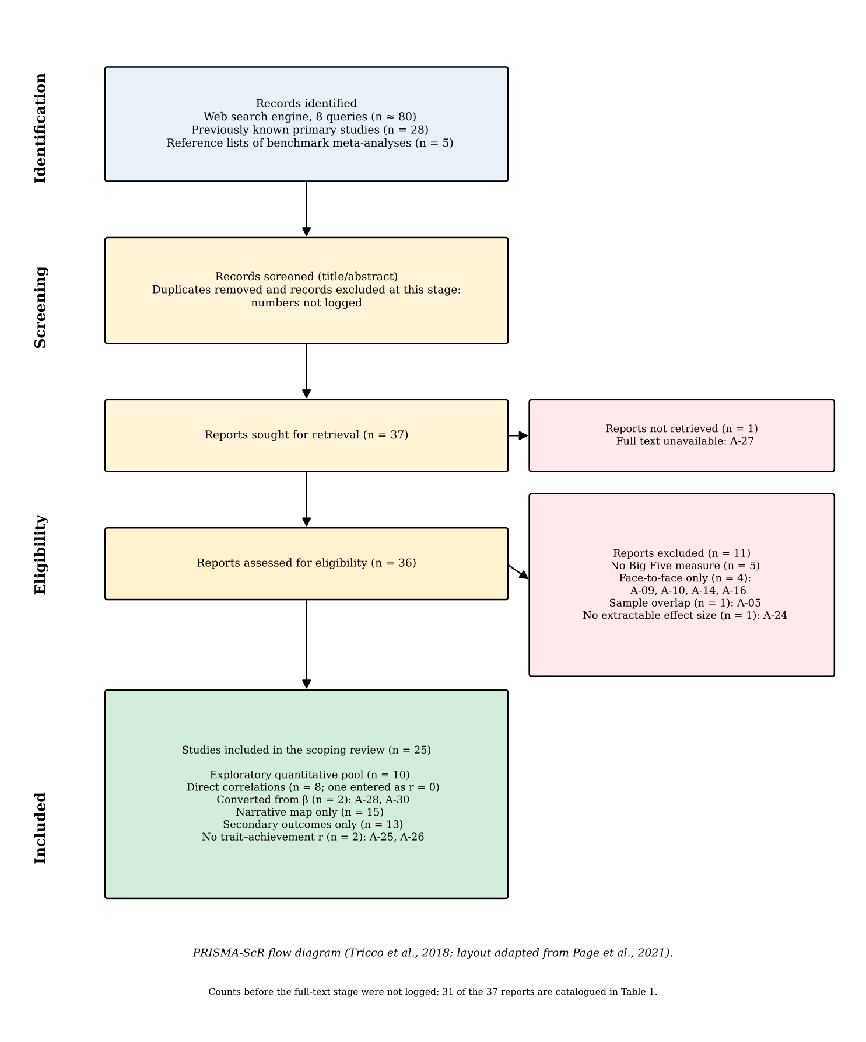
Note. Flow diagram following PRISMA-ScR (Tricco et al., 2018), with the layout of Page et al. (2021). Records were identified from eight web-search-engine queries (about 80 hits), 28 primary studies already known from preliminary searching, and the reference lists of five benchmark meta-analyses. The numbers of duplicates and of records excluded at title and abstract screening were not logged. From the full-text stage onward the counts are exact: of 37 reports sought, one could not be retrieved (A-27) and 36 were assessed; 11 were excluded (no Big Five measure, 5; face-to-face only, 4: A-09, A-10, A-14, A-16; sample overlap, 1: A-05; no extractable effect size, 1: A-24), leaving 25 studies. Of these, 10 contributed correlations to the quantitative pool (8 direct, one of them entered as r = 0; 2 converted from β) and 15 entered the narrative map only. Table 1 catalogues 31 of the 37 reports.

Figure 2
Forest Plot: Conscientiousness and Academic Achievement in Online Learning Environments
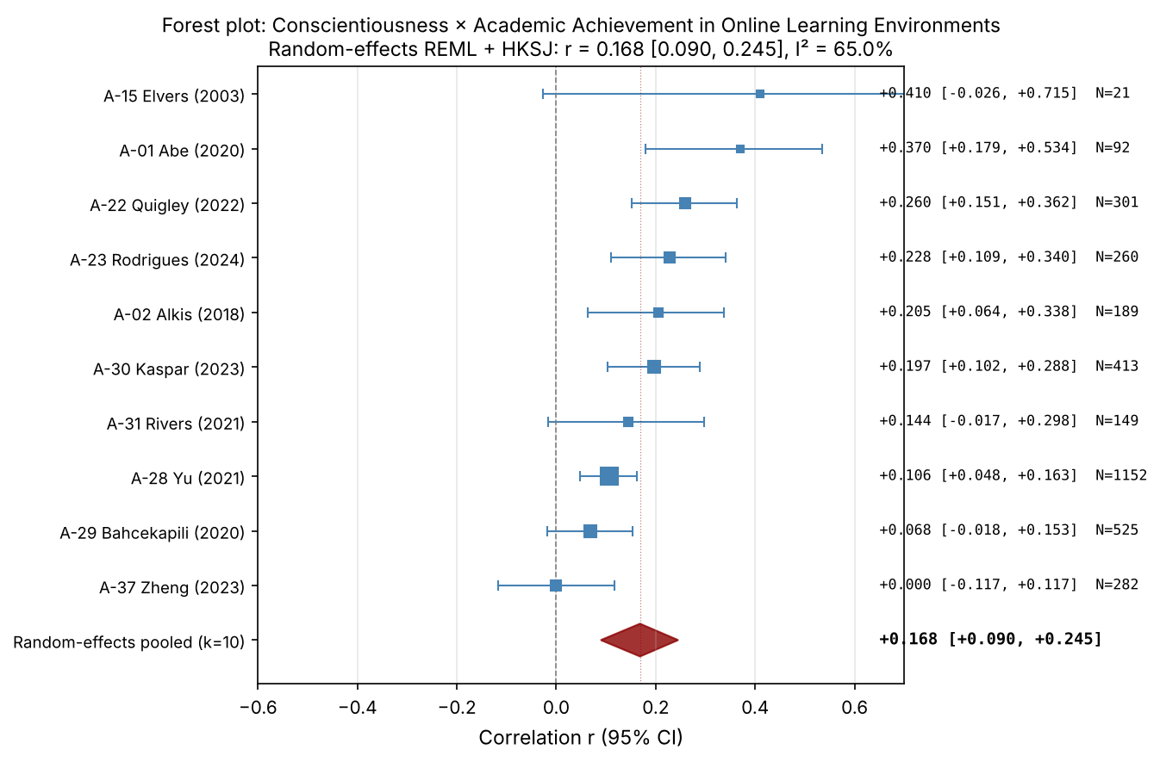
Note. Forest plot of study-level Pearson correlations between Conscientiousness and academic achievement in online learning environments. Each square represents a study; square size is proportional to the inverse-variance weight. Horizontal bars show 95% confidence intervals. The red diamond represents the random-effects REML pooled estimate with HKSJ 95% confidence interval. Studies are sorted by effect size (descending). See Table 2 for pooled statistics.

Figure 3
Forest Plot: Agreeableness and Academic Achievement in Online Learning Environments
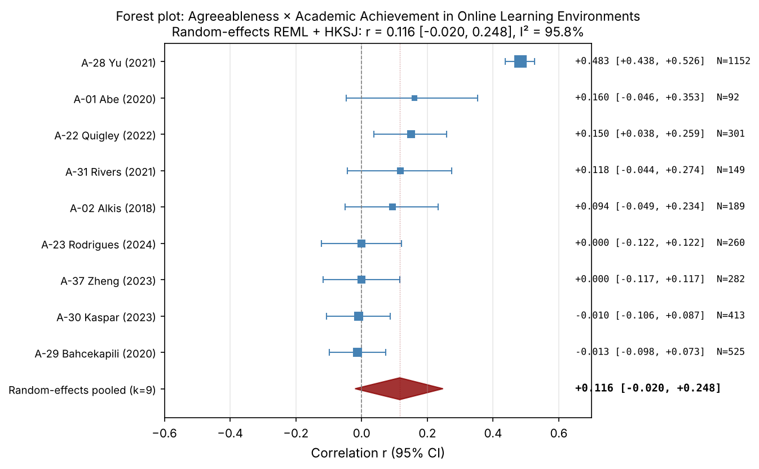
Note. Forest plot of study-level Pearson correlations between Agreeableness and academic achievement in online learning environments. Each square represents a study; square size is proportional to the inverse-variance weight. Horizontal bars show 95% confidence intervals. The red diamond represents the random-effects REML pooled estimate with HKSJ 95% confidence interval. Studies are sorted by effect size (descending). See Table 2 for pooled statistics.

Figure 4
Forest Plot: Openness and Academic Achievement in Online Learning Environments
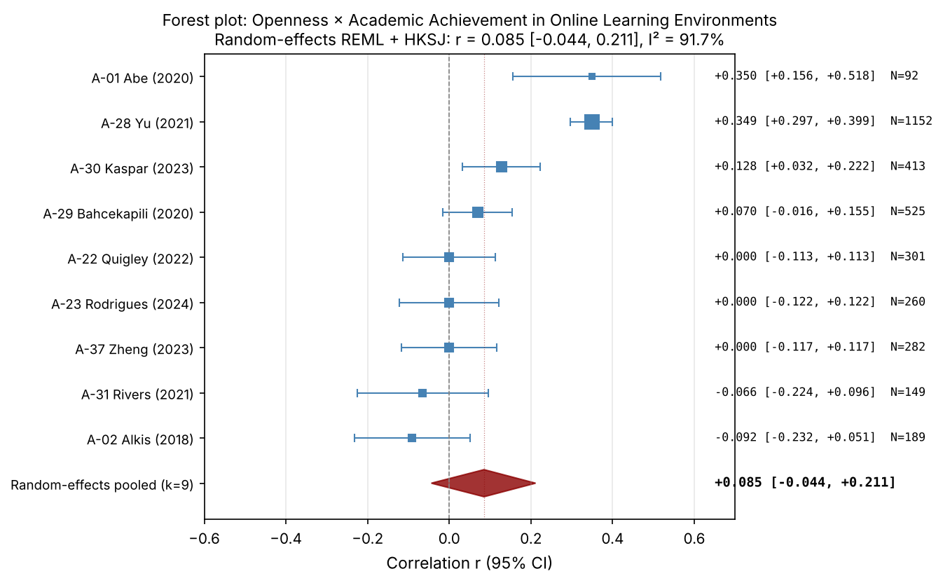
Note. Forest plot of study-level Pearson correlations between Openness and academic achievement in online learning environments. Each square represents a study; square size is proportional to the inverse-variance weight. Horizontal bars show 95% confidence intervals. The red diamond represents the random-effects REML pooled estimate with HKSJ 95% confidence interval. Studies are sorted by effect size (descending). See Table 2 for pooled statistics.

Figure 5
Forest Plot: Neuroticism and Academic Achievement in Online Learning Environments
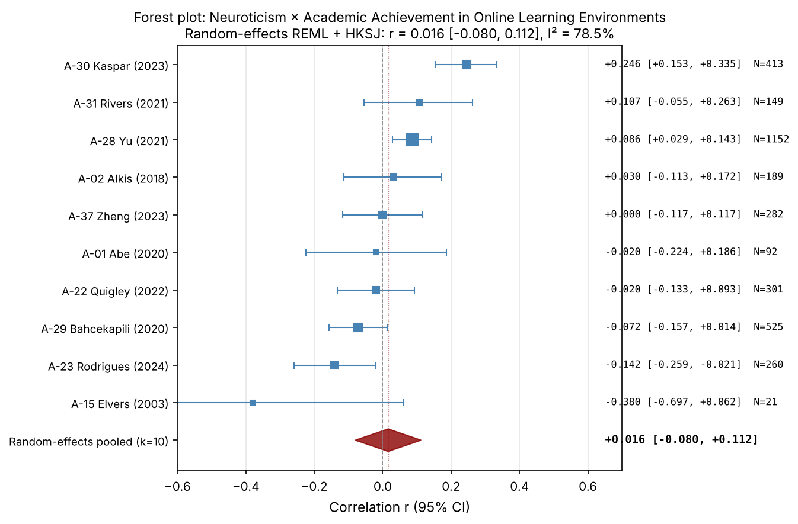
Note. Forest plot of study-level Pearson correlations between Neuroticism and academic achievement in online learning environments. Each square represents a study; square size is proportional to the inverse-variance weight. Horizontal bars show 95% confidence intervals. The red diamond represents the random-effects REML pooled estimate with HKSJ 95% confidence interval. Studies are sorted by effect size (descending). See Table 2 for pooled statistics.

Figure 6
Forest Plot: Extraversion and Academic Achievement in Online Learning Environments
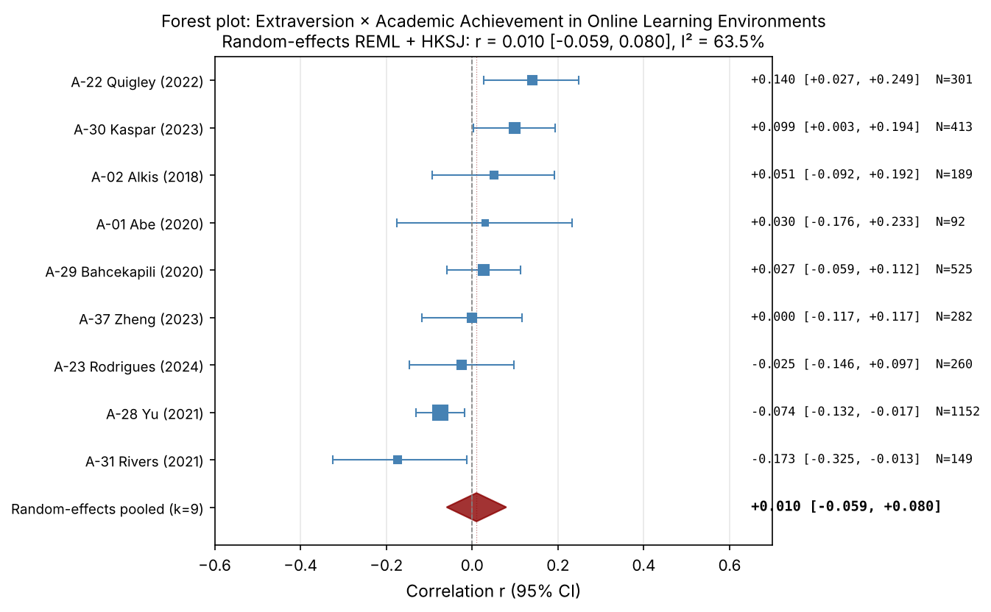
Note. Forest plot of study-level Pearson correlations between Extraversion and academic achievement in online learning environments. Each square represents a study; square size is proportional to the inverse-variance weight. Horizontal bars show 95% confidence intervals. The red diamond represents the random-effects REML pooled estimate with HKSJ 95% confidence interval. Studies are sorted by effect size (descending). See Table 2 for pooled statistics.

Figure 7
Funnel Plot: Conscientiousness and Academic Achievement in Online Learning Environments
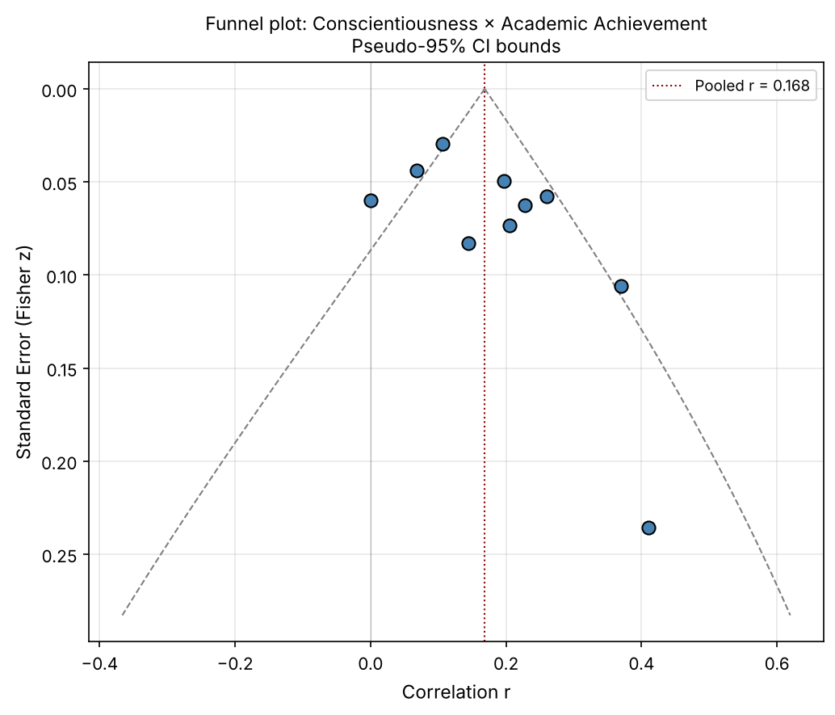
Note. Funnel plot of Pearson correlations between Conscientiousness and academic achievement in online learning environments. Points represent individual studies. The vertical dashed red line indicates the random-effects pooled correlation. Diagonal dashed lines represent pseudo-95% confidence bounds under the assumption of no heterogeneity. Asymmetric dispersion may suggest small-study effects or publication bias. Egger's test: intercept = 2.16, p = .091. See Table 4 for the other diagnostics.

Figure 8
Funnel Plot: Agreeableness and Academic Achievement in Online Learning Environments
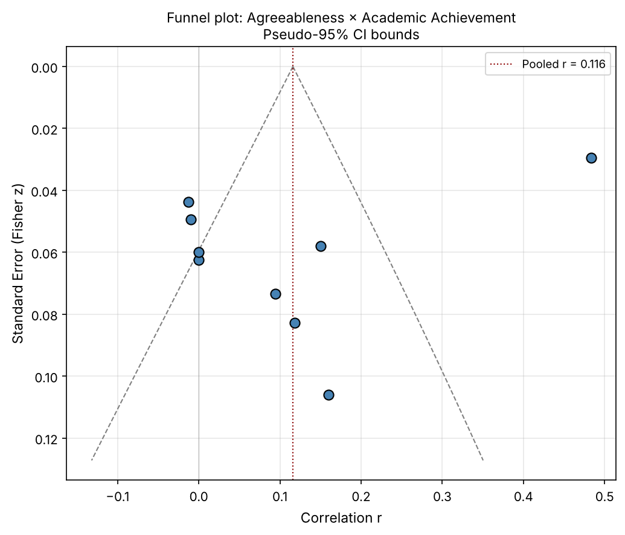
Note. Funnel plot of Pearson correlations between Agreeableness and academic achievement in online learning environments. Points represent individual studies. The vertical dashed red line indicates the random-effects pooled correlation. Diagonal dashed lines represent pseudo-95% confidence bounds under the assumption of no heterogeneity. Asymmetric dispersion may suggest small-study effects or publication bias. Egger's test: intercept = −8.29, p = .066. See Table 4 for the other diagnostics.

Figure 9
Funnel Plot: Openness and Academic Achievement in Online Learning Environments
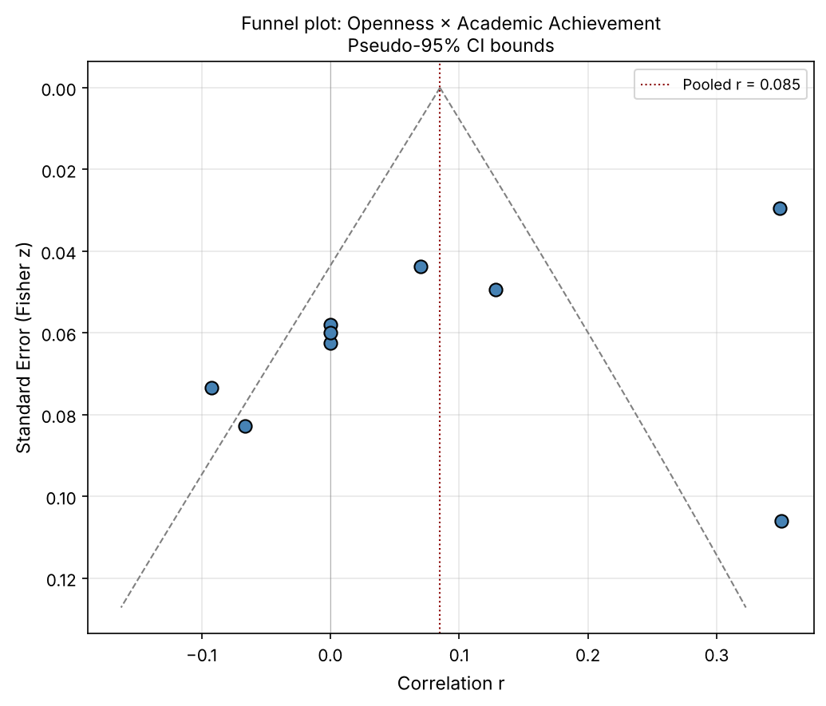
Note. Funnel plot of Pearson correlations between Openness and academic achievement in online learning environments. Points represent individual studies. The vertical dashed red line indicates the random-effects pooled correlation. Diagonal dashed lines represent pseudo-95% confidence bounds under the assumption of no heterogeneity. Asymmetric dispersion may suggest small-study effects or publication bias. Egger's test: intercept = −6.27, p = .046. See Table 4 for the other diagnostics.

Figure 10
Funnel Plot: Neuroticism and Academic Achievement in Online Learning Environments
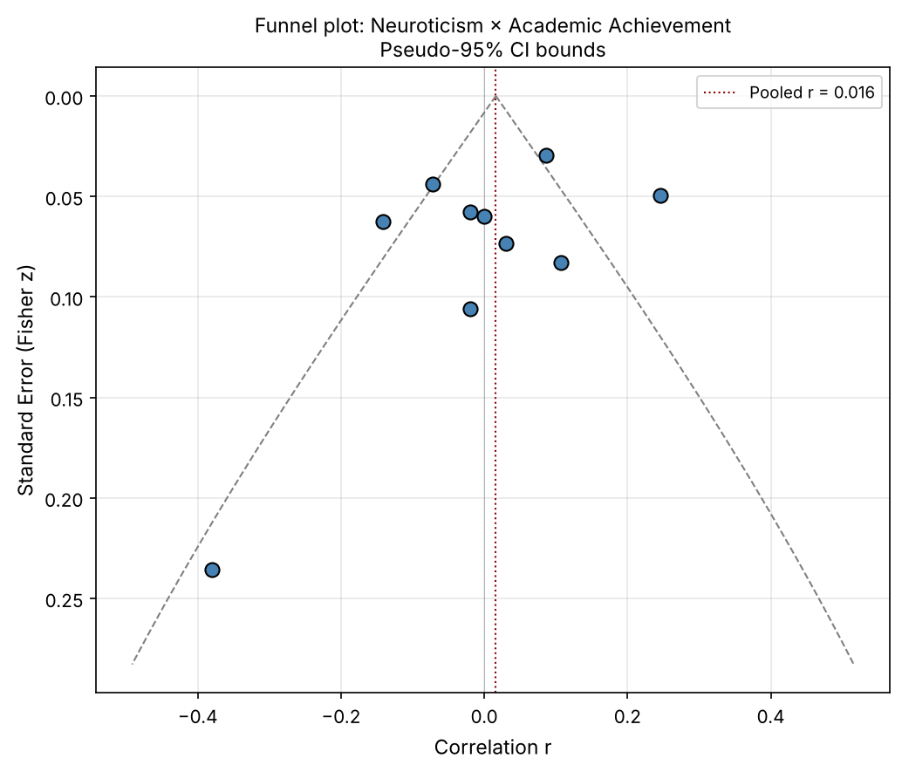
Note. Funnel plot of Pearson correlations between Neuroticism and academic achievement in online learning environments. Points represent individual studies. The vertical dashed red line indicates the random-effects pooled correlation. Diagonal dashed lines represent pseudo-95% confidence bounds under the assumption of no heterogeneity. Asymmetric dispersion may suggest small-study effects or publication bias. Egger's test: intercept = −1.78, p = .302. See Table 4 for the other diagnostics.

Figure 11
Funnel Plot: Extraversion and Academic Achievement in Online Learning Environments
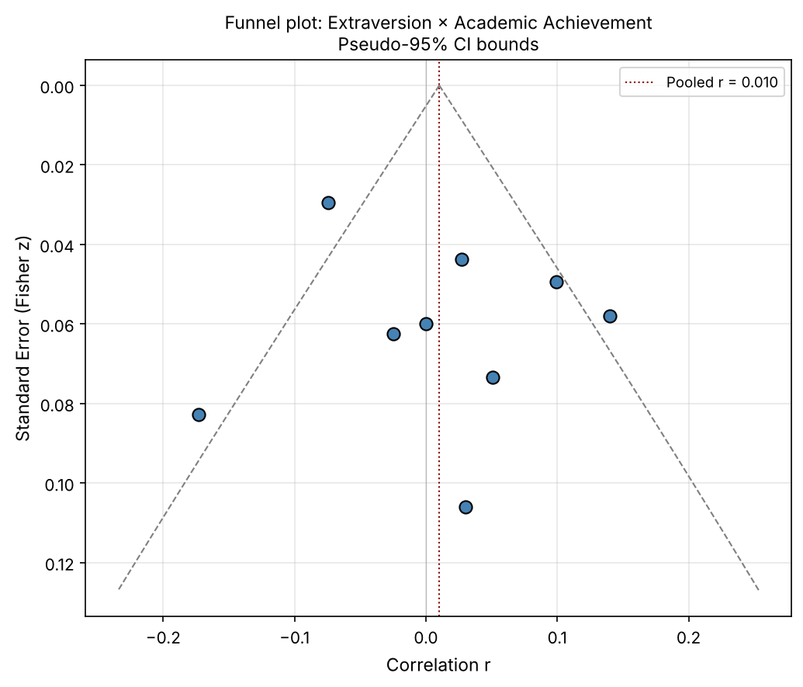
Note. Funnel plot of Pearson correlations between Extraversion and academic achievement in online learning environments. Points represent individual studies. The vertical dashed red line indicates the random-effects pooled correlation. Diagonal dashed lines represent pseudo-95% confidence bounds under the assumption of no heterogeneity. Asymmetric dispersion may suggest small-study effects or publication bias. Egger's test: intercept = 1.27, p = .454. See Table 4 for the other diagnostics.

