CE 500 Special Topics: Modeling Potential Energy Surfaces

Midterm Exam Closed Book March 13, 2024

Write all answers on the exam pages. Use blue books to for scratch work and to develop solutions, then copy key parts of work to the exam pages. Use the space provided with each question to answer it and provide any explanation.

No blue books will be collected.

You are allowed a 1-page 8-1/2 x 11-inch handwritten (both sides) information sheet. This must be submitted with your exam.

You allowed to use Mathematica (or a preferred computing platform) for calculations and you can access the Powerpoint lecture slides I presented in class. You may consult Mathematica documentation, but not the Mathematica lecture notebooks.
You are not permitted to access information from any other source.
You can get full credit for just having the correct answer to a question. Explanation of how you obtained your answer is required where specified.
Partial credit can be applied only if you provide a brief explanation of how you obtained the answer (a description in words, or an equation, or whatever helps me to understand what you did—be concise!). If you can’t work out the mathematics for a particular problem, outline or describe what you would do if you could.
Some questions are given using atomic units, such that ℏ, 4πε₀, and electron mass m_{e} and charge e are all unity. You may give all your answers using these units (i.e., you will not be penalized for omitting these constants in any of your answers).
There are 20 questions, and each question is given equal weight (5 points; 100 points total for the exam) even though some are much harder than others. Use your time wisely.

- Consider the Hamiltonian operator for an electron:
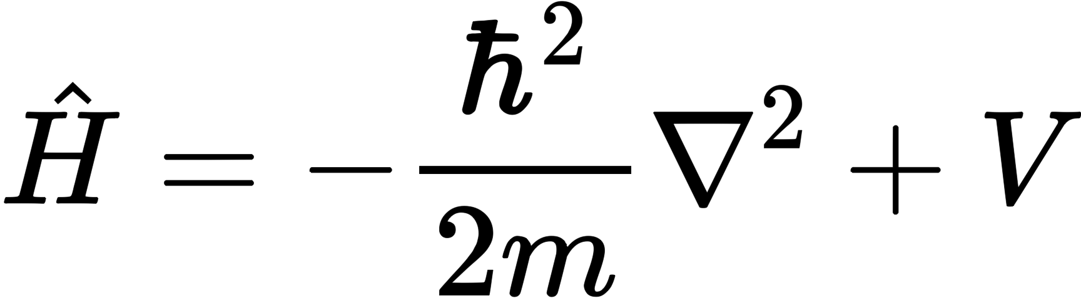
What physical quantity is represented by the Laplacian term?
___________________________________________
- Consider the following 1-dimensional wavefunction on the range x = [0,∞]
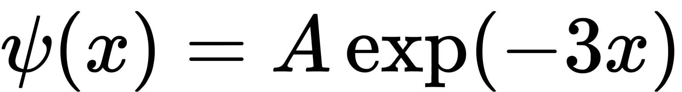
What is the value of the constant A that normalizes the probability density?
____________________________________________
- Circle all and only those statements (just the first letter) that are true about the Hartree-Fock treatment:
  - It is an exact solution of the Schrödinger equation if solved in the complete basis-set limit.
  - It does not accommodate Fermi exchange correlation.
  - It does not accommodate Coulomb correlation.
  - It requires that the orbitals be solved self-consistently via iteration.
  - It does not accommodate the effects of spin.
- Most modern electronic structure codes use Gaussian functions as basis sets with which to represent the molecular orbitals. Circle all and only those statements (just the first letter) that are true:
  - The true hydrogen-atom wavefunction exhibits a cusp at the origin which is also exhibited by Gaussian functions.
  - For a given number of basis functions, it would be more accurate to use Slater functions instead of Gaussian functions.
  - The integrals over basis functions needed to carry out Hartree-Fock calculations are more difficult to evaluate for Slater functions than for Gaussian functions.
  - Some combinations of multiple Gaussian functions are quite similar to Slater functions.
- Consider this 2-electron wavefunction, where ϕ_{i} are spatial orbitals, and α, β are spin states. 1 and 2 refer to spatial or spin coordinates of electrons 1 and 2.
Is this wavefunction antisymmetric? Explain.
- Consider the following normalized 1-dimensional wavefunction on x = [−1, 1]
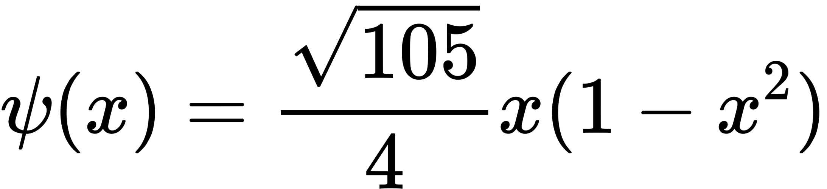
  - Does this wavefunction exhibit gerade or ungerade symmetry? Briefly explain your answer.
——————————————————————————————-
  - What is the expectation value of the kinetic-energy operator for this wavefunction?
  - This wavefunction is the solution to the Schrödinger equation for the external field
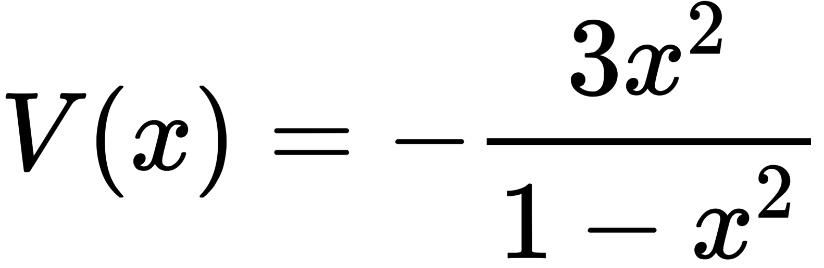
What is the expectation value of the total energy for this system?

  - Consider now the normalized wavefunction
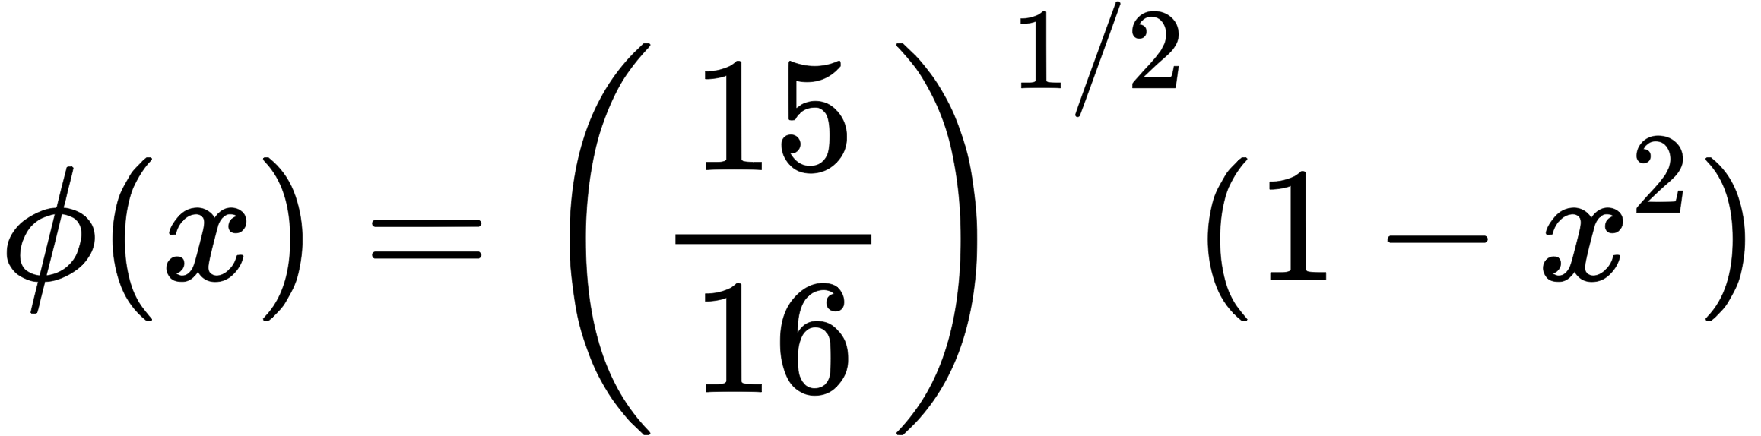
Are ψ and ϕ orthogonal? Explain.

- Circle all and only those statements that are true regarding the hydrogen-like atom wavefunctions ψ_{n,𝓁,m}(r, θ, ϕ).
  - The energy depends only on the principal quantum number n.
  - The wavefunction is positive for all values of its variables.
  - The wavefunction decays as 1/r for r → ∞.
  - The wavefunction is antisymmetric and demonstrates the Pauli principle.
  - Two wavefunctions having different n, 𝓁, m are orthogonal.
  - Electron-electron repulsion is included in the derivation of the wavefunctions.
  - The wavefunctions are complex, but an equivalent real set of wavefunctions can be derived by combining them.
  - The quantum number m relates exclusively to angular, not radial, motion of the electron.
  - Some of the energies for this system are degenerate.
- For spin states α and β, fill in the value of each of the following sums, which are taken over both values of the spin variable s:
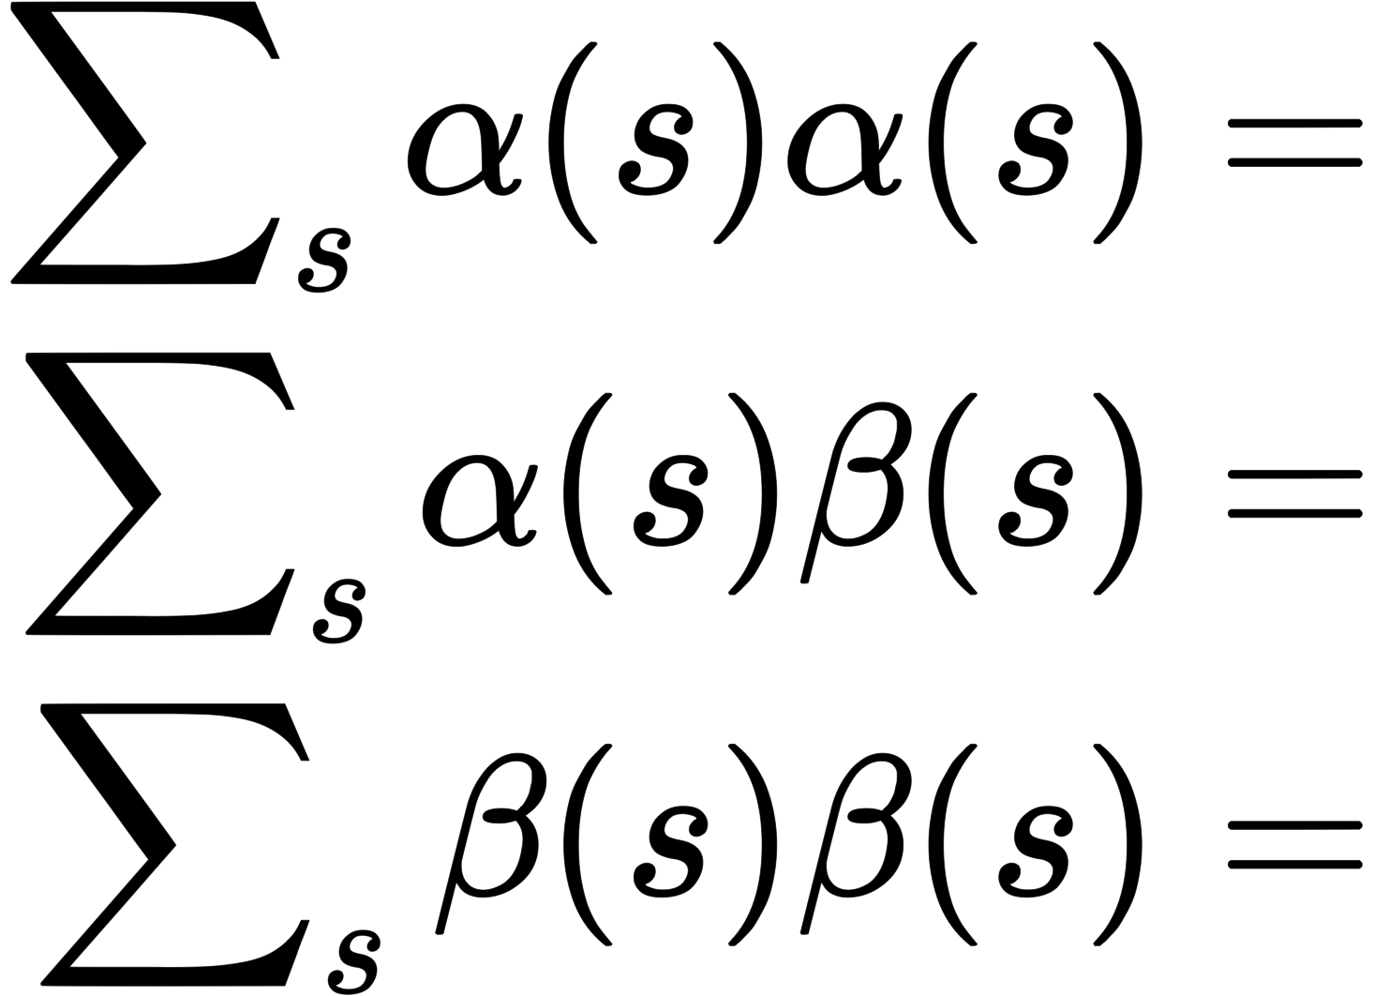

- Explain briefly why an atomic or molecular orbital is limited to occupancy by at most two electrons. Why specifically two?

- Briefly describe the role of (1) the variational principle and (2) Lagrange multipliers in the derivation of the Hartree-Fock equation.
- Consider the following normalized wavefunction in terms of a radial coordinate r and parameter r_{m}:
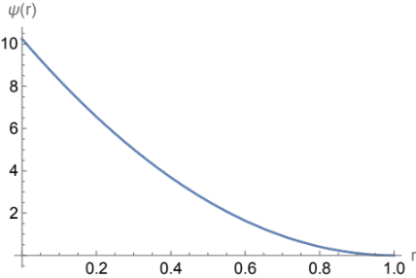
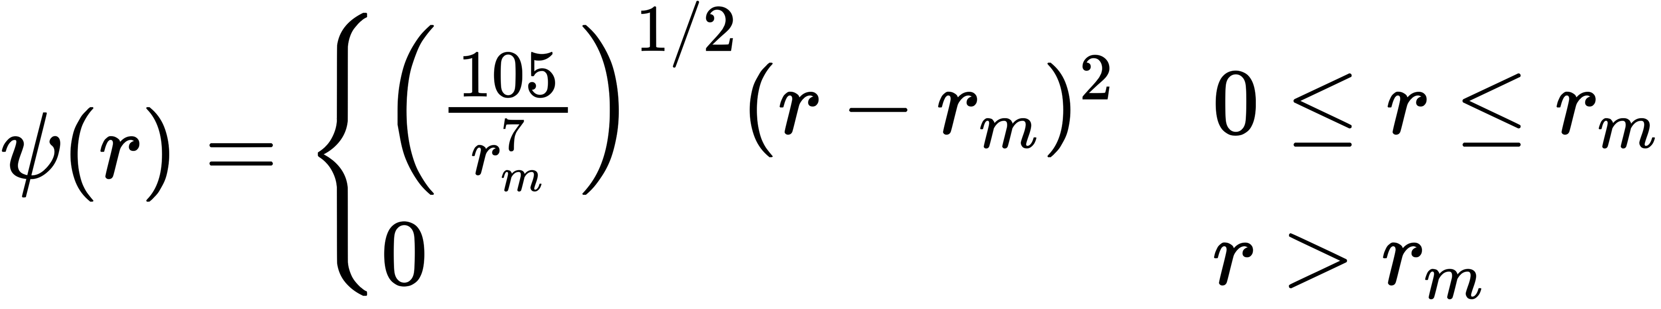

The function is plotted here for r_{m} = 1.
The Laplacian for this wavefunction is
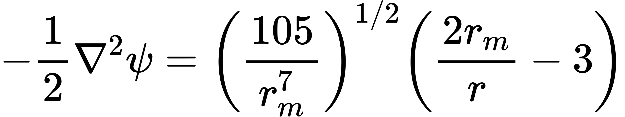

This wavefunction is used to approximate the solution to the hydrogen atom, i.e., an electron in a spherical potential V(r) = -1/r.
        - Use the variational principle to find the value of the parameter r_{m} that yields the optimum ψ. Show your work.
        - What is the expectation energy for the optimum r_{m}? How does it compare to the exact energy for this system?

Remember to include r² when evaluating any spatial integrals over r. You can get partial credit for showing in detail what you would do, even if you can’t complete any calculations.

- In about 20 words or fewer, describe the context in which the Roothaan equation is developed. Where did it come from, what is its purpose?

- The energy obtained by application of the variational principle in Kohn-Sham density functional theory is guaranteed to be greater than the true energy. True/False?______
- What three quantities that are needed to specify the electronic Hamiltonian are obtainable from the electron density?

- Fill in the letter from the list on the right that associates most closely with the names on the left
________Hohenberg-Kohn A. antisymmetric wavefunction
________Roothaan-Hall B. minimize energy of determinant wavefunction
________Pauli C. kinetic-energy functional
________Becke D. basis functions
________Schrödinger E. electron density is sufficient to specify energy
________Hartree-Fock F. exchange functionals
________Kohn-Sham G. wave equation

- Fill in the right-hand side of each of these sum rules, where h_{X} and h_{C} are the exchange and correlation hole functions, respectively.
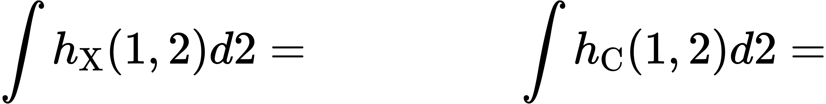
- Apply the local density approximation (LDA) to ε to estimate the following density functional for ρ(x) = sin(x). Evaluate the exact functional and the LDA estimate.

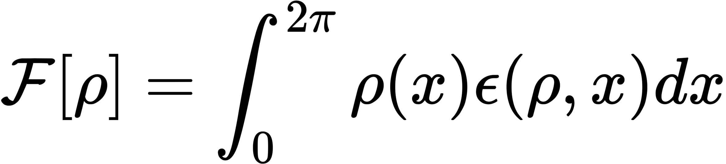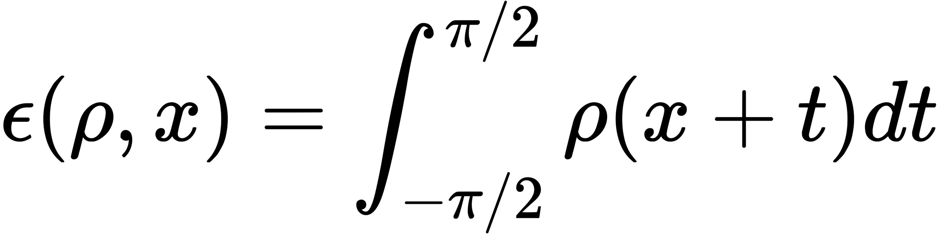

- In about 20 words or fewer, briefly describe the idea of the adiabatic connection in DFT.

- The electron-electron density functional E_{ee}[ρ] is given exactly by the classical Coulomb integral 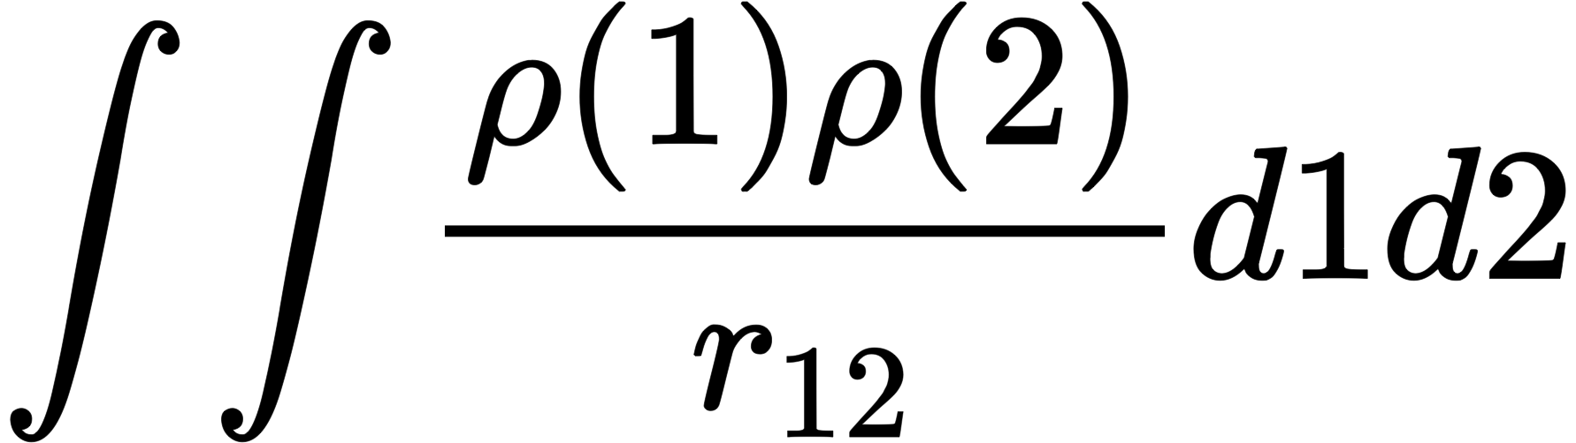 . True or false?_____________________

- Evaluate the functional derivative of this functional:

