Phenolics Results Draft
This draft summarizes the phenolics analysis for the cranberry heat-stress project. The outcome is gallic-acid-equivalent concentration, analyzed separately for long-term and acute experiments.

Objective
The goal of the phenolics analysis was to determine whether heat treatment changes phenolics concentration and whether that response differs across cultivar and experiment type.

Data and Methods
Phenolics analysis started from raw absorbance measurements. We identified true standards, fit calibration lines separately for each date and lab replicate, converted absorbance to estimated concentration, parsed Sample ID into experiment-design variables, and excluded acute A0/A0C rows from the main treatment-effect analysis. Primary inference used mixed-effects regression on row-level mean concentration.

Long-Term Results
In the long-term experiment, the most important result is the cultivar-by-treatment interaction. The observed mean plot already suggests that OTC increases concentration for MQ but decreases concentration for St.
Figure 1. Long-term mean phenolics concentration
Observed long-term mean concentration with standard errors by treatment and cultivar.
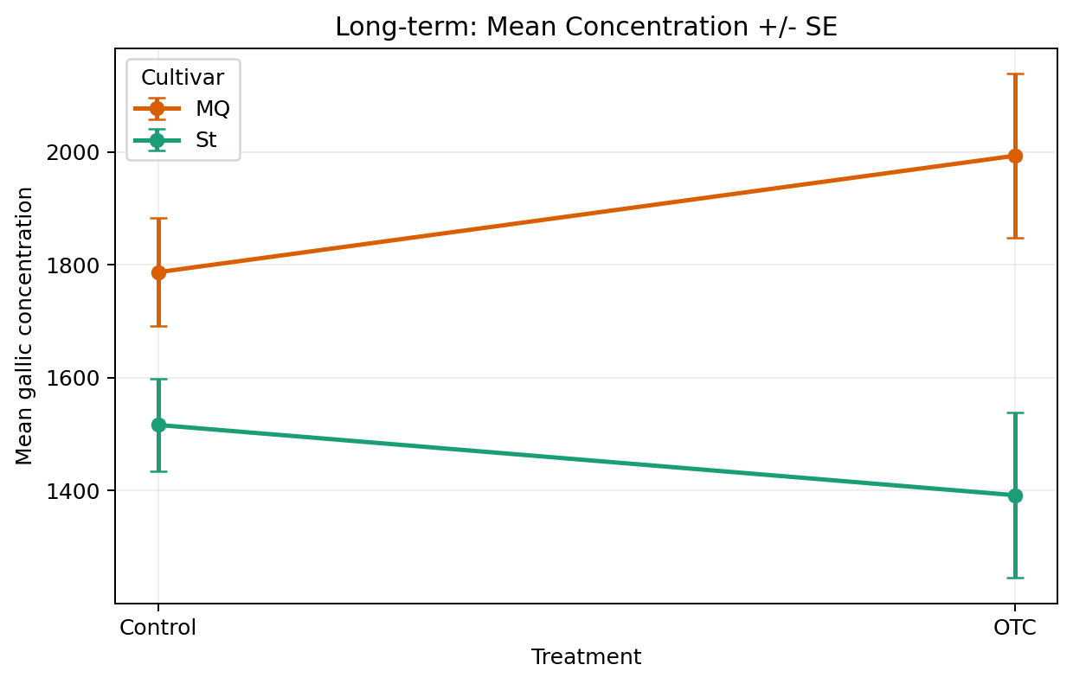
Presentation note: MQ rises from Control to OTC, while St falls from Control to OTC. So the main long-term story is not a single average treatment effect; it is that the treatment response depends on cultivar.

Long-Term Regression Results
Term | p-value | Interpretation
cultivar | 0.0678 | Marginal evidence of baseline cultivar difference
treatment | 0.0344 | OTC changes concentration overall
cultivar × treatment | 0.0165 | Treatment effect differs across cultivars

Coefficient interpretation: for MQ, the estimated OTC effect is +206.5. For St, the estimated OTC effect is 206.5 - 331.1 = -124.6. Main takeaway: long-term phenolics shows a cultivar-specific treatment response. OTC increases concentration in MQ but decreases it in St.
Figure 2. Long-term regression diagnostics
The left panel shows residuals versus fitted values, and the right panel shows the QQ plot.
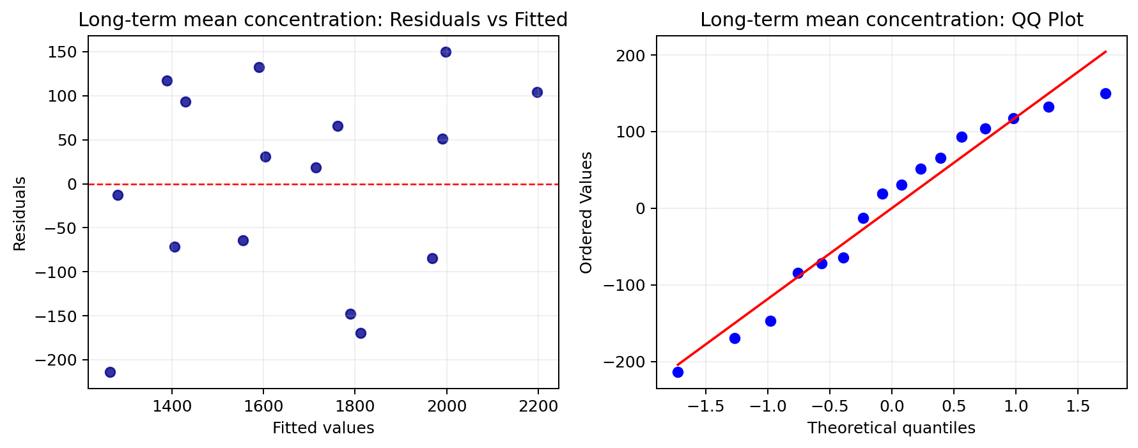
Presentation note: This figure is for model checking rather than treatment interpretation. We mainly want residuals to stay roughly centered around zero and the QQ points to stay reasonably close to the reference line.

Acute Results
In the acute experiment, the response is more complex than in long-term. The observed mean plot shows that heated-versus-control differences change across both cultivar and heat level.
Figure 3. Acute mean phenolics concentration
Observed acute mean concentration with standard errors by heat level, treatment status, and cultivar.
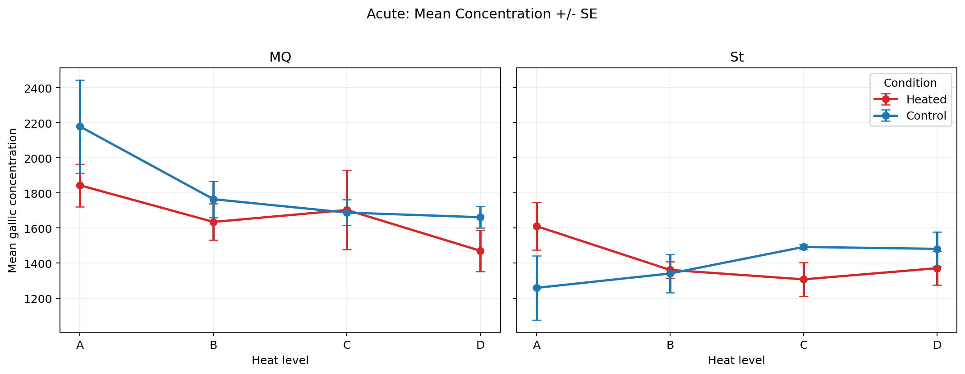
Presentation note: For MQ, control is usually above heated, especially at A and D. For St, the pattern changes by heat level: heated is higher at A, similar at B, and lower at C and D. This is why the acute model is mainly an interaction story.

Acute Regression Results
Term | p-value | Interpretation
heat_level | 0.1016 | No strong global heat-level main effect
cultivar | 0.1264 | No strong global cultivar main effect
is_control | 0.0248 | Heated and control plots differ overall
cultivar × is_control | 0.00115 | Treatment contrast differs across cultivars
heat_level × cultivar × is_control | 0.0265 | Cultivar-specific treatment effect changes across heat levels

Main takeaway: acute phenolics does not show one simple treatment effect. Instead, the treatment effect depends on both cultivar and heat level.
Figure 4. Acute regression diagnostics
The left panel shows residuals versus fitted values, and the right panel shows the QQ plot.
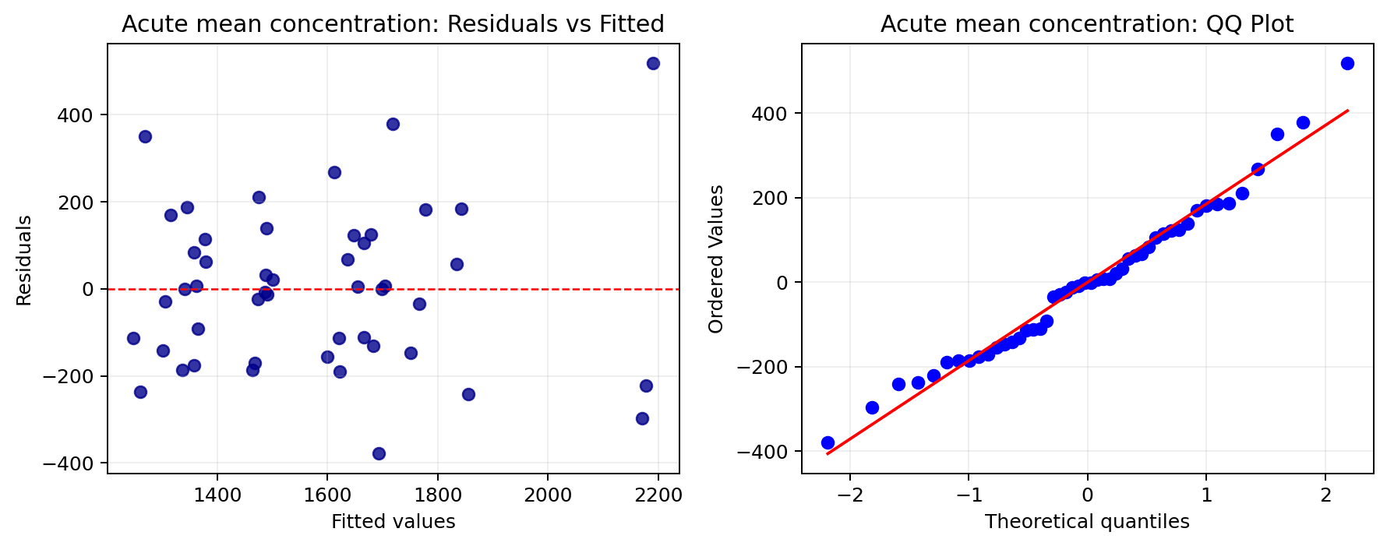
Presentation note: This figure is also for model checking. The goal is to show that there is no major residual pattern and that the normality assumption is not badly violated.

Conclusion
Across both experiments, phenolics is mainly an interaction-driven outcome. In the long-term experiment, OTC has opposite effects for MQ and St. In the acute experiment, the heated-versus-control contrast changes across both cultivar and heat level. This means the biologically important result is not just whether heat matters on average, but how the phenolics response depends on context.

