Yield Results Draft
This draft summarizes the yield analysis for the cranberry heat-stress project. We analyzed two cultivars, Mullica Queen (MQ) and Stevens (St), under both long-term and acute heat experiments. The primary outcomes were healthy fruit weight, rotten-count proportion, and rotten-weight proportion.

Objective
The goal of the yield analysis was to quantify how heat treatment changed cranberry yield outcomes under long-term and acute experimental designs, and to determine whether those effects differed by cultivar.

Data and Methods
We cleaned and locked the long-term and acute yield datasets, standardized treatment and cultivar labels, derived rotten-fruit proportions, and preserved only records that were valid for the yield model. Descriptive paired summaries were computed from heat-minus-control differences. Primary inference used mixed-effects regression to match the grouped and paired structure of the experiment.

Long-Term Results
In the long-term experiment, treatment effects are present but mixed across outcomes. Heated plots tend to have lower healthy fruit weight and somewhat lower rotten proportions than controls.
Figure 1. Long-term healthy fruit weight by treatment and cultivar
Observed means with standard errors. MQ and St show different baseline levels, and treatment differences are modest at the raw-summary level.
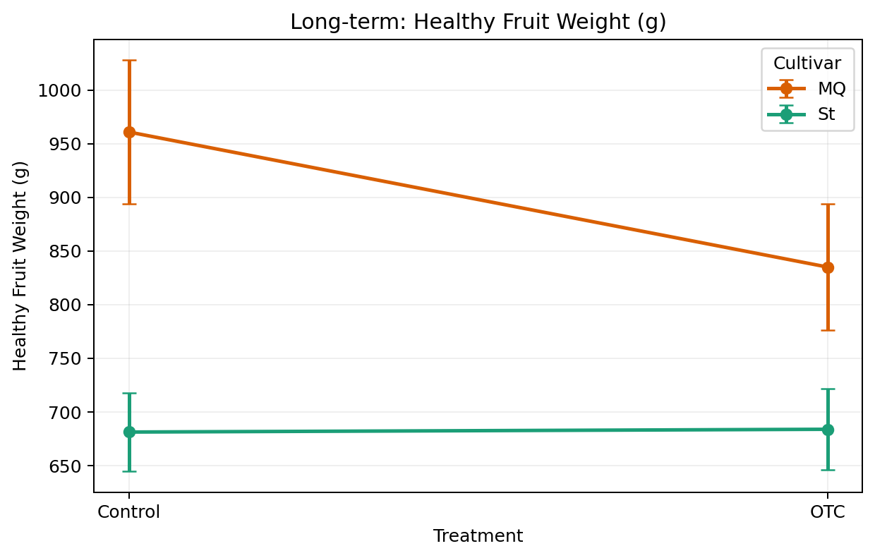
Presentation note: MQ has much higher healthy fruit weight than St overall, and MQ drops under OTC. St changes very little from Control to OTC. So the visual pattern suggests both a strong cultivar difference and a treatment effect, which is consistent with the regression table below.

Long-Term Regression Results
Outcome | Cultivar p | Treatment p | Interaction p | Main takeaway
healthy_weight_g | 1.35e-05 | 0.0426 | 0.1434 | Lower under treatment overall; strong cultivar effect
pct_rotten_count | 0.1458 | 0.0373 | 0.4952 | Lower under treatment overall
pct_rotten_weight | 7.45e-04 | 0.0167 | 0.1698 | Lower under treatment overall; strong cultivar effect

The long-term interaction term was not significant for any of the three yield outcomes, so the main report emphasis should remain on the cultivar and treatment main effects.
Figure 2. Long-term regression diagnostics for healthy_weight_g
The left panel shows residuals versus fitted values, and the right panel shows the QQ plot. We use the healthy-weight model as the representative long-term diagnostic figure in the main report.
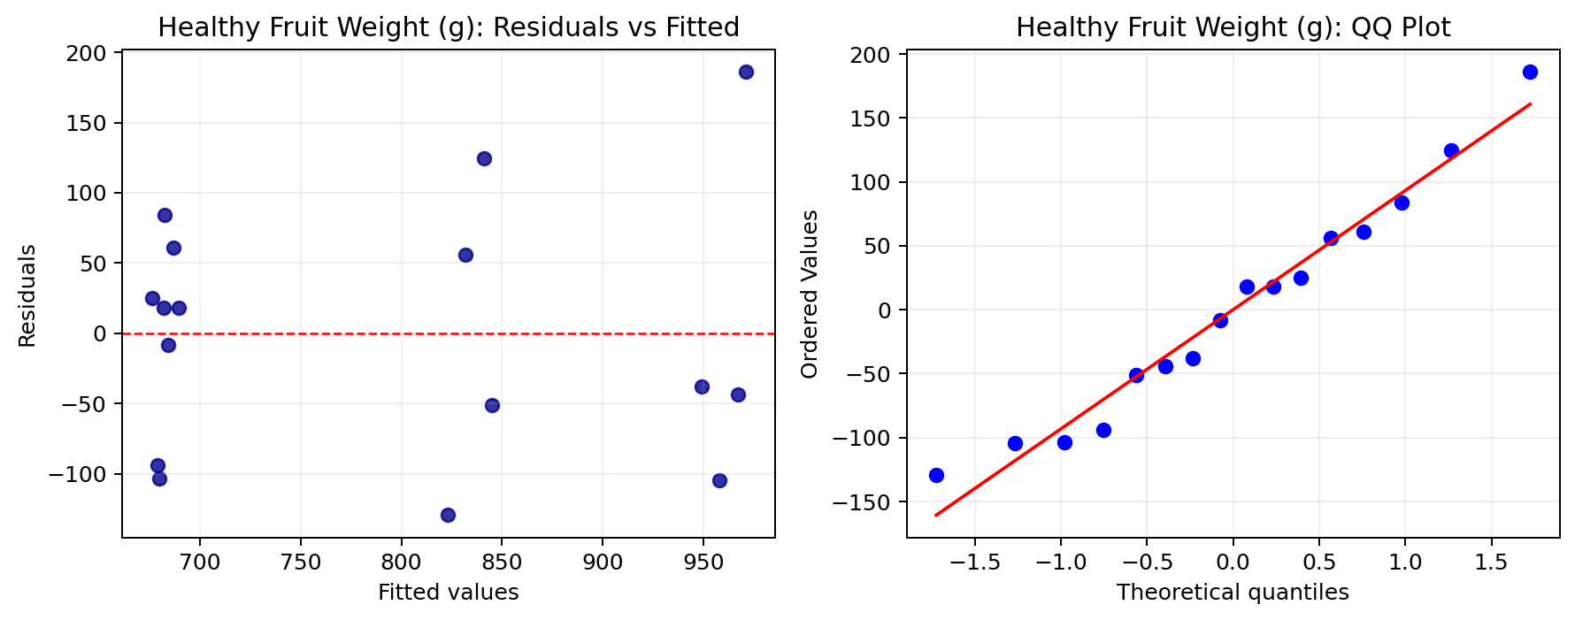
Presentation note: This diagnostic figure is not about treatment direction. It is there to show that the model is reasonably well behaved. We mainly want residuals to stay roughly centered around zero and the QQ points to stay reasonably close to the reference line.

Acute Results
The acute experiment shows a clearer short-term stress pattern than the long-term experiment. Heated plots usually have lower healthy fruit weight and higher rotten proportions than their matched controls.
Figure 3. Acute healthy fruit weight by treatment and heat level
Observed means with standard errors. Acute heated plots generally show lower healthy fruit weight than controls across heat levels.
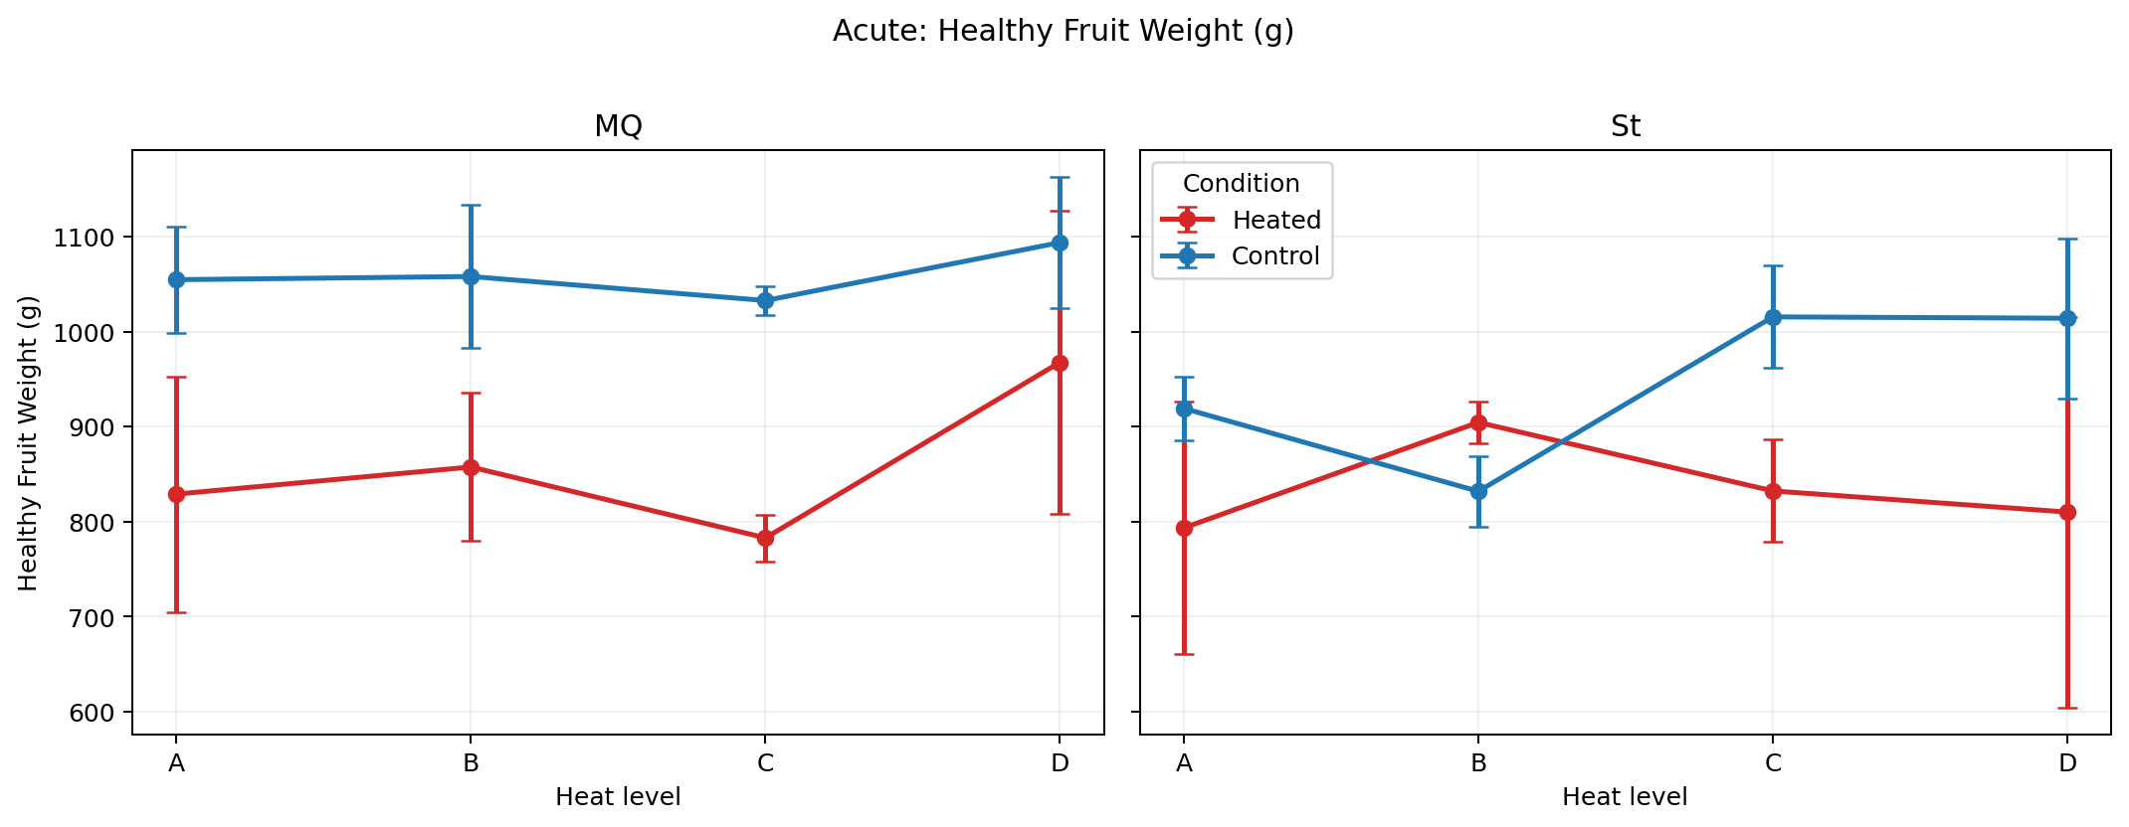
Presentation note: In the acute experiment, the main visual pattern is that control plots usually sit above heated plots, especially for MQ. That is why the regression emphasizes the treated-versus-control contrast rather than a strong overall heat-level effect.

Acute Regression Results
Outcome | Cultivar p | Heat-level p | Control-vs-heated p | Highest interaction p | Main takeaway
healthy_weight_g | 0.7395 | 0.3563 | 0.0245 | 0.3767 | Control retains more healthy fruit weight
pct_rotten_count | 0.6777 | 0.5644 | 0.0183 | 0.3086 | Heated plots show higher rotten-count proportion
pct_rotten_weight | 0.9383 | 0.3146 | 0.0740 | 0.7025 | Same direction, but weaker evidence

Across acute outcomes, the most stable regression signal is the control-versus-heated contrast rather than a strong global difference among heat levels A-D.
Figure 4. Acute regression diagnostics for healthy_weight_g
The left panel shows residuals versus fitted values, and the right panel shows the QQ plot. We use the healthy-weight model as the representative acute diagnostic figure in the main report.
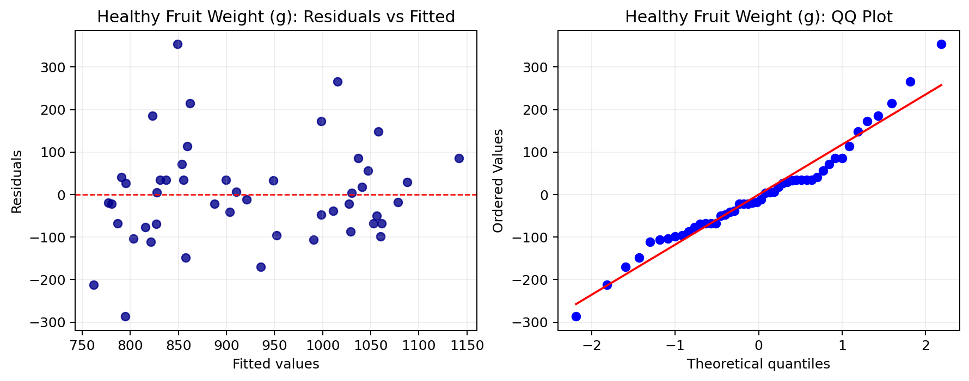
Presentation note: This figure is only for model checking. The goal is to show that there is no major residual pattern and that the normality assumption is not badly violated.

Conclusion
Overall, the yield analysis shows that heat treatment affects cranberry outcomes, but the pattern depends on experiment type. In the acute experiment, heat behaves like a short-term stressor: healthy fruit weight tends to fall and rotten proportions tend to rise. In the long-term experiment, treatment effects are still present, but the pattern is more mixed across outcomes and is also shaped by cultivar differences.

