VICTORIA UNIVERSITY

FACULTY OF SCIENCE AND TECHNOLOGY

OBJECT-ORIENTED PROGRAMMING

GROUP COURSEWORK

GROUP MEMBERS:
S/N | NAME | REG. NUMBER
1. | ETOMET PATRICK | VU-BBC-2411-1019-DAY
2. | OMOLO ISAAC VICTOR | VU-DIT-2411-1595-DAY
3. | WALIGO SALIM | VU-DIT-2411-0215-DAy
4. | NAMATOVU HOPE | VU-DIT-2411-0047-DAY
5. | TUKEI MARK | VU-BIT-2411-0565-DAY

QUESTION ONE
Introduction
Projectile motion refers to the motion of an object that is launched into the air at an angle to the horizontal. It is a two-dimensional motion that can be resolved into horizontal and vertical components.
According to Newton’s First Law of Motion, a projectile will continue in uniform motion horizontally, while Newton’s Second Law explains that its vertical motion is influenced by the force of gravity. Using the principles of kinematics, we can predict key features of a projectile’s path such as time of flight, maximum height, and horizontal range.
To make this concept easier for students at Kiira College Butiki, I decided to design a Java-based simulation program that calculates and displays these values when given the initial velocity and launch angle. This makes learning interactive and practical, while also applying programming skills acquired at Victoria University.

Physics Formulas Used
For an initial velocity $u$ and launch angle $θ$, with gravity :
- Time of Flight (T):
$$T=\frac{2u\sin{θ}}{g}$$
- Maximum Height (H):
$$H=\frac{u^{2}\sin^{2}{θ}}{2g}$$
- Horizontal Range (R):
$$R=\frac{u^{2}\sin{(2θ)}}{g}$$

Where:
( $u$ ) = initial velocity (m/s)
( $θ$ ) = launch angle (degrees)
( $g$ ) = gravitational acceleration (9.8 m/s²)

GitHub Repository link to the program:
https://github.com/isaacvictorfenaldo123-sys/PROJECTILE-MOTION.git

Screenshot: Sample input and output on execution of the program.
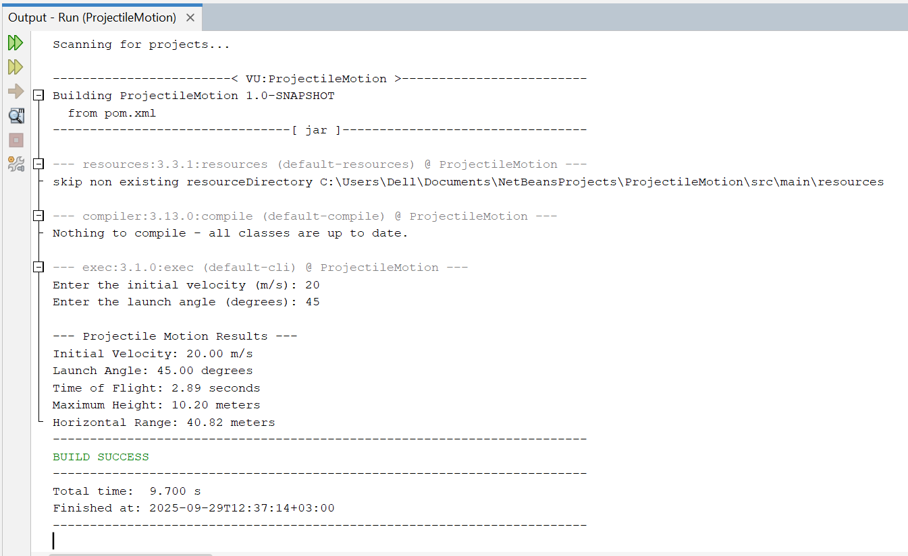

Conclusion
Through this simulation tool, students are able to clearly understand the principles of projectile motion by directly observing the effect of initial velocity and launch angle on the time of flight, height, and range. This practical demonstration bridges the gap between abstract physics formulas and real-world applications.

QUESTION TWO

Exhibition Registration System – SALSA Dance Festival
Case Study: GUI and Database Integration in Java

Introduction
Manual registration using paper forms and spreadsheets has become inefficient. This leads to problems such as duplicate entries, data loss, and difficulty in retrieving participant details.
To address these issues, we have developed a Java-based desktop application to streamline the registration process of SALSA Dance Festival. The system provides a graphical user interface (GUI), full CRUD (Create, Read, Update, Delete) functionality, and integration with a Microsoft Access Database using the UCanAccess JDBC driver.
This project enables organizers to easily register new participants, search for existing records, update participant information, and delete cancelled entries. It also allows uploading and displaying participant ID images, ensuring accuracy and convenience in managing event data.

System Objectives
The main objectives of the system are:
- To provide a user-friendly GUI for participant registration.
- To implement secure user authentication through a login interface.
- To integrate a database for storage and retrieval of participant information.
- To allow CRUD operations for participant management.
- To enable image upload and display for participant identification.
- To validate user inputs and ensure database consistency.

System Requirements
Requirement Type | Description
Programming Language | Java (JDK 24)
IDE Used | Apache NetBeans 27
Database | Microsoft Access (.accdb)
JDBC Driver | UCanAccess
Operating System | Windows 10 or later

Design and Implementation of the Java GUI
The Graphical User Interface (GUI) was designed using Java Swing to ensure a professional and intuitive layout. The main interface allows users to input and manage participant information through labelled form fields and action buttons.
The system uses a JFrame Form with a JTabbedPane that organizes the interface into two main tabs:
- Registration Tab:
- Input fields for participant details.
- Upload button for ID image.
- Control buttons: Register, Search, Update, Delete, Clear, Exit.
- Participants List Tab:
- Displays all participants in a JTable.
- Includes a Print Button to generate a hard copy of the table directly from the application.

GUI Design and Components
The application uses Swing JFrame Form named ExhibitionRegn.form. The form includes:
- Input Fields: Registration ID, Name, Department, Dance Partner, Contact Number, Email
- Buttons: Register, Search, Update, Delete, Clear, Exit
- Image Upload Section: JFileChooser for selecting image and label for preview display

Key Functionalities
Registration
- Validates all fields and email format.
- Checks for duplicate Registration ID.
- Renames image to match Registration ID (e.g., REG001.jpg).
- Copies image into images/ folder.
- Inserts record into database.
Duplicate Check Example:
Checks the entered record to prohibit registering participants with the same Registration ID.
Search
Retrieves participant data by Registration ID and displays it on the form. Includes loading and displaying the ID image from stored file path.
Update
Allows modification of existing participant details. Uses a prepared statement to update database fields securely.

Delete
Removes a participant’s record after user confirmation.
Image Upload
Uses JFileChooser to browse local files.
Renames selected image using Registration ID and stores it under:
src/main/java/vu/exhibitionRegn/images/
The image path is saved in the database and previewed in the GUI.
Input Validation
Validation | Description
Empty Fields | Ensures no field is left blank
Email Format | Validates using regular expressions
Duplicate ID | Checks before inserting record
Contact | Ensures numeric and correct length

Exception Handling
All major operations are enclosed in try-catch blocks.
This prevents runtime errors and provides user-friendly messages.

Database Design
A relational database was created to manage both users and participants. Two tables were designed: Users and Participants.
Users Table
Stores credentials for system login.
Field | Data Type | Description
Username | VARCHAR(50) | User’s login name
Password | VARCHAR(50) | User’s password
Sample Data
Username | Password
admin | 12345
Patrick | 1234
Hope | 1234
Salim | 1234

Participants Table
Stores exhibition participant details.
Field | Data Type | Description
RegistrationID | VARCHAR(10) | Unique ID for each participant
ParticipantName | VARCHAR(100) | Name of participant
Department | VARCHAR(50) | Department
DancePartner | VARCHAR(100) | Partner’s name
ContactNumber | VARCHAR(20) | Contact number
Email | VARCHAR(100) | Email address
IDImagePath | VARCHAR(255) | Path to uploaded image

Database file Link on GitHub
https://github.com/isaacvictorfenaldo123-sys/ExhibitionRegistrationSystem_VU/blob/main/VUE_Exhibition.accdb

Database Operations Using Prepared Statements
The system uses PreparedStatements to perform secure SQL operations. This ensures safety against SQL injection and improves query performance.
Insert (Register Participant)
This operation saves a new participant’s data and their image path to the database after validation.
Search (Retrieve by Registration ID)
Allows users to search participants by entering their unique Registration ID.
Update (Modify Details)
Enables modification of participant information while maintaining a relative image path, e.g.
src/main/java/vu/exhibitionRegn/images/REG003.png.
Delete (Remove Record)
Deletes a participant’s record permanently from the database.
All operations are handled within try-catch blocks for exception handling and error reporting.
Image Upload and Display
The system uses a JFileChooser to browse and upload image files from the user’s local machine. Uploaded images are copied and stored in the directory:
src/main/java/vu/exhibitionRegn/images/
The image path is stored relatively in the database for portability. The image is displayed on the form once uploaded, helping organizers visually verify participant identity.

Input Validation and Data Consistency
Input validation was implemented to ensure:
- All required fields are filled.
- Email addresses follow the correct format (e.g., example@vu.ac.ug).
- Contact numbers contain only digits.
- Duplicate Registration IDs are not allowed.
Consistency between GUI and database is maintained through:
- Real-time synchronization of updates.
- Relative image paths stored with participants.
- Data refresh on every CRUD operation to display the latest records.

Additional Functionality
Login Form
A secure Login Form was added before accessing the main system.
It validates username and password from the Users table.
Tabbed Pane with Table and Print
A tabbed frame was added to display all registered participants in a table view.
Users can print the displayed records using the built-in Print button for reporting.

Dependency Configuration
The system relies on HSQLDB 2.5.1 for local database support, added through Maven dependencies in pom.xml.

Conclusion
The Exhibition Registration System effectively addresses the challenges of manual participant registration. It demonstrates the integration of a GUI with a database, secure login functionality, image handling, and CRUD operations using Java Swing and JDBC.

Appendices

Sample Runs and Screenshots
Figure 1: Login Form
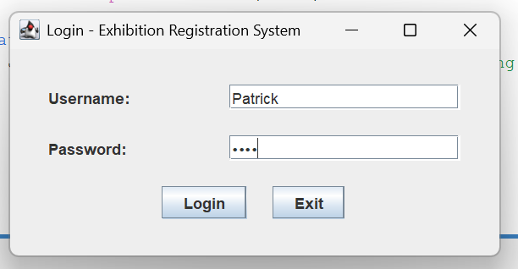

Figure 2: Users Table showing Login Information
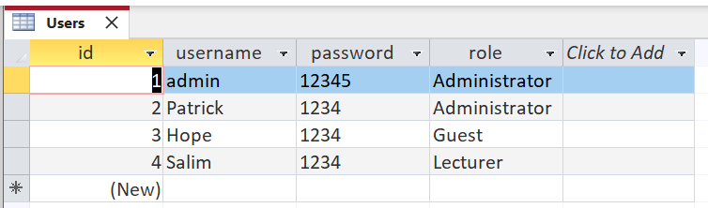

Figure 3: Login Confirmation and Welcome Message
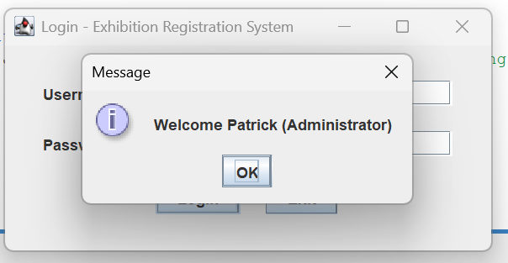

Figure 4: Registration Form Layout
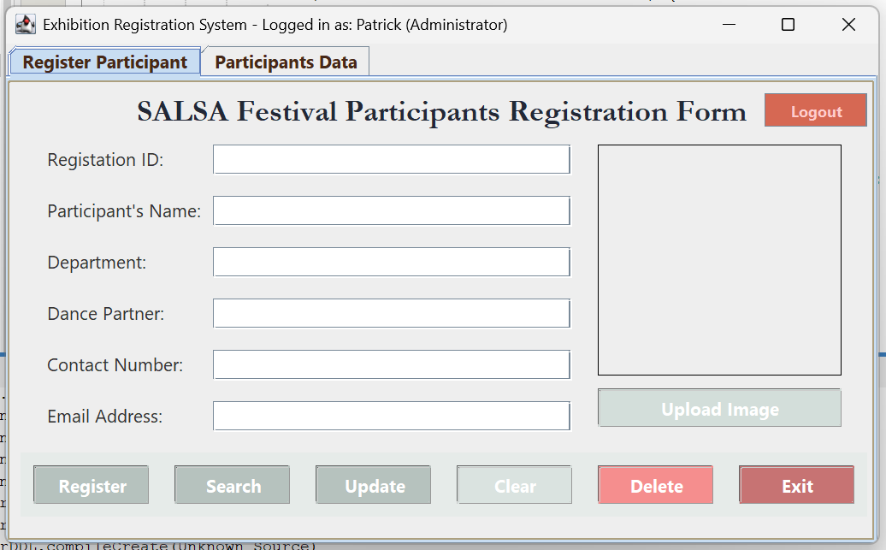
Figure 5: Successful Registration Popup
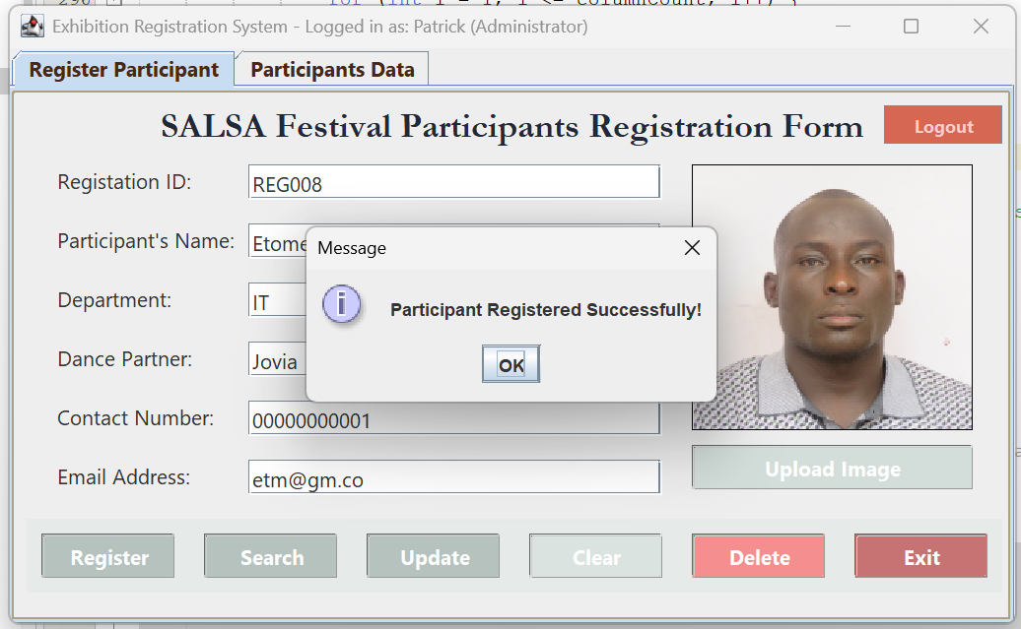
Figure 6: Search Participant Result
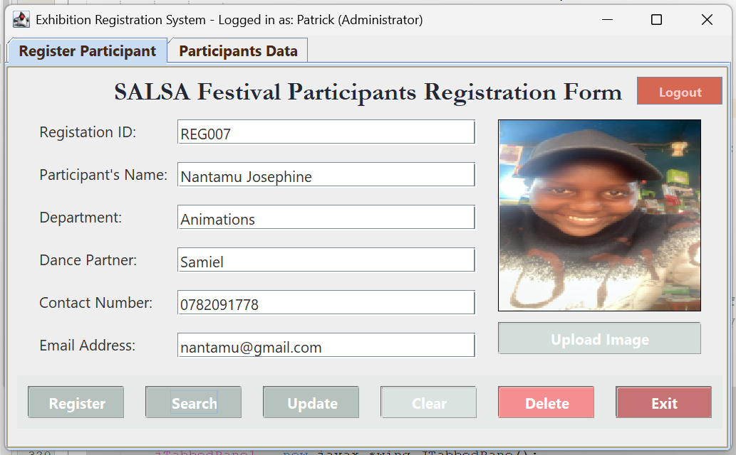
Figure 7: Data table tab
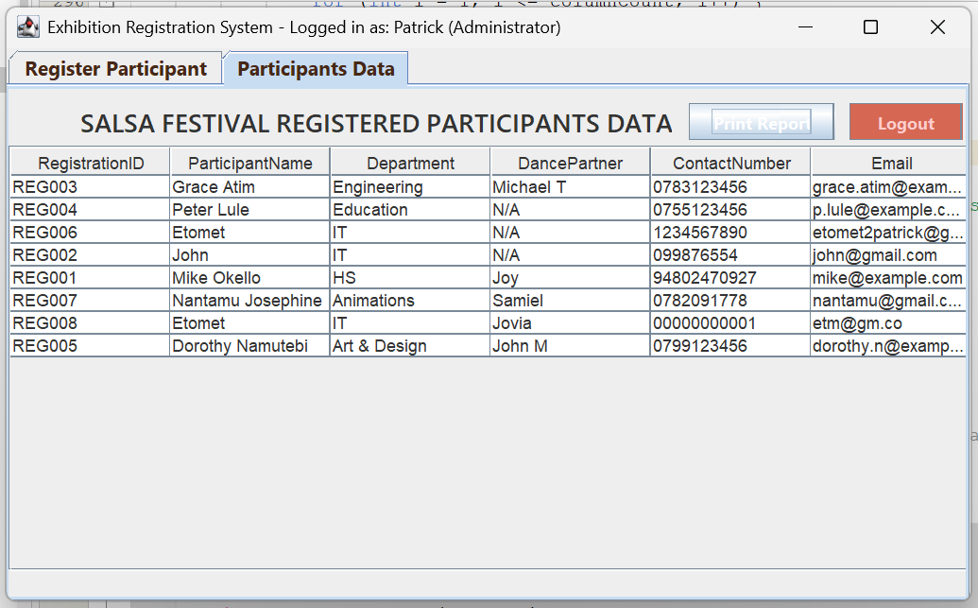

Figure 8: Print Dialogue Box
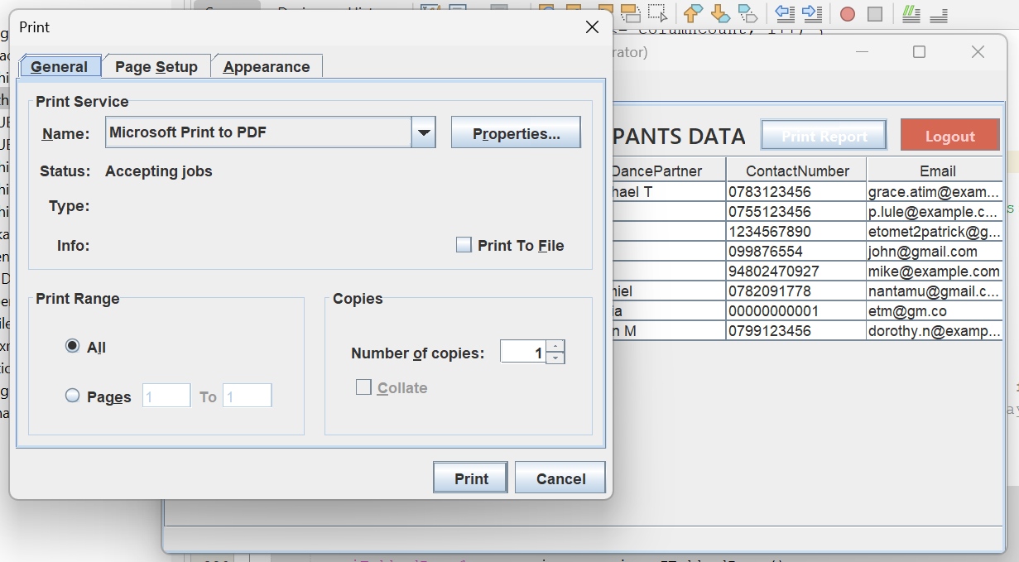
Figure 9: Successful data update Popup
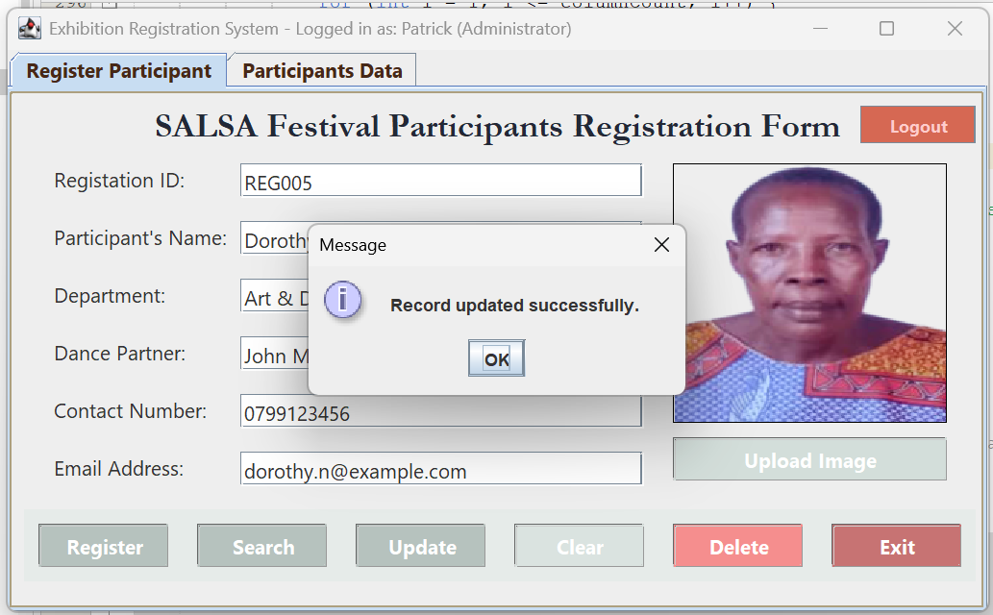

Figure 10: No Record found Popup
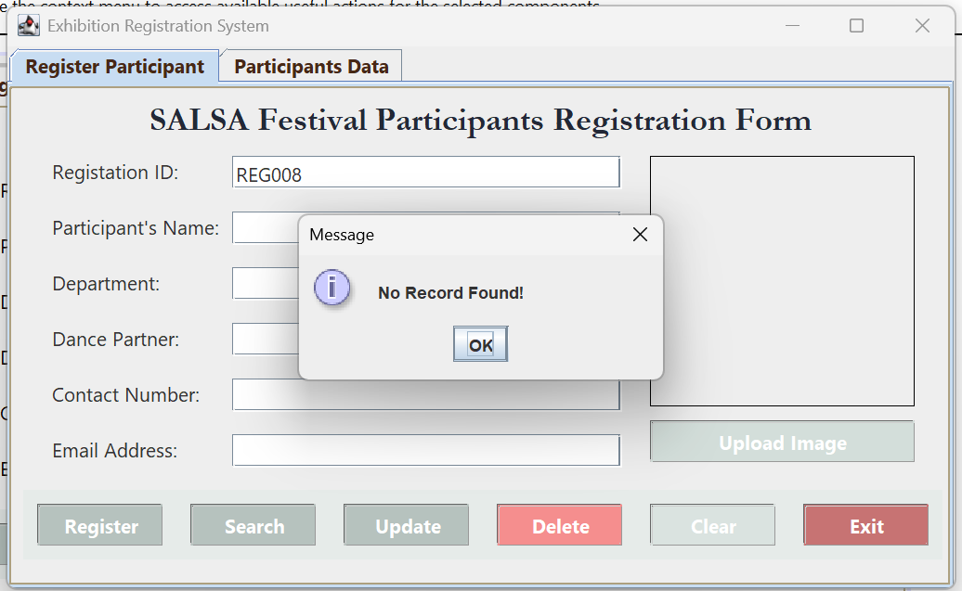

Figure 11: Logout Warning
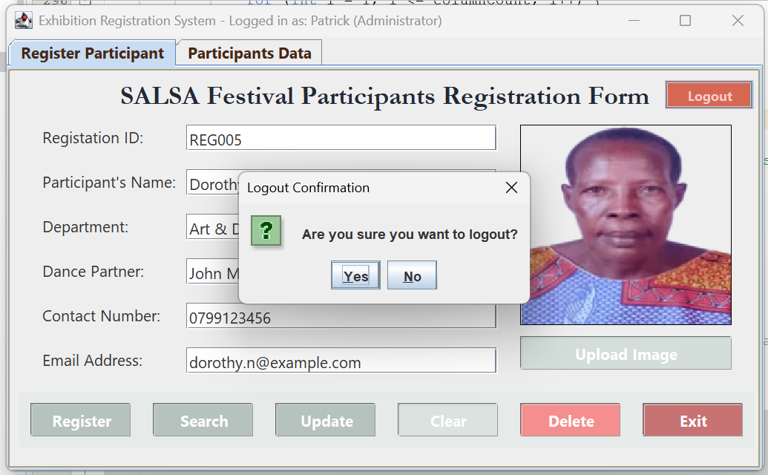

GitHub Repository Link
https://github.com/isaacvictorfenaldo123-sys/ExhibitionRegistrationSystem_VU.git

References
- Oracle Java SE Documentation – https://docs.oracle.com/javase/
- HSQLDB User Guide – http://hsqldb.org/
- NetBeans IDE Documentation – https://netbeans.apache.org/

