Friday; November 6, 2020

9:15. Why a PhD or Graduate School, Why Now?

**REGISTER NOW!**

10:00. Graduate School ***is a job***.

10:30. Graduate School ***is not a job***.

11:20. Working toward mastery: technical skills.

11:50. Working toward mastery: research skills

1:40. Faculty breakout rooms

      

    

++ PL, HCI, SE, ML, NLP, DB, Vision, Robotics, Cybersecurity, Genomics ++

3:05. Non-faculty breakout rooms

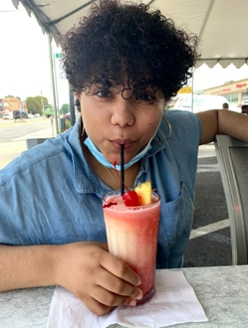 

Yes, No, Maybe, Before, During, After

More Information

<https://phd-recruiting.etosch.w3.uvm.edu/>