**Inputs and Outputs**

The file *invertEIS* executes the inversion algorithm. The inputs to *invertEIS* are:

1. (*fun*) A function which describes the model, in the form of a function handle. The model syntax is outlined in the section **Model Syntax**.
2. (*data*) The data in the form of a matrix of size J x 3, where J is the number of data points. The first column is the angular frequency, the second column is the real part of the impedance, and the third column is the imaginary part of the impedance.
3. (*distType*) Description of the type of distributions in *fun*, in the form of a cell of size L x 1, where L is the number of distributions in the model. You can either specify the type as ‘series’ or ‘parallel’.
4. (*betak*) Initial guesses for the point parameters in *fun*, in the form of a matrix of size K x 1, where K is the number of point parameters.
5. (*Rtaul*) Initial guesses for the distributions in *fun*, in the form of a matrix of size L x 2. The first column are the initial guesses for the resistances associated with the distributions. The second column are the initial guesses for the characteristic timescales associated with the distributions.
6. (*mue*) Initial guess for the log-measurement relative error, in the form of a scalar. The log used in the present work is the natural logarithm.

The outputs to *invertEIS* are:

1. (*modality*) The number of basis functions used to estimate the L-th distribution, in the form of a matrix of size L x 1.
2. (*betak*) Maximum likelihood estimate of the point parameters in *fun*, in the form of a matrix of size K x 3. The first column is the lower 95% credible interval bound, the second column is the maximum likelihood estimate, the third column is the upper 95% credible interval bound.
3. (*Rml*) Maximum likelihood estimates of the resistances associated with the basis functions used to approximate the distributions, in the form of a matrix of size sum(modality) x 1.
4. (*muml*) Maximum likelihood estimates of the log-characteristic timescales associated with the basis functions used to approximate the distributions, in the form of a matrix of size sum(modality) x 1.
5. (*wml*) Maximum likelihood estimates for the log-variance of the log-characteristic timescales associated with the basis functions used in to approximate the distributions.

These are followed by 5 outputs which are only relevant for the authors’ future works. In deference to our industrial partner, we will not describe these outputs in detail, to maintain confidentiality. Users may read a brief description in-file, if so desired. The last two outputs are:

1. (*tl*) Support points for the distributions in *Fl*, in the form of a cell of size L x 1. Each element of the cell contains one set of support points corresponding to that of *Fl*.
2. (*Fl*) Distribution densities, in the form of a cell of size L x 1. Each element of the cell corresponds to one distribution. Thus, tl{1} and Fl{1} describes a discretized form of the first distribution.

We assume that the data is appropriately cleaned, such that it is consistent with the Kramers-Kronig transform [2], and that the parameters of the model are identifiable.

**Example 1: Distribution of Relaxation Time**

**Initial Guesses**

Open the folder *EIS case 1*. Copy over the content to the main folder and load *data_case_1*. You should see a matrix of size 81 x 3 in the workspace:

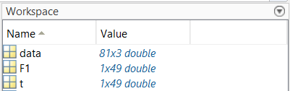

The first column of *data* is the angular frequencies of the data set. The second column is the real part of the impedance. The third column is the imaginary part of the impedance. We may visualize the data on a Nyquist plot:

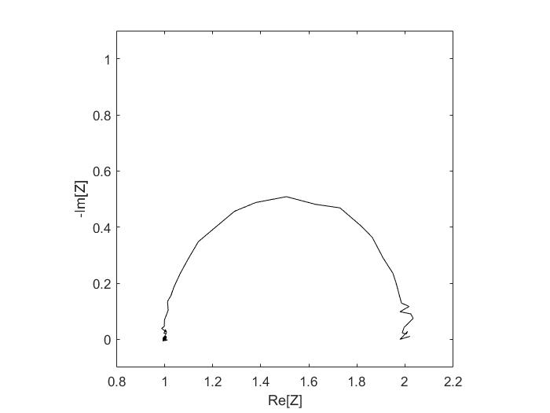

Suppose that we want to fit this data to a model of the form:

$$Z=R_{∞}+\int_{0}^{∞}{\frac{G\left(τ\right)}{1+ωτ}dτ}≡R_{∞}+\int_{-∞}^{∞}{\frac{F\left(t\right)}{1+ω\exp\left(t\right)}dt}$$

The data exhibits an approximately semicircular feature, so we know that the underlying DRT ($F\left(t\right)$) should be approximately Dirac delta. The width of the semicircle gives the mass of the DRT, defined as:

$$\int_{-∞}^{∞}{F\left(t\right)dv}≈1$$

The high-frequency limit gives:

$$R_{∞}≈1$$

If we check the data set, the peak of the semicircle corresponds to $τ≈$ 1. The scatter of the data indicates a log-measurement relative error of approximately -10.5. We now have all the initial guesses we need to run *invertEIS*.

**Writing the Model**

Next, we write a function describing the model:



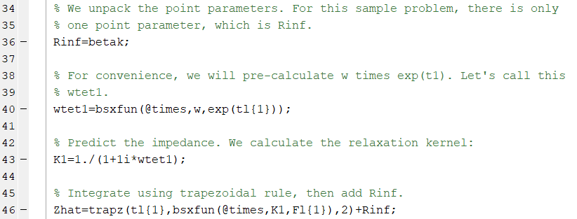

The inputs to this user-defined function is:

1. (*w*) Angular frequencies in the data set, in the form of a matrix of size J x 1.
2. (*betak*) Values for the point parameters in *fun*, in the form of a matrix of size K x 1, where K is the number of point parameters.
3. (*tl*) Support points for the distributions in *Fl*, in the form of a cell of size L x 1. Each element of the cell contains one set of support points corresponding to that of *Fl*.
4. (*Fl*) Distribution densities, in the form of a cell of size L x 1. Each element of the cell corresponds to one distribution. Thus, tl{1} and Fl{1} describes a discretized form of the first distribution.

**Run *invertEIS***

Open *masterFile*. We set the initial guesses:

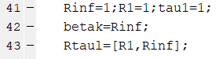



We then specify the distribution types:



Our model consists of a single distribution of the ‘series’ type. The distinction between series and parallel distributions is discussed elsewhere in the literature [1]. We then run *invertEIS*:

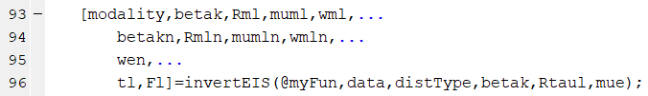

The remainder of the code compares the inversion output with the true underlying distribution, described by F1 and t.

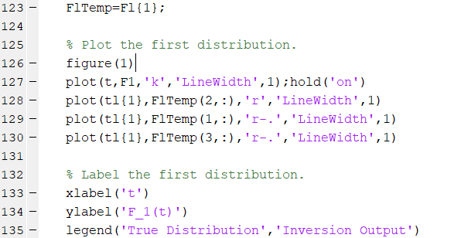

The following result is observed:

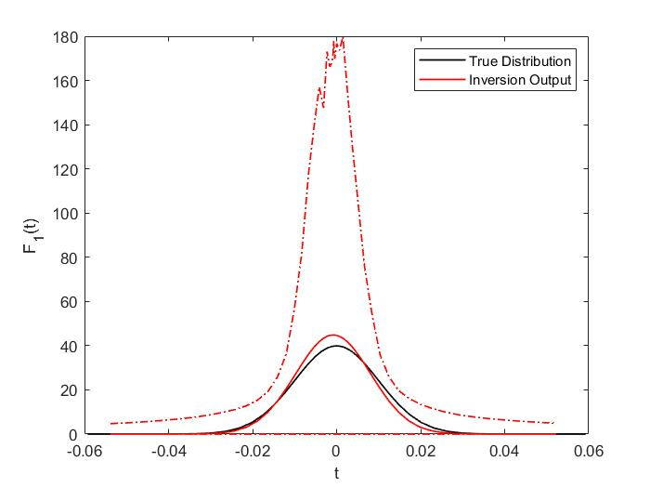

Let us interpret this result. The solid black line is the true distribution, while the solid red line is the inversion output. The top dotted red line is the upper 95% credible interval, while the bottom dotted red line is the lower 95% credible interval.

A possible misconception should be addressed here. The 95% credible interval indicates that, given the noise level inferred from the data via the given model, 95% of all repeat experiments will be bounded within the credible interval. It does not mean that, for example, a distribution of the form $F\left(t\right)$ = 0 is within the credible interval. Observe that the output *Rml*, which implies that the total area under this distribution is bounded within the range 1.001 and 1.011.

**Abbreviated Code for DRT and DDT**

For convenience, we have provided shortcut codes for distribution of relaxation time and distribution of diffusion time models, given as *DRT*, *blockingDDT*, *infiniteDDT*, and *transmissiveDDT*. The nomenclature of these models can be found in [1]. For DRT and transmissive DDT, good initial guesses can be obtained without user input, and the distribution type (*distType*) is obvious. We write the following:

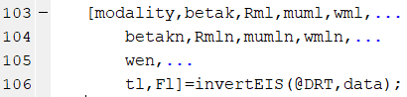

We write down the function name without providing any initial guesses. For *blockingDDT* and *infiniteDDT*, initial guesses and distribution types still must be provided.

**Example 2: More Complex Models**

More complex models can be used by modifying the user-defined function *myFun*. Open *EIS case 5*. Copy over the content to the main folderand load *data_case_5*. As before, visualize the data:

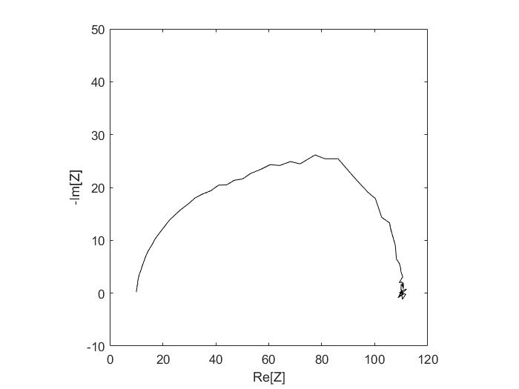

Suppose that we know *a priori* the appropriate form of the model. This is not wholly unreasonable; for many experimental setups, we have a general understanding of the underlying physics, but not the value of parameters in the underlying physics, and certainly not the distribution of those parameter values. In this case, the model is suspected to be the Randles circuit:

$$Z=R_{∞}+\int_{-∞}^{∞}{\frac{F_{1}\left(t\right)}{\frac{1}{1+\frac{1}{R_{1}Y_{2}}}+iω\exp\left(t\right)}dt}$$

Here $Y_{2}$ is the admittance arising from the diffusive component of the Randles circuit, also distributed:

$$Y_{2}=\int_{-∞}^{∞}{\frac{\sqrt{iω\exp\left(t\right)}}{\tanh\left(\sqrt{iω\exp\left(t\right)}\right)}F_{2}\left(t\right)dt}$$

Based on the data, it is clear that $R_{∞}$ is approximately 10; as an initial guess, we might try:

$$\int_{-∞}^{∞}{F_{1}\left(t\right)dt}\sim 50$$

$$\int_{-∞}^{∞}{F_{2}\left(t\right)dt}\sim \frac{1}{50}$$

Note that ${\left[\int_{-∞}^{∞}{F_{2}\left(t\right)dt}\right]}^{-1}$ gives the width of the semicircular feature associated with diffusion. From the literature, it is known that the characteristic timescale associated with the relaxation process (the DRT component) is lower than that associated with the diffusion process (the DDT component). The overlap between the relaxation and the diffusion features on the Nyquist plot indicates similar timescales; based on the angular frequency associated with the minimum Im[Z], we might guess a relaxation timescale of 0.001 and a diffusion timescale of 0.02.

Based on the scatter of data, one might also guess a log-measurement relative error of approximately -10.

**Writing the Model**

The syntax for the user-defined input is the same as before:



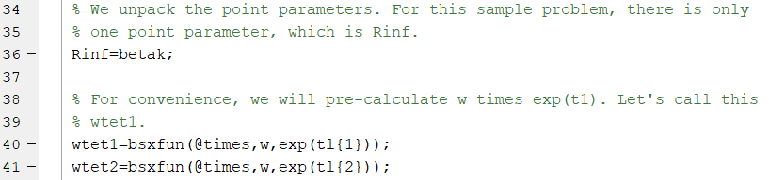

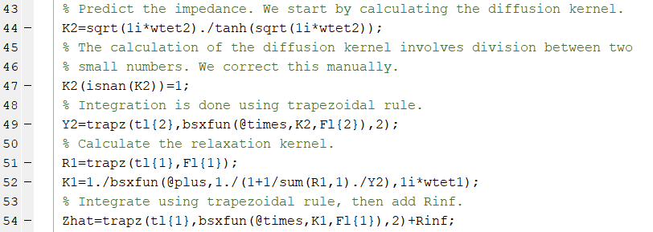

However, we now have two distributions. The code we wrote requires that the characteristic timescale of the first distribution is lower than that of the second. This is true for more complicated models; the first distribution must have a lower characteristic timescale than the second, which is in turn lower than the third, etcetera.

**Run *invertEIS***

Open *masterFile*. Our prior observation of the data set yields the following initial guesses:

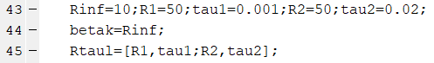



We then define the types of distribution we are using:

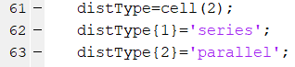

Recall that the relaxation process must correspond to the first distribution in *myFun*, as it is the process with the lower characteristic timescale. Thus, we define the type of the first distribution as ‘series’. The diffusion process corresponds to the second distribution, as it has the higher characteristic timescale, and the type is ‘parallel’ [1].

Having done all the preparatory work, we only need to execute the command:

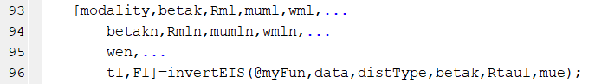

The remainder of *masterFile* deals with data visualization:

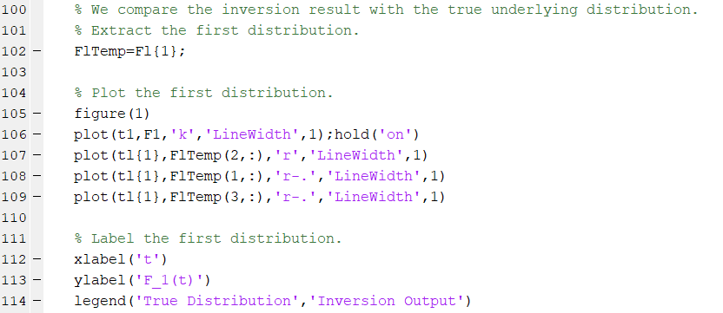

Note that the outputs *tl* and *Fl* are cells of size L x 1. Thus, we need to load those elements prior to further manipulation.

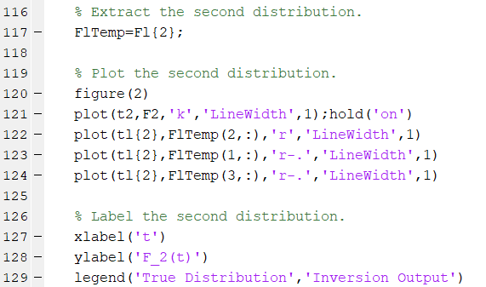

**Further Questions**

The author can be contacted at [suryaeff@mit.edu](mailto:suryaeff@mit.edu) for further instructions for using the code or if you found any error.

**References**

1. Song, Juhyun, and Martin Z. Bazant. "Electrochemical impedance imaging via the distribution of diffusion times." *Physical review letters* 120.11 (2018): 116001.
2. Urquidi-Macdonald, Mirna, Silvia Real, and Digby D. Macdonald. "Applications of Kramers—Kronig transforms in the analysis of electrochemical impedance data—III. Stability and linearity." *Electrochimica Acta* 35.10 (1990): 1559-1566.