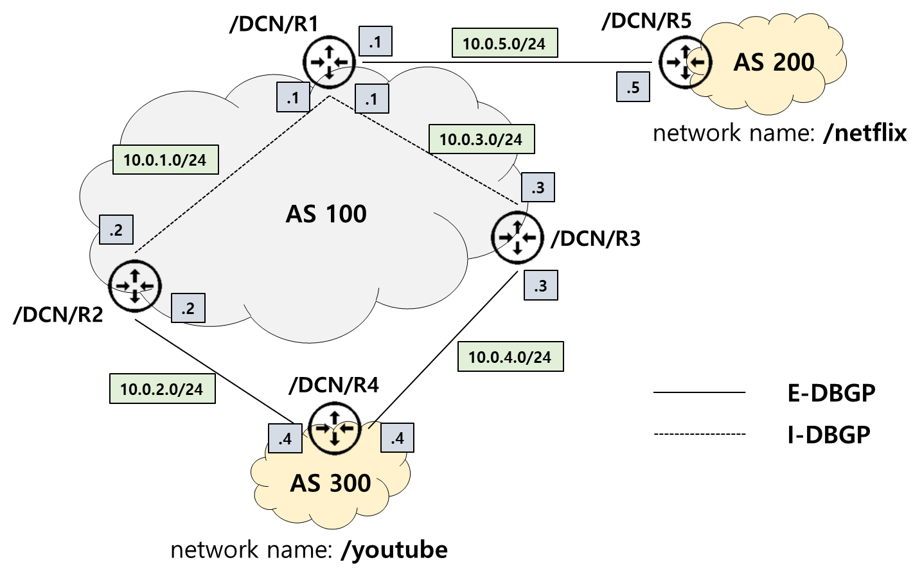

# 1. /DCN/R1 Configuration

## 1) MW-NFD Face Creation

nfdc face create udp4://10.0.1.2

nfdc face create udp4://10.0.3.3

nfdc face create udp4://10.0.5.5

## 2) DCN-BGP Configuration

bgpd> enable

bgpd# configure terminal

bgpd(config)# router dbgp 100

bgpd(config-router)# bgp router-name /DCN/R1

bgpd(config-router)# neighbor /DCN/R2 remote-as 100 uri udp4://10.0.1.2:6363

bgpd(config-router)# neighbor /DCN/R3 remote-as 100 uri udp4://10.0.3.3:6363

bgpd(config-router)# neighbor /DCN/R5 remote-as 200 uri udp4://10.0.5.5:6363

bgpd(config-router)# neighbor /DCN/R2 route-reflector-client

bgpd(config-router)# neighbor /DCN/R3 route-reflector-client

# 2. /DCN/R2 Configuration

## 1) MW-NFD Face Creation

nfdc face create udp4://10.0.1.1

nfdc face create udp4://10.0.2.4

## 2) DCN-BGP Configuration

bgpd> enable

bgpd# configure terminal

bgpd(config)# router dbgp 100

bgpd(config-router)# bgp router-name /DCN/R2

bgpd(config-router)# neighbor /DCN/R1 remote-as 100 uri udp4://10.0.1.1:6363

bgpd(config-router)# neighbor /DCN/R4 remote-as 300 uri udp4://10.0.2.4:6363

bgpd# show dcn bgp

bgpd# show dcn bgp neighbors

bgpd# show dcn bgp summary

# 3. /DCN/R3 Configuration

## 1) MW-NFD Face Creation

nfdc face create udp4://10.0.3.1

nfdc face create udp4://10.0.4.4

## 2) DCN-BGP Configuration

bgpd> enable

bgpd# configure terminal

bgpd(config)# router dbgp 100

bgpd(config-router)# bgp router-name /DCN/R3

bgpd(config-router)# neighbor /DCN/R1 remote-as 100 uri udp4://10.0.3.1:6363

bgpd(config-router)# neighbor /DCN/R4 remote-as 300 uri udp4://10.0.4.4:6363

# 4. /DCN/R4 Configuration

## 1) MW-NFD Face Creation

nfdc face create udp4://10.0.2.2

nfdc face create udp4://10.0.4.3

## 2) DCN-BGP Configuration

bgpd> enable

bgpd# configure terminal

bgpd(config)# router dbgp 300

bgpd(config-router)# bgp router-name /DCN/R4

bgpd(config-router)# neighbor /DCN/R2 remote-as 100 uri udp4://10.0.2.2:6363

bgpd(config-router)# neighbor /DCN/R3 remote-as 100 uri udp4://10.0.4.3:6363

bgpd(config-router)# network /youtube

bgpd(config-router)# neighbor /DCN/R3 weight 1000

bgpd(config-router)# neighbor /DCN/R4 weight 3000

# 5. /DCN/R5 Configuration

## 1) MW-NFD Face Creation

nfdc face create udp4://10.0.5.1

## 2) DCN-BGP Configuration

bgpd> enable

bgpd# configure terminal

bgpd(config)# router dbgp 200

bgpd(config-router)# bgp router-name /DCN/R5

bgpd(config-router)# neighbor /DCN/R1 remote-as 100 uri udp4://10.0.5.1:6363

bgpd(config-router)# network /netflix