**Problem Solving & Critical Thinking**

1. **Define the problem:**

“A man finds himself on a riverbank with a cat, a parrot and a bag of seed. He needs to transport all three to the other side of the river in his boat. However, the boat has room for only the man himself and one other item (either the cat, parrot or seed). In his absence, the cat could eat the parrot, and the parrot would eat the bag of seed. Show how he can get all the passengers to the other side, without leaving the wrong ones alone together.”

The man needs to bring three items across a river. Those items are a cat, a parrot and a seed. The cat will eat the bird, the bird will eat the seed and he can only carry one passenger at a time. How can he complete this task, without allowing them to eat each other?

1. **Break the problem apart:**

Point A = Beginning point

Point B = End point

Cat will eat bird and cannot be left alone with bird

Bird will eat seed and cannot be left alone with bird

1. **Identify potential solutions:**

Man could take parrot first, as cats can be left alone with the bag of seed.

Man could take cat, let bird fly and come back for the bag of seed.

Man could take cat, leave bird and seed, and then return for bird

Man could take the bag of seed, and then come back for cat

1. **Evaluate each potential solution:**

A

1. **Choose a solution and develop a plan to implement it.**

A

1. **Define the problem:**
2. **Break the problem apart:**
3. **Identify potential solutions:**
4. **Evaluate each potential solution:**
5. **Choose a solution and develop a plan to implement it.**

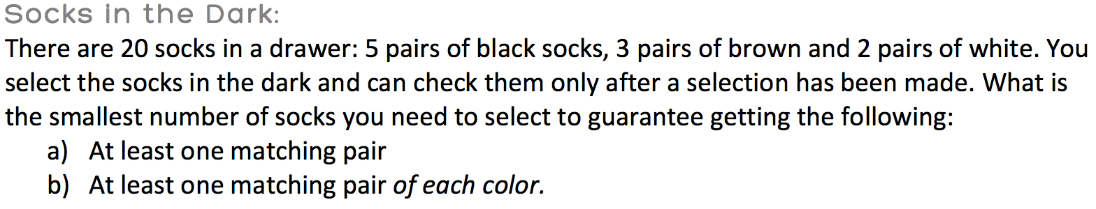

1. **Define the problem:**
2. **Break the problem apart:**
3. **Identify potential solutions:**
4. **Evaluate each potential solution:**
5. **Choose a solution and develop a plan to implement it.**

