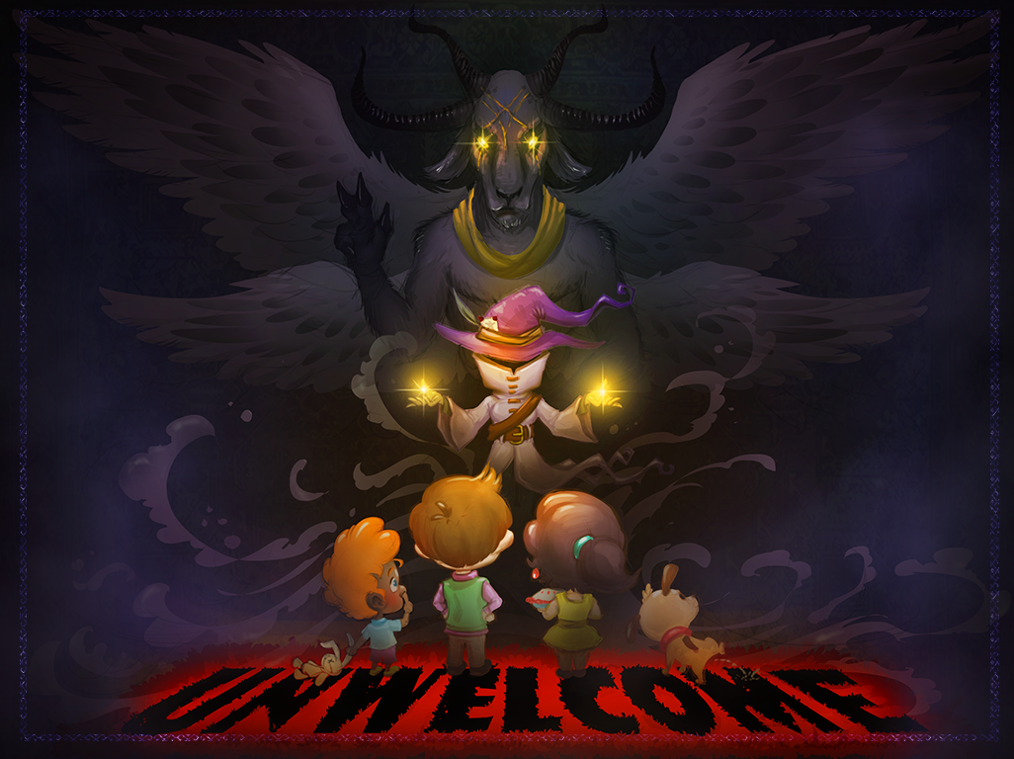

Usability Report

BleB Studios

Sprint 4 – Beta

November 13, 2017

|  |  |  |
| --- | --- | --- |
| **Position Title** | **Name** | **Signature** |
| Level Designer/Producer | Bryan H. |  |
| Artist I | Lexi C. |  |
| Programmer | Emily R. |  |
| Level Designer | Blake P. |  |
| Artist II | Clayton D. |  |

Contents

Summary Overview 3

Methodology 3

Major Takeaways 3

Challenge 3

Conveyance 3

Engagement 3

Playtest Data 4

Demographics 4

Charts 4

Analysis 4

Challenge 5

Charts 5

Qualitative Feedback 6

Analysis 6

Conveyance 7

Charts 7

Qualitative Feedback 8

Analysis 8

Engagement 10

Charts 10

Qualitative Feedback 11

Analysis 11

Major Issues and Bugs 12

Appendix: Raw Notes, Qualitative Feedback, and Observations 13

Raw Notes 13

Qualitative Feedback 14

Observations 17

# Summary Overview

## Methodology

This playtest consisted of two playtesting sessions, held in the Hughes-Trigg Student Center and the Fondren Library Center on the Southern Methodist University campus. Testing took place between 9:30 AM and 12:30 PM on a Monday, while classes were in session. Developers asked potential playtesters to test UNWelcome as they entered the spaces. Potential playtesters were invited to play UNWelcome for as long as they wanted to play and were offered donuts for playtesting. The testing took place alongside 12 other game testing sessions, in a public setting. Testers were observed, but not recorded, and no strict notes were taken on each playtest. Due to an unanticipated bug with the tutorial, some players needed the assistance of the developers to progress through the tutorial. Testers were asked to complete an 11 question usability survey after playing. 22 testers played UNWelcome and completed the survey.

## Major Takeaways

### Challenge

* The most challenging aspect of our game seemed to be understanding the different kinds of demons. This was particularly difficult for people who were not regular gamers.
* We did not have enough tutorial levels to effectively explain our mechanics. This led to a difficulty spike between the tutorials and the first “real” level, which deterred several players.

### Conveyance

* Players had a difficult time understanding how to follow the tutorial, which led to many players encountering the bug that broke the tutorial level.
* Players had trouble understanding the functionality of the attract demon and the spring demon.
* The indicators for the range of the turrets and the neighbor’s walking distance confused players when they appeared.
* Several players initially thought the witch was the intruder, and the neighbors were their player character

### Engagement

* There was a critical issue that many players encountered in the second tutorial level, which prevented them from being able to complete the tutorial. This killed many player’s interests in the game because they did not understand the mechanics.
* Engagement in the game was strongly linked to people’s understanding after coming out of the tutorial levels - people who understood the tutorial spent a long time playing our game, and attempted to finish the game, while people who didn’t understand the tutorial for the most part gave up the first time they failed a level.
* People who enjoyed puzzle games seemed to enjoy our game the most and enjoyed figuring out the nuances of the demons’ functionality.

# Playtest Data

## Demographics

### Charts

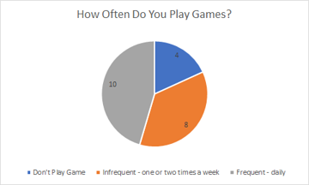 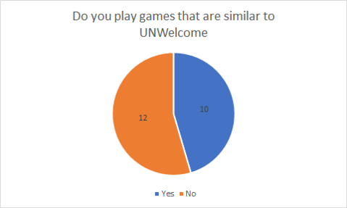

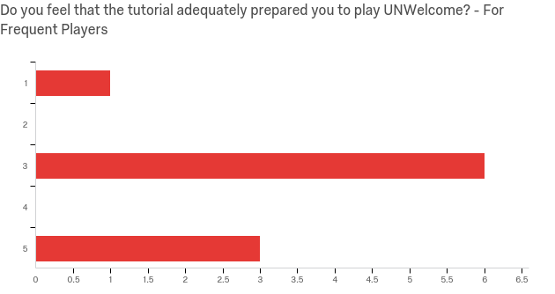

### Analysis

In our testing pool, most testers identified as gamers, with less than 10% saying that they did not play games. Among the players who did play games, roughly half said they played games daily, while the other half played games only a few times per week. Just over half of our players said that they regularly played other puzzle/tower defense games, similar to UNWelcome.

People who played games regularly had a better time understanding the tutorial, and most of the players who did not understand the tutorial did not consider themselves regular gamers. We have concluded that the tutorial is not accessible to new gamers.

## Challenge

### Charts

Responses to survey question, regarding demon functionality:

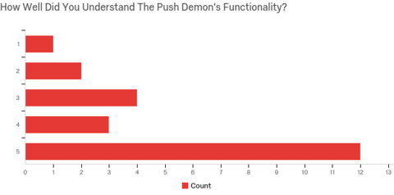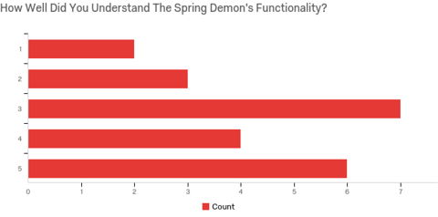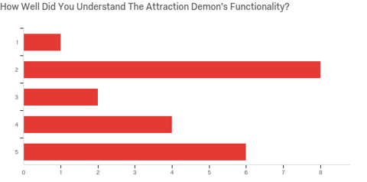

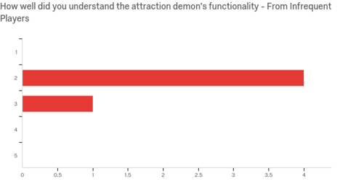

### Qualitative Feedback

Understanding demon functionality was the most challenging aspect for players. Most players understood the push demon, with 65% of the testers rating their understanding of the push demon a 4 or higher (on a scale of 1 to 5). The attraction demon was much more difficult for players to understand, with over 55% of responders rating their understanding to be a 3 or lower. When the results were filtered, there was a clear correlation between players who did not play games regularly, and a poor understanding of the attraction demon. This suggests that our attraction demon is particularly difficult for novice gamers to understand.

While player responses suggested a common understanding of the spring demon, many players were observed using spring demons as shorter-range push demons, rather than the intended use of springing over obstacles. This suggests that some players *thought* they understood the spring demon but did not fully grasp the concept of springing over obstacles, with one player even saying “The spring function was confusing. It would be cool if it could spring over stuff.”

In our observations of testers, there seemed to be a sharp difficulty spike between the tutorial and the first real level of the game, level 3. Several players were observed struggling to understand where to place demons in the level, and many stopped playing after they failed this level.

### Analysis

We are happy that players seemed to enjoy exploring the mechanics of the demons, but we believe that the challenge should be more in finding interesting combinations with the demons, rather than understanding the base mechanics by trial and error. We believe that making the tutorial levels more accessible to the player would help to achieve this, as players will have a better understanding of the tower mechanics when they begin playing levels. We will be adding an intermediate level between the tutorials and level 3, which will also address the difficulty spike that we observed.

## Conveyance

### Charts

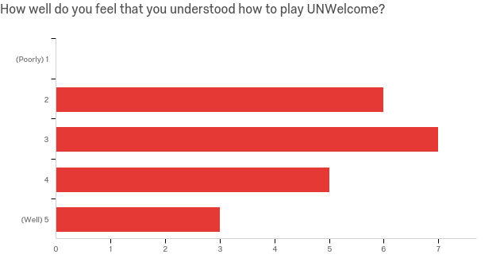

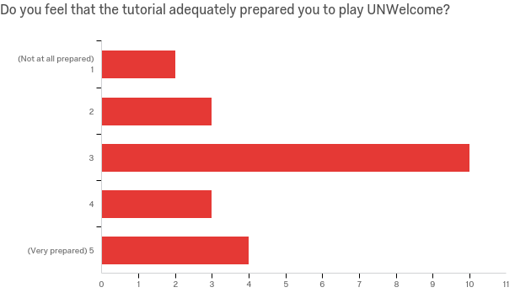

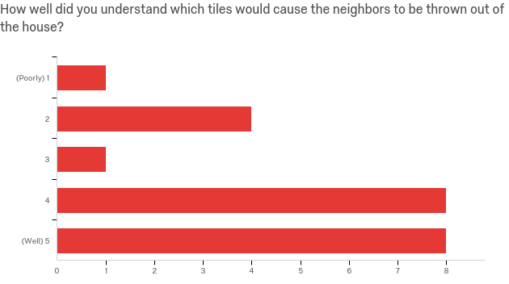

### Qualitative Feedback

Players had a difficult time understanding how to follow the tutorial levels, which led to a shaky understanding of the game as they moved into real levels. Many players were seen tapping and swiping indiscriminately on the play area, and ignoring the instructions in the side panel. This behavior exposed a bug that would break the tutorial levels, which only added to players’ confusion.

The range indicators for demons and neighbors caused a lot of confusion for players. Most players attempted to swipe on the screen when they appeared and did not understand that they were displaying the range of demons, and the number of steps the neighbors would walk on the next turn. Additionally, very few players realized that they could display the ranges of the demons, indicating that they either forgot, or didn’t read that section of the tutorial.

While player feedback suggested that they understood which tiles could be used as exits, many players were observed ignoring chimneys, trapdoors, and doors while playing the game. This suggests that players might have believed that only windows were the only exits.

We observed that some players assumed that they were playing as the neighbor when they first entered the game. Most players were able to figure out their character by the end of the tutorials.

Additionally, players struggled with understanding the functionality of the attract and spring demon. This is in part a conveyance issue, because players could not deduce what the demons might do based on their icons.

### Analysis

Most players seemed to understand the idea of the game, but had trouble understanding what to do, especially at the start of the game. This will be helped with minor adjustments to the UI and some game elements.

Our UI is not as user-friendly as we hoped it would be. To fix this, we will be rearranging buttons, making clickable buttons more distinct, and using more motion to indicate what the player should be doing during the tutorial levels.

Additionally, using range indicators was not as intuitive as we had hoped - very few players knew that they could display the range of the demons by tapping and holding on the demons, and when they did encounter the range indicators accidentally, they did not understand what the indicators meant. We will add a toggle to the side panel that allows players to view range indicators for everything in the level, and will explain this functionality clear in the tutorial.

Several players seemed to believe that windows were the only exits in the levels, especially towards the start of the game. Players that reached later levels, which have fewer window tiles, were able to figure out that other exits could be used, but we will be including a chimney and a trapdoor during the tutorial levels, so that players will be able to identify these as exits earlier in the game.

In general players seemed to enjoy the theme of our game, but some were confused by it. For instance, a few players initially thought that they were playing as the neighbor, and that the witch was the “enemy” of the game. We will attempt to make this clearer to players with minor changes to the witch’s design. Ideally, we would solidify the “story” of the game by adding more personality to the witch in the tutorial and splash screens, and including a short animatic before the start of the game. Unfortunately, this is outside of the scope of what we can do for this project.

## Engagement

### Charts

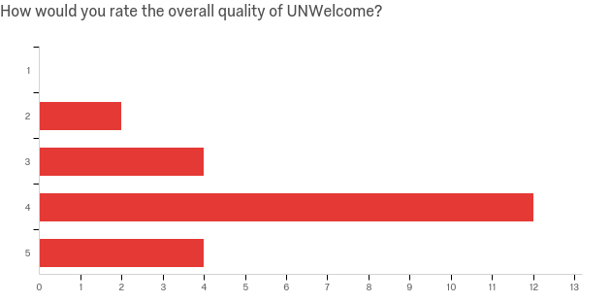

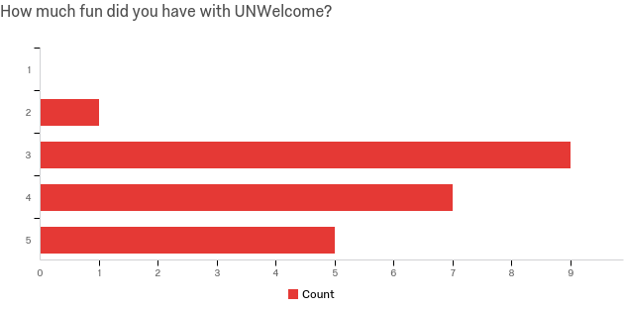

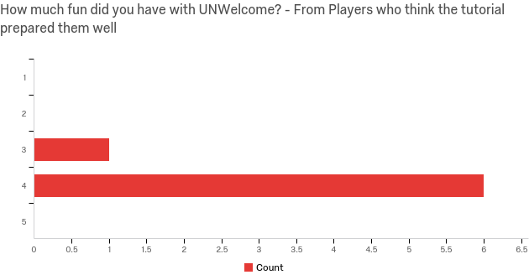

### Qualitative Feedback

Most players were impressed with the quality of the game, with most players rating the quality with a 4 out of 5. However, most testers responded with a 3 out of 5 when asked how much fun they had with the game.

We believe that understanding the tutorial was critical for enjoying the remainder of the game. In observation, most players who were able to understand the tutorial played the game for a long time, and attempted to complete the game, indicating a high level of engagement. However, players who struggled to understand the tutorial, or encountered a bug that broke the second tutorial, seemed very confused when they began level three. These players did not seem to understand the basic flow of the game, and seemed overwhelmed by the level. Many of these players stopped playing the game when they lost level 3. In analyzing the data from our survey, we noticed that of the seven players who thought the tutorial prepared them for the game, six of them responded with a 4 out of 5 when asked how much fun they had playing UNwelcome. This supports our theory that understanding the tutorial was very important for a player to enjoy the game.

On the contrary, some players enjoyed figuring out the mechanics for themselves. One tester wrote: “I enjoyed this game a lot. I would have to play it for a little while to fully understand how to be good at it, but I would enjoy learning how to play.” Many testers who seemed to enjoy figuring out the mechanic for themselves also enjoyed puzzle games. We believe these testers represent the core demographic we were hoping to target.

### Analysis

We believe that our target demographic for engagement is being hit, but too narrowly. Players that were very enthusiastic about the game enjoyed figuring out the demon mechanics for themselves, which we believe represents the “Explorer” demographic we were hoping to attract. However, several players who said that they enjoyed puzzle and tower defense games did not have fun with the game, citing frustration in understanding the mechanics. We want our game to be clear enough for most players to understand *how* to explore the mechanics, and we believe that this will be best resolved by adjusting the tutorials to be more accessible. We believe that making the tutorial more visual and less dependent on the text will be an effective way to help us reach a broader demographic, while retaining the players who already enjoyed the game. We have seen a clear correlation between players who understood the tutorial and players who enjoyed playing UNWelcome, so we are aiming to help more players understand the mechanics earlier in the game.

# Major Issues and Bugs

|  |  |  |
| --- | --- | --- |
| Severity Rating | Severity Category | Description |
| 4 | Unusable | Tutorial levels break if the player does not follow the instructions |
| 3 | Severe | Add one tutorial level to teach spring demon and attraction demon separately. |
| 3 | Severe | Learning curves climbs after the tutorial. Need to change the order of the levels to make the experience more fluent. |
| 3 | Severe | The tutorial text does not explain the game mechanics well. Need more motions and graphics to help explain. |
| 3 | Severe | The summoning UI get blocked by the side panel UI when players try to summon a demon close to the border. |
| 3 | Severe | Most of the players do not know the movement range of the neighbors. |
| 3 | Severe | Players have difficulty in understanding the cooldown mechanics |
| 2 | Moderate | Range indicators and directional indicators appear underneath neighbors (known) |
| 2 | Moderate | Most of the players do not know the attack range of the demons |
| 2 | Moderate | Bug: Demon icon stays after it gets sold |
| 2 | Moderate | Some of the players can not differentiate the demons from the background image. |
| 2 | Moderate | The tutorial is too wordy. Players tend to skip the text tutorial and feel frustrated when they try to play on their own. |
| 2 | Moderate | Some of the players do not know what to do at in tutorial levels. The next step arrow should look more clickable. |
| 2 | Moderate | The range indicator confuses players - the players try to swipe on the indicator. |
| 1 | Irritant | The continuous play button is available, but no player uses it. |
| 1 | Irritant | Players want more demons in the game. |
|  |  |  |
|  |  |  |
|  |  |  |

# Appendix: Raw Notes, Qualitative Feedback, and Observations

### Raw Notes

Notes were taken by developers during playtesting, but untimed.

* Tester believed the witch was the bad guy
* Tester attempting to click on inactive buttons during tutorial
* Developer note : Players should not be able to exit building GUI in the tutorial – this makes the tutorial appear broken
* Tester seems to think that windows are the only exit tiles – ignoring chimneys and trapdoors
* Bug (Known) : Indicators appearing under neighbors
* Players are tapping on the play area during tutorials, especially when the path is highlighted in tutorial 1
* Player seems to be placing attraction demons facing backwards – seems to expect them to be facing the other direction.
* While playing tutorial, players do not seem to notice text appearing in the sidebar, especially after placing the first demon. Get stuck when they have to click “next” button on the text.

### Qualitative Feedback

Responses to open-ended questions on our survey have been recorded below.

Question 1: Roughly how often do you play games?

|  |  |
| --- | --- |
| Responder # | Response |
| 1 | Daily |
| 2 | Everyday barring busy days so minimum like 4 days a week |
| 3 | Everyday |
| 4 | A couple hours a day |
| 5 | daily |
| 6 | Every other day |
| 7 | Almost daily |
| 8 | Not often |
| 9 | never |
| 10 | every day of my life |
| 11 | very often. practically daily |
| 12 | All the time! |
| 13 | weekly, almost daily. |
| 14 | 5hrs |
| 15 | Probably 2-3 hours a day... minimum |
| 16 | everyday |
| 17 | I don't |
| 18 | Once per year |
| 19 | Three times a week |
| 20 | 1-2 hours per week |
| 21 | Not often |

Question 2: If you do play games, do you play games that are similar to UNWelcome?

|  |  |
| --- | --- |
| Responder # | Response |
| 1 | Yes, tower defense games like gemcraft or bloons. Felt more like a puzzle though. |
| 2 | I do like turn based games like fire emblem and xcom so the strategic tiling was up my alley |
| 3 | Yes |
| 4 | I don't. I play RPGs mostly |
| 5 | no |
| 6 | Sometimes! Many times I will play roguelikes or puzzle games similar |
| 7 | Sometimes |
| 8 | No |
| 9 |  |
| 10 | sometimes |
| 11 | puzzle games on my phone |
| 12 | I used to play tower defense, but nothing else like that! |
| 13 | Not usually |
| 14 | Maybe 1 |
| 15 | In art direction, yes. In gameplay, not really |
| 16 | yes |
| 17 | No |
| 18 | No. Usually strategy games |
| 19 | No |
| 20 | Not often |
| 21 | No |

Questions 3 – 10 were likert questions, and have been recorded in charts in the playtest data section.

Question 11: If you do play games, do you play games that are similar to UNWelcome?

|  |  |
| --- | --- |
| Responder # | Response |
| 1 | I didn't like how if you sold a demon before it was used in a turn, you would only receive back a part of the cost. I'm not sure that the health also being the mana bar was well explained, but it seems common enough in other games that it may not need to be taught to the players. Also, the paths that enemies are on could be made a little bit more illuminated/obvious. |
| 2 | The spring demon was invaluable in the later levels, but it's range seemed counter intuitive. I would need it placed and facing on the opposite wall to the one I wanted it to vault someone over. Once I understood it I felt much more satisfied with the game, but I felt hamstrung until then |
| 3 | The attraction direction was reversed to what I expected |
| 4 | The first level, I thought a villager was my character and the witch was a demon. Also tower defense is not my favorite genre but that has nothing to do with the game design. |
| 5 |  |
| 6 |  |
| 7 | the second level |
| 8 | Just confused/frustrated on how the neighbors would be affected when there were multiple in a row |
| 9 | not really fustrated just confused |
| 10 | i didn't understand the recharge time for the demons but maybe i'm just stupid |
| 11 | 1: bugs with deleted towers being displayed 2: sometimes hard to distinguish towers from background elements |
| 12 | I enjoyed this game a lot. I would have to play it for a little while to fully understand how to be good at it, but I would enjoy learning how to play! |
| 13 | Last level hard to track. The spring function was confusing. It would be cool if it could spring over stuff. |
| 14 | Some of the bugs |
| 15 | I feel like the game would benefit from more demon variety, as the spring ddemons abilities were overshadowed by the other two demons |
| 16 |  |
| 17 |  |
| 18 |  |
| 19 | There was a small tutorial glitch and taking away the demons in some areas had a glitch as well |
| 20 | tutorial needs a lot of work, once the bugs are fixed in the tutorial, the game will be great and easier to understand |
| 21 | Animation is ugly |

### Observations

No timed observations were recorded during this playtesting session. All observations have been recorded as raw notes (see above).

|  |  |  |  |
| --- | --- | --- | --- |
| Time | Tester/ Game Action | Expressions | Tester Comments |
|  |  |  |  |
|  |  |  |  |
|  |  |  |  |
|  |  |  |  |
|  |  |  |  |
|  |  |  |  |
|  |  |  |  |
|  |  |  |  |
|  |  |  |  |
|  |  |  |  |
|  |  |  |  |
|  |  |  |  |
|  |  |  |  |
|  |  |  |  |
|  |  |  |  |
|  |  |  |  |
|  |  |  |  |
|  |  |  |  |
|  |  |  |  |
|  |  |  |  |
|  |  |  |  |
|  |  |  |  |
|  |  |  |  |
|  |  |  |  |
|  |  |  |  |
|  |  |  |  |
|  |  |  |  |
|  |  |  |  |
|  |  |  |  |
|  |  |  |  |
|  |  |  |  |
|  |  |  |  |
|  |  |  |  |
|  |  |  |  |
|  |  |  |  |
|  |  |  |  |
|  |  |  |  |
|  |  |  |  |
|  |  |  |  |
|  |  |  |  |
|  |  |  |  |
|  |  |  |  |
|  |  |  |  |
|  |  |  |  |
|  |  |  |  |
|  |  |  |  |
|  |  |  |  |
|  |  |  |  |
|  |  |  |  |
|  |  |  |  |
|  |  |  |  |
|  |  |  |  |
|  |  |  |  |
|  |  |  |  |
|  |  |  |  |
|  |  |  |  |
|  |  |  |  |
|  |  |  |  |
|  |  |  |  |
|  |  |  |  |
|  |  |  |  |
|  |  |  |  |
|  |  |  |  |
|  |  |  |  |
|  |  |  |  |
|  |  |  |  |
|  |  |  |  |
|  |  |  |  |
|  |  |  |  |
|  |  |  |  |
|  |  |  |  |
|  |  |  |  |
|  |  |  |  |
|  |  |  |  |
|  |  |  |  |
|  |  |  |  |
|  |  |  |  |
|  |  |  |  |
|  |  |  |  |
|  |  |  |  |
|  |  |  |  |
|  |  |  |  |
|  |  |  |  |
|  |  |  |  |
|  |  |  |  |
|  |  |  |  |
|  |  |  |  |
|  |  |  |  |
|  |  |  |  |
|  |  |  |  |
|  |  |  |  |
|  |  |  |  |
|  |  |  |  |
|  |  |  |  |
|  |  |  |  |
|  |  |  |  |
|  |  |  |  |
|  |  |  |  |
|  |  |  |  |
|  |  |  |  |
|  |  |  |  |
|  |  |  |  |
|  |  |  |  |
|  |  |  |  |
|  |  |  |  |
|  |  |  |  |
|  |  |  |  |
|  |  |  |  |
|  |  |  |  |
|  |  |  |  |
|  |  |  |  |
|  |  |  |  |
|  |  |  |  |
|  |  |  |  |
|  |  |  |  |
|  |  |  |  |
|  |  |  |  |
|  |  |  |  |
|  |  |  |  |
|  |  |  |  |
|  |  |  |  |
|  |  |  |  |