 | EN original | COMMENTS
 | Business | See attached snapshot #1  This is the title of the tab where the roles on the scope of the Business are managed
 | System | See attached snapshot #2  This is the title of the tab where the roles on System scope are managed
 | Administrators | See attached snapshot #3  The Administrators in the scope of the selected tab and optional party (Party, Business, System)
 | Operators | See attached snapshot #3  The Operators for the selected party
 | Edit User | See attached snapshot #4  Provides the edit user role functionality
 | Role | See attached snapshot #4  Select one of the available roles for that user (Administrator or Operator)
 | Administrator | See attached snapshot #4  Select one of the available roles for that user (Administrator or Operator)
 | Operator | See attached snapshot #4  Select one of the available roles for that user (Administrator or Operator)
 | Attachments are going to expire on {0} | This is a warning message displayed couple of days in advance before the attachments expire due to the retention policy: The attachments belonging to the current message are going to expire on {the date of expiration}. See the snapshot #5
 | Attachments expired due to the {0} weeks retention policy | This is a blocking message displayed when the attachments belonging to a message are not available anymore for download due to the retention policy. See the snapshot#6
 | The system cannot display the message information. Please contact your support team. | This message is displayed when the metadata for a message could not be loaded, affecting the UI.  See the snapshot#7
 | The system is not able to download the message information at this time. Please try again in a few minutes. | The metadata for a given message were not yet loaded and the operation of receiving the metadata is in progress. See the snapshot #8

Snapshot#1 – admin page – business roles
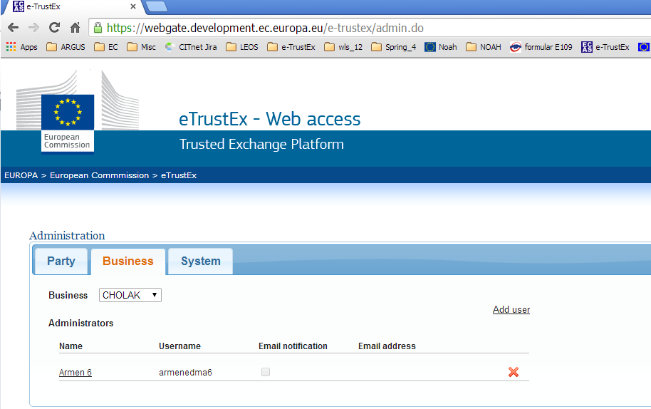

Snapshot#2 – admin page – system roles
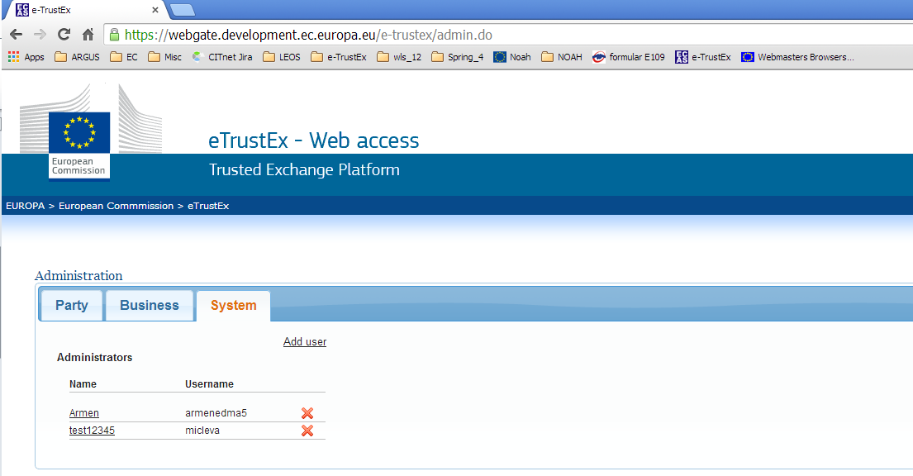

Snapshot#3 – admin page – administrators and operators users
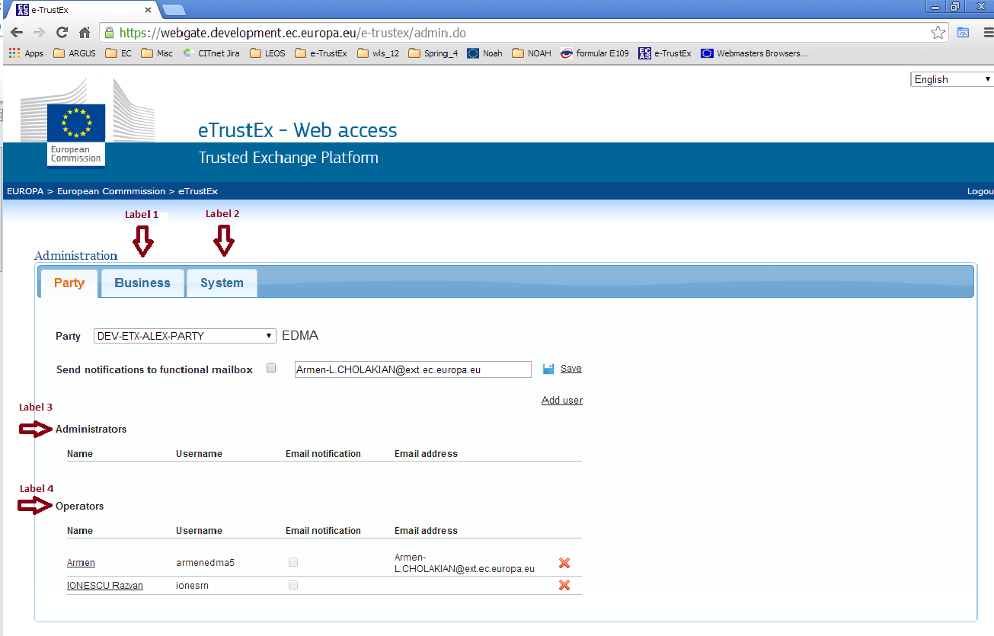

Snapshot#4 – admin page – edit user
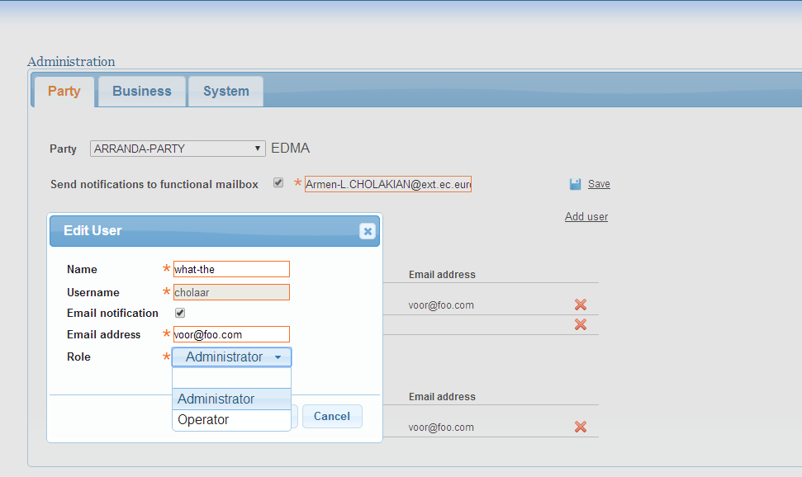

Snapshot #5 – attachment expiration warning message
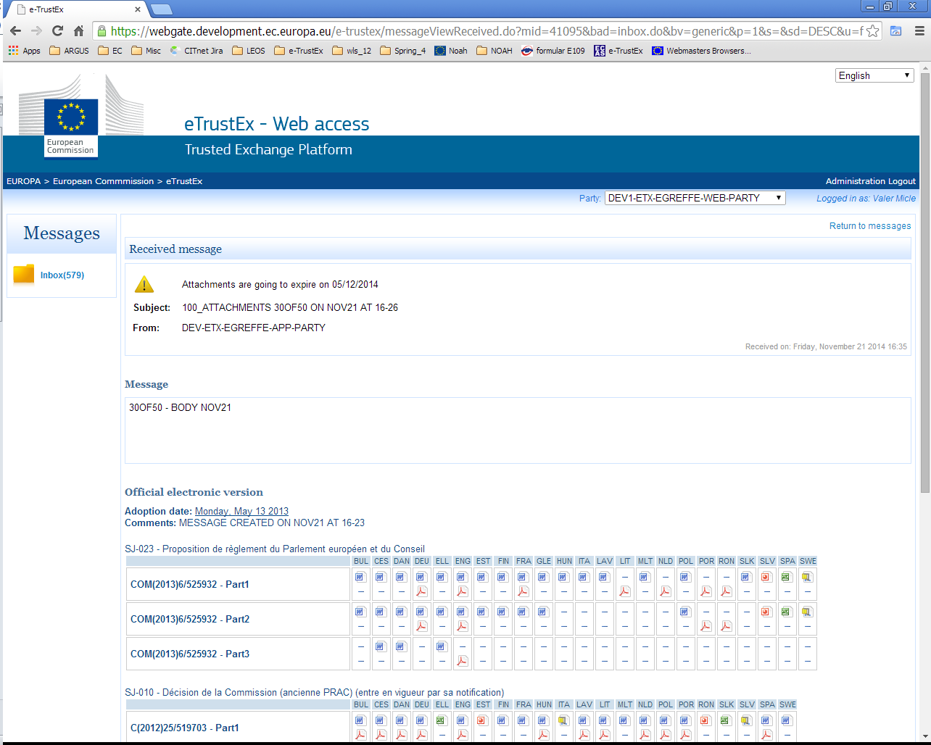
Snapshot #6 – attachment expired due to the retention policy
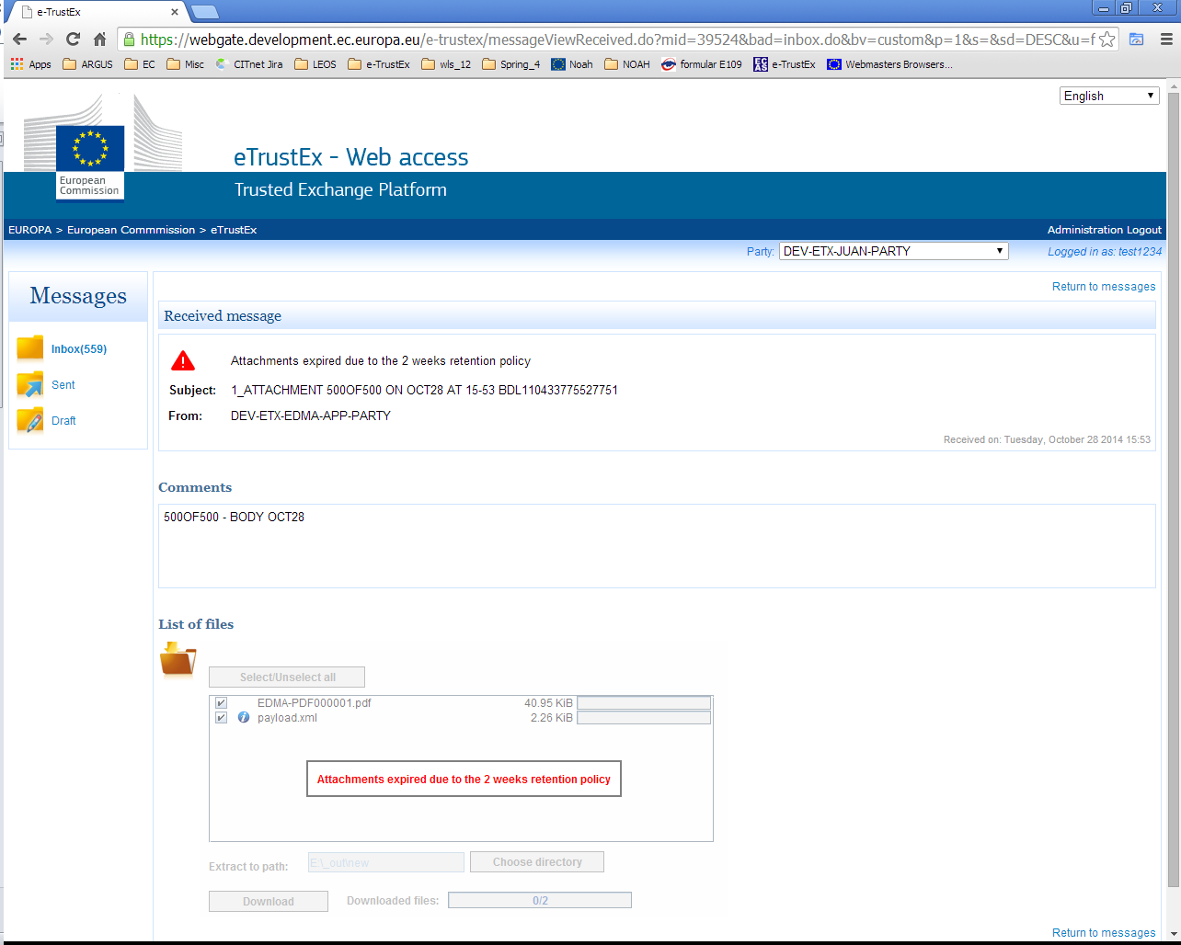
Snapshot #7 – metadata details failed to be loaded for a given message
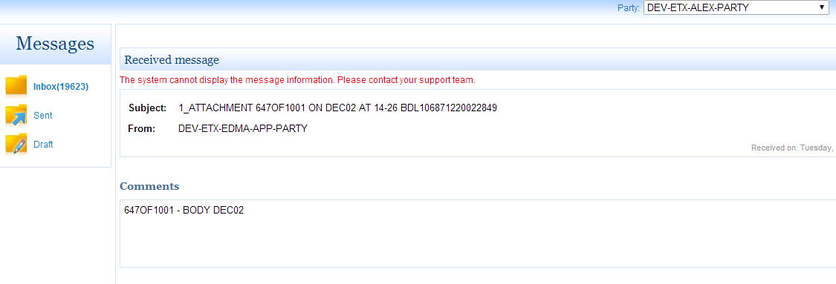
Snapshot #8 – metadata details were not yet loaded for this message
