TODO:
Add screenshots, one per page, like the sample from the next two pages
Snapshot#1 – admin page – business roles
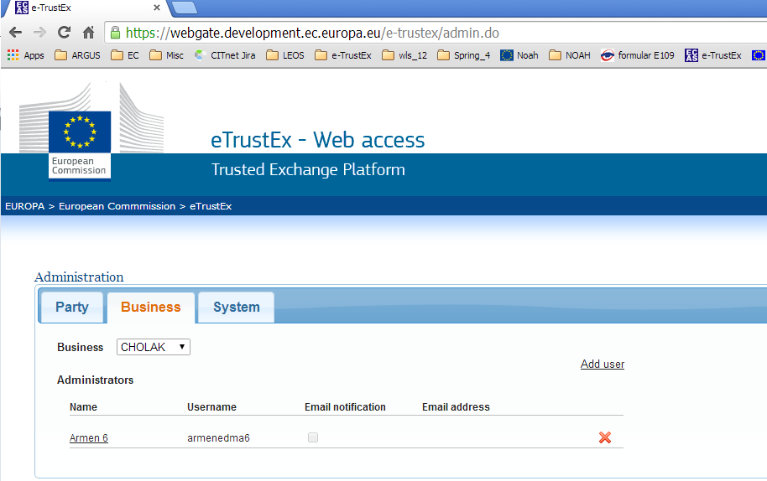

Snapshot#2 – admin page – system roles
