1 Invalid email format

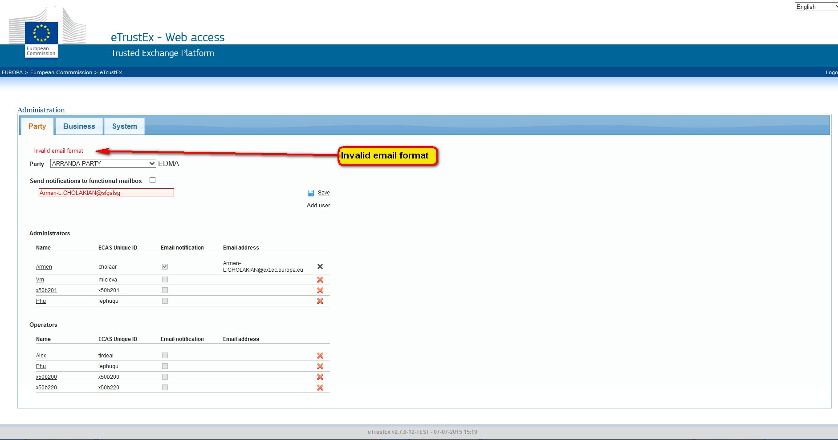

2 ECAS Unique ID

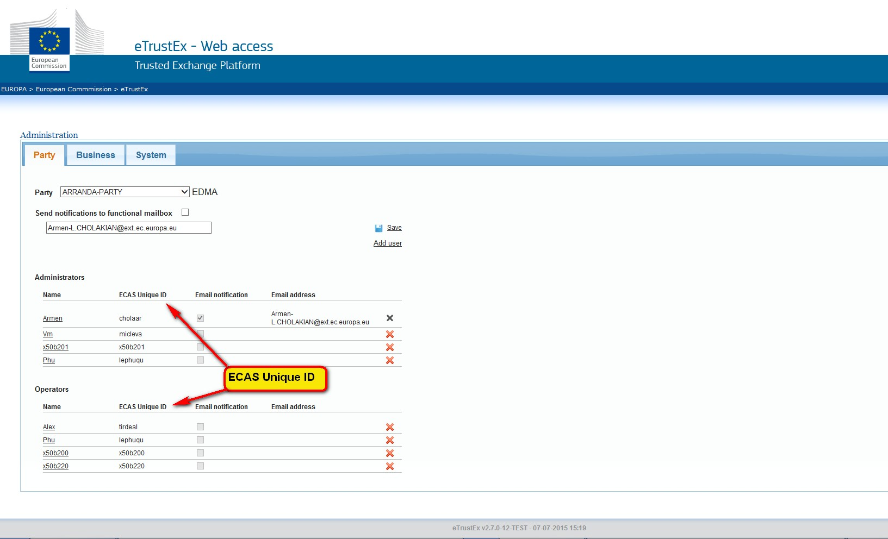

3 At least one email notification is mandatory for this business

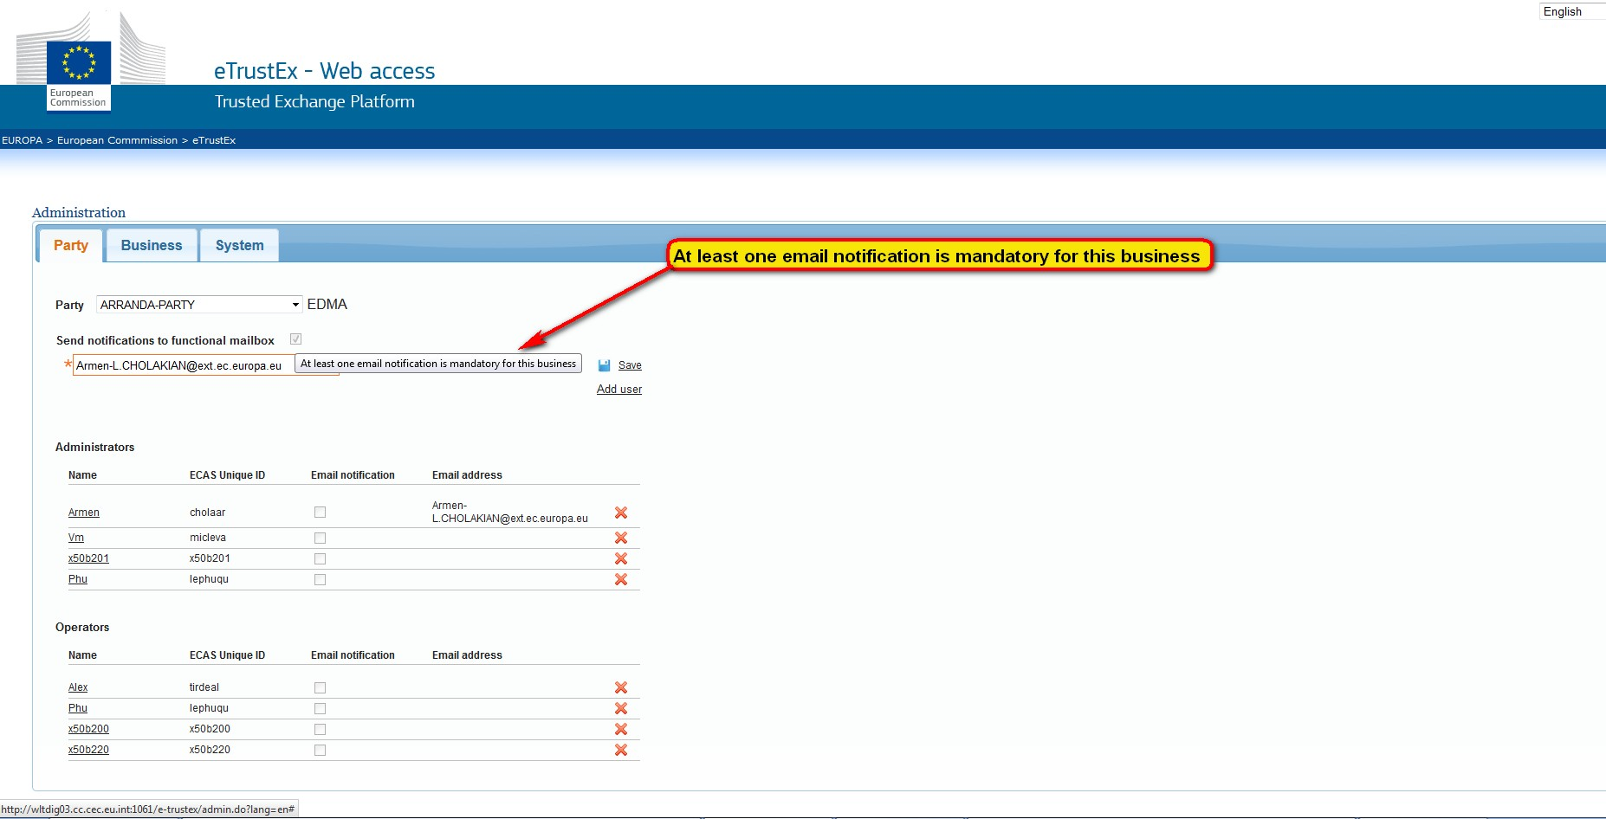

4 Cannot delete this role as at least one email notification is mandatory

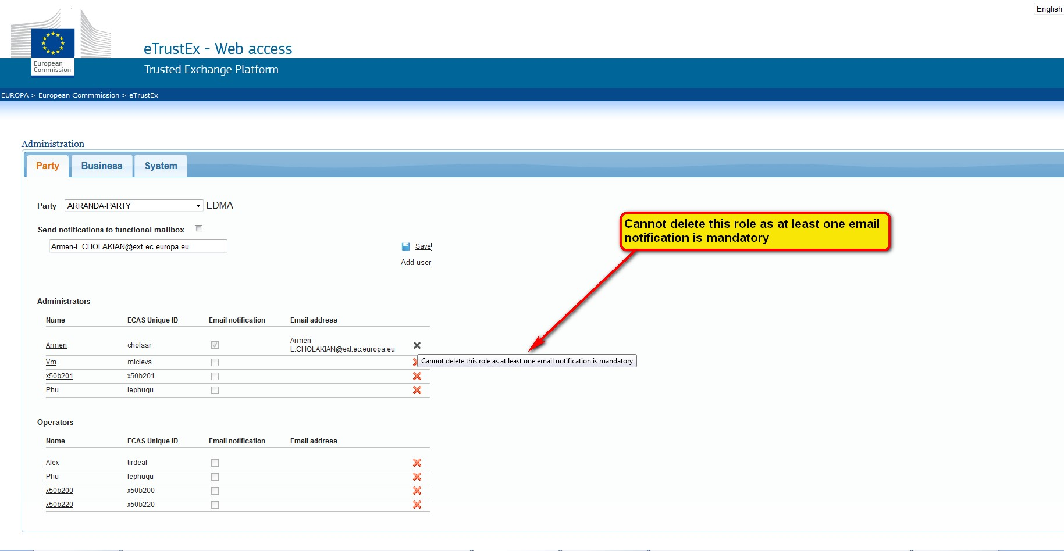

5 e-TrustEx web-site is using cookies. Cookies help us improving the user experience while using the web-site

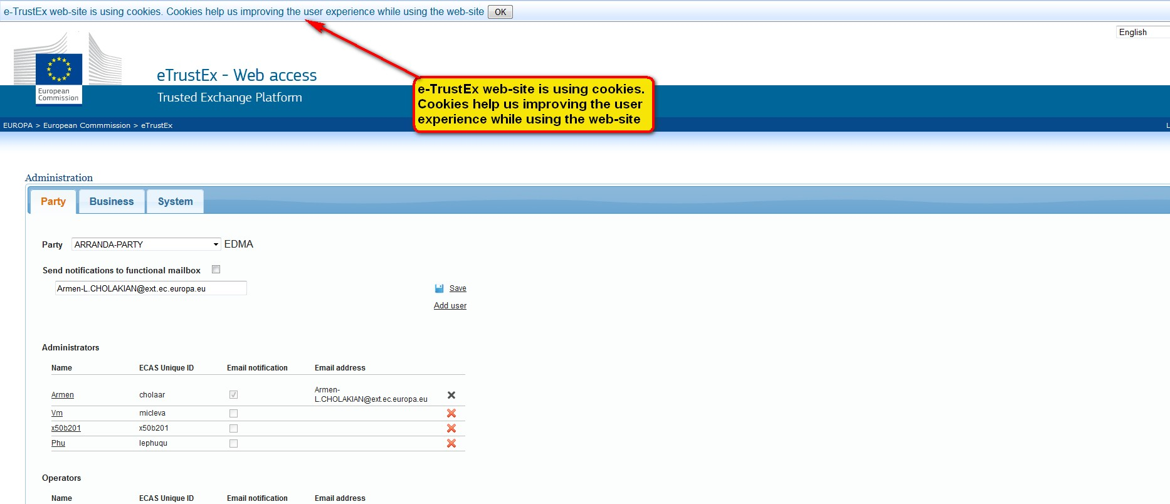

6 The request cannot be completed. Please contact your system administrator

