Screenshot 1 – Message notification
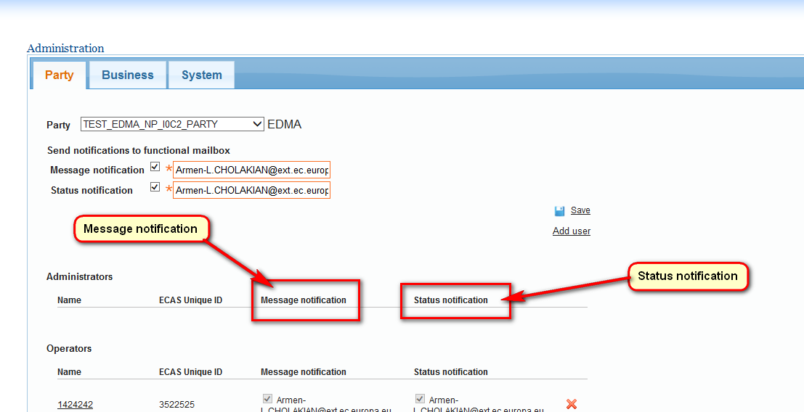

Screenshot 2 - At least one email notification is mandatory for this business

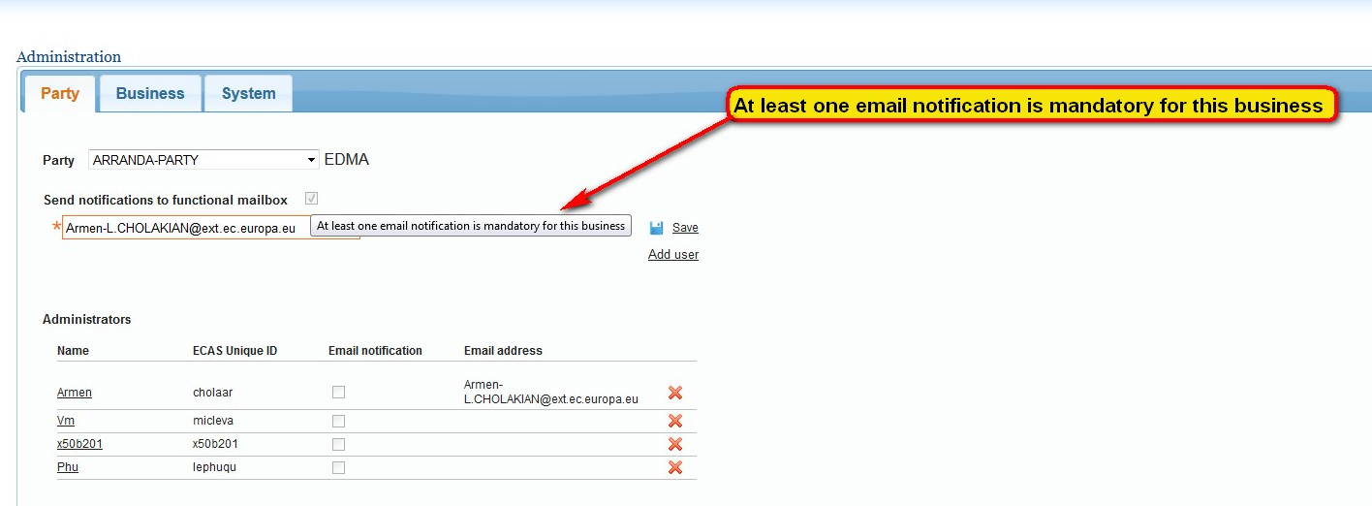

Screenshot 3 - Cannot delete this role as at least one email notification is mandatory

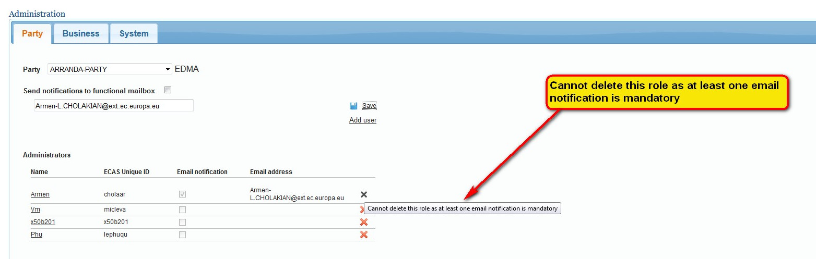

Screenshot 4 – Status notification

Screenshot 5 – Message sent on
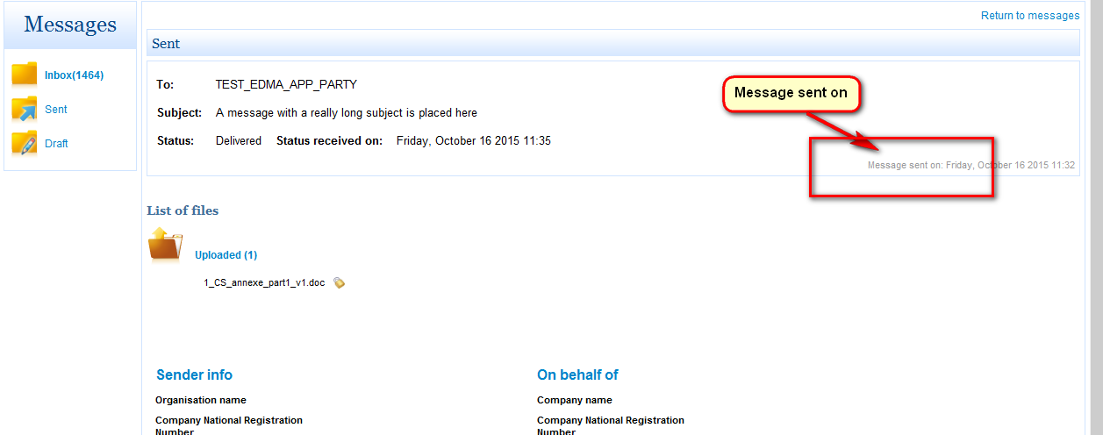

Screenshot 6 – Status
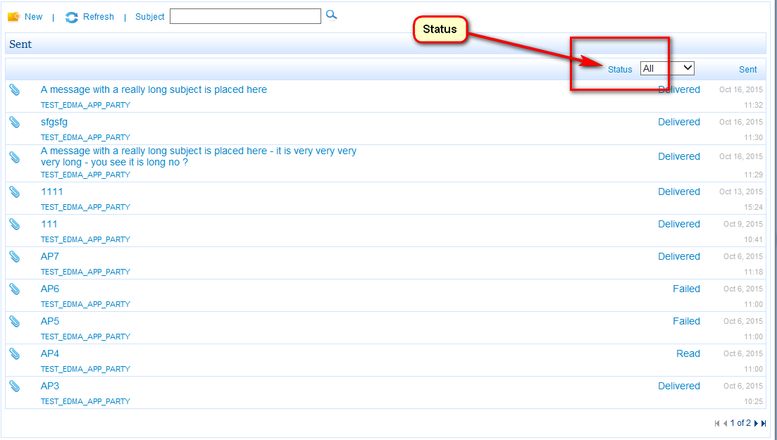

Screenshot 7 - Five labels: "All", "Delivered", "Failed", "None", "Read"
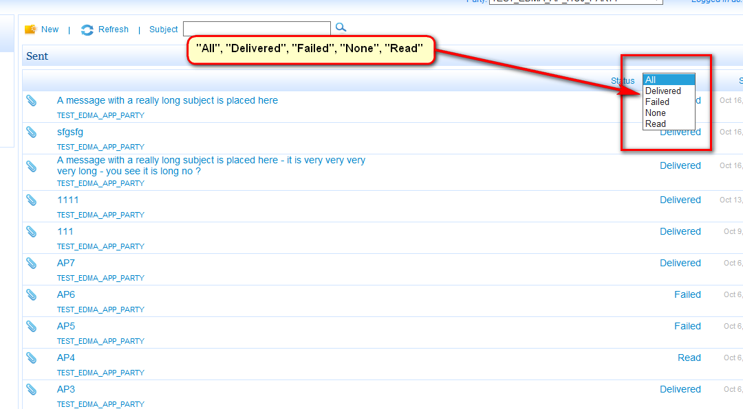

Screenshot 8 – Status received on
