Screenshots for translation request
Screenshot #1 – New/draft message: Please enter a Recipient

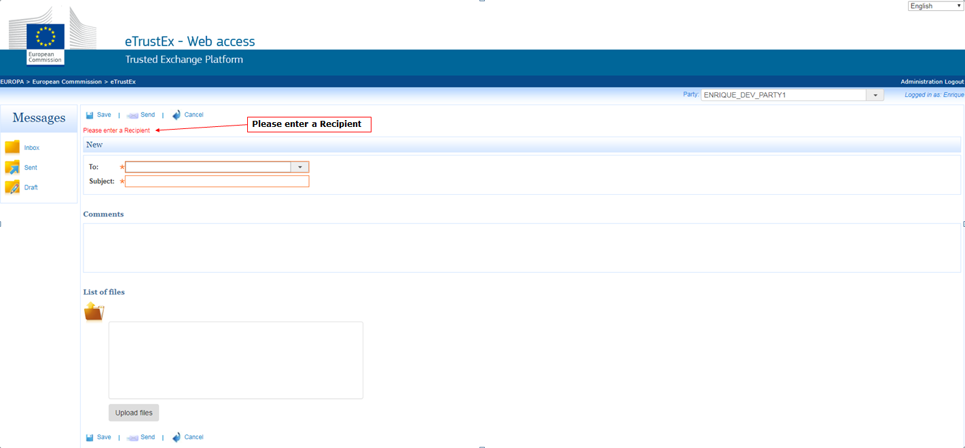
Screenshot #2 – Admin – System: Inactive

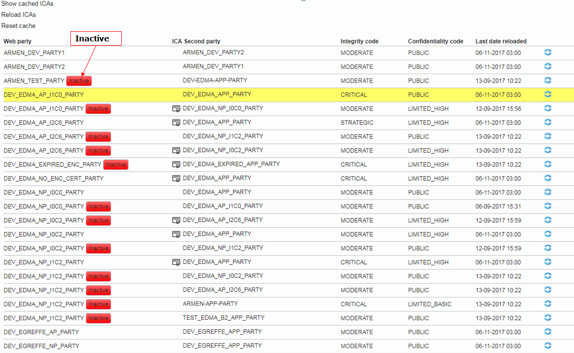
Screenshot #3 – Admin – Business: optional signature, mandatory signature, no encryption, encrypted transmission

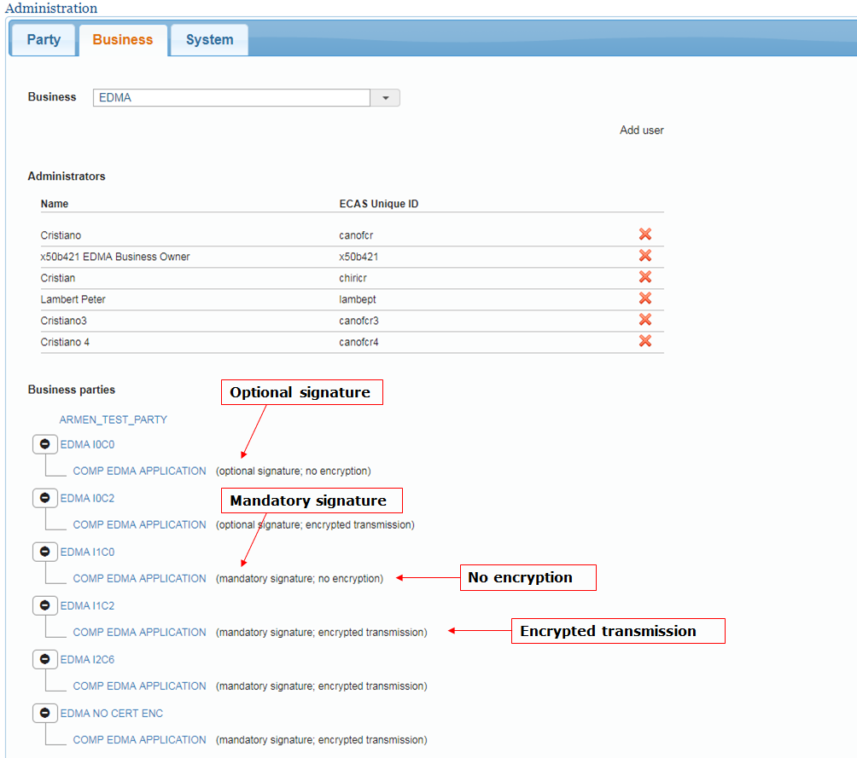
Screenshot #4 – Inbox: Interchange Agreement was not successfully loaded. Please contact the System Administrator

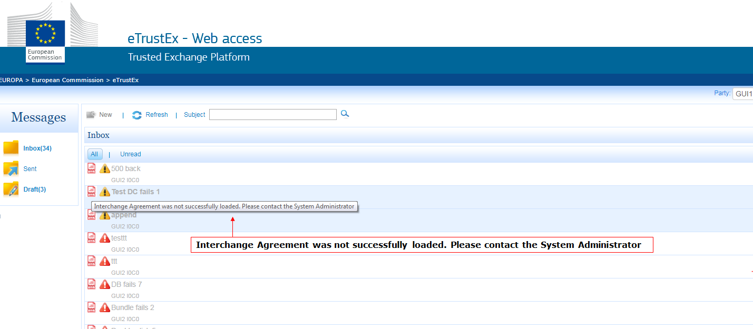
Screenshot #5 – Received message: Download files

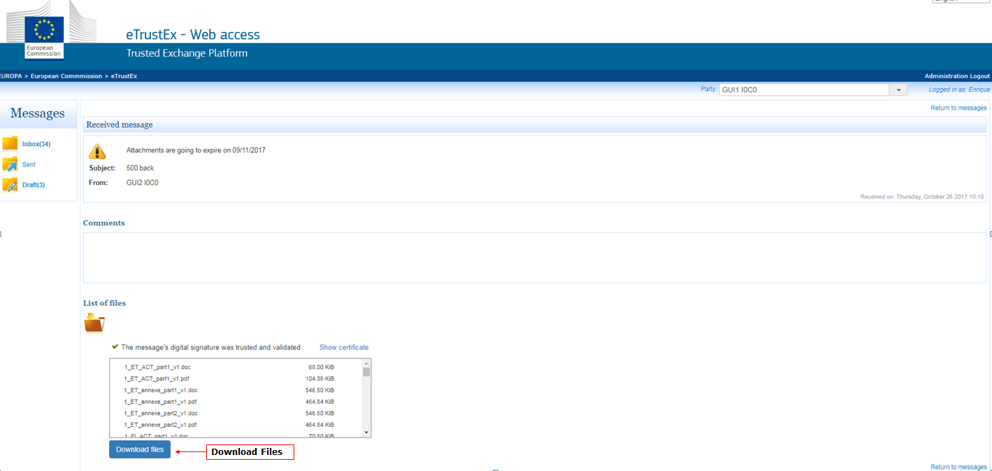
Screenshot #6 – New/draft message: Upload files

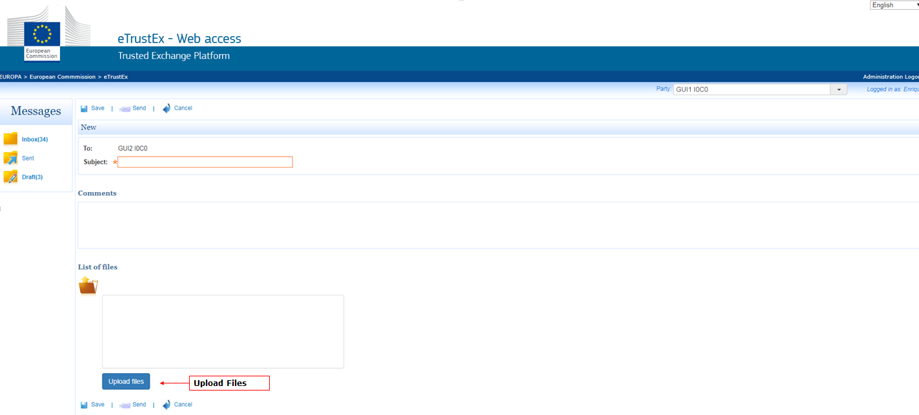
Screenshot #7 – New/draft message: Please select at least one file to upload

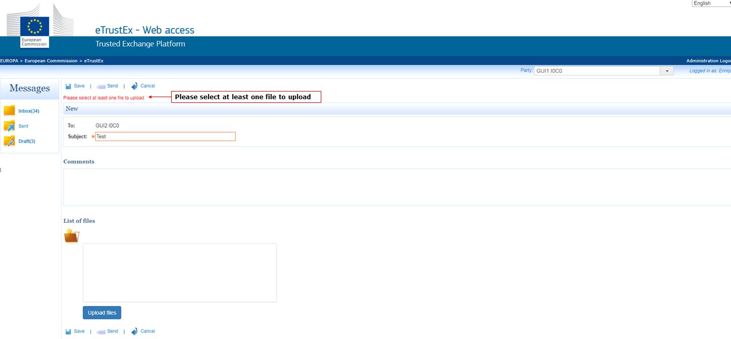
Screenshot #8 – New/draft message: An error occurred while trying to send the message. Please try again or save as draft.

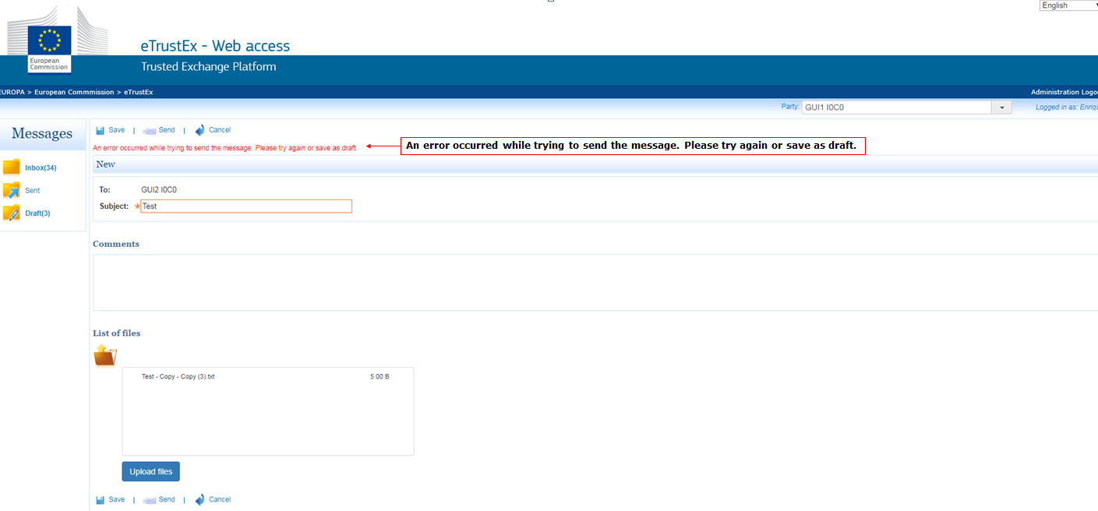
Screenshot #9 – New/draft message: Confidential

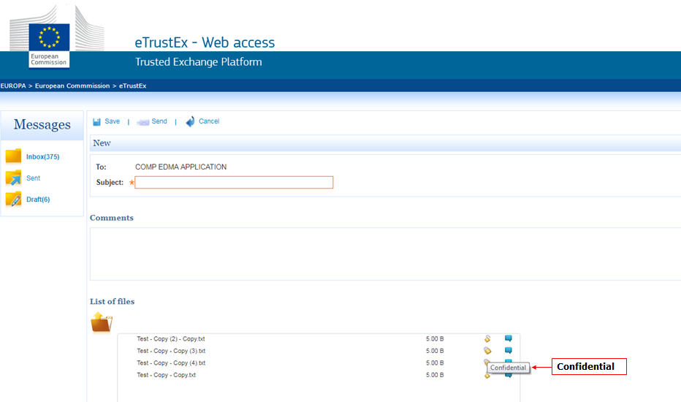
Screenshot #10 – New/draft message: Non confidential

