Screenshots for translation request

Screenshot#1 – Received message: The current e-TrustEx session has expired - to access the application again, please close the browser and all e-TrustEx windows and log in again.

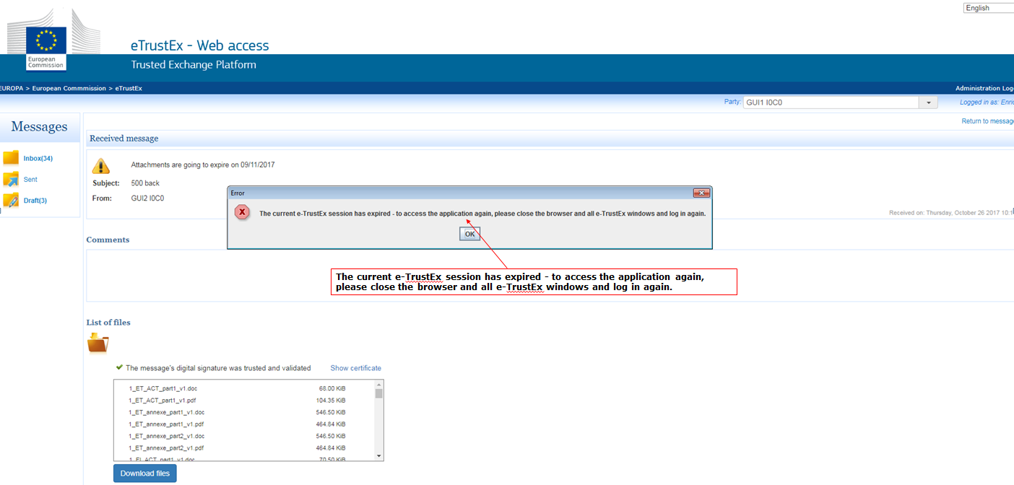
Screenshot#2 – Received message: This message did not contain a mandatory signature.

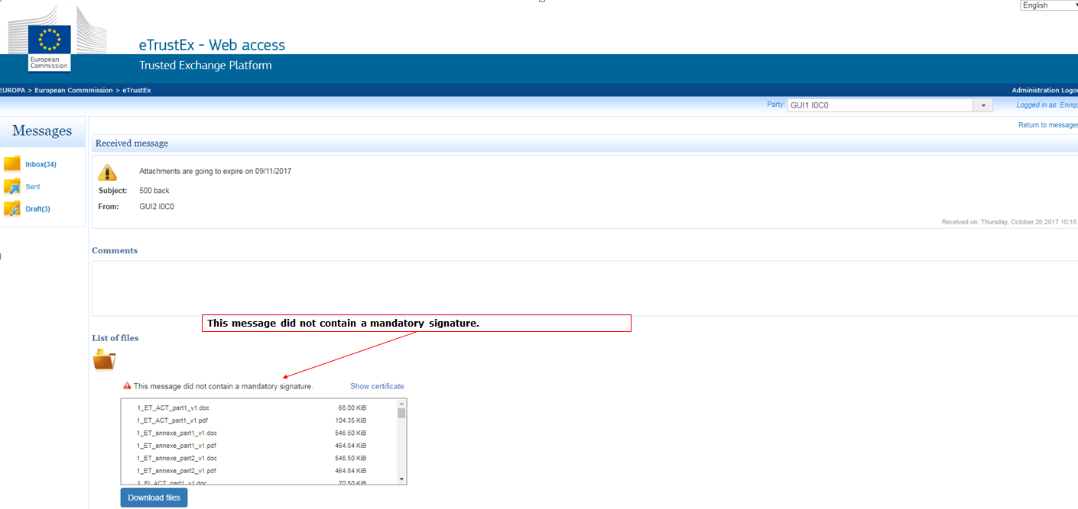
Screenshot#3 – New/draft message: Upload

