Screenshots for translation request
Screenshot #1 – New error message when no valid EC email

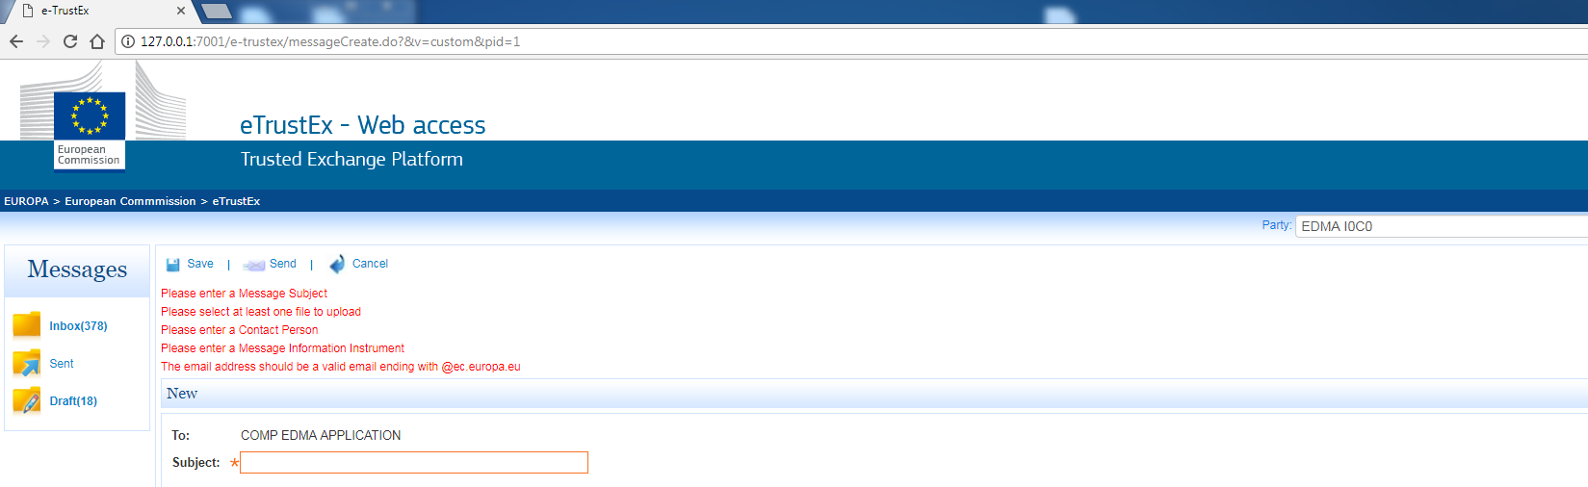
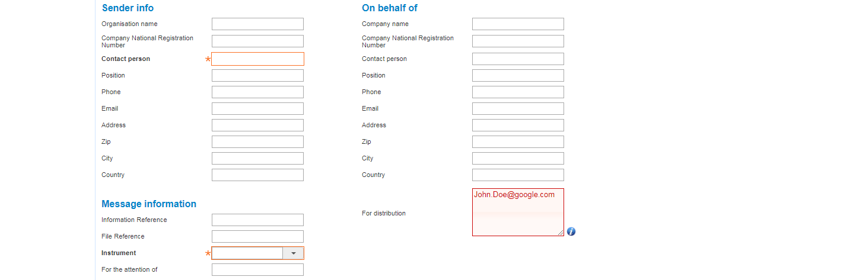
Screenshot #2 – tooltip for distribution

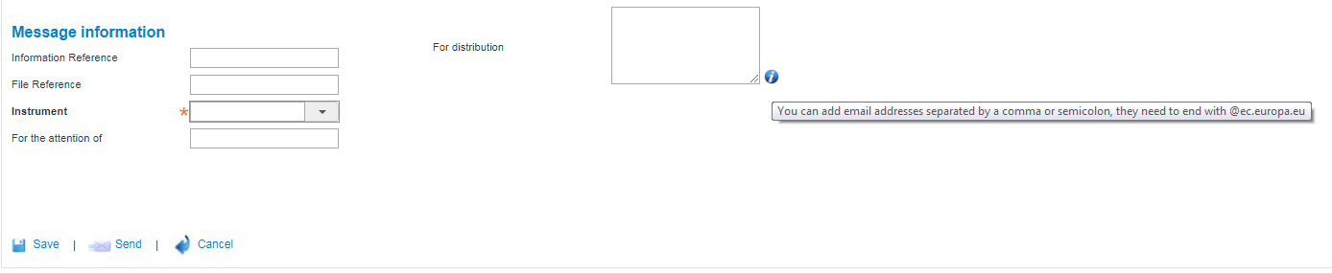

Screenshot #3 – Inbox: Export message in PDF format

