Micro-services architecture
- Directory
- Repository
- Monorepo
- Multi-repo
- Workspace
- Single-package workspace
- Multi-package workspace
- Package
Turborepo solves

Feature | What It Means for You
Remote Caching | Never re-run the same work in CI/local dev
Task Scheduling | Automatically runs scripts in right order
Parallel Execution | Uses all CPU cores to run independent tasks
Easy Setup | Keep your existing scripts and tooling
Flexible Adoption | Add it gradually to an existing project

So You're Right:
"With Turborepo + workspaces using path alias + reference will work in dev, but after build with tsc, JS won't understand @common/*"
✅ Exactly!

/chat-app-root/
├── common/ # Shared low-level things like interfaces, config
│ ├── interface/ # Shared types/interfaces
│
│
├── libs/ # Reusable libraries (not domain-specific)
│ └── logger/ # Centralized logger (Winston/Pino)
│
├── services/ # All business-domain microservices
│ ├── auth/ # Authentication service (JWT, OAuth)
│ ├── users/ # User profiles, avatars, status
│ ├── chat/ # Message handling, rooms, history
│ ├── presence/ # Online/offline, last seen
│ ├── notification/ # In-app/push/email notifications
│ ├── media/ # File uploads, image/video handling
│ └── socket-gateway/ # WebSocket or Socket.IO service
│
├── api-gateway/ # REST gateway that routes to services
├── package.json
├── tsconfig.base.json
└── docker-compose.yml (optional, for local orchestration)

Auth-Service

{
_id: ObjectId,
email: String,
passwordHash: String,
userId: UUID, // shared across services
createdAt, updatedAt
}
User Services
{
_id: ObjectId,
userId: UUID, // foreign key
username: String,
avatarUrl: String,
bio: String,
statusMessage: String
}
Chat Room Schema (1-on-1)
{
_id: ObjectId, // MongoDB's internal ID
roomId: String, // UUID or unique slug for external use
participants: [ // Always 2 in a private room
{
userId: String, // UUID from users service
joinedAt: Date
}
],
createdBy: String, // UUID of the user who started the chat
type: "private", // can be 'private' or 'group' in future
lastMessageAt: Date, // for ordering rooms by activity
createdAt: Date,
updatedAt: Date
}
chat Messages
{
_id: ObjectId, // MongoDB internal ID
messageId: String, // UUID for global uniqueness
roomId: String, // Foreign key to chat.rooms.roomId
senderId: String, // UUID of the user who sent it
type: String, // "text" | "image" | "file" | "reaction" | etc.
content: String, // Raw message content (text or file URL)
metadata: Object, // Optional (image dimensions, file type, etc.)
status: String, // "sent" | "delivered" | "read"
deliveredTo: [String], // List of userIds who got it
readBy: [String], // List of userIds who read it
createdAt: Date,
updatedAt: Date
}

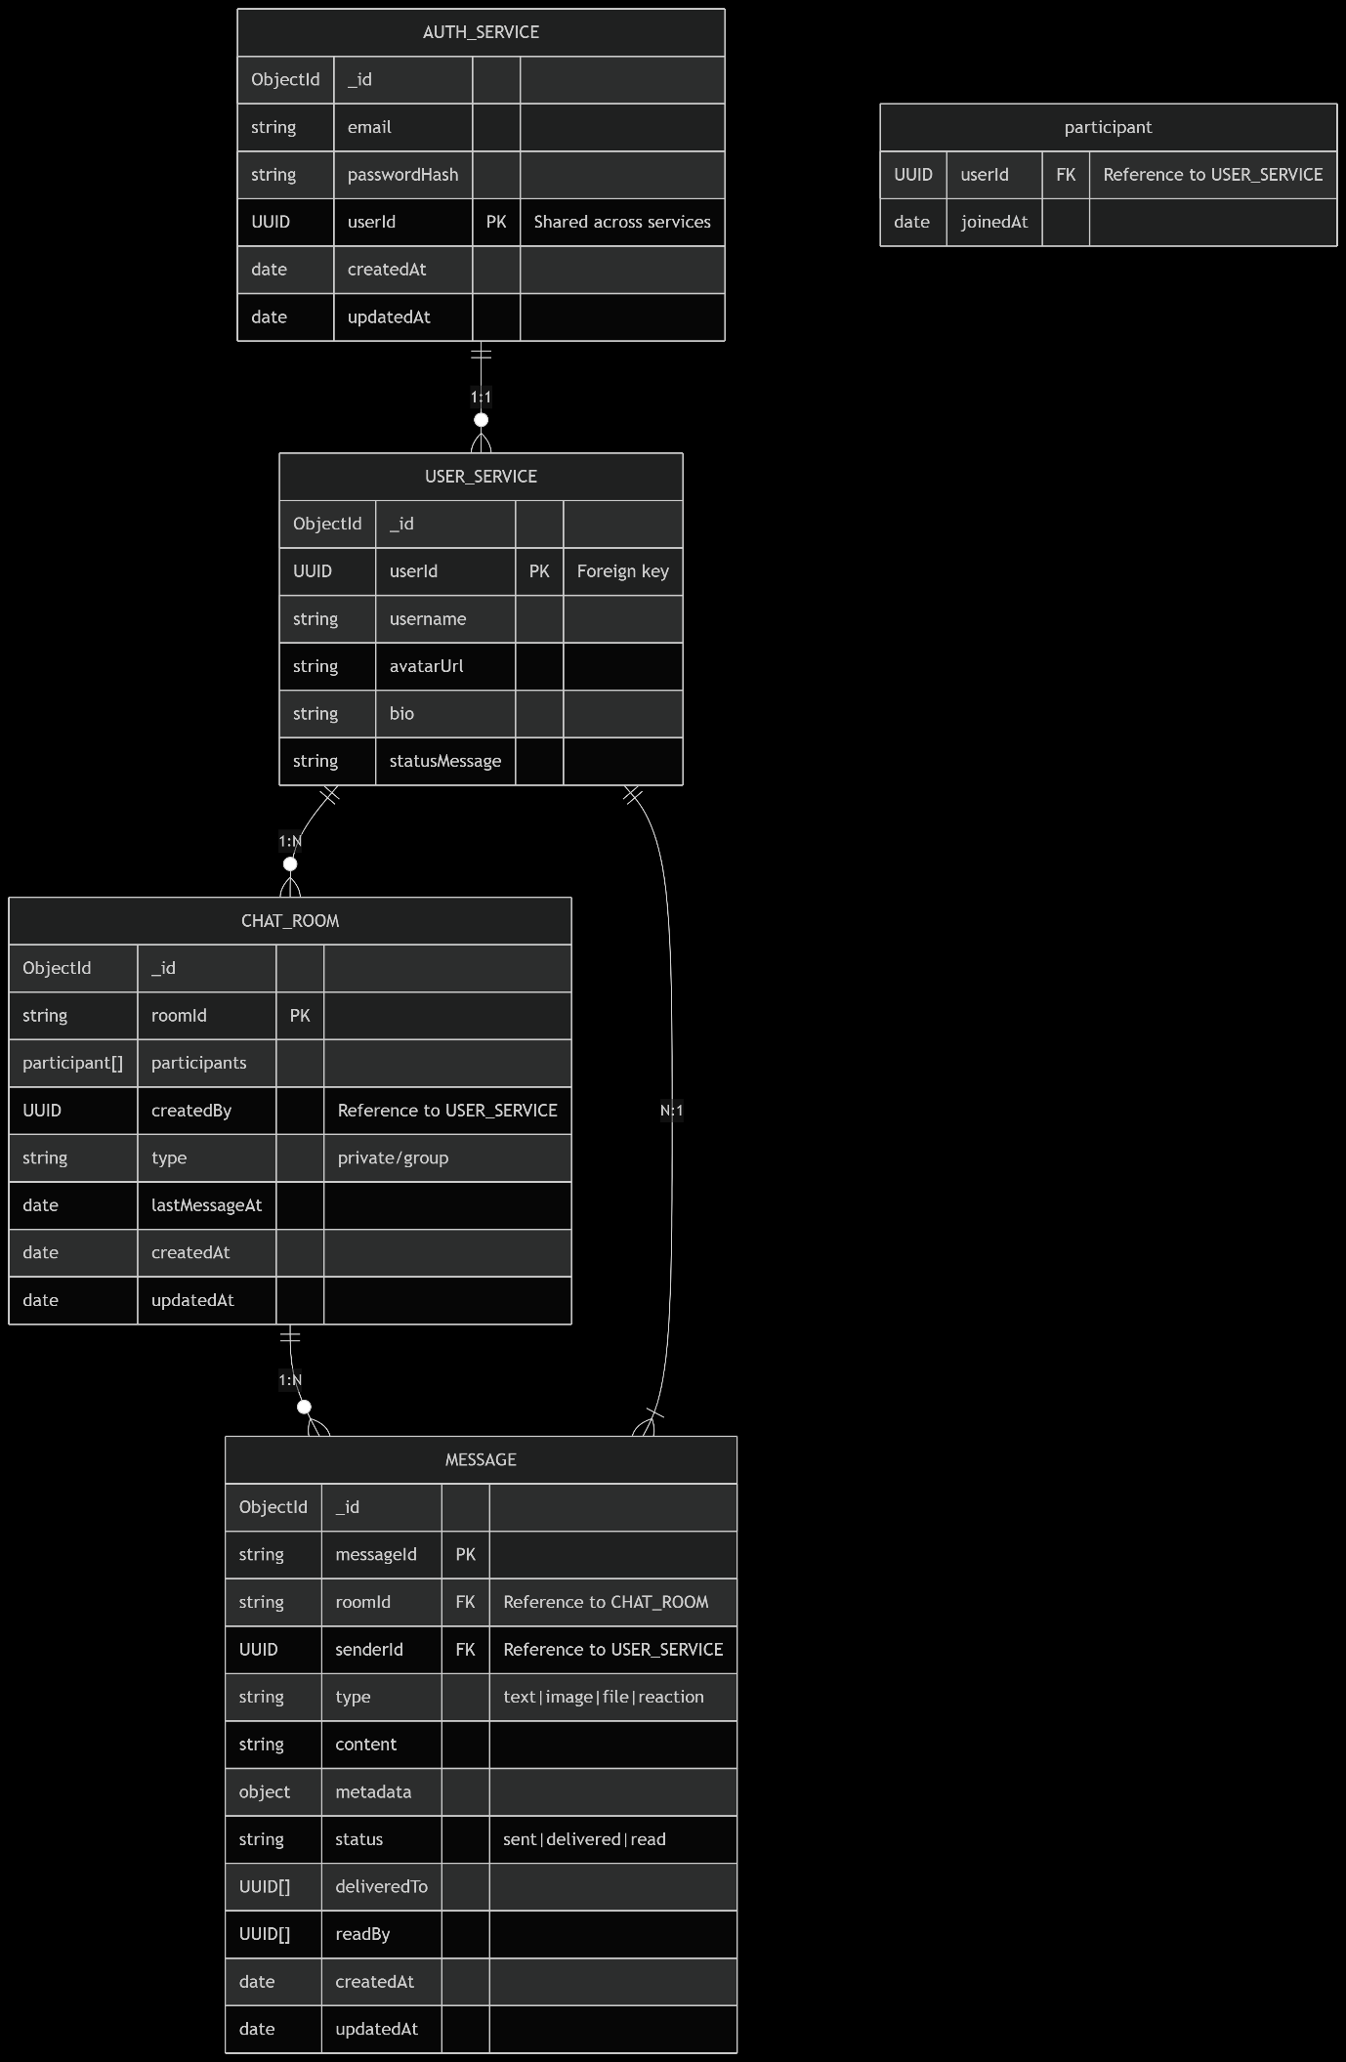

RabbitMq

1. The Publisher (Sending Application / Service)
- This is the starting point.
- The Publisher (also called a Producer) creates a message.
- The message could be anything: a request to start a task, a status update, or data that needs to be processed.
- The Publisher sends this message to the Message Broker.

2. The Message (Data Payload)
- A message is just a piece of data—like a note or instruction—that one part of the system wants another part to know about.
- It might contain:
- What task to run.
- Information about an event.
- A notification that something has completed.
- Technically, a message is often a byte array with headers (metadata).

3. The Broker (Message Broker)
- This is the middleman in the system.
- The Broker receives messages from Producers (Publishers).
- Then, it stores them in Queues.
- The Broker is in charge of:
- Organizing which messages go to which queues.
- Ensuring messages are delivered to the right Consumers.
- Handling retries, persistence, and possibly delivery guarantees.

> 🧠 Example brokers: RabbitMQ, Kafka, Amazon SQS, etc.

4. The Queue
- A Queue is like a waiting line inside the Broker.
- Messages are added to the endd of the queue (FIFO – First In, First Out).
- They sit there until a Consumer picks them up.
- The Queue ensures that each message is processed once, and in the order it arrived (unless configured otherwise).

---

5. The Consumer (Receiving Application / Service)
- This is the endpoint.
- The Consumer is an application or service that reads messages from the Queue.
- Once it gets the message, it can perform an action:
- Run a task.
- Update a database.
- Send an email, etc.
- Once the Consumer successfully processes the message, it usually tells the Broker: "Done!"—so the message can be removed from the queue.

---

### 🧩 Summary (Simple Flow):
```
[Publisher] --sends--> [Message] --> [Broker]
--> stores message in --> [Queue] --> delivers to --> [Consumer]
```

Component | Purpose | Notes
Connection | TCP link between client and broker | Heavy; one per app or service
Channel | Lightweight logical stream inside connection | Handles all messaging and queue ops
Queue | Stores messages until consumed | Must be declared before use

