nodeJs
V8 JavaScript Engine
- It parse and execute the js code
- The V8 JavaScript engine was originally developed by Google for Chrome, but it's not limited to Chrome anymore. It's now used in many other environments because it's open-source and highly performant.
JS Engine by other browsers.
- Firefox has SpiderMonkey
- Safari has JavaScriptCore (also called Nitro)
- Edge was originally based on Chakra but has more recently been rebuilt using Chromium and the V8 engine.

Compilation
- The code converts into machine understanding language (binary) before execution.
- That machine code is run directly by the CPU, with no need for the original source code anymore.
Interpreter
- No compilation phase, parsing, conversion and execution line by line.(Runtime)
- Slower than compiled code (usually)
What about JavaScript?
- JavaScript is traditionally an interpreted language, but
Modern JavaScript Engines like V8 use:
- JavaScript is internally compiled by V8 with just-in-time (JIT) compilation to speed up the execution.
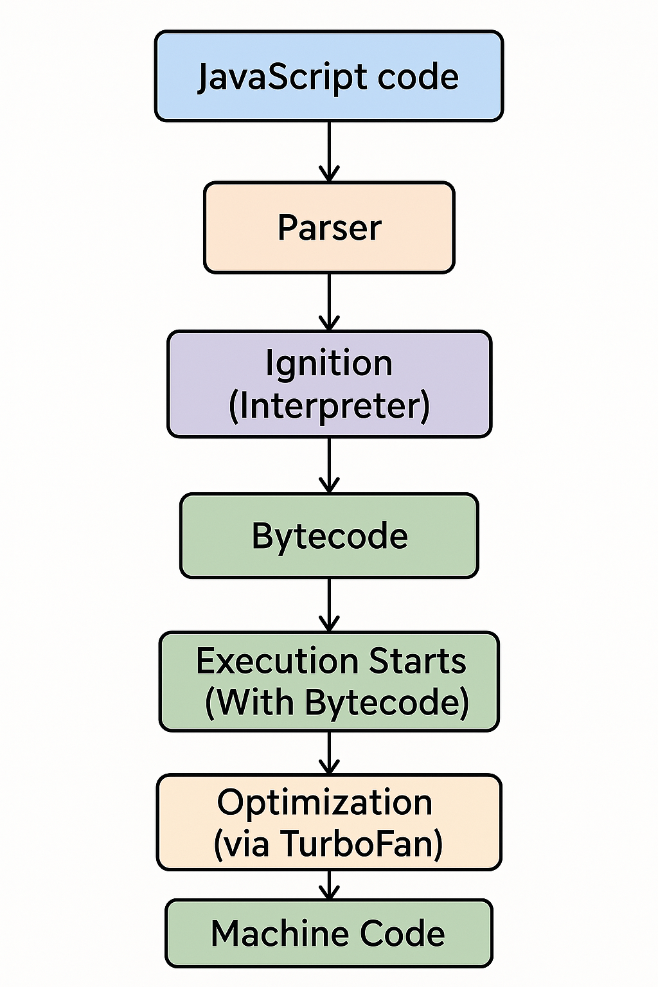
- convert the raw js code into AST (to understand the structure of your code ).
- After creating the AST, convert ast into bytecode.
- After starts execution of this bytecode
- [Profiler watches execution]
- ↓
- Hot code: V8 monitors frequently executed functions, loops, or operations — aka “hot” code.
- Bytecode → Hot code detected
- ↓
- TurboFan → Optimized machine code
- ↓
- Stored in memory
- ↓
- Reused on future calls
- ↓
- [If assumptions fail → De-optimize → Interpreter]
Event-Loop
what happens when Node.js starts:
- Initialize the environment
  - Loading internal modules.
  - Initializing the event loop.
  - Setting up the libuv library (which provides the event loop and async I/O).
  - Preparing the v8 engine (JavaScript engine used by Node.js).
- Execute the input script
(e.g., `node app.js`). during this phase:
  - All synchronous code is executed.
  - Any synchronous calls (`setTimeout`, `fs.readFile`, `http.createServer`, etc.) are registered and their callbacks are scheduled.
  - Any `process.nextTick()` or `Promise.then()` callbacks are also queued to be run.
- Start the event loop
After the script has been parsed and executed:
  - Node.js enters the event loop, which continuously checks if there are any async operations ready to run.
  - It processes callbacks from timers, I/O tasks, `process.nextTick()`, Promises (microtasks), and so on in various phases.
What is the Event Loop?
- Which allows the nodejs to perform the non-blocking I/O operations despite nodejs have only single thread.
- By offloading the operations to system kernel whenever possible.
- Once those operations are completes,the kernel tells nodejs so that callback may be added to poll queue to eventually executed.

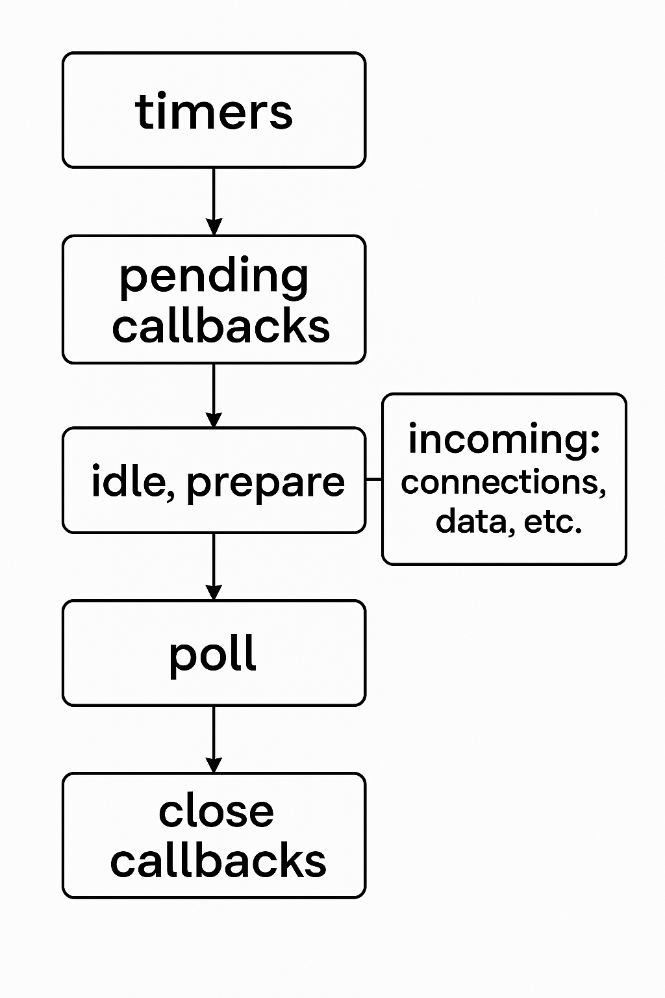

Timer phase
A timer specifies the threshold after which a provided callback may be executed. Timers callbacks will run as early as they can be scheduled after the specified amount of time has passed; however, Operating System scheduling or the running of other callbacks may delay them.
Note
Technically, the poll phase controls when timers are executed.
Concept | Meaning

Starvation | When one phase (e.g., timers) doesn't run because another phase (e.g., poll) is too busy

libuv's max wait | A time limit set to avoid poll phase from running forever

Why important? | Ensures fairness, timely execution of timers, and prevents lags

Pending phase
This phase executes callbacks for some system operations such as types of TCP errors.
What Kind of Callbacks Go Here?
These are usually system-level callbacks that the OS delays for a bit, such as:
- TCP connection errors (like ECONNREFUSED)
- Some types of DNS lookup failures
- Certain asynchronous system operations on Unix/Linux
Poll phase
The poll phase has two main functions:
- Calculating how long it should block and poll for I/O, then
- Processing events in the poll queue.
Possible Scenarios in the Poll Phase
✅ Scenario 1: Poll Queue is NOT empty
➡️ Run all I/O callbacks synchronously from the poll queue
➡️ Keep running until:
- The queue is empty, OR
- A system-defined max limit is reached (to avoid starvation)
Scenario 2: Poll Queue is EMPTY
2A. setImmediate() callbacks exist
  - ✅ Exit poll phase
  - ⏩ Jump directly to check phase to run setImmediate() callbacks

2B. No setImmediate() callbacks
- 💤 Wait for I/O callbacks to be added (i.e., block)
- Once something shows up → execute it immediately
After Poll Queue is Empty
- Once poll finishes:
- Event loop checks: Are there any timers whose time has passed?
- If yes → it loops back to the timers phase to execute setTimeout, setInterval callbacks
Check Phase
What Is the Check Phase?
- The check phase runs after the poll phase and is specifically designed to handle callbacks scheduled with setImmediate().

🚀 What is setImmediate()?
- setImmediate() is a special timer in Node.js.
- unlike setTimeout(fn, 0), it runs in a dedicated phase of the event loop — right after poll.
- It uses a libuv API to queue the callback for execution immediately after the poll phase ends, regardless of how long the poll waited.
Closed callback
close callbacks
If a socket or handle is closed abruptly (e.g. socket.destroy()), the 'close' event will be emitted in this phase. Otherwise, it will be emitted via process.nextTick().

setImmediate() vs setTimeout()
- setImmediate() callback will executes immdeatiley after poll phase completes.
- setTimeout() callback will executes after a minimum threshold in ms has expired.
NOTE:
Order of executions of above one is non-deterministic (in main module) depends upon the performance of the process.
But in within the I/O cycle the immediate callback will executed first.
Process.nextTick()
- Guarantee Async Behavior if an api does not involves the timer, i/o operations.
- Sometimes you want to run a function after everything in the current call stack finishes, but before any I/O happens. That's exactly what process.nextTick() does.
- Avoid Synchronous Bugs
- let data;
- someAsyncFunction(() => {
- console.log(data); // ❌ undefined if called synchronously
- });
- data = 42;
- Handle errors (e.g., in API functions) or perform cleanup tasks immediately after the call stack completes.
- Ensure that callbacks are executed in the expected order, like ensuring events are emitted after handlers are registered.
- Solve timing issues where code might run synchronously but still needs to behave asynchronously.
JavaScript has two main task queues:
- Microtask Immediately after the call stack Promise.then(), queueMicrotask()
- Macrotask On the next event loop tick setTimeout(), setImmediate()
Memory Management
Memory Structure in Node.js
Node.js memory can be broadly divided into two parts:
1. Heap
- Where objects, strings, closures, and other reference types are stored.
- Managed by V8’s Garbage Collector (GC).
- Has a default limit (about 1.5GB – 2GB in 64-bit systems).
- Can be increased using flags like --max-old-space-size.
2. Stack
- Stores primitive values and function calls (execution context).
- Much smaller and faster compared to the heap.
- Automatically managed with function calls and returns.
- Since primitives are small and fixed-size, they're typically stored on the call stack, not the heap.
- They're automatically cleaned up once they go out of scope.
Garbage Collector
Concept | What it means
Reachable | Still accessible in code (via variables, closures, etc.)
Unreachable | No reference from anywhere → eligible for GC
Assigning to null or undefined | Helps remove references → may lead to GC
GC works automatically | You don’t control when it runs, only make data unreachable
If you accidentally hold onto references (like via closures, caches, global variables, or event listeners), V8 thinks you still need that memory, even if you logically don’t.

Common Memory Leak Traps in Node.js
Cause | Why it Leaks
Global variables | Live forever unless manually cleaned.
Closures | Keep outer variables alive unnecessarily.
Long-lived timers/intervals | Keep referencing objects or closures.
EventEmitter leaks | Listeners never removed → held references.
Caching without limit | Stores everything, nothing gets evicted.
How to Prevent / Fix Memory Leaks?
- Avoid global variables unless necessary.
- Remove event listeners using .off() or .removeListener() when they’re no longer needed.
- Monitor object references and closures.
- Implement proper caching policies (e.g., LRU, TTL).
- Periodically check memory usage in production and add alerts if needed.
- Use weak references (WeakMap, WeakSet) when appropriate.

EventEmitter is best used when:
- You want to decouple logic (publish-subscribe pattern).
- There are multiple actions responding to the same event.
- Events occur frequently or over time (streaming, real-time apps).

