support@grokstream.com

Abstract

VM metrics stats can be exported and visualized in Grok.

Grok integration with vmware

# TABLE OF CONTENTS

1. Introduction 1
2. Pre-requisites 1
3. Running Script manually 2
4. Windows Scheduler steps 3
5. Linux cron steps 7

# Introduction

VM metrics stats can be exported and visualized in Grok. With this integration now you can connect to your ESX server and fetch the counter values for the installed VMs and send it to Grok.

# Pre-requisites

Install following packages on your machine using the command given below

%> pip install grokcli

%> pip install pysphere

Please follow the instructions in <https://github.com/grokstream/grok-cli> to ensure grokcli is setup correctly and that you have the correct Grok API key. Once grokcli is setup, the following example will send the installed VM Name and its stats to Grok.

Note: Tested with Python 2.7.7, Python 2.7.5 and pysphere 5.5

# Running the script manually

To run the script manually type below mentioned command in the command prompt.

%> python –m grokcli.vmware --grokServer=<Grok server URL> --grokApiKey=<Grok server API key> --configFilePath=<path to ESX configuration file>

**Eg**: python -m grokcli.vmware --grokServer=https://server.com --grokApiKey=5TITw --configFilePath=d:\test\vmconfig.ini

* grokServer – Grok server url
* grokAPiKey- API key for the Grok server
* configFilePath - full path to config file(.ini file) which contains username, password and host to connect to the ESX server.

Note: Please refer the [sample config file](https://github.com/grokstream/grok-cli/blob/master/docs/vmconfig.ini).

# Setting up a scheduled task on windows to send vmstats every 5 min

To setup a scheduled task in windows follow these steps:

* Go to control panel-->system & security-->administrative tool-->scheduled task

**Step1:**

* Create a basic task

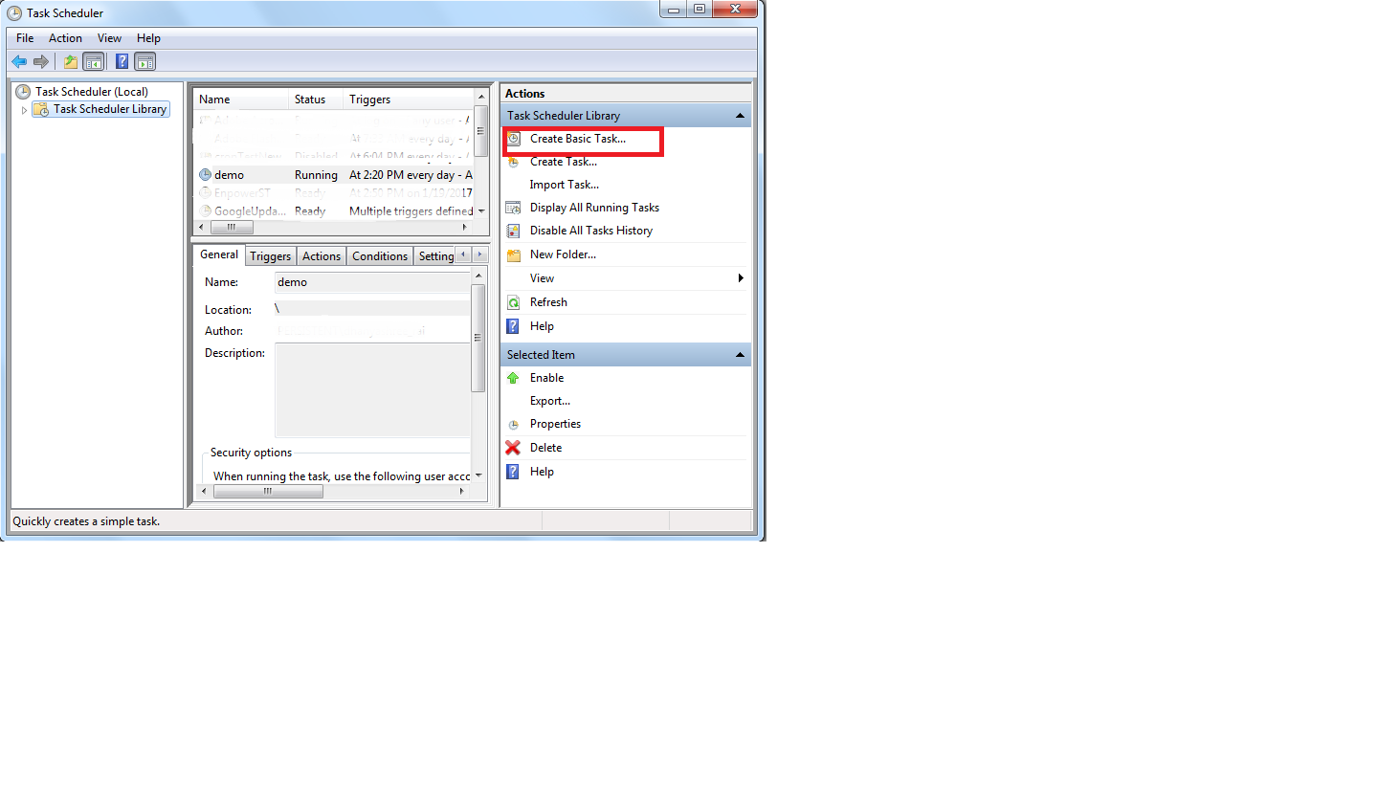

* Enter name and description-->trigger (daily) -->next-->
* Start a Program

Browse through the grokcli package (The python package installed on your machine, which will be under lib/site-packages folder under python folder) select vmware.py file.

* Add arguments

Add the command line arguments which you use while running the command. E.g. for the argument to add given below.

(Eg: --grokServer=https://server.com --grokApiKey=5TITw --configFilePath=d:\test\vmconfig.py)

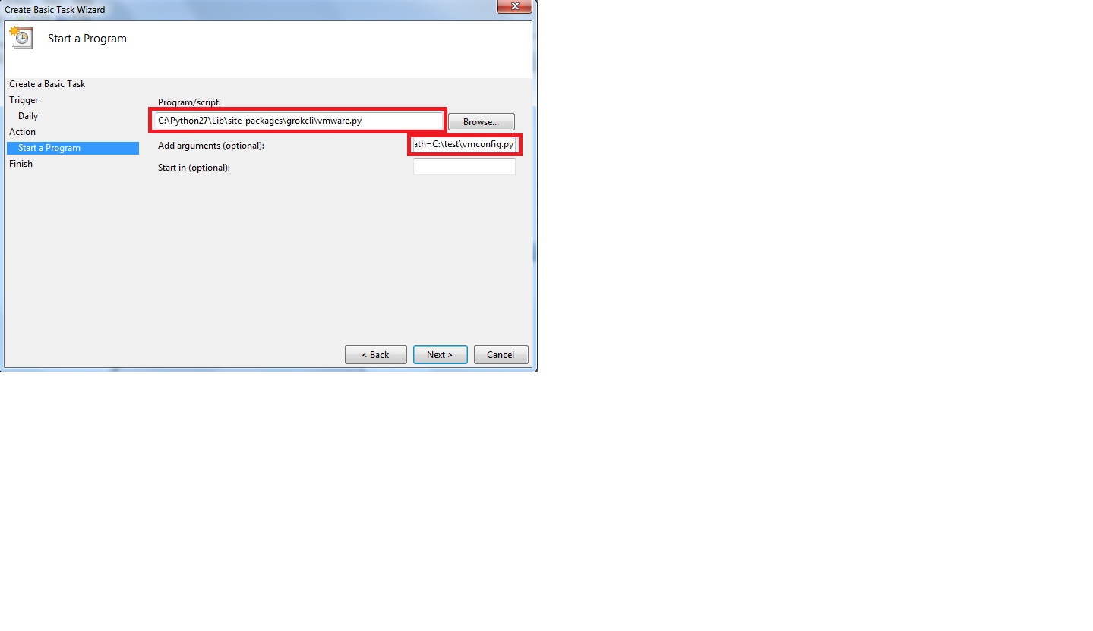

* Click on next--> finish

**Step 2:**

* Goto task scheduler library-->double click on task

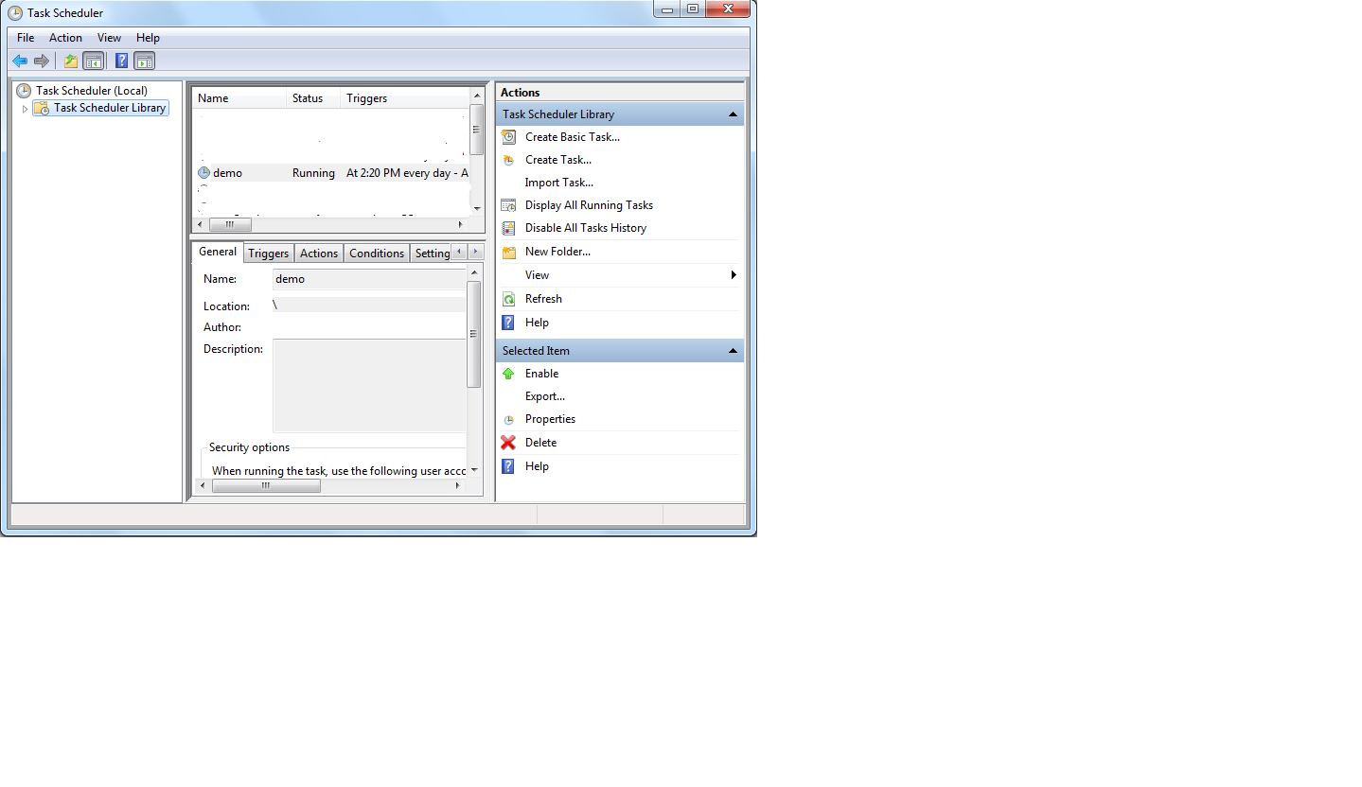

* Under triggers tab click the task and edit

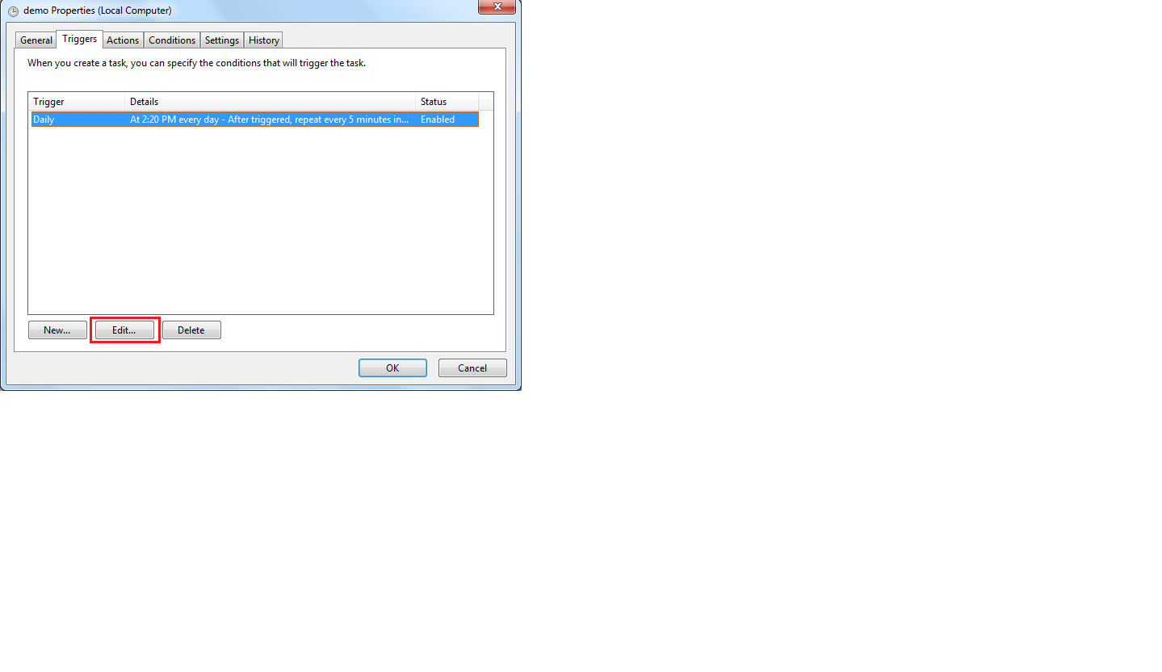

* check for repeats task every(select the duration)
* for a duration of --> indefinitely

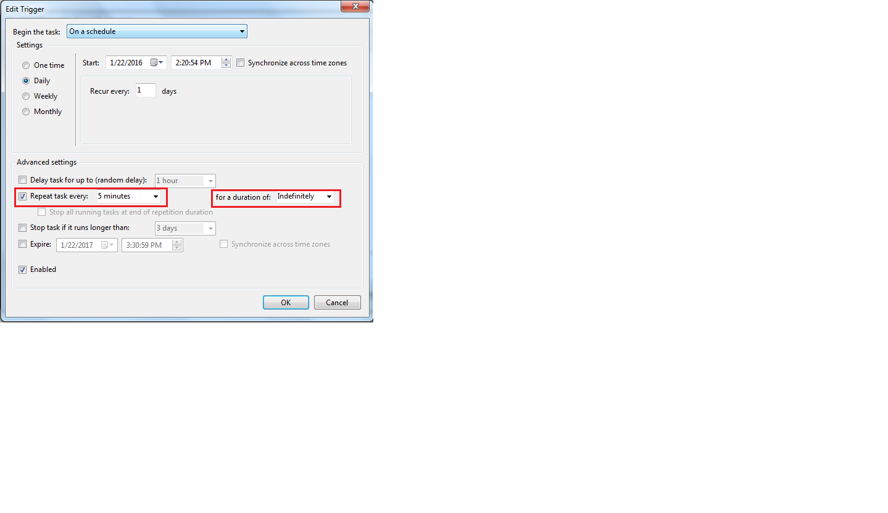

* Click on ok.

Now you have created a scheduled task which will collect stats of the VM installed on the hypervisor every 5 min and send those data to Grok.

# Setting up a cron that runs every 5min in linux

To edit or create your own crontab file, type the following command at the UNIX / Linux shell prompt:

crontab –e

Type following command in crontab file

%> */5 * * * * python –m grokcli.vmware --grokServer=<Grok server URL> --grokApiKey=<Grok server API key> --configFilePath=<path to ESX configuration file>

**Eg**: */5 * * * * python -m grokcli.vmware --grokServer=https://server.com --grokApiKey=5TITw --configFilePath=d:\test\vmconfig.ini

Now you have created a cron which will collect stats of the VM installed on the hypervisor every 5 min and send those data to Grok.