Fox of Hood: User Guide

1. Register for an account

Enter a unique username and a password with at least 8 characters, one special character, and one number. Take a user photo (needed for facial recognition login).

Figure 1 Entering a username and password

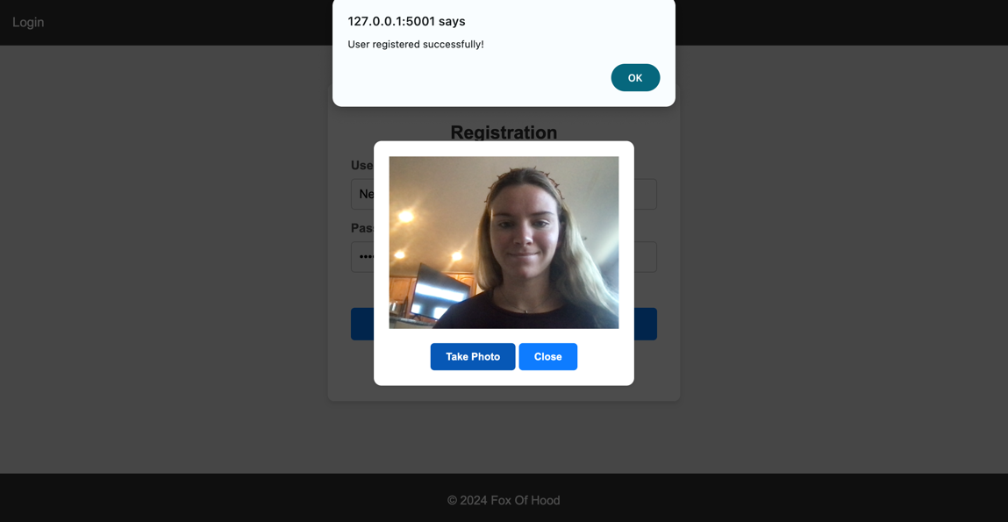

Figure 2 Taking a facial recognition photo

2. Logging into your account

**Option 1:**

Enter your username and password and complete the CAPTCHA. Select “Login”.

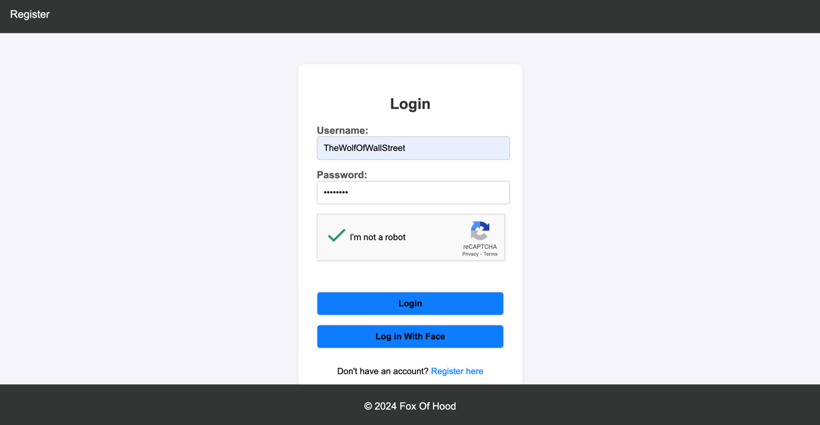

Figure 3 Login with username, password and CAPTCHA

**Option 2:**

Select “Log in With Face” and “OK” after success.

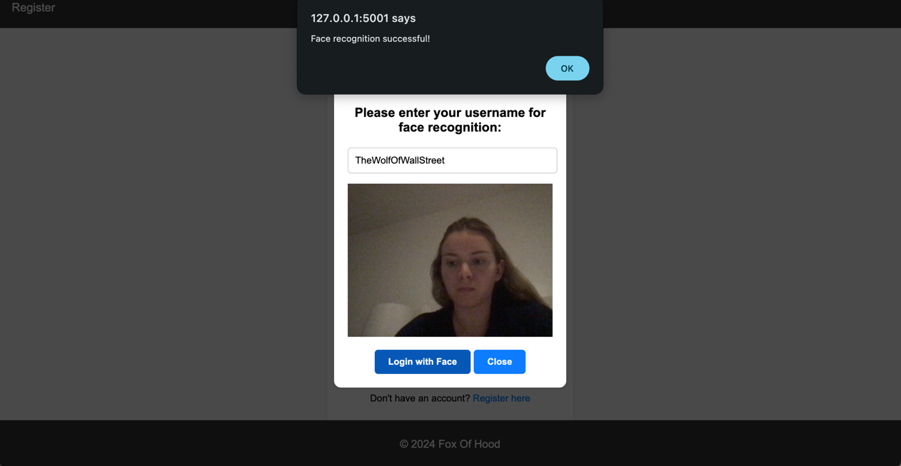

Figure 4 Login with Face

3. Navigating your account

There are 3 main pages for your account usage.

1. **Portfolio Page**

Here you can view your current balance, stocks owned (including their purchase price, current price, the profit percentage and amount of profit). These details are also viewable in the scatterplot below. After buying a stock, it will be added to your stock portfolio!

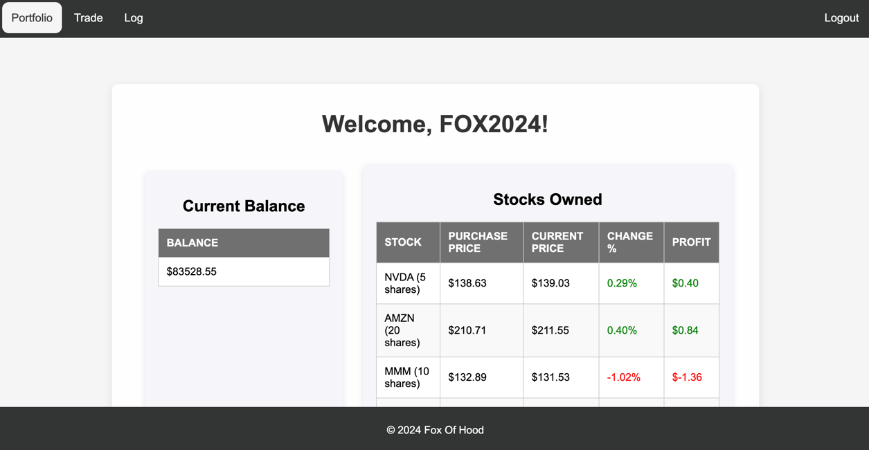

Figure 5 Portfolio Page

Figure 6 Graphed Profit and Loss based on Stocks Owned

1. **Trade Page**

Here you can search, buy and sell stocks, as well as schedule a buy or sell. Your searched stock will display a graph of its price over the last 30 days. There is also a table of top 5 stocks to choose from for trading purposes, as well as a bar graph to compare their prices.

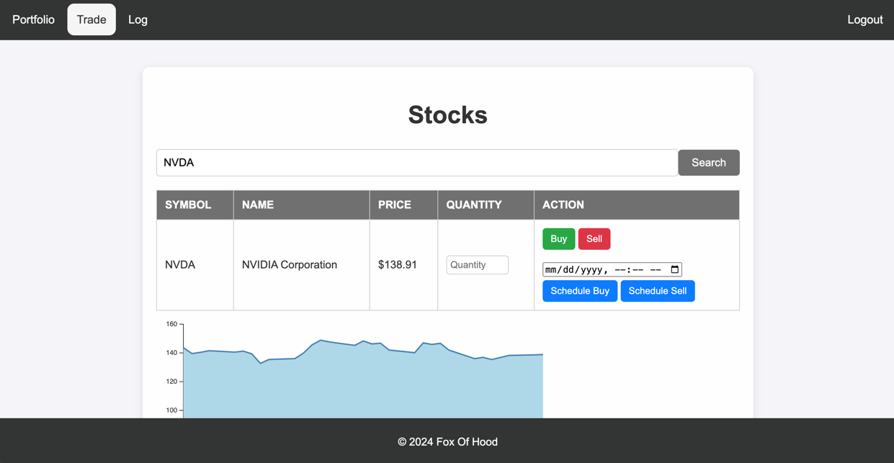

Figure 7 Trade Page

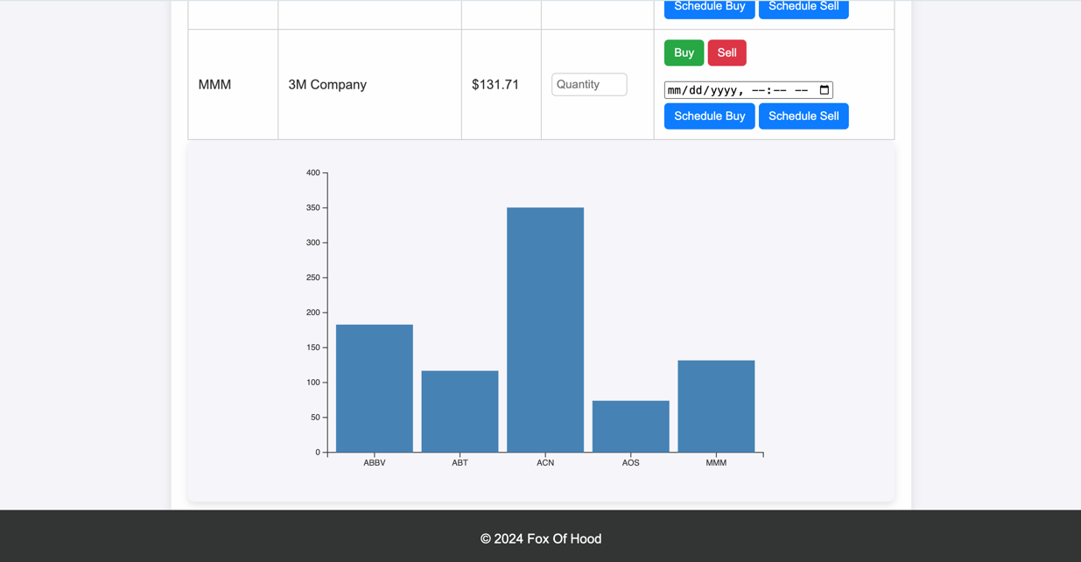

Figure 8 Bottom of Trade Page Displaying Top Stocks

1. **Activity Log Page**

This page displays when you bought or sold a stock, and log in and log out times. For user reference, your updated balance after every activity is shown.

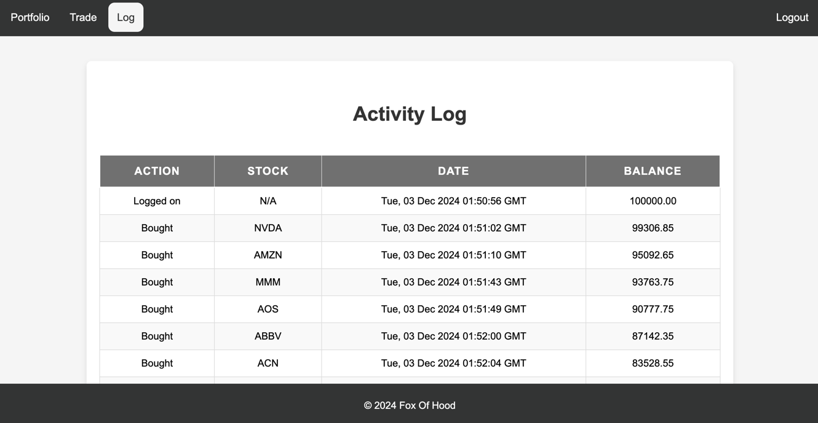

Figure 9 Activity Log showing the action, stock (if applicable), date and time, and remaining balance after activities

1. Trading
2. **Real-time transactions**

After either searching a specific stock or choosing one from the top stocks list on the Trade page, select a quantity of stock to buy or sell, then select the green “Buy” button or red “Sell” for an immediate transaction. You will be notified that the transaction was successful. The changes to your stock portfolio will be immediately visible on your Portfolio and Log pages.

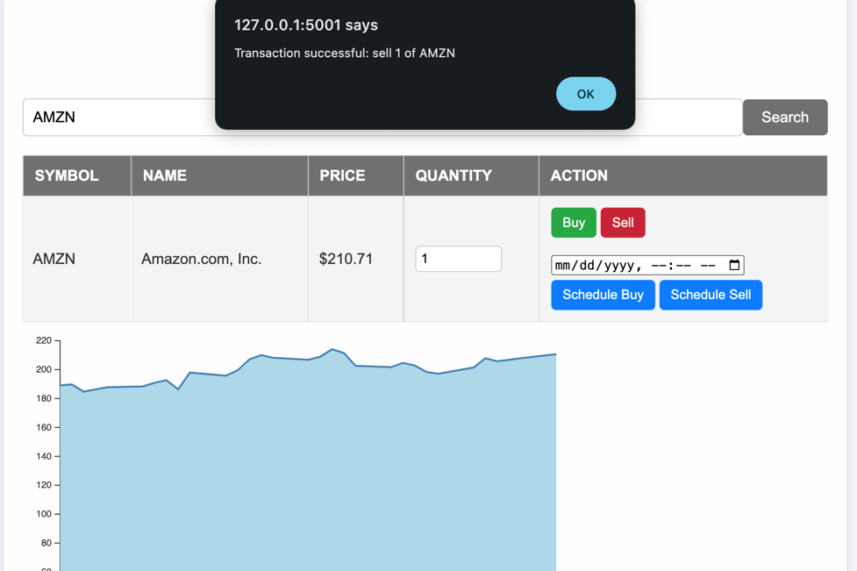

Figure 10 Buying 1 share of AMZN stock

1. **Scheduled transactions**

Instead of immediately buying or selling stocks, your could schedule a buy or sell. After choosing a stock and specifying a quantity, either manually fill in the date and time details or click the calendar icon to select these details as shown below:

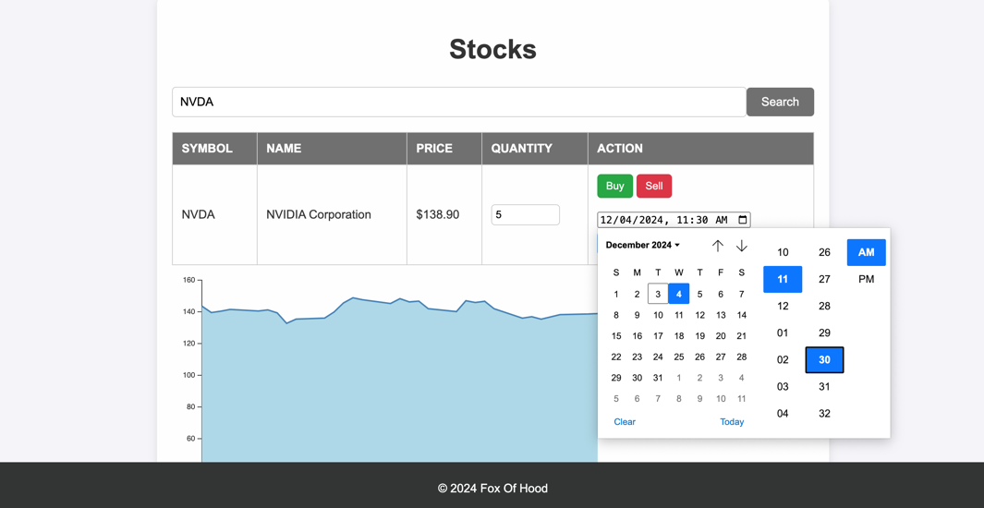

Figure 11 Scheduling buying 5 NVDA shares on 12/04/2024 at 11:30 AM

Next, click out of the calendar and select “Scheduled Buy” or “Scheduled Sell” respectively.

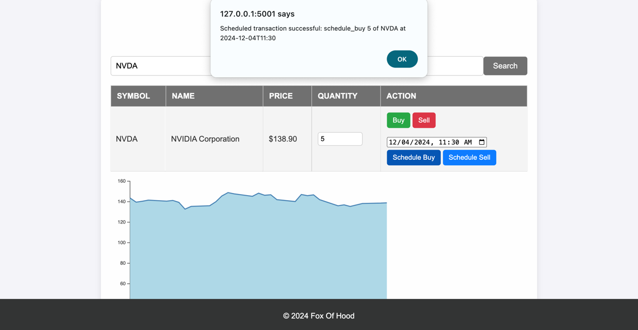

Figure 12 Successfully scheduling a stock purchase

1. Logging out

Simply click on the “Logout” button on any of the 3 pages and you will be redirected to this page.

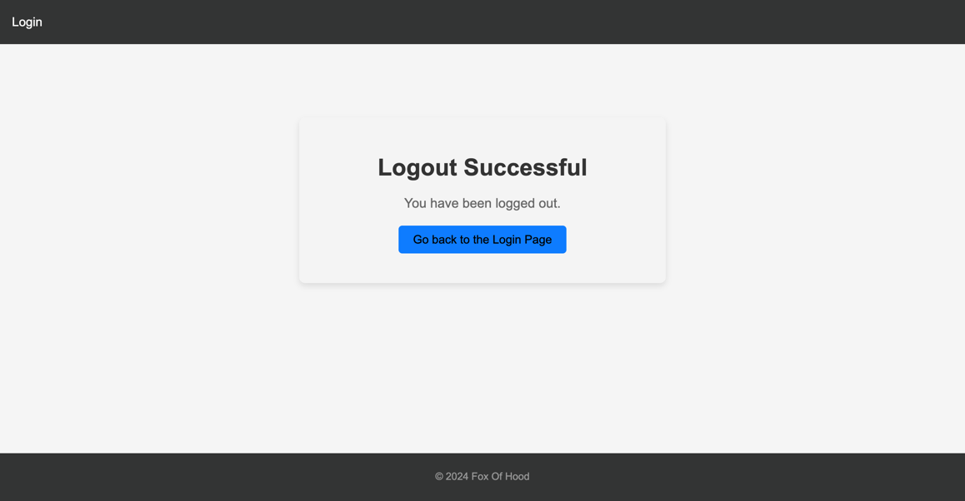

Figure 13 Logout page