Warranty Wallet
1. Users and the problem

People lose coverage they already paid for.
Lost receipts  Paper bills fade, emails get buried, and proof takes days to find when a product breaks. |  | Forgotten dates  People do not know when a warranty or promotional coverage period ends, or that it already expired. |  | Confusing claims  Unsure who to contact, what company warranty policy applies, or what to send, so many give up.

Who are our users?
Students, young adults, and households who buy phones, laptops, and appliances (and manage recurring subscriptions) and have to find proof of purchase when something breaks.
Our idea in one sentence
A mobile app that organizes your purchases and receipts, warns you before warranties expire, and automates filing and tracking claims.

What users told us
2. Findings from 3 anonymous conversations

Person 1  INCIDENT  Laptop screen fault  WORKAROUND  Searched old emails and bags  DIFFICULTY  Took days to find proof  SURPRISE  Did not know warranty end date  Verdict: Supports |  | Person 2  INCIDENT  Phone charger stopped  WORKAROUND  Kept a photo in the gallery  DIFFICULTY  Unsure how to make a claim  SURPRISE  Warranty had already expired  Verdict: Partly supports |  | Person 3  INCIDENT  Washing machine repair  WORKAROUND  Paper bills in a drawer  DIFFICULTY  Faded bill, hard to read  SURPRISE  Wants reminders more than storage  Verdict: Supports

Does the evidence support the idea? Mostly yes.
All three struggled with proof of purchase or warranty timing. Person 2 mainly struggled with claiming, while Person 3 valued reminders more than storage.
What we changed: Reminders and guided claims now come first in the journey, and our MVP uses fast structured input + receipt photo backup with pre-populated brand warranty defaults so faded bills never block a claim.

Our solution
3. Proposed solution and core user journey

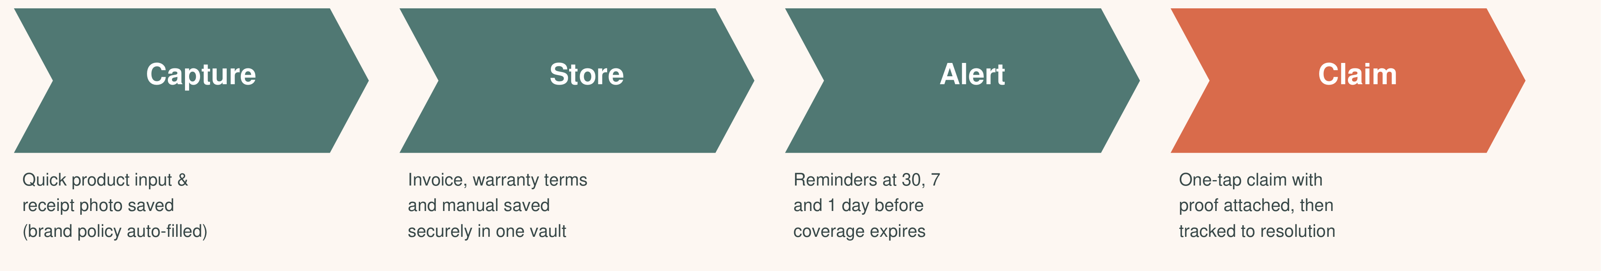
Three stages: CAPTURE (log & photo) PROTECT (store and alert) CLAIM (draft and track)
Journey: buy a product, log purchase details & save receipt photo (warranty length auto-suggested from our brand database), get warned before expiry, product breaks, send a ready claim, follow it to resolution.

Three core features
4. What we build, and what we do not

1 Quick capture & vault  Fast user input + receipt photo backup for a reliable MVP, paired with a pre-populated brand warranty database (OCR scanning added in Phase 2). |  | 2 Alerts and storage  Invoice photo, warranty terms, and manual stored securely. Proactive reminders at 30, 7, and 1 day before expiry. |  | 3 Claim generator  One tap drafts a claim message with proof attached, matches company warranty requirements, and tracks status to resolution.

Out of scope for now & future vision
Out of scope for MVP: Automated OCR receipt scanning (Phase 2) | Resale valuation | Retailer dashboard | Bank or email integration | Marketplace listing
Future platform vision: Subscription & student promo tracking (seeded via promotional directory scraping) | Ad-supported free student tier | White-label brand customization
Rule: we hold these three core MVP features until they work end to end.

Feasibility and plan
5. Milestones, risks and support needed

Top risks  Faded receipts / OCR complexity: Fix: structured user input + photo backup for MVP; add OCR in Phase 2  No warranty length on receipt: Fix: scraped brand warranty database + defaults by product type  Scope creep: Fix: hold the 3 core MVP features before expanding to subscriptions |  | Dependencies  - Wireframes before prototype  - Brand warranty & promo database seeded before capture module  - Data model before alerts and claims  - Working end-to-end prototype before user tests & investor demo |  | Support needed  - Advice on warranty data scraping & OCR tools  - Help finding test users  - Feedback on claim wording  Next owners (to Session 4):  Board and link: Member A  Wireframes: Member B  Warranty DB & scraper research: Member C  2 more interviews: Member D

