Designing a 28-bit Computer in Logisim
CPU, Booth multiplier, cache and DMA controller

Computer Architecture Laboratory - Project Report

Member | Roll | Part of the machine
Shemonty | 2407107 | Datapath and ALU
Ratul | 2407108 | Control unit
Mahima | 2407106 | Arithmetic (Booth multiplier)
Rup | 2407109 | Memory system and system integration
Thowai | 2407109 | Cache work in the early CPU file

Tool: Logisim 2.7.1 (the circuit file also opens in newer versions, see section 12).

1. What this project is
The task was to build a working computer in Logisim: a CPU, a main memory, at least six instructions, and at least two extra components on top. We went a bit further than the minimum. The final machine has a 28-bit word, a 16-register CPU with 32 instructions, a hardware Booth multiplier, a direct-mapped cache and a DMA controller that copies blocks of memory without the CPU touching every word.
Everything lives in one file, Computer_28bit.circ. You load a program image into the RAM, press Reset, turn the clock on, and the machine runs. Two example programs and a small assembler come with it, so a program can be written as text instead of being typed in as hex.
Feature | Value
Word size | 28 bits (given for our team)
Registers | 16 general purpose, 28 bits each, two read ports and one write port
Instructions | 32 opcodes, plus 8 assembler shortcuts (LI, MOV, NOT, INC, DEC, CALL, RET and so on)
Main memory | 4096 words x 28 bits (12-bit address)
Control | Micro-programmed: a 1024 x 28 ROM indexed by state and opcode
Multiplier | Radix-2 Booth, 28 x 28 -> 56 bit, 28 clock cycles
Cache | Direct mapped, 16 lines of one word, write-through
DMA | Block copy of up to 1023 words, CPU waits while it runs
Adders | Ripple-carry, built from gate-level full adders

2. Where we started, and why we rebuilt
When we put the team's files side by side, they did not form a computer yet. We had three separate circuit files: a 28-bit ALU with a register file, a 28-bit Booth multiplier, and a small accumulator CPU. We went through each one before deciding what to keep.
- cput_thowai.circ pulls in two other files (28-bit-ALU.circ and thowa_fixed.circ) that were not in the folder, so it could not even load its ALU or cache. Its CPU also had a 4-bit address, which means 16 words of memory in total, and only eight instructions.
- ALU_Register.circ was saved by Logisim-evolution 4.0, not by 2.7.1. It lists TTL, TCL and SoC libraries that 2.7.1 does not have, so the lab version cannot open it.
- Booths_28_bits.circ is a good standalone Booth design (a counter and a small ROM drive the shift registers) but it only has input pins. There is no output pin, so the product is visible only by opening the sub-circuit, and nothing connects it to a CPU.
- Nothing used one common instruction format, so the three pieces could not simply be wired together.
Patching each file would have meant fixing the memory width, the missing libraries and the interfaces all at once. We decided it was cleaner to define one instruction format and one set of interfaces first, then rebuild every block against them. The ideas from the team's files survived: the full-adder based ALU, the 16-entry register file, and the Booth algorithm with a counter that stops after 28 steps. The original three files are still in the project folder, unchanged, for reference.
To avoid wiring mistakes in a design with more than three thousand components, we described the circuits in a small Python script (the tools folder) that writes the .circ file. The script asks Logisim itself where every pin sits, so the generated wires land on real connection points. The output is an ordinary Logisim file and can be edited by hand afterwards.

3. Architecture overview
The machine has five parts around one memory bus: the CPU, the cache, the DMA controller, the main memory and a few pins for the outside world. The CPU asks the cache for every instruction and every data word. On a miss the CPU stalls for a cycle while the cache line is filled from RAM. When a DMA transfer is running, the DMA controller takes over the memory bus and the CPU waits.
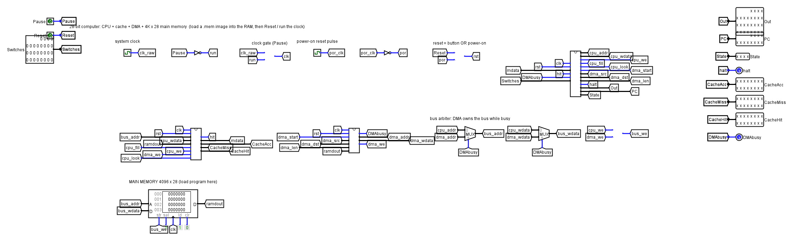
Figure 1. The top-level circuit (main). CPU, Cache and DMA are sub-circuits; the RAM sits in the main circuit so that an image can be loaded into it.
Pins on the main circuit:
Pin | Direction | Meaning
Pause | in | 1 stops the clock, useful for stepping by hand
Reset | in | 1 clears the CPU, cache and DMA. A short power-on reset also fires by itself
Switches | in (28 bit) | read by the IN instruction
Out | out (28 bit) | the output register written by OUT
PC, State | out | program counter and control state, handy while demonstrating
halt | out | goes to 1 after HLT
CacheAcc / CacheMiss / CacheHit | out (16 bit) | cache look-ups, line fills and hits
DMAbusy | out | 1 while a DMA copy is running

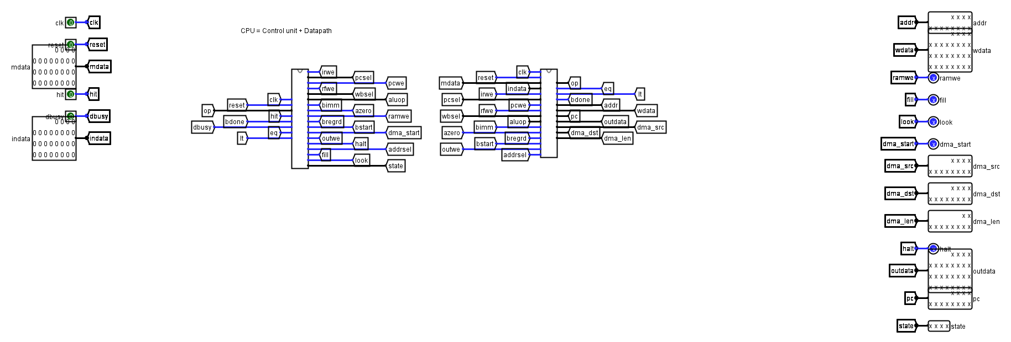
Figure 1b. The CPU sub-circuit is just the control unit wired to the datapath.

4. Instruction set
Every instruction is one 28-bit word.
27 .. 22 | 21 .. 18 | 17 .. 14 | 13 .. 10 | 9 .. 0
opcode | rd | ra | rb | (low bits of imm)

Immediate-type instructions use bits 13..0 as a signed 14-bit number (-8192 to 8191). Jump and branch targets are the low 12 bits, and the DMA length is the low 10 bits. The register fields are 4 bits, so r0 to r15. r0 is an ordinary register, not hard-wired to zero. The assembler uses r15 as the link register for CALL and RET.
Opcode | Mnemonic | What it does
0 | NOP | nothing
1 | HLT | stop, halt pin goes high
2-6 | ADD SUB AND OR XOR rd,ra,rb | rd = ra op rb
7-9 | SHL SHR SAR rd,ra,rb | shift ra by rb[4:0]; SAR keeps the sign
10 | MUL rd,ra,rb | low 28 bits of the signed product (Booth)
11 | MULH rd,ra,rb | high 28 bits of the signed product
12 | ADDI rd,ra,imm | rd = ra + imm
13 | LDI rd,imm | rd = imm (sign extended)
14 | LUI rd,imm | rd = imm << 14, used with ADDI to build big constants
16 | LD rd,[ra+imm] | load a word
17 | ST rd,[ra+imm] | store a word
18 | JMP addr | PC = addr
19-21 | BEQ BNE BLT rd,ra,addr | branch if rd == ra, != ra, or < ra (signed)
22 | JAL rd,addr | rd = return address, PC = addr
23 | JR ra | PC = ra (return)
24 | OUT ra | output register = ra
25 | IN rd | rd = Switches pin
26 | DMA rd,ra,len | copy len words from RAM[ra] to RAM[rd]
27-29 | SHLI SHRI SARI rd,ra,imm | shift by a constant
30-32 | ANDI ORI XORI rd,ra,imm | logic with a sign-extended constant

The pseudo-instructions are expanded by the assembler: LI picks LDI, or LUI followed by ADDI, depending on the size of the number; MOV is ADDI with zero; NOT is XORI with -1; CALL is JAL r15; RET is JR r15.

5. The control unit
We used a micro-programmed control unit because it is easy to change and easy to check. A 4-bit state register and the 6-bit opcode form a 10-bit address into a ROM of 1024 words. Each word is 28 bits wide and holds the control signals for that state and opcode: next state, write enables, which value to write back, the ALU operation, branch type, and so on. The ROM contents are generated by the same Python module (isa.py) that the assembler and the reference model use, so the three can never disagree about an opcode.
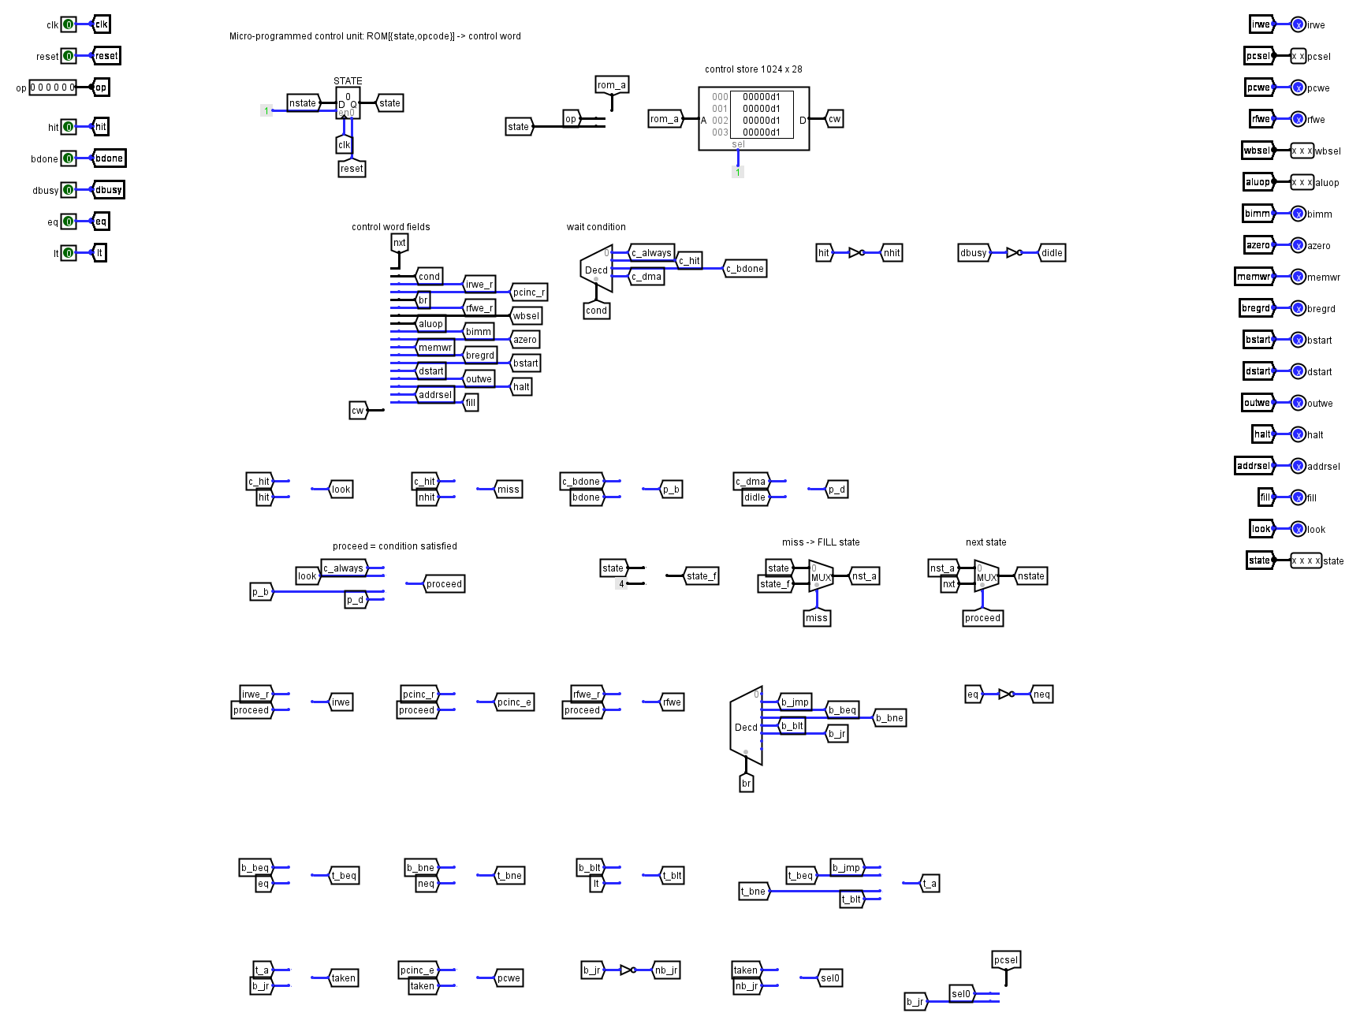
Figure 2. Control unit: state register, control ROM, wait condition logic and branch decision.
State | Name | What happens
0 | FETCH | read the instruction at PC through the cache; IR and PC are updated if it hits
1 | EXEC | decode and do the work of most instructions
2 | MULWAIT | wait for the Booth unit, then write the result
3 | MEM | second step of LD and ST
4 | FILL_F | cache miss during fetch: copy the line from RAM
5 | HALT | stay here
6 | DMAWAIT | wait until the DMA unit is idle
7 | FILL_M | cache miss during a load: copy the line from RAM

Every state has a wait condition (always, cache hit, multiplier done, DMA idle). A single signal called proceed says whether the condition is met. Register writes, IR loading and PC updates are ANDed with proceed, so a stalled cycle never changes the machine. If the condition is the cache hit and it fails, the next state is the matching FILL state, which is just the current state with bit 2 set. This kept the state diagram small: a miss costs exactly one extra cycle, then the same state runs again and hits.

6. Datapath and ALU
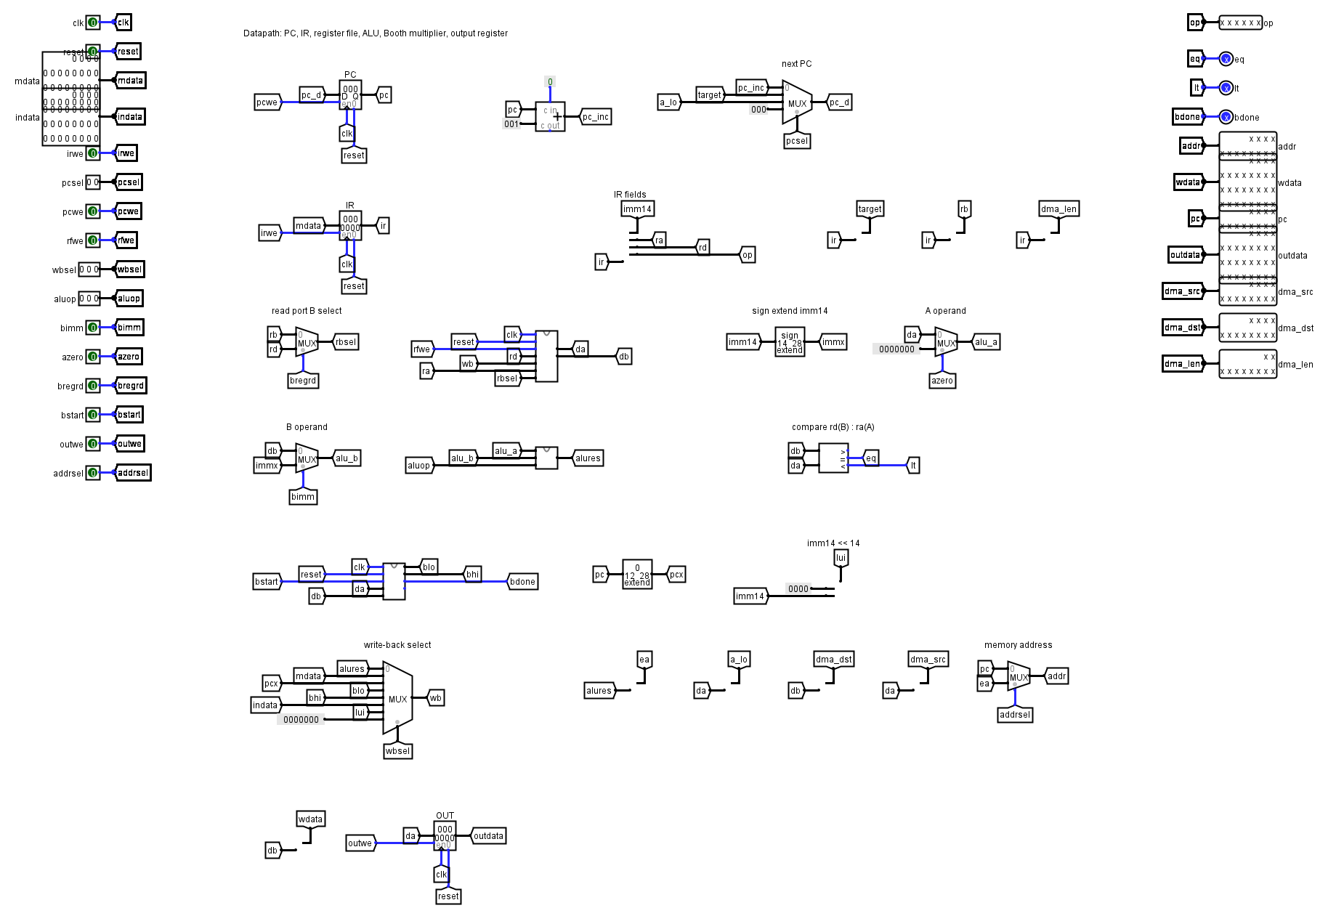
Figure 3. Datapath: PC, IR, register file, ALU, Booth unit, write-back multiplexer and output register.
The datapath is a conventional one. PC and IR are registers. The register file reads two registers each cycle; a multiplexer lets read port B pick the rd field instead of rb, which is how stores, branches and DMA get a second register out of a format that has only one spare field. A comparator on the two read ports gives the equal and less-than flags for branches. The write-back multiplexer chooses between the ALU result, memory data, the PC (for JAL), the two halves of the Booth product, the input pins and the LUI constant.
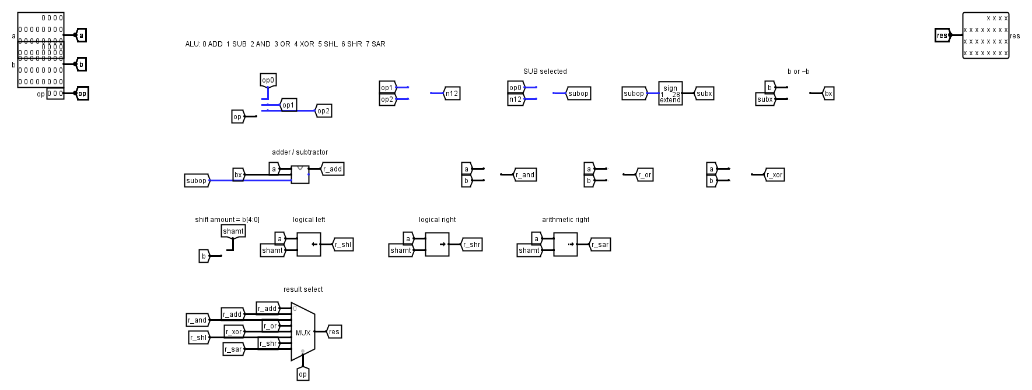
Figure 4. The ALU: gate-level adder/subtractor, bitwise gates, three shifters, result multiplexer.
In the ALU, addition and subtraction share one 28-bit ripple-carry adder. For SUB the second operand is XORed with the subtract signal and the same signal goes into the carry input, which is the usual two's-complement trick. The adder itself is made of 28 copies of a gate-level full adder (two XOR, two AND and an OR). Logic operations use 28-bit-wide gates, and the three shifters (logical left, logical right, arithmetic right) use the low five bits of operand B as the amount.

7. The Booth multiplier
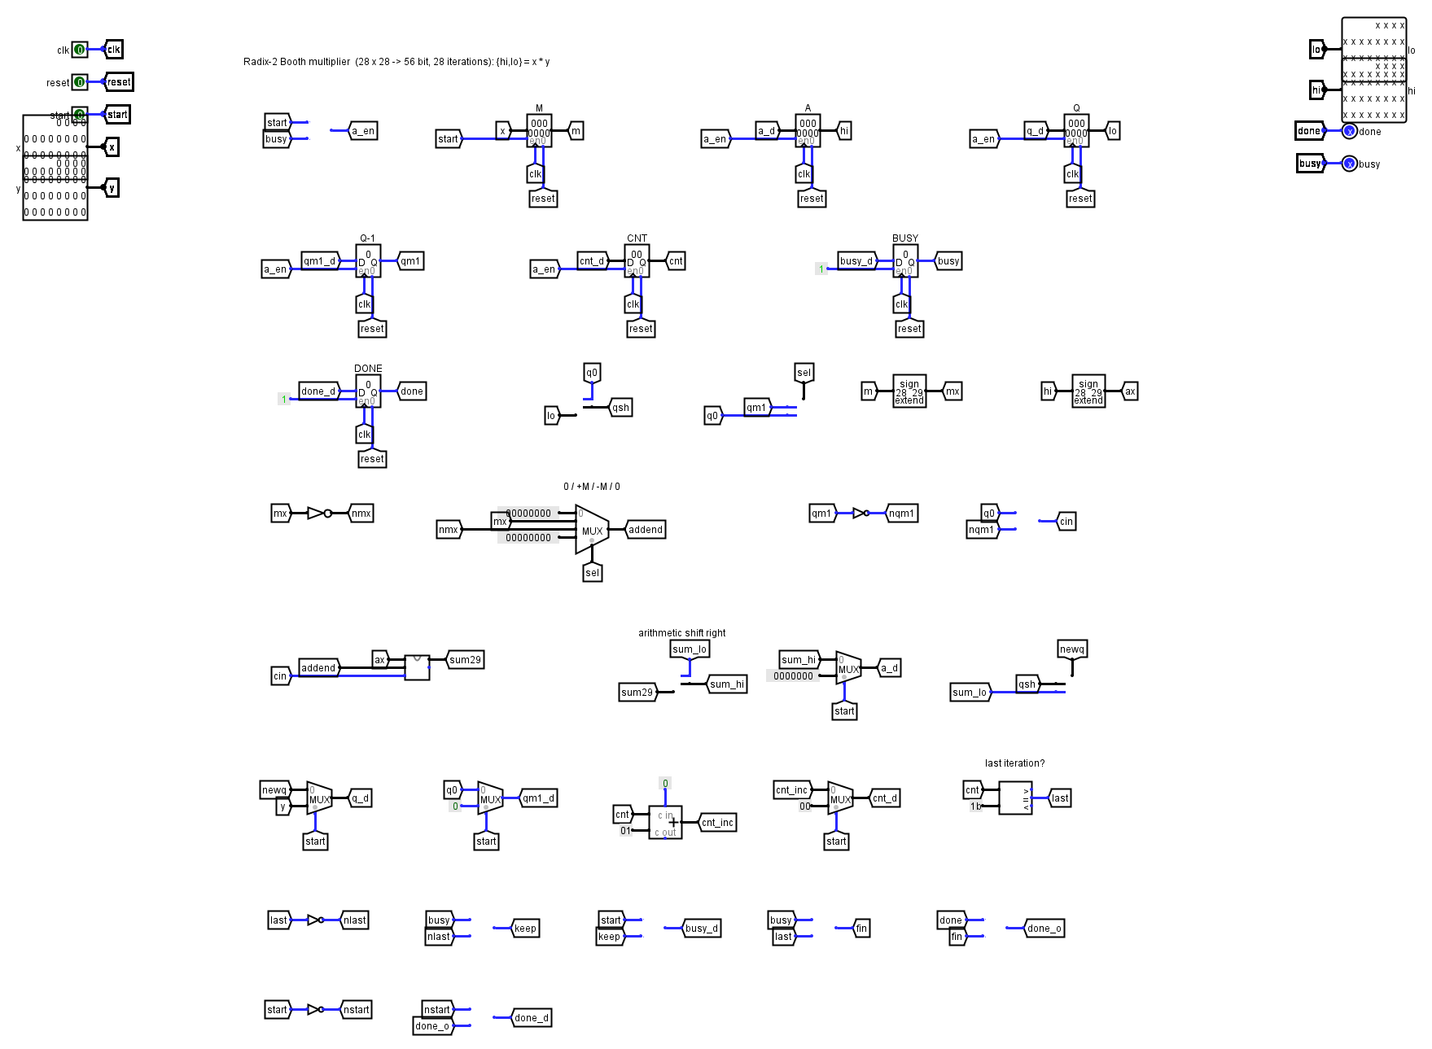
Figure 5. Booth multiplier: M, A, Q, Q-1 and counter registers around one 29-bit adder.
The multiplier follows textbook radix-2 Booth recoding. Registers A (accumulator), Q (multiplier) and a single bit Q-1 are cleared or loaded when the CPU pulses start, and M holds the multiplicand. On each clock the two bits Q0 and Q-1 are looked at: 01 adds M, 10 subtracts M, and 00 or 11 adds nothing. Then the A:Q:Q-1 chain shifts right arithmetically. After 28 rounds the 56-bit product sits in A (high half) and Q (low half), and a done flag goes high.
One detail is worth writing down: if A and M are only 28 bits wide, subtracting the most negative number (-2^27) overflows. We therefore add in 29 bits with sign extension and drop the extra bit during the shift. With that, the edge cases all come out right, including (-2^27) x (-2^27) and (-2^27) x (-1).
MUL writes the low half of the product to rd and MULH the high half. A 28-cycle multiply sounds slow next to a one-cycle ADD, but it only uses one adder and a few registers, which is the whole point of Booth's method in hardware.

8. Cache
The cache sits between the CPU and RAM. It is direct mapped with 16 lines of one word each. The 12-bit address splits into an 8-bit tag and a 4-bit index. Each line has a 28-bit data register, an 8-bit tag register and a valid bit. A hit means the valid bit is set and the stored tag equals the address tag.
- Read hit: the word comes out in the same cycle.
- Read miss: the CPU enters a FILL state, the line is loaded from RAM, then the access repeats and hits.
- Write: write-through. A store goes to RAM and also updates the cache line, so a cache line is never older than RAM.
- Statistics: two 16-bit counters count completed look-ups and line fills. Hits are look-ups minus fills and appear on the CacheHit pin.
We built the cache arrays out of registers rather than Logisim RAM blocks. Part of the reason is practical: Logisim's image loader writes the program into every RAM it can find in the design, so extra RAM blocks inside the cache would be overwritten by the program. The other reason is that register contents are visible while the circuit runs, which makes the cache easy to explain in a demo.

9. DMA controller
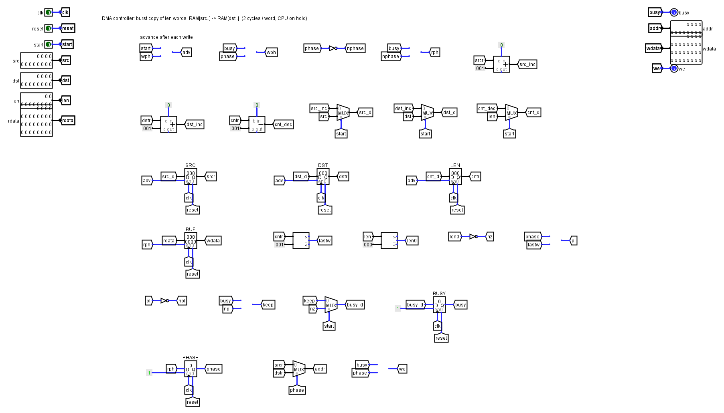
Figure 7. DMA controller: address and length registers, a one-word buffer and a two-phase state.
The DMA instruction takes a destination register, a source register and a length: DMA rd,ra,len. The CPU hands these three values to the controller and goes to DMAWAIT. The controller then takes the memory bus and copies the block one word at a time using two clock cycles per word: one to read the source word into a buffer, one to write it to the destination. When the counter reaches the end, it releases the bus, the CPU sees DMAbusy drop and continues. A length of zero does nothing and does not hang.
The interesting part is the cache. DMA writes go straight to RAM and would leave stale words in the cache. So every DMA write also clears the valid bit of the cache line it maps to. Our DMA test reads the destination area first (filling the cache with old values), runs the copy, then reads the area again. It only passes if the new data comes back, which proves the invalidation works.

10. Programs and the assembler
asm.py turns a text program into a Logisim memory image (the "v2.0 raw" format that Logisim's Load Image menu expects), and also writes a listing with the address and machine word of every line. Syntax is simple: labels end with a colon, comments start with a semicolon, registers are r0 to r15 and memory operands look like [r3+4].
File | What it shows
demo.asm | Fibonacci, 10! with MUL, a 54-bit product with MUL and MULH, a squares table summed twice (cache), a DMA copy that is checked, and a gcd subroutine
echo.asm | Copies the Switches pins to the Out pin forever; good for showing IN and OUT live
test_isa.asm | Uses every instruction, including Booth edge cases, branches and call/return
test_dma.asm | DMA copy with cache coherence, zero-length copy, overlapping copy
smoke.asm | Five instructions, adds 5 and 7 and halts

The demo prints these values on the Out pin, in order: 1 1 2 3 5 8 13 21 34 55 (Fibonacci), 3628800 (10!), 45423444 and 195687384 (the high and low halves of 123456789 x 98765432), 10416 three times (the squares sum before and after the cache is warm, then the DMA copy), and finally 21 (gcd of 1071 and 462). When it halts, 818 instructions have run and the cache counters read 914 look-ups, 208 misses and 706 hits, a hit rate of about 77 percent.

11. How we tested it
Looking at waveforms by hand does not scale to a design this size, so we tested the circuit against a second, independent model of the machine. iss.py is a small instruction-set simulator written in Python from the instruction definitions only; it shares no logic with the circuit. For each test program we run both, and compare the sequence of values written to the Out register.
The circuit side runs in real Logisim 2.7.1 with no window (its -tty mode), loading the program image into the RAM and recording the output pins at every clock tick until the halt pin rises.
Test | Result
smoke.asm (5 instructions) | passed
test_isa.asm (181 instructions executed, 44 checked outputs) | passed
test_dma.asm (259 instructions executed, DMA and cache coherence) | passed
demo.asm (818 instructions executed, 17 outputs) | passed
37 random programs of about 150 instructions each (ALU, MUL/MULH, shifts, loads, stores, forward branches, DMA) | all identical to the model

The random programs use seeds 1-12, 100-104 and 200-219, so they can be regenerated. Together they gave us far more confidence in the Booth multiplier and the branch logic than a handful of hand-picked tests would have.

12. Running it

In Logisim 2.7.1
- Open Computer_28bit.circ. The main circuit opens by default.
- With the Poke tool, right-click the RAM at the bottom and choose Load Image. Pick programs/demo.mem.
- Press Reset once (click the Reset pin to 1, then back to 0).
- Simulate > Ticks Enabled (Ctrl+K), or step with Ctrl+T. Watch Out, PC, State and the cache counters.
- To run a new program, edit the .asm file, run python tools/asm.py your.asm, and load the new .mem.
RAM contents are not stored inside a Logisim 2.7.1 file, so the image has to be loaded each time the file is opened. This is a Logisim limitation, not something specific to our design.

A note about Logisim-evolution
The file is written in the 2.7.1 format. Logisim-evolution can open it in compatibility mode, but we found that evolution redraws some library parts (registers, counters, RAM and ROM) with different pin positions, so wires that were attached correctly in 2.7.1 can end up unconnected there. We have not made the file work in evolution and we do not recommend using it for the demonstration. Please present with 2.7.1.

13. Problems we ran into
- Image loading hit the wrong memories. Our first cache used small RAM blocks; Logisim's loader writes the program into all of them and complained the file was too big. Moving the cache arrays into registers fixed it.
- A processor built from registers wakes up undefined in some Logisim versions. A short power-on reset pulse inside main clears everything, so the machine starts clean even before Reset is pressed.
- Wires and labels at ten-pixel pitch make a messy picture. The generator staggers the label stubs on crowded sub-circuit pins so names can be read.
- The Booth overflow case described in section 7.
- Both the plan slides and the files assumed 24-bit words at one point; the assignment gave us 28, so every width in the final design is 28.

14. What is missing
- There is no divide instruction. Our early slides mentioned a restoring divider; we did not build one.
- There is no parity or error-correcting memory. The two additional components we finished are the cache and the DMA controller, plus the Booth multiplier as an instruction-set upgrade.
- There is no interrupt support and no stack pointer; CALL and RET use a link register.
- The cache is small and has no associativity, so two addresses 16 words apart keep evicting each other (test_isa.asm does this on purpose).
If we had another week we would add a divider with the same start/done handshake as the Booth unit, and a parity bit per memory word.

15. Files in the submission
File | Purpose
Computer_28bit.circ | the whole computer (Logisim 2.7.1)
programs/*.asm, *.mem, *.lst | source, loadable image and listing for each program
tools/asm.py | assembler
tools/iss.py, selftest.py, fuzz.py, sim.py | reference model and test scripts
tools/design.py, lgen.py, isa.py | scripts that generate the circuit and its control ROM
docs/ | this report, the slides and the circuit screenshots
ALU_Register.circ, Booths_28_bits.circ, cput_thowai.circ | the team's earlier files, unchanged

